**SIR M. VISVESVARAYA INSTITUTE OF TECHNOLOGY**

International Airport Road, Hunasamaranahalli,

Yelahanka, Sir M Visvesvaraya Inst Rd, Yelahanka,

Bengaluru, Karnataka 562157

Phone: 08028467248

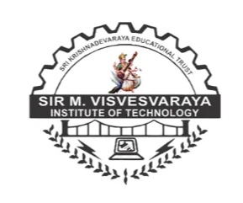

SKILL DEVELOPMENT ACTIVITY:

Topic : **INTELLECT QUIZ**

**Names:** Rafaath Elmi and Syed Sakeena

**USN:** MCA01, MCA20

**Semester:** 1st Sem

**Department:** MCA

**Subject:** Web Technologies

**Faculty in Charge:** Ms. R. Latha

Assoc. Prof

Dept. of MCA

Date: Signature

[Document subtitle]