_T_EMBLEMY



T_Emblemy logo

**Description**

* _T_Emblemy is a collectible books store in Mayfair that has been selling rare, used classic fiction for 40 years.
* Due to some financial issues, the store has to close down and the owner would like to proceed with an e-commerce in Mile End, ‘under the arches’, a warehouse space.

**Aims & objectives**

* To save her business
* To perceive previously unreachable market for collectible books in the USA, Canada, New Zealand and Australia.
* Target maximum audience worldwide as internet is fast-growing.

**Target Audience**

* Mainly unreachable market in USA, Canada, New Zealand, Australia.
* For further profits, worldwide shipping is available.
* For fiction lovers/bookworms.
* For people who cannot afford to buy new books, so used books will be sold at a cheaper price.
* For people in search of rare fictional books.

**Sitemap**

Home

A little about us

Background Image

Promotional Video

Logo

Home

By Post/Pick Up

Additional fee for delivery

2-3 books

19th Century Books

Book 4

Book 3

Book 1

Book 2

Contact Us

Delivery

Books

**Some Photos that will be used**



Background image

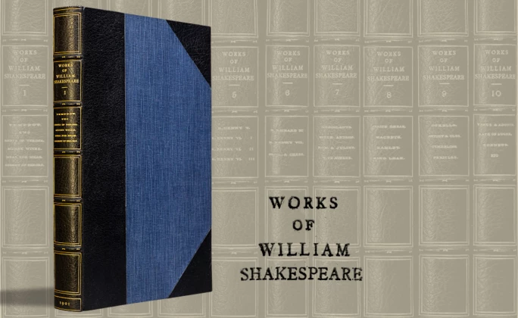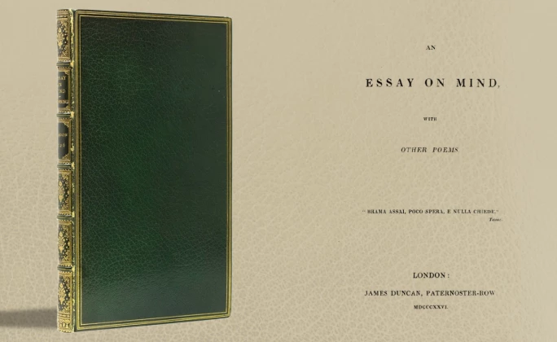

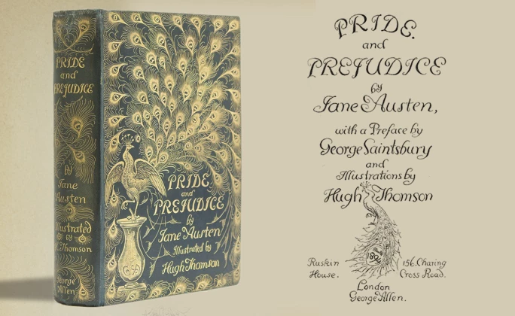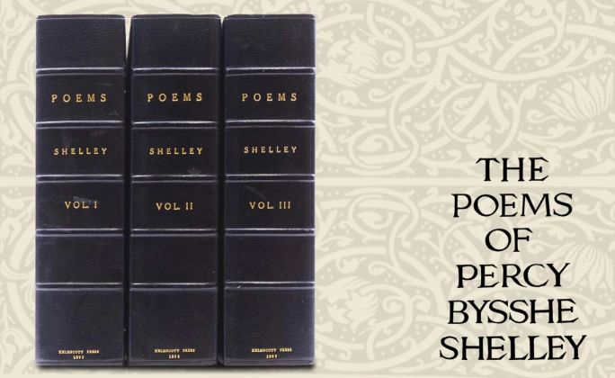

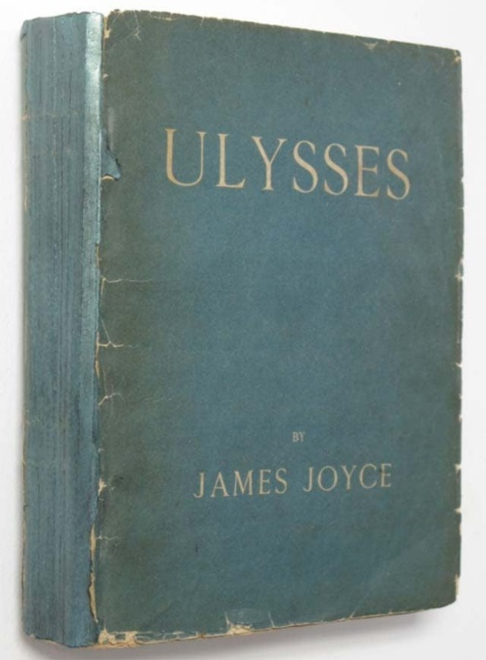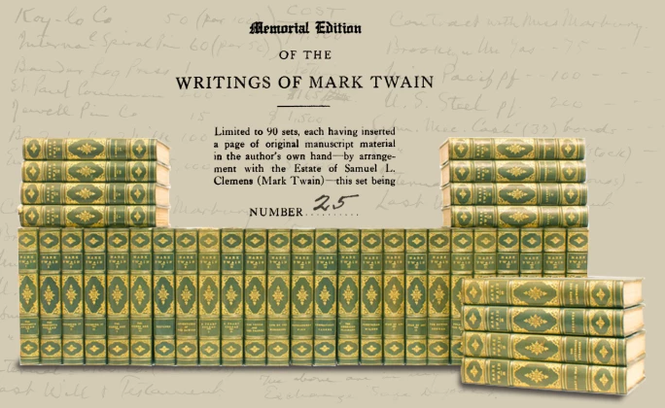

[](https://www.youtube.com/embed/Qzs01gzQxJU?feature=oembed)

A Promotional Video

**Fonts that will be used**

* Arial
* Verdana

**Font Effects:**

* Bold
* Italic
* Font color
* Font Size – range of 10px – 70px

**Timeline**

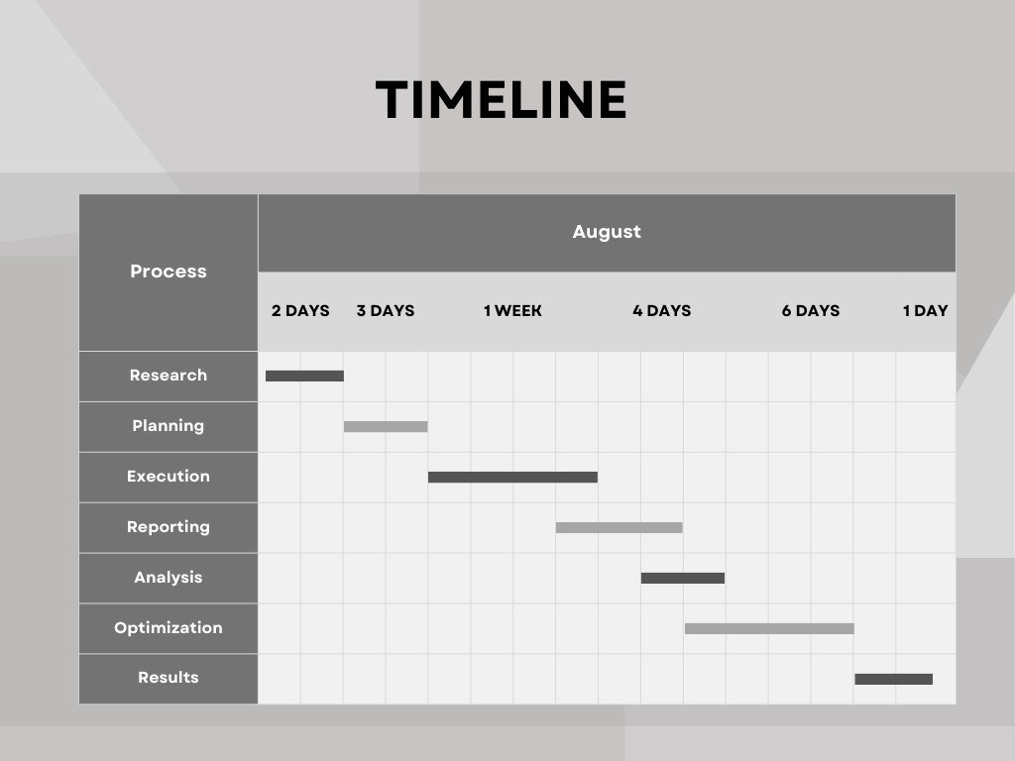

**Page Layout for Home.html**

Navigation Bar

Search bar

Logo



Background Image

Promotional Video

A little story about _T_Emblemy

_T_Emblemy

**Page Layout for Books.html**

Navigation Bar

Search bar

Logo



Book 1

Book 2

Book Details

Book Details

Filter

_T_Emblemy

**Note:** Other webpages will be quite similar to Books.html