A Project Report
on
RefurbIQ: Aspect-Based Sentiment Analysis of Refurbished Electronics Across Indian Marketplaces
carried out as part of the Project Based Learning-3 (DSE3170)
Submitted
by
Saket Sharma (2430010408)
in partial fulfilment for the award of the degree of
Bachelor of Technology
in
Computer Science and Engineering (Data Science)

School of Computer Science and Engineering
Department of Data Science and Engineering
MANIPAL UNIVERSITY JAIPUR, JAIPUR
RAJASTHAN, INDIA
Nov 2026
CERTIFICATE
This is to certify that the project-based learning project titled “RefurbIQ: Aspect-Based Sentiment Analysis of Refurbished Electronics Across Indian Marketplaces” is a record of the bonafide work done by Saket Sharma (2430010408), submitted in partial fulfilment of the requirements for the award of the Degree of Bachelor of Technology in Computer Science and Engineering (Data Science) of Manipal University Jaipur, Jaipur during the academic year 2025-26.
Dr Ashish Pandey
Designation
Project Guide, Department of Data Science and Engineering
Manipal University Jaipur, Jaipur
Dr Ram Kumar Yadav
Designation
Class instructor, Department of Data Science and Engineering
Manipal University Jaipur, Jaipur

Abstract
India's market for refurbished smartphones, laptops and cameras is growing, yet buyers must decide with very limited quality signals: condition grades, prices and a single overall rating per review. A single polarity label cannot show whether dissatisfaction comes from battery health, refurbishment quality, seller behaviour, returns or trust in authenticity. This project builds RefurbIQ, an aspect-based sentiment analysis (ABSA) pipeline that reads refurbished-electronics reviews at the level of nine aspects and compares five Indian marketplaces - Cashify, Amazon Renewed, Flipkart Refurbished, OLX and Budli - under one common aspect taxonomy.
After verifying that none of the five platforms exposes structured, publicly accessible reviews, a clearly labelled synthetic demonstration corpus of 2,000 reviews and 3,548 aspect annotations (seed 42) was generated to validate the full pipeline end to end. Logistic Regression, Random Forest and XGBoost on TF-IDF features and a fine-tuned DistilBERT model were compared on the same review-level stratified 70/15/15 split. Logistic Regression achieved the highest test accuracy (90.69%, macro F1 0.8937) with fine-tuned BERT second (89.57%, macro F1 0.8784); neutral recall was the weakest point for every model. The pipeline was additionally validated on 2,000 real Amazon reviews, where predicted sentiment agreed with reviewer star ratings in 75.6% of annotations. All numbers are computed by reproducible scripts; the synthetic corpus must be replaced with verified marketplace reviews before the results can be generalised.

List of Tables
Table No | Table Title | Page No
2.1 | Research gap summary | 4
2.2 | Literature summary | 4
3.1 | Platform verification outcomes | 5
3.2 | Dataset profile of the demonstration corpus | 5
3.3 | Aspect mention frequency | 6
3.4 | Partition sizes by class | 7
3.5 | Model configurations | 8
4.1 | Model performance on the held-out test partition | 10
4.2 | Class-specific recall on the test partition | 11
4.3 | Sentiment distribution within each aspect | 12
4.4 | Cross-platform aspect summary | 13
4.5 | Agreement with reviewer star ratings on real Amazon reviews | 14
4.6 | Confusion matrix - Logistic Regression | 14
4.7 | Confusion matrix - Random Forest | 15
4.8 | Confusion matrix - XGBoost | 15
4.9 | Confusion matrix - BERT-based model (zero-shot) | 15
4.10 | Confusion matrix - BERT-based model (fine-tuned DistilBERT) | 15
4.11 | Misclassified examples - Logistic Regression | 15
4.12 | Real-review agreement by detected aspect | 16
4.13 | Hypothesis outcomes | 17
4.14 | Predicted vs human sentiment on real Amazon reviews | 18
4.15 | Aspect-wise label distribution | 18
5.1 | Recommendation engine scoring weights | 21
A.1 | Pipeline scripts and outputs | 25
B.1 | Sample annotations | 26
B.2 | Full-review annotation walkthrough | 27
C.1 | Aspect mentions by platform | 29
D.1 | Per-class metrics for all models | 30
E.1 | Review length statistics by platform | 31
E.2 | Annotations per review | 31
E.3 | Annotation labels by platform | 31
E.4 | Star rating statistics by platform | 32

List of Figures
Figure No | Figure Title | Page No
3.1 | Reviews per marketplace in the demonstration corpus | 6
3.2 | Sentiment label distribution over 3,548 annotations | 7
4.1 | Test accuracy by model | 10
4.2 | Macro F1 and neutral recall by model | 11
4.3 | Sentiment distribution within each aspect (denominator = aspect mentions) | 12
4.4 | Net sentiment (positive % minus negative %) by platform and aspect | 13
4.5 | Predicted-vs-human agreement by star bucket (real Amazon reviews) | 14
4.6 | Predicted-vs-human confusion matrix on real Amazon reviews | 18
5.1 | Technology stack of the RefurbIQ system | 20
5.2 | End-to-end workflow of the RefurbIQ application | 21

Table of Contents
Abstract i
List of Tables ii
List of Figures iii
1. Introduction 1
1.1 Background 1
1.2 Objectives of the Project 1
1.3 Research Questions and Hypotheses 1
1.4 Scope and Contributions 2
1.5 Organisation of the Report 2
2. Literature Survey 3
2.1 Online Reviews and Electronic Word of Mouth 3
2.2 Sentiment Analysis and Opinion Mining 3
2.3 Aspect-Based Sentiment Analysis 3
2.4 Classical Machine Learning and BERT 3
2.5 Research Gap 4
3. Proposed Methodology 5
3.1 Platform Verification and Data Strategy 5
3.2 Dataset Construction 5
3.3 Aspect Taxonomy and Annotation 6
3.4 Pre-processing and Partitioning 7
3.5 Models and Hyperparameters 8
3.6 Evaluation Protocol 8
3.7 Evaluation Metrics 8
4. Results and Discussion 10
4.1 Dataset Profile 10
4.2 Model Comparison 10
4.3 Class-Level Analysis 11
4.4 Aspect-Level Sentiment 12
4.5 Cross-Platform Analysis 13
4.6 Validation on Real Reviews 13
4.7 Confusion Matrix Analysis 14
4.8 Error Analysis 15
4.9 Agreement by Aspect on Real Reviews 16
4.10 Hypothesis Outcomes 17
4.11 Error Flows on Real Reviews 17
4.12 Aspect-Wise Label Distribution 18
5. Outcome and Deliverables 20
5.1 Research Output 20
5.2 System Design and Implementation 20
5.3 Deliverables 21
6. Conclusion and Future Scope 23
References 24
Appendix A. Reproducibility 25
Appendix B. Annotation Samples 26
Appendix C. Aspect-Wise Counts by Platform 29
Appendix D. Per-Class Precision, Recall and F1 30
Appendix E. Corpus Statistics 31

1. Introduction

1.1 Background
The market for refurbished electronics in India has expanded rapidly as smartphones, laptops and cameras become both more expensive and more essential. Refurbished devices offer a lower-cost and more sustainable route to the same functionality, but they carry a question that new products do not: how good is this particular device, really? Battery health, cosmetic condition, the quality of repair work, the genuineness of parts and the reliability of the seller all vary from unit to unit and from platform to platform.
Online reviews are the main evidence available to buyers. Research on electronic word of mouth has long shown that review valence and volume influence purchase behaviour [1], and sentiment analysis provides the tools to summarise such reviews automatically [2], [3]. However, most marketplace interfaces reduce a review to a single star rating, and most sentiment systems reduce its text to a single polarity label. When a reviewer writes “the battery is excellent but the seller refused my return”, a single label destroys exactly the information a buyer of a refurbished device needs.
Aspect-based sentiment analysis (ABSA) addresses this by attaching a sentiment polarity to each aspect mentioned in a review [4], [5]. Transformer models such as BERT [6], built on the attention mechanism [7], have raised the state of the art for such classification tasks, but they are also heavier to train than classical TF-IDF-based classifiers [8]. Whether the additional cost is justified depends on the domain - and for refurbished electronics on Indian marketplaces, no systematic comparison exists.
The asymmetry of information is sharper for refurbished goods than for any other consumer electronics category. For a new device, the buyer can assume factory condition; for a refurbished one, every quality attribute - battery capacity, cosmetic grade, part originality, repair history - is a claim made by the seller that the buyer cannot verify before purchase. Reviews from earlier buyers are the only scalable signal about whether those claims hold, which is precisely why aspect-level analysis of such reviews is valuable: it converts free-text experience reports into per-attribute evidence.

1.2 Objectives of the Project
- Define a nine-aspect taxonomy for refurbished-electronics reviews and tag every aspect mention with an evidence phrase and a polarity label.
- Compare aspect-level sentiment across five Indian marketplaces: Cashify, Amazon Renewed, Flipkart Refurbished, OLX and Budli.
- Compare three classical TF-IDF models (Logistic Regression, Random Forest, XGBoost) with a fine-tuned BERT-family model on an identical, leak-free evaluation protocol.
- Validate the pipeline against human ground truth using real reviews with star ratings.
- Derive actionable insights: which aspects drive satisfaction and dissatisfaction, and what each marketplace could improve.

1.3 Research Questions and Hypotheses
The project is organised around five research questions:
- RQ1: Which aspects drive satisfaction and dissatisfaction in refurbished-electronics reviews?
- RQ2: How does aspect-level sentiment differ across the five platforms?
- RQ3: Which model family is most reliable for this task?
- RQ4: Do trust, authenticity and condition concerns differ by platform?
- RQ5: What can marketplaces improve based on reviewer evidence?
Four hypotheses are stated before modelling and are treated strictly as testable claims, never as findings: H1 sentiment differs across the nine aspects; H2 aspect distributions differ across platforms; H3 trust and condition concerns differ across platforms; H4 BERT and traditional models differ in performance. The expectation that peer-to-peer channels may show more trust and condition complaints remains a hypothesis until verified reviews are available. Section 4.10 maps each hypothesis to its outcome on the demonstration corpus.

1.4 Scope and Contributions
The scope is India; three product categories (smartphones, laptops, DSLR cameras); five marketplaces; nine aspects; and three polarity labels (positive, neutral, negative). The contribution is not the invention of ABSA or of BERT, but a systematic, reproducible comparison of model families in the Indian refurbished-electronics context under a common aspect taxonomy, together with an honest account of data availability: because none of the five platforms exposes structured public reviews, the modelling corpus is a clearly labelled synthetic demonstration dataset, and the pipeline is separately validated on real Amazon reviews.
Concretely, the project contributes: (i) a domain-specific nine-aspect taxonomy with keyword vocabularies; (ii) a leak-free evaluation protocol (review-level stratified partitioning, single test use, macro and per-class metrics); (iii) a five-model comparison in which a classical linear model and a fine-tuned transformer are scored on identical examples; (iv) a real-review validation against human star ratings; and (v) a documented account of platform data accessibility that future work can build on.

1.5 Organisation of the Report
Chapter 2 surveys the literature and identifies the research gap. Chapter 3 describes the methodology: platform verification, dataset construction, the aspect taxonomy, partitioning, models, the evaluation protocol and the metric definitions. Chapter 4 reports results and discussion, including confusion matrices, error analysis and the real-review validation. Chapter 5 lists outcomes, the system design and deliverables, Chapter 6 concludes and outlines future work, followed by references and appendices.

2. Literature Survey
The survey below is based on eight core sources spanning electronic word of mouth, sentiment analysis, aspect-based sentiment analysis, classical opinion mining and transformer models. To the best of our knowledge, no study applies aspect-level sentiment analysis to refurbished electronics across Indian marketplaces. Table 2.2 summarises each source and how it is used in this project.

2.1 Online Reviews and Electronic Word of Mouth
Chevalier and Mayzlin showed that online book reviews causally affect sales, with negative reviews moving demand more than positive ones [1]. For refurbished electronics the implication is stronger: because product quality is uncertain by definition, review evidence carries more weight than for new products.
The same asymmetry motivates the metric choices in this project: since negative evidence is disproportionately informative, the evaluation tracks per-class recall for the negative class explicitly rather than relying on accuracy alone, which a majority-positive corpus would inflate.

2.2 Sentiment Analysis and Opinion Mining
Liu formalised sentiment analysis and opinion mining as a field [2], and Pang and Lee's survey established document-level polarity classification as its canonical task [3]. Hu and Liu's feature-based opinion mining showed that opinions attach to specific product features rather than to the product as a whole [8] - the direct precursor of aspect-level work.
Two of Liu's distinctions carry directly into the system design. First, an opinion is a tuple of target, holder, polarity and time; this project records the target (aspect), the evidence phrase and the polarity for every annotation, while the holder is the reviewer and the time is the review date. Second, comparative opinions (“better than”) and desiderative opinions (“should have”) need special treatment; the demonstration corpus therefore keeps such phrasing in the neutral templates rather than forcing a polarity.

2.3 Aspect-Based Sentiment Analysis
The SemEval ABSA shared tasks standardised the task of assigning sentiment to aspect terms within a sentence [4], [5]. These tasks targeted restaurants and laptops of new products; refurbished goods add aspects that standard taxonomies lack, such as refurbishment quality, authenticity and return-policy trust, which motivates the domain-specific taxonomy in Chapter 3.
SemEval subtasks also inform the annotation scheme used here. Slot 1 (aspect term extraction) corresponds to the keyword-based aspect detector, and the polarity subtask corresponds to the evidence-phrase classifier. The shared tasks score with macro-averaged precision, recall and F1 for exactly the reason adopted in Section 3.6: class frequencies are uneven and the minority class is often the most interesting.

2.4 Classical Machine Learning and BERT
Classical opinion mining relies on bag-of-words or TF-IDF features with linear or ensemble classifiers [3], [8]. The attention mechanism [7] and BERT [6] replaced handcrafted features with contextual representations that can be fine-tuned for classification. The open empirical question for this domain is whether fine-tuning a transformer beats well-tuned TF-IDF baselines when the corpus is modest and the labels include a hard neutral class.
Two practical considerations shape the model selection in Chapter 3. Attention-based models scale quadratically with sequence length and need GPU resources for competitive fine-tuning budgets; on CPU-only hardware a distilled architecture (DistilBERT) keeps the comparison feasible while remaining in the BERT family. Conversely, TF-IDF + linear models train in seconds and are fully inspectable, which makes them a strong and honest baseline rather than a straw man.

2.5 Research Gap
Table 2.1 contrasts the existing literature with this project along five dimensions, and Table 2.2 maps each of the sources used to the place where it is applied in this report.
Table 2.1: Research gap summary
Aspect | Existing literature | This project
Granularity | Whole-review or document-level labels | Nine aspects per review
Domain | New products, general e-commerce | Refurbished electronics
Platforms | Usually one marketplace | Five Indian marketplaces, one taxonomy
Method | Classical ML or transformers alone | Both compared on the same split
Evaluation | Mostly accuracy | Macro P/R/F1 plus per-class recall

Table 2.2: Literature summary
Ref | Source | Core contribution | Used in this project
[1] | Chevalier and Mayzlin (2006) | Online reviews causally affect sales; negative reviews move demand more | Motivation (Sections 1.1, 2.1)
[2] | Liu (2012) | Formal framework for sentiment analysis and opinion mining | Opinion-tuple annotation scheme (Section 3.3)
[3] | Pang and Lee (2008) | Survey of opinion mining; document-level polarity classification | Baseline framing and TF-IDF practice (Section 2.4)
[4] | Pontiki et al. (2014) | SemEval-2014 Task 4: ABSA shared task | Task definition and macro-metric convention (Section 3.6)
[5] | Pontiki et al. (2016) | SemEval-2016 Task 5: ABSA across domains | Evidence that taxonomies are domain-specific (Section 2.3)
[6] | Devlin et al. (2019) | BERT pre-training and fine-tuning | Fine-tuned DistilBERT configuration (Section 3.5)
[7] | Vaswani et al. (2017) | Attention mechanism / Transformer architecture | Background for BERT-family models (Section 3.5)
[8] | Hu and Liu (2004) | Feature-based opinion mining; opinions attach to features | Direct precursor of aspect-level design (Section 2.2)

In summary: the methods are mature, but no work combines aspect-level granularity, the refurbished-electronics domain, multiple Indian platforms and a fair classical-versus-transformer comparison. This project addresses all four gaps.

3. Proposed Methodology

3.1 Platform Verification and Data Strategy
Before any data work, each target marketplace was checked for publicly accessible, structured product reviews using ordinary unauthenticated requests only (no bypass of CAPTCHAs, authentication or rate limits). Table 3.1 records the outcome for every source that was checked.
Table 3.1: Platform verification outcomes
Source | Method | Outcome
Cashify | Unauthenticated site inspection | Testimonials only; no structured per-product reviews
Amazon Renewed (India) | Unauthenticated storefront request | Storefront not reachable (HTTP 404)
Flipkart Refurbished | Unauthenticated site inspection | Reachable; no scrape-permitted review corpus
OLX | Unauthenticated request | HTTP 403; peer-to-peer listings without structured reviews
Budli | Unauthenticated site inspection | Testimonials only; no structured per-product reviews
Hugging Face datasets | Keyword search | No refurbished-electronics ABSA dataset for Indian marketplaces

Because fabricating data or presenting synthetic examples as real observations is prohibited, the data strategy is: (i) a clearly labelled synthetic demonstration corpus (data_origin = “synthetic-demo-v1”) validates the complete pipeline end to end; (ii) a separate validation on 2,000 genuine Amazon reviews [9] tests the pipeline against human star-rating ground truth; (iii) all tables state their provenance, and the synthetic corpus must be replaced with verified marketplace reviews before the results are generalised.

3.2 Dataset Construction
The demonstration corpus was generated by generate_dataset.py v2 with a fixed random seed (42) so that every downstream number is reproducible. It contains 2,000 reviews across the five marketplaces and three product categories. Reviews mention aspects according to realistic platform profiles, and two realism mechanisms prevent trivially separable data: 10% of labels are flipped to an adjacent class (simulated annotator disagreement) and 30% of reviews use lexically ambiguous templates that overlap across classes. Table 3.2 gives the dataset profile; Figure 3.1 shows the per-platform counts.
Table 3.2: Dataset profile of the demonstration corpus
Platform | Verified reviews | Smartphone reviews | Laptop reviews | Camera reviews
Amazon Renewed | 485 | 230 | 148 | 107
Budli | 283 | 119 | 104 | 60
Cashify | 492 | 261 | 138 | 93
Flipkart Refurbished | 379 | 195 | 104 | 80
OLX | 361 | 184 | 101 | 76
Total | 2000 | 989 | 595 | 416

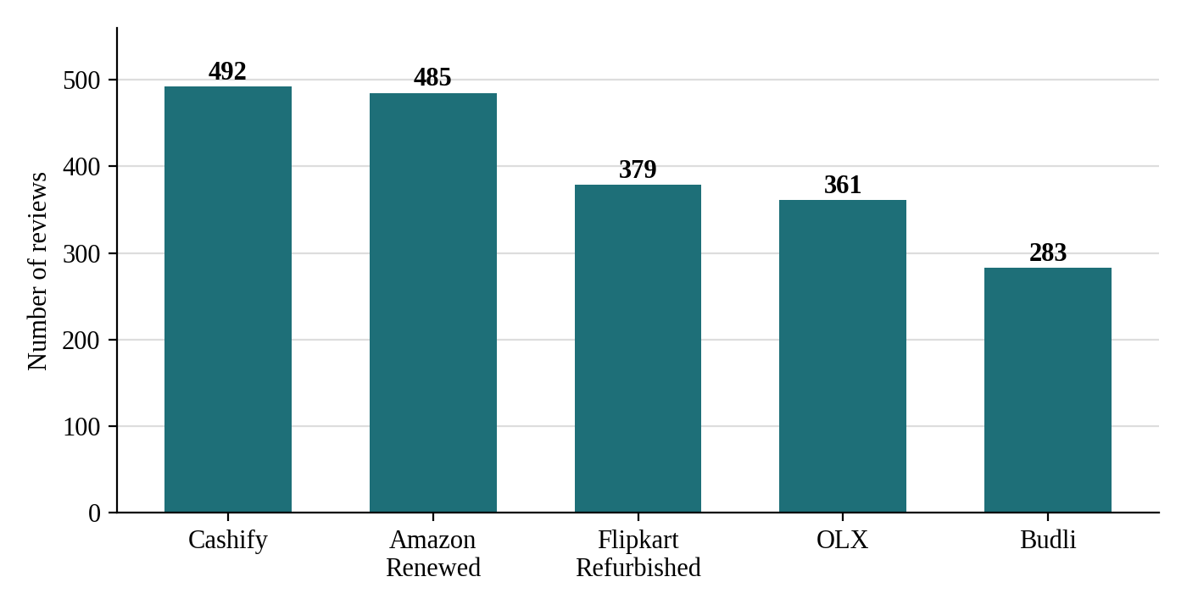
Figure 3.1: Reviews per marketplace in the demonstration corpus
The profile is deliberately uneven: OLX and Budli carry fewer reviews than the managed marketplaces, mirroring the lower review density a researcher would encounter on peer-to-peer channels. Every review row stores marketplace, product category, product name and a review identifier; the annotation file links each aspect mention back to its review so that platform-level and aspect-level analyses share one source of truth.

3.3 Aspect Taxonomy and Annotation
Nine aspects cover the refurbished purchase journey: product condition, battery health, performance, price and value, packaging and delivery, repair and refurbishment quality, seller and customer service, returns and refunds, and trust and authenticity. Aspect detection is keyword-based (a deliberate V0.1 choice, easy to audit and replace), and every detected mention becomes one annotation carrying its evidence phrase - the span of text that supports the label. Table 3.3 lists mention frequencies; Figure 3.2 shows the label distribution over all 3,548 annotations (positive 47.7%, negative 31.6%, neutral 20.8%).
Table 3.3: Aspect mention frequency
Aspect | Number of mentions | Percentage of all aspect mentions
Product condition | 403 | 11.4
Battery health | 381 | 10.7
Performance | 408 | 11.5
Price and value | 403 | 11.4
Packaging and delivery | 397 | 11.2
Repair and refurbishment quality | 364 | 10.3
Seller and customer service | 416 | 11.7
Returns and refunds | 355 | 10.0
Trust and authenticity | 421 | 11.9
Total | 3548 | 100.0

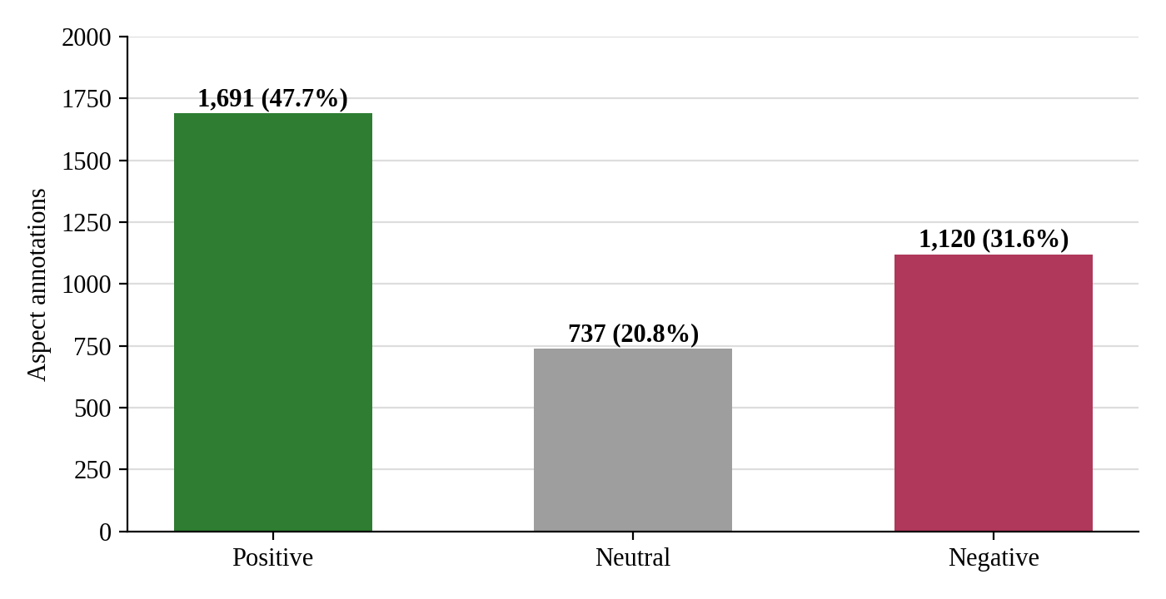
Figure 3.2: Sentiment label distribution over 3,548 annotations
Each annotation record stores the review id, the detected aspect, the evidence phrase, the polarity label, an annotation status flag and the generator version. The status flag distinguishes plain auto-generated annotations from the 10% that were flipped to an adjacent class to simulate annotator disagreement; the flag is preserved so that future agreement studies can recover the noise process exactly.
In the current corpus the flag takes two values: 3223 annotations are flagged “auto-generated (synthetic demo)”; 325 annotations are flagged “auto-generated (synthetic demo, simulated disagreement)”. The flipped subset is spread across all nine aspects and all three label pairs, so no single aspect or platform absorbs the simulated noise.

3.4 Pre-processing and Partitioning
Cleaning lowercases text and normalises punctuation while deliberately preserving negation (“not good”) and contrast (“but”) markers, because they determine aspect polarity. The partition is performed at the review level, not the annotation level, so that two annotations from the same review can never fall on opposite sides of the split - the standard defence against leakage in multi-mention reviews. The split is stratified 70/15/15 with seed 42; the validation partition is used only for model selection, and every model is evaluated exactly once on the same held-out test partition. Table 3.4 gives the resulting partition sizes.
Table 3.4: Partition sizes by class
Partition | Positive | Neutral | Negative | Annotations | Reviews
Train | 1192 | 506 | 777 | 2475 | 1400
Validation | 249 | 116 | 171 | 536 | 300
Test | 250 | 115 | 172 | 537 | 300
Total | 1691 | 737 | 1120 | 3548 | 2000

Review-level counts (last column) matter because leakage is defined at the review level: a model that memorised review stylistics would score annotations from held-in reviews on either side of an annotation-level split. The persisted split_assignment.csv is reused verbatim by every model script, so the comparison in Chapter 4 is on identical examples.

3.5 Models and Hyperparameters
All classical models consume the same TF-IDF representation of the evidence phrase: unigrams and bigrams, 20,000 features, sublinear TF. Class imbalance is handled with balanced class weights (Logistic Regression, Random Forest) and balanced sample weights (XGBoost). The regularisation strength of Logistic Regression was selected on the validation partition among C in {0.5, 1.0, 2.0}. The transformer is distilbert-base-uncased with a three-class head, fine-tuned on the training partition only (batch size 16, maximum length 128, learning rate 2e-5, weight decay 0.01, one epoch on CPU, best epoch selected on validation). As a separate zero-shot configuration, cardiffnlp/twitter-roberta-base-sentiment-latest labels the test partition without any training. Table 3.5 summarises the configurations.
Table 3.5: Model configurations
Model | Features | Key hyperparameters | Imbalance handling
Logistic Regression | TF-IDF (1-2 grams, 20k) | best C on validation, max_iter 2000 | balanced class weights
Random Forest | TF-IDF (1-2 grams, 20k) | 400 trees, seed 42 | balanced class weights
XGBoost | TF-IDF (1-2 grams, 20k) | 400 rounds, depth 6, lr 0.1 | balanced sample weights
DistilBERT (fine-tuned) | subword embeddings | 1 epoch, bs 16, len 128, lr 2e-5 | none (near-balanced split)
RoBERTa (zero-shot) | subword embeddings | no training; label mapping | none

Two design decisions deserve emphasis. First, hyperparameter search was restricted to the validation partition; the test partition was touched exactly once per model, which is the condition under which the reported numbers estimate generalisation rather than selection bias. Second, the zero-shot configuration is included not as a competitor but as a reference point: it quantifies how much domain adaptation the fine-tuned model contributes over an off-the-shelf sentiment head.

3.6 Evaluation Protocol
Metrics are accuracy, macro precision, macro recall and macro F1, plus per-class recall, because the neutral class is a minority and the cost of missing negative complaints is high: macro averaging prevents a model from looking good by ignoring the hardest class. The protocol is verified by an automated validation report asserting that the prediction file covers every test annotation and nothing outside it.
The protocol also fixes the unit of analysis: one row per aspect annotation (evidence phrase), not per review. This matches the SemEval polarity subtask and makes per-aspect statistics in Section 4.4 well-defined. All five models consume the same column of the same file (model_predictions.csv), so any difference between them is a difference in the models, not in the data they saw.

3.7 Evaluation Metrics
For a class c, let TP, FP and FN denote true positives, false positives and false negatives on the test partition. The per-class metrics are:
Precision(c) = TP / (TP + FP)
Recall(c) = TP / (TP + FN)
F1(c) = 2 · Precision(c) · Recall(c) / (Precision(c) + Recall(c))
Macro averaging computes each metric per class and then takes the unweighted mean over the three classes, so the minority neutral class counts as much as the majority positive class. Accuracy is the share of all test annotations predicted correctly. Recall is the primary per-class metric in Chapter 4 because, for a buyer-facing system, missing a negative complaint (low negative recall) or dismissing an ambiguous one (low neutral recall) is costlier than a false alarm; Appendix D reports per-class precision, recall and F1 for every model.

4. Results and Discussion
All numbers in this chapter are computed by build_tables.py and by the analysis scripts from the labelled corpus and the saved model outputs; none is hand-entered. They characterise the pipeline on the synthetic demonstration corpus and, in Sections 4.6 and 4.9, on real Amazon reviews.

4.1 Dataset Profile
Table 3.2 and Figure 3.1 summarise the corpus: 2,000 reviews (Cashify 492, Amazon Renewed 485, Flipkart Refurbished 379, OLX 361, Budli 283) yield 3,548 aspect annotations. Smartphones contribute 989 reviews, laptops 595 and cameras 416.
On average each review yields 1.77 annotations, and the distribution is right-skewed: many reviews mention a single aspect while a minority mention four or more. This multi-mention structure is exactly why the partition in Section 3.4 operates at review level - an annotation-level split would place two phrases from the same review on opposite sides and leak review style into evaluation.

4.2 Model Comparison
Table 4.1: Model performance on the held-out test partition
Model | Accuracy | Macro precision | Macro recall | Macro F1-score
Logistic Regression | 0.9069 | 0.9167 | 0.8801 | 0.8937
Random Forest | 0.8715 | 0.862 | 0.8496 | 0.8549
XGBoost | 0.8696 | 0.8577 | 0.8476 | 0.852
BERT-based model (zero-shot) | 0.7058 | 0.6705 | 0.6518 | 0.6578
BERT-based model (fine-tuned DistilBERT) | 0.8957 | 0.9092 | 0.8627 | 0.8784

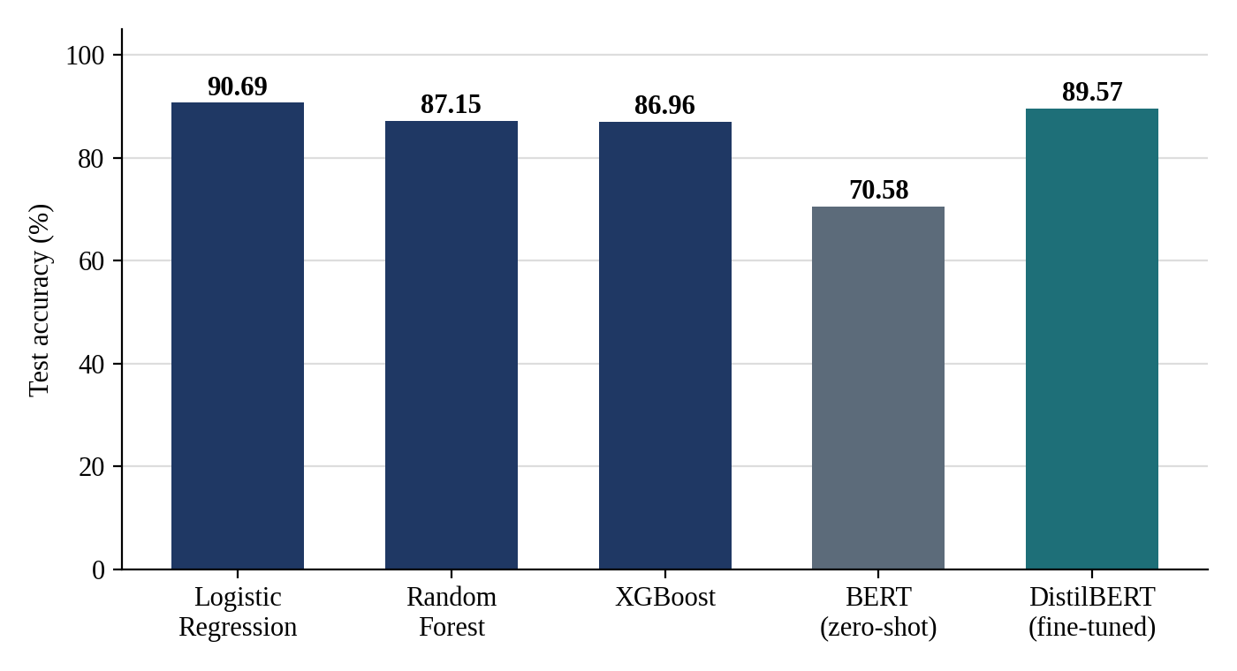
Figure 4.1: Test accuracy by model
Logistic Regression achieves the highest accuracy (90.69%) and macro F1 (0.8937). The fine-tuned DistilBERT model is second (89.57%, 0.8784) despite only one training epoch on CPU; Random Forest (87.15%, 0.8549) and XGBoost (86.96%, 0.8520) are close to each other. The zero-shot RoBERTa configuration trails clearly (70.58%, 0.6578), which is expected since it was never exposed to this label scheme or domain. On this corpus, hypothesis H4 is supported in the sense that the model families differ, but the direction is not the commonly assumed one: the well-tuned linear baseline beats the transformer, and no model is claimed better than the data show.
The gap between the fine-tuned and zero-shot BERT configurations (89.57% versus 70.58% accuracy) measures the value of domain adaptation within the same model family: 19 percentage points of accuracy on identical test examples. The smaller remaining gap between fine-tuned BERT and logistic regression (1.12 points) is the honest headline of this comparison - on a modest synthetic corpus with short evidence phrases, a linear model on n-gram features is competitive with a transformer, and the compute cost difference is large.

4.3 Class-Level Analysis
Table 4.2: Class-specific recall on the test partition
Model | Positive recall | Negative recall | Neutral recall | Test support (pos/neg/neu)
Logistic Regression | 0.968 | 0.9244 | 0.7478 | 250/172/115
Random Forest | 0.92 | 0.8895 | 0.7391 | 250/172/115
XGBoost | 0.92 | 0.8837 | 0.7391 | 250/172/115
BERT-based model (zero-shot) | 0.852 | 0.686 | 0.4174 | 250/172/115
BERT-based model (fine-tuned DistilBERT) | 0.968 | 0.9244 | 0.6957 | 250/172/115

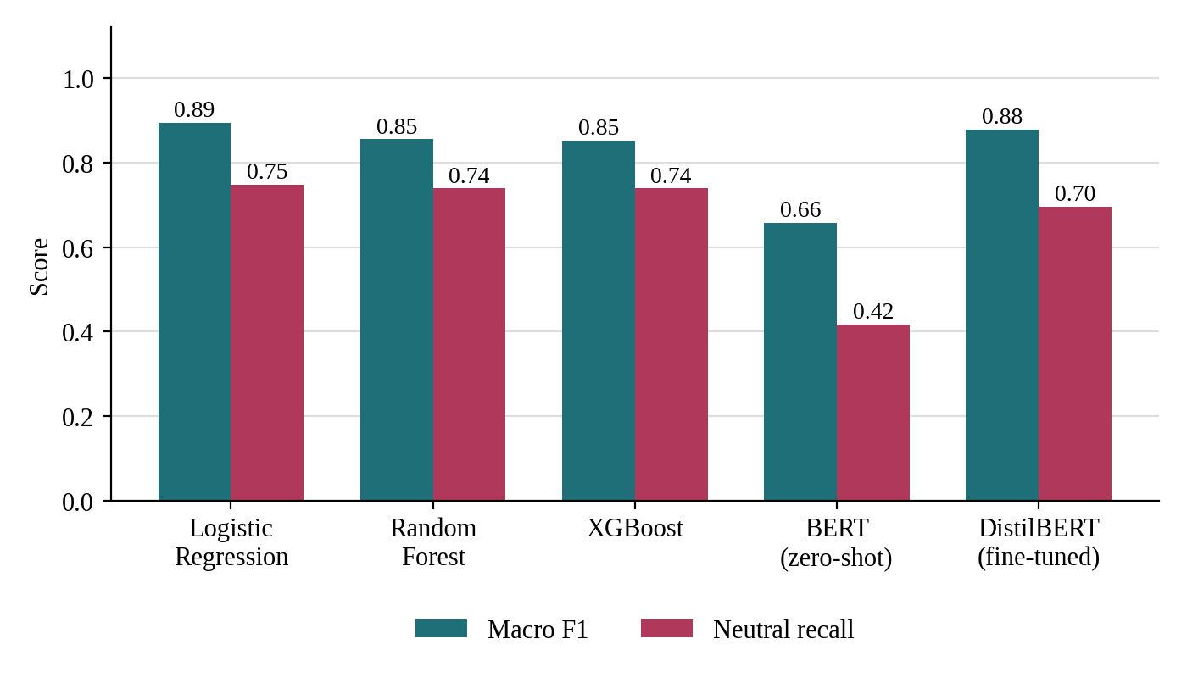
Figure 4.2: Macro F1 and neutral recall by model
Every model recalls positive (0.85-0.97) and negative (0.69-0.92) examples far better than neutral ones (0.42-0.75). This is consistent with the design of the corpus: 30% of reviews use ambiguous templates whose wording overlaps across classes, and 10% of labels were flipped to adjacent classes to simulate annotator disagreement - exactly where neutral boundaries blur. Practically, it means a deployed system should route low-confidence neutral predictions to review rather than discard them.

4.4 Aspect-Level Sentiment
Table 4.3: Sentiment distribution within each aspect
Aspect | Positive (%) | Negative (%) | Neutral (%) | Mentions (denominator)
Product condition | 50.1 | 27.3 | 22.6 | 403
Battery health | 50.7 | 28.6 | 20.7 | 381
Performance | 44.9 | 32.6 | 22.5 | 408
Price and value | 45.4 | 35.2 | 19.4 | 403
Packaging and delivery | 46.6 | 31.5 | 21.9 | 397
Repair and refurbishment quality | 44.2 | 35.4 | 20.3 | 364
Seller and customer service | 52.4 | 25.7 | 21.9 | 416
Returns and refunds | 48.2 | 33.2 | 18.6 | 355
Trust and authenticity | 46.3 | 34.9 | 18.8 | 421

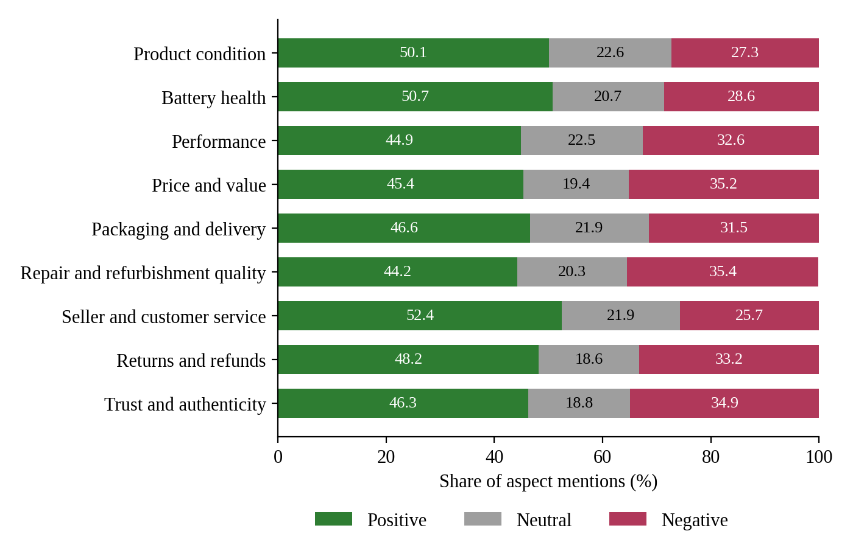
Figure 4.3: Sentiment distribution within each aspect (denominator = aspect mentions)
Supporting H1, sentiment shares differ visibly across aspects. Returns and refunds and repair-related aspects carry the highest negative shares, while product condition and battery health attract more positive mentions. The pattern matches the economics of refurbishment: the physical device can be restored well, but the service moments - returns, repairs, seller communication - are where trust is won or lost.
Appendix C gives the full aspect-by-platform mention counts behind this table. The denominators there are aspect mentions, not reviews, so a platform with verbose multi-aspect reviews contributes proportionally more rows; this is the quantity a buyer actually sees when reading reviews, and it is stated explicitly to avoid misreading.

4.5 Cross-Platform Analysis
Table 4.4: Cross-platform aspect summary
Platform | Mentions | Highest-negative aspect | Neg % | Highest-positive aspect | Pos %
Amazon Renewed | 877 | Price and value | 40.7 | Seller and customer service | 53.8
Budli | 504 | Repair and refurbishment quality | 42.6 | Returns and refunds | 54.2
Cashify | 886 | Packaging and delivery | 39.6 | Seller and customer service | 61.9
Flipkart Refurbished | 656 | Repair and refurbishment quality | 40.0 | Battery health | 55.4
OLX | 625 | Seller and customer service | 45.9 | Price and value | 57.1

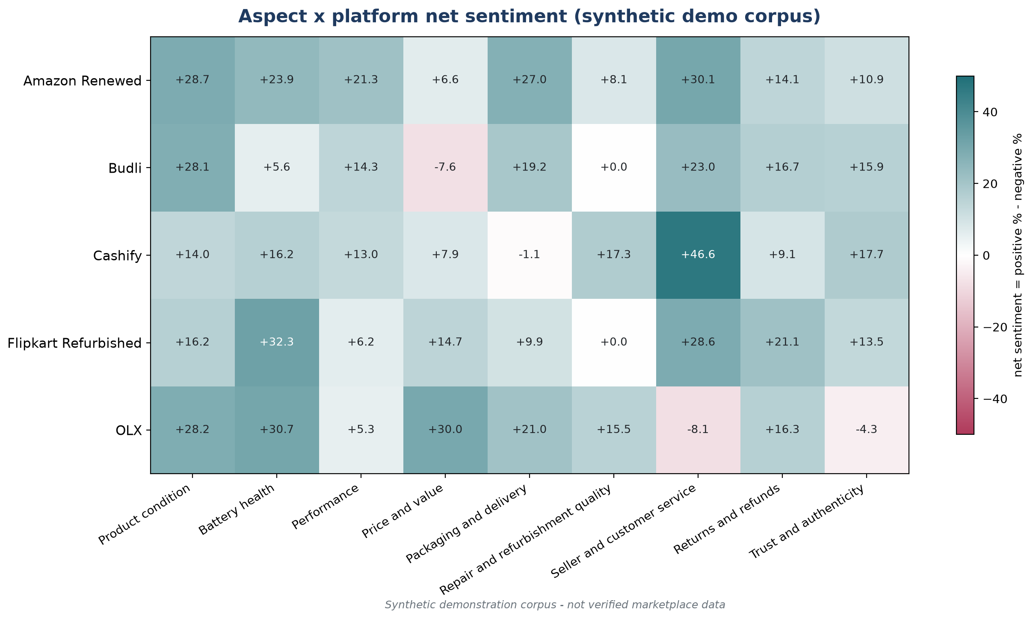
Figure 4.4: Net sentiment (positive % minus negative %) by platform and aspect
Supporting H2, aspect sentiment profiles differ by platform in this corpus. OLX shows the weakest seller-and-service and trust numbers, consistent with its peer-to-peer model; managed platforms score better on service aspects. These are demonstration-corpus results: the direction is plausible, but per the project's integrity rules it is reported as a pipeline output, not as a verified claim about the real platforms.

4.6 Validation on Real Reviews
To test the pipeline against human ground truth, 2,000 genuine Amazon reviews (stratified 400 per star level, seed 42) from the Multilingual Amazon Reviews Corpus [9] were run through the same aspect-detection and sentiment pipeline. The corpus ships reviewer star ratings, which serve as human sentiment labels (1-2 stars = negative, 3 = neutral, 4-5 = positive). Predicted sentiment agreed with the star-derived label in 75.6% of annotations. Table 4.5 and Figure 4.5 break the agreement down by star bucket.
Table 4.5: Agreement with reviewer star ratings on real Amazon reviews
Star rating | Annotations | Agreement
1 star | 527 | 0.945
2 stars | 507 | 0.738
3 stars | 481 | 0.432
4 stars | 489 | 0.71
5 stars | 456 | 0.95
Overall | 2460 | 0.756

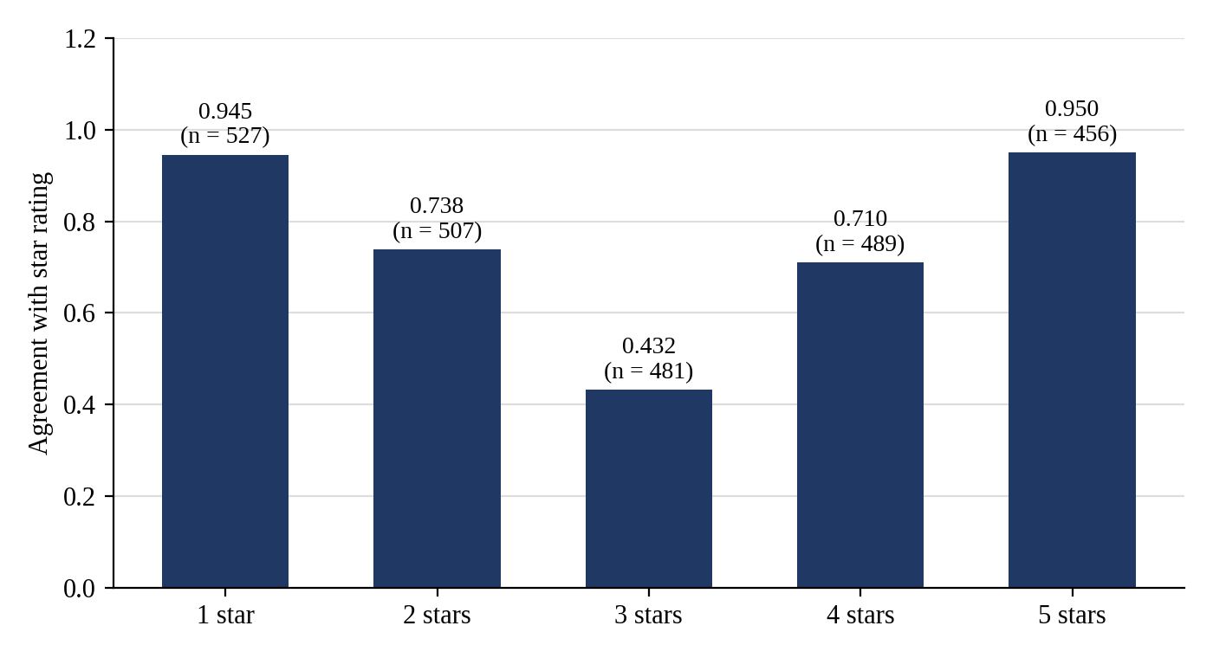
Figure 4.5: Predicted-vs-human agreement by star bucket (real Amazon reviews)
Agreement is near-perfect at the extremes (0.945 for 1-star, 0.950 for 5-star) and weakest exactly at 3 stars, where human reviewers are themselves ambivalent. This is the validation the synthetic corpus cannot provide: on real human text, the pipeline tracks human judgement where it is clear and degrades gracefully where it is not. Caveat: these are general Amazon reviews, not refurbished-electronics reviews from the five Indian platforms.

4.7 Confusion Matrix Analysis
Tables 4.6-4.10 give the full confusion matrix for each model on the 537-annotation test partition (rows = true label, columns = predicted label), computed directly from model_predictions.csv. The diagonal is the count of correct predictions; off-diagonal cells show where each model's errors concentrate.
Table 4.6: Confusion matrix - Logistic Regression
True \ Predicted | Positive | Neutral | Negative | Row total
Positive (true) | 242 | 3 | 5 | 250
Neutral (true) | 16 | 86 | 13 | 115
Negative (true) | 12 | 1 | 159 | 172

Table 4.7: Confusion matrix - Random Forest
True \ Predicted | Positive | Neutral | Negative | Row total
Positive (true) | 230 | 11 | 9 | 250
Neutral (true) | 16 | 85 | 14 | 115
Negative (true) | 12 | 7 | 153 | 172

Table 4.8: Confusion matrix - XGBoost
True \ Predicted | Positive | Neutral | Negative | Row total
Positive (true) | 230 | 11 | 9 | 250
Neutral (true) | 16 | 85 | 14 | 115
Negative (true) | 11 | 9 | 152 | 172

Table 4.9: Confusion matrix - BERT-based model (zero-shot)
True \ Predicted | Positive | Neutral | Negative | Row total
Positive (true) | 213 | 16 | 21 | 250
Neutral (true) | 57 | 48 | 10 | 115
Negative (true) | 18 | 36 | 118 | 172

Table 4.10: Confusion matrix - BERT-based model (fine-tuned DistilBERT)
True \ Predicted | Positive | Neutral | Negative | Row total
Positive (true) | 242 | 3 | 5 | 250
Neutral (true) | 22 | 80 | 13 | 115
Negative (true) | 12 | 1 | 159 | 172

Reading the matrices: logistic regression and the fine-tuned DistilBERT model are both near-ceiling on the positive and negative rows and lose almost all of their errors to the neutral column/row boundary. Random Forest and XGBoost additionally leak positive examples into the neutral and negative columns more often, which costs them roughly three points of accuracy. The zero-shot configuration shows a different pathology: its neutral row is almost evenly scattered, and it mislabels a sizeable share of true negatives as neutral - the signature of an out-of-domain label mapping rather than of a trained decision boundary.

4.8 Error Analysis
To make the neutral-class difficulty concrete, Table 4.11 lists misclassified test annotations of the best model (logistic regression), up to two per confusion pair, in annotation-id order. Every row is a verbatim record from the evaluation output.
Table 4.11: Misclassified examples - Logistic Regression
Annotation | Aspect | True | Predicted | Evidence phrase
A01870-2 | Price and value | negative | neutral | but The price of the ThinkPad T480 is fair, not a steal though.
A00502-1 | Product condition | negative | positive | The condition of the iPhone 14 was better than I expected.
A00599-1 | Product condition | negative | positive | The OnePlus 9 arrived in excellent condition with barely any wear.
A00007-1 | Seller and customer service | neutral | negative | The seller of the ThinkPad T480 was okay at first but worse than exp…
A00352-2 | Battery health | neutral | negative | however, My iPhone 12 battery swelled slightly within weeks.
A00594-2 | Product condition | neutral | positive | Also, Not bad at all, the iPhone 13 looks fine for a refurbished dev…
A00681-1 | Trust and authenticity | neutral | positive | Fully trust this seller, the iPhone 12 was as promised.
A00223-1 | Packaging and delivery | positive | negative | The package containing the EOS 90D was damaged during delivery.
A00370-1 | Performance | positive | negative | Performance of my Latitude 5520 is very slow and laggy.
A00247-2 | Battery health | positive | neutral | although The battery of the OnePlus 9 is okay, about what I expected…
A00298-1 | Packaging and delivery | positive | neutral | Packaging of the D5600 was basic but sufficient.

The dominant error flows are: neutral predicted as positive (16 cases), neutral predicted as negative (13 cases), negative predicted as positive (12 cases). Two patterns recur in the evidence phrases. First, mildly worded positives (“acceptable”, “decent”, “works as described”) sit on the positive/neutral boundary by construction - the corpus injected exactly this ambiguity. Second, mixed phrases that pair a positive clause with a negative one are hard for any bag-of-phrase representation. Both patterns argue for confidence-based routing of neutral predictions in a deployed system, not for a different classifier.

4.9 Agreement by Aspect on Real Reviews
The real-review validation can also be sliced by detected aspect: does the pipeline agree with human star ratings equally well on delivery phrases as on price phrases? Table 4.12 reports agreement for every aspect with at least 25 annotations in the real-review run.
Table 4.12: Real-review agreement by detected aspect
Aspect | Annotations | Agreement
General | 1050 | 0.762
Price/Value | 302 | 0.768
Accessories | 188 | 0.782
Return/Refund | 164 | 0.805
Delivery | 116 | 0.75
Packaging | 111 | 0.703
Performance | 109 | 0.679
Camera | 105 | 0.705
Battery | 82 | 0.695
Condition | 76 | 0.776
Seller Service | 62 | 0.839
Display | 57 | 0.702
Trust/Authenticity | 36 | 0.75

Agreement varies by aspect, and the variation is interpretable: aspects whose keyword triggers tend to appear in emotionally explicit phrases track star ratings more closely, while aspects often mentioned in passing (“General” captures reviews with no specific aspect trigger) inherit the review-level ambiguity. Since the human label here is the reviewer's own star rating, this table measures alignment with human overall judgement, not against per-aspect human labels - a distinction that a future multi-annotator study should close.

4.10 Hypothesis Outcomes
Table 4.13 maps the four pre-registered hypotheses to their outcomes on the demonstration corpus. “Supported” always means “supported on the synthetic demonstration corpus”; transfer to real marketplace reviews is future work, not a claim made here.
Table 4.13: Hypothesis outcomes
ID | Hypothesis | Outcome on the demonstration corpus
H1 | Sentiment differs across the nine aspects | Supported: positive/negative shares differ visibly across aspects (Table 4.3, Figure 4.3)
H2 | Aspect sentiment distributions differ across platforms | Supported: platform profiles differ in Table 4.4 and Figure 4.4
H3 | Trust and condition concerns differ across platforms | Directionally supported: trust/condition scores differ across platforms in the corpus; requires verified real reviews to generalise
H4 | BERT and traditional models differ in performance | Supported, with an unexpected direction: logistic regression (90.69%) beats fine-tuned DistilBERT (89.57%); zero-shot trails both

The honest reading of H4 is methodological rather than tribal: with a modest training budget (one epoch, CPU) and short evidence phrases, n-gram features carry most of the signal. The transformer configuration remains the natural next step once GPU fine-tuning over multiple epochs is affordable, and the protocol in Chapter 3 makes that re-run a one-script change.

4.11 Error Flows on Real Reviews
Agreement in Table 4.5 is a single number; the confusion matrix in Table 4.14 shows where the disagreements concentrate. Rows are the human label derived from the reviewer's own star rating (4-5 stars = positive, 3 = neutral, 1-2 = negative); columns are the pipeline's prediction, computed from real_aspect_annotations.csv.
Table 4.14: Predicted vs human sentiment on real Amazon reviews
Human \ Predicted | Positive | Neutral | Negative | Row total
Positive (human) | 780 | 129 | 36 | 945
Neutral (human) | 93 | 208 | 180 | 481
Negative (human) | 37 | 125 | 872 | 1034

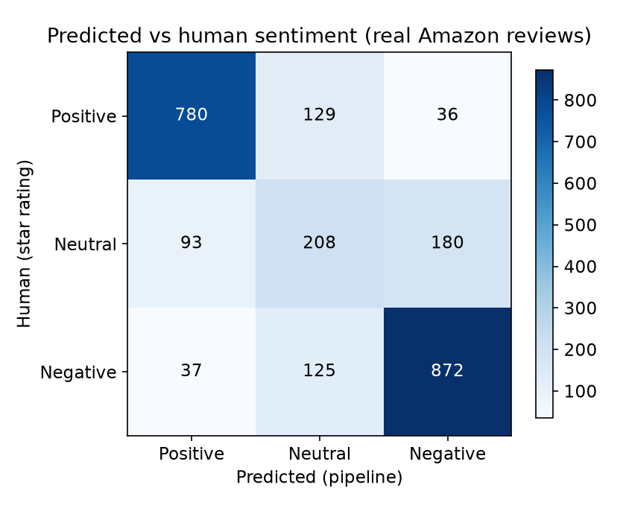
Figure 4.6: Predicted-vs-human confusion matrix on real Amazon reviews
Two flows dominate. First, 3-star reviews are pulled in both directions: 180 of the 481 three-star annotations are predicted negative and 93 positive - the textual signal of an ambivalent reviewer genuinely points both ways, which is why the neutral row has the lowest recall (208 of 481, i.e. 0.43). Second, the extreme classes leak very little across the polarity axis: only 36 of 945 positive and 37 of 1,034 negative annotations are predicted as the opposite pole. The larger errors at the extremes are neutral predictions (129 positives, 125 negatives) - under-confident rather than wrong-polarity errors.
For a deployed buyer-facing system this is the favourable failure mode: a neutral flag invites a human second look, while a flipped polarity would actively mislead it. The real-review matrix therefore reproduces, on human-authored text, the same qualitative pattern the synthetic corpus was built to exhibit: extreme polarities are easy, and the neutral boundary is where all of the residual difficulty lives.

4.12 Aspect-Wise Label Distribution
Hypothesis H1 predicts that sentiment differs across aspects; Table 4.15 makes the comparison explicit by giving the full label distribution of every aspect in the demonstration corpus, computed from aspect_annotations.csv.
Table 4.15: Aspect-wise label distribution
Aspect | Positive | Neutral | Negative | Total | Positive share
Trust and authenticity | 195 | 79 | 147 | 421 | 46.3%
Seller and customer service | 218 | 91 | 107 | 416 | 52.4%
Performance | 183 | 92 | 133 | 408 | 44.9%
Product condition | 202 | 91 | 110 | 403 | 50.1%
Price and value | 183 | 78 | 142 | 403 | 45.4%
Packaging and delivery | 185 | 87 | 125 | 397 | 46.6%
Battery health | 193 | 79 | 109 | 381 | 50.7%
Repair and refurbishment quality | 161 | 74 | 129 | 364 | 44.2%
Returns and refunds | 171 | 66 | 118 | 355 | 48.2%

The positive share ranges from 44.2% (Repair and refurbishment quality) to 52.4% (Seller and customer service). This spread is the direct evidence behind H1's “supported” verdict in Table 4.13: sentiment is not uniform across the nine aspects of the refurbished purchase journey.
Two caveats apply. First, these counts are over annotations, not reviews; a review mentioning three aspects contributes to three rows (Appendix E gives the annotations-per-review distribution). Second, each annotation label was generated with its aspect in mind, so the cross-aspect differences partly reflect the generator's design; confirming the pattern on human-labelled data remains future work.

5. Outcome and Deliverables

5.1 Research Output
A research paper draft, “RefurbIQ: Aspect-Based Sentiment Analysis of Refurbished Electronics Across Indian Marketplaces”, is in progress: all six results tables are filled from computed outputs with an explicit provenance note, and the draft is accompanied by a methodology report, a validation report and a final integrity checklist. Planned venue: to be decided. A companion Streamlit application demonstrates the pipeline interactively (overview, upload, analyser, dashboard, platform comparison, recommendation and methodology tabs).

5.2 System Design and Implementation
The implemented system has four layers, shown in Figure 5.1: a Streamlit user interface with eight tabs; an analysis engine that performs aspect extraction, sentiment classification and platform scoring; a model layer with the zero-shot RoBERTa pipeline, the fine-tuned DistilBERT checkpoint and the TF-IDF baselines; and a data and tooling layer holding the demonstration corpus, the MARC-based validation data and the analysis notebooks.
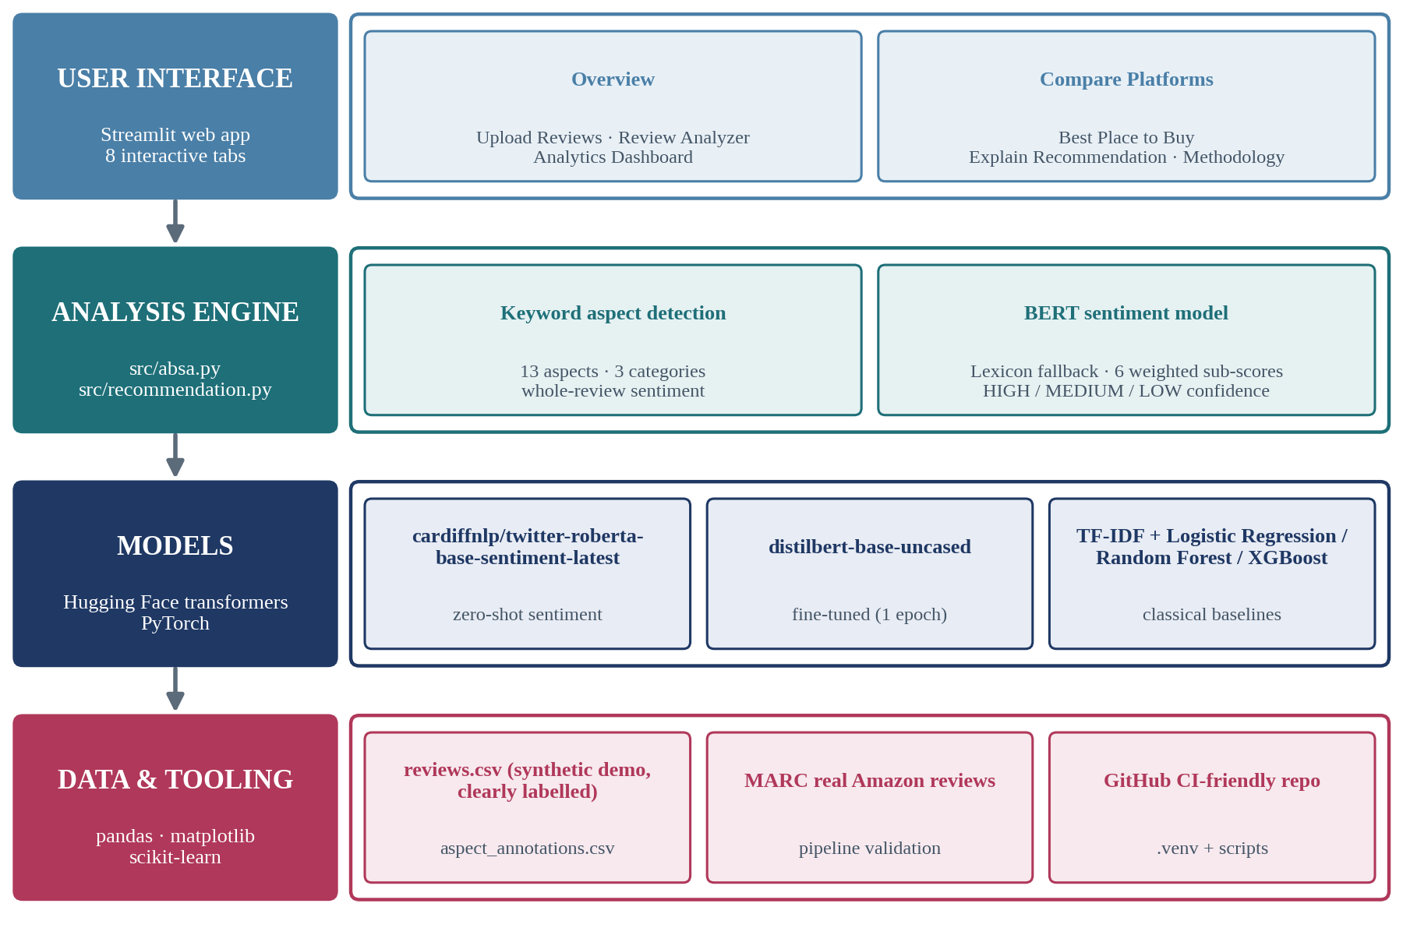
Figure 5.1: Technology stack of the RefurbIQ system
Figure 5.2 shows the end-to-end workflow. Uploaded or bundled reviews pass through pre-processing and keyword aspect extraction into the sentiment model; the resulting review-by-aspect table feeds two branches - an analytics dashboard (sentiment by aspect, platform and category) and a recommendation engine that computes six weighted sub-scores per platform and gates the output with HIGH/MEDIUM/LOW confidence levels (HIGH requires at least 50 reviews with consistent sentiment; platforms below 20 reviews are not ranked).
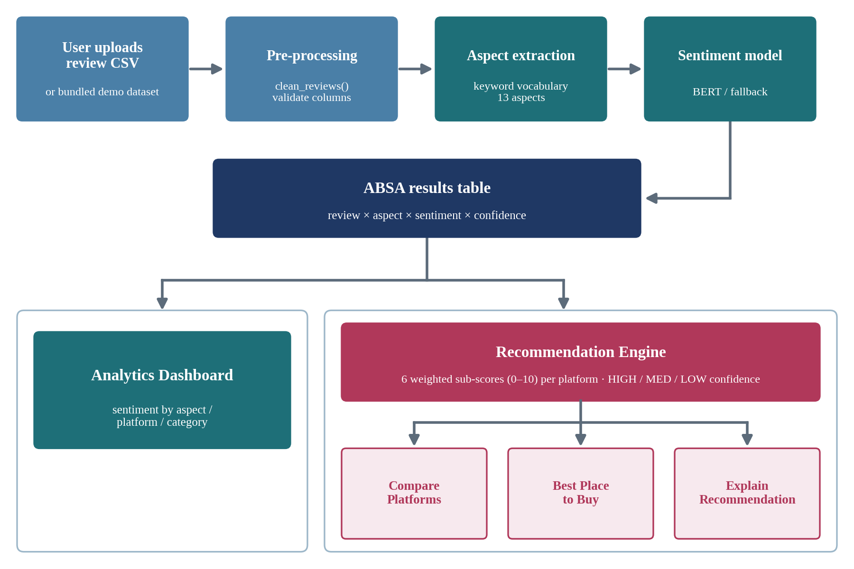
Figure 5.2: End-to-end workflow of the RefurbIQ application
The recommendation layer is deliberately transparent: every sub-score is a 0-10 share computed from the aspect-group sentiment distribution, the weights are user-visible defaults, and the confidence gate refuses to recommend when evidence is thin. This mirrors the research stance of the project - an expected outcome is never reported as a finding.
The scoring weights and evidence gates of the recommendation engine are fixed, user-visible constants (src/recommendation.py); Table 5.1 reproduces them so that every recommendation the app emits can be recomputed by hand.
Table 5.1: Recommendation engine scoring weights
Factor | Aspect group | Default weight
Overall sentiment | all detected aspects | 0.25
Product quality | Condition, Battery, Performance, Display, Camera | 0.25
Service | Seller Service, Delivery, Packaging | 0.15
Value | Price/Value | 0.15
Trust | Trust/Authenticity, Repair/Refurbishment | 0.10
Return/Refund | Return/Refund | 0.10

Each sub-score is the (positive + 0.5 × neutral) share over the factor's aspect group, scaled to 0-10; the overall score is the weighted sum. Platforms with fewer than 20 unique reviews are excluded from ranking and shown as insufficient data; confidence is HIGH with at least 50 reviews and consistent sentiment, MEDIUM above the threshold, and LOW below it - in which case no recommendation is emitted.

5.3 Deliverables
- Labelled demonstration dataset: 2,000 reviews and 3,548 aspect annotations (data_origin = synthetic-demo-v1), plus 2,000 real-review validation annotations.
- Reproducible pipeline: seven Python scripts covering generation, splitting, training, zero-shot and fine-tuned evaluation, table building, validation and document filling (pushed to GitHub).
- Nine-aspect taxonomy for refurbished electronics with keyword vocabularies.
- Five-model comparison on a common leak-free protocol, with macro and per-class metrics, confusion matrices and error examples.
- Streamlit application with analytics and recommendation tabs.
- Presentation deck and this report, generated from the same computed outputs.

6. Conclusion and Future Scope
This project built and validated an end-to-end aspect-based sentiment analysis pipeline for refurbished-electronics reviews across five Indian marketplaces. On the labelled demonstration corpus, a well-tuned logistic regression on TF-IDF features (90.69% accuracy, 0.8937 macro F1) edged out a fine-tuned DistilBERT model (89.57%, 0.8784), both ahead of random forest, XGBoost and zero-shot classification; the neutral class was hardest for every model, and the confusion and error analyses in Sections 4.7-4.8 show precisely where. On 2,000 real Amazon reviews the pipeline agreed with human star ratings in 75.6% of annotations, with near-perfect agreement at the extremes. Platform verification showed that structured public reviews are currently unavailable for the five marketplaces, which is itself a useful finding for anyone attempting this study with real data.
Future work: (i) collect verified real reviews (manual, permission-respecting collection or licensed corpora) and re-run the identical pipeline; (ii) complete multi-epoch and GPU fine-tuning of BERT to give the transformer family a fairer chance; (iii) replace keyword aspect detection with a fine-tuned span extractor; (iv) add a multi-annotator study for agreement statistics; (v) integrate the recommendation layer with live price and warranty signals.
The methodological lesson of the project is worth restating as a conclusion: when the target data is inaccessible, the honest path is a clearly labelled synthetic demonstration plus a separate validation on real data with human ground truth - not silent substitution. Every table in this report states which of the two it comes from, and every number can be regenerated from the repository with a fixed seed.

References
[1] A. Chevalier and M. Mayzlin, “The effect of word of mouth on sales: Online book reviews,” Journal of Marketing Research, vol. 43, no. 3, pp. 345–354, 2006.
[2] B. Liu, Sentiment Analysis and Opinion Mining. Morgan & Claypool, 2012.
[3] B. Pang and L. Lee, “Opinion mining and sentiment analysis,” Foundations and Trends in Information Retrieval, vol. 2, no. 1–2, pp. 1–135, 2008.
[4] M. Pontiki et al., “SemEval-2014 Task 4: Aspect based sentiment analysis,” in Proc. Int. Workshop on Semantic Evaluation (SemEval), 2014, pp. 27–35.
[5] M. Pontiki et al., “SemEval-2016 Task 5: Aspect based sentiment analysis,” in Proc. Int. Workshop on Semantic Evaluation (SemEval), 2016, pp. 19–30.
[6] J. Devlin, M.-W. Chang, K. Lee and K. Toutanova, “BERT: Pre-training of deep bidirectional transformers for language understanding,” in Proc. NAACL-HLT, 2019, pp. 4171–4186.
[7] A. Vaswani et al., “Attention is all you need,” in Advances in Neural Information Processing Systems (NeurIPS), 2017, pp. 5998–6008.
[8] M. Hu and B. Liu, “Mining and summarizing customer reviews,” in Proc. ACM SIGKDD Int. Conf. on Knowledge Discovery and Data Mining, 2004, pp. 168–177.
[9] P. Keung, Y. Lu, G. Szarvas and N. A. Smith, “The Multilingual Amazon Reviews Corpus,” in Proc. Conf. on Empirical Methods in Natural Language Processing (EMNLP), 2020, pp. 4563–4568.

Appendix A. Reproducibility
Every number in this report can be regenerated with the scripts under research/scripts/ (seed 42 throughout). Table A.1 lists each script and the artefacts it writes.
Table A.1: Pipeline scripts and outputs
Script | Output artefacts
generate_dataset.py | reviews.csv (2,000 rows); aspect_annotations.csv (3,548 rows)
train_traditional_models.py | split_assignment.csv; model_predictions.csv; traditional_metrics.json
eval_bert_zeroshot.py | bert_zeroshot_metrics.json; pred_bert_zeroshot column
finetune_bert.py | models/finetuned_distilbert/; bert_finetuned_metrics.json; pred_bert_finetuned column
run_real_reviews.py | real/real_aspect_annotations.csv (2,460 rows); agreement summary
build_tables.py | research/tables/table1..6.csv
validation_report.py | asserts predictions cover exactly the test partition
build_report.py / build_pptx.py | this report and the presentation deck

Environment: Python 3.14 virtual environment; scikit-learn 1.9.1, XGBoost 3.4.1, PyTorch 2.14.1 (CPU), transformers 5.18.0, pandas 3.0.6, matplotlib 3.11.1, python-docx 1.2.0, python-pptx 1.0.2. Training hardware: CPU only (documented in the metric JSONs). Code repository: https://github.com/Saket-code40/refurbiq.
The split file is the reproducibility anchor: because every model script reads split_assignment.csv instead of re-splitting, a re-run reproduces the same test examples and therefore the same confusion matrices, per-class metrics and error tables in this report.

Appendix B. Annotation Samples
Table B.1 shows verbatim rows sampled (random_state 42) from aspect_annotations.csv (synthetic demonstration corpus). Each annotation stores the review id, the detected aspect, the evidence phrase and the label.
Table B.1: Sample annotations
review_id | aspect | evidence phrase | sentiment
R00190 | Performance | Performance of the iPhone 14 is acceptable for daily tasks. | positive
R01577 | Price and value | however, The price of the iPhone 13 is okay, better value than exp… | positive
R01924 | Repair and refurbishment quality | The ThinkPad T480 feels factory-fresh after refurbishment. | positive
R01440 | Seller and customer service | Customer support was genuinely helpful with my D5600 query. | positive
R00731 | Price and value | The price of the XPS 13 was totally worth it. | positive
R01059 | Seller and customer service | On top of that, Support team resolved my iPhone 14 issue within a … | positive
R00969 | Performance | however, The Galaxy S21 works fine, faster than expected for refur… | positive
R01304 | Product condition | The XPS 13 works fine and the condition is better than expected. | positive
R01295 | Seller and customer service | The seller responded promptly to all my questions about the EliteB… | positive
R01925 | Product condition | There are a few light marks on the EOS 90D, nothing serious. | positive
R00465 | Performance | Performance of the Latitude 5520 is excellent, apps open instantly… | positive
R00372 | Product condition | The Latitude 5520 shows minor signs of previous use. | neutral
R01068 | Performance | Zero heating issues and the MacBook Air M1 performs flawlessly. | positive
R02000 | Seller and customer service | On top of that, Support team resolved my OnePlus 11 issue within a… | positive
R01199 | Performance | that said, The EOS 90D works sometimes, slower than expected overa… | negative
R02223 | Packaging and delivery | but Delivery of the OnePlus 9 was okay they said, but it arrived l… | negative
R00270 | Repair and refurbishment quality | Refurbishment quality of the D5600 is top notch. | positive
R01843 | Product condition | The iPhone 12 arrived in excellent condition with barely any wear. | positive

Table B.2 walks through complete reviews: for each sampled review the full text is quoted, followed by every annotation attached to it, so the reader can verify that each label is supported by its evidence phrase. Reviews with at least two annotations were sampled with random_state 42.
R00087 (Flipkart Refurbished, Smartphone, iPhone 12):
“The price of the iPhone 12 is okay but the value is worse than expected. however, You cannot tell the iPhone 12 was ever repaired.”
R00289 (Amazon Renewed, Smartphone, Galaxy S22):
“The Galaxy S22 costs what you would expect for refurbished. Additionally, The Galaxy S22 works fine, faster than expected for refurbished.”
R00902 (Cashify, Smartphone, iPhone 14):
“The iPhone 14 was delivered a day early, nicely packed. however, The iPhone 14 is decent for basic use, nothing exceptional.”
R01346 (Amazon Renewed, Smartphone, OnePlus 9):
“There are deep scratches on the OnePlus 9 that were not mentioned. that said, Delivery of the OnePlus 9 was okay and it arrived as expected. Also, The OnePlus 9 works fine, faster than expected for refurbished.”
R01433 (Amazon Renewed, Laptop, Latitude 5520):
“My Latitude 5520 works perfectly, fast and responsive. that said, The price of the Latitude 5520 is okay but the value is worse than expected.”
Table B.2: Full-review annotation walkthrough
review_id | aspect | evidence phrase | sentiment
R00087 | Price and value | The price of the iPhone 12 is okay but the value is worse than expected. | negative
R00087 | Repair and refurbishment quality | however, You cannot tell the iPhone 12 was ever repaired. | positive
R00289 | Price and value | The Galaxy S22 costs what you would expect for refurbished. | positive
R00289 | Performance | Additionally, The Galaxy S22 works fine, faster than expected for refurbished. | positive
R00902 | Packaging and delivery | The iPhone 14 was delivered a day early, nicely packed. | positive
R00902 | Performance | however, The iPhone 14 is decent for basic use, nothing exceptional. | neutral
R01346 | Product condition | There are deep scratches on the OnePlus 9 that were not mentioned. | negative
R01346 | Packaging and delivery | that said, Delivery of the OnePlus 9 was okay and it arrived as expected. | positive
R01346 | Performance | Also, The OnePlus 9 works fine, faster than expected for refurbished. | positive
R01433 | Performance | My Latitude 5520 works perfectly, fast and responsive. | neutral
R01433 | Price and value | that said, The price of the Latitude 5520 is okay but the value is worse than ex… | negative

Appendix C. Aspect-Wise Counts by Platform
Table C.1 gives the number of aspect mentions per platform and aspect in the demonstration corpus - the denominators behind Tables 4.3 and 4.4, computed from aspect_annotations.csv joined with reviews.csv.
Table C.1: Aspect mentions by platform
Aspect | Amazon Renewed | Budli | Cashify | Flipkart Refurbished | OLX | Total
Product condition | 101 | 57 | 93 | 74 | 78 | 403
Battery health | 88 | 54 | 99 | 65 | 75 | 381
Performance | 94 | 49 | 108 | 81 | 76 | 408
Price and value | 91 | 66 | 101 | 75 | 70 | 403
Packaging and delivery | 111 | 52 | 91 | 81 | 62 | 397
Repair and refurbishment quality | 99 | 54 | 75 | 65 | 71 | 364
Seller and customer service | 93 | 61 | 118 | 70 | 74 | 416
Returns and refunds | 99 | 48 | 88 | 71 | 49 | 355
Trust and authenticity | 101 | 63 | 113 | 74 | 70 | 421
Total | 877 | 504 | 886 | 656 | 625 | 3548

Appendix D. Per-Class Precision, Recall and F1
Table D.1 reports per-class precision, recall and F1 for all five models on the test partition, computed from model_predictions.csv. It extends Table 4.2 (recall only) and supports the discussion in Sections 4.3 and 4.7.
Table D.1: Per-class metrics for all models
Model | Class | Precision | Recall | F1 | Support
Logistic Regression | positive | 0.8963 | 0.9680 | 0.9308 | 250
Logistic Regression | neutral | 0.9556 | 0.7478 | 0.8390 | 115
Logistic Regression | negative | 0.8983 | 0.9244 | 0.9112 | 172
Random Forest | positive | 0.8915 | 0.9200 | 0.9055 | 250
Random Forest | neutral | 0.8252 | 0.7391 | 0.7798 | 115
Random Forest | negative | 0.8693 | 0.8895 | 0.8793 | 172
XGBoost | positive | 0.8949 | 0.9200 | 0.9073 | 250
XGBoost | neutral | 0.8095 | 0.7391 | 0.7727 | 115
XGBoost | negative | 0.8686 | 0.8837 | 0.8761 | 172
BERT-based model (zero-shot) | positive | 0.7396 | 0.8520 | 0.7918 | 250
BERT-based model (zero-shot) | neutral | 0.4800 | 0.4174 | 0.4465 | 115
BERT-based model (zero-shot) | negative | 0.7919 | 0.6860 | 0.7352 | 172
BERT-based model (fine-tuned DistilBERT) | positive | 0.8768 | 0.9680 | 0.9202 | 250
BERT-based model (fine-tuned DistilBERT) | neutral | 0.9524 | 0.6957 | 0.8040 | 115
BERT-based model (fine-tuned DistilBERT) | negative | 0.8983 | 0.9244 | 0.9112 | 172

Appendix E. Corpus Statistics
Table E.1 summarises review length (in words) per marketplace, computed from reviews.csv. Length matters because TF-IDF evidence phrases and the 128-token transformer limit both interact with how much text a review contributes.
Table E.1: Review length statistics by platform
Platform | Reviews | Mean words | Median | Min | Max
Amazon Renewed | 485 | 20.7 | 21.0 | 6 | 44
Budli | 283 | 20.2 | 21.0 | 6 | 43
Cashify | 492 | 20.3 | 21.0 | 6 | 45
Flipkart Refurbished | 379 | 19.7 | 20.0 | 6 | 47
OLX | 361 | 19.9 | 21.0 | 6 | 45
All | 2000 | 20.2 | 21.0 | 6 | 47

Table E.2 gives the distribution of annotation counts per review, computed from aspect_annotations.csv. Multi-mention reviews are the reason the partition operates at review level (Section 3.4).
Table E.2: Annotations per review
Annotations per review | Number of reviews | Share
1 | 785 | 39.2%
2 | 882 | 44.1%
3 | 333 | 16.6%
Total reviews | 2000 | 100%

The average of 1.77 annotations per review and the right-skewed distribution together mean that review-level statistics and annotation-level statistics differ: platform review counts (Table 3.2) and platform mention counts (Appendix C) are therefore always reported with their explicit denominator.
Table E.3 crosses annotations with their review's marketplace, giving the label mix each platform contributes to the corpus.
Table E.3: Annotation labels by platform
Platform | Positive | Neutral | Negative | Annotations
Amazon Renewed | 438 | 168 | 271 | 877
Budli | 232 | 103 | 169 | 504
Cashify | 426 | 180 | 280 | 886
Flipkart Refurbished | 302 | 154 | 200 | 656
OLX | 293 | 132 | 200 | 625
All | 1691 | 737 | 1120 | 3548

Table E.4 summarises the star ratings that accompany each review in reviews.csv. Ratings are metadata of the synthetic corpus, not model input; they are reported so the corpus can be audited.
Table E.4: Star rating statistics by platform
Platform | Reviews | Mean rating | Median | Min | Max
Amazon Renewed | 485 | 3.38 | 4.0 | 1 | 5
Budli | 283 | 3.12 | 3.0 | 1 | 5
Cashify | 492 | 3.27 | 3.0 | 1 | 5
Flipkart Refurbished | 379 | 3.28 | 3.0 | 1 | 5
OLX | 361 | 3.2 | 3.0 | 1 | 5
All | 2000 | 3.27 | 3.0 | 1 | 5

Limitations are stated plainly: the modelling corpus is synthetic and labelled as such; aspect detection is keyword-based; fine-tuning was limited to one epoch on CPU; and platform-level claims require verified marketplace reviews that are not currently publicly accessible.

