Data Augmentation chosen is normalization

# Choice between Optimizers

## Adam

LR = 0.001, Epochs = 10, Batch = 32 **(Base case for comparison)**

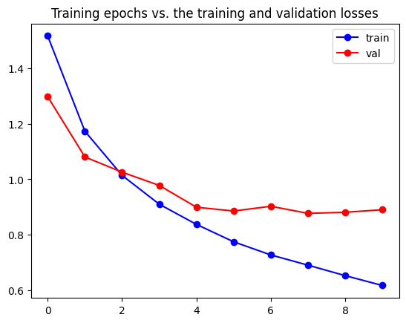

71.05

Accuracy for class: plane is 68.7 %

Accuracy for class: car is 85.2 %

Accuracy for class: bird is 54.3 %

Accuracy for class: cat is 49.5 %

Accuracy for class: deer is 75.6 %

Accuracy for class: dog is 61.9 %

Accuracy for class: frog is 84.2 %

Accuracy for class: horse is 75.5 %

Accuracy for class: ship is 84.1 %

Accuracy for class: truck is 71.5 %

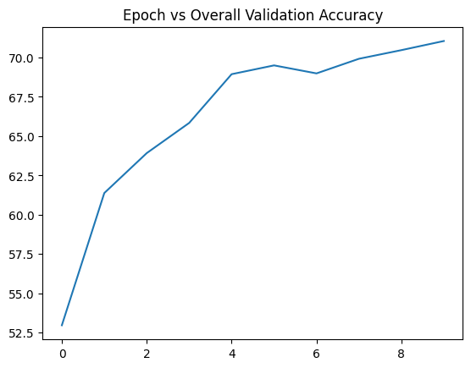 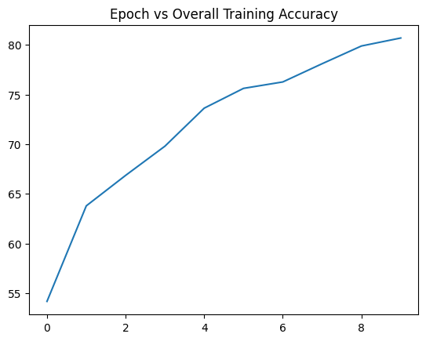

## SGD

LR = 0.001, Epochs = 10, Batch = 32, Momentum = 0.9

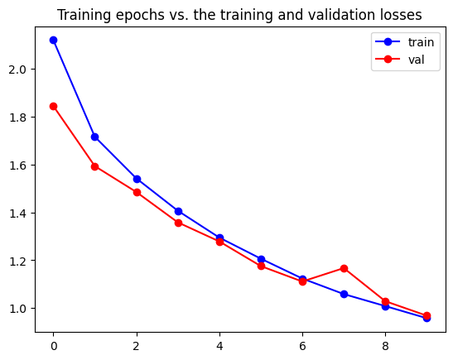

66.06

Accuracy for class: plane is 64.6 %

Accuracy for class: car is 78.6 %

Accuracy for class: bird is 45.5 %

Accuracy for class: cat is 56.2 %

Accuracy for class: deer is 58.7 %

Accuracy for class: dog is 51.2 %

Accuracy for class: frog is 72.5 %

Accuracy for class: horse is 74.1 %

Accuracy for class: ship is 80.5 %

Accuracy for class: truck is 78.7 %

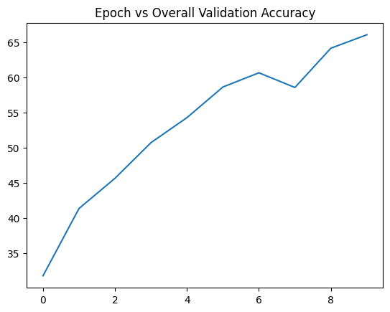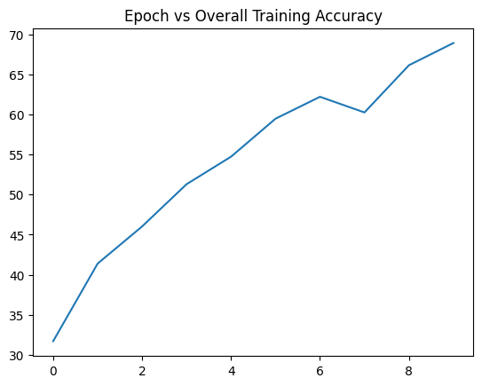

# Choice between LR

## LR = 0.001

Refer base case (Pg1)

## LR = 0.01

Epochs = 10, Batch = 32, Adam

Learning rate is too large, updates may be overshooting local minima and it is unable to converge.

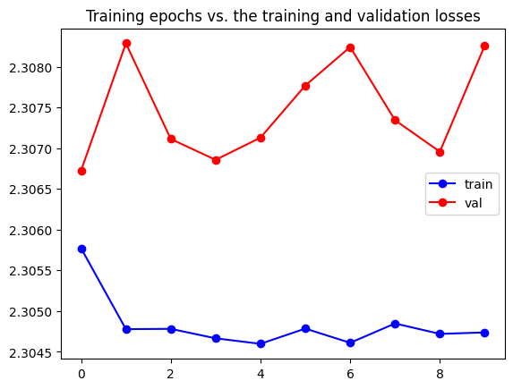

10.0

Accuracy for class: plane is 0.0 %

Accuracy for class: car is 0.0 %

Accuracy for class: bird is 0.0 %

Accuracy for class: cat is 0.0 %

Accuracy for class: deer is 100.0 %

Accuracy for class: dog is 0.0 %

Accuracy for class: frog is 0.0 %

Accuracy for class: horse is 0.0 %

Accuracy for class: ship is 0.0 %

Accuracy for class: truck is 0.0 %

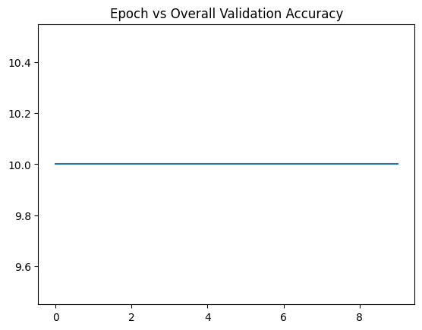 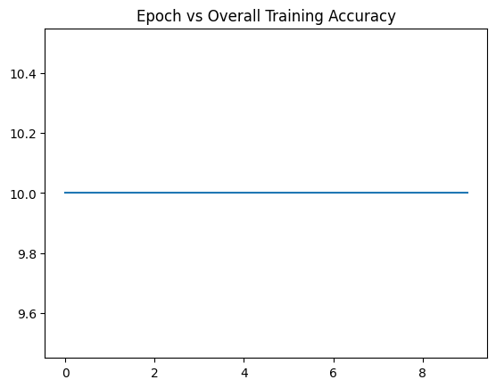

## LR = 0.0001

Epochs = 10, Batch = 32, Adam

Learning rate is too low for solution to converge sufficiently in 10 epochs.

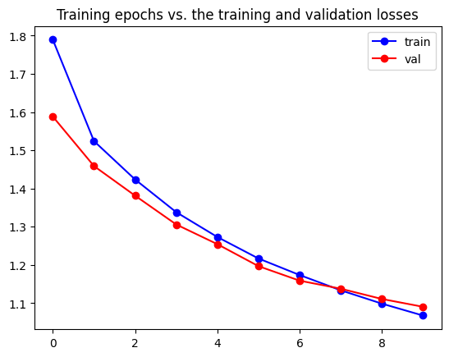

60.95

Accuracy for class: plane is 58.1 %

Accuracy for class: car is 67.9 %

Accuracy for class: bird is 42.8 %

Accuracy for class: cat is 50.0 %

Accuracy for class: deer is 43.3 %

Accuracy for class: dog is 42.5 %

Accuracy for class: frog is 81.2 %

Accuracy for class: horse is 67.8 %

Accuracy for class: ship is 85.2 %

Accuracy for class: truck is 70.7 %

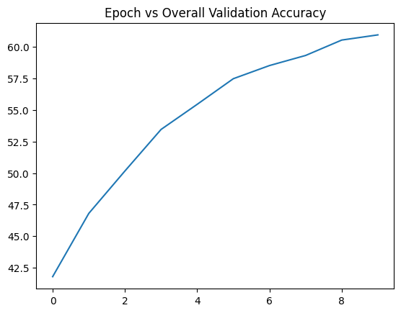 

# Analysis

## Training and Validation Loss Curves

For LR = 0.001, both training and validation losses decrease consistently, with final values being approximately 0.6 and 0.9 respectively.

For LR = 0.0001 too, both training and validation losses decrease consistently, but drop by much smaller amounts, with final values being around 1.1 approximately for both.

For LR = 0.01, losses increase/decrease randomly. Learning rate is too large to train the model and it tends to overcorrect at each step.

## Class-wise Accuracy

For LR = 0.01, the entire model is biased. Hence, this model performs very poorly with 0% accuracy for all other classes (100% accuracy for deer class is not a positive, only shows classification of all inputs solely as deer).

For LR = 0.001 and 0.0001, Class-wise accuracy is better distributed with value ranges being similar among classes. Out of these, LR = 0.001 predicts most classes more accurately.

# Choice between Batch Size

## Batch Size = 32

Refer base case (Pg1)

## Batch Size = 16

LR = 0.001, Epochs = 10, Adam

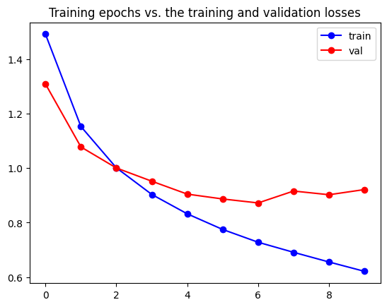

69.89

Accuracy for class: plane is 81.4 %

Accuracy for class: car is 78.1 %

Accuracy for class: bird is 54.4 %

Accuracy for class: cat is 48.5 %

Accuracy for class: deer is 68.9 %

Accuracy for class: dog is 49.1 %

Accuracy for class: frog is 79.7 %

Accuracy for class: horse is 76.7 %

Accuracy for class: ship is 82.4 %

Accuracy for class: truck is 79.7 %

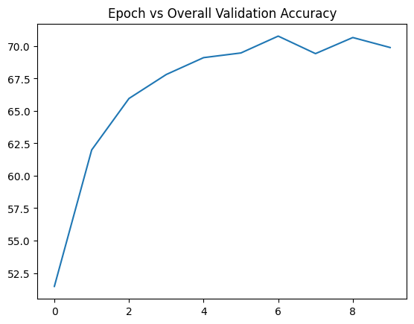 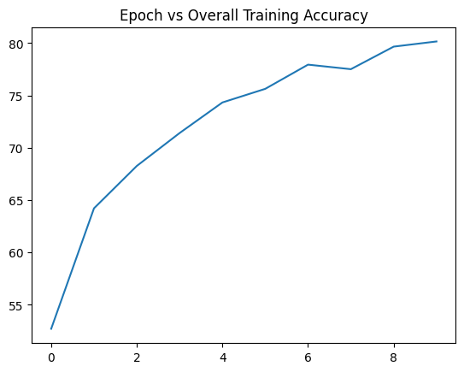

## Batch Size = 8

LR = 0.001, Epochs = 10, Adam

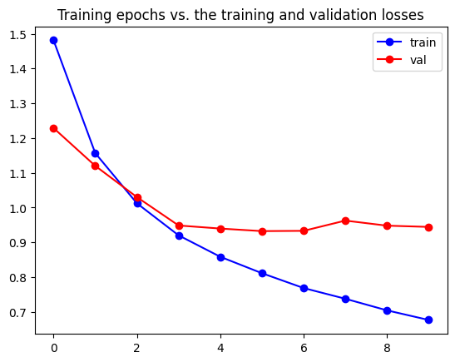

68.82

Accuracy for class: plane is 75.8 %

Accuracy for class: car is 75.9 %

Accuracy for class: bird is 49.1 %

Accuracy for class: cat is 51.0 %

Accuracy for class: deer is 66.9 %

Accuracy for class: dog is 58.7 %

Accuracy for class: frog is 79.9 %

Accuracy for class: horse is 74.9 %

Accuracy for class: ship is 76.8 %

Accuracy for class: truck is 79.2 %

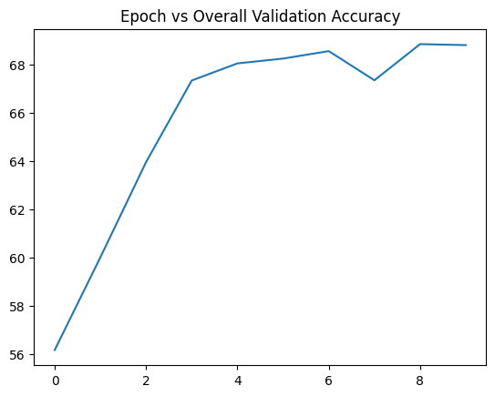 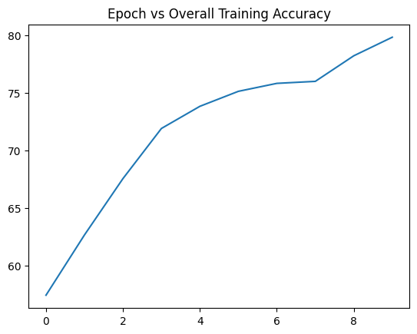

## Batch Size = 4

LR = 0.001, Epochs = 10, Adam

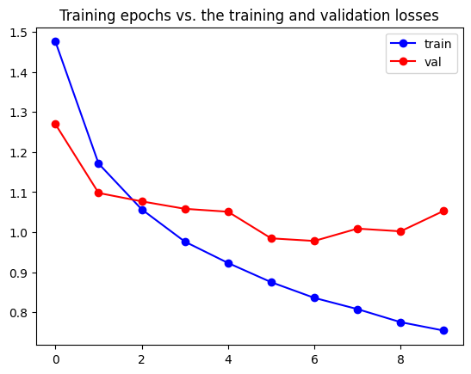

67.07

Accuracy for class: plane is 54.1 %

Accuracy for class: car is 72.1 %

Accuracy for class: bird is 48.8 %

Accuracy for class: cat is 41.0 %

Accuracy for class: deer is 70.3 %

Accuracy for class: dog is 61.6 %

Accuracy for class: frog is 78.3 %

Accuracy for class: horse is 74.6 %

Accuracy for class: ship is 82.2 %

Accuracy for class: truck is 87.7 %

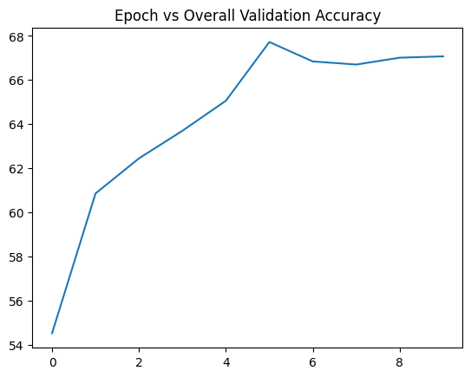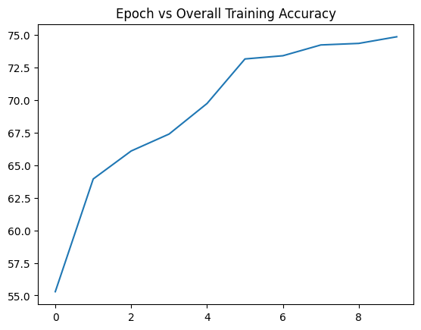

Time heavy – batch size

# Batch-size vs. Overall Validation Accuracy

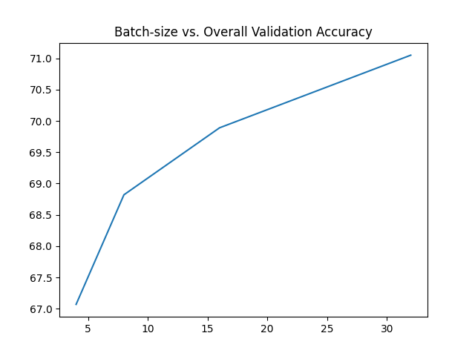

# Variance with Epochs

## Over 30 Epochs

LR = 0.001, Batch Size = 32, Adam

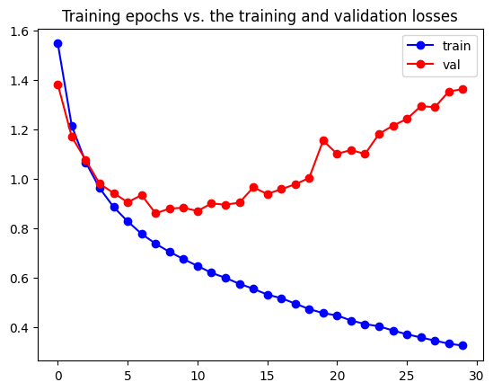

68.27

Accuracy for class: plane is 70.7 %

Accuracy for class: car is 81.2 %

Accuracy for class: bird is 52.4 %

Accuracy for class: cat is 53.1 %

Accuracy for class: deer is 66.6 %

Accuracy for class: dog is 52.1 %

Accuracy for class: frog is 77.4 %

Accuracy for class: horse is 69.1 %

Accuracy for class: ship is 78.9 %

Accuracy for class: truck is 81.2 %

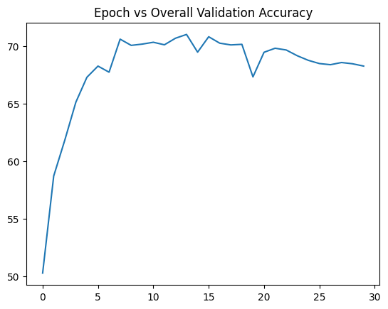 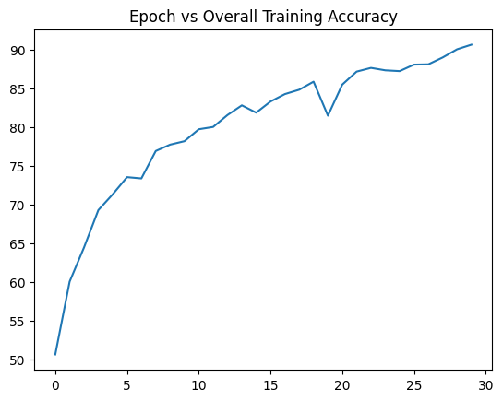

# Analysis

Increasing the number of training epochs will always improve the overall training accuracy. However, this leads to overfitting beyond a point and costs the overall validation accuracy. In the above two graphs, training accuracy increases over almost all of 30 epochs, however, validation accuracy reaches its best around 10 epochs, after which it proceeds to decrease.

Hence, increasing the number of epochs does not always help.

# Effect of Data Augmentation

## With Augmentation

Refer base case (Pg1)

## Without Augmentation

LR = 0.001, Adam, Batch Size = 32, CELoss

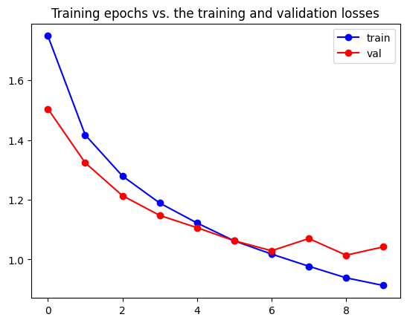

64.14

Accuracy for class: plane is 59.4 %

Accuracy for class: car is 78.0 %

Accuracy for class: bird is 43.4 %

Accuracy for class: cat is 45.9 %

Accuracy for class: deer is 66.4 %

Accuracy for class: dog is 61.9 %

Accuracy for class: frog is 76.6 %

Accuracy for class: horse is 75.0 %

Accuracy for class: ship is 63.0 %

Accuracy for class: truck is 71.8 %

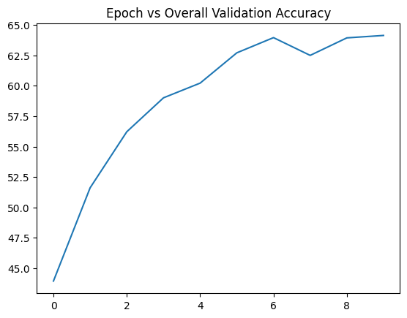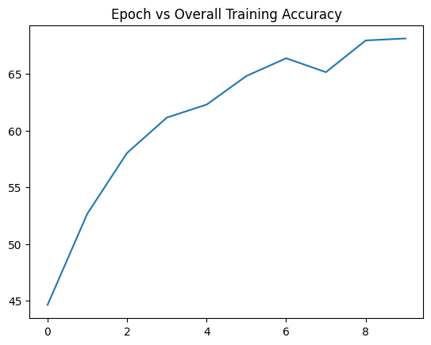

# Analysis

What effect do you observe on the class-wise and overall validation accuracy as compared to training with data augmentations? Hint: find the training accuracy as well. Does it ring a bell?

# LR Scheduler

## Regular

Refer base case (Pg1)

## ExpLR

Batch Size = 32, Adam, Epochs = 10

Initial LR = 0.01, Gamma = 0.8

Converged to Quickly? – 0.5 pe

## StepLR

10

gamma = 0.5

Initial 0.002

3 Steps

Adam batch 32

Working well

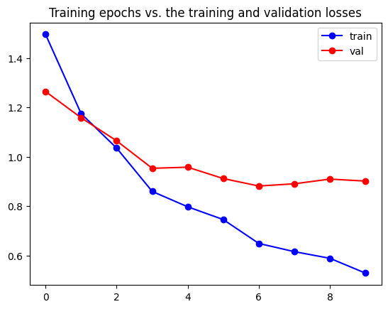

70.7

Accuracy for class: plane is 71.2 %

Accuracy for class: car is 85.1 %

Accuracy for class: bird is 57.5 %

Accuracy for class: cat is 46.6 %

Accuracy for class: deer is 69.3 %

Accuracy for class: dog is 64.0 %

Accuracy for class: frog is 80.2 %

Accuracy for class: horse is 74.1 %

Accuracy for class: ship is 79.5 %

Accuracy for class: truck is 79.5 %

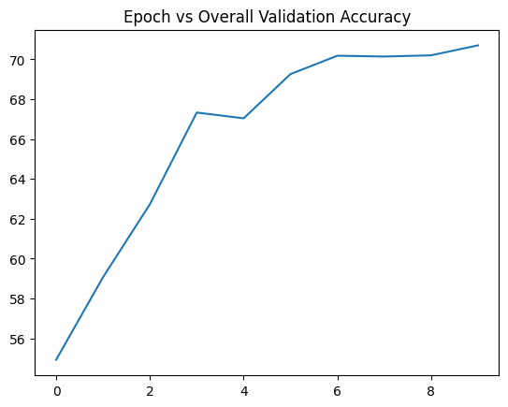

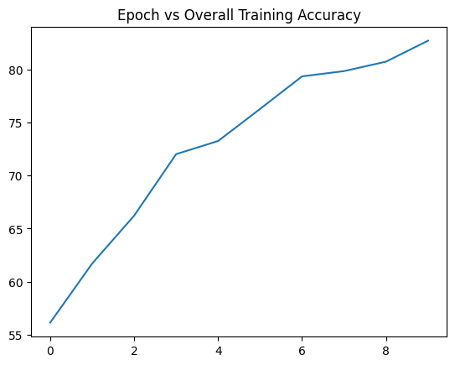

Choicce of LR sched justify

Check not improving?

Issues faced with both exp and linear

for a small number of epochs

Hence increasing epochs

Show that less tendency to overfit in that case

Diagrams

Exp to deep, linear only up

Other LR Scheduler’s Tested –

ExpLR, LinearLR – Both of which performed poorly compared to StepLR

Report your analysis.

Report the training and validation loss curves, and class-wise accuracy. What are your observations?

# Loss Function

## Cross-Entropy Loss

Base Case

## KL Divergence Loss

LR0.001

Adam batch 32

epoch 10

outputs = torch.nn.functional.log_softmax(outputs,dim=1)

loss = criterion(outputs, labels.float().view(-1, 1))

Compare the performance with the Cross- Entropy Loss in terms of convergence, and class-wise accuracy.