Q1) Given data = {2, 3, 4, 5, 6, 7; 1, 5, 3 , 6, 7, 8}. Compute the principal component using PCA algorithm. [2021]
Solution: Given the full PCA computation for the dataset
{(2,1),(3,5),(4,3),(5,6),(6,7),(7,8)}.

1. Organize the Data
We interpret the given data
{2,3,4,5,6,7; 1,5,3,6,7,8} as 6 two-dimensional points:
x=[2,3,4,5,6,7],y=[1,5,3,6,7,8].

2. Compute the Mean
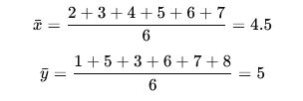

3. Center the Data

Subtract the mean from each coordinate:
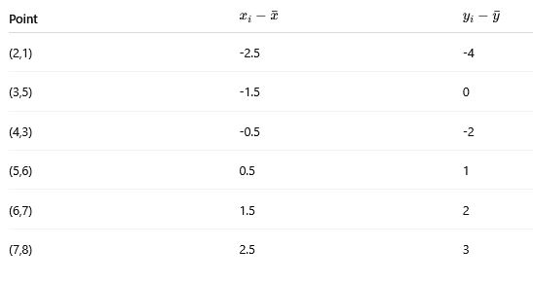
4. Compute Covariance Matrix:
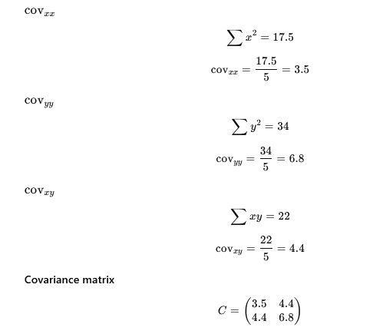
5. Compute Eigenvalues:
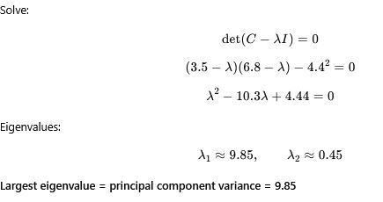
6. Compute Eigenvector for Principal Component:
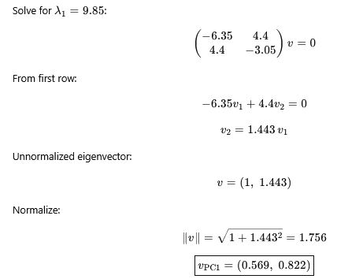
Final Answer: Principal Component:
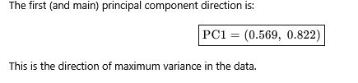
Q2) Cluster the following eight points (with (x, y) representing locations) into three clusters: A1(2,10), A2(2, 5), A3(8, 4), A4(5, 8), A5(7, 5), A6(6, 4), A7(1, 2) A8(4, 9). Initial cluster centers are A1(2, 10), A4(5, 8), and A7(1, 2). The distance function between two points a = (x1, y1) and b = (x2, y2) is defined as P(a, b) = |x2 – x1| + |y2 – y1|. Use k-means algorithm to find the three cluster centers after the second iteration.

Solution: Given Points
A1(2,10), A2(2,5), A3(8,4), A4(5,8),
A5(7,5), A6(6,4), A7(1,2), A8(4,9)
Initial centers (Iteration 0):
C1 = A1(2,10), C2 = A4(5,8), C3 = A7(1,2)
Distance metric:
P(a,b)=∣x2−x1∣+∣y2−y1∣(Manhattan distance)
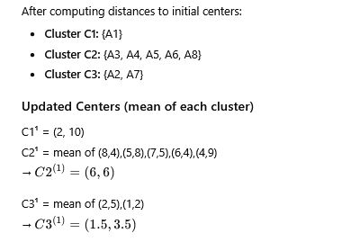

Iteration 2 → Reassign Points Using New Centers
Distances computed to:
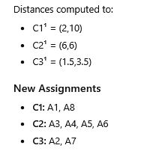
Updated Centers After Iteration 2:
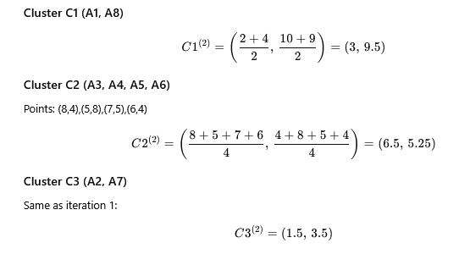
Final Answer: Cluster Centers After the Second Iteration:
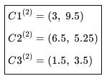
Q3) Explain and apply Flajolet-Martin algorithm on the following stream of data to identify unique elements in the stream. S = {1, 3, 2, 1, 2, 3, 4, 3, 1, 2, 3, 1}. Given: h(x) = (6x+1) mod 5.

Solution:

1. What the Flajolet–Martin Algorithm Does
The FM algorithm estimates the number of distinct elements in a data stream using hashing.

Key idea
- Hash each element to an integer.
- Convert the hash value to binary.
- Count the number of trailing zeros in each hashed value.
- Keep the maximum number of trailing zeros observed:
R=max(trailing zeros)
- Estimated number of distinct elements:
Estimate= 2^{R}​

2. Compute Hash Values for Each Distinct Element
The distinct elements in the stream are:
{1,2,3,4}
Apply the hash function:

h(1)
h(1)=(6⋅1+1) mod 5=7 mod 5=2

h(2)
h(2)=(6⋅2+1) mod 5=13 mod 5=3

h(3)
h(3)=(6⋅3+1) mod 5=19 mod 5=4

h(4)
h(4)=(6⋅4+1) mod 5=25 mod 5=0

3. Convert Hash Values to Binary
x | h(x) | Binary | Trailing zeros
1 | 2 | 10 | 1
2 | 3 | 11 | 0
3 | 4 | 100 | 2
4 | 0 | 0 | Infinity? No → treat as very large but limited by hash range
However, FM only counts trailing zeros within the hash range.
Since the hash function outputs values 0–4, we write them in 3-bit binary:
h(x) | 3-bit binary | Trailing zeros
0 | 000 | 3
1 | 001 | 0
2 | 010 | 1
3 | 011 | 0
4 | 100 | 2
Thus for our hashed values:
x | h(x) | Binary | Trailing zeros
1 | 2 | 010 | 1
2 | 3 | 011 | 0
3 | 4 | 100 | 2
4 | 0 | 000 | 3

4. FM Algorithm → Take the Maximum Trailing Zero Count
R=max⁡(1,0,2,3)=3

5. FM Estimate of Number of Distinct Elements
Distinct estimate=2^{R}=2³=8

Final Result

Flajolet–Martin estimate of unique elements = 8

Actual number of distinct elements in the stream = 4
The difference occurs because the hash range is very small (0–4). FM accuracy increases with:
- larger hash ranges
- multiple independent hash functions
- averaging or median-of-means improvements.
Q4) Explain the benefits of the PCZ algorithm over Apriori algorithm.
Solution:

Benefits of PCZ Algorithm Over Apriori Algorithm
The PCZ (Partition–Count–Zoom) algorithm is an improvement over Apriori. It was designed to reduce the computational cost of candidate generation and database scanning.
Here are the key advantages:

1. Fewer Database Scans

Apriori
- Requires repeated full database scans for every k-itemset level.
- If the largest frequent itemset is size k, Apriori may scan the database k times.

PCZ
- Divides the dataset into partitions and processes each partition locally.
- A complete scan of the full database is performed only once (or at most twice).
➡Result: Major reduction in I/O cost.

2. Reduced Candidate Generation

Apriori
- Generates huge numbers of intermediate candidate itemsets.
- Candidate growth can be exponential.

PCZ
- Works on local frequent itemsets within partitions, which generates:
  - fewer candidates,
  - smaller search space.
➡ Result: Less memory use and faster mining.

3. Local Pruning of Infrequent Patterns

Apriori
- Applies pruning only after counting support in the entire database.

PCZ
- Performs local pruning inside each partition before combining results.
- Many itemsets are eliminated early.
➡ Result: Faster and more efficient processing.

4. Avoids Repeated Candidate-Count Matching

Apriori
- Relies on repeated matching of candidates against transaction records.

PCZ
- Partitions transactions so that counting support takes place on smaller subsets, reducing matching overhead.
➡Result: Lower computational complexity.

5. Scales Better for Large Datasets
Because PCZ processes partitions independently:
- Supports parallel and distributed execution easily.
- Memory requirement is smaller (each partition can fit into memory).
➡Result: PCZ is more scalable for big data environments.

6. Zooming Phase Improves Accuracy
In the Zoom phase, PCZ:
- Re-evaluates only the potential global frequent itemsets (PGFIs)
- Ensures no true frequent patterns are missed.
This improves correctness without heavy redundant computation.

7. Overall Efficiency Improvement
Compared to Apriori, PCZ offers:
- fewer candidate itemsets
- fewer database scans
- less memory usage
- reduced computation time
- improved scalability
➡Overall, PCZ is significantly more efficient than Apriori, particularly on large and sparse datasets.

Summary Table
Feature | Apriori | PCZ
DB scans | Many | 1–2
Candidate generation | Large | Small
Pruning | Global only | Local + global
Scalability | Moderate | High
Parallelism | Limited | Easy
Memory usage | High | Lower
Efficiency | Lower | Higher
Q5) What is heartbeat in Hadoop?
Solution:
A heartbeat in Hadoop is a periodic message sent by:
- DataNodes → NameNode (in HDFS)
- NodeManagers → ResourceManager (in YARN)
It tells the master that:
- The node is active.
- The node is healthy.
- The node can send/receive tasks or store/serve data.

Purpose of Heartbeats in Hadoop

1. Node Health Monitoring
If a DataNode or NodeManager stops sending heartbeats for a predefined time (default ~10 min), the master marks it dead.

2. Block Management (HDFS)
For DataNodes → NameNode:
- Heartbeats report block statuses.
- NameNode uses this to maintain replication levels.

3. Task Scheduling (YARN)
For NodeManagers → ResourceManager:
- Heartbeats carry information about available CPU, memory, and running containers.
- ResourceManager decides where to place new tasks.

4. Failure Recovery
If a heartbeat is missed:
- NameNode starts re-replication of blocks stored on that DataNode.
- ResourceManager reschedules tasks from the failed NodeManager.

Frequency
Typical heartbeat intervals:
- DataNode heartbeat: every 3 seconds
- NodeManager heartbeat: every 1 second
(These are configurable.)

Summary (Simple Explanation)
Heartbeat in Hadoop = “I am alive” signal from worker nodes.
It ensures:
- nodes are active
- tasks can be assigned
- failures are detected quickly
- HDFS block replicas stay consistent
Q6) The database has 6 transactions. Assume support threshold = 50% and confidence = 60%.
TID | Items Brought
10 | Beer, Nuts, Diaper
20 | Beer, Coffee, Diaper
30 | Beer, Coffee, Diaper
40 | Nuts, Eggs, Milk
50 | Nuts, Coffee, Diaper, Eggs, Milk
60 | Beer, Nuts, Diaper
  - Use Apriori algorithm to find all frequent itemsets.
  - Show all the strong transaction rules (with support and confidence).
Solution:
Below is the complete Apriori solution for the given database with:
- Minimum support = 50% → support count ≥ 3 (because 50% of 6 = 3)
- Minimum confidence = 60%

TRANSACTIONS
TID | Items
10 | Beer, Nuts, Diaper
20 | Beer, Coffee, Diaper
30 | Beer, Coffee, Diaper
40 | Nuts, Eggs, Milk
50 | Nuts, Coffee, Diaper, Eggs, Milk
60 | Beer, Nuts, Diaper

PART (i) — Find all frequent itemsets using Apriori

STEP 1 — 1-Frequent Itemsets (L1)
Count occurrences of each item:
Item | Count
Beer | 4 (10,20,30,60)
Nuts | 4 (10,40,50,60)
Diaper | 5 (10,20,30,50,60)
Coffee | 3 (20,30,50)
Eggs | 2 (40,50)
Milk | 2 (40,50)

STEP 2 — Generate Candidate 2-itemsets (C2)
Only from L1.
Compute their supports:
2-itemset | Count | Frequent?
Beer, Nuts | 2 | ❌
Beer, Diaper | 4 | ✅
Beer, Coffee | 2 | ❌
Nuts, Diaper | 3 | ✅
Nuts, Coffee | 1 | ❌
Diaper, Coffee | 3 | ✅
Thus:
L2={(Beer,Diaper),(Nuts,Diaper),(Diaper,Coffee)}

STEP 3 — Generate Candidate 3-itemsets (C3)
We only combine 2-itemsets that share common prefixes.
Possible candidate:
(Beer,Diaper)∩(Diaper,Coffee)→(Beer,Diaper,Coffee)
Count support of each candidate:

Candidate: (Beer, Diaper, Coffee)
Appears in TIDs 20, 30 → support = 2 → ❌ Not frequent.

Candidate: (Nuts, Diaper, Coffee)
Appears only in TID 50 → support = 1 → ❌ Not frequent.

Candidate: (Beer, Nuts, Diaper)
Transaction = 2 → ❌ Not frequent.

FINAL FREQUENT ITEMSETS
L1={Beer,Nuts,Diaper,Coffee}
​ L2={(Beer,Diaper),(Nuts,Diaper),(Diaper,Coffee)}
There are no frequent 3-itemsets.

PART (ii) — Strong Association Rules
For each frequent 2-itemset:
A → B is strong if
confidence≥60%
Support threshold (≥ 50%) is already satisfied for all these pairs.

1. From (Beer, Diaper)
Support = 4/6 = 66.7%

Rule 1
Beer→Diaper
Confidence = 4/4 = 100% → ✔ Strong

Rule 2
Diaper→Beer
Confidence = 4/5 = 80% → ✔ Strong

2. From (Nuts, Diaper)
Support = 3/6 = 50%

Rule 3
Nuts→Diaper
Confidence = 3/4 = 75% → ✔ Strong

Rule 4
Diaper→Nuts
Confidence = 3/5 = 60% → ✔ Strong

3. From (Diaper, Coffee)
Support = 3/6 = 50%

Rule 5
Diaper→CoffeeDiaper
Confidence = 3/5 = 60% → ✔ Strong

Rule 6
Coffee→DiaperCoffee
Confidence = 3/3 = 100% → ✔ Strong

FINAL STRONG ASSOCIATION RULES
Beer→Diaper (100%)
​ Diaper→Beer (80%)
​ Nuts→Diaper (75%)
Diaper→Coffee (60%)
Coffee→Diaper (100%)​
All above rules also satisfy support ≥ 50%.

