What is Regression Modeling?
Regression modeling is a statistical technique used to examine the relationship between one dependent variable (target) and one or more independent variables (predictors or features).
It helps you:
- Predict outcomes
- Understand relationships
- Forecast trends
- Make data-driven decisions

Types of Regression Models
- Linear Regression
  - Simple Linear Regression: One independent variable
y=β0​+β1​x+ε
Multiple Linear Regression: Multiple independent variables
y=β0​+β1​x1​+β2​x2​+⋯+βn​xn​+ε
- Polynomial Regression
  - Fits a non-linear curve using polynomial terms of predictors.
- Logistic Regression
  - For binary classification problems (output is 0 or 1).
- Ridge, Lasso, and Elastic Net Regression
  - Regularized models to prevent overfitting.
  - Ridge adds L2 penalty, Lasso adds L1 penalty, and Elastic Net combines both.
- Nonlinear Regression
  - Models a nonlinear relationship directly between variables.
- Quantile Regression
  - Estimates the conditional median or other quantiles of the response variable.

Key Concepts
- Dependent variable (y): What you want to predict
- Independent variables (X): The features used for prediction
- Coefficients (β): Represent the strength and direction of the relationship
- Residuals (ε): Difference between predicted and actual values

Assumptions of Linear Regression
- Linearity: Relationship between X and y is linear
- Independence: Observations are independent
- Homoscedasticity: Constant variance of residuals
- Normality: Residuals are normally distributed
- No multicollinearity: Independent variables should not be highly correlated

Common Evaluation Metrics
- R-squared (R²): Proportion of variance explained by the model
- Adjusted R²: Adjusts R² for the number of predictors
- MSE (Mean Squared Error)
- RMSE (Root Mean Squared Error)
- MAE (Mean Absolute Error)

Example (Python Code)
from sklearn.linear_model import LinearRegression
from sklearn.model_selection import train_test_split
from sklearn.metrics import mean_squared_error
# Sample dataset
X = df[['feature1', 'feature2']]
y = df['target']
# Train-test split
X_train, X_test, y_train, y_test = train_test_split(X, y, test_size=0.2, random_state=42)
# Fit model
model = LinearRegression()
model.fit(X_train, y_train)
# Predict
y_pred = model.predict(X_test)
# Evaluate
mse = mean_squared_error(y_test, y_pred)
print(f"MSE: {mse}")

What is Multivariate Analysis?
Multivariate Analysis (MVA) refers to a set of statistical techniques used to analyze data that arises from more than one variable. It's often used to understand the relationships between variables and to reduce dimensionality.
If you're working with more than two variables, you're in the territory of multivariate statistics.

Why Use Multivariate Analysis?
- To understand interactions between variables
- To control for confounding variables
- To reduce data complexity (dimensionality reduction)
- To classify, predict, or cluster observations
- To visualize high-dimensional data

Common Multivariate Analysis Techniques

1. Multiple Linear Regression (MLR)
Used to predict a continuous outcome from multiple predictors.
Example:
Predicting house price using square footage, number of bedrooms, and location.

2. MANOVA (Multivariate Analysis of Variance)
Extension of ANOVA when there are multiple dependent variables.
Example:
Studying how education level affects both income and job satisfaction.

3. Principal Component Analysis (PCA)
Used for dimensionality reduction — reduces the number of variables while preserving variance.
Example:
Reducing hundreds of customer survey questions into a few latent factors.

4. Factor Analysis
Similar to PCA, but assumes that observed variables are influenced by latent (unobserved) factors.
Example:
Identifying underlying psychological traits from questionnaire data.

5. Canonical Correlation Analysis (CCA)
Examines the relationship between two sets of variables.
Example:
Relating academic performance (GPA, test scores) with psychological factors (motivation, anxiety).

6. Cluster Analysis
Groups observations into clusters based on similarity across multiple variables.
Example:
Customer segmentation using age, income, and purchasing behavior.

7. Discriminant Analysis
Used for classification — predicts group membership based on predictor variables.
Example:
Predicting whether a patient has a disease based on blood test results.

8. Multidimensional Scaling (MDS)
Used to visualize similarity or dissimilarity in data — places objects in geometric space based on distance/similarity.

Example (PCA in Python)
from sklearn.decomposition import PCA
from sklearn.preprocessing import StandardScaler
# Standardize the features
scaler = StandardScaler()
X_scaled = scaler.fit_transform(X)
# Apply PCA
pca = PCA(n_components=2)
X_pca = pca.fit_transform(X_scaled)
# Explained variance
print(pca.explained_variance_ratio_)
When to Use Multivariate Analysis?
Situation | Recommended Technique
Predict continuous outcome with multiple predictors | Multiple Linear Regression
Analyze multiple dependent variables | MANOVA
Reduce number of variables | PCA / Factor Analysis
Classify into categories | Discriminant Analysis
Explore natural groupings | Cluster Analysis
Study relationships between variable sets | CCA

What is Bayesian Modeling?
Bayesian modeling is a statistical approach that uses Bayes’ Theorem to update the probability of a hypothesis as more evidence or information becomes available. It provides a probabilistic framework to reason under uncertainty.

Core Idea: Bayes' Theorem
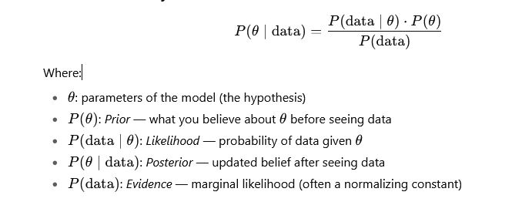

Bayesian Workflow
- Specify a prior
What do you already believe about the parameters?
- Collect data
Observe real-world data (evidence).
- Compute the likelihood
How likely is the data under your current model?
- Update your beliefs
Use Bayes’ Theorem to compute the posterior.
- Make predictions
Use the posterior to make probabilistic predictions

Why Use Bayesian Modeling?
- Incorporates prior knowledge
- Quantifies uncertainty explicitly
- Handles small data better than frequentist methods
- Produces distributions over parameters (not just point estimates)
- Flexible and interpretable
Bayesian vs Frequentist
Feature | Bayesian | Frequentist
Prior beliefs | Used explicitly | Not used
Output | Posterior distribution | Point estimates, p-values
Interpretation | Probabilistic | Fixed parameters
Flexibility | Very flexible (e.g., priors) | More rigid
Example: Bayesian Linear Regression (Using PyMC)
import pymc as pm
import numpy as np

# Simulate some data
np.random.seed(42)
X = np.random.normal(0, 1, 100)
y = 3 * X + np.random.normal(0, 1, 100)

with pm.Model() as model:
# Priors
alpha = pm.Normal("alpha", mu=0, sigma=10)
beta = pm.Normal("beta", mu=0, sigma=10)
sigma = pm.HalfNormal("sigma", sigma=1)

# Likelihood
mu = alpha + beta * X
y_obs = pm.Normal("y_obs", mu=mu, sigma=sigma, observed=y)

# Inference
trace = pm.sample(1000, tune=1000)
pm.summary(trace).round(2)
Inference and Bayesian Network:

Part 1: Bayesian Networks

What is a Bayesian Network?
A Bayesian Network (BN) is a graphical model that represents a set of variables and their conditional dependencies via a Directed Acyclic Graph (DAG).
- Nodes represent random variables
- Edges represent probabilistic dependencies
- Each node has a Conditional Probability Distribution (CPD)
Bayesian Networks are a compact way to represent a joint probability distribution over many variables.

Example: Simple Bayesian Network
Let’s say we have:
- Rain (R)
- Sprinkler (S)
- Wet Grass (W)
Structure:
R → W ← S
This means:
- Wet grass depends on Rain and Sprinkler
- Rain and Sprinkler are independent
So the joint probability is:
P(R,S,W)=P(R)⋅P(S)⋅P(W∣R,S)

Uses of Bayesian Networks
- Medical diagnosis
- Decision support systems
- Fault detection
- Natural language processing
- Risk analysis

Part 2: Inference in Bayesian Networks

What is Inference?
Inference is the process of computing the probability of unknown variables given observed evidence.

Two Main Types:
- Marginal Inference:
  - Compute the probability distribution of a variable by summing out others.
  - Example: What is P(W)?
- Conditional Inference:
  - Compute the probability of a variable given evidence.
  - Example: What is P(R∣W=true)?

Inference Algorithms

1. Exact Inference
- Variable Elimination: Systematically sums out variables
- Belief Propagation: Message-passing in tree-structured networks

2. Approximate Inference
- Sampling Methods:
  - Monte Carlo Sampling
  - Gibbs Sampling
  - Rejection Sampling
These are used when exact methods are too computationally expensive.

Example (Python with pgmpy)
from pgmpy.models import BayesianModel
from pgmpy.factors.discrete import TabularCPD
from pgmpy.inference import VariableElimination
# Define the model structure
model = BayesianModel([('Rain', 'WetGrass'), ('Sprinkler', 'WetGrass')])

# Define CPDs
cpd_rain = TabularCPD('Rain', 2, [[0.2], [0.8]])
cpd_sprinkler = TabularCPD('Sprinkler', 2, [[0.1], [0.9]])
cpd_wetgrass = TabularCPD(
variable='WetGrass',
variable_card=2,
values=[[0.99, 0.9, 0.9, 0.0], # P(WetGrass=False | ...)
[0.01, 0.1, 0.1, 1.0]], # P(WetGrass=True | ...)
evidence=['Rain', 'Sprinkler'],
evidence_card=[2, 2]
)
# Add CPDs to the model
model.add_cpds(cpd_rain, cpd_sprinkler, cpd_wetgrass)

# Check model validity
print("Model is valid:", model.check_model())
# Perform inference
infer = VariableElimination(model)
posterior = infer.query(variables=['Rain'], evidence={'WetGrass': 1})
print(posterior)

Interpretation
- Bayesian Networks let you represent knowledge compactly using conditional dependencies.
- Inference lets you compute beliefs given observed data.
- This is key in decision-making under uncertainty.

When Should You Use Bayesian Networks?
Use BNs when:
- Variables are interdependent, and you want to model causal or probabilistic relationships
- You need to reason under uncertainty
- You want a model that is both interpretable and extensible
- You're working on problems like diagnostics, prediction, or planning

What are Support Vector Machines (SVMs)?
Support Vector Machines are supervised learning models used primarily for:
- Classification
- Regression (SVR)
- Anomaly detection
They work by finding the optimal hyperplane that separates data points of different classes with the maximum margin.

Core Idea
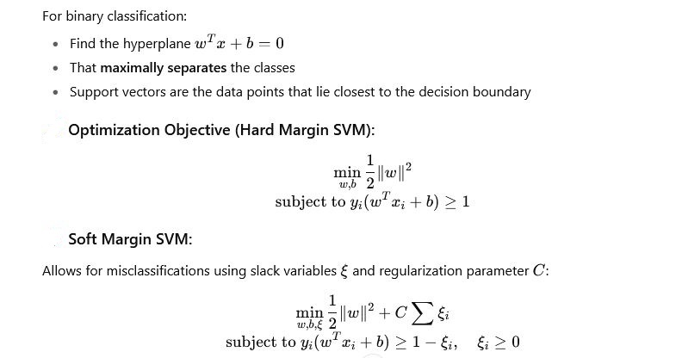

What are Kernel Methods?
Kernel methods allow SVMs to perform non-linear classification by implicitly mapping data into a higher-dimensional space, where it becomes linearly separable.
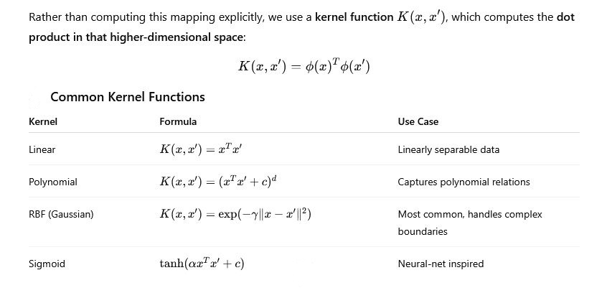

SVM with Kernel Trick (Intuition)
- Data is not linearly separable in the input space.
- Use a kernel function to compute distances as if in a higher-dimensional space.
- Train SVM using these kernelized distances.
- Decision boundary becomes non-linear in original space.

When to Use SVMs
Works well when:
- Clear margin of separation
- High-dimensional space (e.g., text classification)
- Small-to-medium datasets
Less ideal when:
- Very large datasets (SVMs can be slow)
- Highly noisy or overlapping classes
- Need for direct probability outputs (though probability=True is available)

Support Vector Regression (SVR)
SVM can also be adapted for regression:
- Instead of maximizing the margin between classes, SVR fits a function within a tube (margin of tolerance) ε.
- Points outside this tube are penalized.

Summary Table
Concept | Description
SVM | Finds hyperplane to separate classes
Support Vectors | Points closest to the decision boundary
Hard Margin | No misclassification allowed
Soft Margin | Allows some misclassification
Kernel Method | Transforms data into higher dimension without explicitly computing it
RBF Kernel | Good general-purpose kernel
SVR | Version of SVM for regression

Time Series Analysis:

What is Time Series Analysis?
Time Series Analysis (TSA) involves analyzing data that is collected over time to:
- Understand the underlying structure and function that produced the observations
- Forecast future values based on past trends

Key Components of a Time Series
- Trend – The long-term increase or decrease in the data
(e.g., rising sales over years)
- Seasonality – Regular, periodic fluctuations
(e.g., higher ice cream sales in summer)
- Cyclicality – Long-term oscillations not of fixed period
(e.g., business cycles)
- Irregular/Noise – Random variation or residuals
(e.g., one-off events like COVID-19)

Common Time Series Models

1. ARIMA (AutoRegressive Integrated Moving Average)
- Best for non-seasonal data
- Combines:
  - AR (AutoRegression): Regression of the variable on its past values
  - I (Integrated): Differencing of raw observations to make data stationary
  - MA (Moving Average): Dependency between an observation and residual errors from a moving average model

2. SARIMA (Seasonal ARIMA)
- Extension of ARIMA to handle seasonal effects

3. Exponential Smoothing Methods
- Simple Exponential Smoothing
- Holt’s Linear Trend Method
- Holt-Winters Method (handles trend and seasonality)

4. State Space Models / Kalman Filters
- Useful for real-time estimation and forecasting

5. Prophet (by Facebook)
- Good for business time series with multiple seasonality and holiday effects

6. LSTM / RNN (Neural Networks)
- Deep learning models for sequential data — good when data is complex and nonlinear

Steps in Time Series Analysis
- Plot the Time Series
- Check for Stationarity
  - Use ADF Test (Augmented Dickey-Fuller)
- Make Stationary (if needed)
  - Differencing, transformation (log, sqrt)
- Decompose the Series
  - Trend, Seasonality, Residual
- Model Selection
  - Use ACF and PACF plots to identify ARIMA parameters
- Model Fitting
- Forecasting
- Evaluate the Model
  - Use MAE, RMSE, MAPE, etc.

Visualization Tools
- Line plots for raw data
- Seasonal plots to observe repeating patterns
- ACF/PACF plots for model identification
- Decomposition plots to break down components

Tools & Libraries

In Python:
- pandas – data manipulation
- matplotlib / seaborn – visualization
- statsmodels – ARIMA, ADF test, etc.
- pmdarima – auto ARIMA
- prophet – for forecasting
- scikit-learn – metrics, preprocessing
- keras / tensorflow – deep learning models

Example Use Cases
- Stock price prediction
- Weather forecasting
- Sales forecasting
- Energy consumption prediction
- Traffic flow analysis
Linear System Time Series Analysis:

What Is a Linear System in Time Series?
In time series analysis, linear systems refer to models where the output (observed time series) is a linear function of past inputs, outputs, and noise terms.
These models assume linearity in terms of convolution or filtering operations — widely used in:
- Signal processing
- Control systems
- Econometrics
- Time series forecasting

General Structure of a Linear Time-Invariant (LTI) System
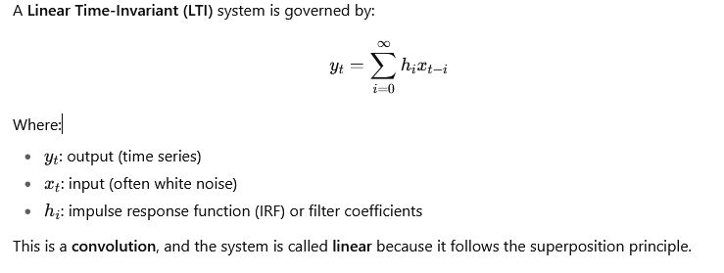

Common Linear Time Series Models:
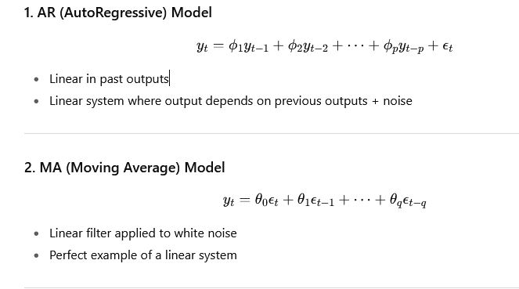
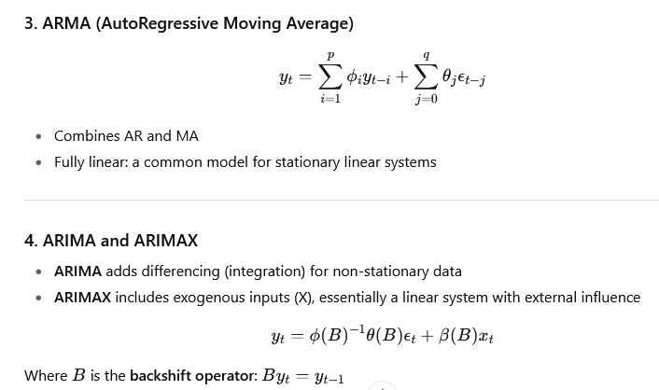
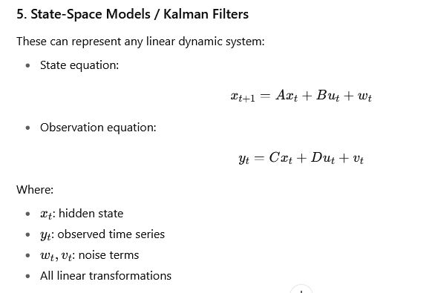
Impulse Response Function (IRF):
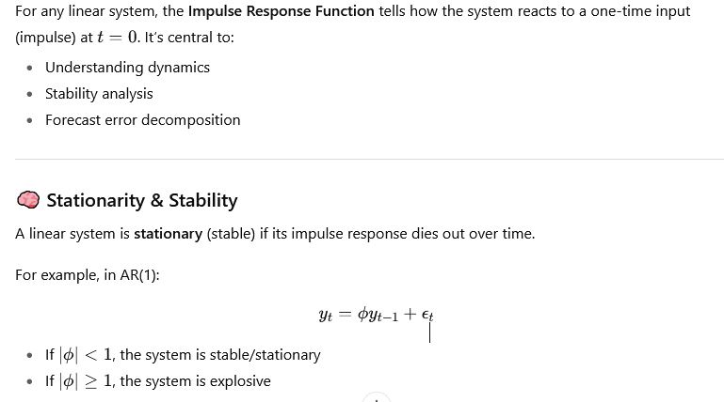

Filters as Linear Systems
You can treat many smoothing or transformation methods as linear filters, e.g.:
- Moving averages (MA)
- Exponential smoothing
- Bandpass filters (Hodrick-Prescott filter)
Each is a linear operator applied to a time series.

Spectral Analysis (Frequency Domain View)
- Linear systems can be analyzed in frequency space using Fourier transforms
- Tools: Power Spectral Density (PSD), Transfer Functions
- Useful when periodicity and cycles are of interest

Summary
Concept | Linear? | Description
AR(p) | ✅ | Output depends linearly on past outputs
MA(q) | ✅ | Output is linear combination of past noise
ARMA | ✅ | Combines AR and MA
ARIMA | ✅ | Adds differencing for non-stationarity
State-Space | ✅ | Linear equations for hidden state and output
Neural Networks | ❌ | Nonlinear system
Nonlinear Dynamics in Time Series:
This is especially useful when real-world systems exhibit:
- Chaotic behavior
- Sudden regime shifts
- Threshold effects
- Asymmetry
- Volatility clustering
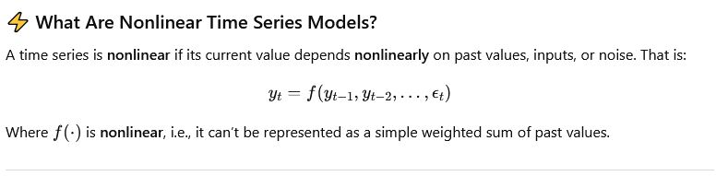

Why Nonlinear Models?
- Linear models (ARMA/ARIMA) can only model symmetric, stable, mean-reverting behavior
- Many real systems (e.g., finance, climate, biology) exhibit:
  - Volatility bursts (finance)
  - Limit cycles (biology)
  - Tipping points (ecology, economics)
  - Regime switches (macroeconomics)

Categories of Nonlinear Time Series Models

1. Threshold Models
These models switch regimes based on thresholds.
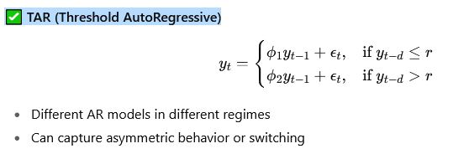

2. Machine Learning / Deep Learning Models

LSTM / RNN / GRU
- Capture long-term nonlinear dependencies
- Often used in:
  - Language modeling
  - Financial forecasting
  - Weather prediction

Other ML Models:
- Random Forests
- Gradient Boosting Machines (XGBoost, LightGBM)
- Gaussian Processes (nonparametric, nonlinear models)

6. Chaos and Dynamical Systems
- Focuses on systems that are deterministic but sensitive to initial conditions
- Time series from chaotic systems look random but are generated by deterministic nonlinear rules

Example: Logistic Map
- Shows periodic, chaotic, and bifurcating behavior depending on rrr

7. Delay Embedding & Phase Space Reconstruction
Used to study the geometry of nonlinear time series.
- Takens’ Theorem:
You can reconstruct the state space of a dynamical system using delayed versions of the time series,
- Useful for analyzing chaos, attractors, and nonlinear structure

Tools & Python Libraries
Model Type | Python Tool
GARCH | arch
TAR/STAR | statsmodels.tsa.regime_switching (partial)
NAR/NARX | sklearn, tensorflow, keras, torch
LSTM | keras, torch
Chaos / Nonlinear Dynamics | nolds, pyEDM, tisean, pyts

Common Nonlinear Diagnostics
- BDS Test (Brock-Dechert-Scheinkman) – Tests for independence/nonlinearity
- ARCH Test – Tests for heteroskedasticity
- Lyapunov Exponents – Measures chaos
- Recurrence Plots – Visualizes structure in state space

Example: When Nonlinear Matters
System | Linear Enough? | Use Nonlinear?
Stock prices (mean) | ✅ Often linear
Stock volatility | ❌ Use GARCH
Climate systems | ❌ Nonlinear dynamical systems
Power consumption | Mixed
Language models | ❌ LSTM/transformers
Biological signals (EEG, ECG) | ❌ Often chaotic/nonlinear
Rule Induction:
Rule induction is a method in machine learning and data mining that involves deriving general rules or patterns from specific observed data. It’s one of the key techniques used for building interpretable models, such as if–then rules, which can explain relationships in data.

Basic Idea
Rule induction aims to find rules of the form:
IF (conditions) THEN (conclusion)
For example, in a dataset about weather and playing tennis:
IF (Outlook = Sunny) AND (Humidity = High) THEN (Play = No)
Each rule captures a relationship between input attributes and a target outcome.

Typical Steps in Rule Induction
- Data Collection
Gather examples (instances) with attributes and target labels.
- Rule Generation
Use algorithms to generate candidate rules that fit subsets of the data.
- Rule Evaluation
Assess each rule based on measures such as accuracy, coverage, precision, recall, or information gain.
- Rule Pruning / Simplification
Remove or simplify rules that are too specific or redundant to avoid overfitting.
- Rule Ordering / Selection
Organize rules into a decision list or a set (e.g., ordered vs unordered rule sets).

Common Algorithms for Rule Induction
- ID3 / C4.5 / C5.0 — originally decision tree algorithms but can extract rules from trees.
- RIPPER (Repeated Incremental Pruning to Produce Error Reduction)
- CN2 Algorithm
- FOIL (First Order Inductive Learner) — works with relational or logical data.
- Apriori / Association Rule Mining — finds frequent “if–then” patterns (e.g., “market basket analysis”).

Applications
- Classification: Deriving interpretable models for prediction.
- Knowledge discovery: Extracting human-readable insights from data.
- Expert systems: Encoding domain knowledge in logical form.
- Business analytics: Finding actionable patterns (e.g., customer behavior).

Example
Suppose you have data about credit risk:
Income | Age | Loan Amount | Default
High | 45 | 20k | No
Low | 23 | 15k | Yes
Medium | 30 | 10k | No
A rule induction algorithm might produce:
- IF Income = Low AND Loan Amount > 10k THEN Default = Yes
- IF Income = High THEN Default = No
Neural Networks:
Neural Networks are a core concept in artificial intelligence (AI) and machine learning (ML) — computational models inspired by how the human brain processes information.
They consist of layers of interconnected “neurons” (mathematical functions) that learn to map inputs to outputs by adjusting internal parameters (weights and biases).

Basic Structure
A neural network is made up of:
- Input layer – takes in the data (features).
- Hidden layers – perform intermediate computations using weighted connections and activation functions.
- Output layer – produces the final result (e.g., class label, numeric value).
Each neuron performs:
output=f(W⋅X+b)
where:
- W= weights
- X = input vector
- b = bias
- f = activation function (e.g., sigmoid, ReLU, tanh)

How They Learn
Neural networks learn by adjusting weights to minimize prediction errors.
- Forward propagation
  - Inputs pass through the layers to produce an output.
- Loss computation
  - Compare the predicted output with the true label using a loss function (e.g., mean squared error, cross-entropy).
- Backward propagation (Backpropagation)
  - Compute gradients (partial derivatives) of the loss w.r.t. each weight.
- Weight update
  - Adjust weights using an optimization algorithm like Gradient Descent.

Common Types of Neural Networks
Type | Description | Typical Use
Feedforward Neural Network (FNN) | Basic structure; information flows from input to output. | Simple classification/regression
Convolutional Neural Network (CNN) | Uses convolution layers to detect patterns. | Image processing, vision tasks
Recurrent Neural Network (RNN) | Has feedback loops for sequential data. | Time series, language modeling
Long Short-Term Memory (LSTM) | Type of RNN that avoids vanishing gradients. | Speech, text, forecasting
Transformer | Uses attention mechanisms for context. | Modern NLP models (e.g., GPT, BERT)
Autoencoder | Learns efficient representations (encoding-decoding). | Dimensionality reduction, denoising
Generative Adversarial Network (GAN) | Two networks (generator + discriminator) compete. | Image synthesis, deepfakes
from tensorflow.keras.models import Sequential
from tensorflow.keras.layers import Dense

# Create a simple feedforward network
model = Sequential([
Dense(8, activation='relu', input_shape=(4,)), # hidden layer
Dense(3, activation='softmax') # output layer
])

model.compile(optimizer='adam',
loss='categorical_crossentropy',
metrics=['accuracy'])
# Train the model
model.fit(X_train, y_train, epochs=50, batch_size=8)
This could classify, for example, flowers in the Iris dataset based on 4 input features.

Applications of Neural Networks
- Image recognition (e.g., facial recognition, medical imaging)
- Natural language processing (e.g., ChatGPT, translation, sentiment analysis)
- Speech recognition and synthesis
- Autonomous vehicles
- Financial forecasting
- Game AI and reinforcement learning
Learning and Generalization:
Learning and Generalization are core concepts in machine learning — they explain how models acquire knowledge from data and how well that knowledge applies to new, unseen data.

1. What Is Learning?
Learning in machine learning means:
Improving a model’s performance on a specific task through experience (data).
Formally, a learning algorithm tries to find a function fff that maps inputs XXX to outputs YYY such that:
f(X)≈Yf(X) \approx Yf(X)≈Y
for both the training data and new data.

Types of Learning
Type | Description | Example
Supervised Learning | Learn from labeled data (inputs + correct outputs). | Predicting house prices, spam detection
Unsupervised Learning | Learn patterns from unlabeled data. | Clustering customers, finding topics in text
Semi-Supervised Learning | Mix of labeled and unlabeled data. | Partially labeled medical data
Reinforcement Learning | Learn by trial and error to maximize a reward. | Game playing, robot control

2. What Is Generalization?
Generalization is the ability of a trained model to perform well on new, unseen data — not just the data it was trained on.
A model that has learned patterns that truly represent the underlying relationships in the data will generalize well.

Training vs. Generalization
Model Behavior | Description
Underfitting | Model is too simple — fails to capture patterns in training data (low training & test accuracy).
Good Generalization | Model captures patterns in training data and performs well on new data.
Overfitting | Model memorizes training data — performs well on training but poorly on unseen data.

3. Techniques to Improve Generalization
Technique | How It Helps
Regularization (L1, L2, Dropout) | Penalizes overly complex models.
Early stopping | Stops training before overfitting occurs.
Cross-validation | Tests performance on multiple splits of data.
Data augmentation | Creates variations of training data (e.g., flipped images).
Simpler models | Reduce complexity to capture only essential patterns.
Ensemble methods | Combine multiple models to reduce variance.

Example: Learning vs. Generalization in Action
Imagine training a neural network to classify cats vs. dogs:
- Learning phase:
The network adjusts its weights to minimize classification error on the training images.
- Generalization phase:
When you give it new pictures of cats and dogs, it should still predict correctly — even if the lighting or poses are different.
If it memorizes specific images instead of learning general features (like ears, fur, shape), it won’t generalize well.

In Short:
Concept | Definition
Learning | The process of fitting a model to training data.
Generalization | The ability of that model to perform well on unseen data.
Competitive Learning:
Competitive Learning is a type of unsupervised learning used in neural networks where neurons compete with each other to respond to input patterns — only one (or a few) “win” and get updated.
It’s inspired by biological processes in the brain, where neurons specialize in responding to particular stimuli.

Core Idea
In competitive learning, when an input pattern is presented:
- All neurons compute an activation (a similarity score) to the input.
- The neuron with the highest activation — the winner — is selected.
- Only the winner’s weights are updated to become more like the input pattern.
This “winner-takes-all” mechanism causes neurons to specialize — each one becomes sensitive to different kinds of inputs.

Rule Summary:

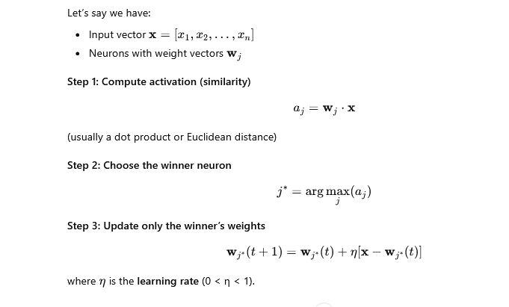

Intuitive Example
Imagine three neurons trying to learn colors:
- Neuron 1 → specializes in red tones
- Neuron 2 → specializes in green tones
- Neuron 3 → specializes in blue tones
When a red color input comes in, Neuron 1 “wins” and updates its weights to become even more like red.
Over time, each neuron becomes responsible for recognizing a region of the color space.

Properties
Feature | Description
Learning type | Unsupervised
Goal | Cluster inputs into groups based on similarity
Update rule | Only winner (or nearby neurons) update weights
Biological analogy | Neurons compete for activation — “winner-takes-all” behavior

Applications
- Clustering and pattern recognition
- Vector quantization (data compression)
- Self-Organizing Maps (SOMs) — an extension of competitive learning where neighboring neurons also learn
- Feature extraction — discovering meaningful internal representations
- Speech and image recognition

Comparison with Other Learning Paradigms
Type of Learning | Data | Goal | Example Algorithm
Supervised | Labeled | Learn mapping X→YX \to YX→Y | Backpropagation
Unsupervised (Competitive) | Unlabeled | Discover patterns / clusters | Competitive Learning, SOM
Reinforcement | Feedback signals | Learn actions to maximize reward | Q-learning
Principal Component Analysis:
Principal Component Analysis (PCA) is a statistical and machine learning technique used for dimensionality reduction, data compression, and feature extraction — while preserving as much variance (information) as possible from the original dataset.

1. Goal of PCA
- High-dimensional datasets often contain redundant or correlated features.
- PCA transforms these features into a smaller set of uncorrelated variables called principal components (PCs).
- Each principal component captures a direction of maximum variance in the data.

2. Mathematical Intuition

Suppose you have a dataset X with n samples and p features.

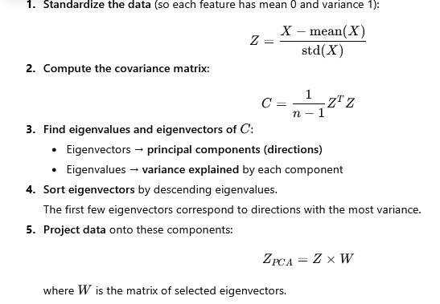

3. Key Outputs
- Principal components (PCs): New features that are linear combinations of original features.
- Explained variance ratio: Proportion of total variance captured by each PC.
- Scree plot: A plot showing how much variance each component explains — used to decide how many PCs to keep.
- Example in Python (using scikit-learn)
from sklearn.decomposition import PCA
from sklearn.preprocessing import StandardScaler
import matplotlib.pyplot as plt

# Assume X is your data matrix
X_scaled = StandardScaler().fit_transform(X)

# Apply PCA
pca = PCA(n_components=2)
X_pca = pca.fit_transform(X_scaled)

# Explained variance
print(pca.explained_variance_ratio_)

# Plot
plt.scatter(X_pca[:, 0], X_pca[:, 1])
plt.xlabel('PC1')
plt.ylabel('PC2')
plt.title('PCA projection')
plt.show()

5. Applications
- Data visualization (e.g., plotting high-dimensional data in 2D or 3D)
- Noise reduction
- Preprocessing before clustering or classification
- Feature extraction in image compression, genomics, finance, etc.
6. Intuition Example
If you have data on height and weight:
- They’re correlated (taller people tend to weigh more).
- PCA finds a new axis (the first PC) capturing most of that variation — roughly corresponding to “body size.”
- The second PC might capture small variations orthogonal to the first (like differences in body composition).
Neural Networks:
1. What Is a Neural Network?
A Neural Network is a computational model inspired by how the human brain works.
It’s made up of layers of interconnected nodes (or neurons) that process data and learn patterns.
Each neuron:
- Takes inputs,
- Applies a weighted sum + bias,
- Passes the result through a nonlinear activation function,
- Sends the output to the next layer.

2. Structure of a Neural Network
A typical feedforward neural network (also called a Multilayer Perceptron, MLP) looks like this:
Input Layer → Hidden Layers → Output Layer

- Input layer
Receives data (e.g., pixel values, features, etc.).

- Hidden layers
Each neuron learns intermediate patterns (features) using weights and biases.

- Output layer
Produces final predictions (e.g., probabilities for classes).

3. The Mathematics
Each neuron computes:
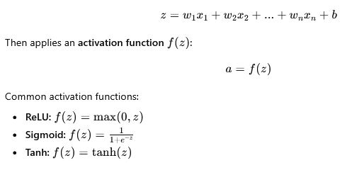

4. Learning Process (Training)
Neural networks learn by adjusting weights to minimize a loss function.
- Forward propagation – compute predictions.
- Loss computation – measure how far predictions are from the truth.
- Backward propagation (Backpropagation) – compute gradients of loss w.r.t. each weight.
- Optimization – update weights using an algorithm like Gradient Descent:
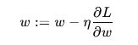
where η = learning rate, and L = loss function.

5. Example (Using Python & Keras)
from tensorflow.keras.models import Sequential
from tensorflow.keras.layers import Dense

# Define model
model = Sequential([
Dense(16, activation='relu', input_shape=(10,)), # 10 input features
Dense(8, activation='relu'),
Dense(1, activation='sigmoid') # Output layer
])
# Compile model
model.compile(optimizer='adam', loss='binary_crossentropy', metrics=['accuracy'])
# Train
model.fit(X_train, y_train, epochs=20, batch_size=32, validation_data=(X_val, y_val))

6. Types of Neural Networks
Type | Description | Common Uses
Feedforward NN (MLP) | Fully connected layers | General classification/regression
Convolutional NN (CNN) | Uses convolution filters | Image, video, spatial data
Recurrent NN (RNN) | Processes sequences | Text, speech, time series
LSTM / GRU | Advanced RNNs with memory | Language modeling, forecasting
Transformer | Attention-based model | NLP, vision (modern state-of-the-art)

7. Key Ideas to Remember
- Neural networks learn features automatically (no manual feature engineering).
- More layers = “deeper” network (hence deep learning).
- Too deep without enough data → risk of overfitting.
- Training is computationally intensive but scales well with GPUs.
Fuzzy Logic: Extracting Fuzzy Model form Data:

1. What Is Fuzzy Logic?
Fuzzy Logic is an extension of classical (binary) logic that allows degrees of truth — values between 0 and 1 — instead of only 0 or 1.
It’s useful for modeling uncertainty, vagueness, and human-like reasoning (e.g., “temperature is warm,” not just hot or cold).
A fuzzy model describes a system using:
- Fuzzy sets (like “Low,” “Medium,” “High”)
- Membership functions (how strongly data belong to each fuzzy set)
- IF–THEN rules that relate inputs to outputs.

2. What Is “Extracting a Fuzzy Model from Data”?
It means learning or building a fuzzy inference system (FIS) automatically from measured data rather than designing it manually by experts.

Goal:
Given input–output data {(x1,y1),(x2,y2),...,(xn,yn)}
find:
- Fuzzy rules (e.g., If temperature is high and humidity is low then fan speed is medium),
- Membership functions (MFs),
- Parameters (centers, spreads, etc.)
that best approximate the data.

3. Main Approaches
There are several standard data-driven fuzzy modeling methods:

A. Grid Partitioning (Mamdani or Sugeno models)
- Divide each input’s domain into fuzzy regions (Low, Medium, High, etc.).
- Combine them to form all possible rule combinations.
- Estimate the consequent (output) parameters by least squares or averaging.
- Simple but can suffer from rule explosion if too many inputs.

B. Clustering-Based Methods
These use data clustering to determine fuzzy rules and membership functions automatically.

👉 Fuzzy C-Means (FCM)
- Groups data into c fuzzy clusters.
- Each cluster represents a fuzzy rule.
- Cluster centers define fuzzy sets; membership grades define rule weights.
Example rule derived from clustering:
IF (x is close to cluster₁ center) THEN (y ≈ cluster₁ output).

👉 Subtractive Clustering
- Finds potential cluster centers based on data density.
- Efficient for large datasets and automatically determines number of rules.

C. ANFIS (Adaptive Neuro-Fuzzy Inference System)
- A hybrid system combining neural networks and fuzzy logic.
- Learns fuzzy rules and membership function parameters using backpropagation + least squares.
- Typically based on a Sugeno-type fuzzy model.
Structure:
- Layer 1: Fuzzification
- Layer 2: Rule firing strength
- Layer 3: Normalization
- Layer 4: Consequent (linear output)
- Layer 5: Aggregation (sum of outputs)

🔢 4. General Steps for Fuzzy Model Extraction
Step | Description
1. Data Collection | Gather representative input–output samples.
2. Data Preprocessing | Normalize data, handle missing values, etc.
3. Fuzzification / Clustering | Use fuzzy c-means or subtractive clustering to find fuzzy sets and rules.
4. Rule Generation | Translate clusters into fuzzy IF–THEN rules.
5. Parameter Estimation | Optimize membership function parameters and consequent parameters.
6. Validation | Test model accuracy using unseen data.

5. Evaluation Metrics
To validate the fuzzy model, you can use:
- Root Mean Square Error (RMSE)
- Mean Absolute Error (MAE)
- Coefficient of Determination (R²)
- Interpretability (simplicity and linguistic clarity of rules)

6. Advantages of Fuzzy Data-Driven Models
Can model nonlinear systems
Handles uncertainty and vague data
Produces interpretable models (human-readable rules)
Works well with small or noisy datasets

Example Fuzzy Rule Extraction (Conceptually)
Given data like:
Temp (°C) | Humidity (%) | Fan Speed
20 | 40 | 30
25 | 50 | 45
30 | 60 | 60
You might derive fuzzy rules such as:
- IF Temp is Low AND Humidity is Low, THEN Fan Speed is Low
- IF Temp is Medium AND Humidity is Medium, THEN Fan Speed is Medium
- IF Temp is High AND Humidity is High, THEN Fan Speed is High
Fuzzy Decision Tree:

1. What Is a Fuzzy Decision Tree?
A Fuzzy Decision Tree is an extension of the traditional Crisp Decision Tree (like ID3, C4.5, CART) where:
- Attributes and data values are represented using fuzzy sets instead of sharp thresholds.
- Decisions (like “IF Temperature > 25°C”) become fuzzy rules (like “IF Temperature is High”).
- Each data sample can partially belong to multiple nodes or classes with degrees of membership (values between 0 and 1).
This allows FDTs to reason with vague or noisy data, much like humans do.

2. Basic Idea
In a traditional decision tree, we split the data at each node using a crisp condition:
IF temperature ≥ 25 THEN go right ELSE go left
In a fuzzy decision tree, we use fuzzy sets:
IF temperature is Medium THEN go to fuzzy node 1
IF temperature is High THEN go to fuzzy node 2
Each sample partially follows both branches, depending on its membership degree in each fuzzy set.

3. Structure of a Fuzzy Decision Tree
Like a standard decision tree, an FDT has:
- Root node: represents the full dataset
- Internal nodes: fuzzy tests on attributes
- Edges: fuzzy linguistic terms (e.g., Low, Medium, High)
- Leaves: fuzzy class labels or crisp class assignments

4. Fuzzy Decision Tree Algorithm (General Steps)

Step 1. Fuzzification
Convert input attributes into fuzzy sets using membership functions.
Example: for attribute Temperature (°C)
- Low: μLow(x)
- Medium: μMedium(x)
- High: μHigh(x)

Step 2. Fuzzy Partitioning
Each instance contributes partially to multiple fuzzy subsets of an attribute.
Example:
Temp | μLow | μMed | μHigh
20°C | 0.8 | 0.2 | 0.0
30°C | 0.0 | 0.4 | 0.6

Step 3. Fuzzy Entropy or Information Gain
At each node, choose the best attribute to split using fuzzy information measures, such as:
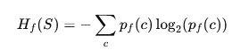
where pf(c)p_f(c)pf​(c) is the fuzzy probability of class ccc (computed with membership weights).
Choose the attribute with the maximum fuzzy information gain.

Step 4. Recursive Tree Growth
- For each fuzzy subset (like “Temperature is High”), create a new node.
- Continue partitioning recursively until:
  - Fuzzy entropy is low, or
  - Minimum number of samples per node is reached.

Step 5. Defuzzification (if needed)
At prediction time, a new sample travels down multiple fuzzy paths.
Each leaf provides a fuzzy class degree — combine and defuzzify (e.g., weighted average or max membership) to produce a final output.

5. Example of a Fuzzy Decision Rule
Traditional:
IF Temperature > 30°C AND Humidity < 40% THEN Class = “Play = No”
Fuzzy:
IF Temperature is High (μ = 0.7) AND Humidity is Low (μ = 0.5)
THEN Class = “Play = No” with confidence 0.7 × 0.5 = 0.35

6. Example Workflow (Conceptual)
Given dataset:
Temp (°C) | Humidity (%) | Play
20 | 80 | No
25 | 60 | Yes
30 | 40 | Yes
35 | 30 | No
- Define fuzzy sets for Temp and Humidity (Low, Medium, High).
- Compute membership degrees for each instance.
- Calculate fuzzy entropy for each possible split.
- Grow tree based on fuzzy information gain.
- Obtain fuzzy rules at leaves:
  - IF Temp is Medium AND Humidity is High THEN Play = Yes
  - IF Temp is High AND Humidity is Low THEN Play = No

7. Advantages of FDTs
Handle uncertainty and vagueness naturally
Produce interpretable “IF–THEN” rules
Can outperform crisp trees on noisy or continuous data
Good for small datasets

8. Challenges
Defining appropriate membership functions
Higher computational complexity (because of fuzzy calculations)
May require parameter tuning or hybrid optimization (e.g., genetic algorithms, ANFIS)
Stochastic Search Methods:

1. What Are Stochastic Search Methods?
A stochastic search method is an optimization approach that uses randomness (stochasticity) to explore a search space and find near-optimal solutions to a problem.
Unlike deterministic algorithms (which follow a fixed path), stochastic methods incorporate randomness in:
- Initialization (starting points),
- Solution updates,
- Selection and mutation.
They are especially useful when:
- The search space is complex, nonlinear, or multi-modal (many local minima),
- The objective function is non-differentiable or unknown.

2. Key Features
Characteristic | Description
Randomness | Used to explore the search space globally
Population-based or single-point | Can evolve one or many solutions
Heuristic / Metaheuristic | Does not guarantee a global optimum, but often finds very good ones
Domain-independent | Works for many problem types

3. General Procedure
The typical stochastic optimization process:
- Initialize: Generate one or more random candidate solutions.
- Evaluate: Compute a fitness or objective value for each candidate.
- Update: Modify candidates randomly (with some intelligent bias toward better ones).
- Select: Keep the best solutions.
- Repeat until stopping criteria are met (e.g., max iterations or convergence).

4. Major Stochastic Search Algorithms
Here’s an overview of the main types.

A. Random Search
- Simplest stochastic method.
- Randomly sample solutions across the search space.
- Keep track of the best one found so far.
Useful when the objective function is black-box or very noisy.

B. Simulated Annealing (SA)
- Inspired by the annealing process in metallurgy.
- Explores solutions randomly but accepts worse ones with some probability to escape local minima.
Acceptance probability:
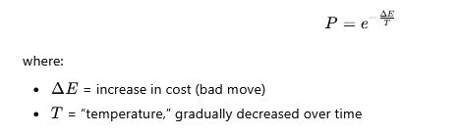
Strength: Good at escaping local minima
Weakness: Requires careful tuning of cooling schedule

C. Genetic Algorithms (GA)
- Based on biological evolution (selection, crossover, mutation).
- Maintains a population of candidate solutions.
- Uses a fitness function to evaluate each.
Process:
- Select best individuals (selection)
- Combine them (crossover)
- Randomly alter genes (mutation)
- Repeat evolution
Strength: Great for combinatorial or discrete optimization
Weakness: Can be slow; may need large populations

D. Particle Swarm Optimization (PSO)
- Inspired by flocking birds or schooling fish.
- Each particle moves through the search space, influenced by:
  - Its own best-known position,
  - The group’s global best.
Velocity update:
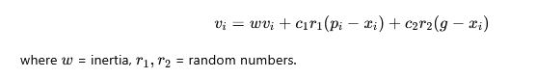
Strength: Fast convergence on smooth problems
Weakness: May get trapped in local minima

E. Ant Colony Optimization (ACO)
- Simulates the pheromone trail behavior of ants.
- Paths with better results get stronger pheromone trails, attracting more ants (solutions).
- Useful for pathfinding and combinatorial problems (like TSP).

F. Evolution Strategies (ES) and Differential Evolution (DE)
- ES: Similar to GA but focuses on continuous variables and adaptive mutation rates.
- DE: Uses vector differences between population members to explore space.
Strength: Very effective for continuous optimization
Common in engineering and control design

5. When to Use Stochastic Search
Scenario | Why Use It
Objective function is noisy or unknown | Deterministic methods fail
Many local minima | Stochastic jumps can escape traps
Gradient unavailable | Works without derivatives
Complex or discrete space | Handles categorical variables easily

7. Comparison Summary
Algorithm | Type | Best for | Key Feature
Random Search | Single-point | Any | Pure randomness
Simulated Annealing | Single-point | Continuous | Probabilistic hill-climbing
Genetic Algorithm | Population | Discrete/Complex | Evolution-inspired
Particle Swarm Optimization | Population | Continuous | Velocity updates
Ant Colony Optimization | Population | Graphs/paths | Pheromone-based learning
Differential Evolution | Population | Continuous | Vector-difference mutation

8. Applications
- Machine learning hyperparameter tuning
- Neural network weight optimization
- Scheduling and logistics
- Engineering design (e.g., control systems, circuits)
- Game AI and robotics
- Financial modeling and portfolio optimization

9. Advantages and Limitations

Advantages:
- Global exploration (can escape local minima)
- Gradient-free (no derivatives needed)
- Flexible and domain-independent
- Easy to parallelize

Limitations:
- Computationally expensive
- Requires parameter tuning
- No formal guarantee of finding the global optimum

In summary
Stochastic Search Methods use randomized exploration to find good (often near-optimal) solutions for complex problems where deterministic methods struggle.
They balance exploration (searching new areas) and exploitation (refining good solutions) — the hallmark of intelligent search.

