ANNEXURE-II: PRODUCT INFORMATION SHEET
(To be submitted separately in respect of each product applied for)
S. No. | Particulars | Details to be furnished by the Applicant
1 | Name of the product | ReMeDi® IoT
2 | Brand name and generic / technical name of the product | Brand: ReMeDi® IoT (Neurosynaptic Communications Pvt. Ltd.)  Generic: IoT-enabled point-of-care diagnostics and teleconsultation integration platform
3 | Category (medicine / consumable / equipment / device / diagnostic kit / software or system / other) | Software
4 | Detailed product description | ReMeDi IoT connects ReMeDi point-of-care medical devices (ECG, spirometer, digital stethoscope, dermatoscope, otoscope, BP, SpO₂, temperature) to State HMIS/HIS/EMR and third-party teleconsultation platforms through the ReMeDi Cloud.  ReMeDi IoT and ReMeDi e-Sanjeevani are separate products that use the same app user interface for the health worker. The only difference is in how ReMeDi Cloud handles the calls: e-Sanjeevani requests are processed by the e-Sanjeevani handler, while ReMeDi IoT requests from State or third-party systems are processed by the IoT handler.  Proven example – e-Sanjeevani: the CHO/Doctor selects ReMeDi under Clinical Examination and initiates tests; the request appears in the ReMeDi app on the health worker's Android tablet; tests are performed with the connected devices and results return to e-Sanjeevani automatically. Integration completion confirmed by C-DAC (Feb 2025). ReMeDi IoT offers the same flow to any integrating system.  High-level architecture (enlarged view in Enclosure A, last page):  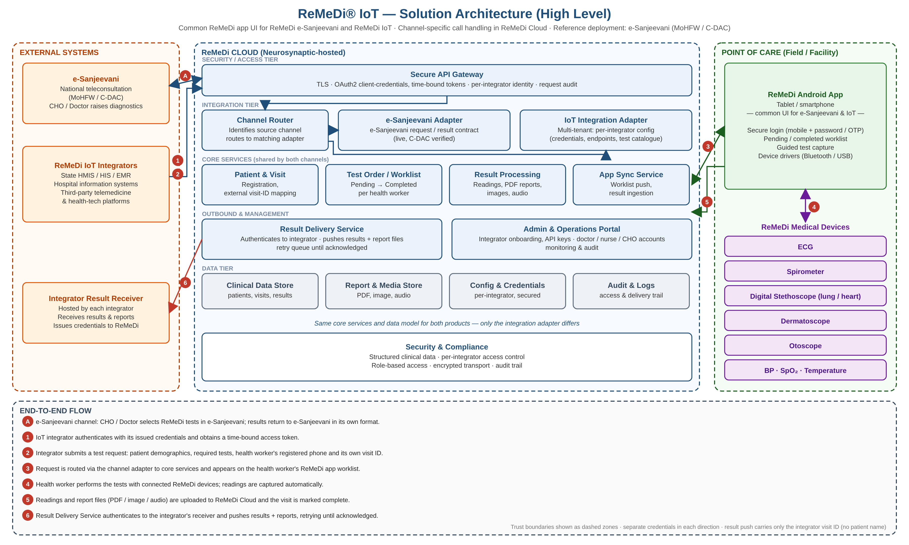
5 | Intended use and clinical indication
6 | Clinical or technical justification, and necessity for introduction
7 | Innovation and uniqueness of the product
8 | Technical specifications (detailed sheet to be enclosed)
9 | Regulatory approvals and certifications (e.g. FDA / CEA/ USFDA etc. as per applicable for the product) held, with number and validity
10 | Risk classification under the Medical Devices Rules, 2017, where applicable
11 | Shelf life and storage conditions, where applicable
12 | Specificity and sensitivity data, for diagnostic and screening products
13 | Clinical validation, clinical trials and research publications (copies to be enclosed)
14 | Existing alternatives available in Public Health Institutions, and comparative analysis with the offered product
15 | Compatibility with existing equipment, consumables and systems | Same app UI as the live ReMeDi e-Sanjeevani integration (C-DAC). Open, API-key based integration for State HMIS/HIS/EMR and third-party platforms. Works with existing ReMeDi devices (no hardware change) over Bluetooth/USB on Android tablets/phones.
16 | Infrastructure required for installation and use (space, power, water, gases, network etc.) | Android tablet/phone, internet connectivity (mobile data/Wi-Fi), standard power for device charging. No additional server infrastructure at the facility – hosted on ReMeDi Cloud.
17 | Manpower required, and training to be provided by the Applicant
18 | Warranty period, and terms of CMC / AMC after the warranty period
19 | Service response time and availability of spares and consumables, with the period of assured availability
20 | Recurring cost of consumables, reagents and spares per test or per use, where applicable
21 | Indicative unit cost (exclusive of taxes) and applicable rate of GST, with HSN code
22 | Indicative annual quantity proposed, and budgetary implication
23 | Whether the product is offered on the Government e-Marketplace (GeM); if so, the product listing details
24 | Whether the product is included in the drug, consumable or equipment list of any other State or Central Government institution; if so, details
25 | Details of the pilot implementation, if any, offered by the Applicant
26 | Patent Certificate/ Proprietary Certificate of the product
Signature and stamp of the Authorised Signatory: ______________________
Note: A separate annexure to be provided for each product.

Enclosure A – ReMeDi® IoT Solution Architecture (High Level)

