ReMeDi® e-Sanjeevani
Technical Specification Document
Point-of-care diagnostics integrated with the national e-Sanjeevani teleconsultation platform (MoHFW / C-DAC)
Neurosynaptic Communications Pvt. Ltd.
Version 1.0 · October 2026 · Confidential

Document Control
Item | Details
Document | ReMeDi e-Sanjeevani – Technical Specification
Version | 1.0
Date | 29 October 2026
Prepared by | Saket Barmate, Engineering Manager
Reviewed / Approved by | Sameer, Neurosynaptic Communications Pvt. Ltd.
Organisation | Neurosynaptic Communications Pvt. Ltd.
Classification | Confidential – for official evaluation

1. Introduction

1.1 Purpose
This document describes the technical specification of the ReMeDi e-Sanjeevani solution: its architecture, workflow, mobile application, connected medical devices, integration with the e-Sanjeevani platform, security, and validation status. It is intended for review by programme officials and technical evaluators.

1.2 Product Overview
ReMeDi e-Sanjeevani enables a Community Health Officer (CHO) or Doctor using the e-Sanjeevani teleconsultation platform to request point-of-care diagnostic tests for a patient. The request is delivered to the ReMeDi e-Sanjeevani Android application used by the health worker, who performs the tests using ReMeDi medical devices. Results, reports and recordings are returned automatically to e-Sanjeevani and are available to the clinician within the patient's case.

1.3 Key Highlights
- Live integration with e-Sanjeevani; completion of integration confirmed by C-DAC (February 2025).
- 27 diagnostic parameters across physiology, fetal care, blood chemistry and rapid / urine tests.
- Diagnostic request initiated directly from the e-Sanjeevani Clinical Examination section – no separate portal needed by the clinician.
- Results, PDF reports (ECG, spirometry, imaging) and stethoscope audio returned automatically to e-Sanjeevani.
- Android application distributed through the Google Play Store; validated on Android 12, 13 and 14 tablets and smartphones.
- Validation testing completed and documented, with a requirement traceability matrix.

2. System Architecture
The solution has four layers: the e-Sanjeevani platform, ReMeDi Cloud, the ReMeDi e-Sanjeevani Android application at the point of care, and the ReMeDi medical devices.
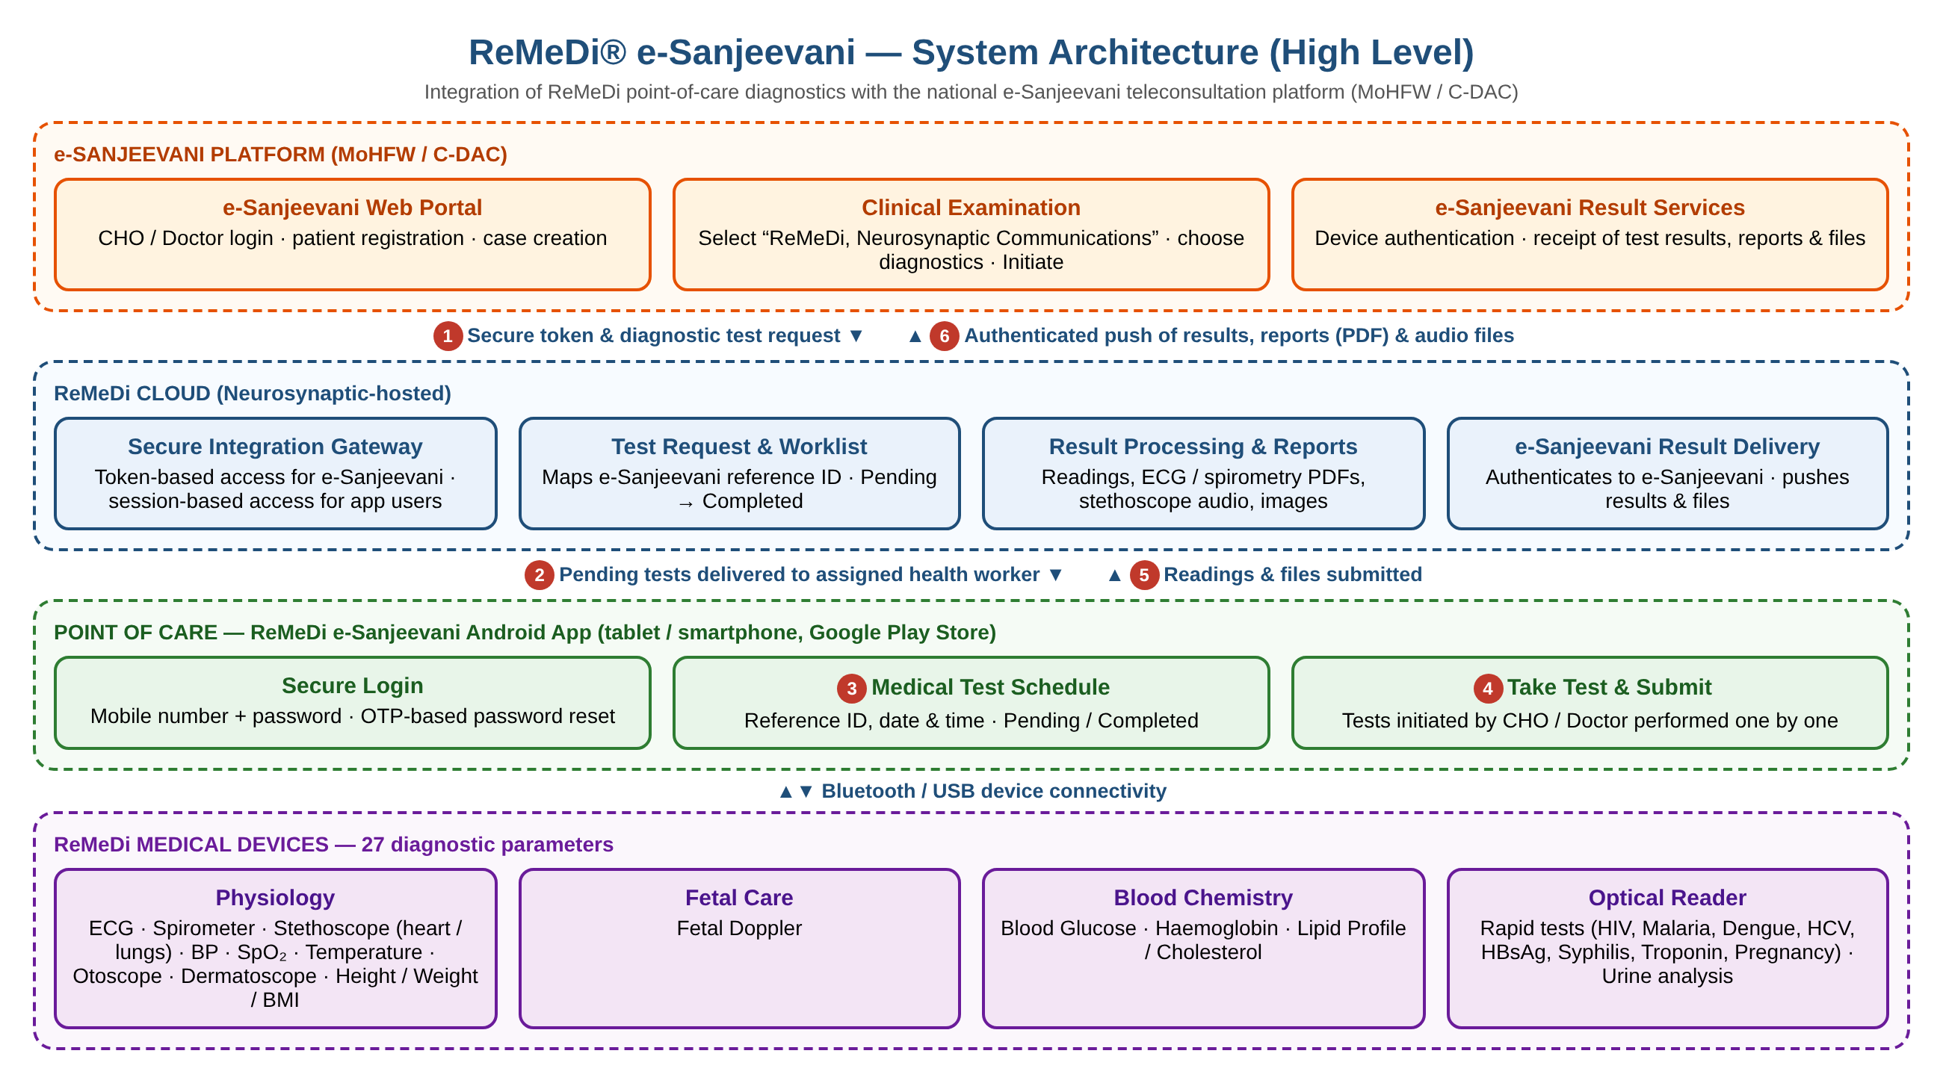
Figure 1 – ReMeDi e-Sanjeevani high-level architecture

2.1 Architecture Components
Layer | Component | Function
e-Sanjeevani (MoHFW / C-DAC) | Web portal & Clinical Examination | CHO / Doctor registers the patient, creates a case and initiates ReMeDi diagnostics.
e-Sanjeevani (MoHFW / C-DAC) | Result services | Authenticates ReMeDi and receives test results, reports and files.
ReMeDi Cloud | Secure integration gateway | Token-based access for e-Sanjeevani; session-based access for app users.
ReMeDi Cloud | Test request & worklist | Records each request against the e-Sanjeevani reference ID and tracks it from Pending to Completed.
ReMeDi Cloud | Result processing & reports | Stores readings and generates / stores ECG and spirometry PDFs, images and audio.
ReMeDi Cloud | Result delivery | Authenticates to e-Sanjeevani and pushes results and files to the patient case.
Point of care | ReMeDi e-Sanjeevani Android app | Health worker login, medical test schedule, guided test capture and submission.
Point of care | ReMeDi medical devices | Capture of physiological and laboratory parameters over Bluetooth / USB.

2.2 End-to-End Data Flow
Step | Description
1 | CHO / Doctor initiates diagnostics in e-Sanjeevani; the request (patient details, tests, health worker's phone number and reference ID) is sent securely to ReMeDi Cloud.
2 | ReMeDi Cloud adds the request to the assigned health worker's pending list.
3 | The health worker sees the request in the Medical Test Schedule (reference ID, date and time).
4 | The health worker selects "Take Test" and performs each requested test with the connected ReMeDi devices.
5 | Readings and files are submitted to ReMeDi Cloud and the request is marked Completed.
6 | ReMeDi Cloud authenticates to e-Sanjeevani and delivers the results, PDF reports and audio files to the patient case.

3. Functional Workflow

3.1 e-Sanjeevani Portal (CHO / Doctor)
- Open the e-Sanjeevani web application and log in as CHO / Doctor.
- Register a new patient (Add Patient) or select a registered patient.
- Expand the patient actions and select Create Case.
- Enter chief complaints, patient history and clinical examination details.
- In Clinical Examination, select "ReMeDi, Neurosynaptic Communications Pvt Ltd".
- Select the required diagnostics and click Initiate to send the request to the health worker.

3.2 ReMeDi e-Sanjeevani App (Health Worker)
- Install the ReMeDi e-Sanjeevani application from the Google Play Store.
- Log in with the registered mobile number and password (OTP-based Forgot Password available).
- View the Medical Test Schedule: patient reference ID with date and time of initiation; use Refresh to update.
- Verify the reference ID and select Take Test; the parameters requested by the CHO / Doctor are displayed.
- Complete each test individually and select Submit to send results back to e-Sanjeevani.
- Completed requests move to the Completed list, where results can be viewed.

4. Mobile Application Specification
Attribute | Specification
Application | ReMeDi e-Sanjeevani (Android)
Version validated | 4.1.3 (build 13)
Operating system | Android 12, 13 and 14
Device form factor | Android tablet or smartphone
Validated devices | Samsung Galaxy S21 FE, Galaxy S23, Galaxy Tab A7, Tab A8, Tab A9
Hardware (validated configuration) | 8 GB / 16 GB RAM, Snapdragon processor
Network | 4G LTE / 5G / Wi-Fi
Device connectivity | Bluetooth / USB to ReMeDi medical devices
Distribution | Google Play Store
User roles | Health worker (Nurse / CHO operator); requests are initiated by CHO / Doctor in e-Sanjeevani
Core functions | Login, OTP-based password reset, pending / completed test lists, guided test capture, result submission, result and report viewing

5. Medical Devices and Diagnostic Parameters
The ReMeDi kit devices fall into four groups:
Group | Devices / Tests
Physiology | Temperature, Pulse Oximeter (SpO₂ / pulse rate), Blood Pressure (sphygmomanometer), ECG, Stethoscope (heart and lungs), Spirometer, Otoscope, Dermatoscope, Height, Weight, BMI, Heart Rate
Fetal Care | Fetal Doppler
Blood Chemistry | Blood Glucose, Haemoglobin, Lipid Profile / Cholesterol
Optical Reader (Rapid & Urine) | Rapid tests: Pregnancy, HIV, Malaria, Dengue, Syphilis, Troponin, Hepatitis C (HCV), Hepatitis B (HBsAg); Urine test: 10 urine parameters

5.1 Parameters Available through e-Sanjeevani
# | Physiology Tests & Scope | Blood & Urine Chemistry Tests
1 | Fetal Doppler | Cholesterol
2 | Spirometer | Blood Glucose
3 | Temperature | Dengue
4 | Heart Rate | HCV
5 | Otoscope | Hepatitis B
6 | Stethoscope – Heart | Malaria
7 | Blood Pressure (Sys/Dia) | Hepatitis C
8 | Dermascope | Troponin
9 | Height | HIV
10 | Pregnancy | Urine Checkup
11 | Stethoscope – Lungs | Hemoglobin
12 | BMI | Lipid Profile
13 | ECG | Pulse Oximeter (SpO₂/Pulse Rate)
14 | Weight | Syphilis

Detailed device specifications are provided in the enclosed "Technical Specifications – ReMeDi Devices" document.

5.2 Result Formats
Test type | Data returned to e-Sanjeevani
Vitals and numeric tests (BP, SpO₂, temperature, glucose, etc.) | Structured readings with units
ECG, Spirometer | Structured readings and PDF report
Dermatoscope, Otoscope | PDF report with captured images
Stethoscope (heart / lungs) | Audio recording (WAV)

6. Integration Specification
ReMeDi Cloud and e-Sanjeevani communicate through secure, authenticated web service interfaces in both directions. Each request is identified by the e-Sanjeevani reference ID so that results are always associated with the correct patient case.
Interface | Direction | Purpose | Security
Access token | e-Sanjeevani → ReMeDi | Authenticates e-Sanjeevani before requests are sent | Client credentials; time-bound bearer token
Test request | e-Sanjeevani → ReMeDi | Sends patient details, requested tests and the health worker's phone number | Bearer token
Health worker app services | App ↔ ReMeDi | Login, OTP verification, pending / completed lists, result submission, report retrieval | Authenticated user session
Device token | ReMeDi → e-Sanjeevani | Authenticates ReMeDi before results are delivered | Credentials issued by e-Sanjeevani
Result & file delivery | ReMeDi → e-Sanjeevani | Delivers test results, PDF reports and audio files to the case | Device token

Detailed API documentation is available on request.

7. Security and Data Protection
- Role-based access control: only authorised CHOs / Doctors initiate tests and only registered health workers perform them.
- Mutual authentication: separate credentials are used for e-Sanjeevani → ReMeDi and ReMeDi → e-Sanjeevani calls.
- Time-bound access tokens and authenticated user sessions on the mobile application.
- OTP verification on the registered mobile number for password reset.
- Patient results are linked to the e-Sanjeevani reference ID, so results go only to the originating case.
- Encrypted data transmission between all components.
- Periodic data backup and restore, verified during validation testing.

8. Non-Functional Specification
Attribute | Specification
Performance | Application response time verified under normal and high load (RTM TC-701)
Scalability | Cloud-hosted backend designed to scale with growing numbers of users, facilities and devices
Availability | Target 99.9% uptime with failover mechanisms
Data management | Periodic backup and restore of patient records (RTM TC-901)
Usability | Guided, step-by-step test capture designed for frontline health workers
Connectivity | Operates over 4G LTE, 5G or Wi-Fi

9. Validation and Testing
Item | Details
Integration status | Integration with e-Sanjeevani completed; confirmed by C-DAC (February 2025)
Test report | ReMeDi-eSanjeevani Test Report, prepared for COEP (College of Engineering Pune), 07 March 2025
Testing period | 3 June 2024 to 26 August 2024
Test cases | 86 test cases executed; testing reported 100% complete
Test types | Functional, integration, security, performance and UI/UX testing – all passed
Diagnostic parameters tested | All 27 parameters listed in Section 5.1 – passed
Traceability | Requirement Traceability Matrix maps authentication, device connectivity, security (RBAC), performance and data management requirements to passed test cases

9.1 Requirement Traceability Summary
Req. ID | Requirement | Test Case | Status
FR-001 | User login | TC-101 | Pass
FR-002 | Forgot password recovery | TC-102 | Pass
FR-005 | Medical device integration (BP, ECG, glucose) | TC-401 | Pass
FR-007 | Role-based access control | TC-601 | Pass
FR-008 | Application response time | TC-701 | Pass
FR-010 | Data storage & backup | TC-901 | Pass

10. Deployment and Operating Requirements
- Android tablet or smartphone (Android 12 or above) with the ReMeDi e-Sanjeevani app installed from the Google Play Store.
- ReMeDi medical device kit for the tests to be offered at the facility.
- Internet connectivity (4G / 5G / Wi-Fi) at the point of care.
- Health worker accounts registered against their mobile numbers.
- Active e-Sanjeevani CHO / Doctor accounts to initiate diagnostics.
- No additional server infrastructure is required at the facility; the backend is hosted on ReMeDi Cloud.

11. Enclosures
# | Document
A | Technical Specifications – ReMeDi Devices
B | ReMeDi e-Sanjeevani Workflow and Block Diagram
C | C-DAC email confirming completion of integration (07 February 2025)
D | ReMeDi-eSanjeevani Test Report (07 March 2025)
E | Requirement Traceability Matrix – e-Sanjeevani
F | ReMeDi e-Sanjeevani operations video (link)

