E-Commerce Profitability & Marketing ROI Analysis

Summary
Objective: To analyze e-commerce order profitability, channel performance, return rates, and marketing efficiency to identify actionable cost-saving measures and revenue-optimizing opportunities.
Key Findings & Recommendations:
- Marketing Budget Optimization: To achieve a 20% budget reduction without sacrificing proportional revenue, immediately pause Email Marketing (which accounts for nearly 5% of spend but under 1.5% of revenue) and scale back Facebook Ads. Seasonally, marketing budgets should be throttled during July, August, and November, which demonstrate the lowest Return on Ad Spend (ROAS) of the year.
- Channel Profitability & Fee Mitigation: Third-party platform fees are eating margins. Marketplace and Social Commerce carry average platform fees of 18.97 USD and 9.87 USD per order, restricting average profit to 15.39 USD and 17.10 USD, respectively. Direct marketing efforts toward the Mobile App and Website, which carry 0 USD in platform fees and yield over double the profit per order (36.32 USD and 31.59 USD).
- Targeted Quality Control for High-Return Categories: Electronics (8.61% return rate), Books (8.36%), and Clothing (8.19%) are driving the highest volume of returns, representing significant revenue leakage. Implement stricter sizing guides for clothing, enhanced QA for electronics, and re-evaluate Social Commerce, which has a disproportionately high channel return rate of 9.13%.

Methodology & Data Preparation
This analysis relies on three primary operational datasets: Marketing Spend, Orders, and Products. Before extracting insights, the raw data underwent rigorous validation to ensure structural integrity and financial accuracy.
Calculated order totals (combining base product cost, shipping cost, platform fees, and transaction fees) were programmatically verified against the recorded total costs to prevent margin miscalculation. Duplicate records were identified and isolated. To facilitate downstream analysis, raw temporal strings were parsed into functional datetime objects, and custom aggregate metrics—including Return on Ad Spend (ROAS), Profit Margin Percentage, and Return Rates—were engineered to standardize performance tracking across all product categories and marketing channels.

Core Insights & Analysis
What is the average profit margin by product category? Which are most/least profitable, and why?
Product profitability is highly polarized across the portfolio. Electronics (52.33 USD average profit) and Toys (34.18 USD average profit) deliver the highest absolute margins per order. Conversely, Beauty (15.48 USD average profit) and Books (9.41 USD average profit) severely underperform.
The primary driver of this discrepancy is the shipping cost burden. For low-profit items like Books and Beauty, flat shipping rates represent a massive percentage of the base product cost, eroding margins almost entirely. High-weight or high-bulk items that command lower retail prices are currently unsustainable under the existing fulfillment model.
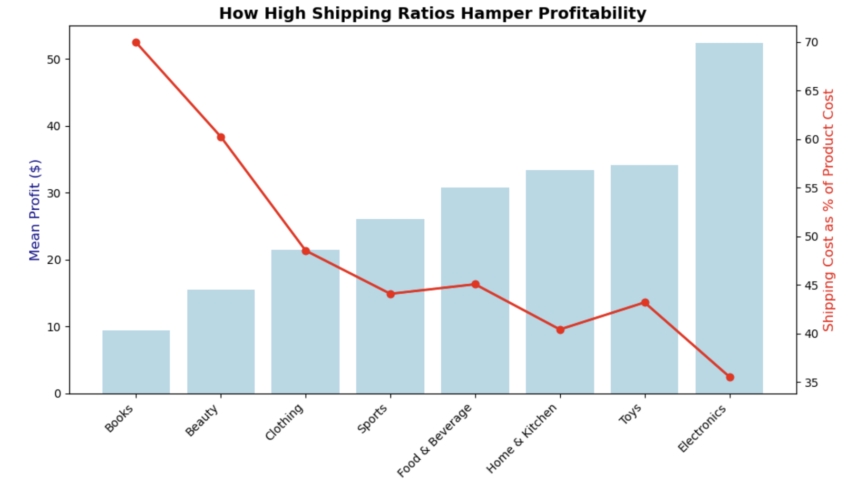How does profitability differ across sales channels?
Sales channels with direct ownership drastically outperform third-party platforms. The Mobile App yields the highest profitability at 36.32 USD per order, followed closely by the Website at 31.59 USD.
Social Commerce (17.10 USD average profit) and Marketplace (15.39 USD average profit) represent the worst-performing channels. This suppression in profitability is entirely driven by third-party platform fees. Owned channels incur zero platform fees, allowing the business to retain the full retail margin, whereas Marketplace orders surrender an average of 18.97 USD per transaction directly to the hosting platform.
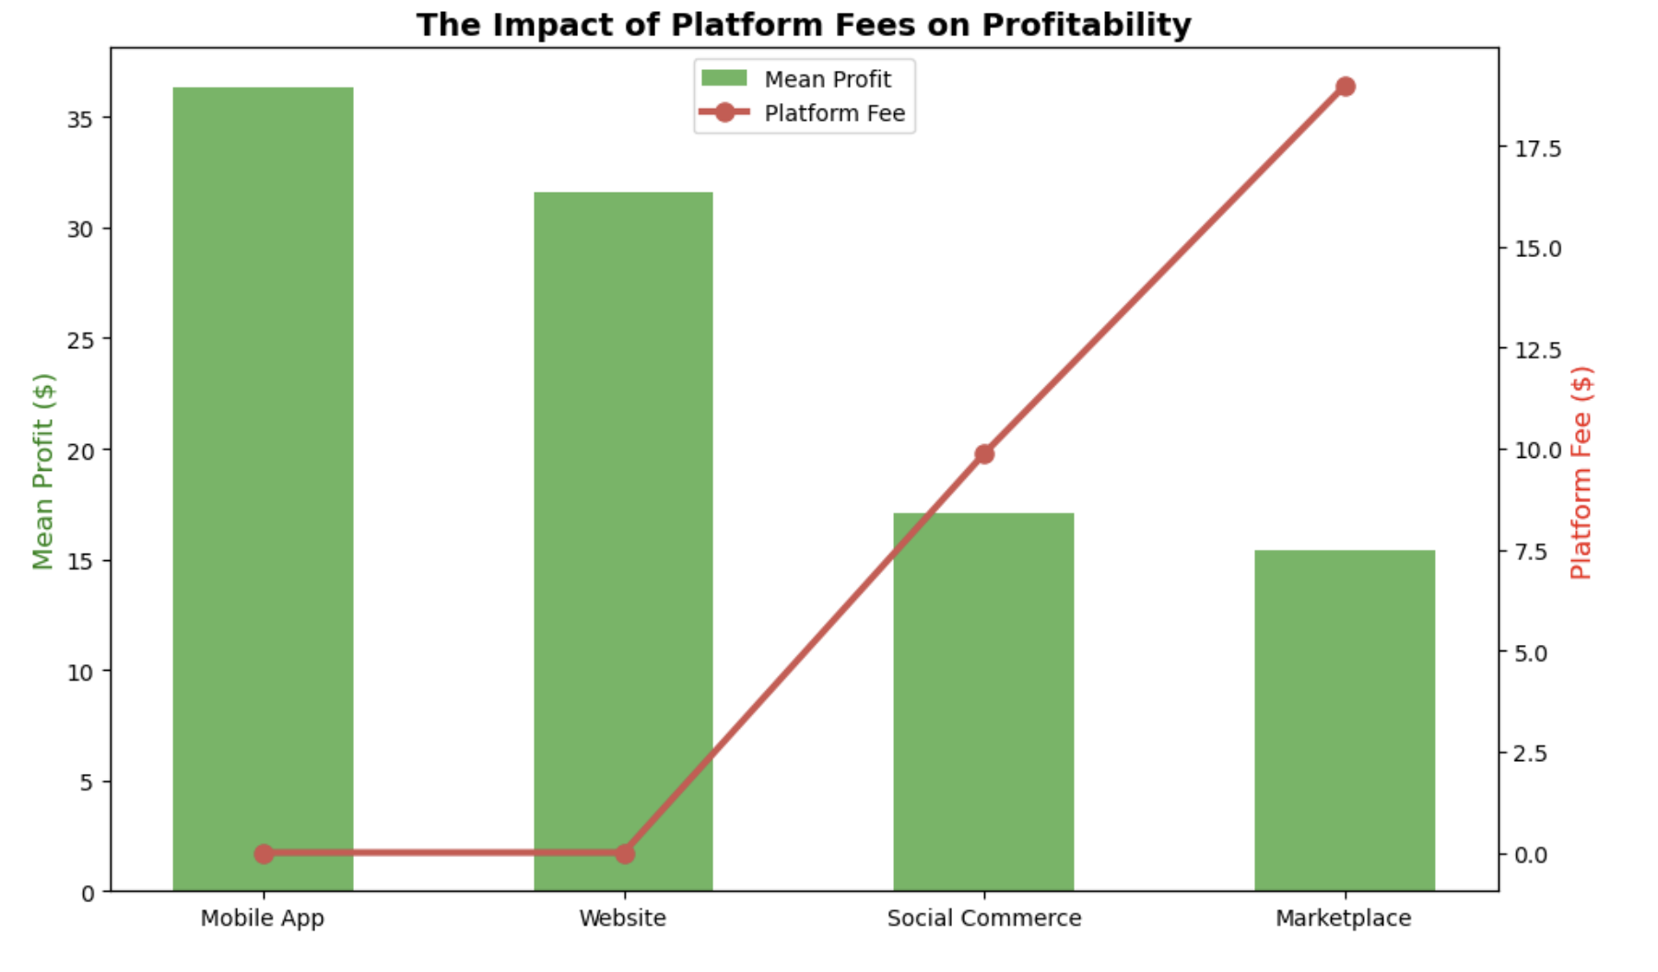3.3. What is the return rate by category and channel?
Returns represent an estimated 18,500 USD in revenue leakage over the analyzed period. The data reveals distinct concentrations of return behavior:
By Product Category:
- Electronics: 8.61%
- Books: 8.36%
- Clothing: 8.19%
- Sports: 7.19%
- Toys: 7.00%
- Home & Kitchen: 6.00%
- Beauty: 5.85%
- Food & Beverage: 5.66%

By Sales Channel:
- Social Commerce: 9.13%
- Mobile App: 7.30%
- Website: 7.04%
- Marketplace: 6.44%

The compounding effect of high return rates in Electronics (a high-margin category) and Social Commerce (a high-fee, low-margin channel) creates an immediate priority for operational intervention.
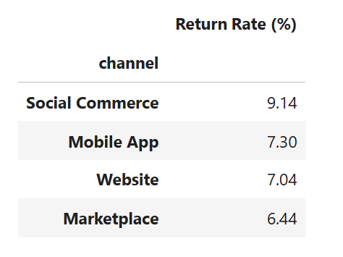
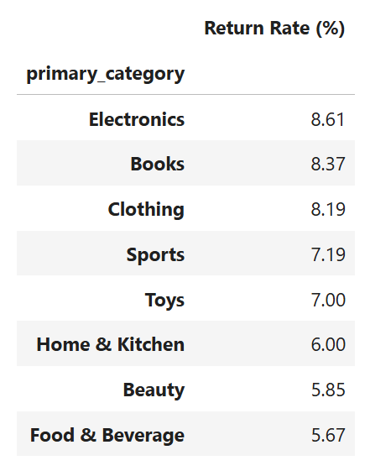

Which advertising platform delivers the best ROAS?
TikTok Ads and Influencer marketing are the premier acquisition channels, generating superior ROAS at 24.43 and 23.44 respectively.
Email Marketing is a severe underperformer. While not strictly negative in raw generated revenue, it yields an unsustainable ROAS of just 5.40 and carries the highest Cost Per Acquisition (CPA) at 26.01 USD. It currently consumes approximately 4.8% of the total marketing budget while generating under 1.5% of the total attributed revenue.
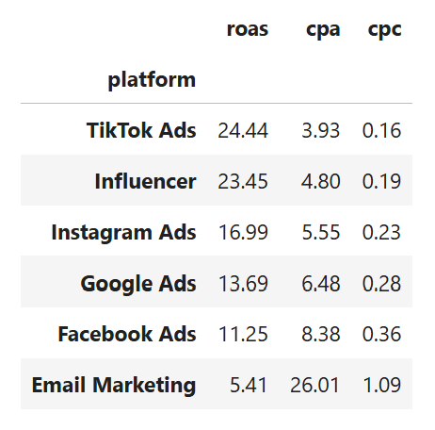

Recommended 20% Marketing Budget Reduction Strategy
To achieve the mandated 20% reduction in marketing expenditure while protecting top-line revenue, reductions must target proven inefficiencies:
Platform-Level Reductions: Eliminate Email Marketing entirely to recapture ~5% of the total budget immediately. Reduce Facebook Ads spend by approximately 15% of the total portfolio budget. Facebook consumes over 21% of the total budget but yields under 15% of the revenue.
Seasonal Reductions: Scale back ad pacing aggressively during July, August, and November. July and August represent a severe mid-summer slump, establishing the lowest ROAS floors of the year (11.06 and 11.52). November posts the highest total spend of the year but delivers a poor ROAS of 13.50, indicating that heavy holiday-season spending is hitting a point of diminishing returns due to saturated auction competition.
