CCAS PRESENTATION
10-Slide Wireframe + UI/UX + PPT Design Blueprint
City Corporation Automation System (CCAS)

Design goal
Create a presentation that feels like a modern public-service product case study — trustworthy, clean, visual and technically credible. The deck should communicate one idea per slide, use diagrams instead of paragraphs, and make the software-engineering artifacts easy to understand.

Prepared from the supplied SRS and Software Engineering Case Study Report, with additional research into public-sector design systems and accessible presentation practice.
Research references: Microsoft PowerPoint accessibility guidance; U.S. Web Design System (USWDS); GOV.UK Design System.

A. Executive Design Direction
Recommended visual direction: “Civic Digital / Smart City” — a restrained government-service aesthetic combined with modern SaaS dashboard styling.
PRODUCTION STANDARD — These wireframes are intentionally designed as professional presentation blueprints, not AI-generated decorative mockups. The final PPT must look spacious, deliberate, grid-aligned and presentation-ready: generous white space, consistent alignment, crisp diagrams, restrained color, clear hierarchy and purposeful visuals. Avoid anything that looks like a sloppy AI image, crowded student PPT, random icon collage, inconsistent fonts, excessive gradients, heavy shadows, unnecessary 3D effects or decorative elements that do not communicate information.
System | Recommendation | Why
Color | Navy #19375F + Blue #2D69AA + Off-white #F6F8FA; Green for success; Orange only for warnings. | Signals trust and civic professionalism while keeping the interface modern.
Typography | Aptos / Aptos Display; 30–34 pt slide titles; 18–22 pt body; 12–14 pt labels. | Keeps the deck readable from the back of a classroom. Microsoft recommends sans-serif fonts and larger text for accessibility. citeturn0search0
Grid | 16:9; 12-column grid; 0.6–0.7 in outer margins; 24–32 px equivalent spacing. | Creates consistency and prevents crowded layouts.
Visual language | Rounded cards, thin borders, simple line icons, flat diagrams, no heavy 3D effects. | Matches modern government/service design systems and keeps technical diagrams legible.
Data visualization | Use 1 chart or 1 process diagram at a time; highlight only the key message. | USWDS recommends simple, familiar visualizations and limiting a visualization to a central theme. citeturn1search0
Accessibility | High contrast, meaningful slide titles, no color-only meaning, alt text for visuals, logical reading order. | Supported by Microsoft, GOV.UK and USWDS accessibility guidance. citeturn0search1turn1search1turn1search3

Core storytelling rule
Do not design the deck as a compressed copy of the report. The report contains detail; the PPT should create a visual story: Problem → Proposed solution → Feasibility → Requirements → Architecture → Modules → Technology/Security → Testing/Management → Conclusion/Future.

B. Global Slide System
- Every slide has one clear message. The title should state the message, not just the topic. Example: “CCAS replaces fragmented manual services with one digital workflow.”
- Keep the top 15% of the slide for title/context and the remaining 85% for one dominant visual composition.
- Use cards only when grouping genuinely different concepts; do not put every bullet inside a card.
- Use diagrams, flows and UI mockups for system concepts. Use short bullets for requirements and risk items.
- Use a consistent footer with project name + slide number, but keep it visually quiet.
- Prefer left alignment for explanatory text. Microsoft specifically recommends sufficient white space and left-aligned paragraphs for readability.
- Use a single accent color per slide. Green/orange are semantic accents, not decorative colors.

SLIDE 1 — City Corporation Automation System
Purpose: Establish identity, credibility and the project context in under 10 seconds.
Content to put on the slide:
- CCAS — City Corporation Automation System
- Subtitle: Software Engineering Case Study / Software Requirements & System Design
- B.Tech CSE (AI & ML), Semester 5, Group 8
- Academic Year 2026–27
- Team names can be placed in a small footer line rather than competing with the title.
Wireframe / spatial blueprint: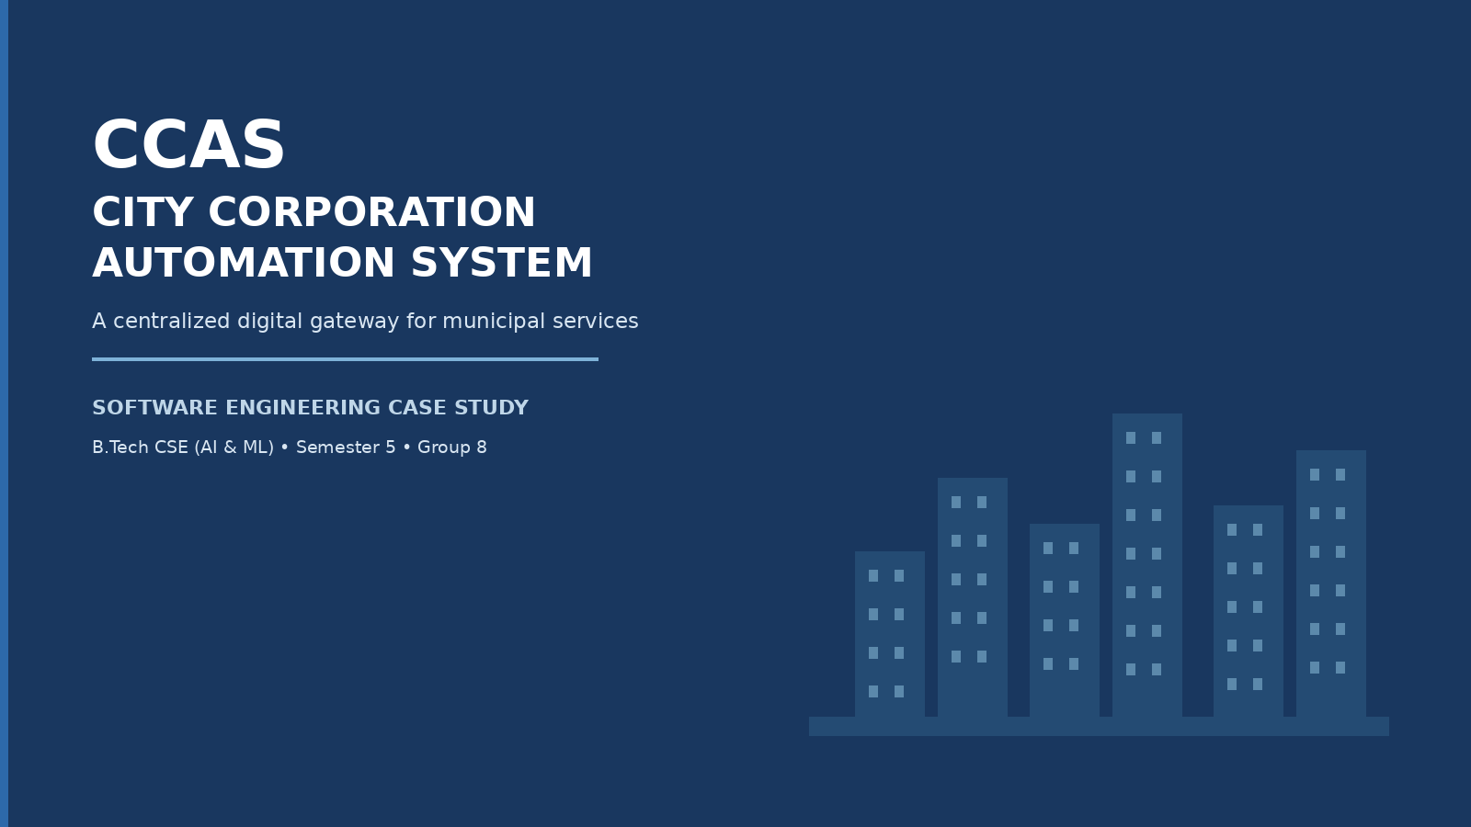
CCAS
CITY CORPORATION
AUTOMATION SYSTEM
One-line descriptor: A centralized digital platform for municipal services
Software Engineering Lab | B.Tech CSE (AI & ML) • Sem 5 • Group 8
Team / university information

How to design it:
- Use a dark navy full-bleed background with one civic/smart-city line illustration on the right.
- Title should occupy about 45% of the slide width; keep the right side visually lighter.
- Use one thin blue accent line or glow, not multiple decorative elements.
- Do not use a generic stock-photo collage.
Visual assets / diagrams:
- Minimal city skyline / municipal building line illustration.
- Optional small icons: certificate, tax, complaint, payment.
- Keep the illustration abstract so the title remains dominant.
Presenter delivery:
Open with the problem domain, not the technology. Say: “CCAS is our proposed centralized platform for bringing major city-corporation services into one digital workflow.”
Avoid
Do not put the entire team list, course outcomes, Bloom level, issue date and submission date on the cover.

SLIDE 2 — The Problem: Municipal Services Are Fragmented
Purpose: Make the audience feel the current pain before introducing the solution.
Content to put on the slide:
- Repeated office visits and queues
- Paper files and duplicated citizen data
- Limited visibility into application/complaint status
- Delayed tax/payment collection
- Manual reporting and weak monitoring
- Bottom takeaway: “Citizens need one place to apply, pay, track and communicate.”
Wireframe / spatial blueprint: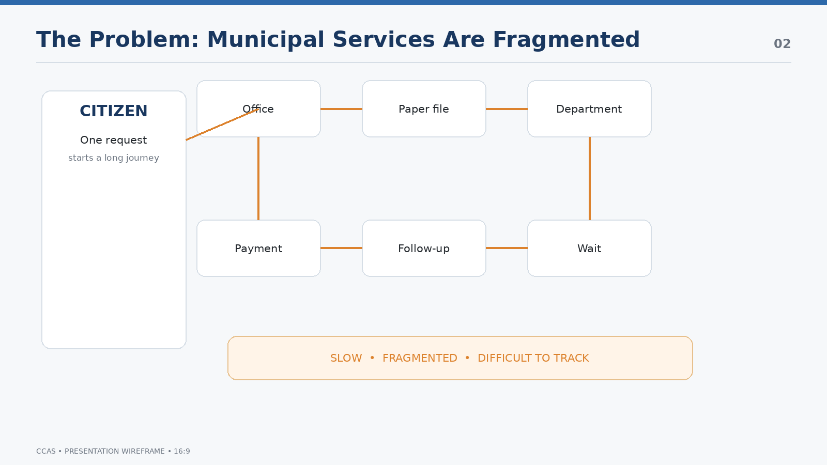
EXISTING EXPERIENCE
Citizen | → | Multiple counters / departments / files
Apply | Verify | Return
Pay | Follow-up | Wait
Outcome: slow • fragmented • difficult to track

How to design it:
- Use a “before” journey rather than a wall of bullet points.
- Show fragmentation visually with 5–6 nodes connected by thin lines.
- Use orange only to highlight friction points.
- Keep the problem statement to one sentence at the bottom.
Visual assets / diagrams:
- Icon journey: office → document → queue → department → payment → complaint.
- A small orange “friction” marker can sit beside repeated visits and status uncertainty.
Presenter delivery:
Explain one citizen journey: “A simple certificate or complaint can require multiple interactions, while the citizen has little visibility into what happens next.”
Avoid
Do not spend time explaining every municipal service here.

SLIDE 3 — The Proposed Solution: One Digital Municipal Gateway
Purpose: Transition from pain to solution and show the value proposition.
Content to put on the slide:
- Centralized web application
- One citizen account for multiple services
- Applications and complaints routed to responsible departments
- Online payment + instant receipt
- Status changes recorded and notified
- Administrative dashboards and reports
Wireframe / spatial blueprint: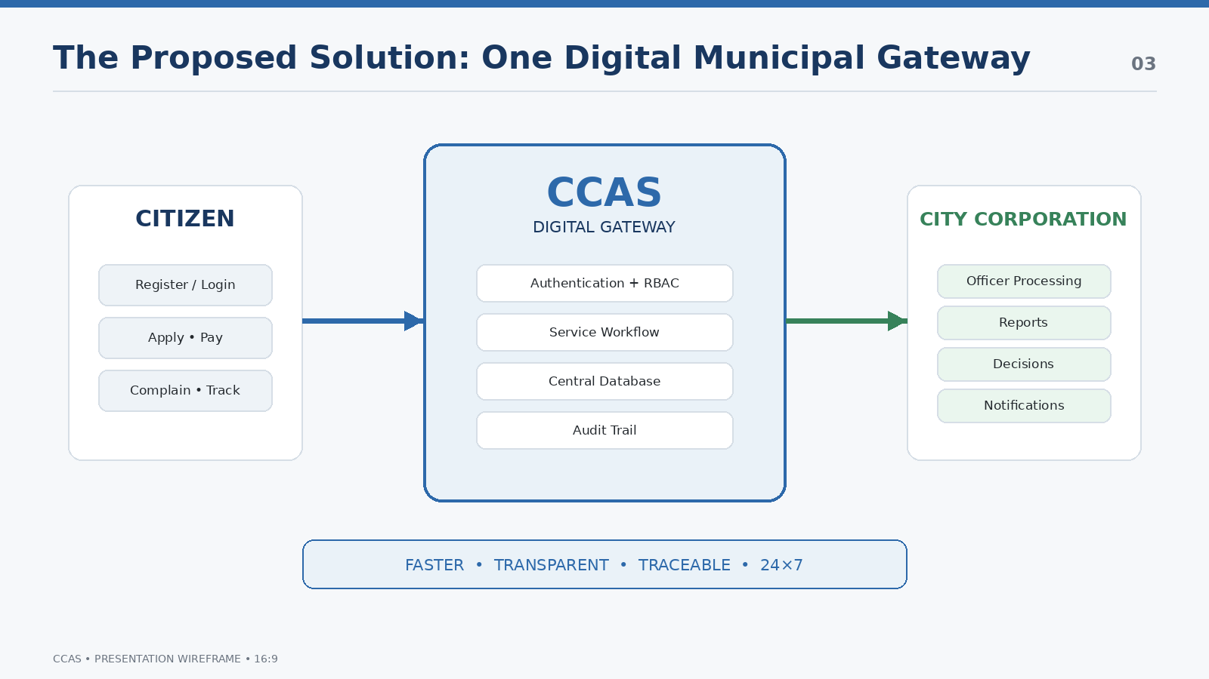
CITIZEN | CCAS DIGITAL GATEWAY | CITY CORPORATION
Register / Login | Authentication + Workflow | Officer / Admin Processing
Apply • Pay • Complain • Track | Central Database + Audit Trail | Reports • Decisions • Resolution
RESULT: faster • transparent • traceable • 24×7

How to design it:
- Make this the strongest “solution” slide: big central CCAS node, users on left, corporation on right.
- Use 4 small outcome chips along the bottom: Faster, Transparent, Traceable, 24×7.
- Use one simple arrow direction: Citizen → CCAS → Department → Notification back to Citizen.
Visual assets / diagrams:
- Central portal / gateway illustration.
- Four icon chips: certificate, payment, complaint, tracking.
Presenter delivery:
Say: “The key design decision is centralization: the citizen should not need to understand the corporation’s internal department structure.”
Avoid
Do not show implementation technologies yet; that comes later.

SLIDE 4 — Feasibility + Incremental Delivery
Purpose: Show that the proposed system is practical and that the development approach reduces risk.
Content to put on the slide:
- Technical: mature/open-source stack; modest cloud deployment
- Economic: low licence cost; recurring hosting/SMS/payment costs
- Operational: mobile-friendly, simple workflow, short training
- Schedule: 16-week academic project plan
- Increment 1: user/access + certificates/licences
- Increment 2: property tax + payment
- Increment 3: complaints + notifications + dashboards
Wireframe / spatial blueprint: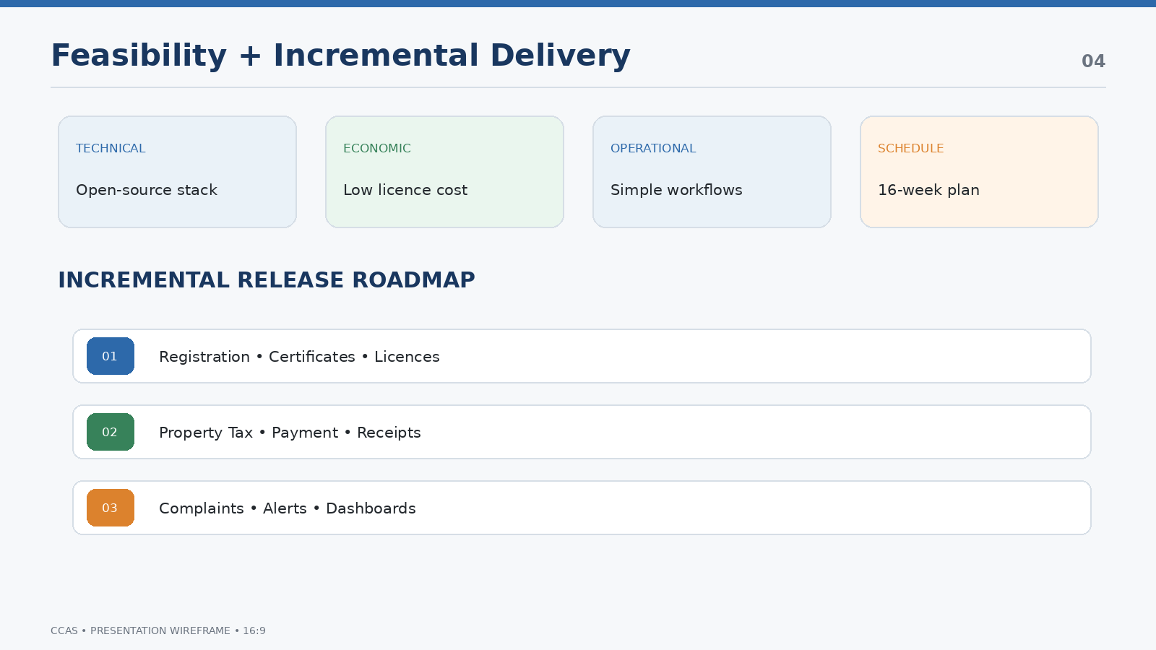
FEASIBILITY
TECHNICAL | ECONOMIC | OPERATIONAL | SCHEDULE
1 | Registration • Certificates • Licences
2 | Property • Tax • Payment • Receipts
3 | Complaints • Alerts • Dashboards • Reports

How to design it:
- Split the slide into a 4-card feasibility strip and a 3-step delivery roadmap.
- Use the same colors for increments throughout the deck.
- Make the 16-week plan a small annotation, not a full Gantt chart.
- Use arrows between increments to show iterative delivery.
Visual assets / diagrams:
- Three horizontal release bars are more readable than the full report figure.
- Small check icons can show each increment is a working release.
Presenter delivery:
Explain why Incremental was selected over a rigid one-shot delivery: users can see early releases, feedback can be incorporated, and risk is distributed.
Avoid
Do not reproduce the entire report paragraph on waterfall vs incremental.

SLIDE 5 — Who Uses CCAS? Requirements by Role
Purpose: Turn the SRS user classes and functional requirements into a clear actor map.
Content to put on the slide:
- Citizen: register, apply, pay, complain, track, download
- Department Officer: verify, approve/reject, assign, report
- Field Staff: receive complaint, update progress, upload proof
- Administrator: manage users/services/fees, analytics, audit
- Highlight three requirement groups: identity/access, service requests, property/payment.
Wireframe / spatial blueprint: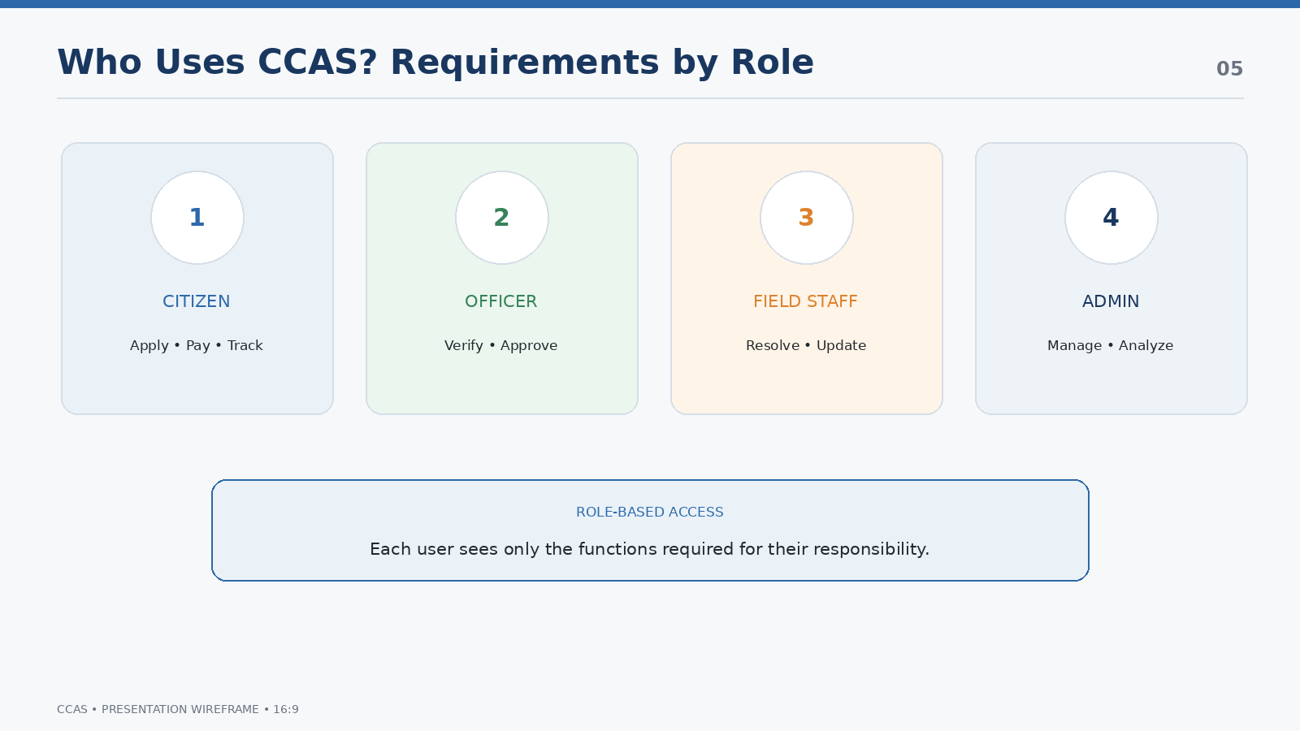
USER ROLES
CITIZEN | OFFICER | FIELD STAFF | ADMIN
Apply / Pay / Track | Verify / Approve | Resolve / Update | Manage / Analyze
SRS → FR1–FR6 shown as a compact “must-have” strip

How to design it:
- Use four role cards with one-line responsibilities.
- Do not paste the FR table; summarize the highest-value requirements.
- Use role-specific icons, but keep all icons in the same line style.
- Put FR identifiers in tiny labels only if the faculty expects traceability.
Visual assets / diagrams:
- Citizen, officer, field staff and admin icons.
- Optional mini-flow: Citizen request → Officer verification → Field resolution → Admin monitoring.
Presenter delivery:
Say: “The system is role-based. This is important because the same portal supports citizen self-service and internal municipal operations without exposing unauthorized functions.”
Avoid
Do not overload the slide with all 40 FR/NFR identifiers.

SLIDE 6 — System Architecture: Three Layers, One Flow
Purpose: Explain how the system is organized technically without turning the slide into a code diagram.
Content to put on the slide:
- Presentation layer: citizen portal, officer dashboard, admin console
- Application layer: authentication/RBAC, certificates/licences, tax/payment, complaints, notifications, reporting
- Data layer: relational database, protected file storage, audit/event logs
- External services: payment gateway, SMS/e-mail gateway
- Communication: HTTPS + REST APIs / JSON
Wireframe / spatial blueprint: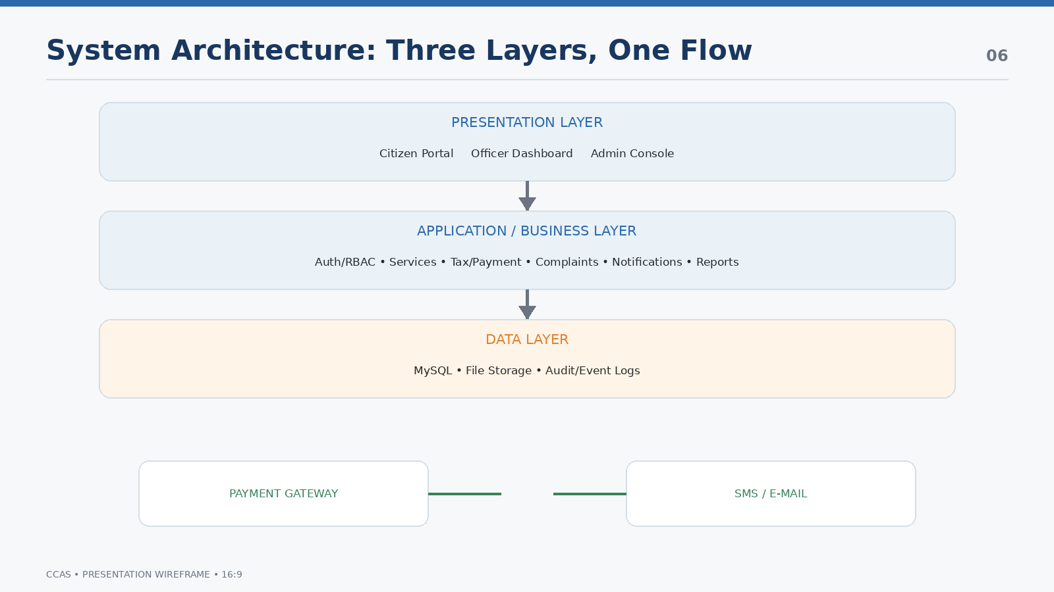
PRESENTATION LAYER
Citizen Portal | Officer Dashboard | Admin Console
APPLICATION / BUSINESS LAYER
Auth/RBAC • Services • Tax/Payment • Complaints • Notifications • Reports
DATA LAYER
MySQL • File Storage • Audit/Event Logs
Payment Gateway ↔ CCAS ↔ SMS/E-mail Gateway

How to design it:
- Make the three layers the visual hero. Use horizontal stacked layers.
- Use small arrows downward for requests and upward for responses.
- Put external services outside the main stack to emphasize integrations.
- Keep labels short; the speaker explains the details.
Visual assets / diagrams:
- Three-layer architecture diagram based on the report’s Figure 3.
- Small API/cloud icons for external gateways.
Presenter delivery:
Walk from top to bottom: user interface → business rules → persistent data. Then point to the external payment and notification services.
Avoid
Do not include low-level server specifications on this slide.

SLIDE 7 — Core Modules + Complaint Lifecycle
Purpose: Show the product as six coherent service modules and demonstrate one end-to-end workflow.
Content to put on the slide:
- M1 User & Access Management
- M2 Certificate & Licence Services
- M3 Property Tax & Payment
- M4 Complaint Management
- M5 Notification Management
- M6 Reports & Dashboard
- Complaint flow: submit → validate → ID → assign → resolve → notify
Wireframe / spatial blueprint: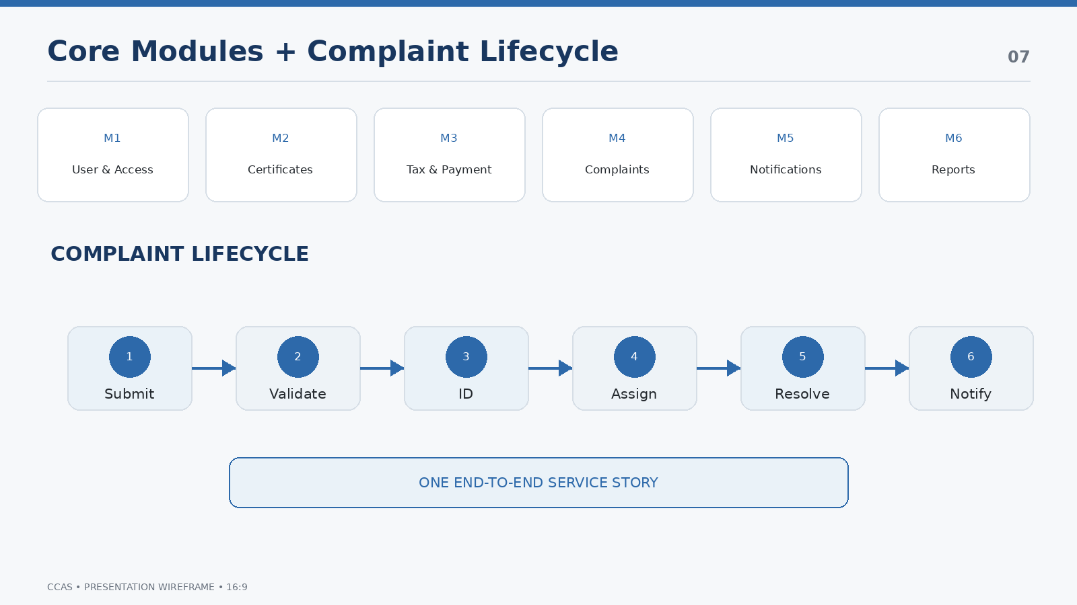
CCAS MODULES
M1 | M2 | M3 | M4 | M5 | M6
User | Certificate | Tax/Pay | Complaint | Notify | Reports
Complaint Lifecycle
Submit | Validate | ID | Assign | Resolve | Notify

How to design it:
- Top: six compact module tiles. Bottom: one large lifecycle flow.
- Make the complaint workflow visually stronger than the module list because it demonstrates system behavior.
- Use numbered circles for lifecycle steps.
- Do not put detailed module descriptions into the six tiles.
Visual assets / diagrams:
- Use the report’s complaint sequence as the source of truth for the flow.
- Use a status/progress metaphor to make the workflow instantly understandable.
Presenter delivery:
Tell the complaint story in 20–30 seconds. This gives the audience a concrete example of how multiple modules cooperate.
Avoid
Do not attempt to explain every module in depth.

SLIDE 8 — Technology, UI & Security
Purpose: Show implementation credibility and demonstrate that security is built into the design.
Content to put on the slide:
- Frontend: HTML5, CSS3, JavaScript, Bootstrap
- Backend: Node.js + Express REST API
- Database: MySQL 8
- Tools: VS Code, Git/GitHub, Postman, draw.io
- Security: bcrypt hashing, JWT sessions, prepared statements, input validation, RBAC, HTTPS
- UI principles: responsive, clear feedback, validation, readable forms
Wireframe / spatial blueprint: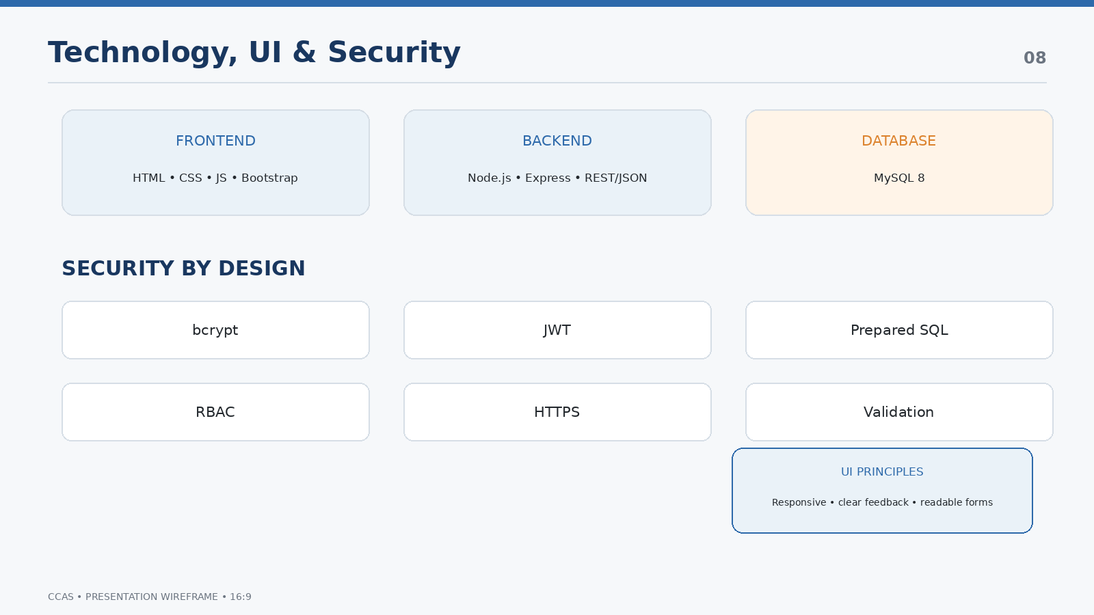
TECH STACK
FRONTEND | BACKEND | DATABASE
HTML • CSS • JS • Bootstrap | Node.js • Express • REST/JSON | MySQL 8
SECURITY
Hashing | JWT | Prepared SQL | RBAC | HTTPS | Validation

How to design it:
- Use a technology stack strip at the top and a security shield row underneath.
- Include a small cropped citizen dashboard wireframe on the far right only if space allows; otherwise keep this slide technical.
- Use logos sparingly; text labels are safer and cleaner in an academic PPT.
- Keep security items as short chips.
Visual assets / diagrams:
- Optional miniature dashboard screenshot/wireframe from the report’s citizen UI.
- Security shield icon and six small security chips.
Presenter delivery:
Connect each technology to its job instead of just listing names: Bootstrap → responsive UI; Express → REST APIs; MySQL → persistent data; RBAC → authorization.
Avoid
Do not turn the slide into a list of software logos.

SLIDE 9 — Testing, Project Management & Risk
Purpose: Prove that the system is engineered, not merely conceptual.
Content to put on the slide:
- Testing levels: unit, integration, system, UAT
- Test techniques: equivalence partitioning, boundary value analysis, white-box critical logic
- Representative cases: login, registration, certificate, file validation, tax penalty
- Planning: 16-week schedule
- COCOMO: ~14 KLOC; 38.3 person-months; 10.0 months; ~4 average staff
- Risks: requirements, security/data leakage, payment gateway downtime
Wireframe / spatial blueprint: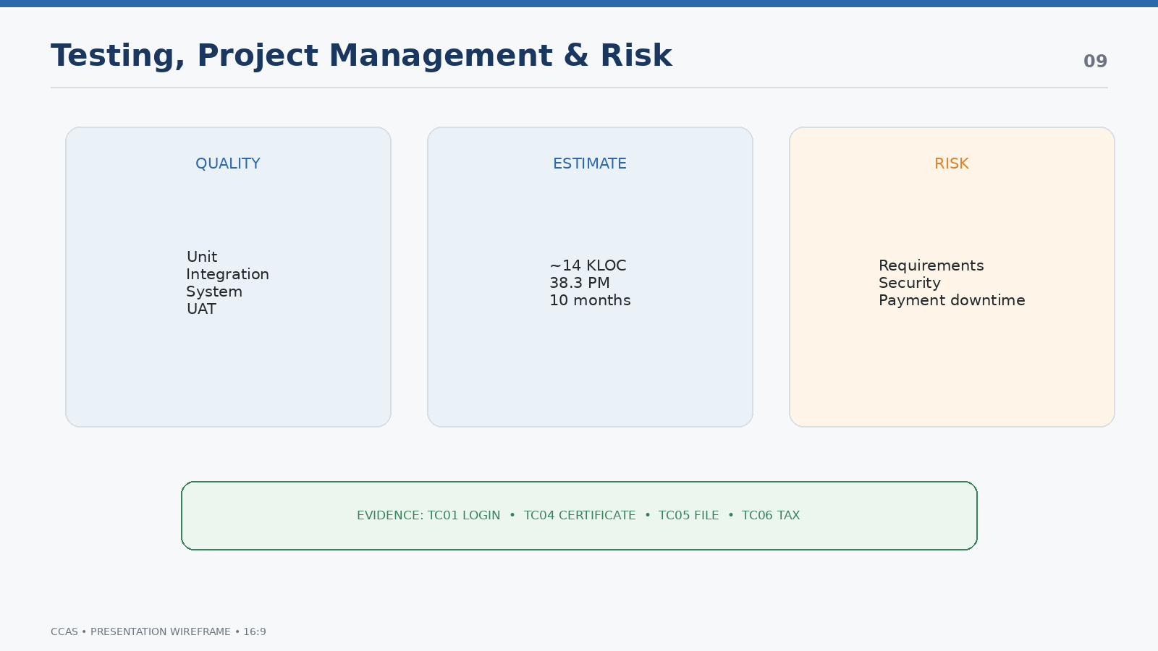
QUALITY ASSURANCE
TEST PYRAMID | PROJECT ESTIMATE | RISK
Unit → Integration → System → UAT | 14 KLOC  38.3 PM  10 months | Security / Payment / Changes
Evidence
TC01 Login • TC04 Certificate • TC05 File • TC06 Tax

How to design it:
- Use three vertical columns rather than a long table.
- Give the COCOMO numbers visual prominence because they demonstrate project-management analysis.
- Use a small risk matrix or three risk cards instead of a paragraph.
- Use “Evidence” at the bottom to connect the testing section to actual test cases.
Visual assets / diagrams:
- Test funnel/pyramid.
- Three-number COCOMO callout.
- Risk cards with impact labels; do not rely only on red/green color.
Presenter delivery:
Explain that testing was planned alongside incremental development and that each release is verified before moving forward.
Avoid
Do not claim that all tests passed unless the report explicitly documents pass results.

SLIDE 10 — Conclusion: From Paper Processes to Smart-City Foundation
Purpose: Finish with a strong outcome and a credible future roadmap.
Content to put on the slide:
- CCAS creates a secure, transparent and efficient digital municipal platform.
- Reduces office visits and manual work
- Improves approval/complaint resolution and revenue collection
- Provides reliable information for management decisions
- Future: mobile app, AI complaint classification, GIS, AI chatbot, IoT/smart-city integration, predictive analytics, digital identity
Wireframe / spatial blueprint: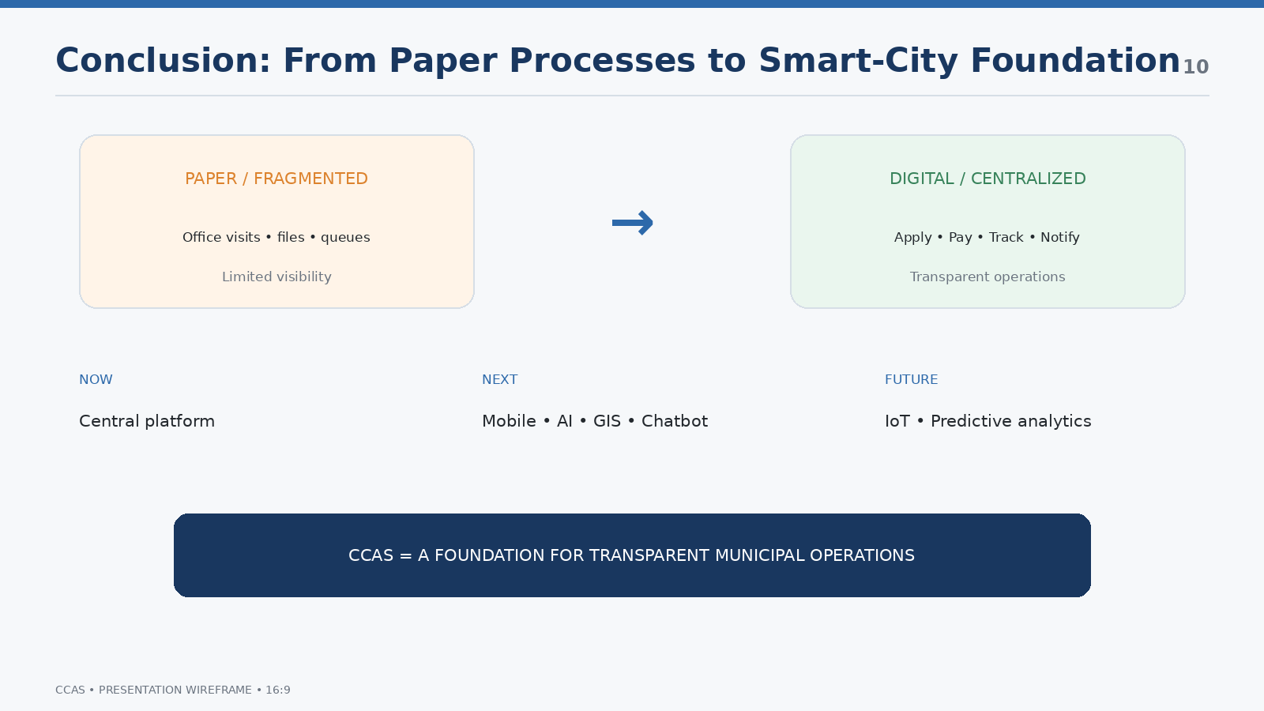
THE OUTCOME
PAPER / FRAGMENTED | → | DIGITAL / CENTRALIZED
Applications • Complaints • Payments • Certificates • Notifications
NOW | NEXT | FUTURE
Central platform | AI + GIS + Mobile | IoT + Predictive Smart City

How to design it:
- Make this a visual summary, not a repeat of the introduction.
- Use a left-to-right transformation arrow: fragmented municipal service → centralized digital service → smart-city foundation.
- Future scope should be a roadmap, not a bullet dump.
- End with one strong sentence in large type.
Visual assets / diagrams:
- Simple transformation illustration.
- Future roadmap icons: mobile, AI, map/GIS, chatbot, IoT, analytics.
Presenter delivery:
Close with: “CCAS is not only an online portal; it is a foundation for transparent municipal operations and future smart-city integration.”
Avoid
Do not introduce a completely new feature in the final slide that was not in the source documents.

C. PowerPoint Production Checklist
- Canvas: 16:9 widescreen.
- Create a Slide Master with title position, footer, page number and grid.
- Use 3–4 master layouts: Cover, Problem/Solution, Diagram, Three-Column, Conclusion.
- Use Aptos/Aptos Display or another clean sans-serif family. Avoid decorative display fonts.
- Keep body text generally at 18 pt or above in the final PPT; the wireframe document uses smaller type only for planning.
- Use high contrast and never communicate status through color alone. Microsoft recommends strong contrast, meaningful titles and accessible reading order.
- Use one visual focal point per slide. For data/diagrams, communicate one central idea rather than several unrelated messages.
- Use a consistent icon family. Do not mix 3D icons, emoji, outline icons and photographic icons.
- Use a 12-column grid and consistent spacing. Align card edges and diagram nodes.
- Keep animation subtle: Appear/Fade for sequence steps; avoid Fly In, Bounce and excessive motion.
- Before submission, run PowerPoint Accessibility Checker and verify reading order, contrast and alt text.

D. Source-to-Slide Traceability
PPT Slide | Primary source section | What is carried into the PPT
1 | SRS Introduction / Case Study cover | System identity, course/team context
2 | Case Study: Introduction + Existing System Limitations | Citizen pain points and problem statement
3 | SRS Purpose/Scope + Case Study Proposed System | Centralized digital workflow and benefits
4 | Case Study Feasibility + Incremental Process Model | Four feasibility dimensions + 3 increments
5 | SRS Functional Requirements + Case Study User Classes | Roles and representative FRs
6 | Case Study System Architecture + DFD | Three-layer architecture and integrations
7 | SRS modules + Case Study module/sequence sections | Six modules + complaint lifecycle
8 | Case Study Implementation + Security + SRS interfaces | Tech stack, UI and security
9 | Case Study Testing + COCOMO + Risk Management | Testing levels, estimate and key risks
10 | SRS Future Enhancement + Case Study Conclusion | Conclusion and future roadmap

Research note
Public-sector design systems consistently emphasize clear navigation, simple and intuitive use, accessibility, high contrast, logical information hierarchy and testing with real user needs. GOV.UK recommends simplifying user journeys before adding navigation, while USWDS emphasizes accessible, mobile-friendly government services and task-oriented navigation. These principles are used here as design guidance; they do not replace the requirements in your CCAS SRS.

E. Research References
1. Microsoft Support — Make your PowerPoint presentations accessible to people with disabilities: https://support.microsoft.com/en-us/accessibility/powerpoint/make-your-powerpoint-presentations-accessible-to-people-with-disabilities
2. U.S. Web Design System — Design principles: https://designsystem.digital.gov/design-principles/
3. U.S. Web Design System — Data visualizations: https://designsystem.digital.gov/components/data-visualizations/
4. U.S. Web Design System — Getting started for designers: https://designsystem.digital.gov/documentation/getting-started-for-designers/
5. GOV.UK Design System — Accessibility strategy: https://design-system.service.gov.uk/accessibility/accessibility-strategy/
6. GOV.UK Design System — Navigate a service: https://design-system.service.gov.uk/patterns/navigate-a-service/
7. Supplied source: SOFTWARE REQUIREMENTS SPECIFICATION (SRS) — City Corporation Automation System (7 pages).
8. Supplied source: City Corporation Automation System — Software Engineering Case Study Report (17 pages).

