DETAILED PROJECT REPORT
PROJECT
GARUDA

AI-Powered Intelligent Co-Driver & Accident Prevention System

₹2.9 Bn  India ADAS Market 2025  CAGR 16.4% → ₹8.4 Bn by 2032 | 1.70 L  Road Deaths in India (2024)  MoRTH Provisional Data | Oct 2026  Mandatory ADAS Deadline  All trucks & buses on road | <100ms  Edge AI Response Time  Onboard, no cloud required

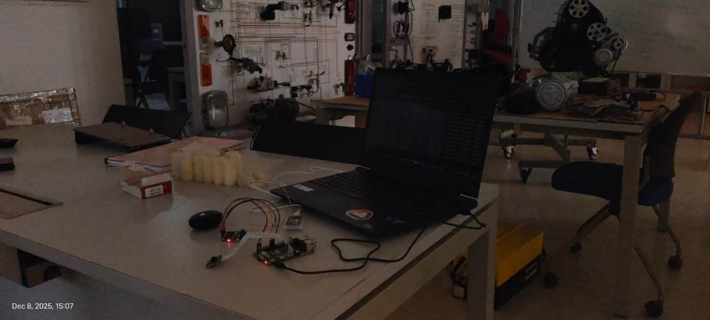

Table of Contents
Table of Contents 2
1. Executive Summary 4
1.1 The Core Innovation 4
2. Problem Statement & Market Need 6
2.1 India's Road Safety Crisis 6
2.2 Why Existing Solutions Fail 6
2.3 The Regulatory Catalyst — Why Now 7
3. System Architecture 8
3.1 Architecture Overview 8
3.2 Three-Tier Processing Architecture 8
3.2.1 Edge AI Layer (Onboard, <50–100ms) 8
3.2.2 Multi-Modal Fusion Engine 8
3.3 BLE Offline Mesh Network — Novel V2V Protocol 9
3.4 Fog & Cloud Layers 9
4. Hardware Design & Engineering 11
4.1 System Wiring & Electrical Architecture 11
4.2 Power Architecture 11
4.3 Sensor Stack 11
4.4 Legacy Vehicle Adaptation 12
5. Vehicle Installation & Physical Integration 13
5.1 Installation Overview 13
5.2 Mounting Positions & Rationale 13
6. AI & Machine Learning Architecture 15
6.1 Model Stack Overview 15
6.2 Drowsiness Detection — Technical Detail 15
6.3 Indian Road Dataset — The Core Moat 16
7. Intellectual Property & Patent Landscape 21
7.1 Novel Technical Contributions Warranting Protection 21
7.2 IP Strategy 21
8. Competitive Analysis 23
8.1 Competitive Positioning Matrix 23
8.2 Why Garuda Cannot Be Easily Replicated 23
9. Results……………………………………………………………………………………………………..
10. Closing Statement 31

1. Executive Summary
Project Garuda is an AI-powered, edge-first intelligent co-driver and accident prevention system designed specifically for India's commercial vehicle landscape. Built to operate entirely without internet connectivity, Garuda integrates computer vision, multi-modal sensor fusion, and a proprietary offline BLE mesh network to deliver sub-100ms accident risk prediction and real-time driver guidance directly onboard the vehicle.

India stands at a critical inflection point in road safety. With 4.73 lakh road accidents and 1.70 lakh fatalities recorded in 2024 — more than any other nation — and a Government of India mandate (AIS-184, effective October 2026) requiring all existing commercial vehicles to install ADAS-compliant systems, the retrofit aftermarket for intelligent driver assistance is being created overnight. Garuda is purpose-built to be the premium platform that meets this mandate head-on.

4.73 L  Road Accidents (2024)  MoRTH Provisional | 39.2%  Accidents on National Highways  Just 5% of road network | 10 M+  Vehicles Requiring ADAS by Oct 2026  Retrofit market creation event | 40x  LTV:CAC Ratio  Unit economics base case

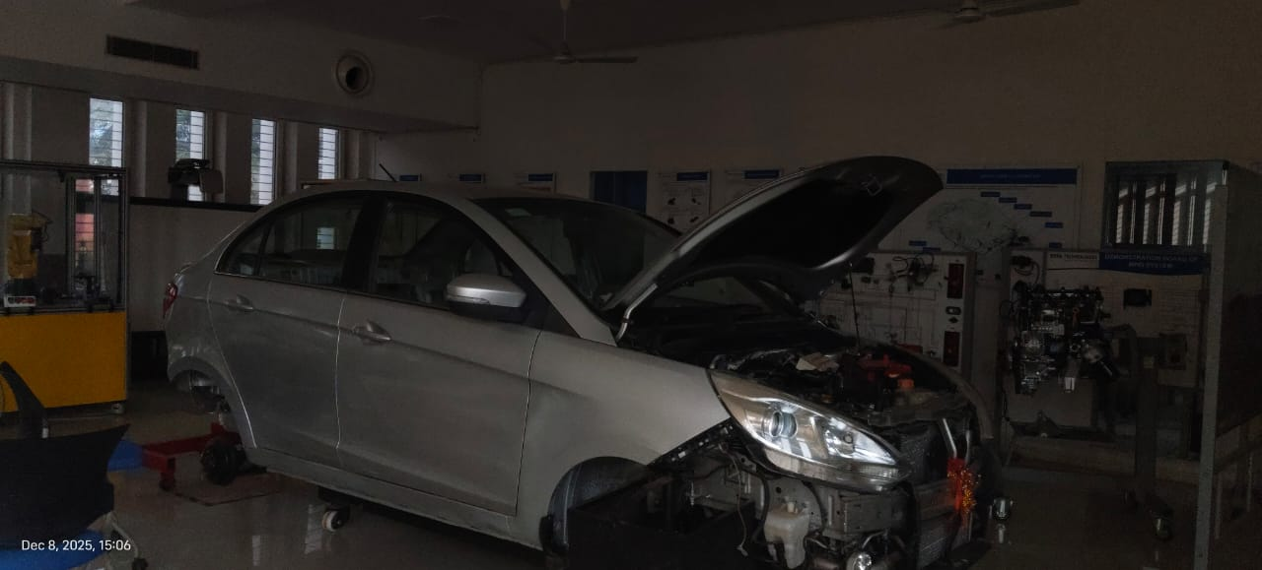

1.1 The Core Innovation
Unlike conventional ADAS solutions that require cloud connectivity, OBD-II ports, or pre-installed vehicle infrastructure, Garuda is a fully self-contained intelligent platform. Its three-layer architecture — Edge AI (onboard), Fog (local cluster), and Cloud (global learning) — ensures that life-saving interventions happen in <100ms regardless of network availability. This makes it uniquely suited to India's high-risk highway corridors where both connectivity and vehicle age present significant challenges.

Core Capability | Technical Approach | Unique Advantage
Drowsiness Detection | EAR (Eye Aspect Ratio) + head tilt via MediaPipe Face Mesh | Works on old trucks — no smartwatch or biometric sensor required
Collision Prediction | YOLOv8-nano road camera + CNN-LSTM risk scoring (0–1) | Fine-tuned on Indian roads — handles cows, potholes, overloaded trucks
Offline V2V Communication | BLE mesh network — no internet needed, <200ms broadcast | Only ADAS platform with offline vehicle-to-vehicle alerting in India
Legacy Vehicle Support | No OBD-II, no smartphone — direct 12V battery connection | Works on 15-year-old trucks and auto-rickshaws — total India coverage
Emergency Response | Automatic GPS-linked SOS to 112 + emergency contacts | Operates even if driver is incapacitated

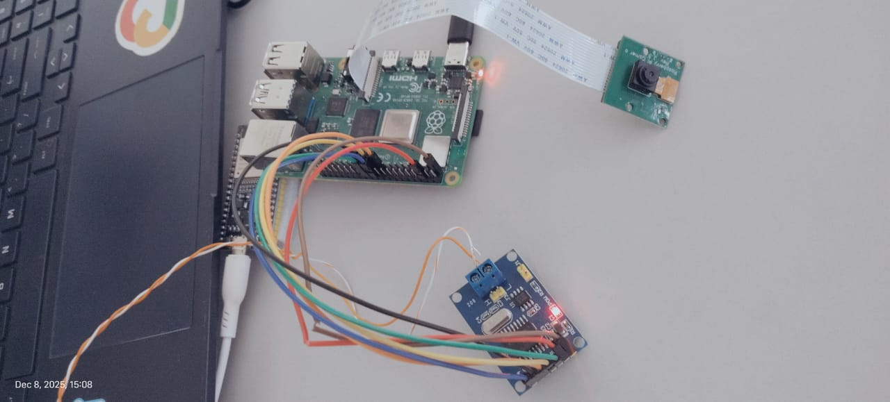

2. Problem Statement & Market Need

2.1 India's Road Safety Crisis
India's road mortality data is unambiguous and worsening. The country recorded 4.73 lakh road accidents and 1.70 lakh deaths in 2024 — a rate of one death every three minutes. Since 2005, road fatalities have increased by 177%, and India surpassed China in 2021 to become the world's most dangerous road environment by absolute deaths. The economic cost is estimated at ₹1.47 lakh crore annually by the World Bank.

The concentration of risk is striking: national highways and expressways represent only 5% of India's road network, yet account for 39.2% of all accidents and 36.2% of all deaths. Heavy commercial vehicles — trucks and buses — are disproportionately responsible for fatal highway incidents. This is exactly the segment Garuda targets.

2.2 Why Existing Solutions Fail
The central failure of existing road safety interventions is that they are reactive rather than preventive. Better roads reduce severity; better enforcement deters violations; better hospitals improve survival. None of these stop the accident from happening. Garuda operates in the microseconds before impact — the only window where lives can be saved.

Existing Approach | Critical Limitation | Garuda's Solution
OEM-installed ADAS (Bosch, Mobileye) | Only on new vehicles. 9.9M existing fleet has zero coverage. | Retrofit platform works on any vehicle from 2001 or even older
Cloud-dependent telematics (BlackBuck, Letstrack) | Requires internet. NH corridors in Odisha/Jharkhand have <40% 4G coverage. | 100% offline Edge AI — no SIM card needed for life-saving alerts
Smartphone-based apps (Trucker apps) | Assumes driver has smartphone and keeps it charged and mounted. | Standalone hardware — no smartphone dependency at all
OBD-II dongles | Pre-BS4 trucks (majority of fleet) have no OBD-II port. | Direct 12V power + CAN-less architecture — any vehicle supported
Government enforcement (speed cameras, challans) | Reactive. Violation is already recorded after the dangerous act. | Proactive <100ms intervention — alerts before dangerous behaviour escalates

2.3 The Regulatory Catalyst — Why Now
The Government of India has created a mandatory market through three sequential regulatory actions that align precisely with Garuda's technical capabilities:

Date | Regulatory Event | Impact on Garuda
March 20, 2025 | MoRTH issues draft notification G.S.R. 184(E) — proposes mandatory ADAS for M2/M3 (buses) and N2/N3 (trucks) | Garuda's DDAWS + AEBS + LDWS features align directly with AIS-184 standards
April 1, 2026 | ADAS mandatory for ALL NEW MODELS of trucks and buses — AIS-184 Driver Drowsiness Warning required | Fleet operators must upgrade; retrofit aftermarket created overnight
October 1, 2026 | ADAS mandatory for ALL EXISTING MODELS currently on the road — entire fleet must comply | 10 million+ vehicles require compliant retrofit systems — largest single demand event in India automotive history
2027 (announced) | Bharat NCAP 2.0 includes ADAS assessments for passenger vehicles | Phase 3 consumer market validated and de-risked

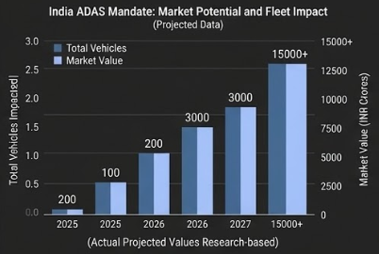

3. System Architecture

3.1 Architecture Overview
Garuda's architecture is organized into three processing tiers — Edge, Fog, and Cloud — each with distinct latency targets, capabilities, and failure modes. The critical design principle is graceful degradation: if cloud connectivity is lost, Fog takes over; if Fog is unavailable, Edge operates autonomously with full life-safety functionality intact.
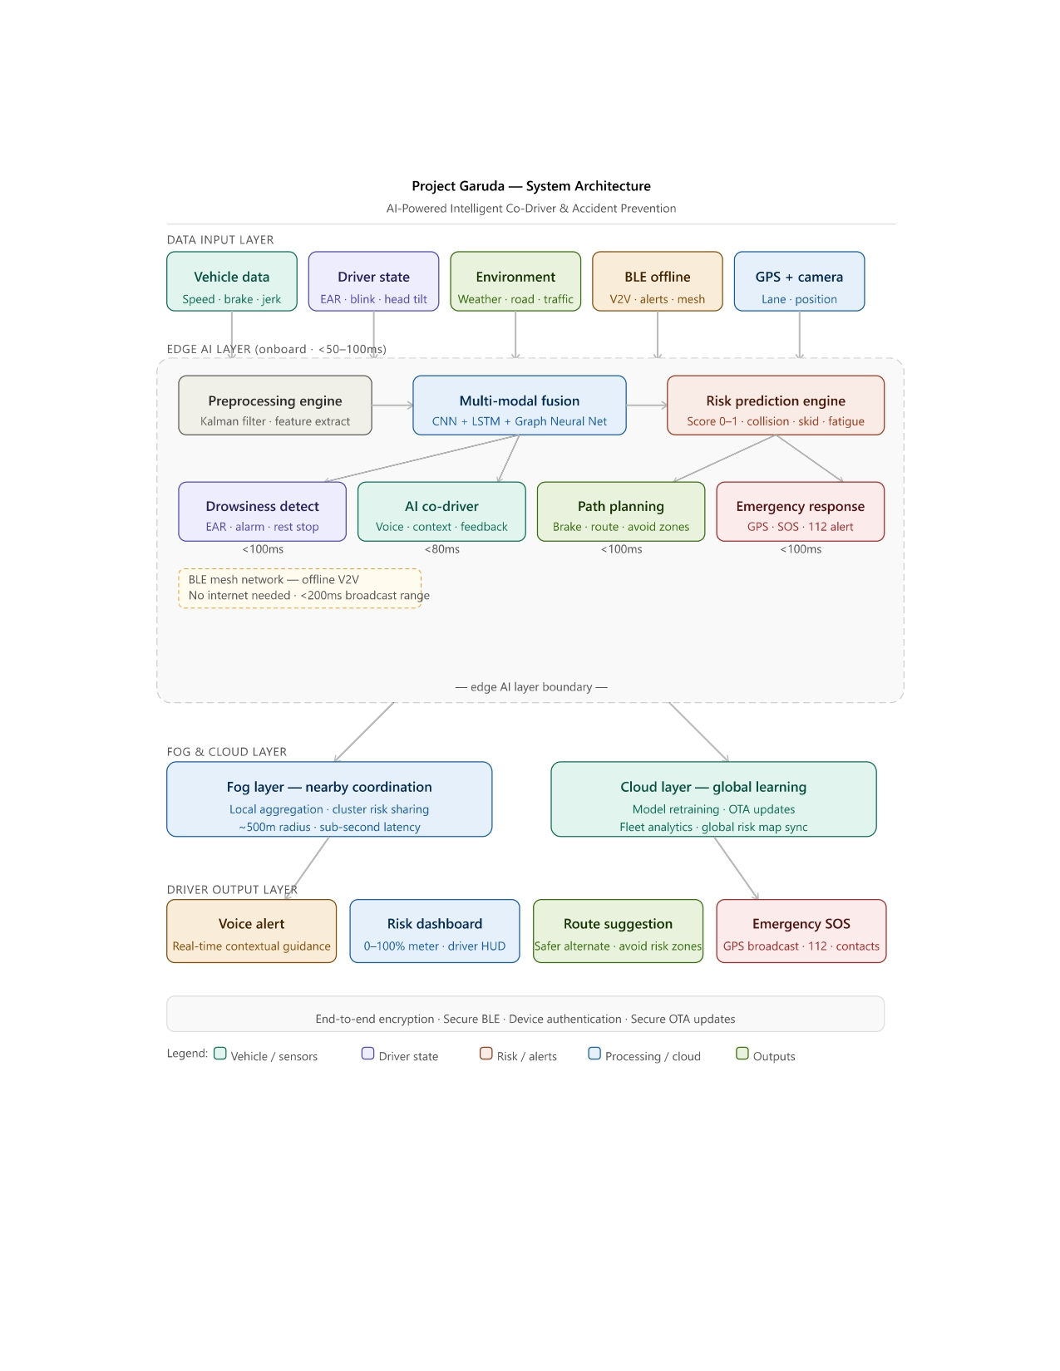
(Fig 1.4 – High Level Architecture Diagram)

3.2 Three-Tier Processing Architecture

3.2.1 Edge AI Layer (Onboard, <50–100ms)
The Edge layer is the operational core of Garuda. All safety-critical computations occur here, on a Raspberry Pi 4 Compute Module (or equivalent embedded SoC) mounted permanently in the vehicle. This layer processes five distinct data streams simultaneously:

- Vehicle Data — Speed, brake pressure, lateral jerk, yaw rate, and longitudinal acceleration captured at 50Hz via CAN bus (BS4+ vehicles) or direct analog integration (legacy vehicles).
- Driver State — Eye Aspect Ratio (EAR), blink frequency, head tilt angle, and microsleep event detection via MediaPipe Face Mesh processing a dedicated driver-facing infrared camera at 15 FPS.
- Environment — Road condition classification (wet/dry/fog), traffic density estimation, and ambient light level via the forward-facing road camera processed through YOLOv8-nano.
- BLE Offline Mesh — Vehicle-to-vehicle hazard broadcasts received from nearby Garuda-equipped vehicles within ~500m radius, processed and fused without internet connectivity.
- GPS + Camera — Lane departure detection, position on known high-risk zones, and road geometry analysis for forward collision warning calculations.

3.2.2 Multi-Modal Fusion Engine
The fusion engine is Garuda's core intellectual property. A three-stage pipeline processes all sensor streams into a unified risk score:

Stage | Component | Model / Method | Output
1. Preprocess | Kalman Filter + Feature Extractor | Extended Kalman Filter for sensor noise; hand-crafted features for drowsiness EAR, jerk amplitude, and weather class | Clean sensor vectors at uniform 20Hz
2. Fusion | CNN + LSTM + Graph Neural Network | CNN for spatial road features; LSTM for temporal driver state sequences; GNN for multi-vehicle convoy risk propagation | Fused latent risk representation
3. Prediction | Risk Scoring Engine | Gradient boosted classifier on fused features — outputs continuous score 0.0–1.0 for collision, skid, fatigue, and lane-departure risks | Risk score 0–1 at <50ms latency

3.3 BLE Offline Mesh Network — Novel V2V Protocol
Garuda's offline vehicle-to-vehicle communication system is a significant technical differentiator with no equivalent in the Indian commercial vehicle ADAS market. The system operates as follows:

- Each Garuda unit broadcasts a compact hazard packet (risk score, GPS coordinate, heading, speed) over Bluetooth Low Energy at 1Hz with 200ms maximum propagation delay.
- Any Garuda-equipped vehicle within ~500m radius receives this broadcast and integrates it into its own risk calculation — warning the downstream driver of a hazard it cannot yet see.
- No internet, no SIM card, no infrastructure is required. The mesh is peer-to-peer and decentralized — it functions even in zero-connectivity mountain passes and mining zones.
- When internet connectivity is available, hazard packets are also forwarded to the cloud layer for fleet-wide risk map updates — building Garuda's proprietary Indian road hazard dataset.

3.4 Fog & Cloud Layers
The Fog Layer provides local coordination among vehicles within a ~500m cluster. When multiple Garuda-equipped vehicles are traveling in proximity (convoy, highway traffic), the fog layer aggregates individual risk scores, identifies cluster-level hazards invisible to any single vehicle, and propagates warnings across the group with sub-second latency.

The Cloud Layer serves three functions: (1) continuous AI model retraining on new labeled data from the fleet, (2) over-the-air (OTA) model updates pushed to all devices, and (3) the global risk map — a live, crowd-sourced hazard intelligence layer covering India's national highway network.

4. Hardware Design & Engineering

4.1 System Wiring & Electrical Architecture
Garuda's hardware is designed to meet automotive-grade reliability standards (IP67 enclosure, operating temperature -10°C to +70°C) while maintaining a Bill of Materials (BOM) cost of ₹6,500–7,000 at 500-unit production run. The complete electrical system is organized around a central compute module with four primary subsystems:
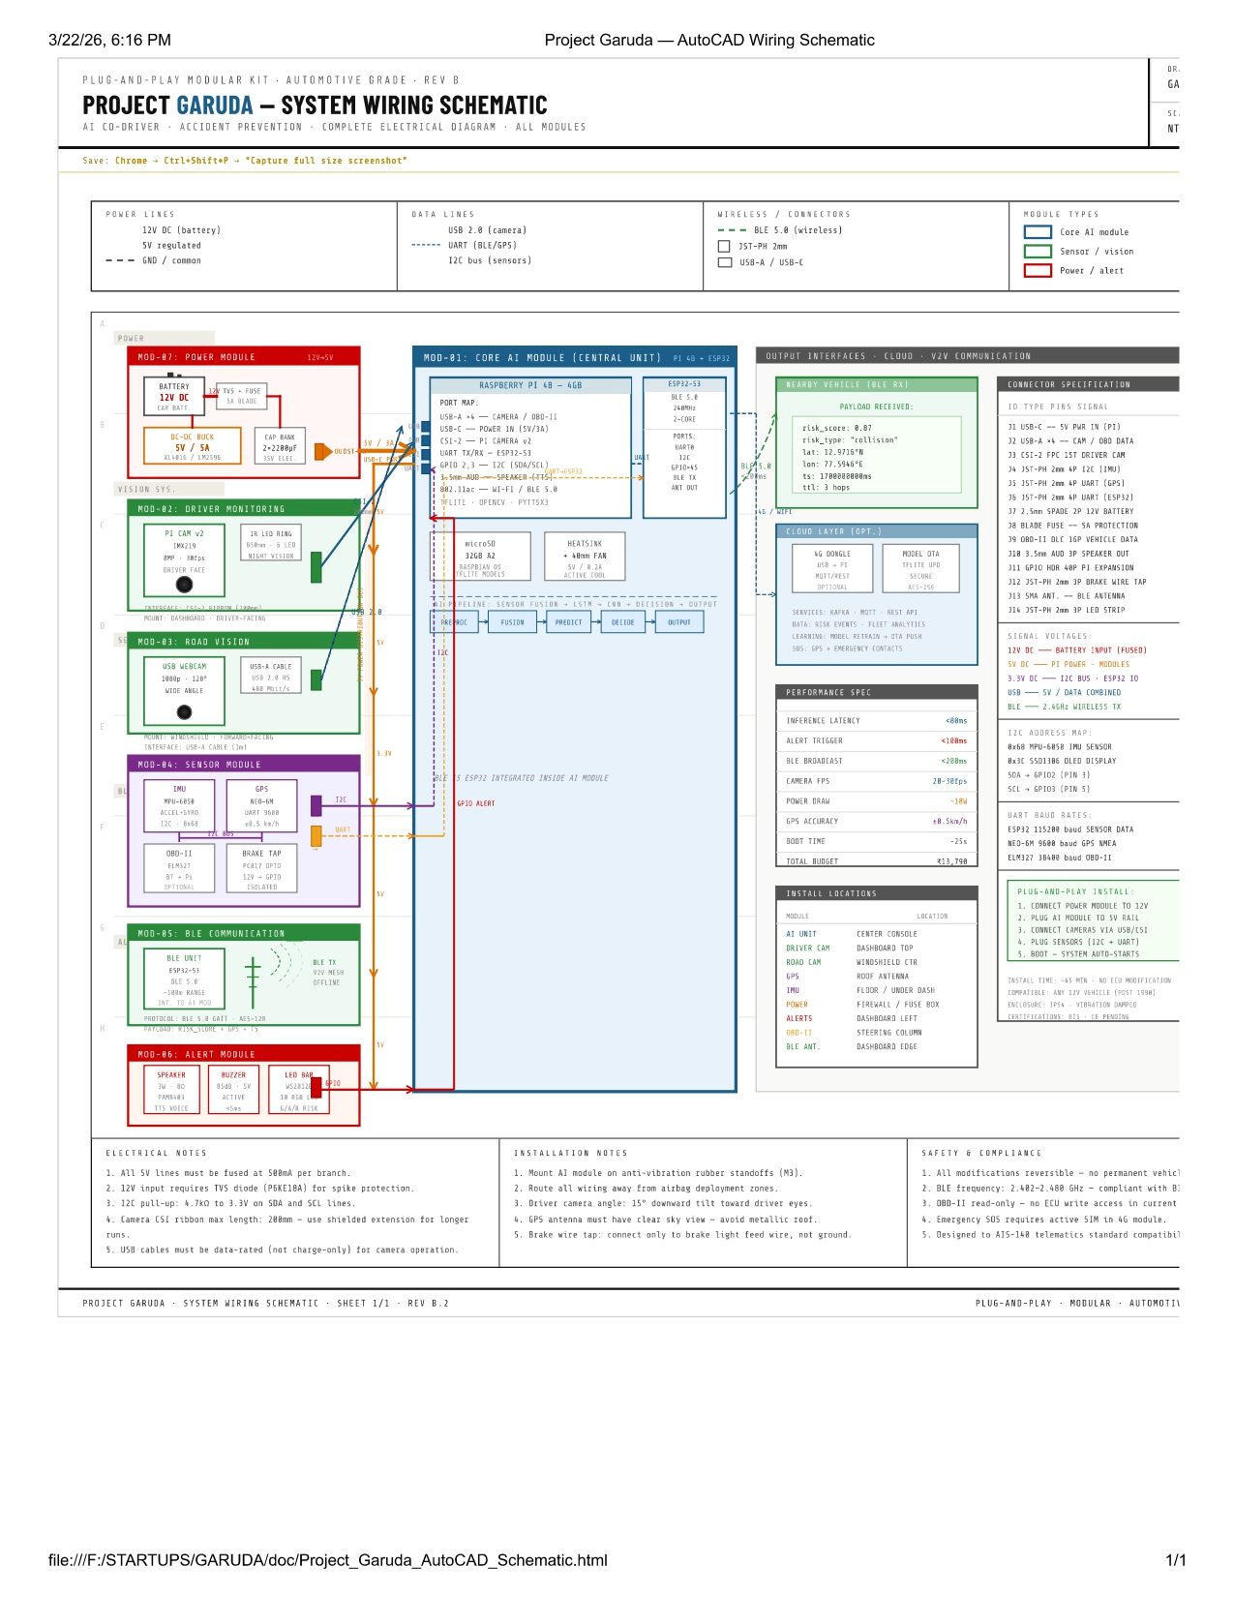
Figure: Project Garuda — AutoCAD System Wiring Schematic Rev B.2: Complete electrical diagram, all modules

4.2 Power Architecture
The power system is designed for automotive environments with no clean regulated input. Garuda draws from the vehicle's 12V DC bus (from the battery or alternator circuit) and conditions it internally:

Power Rail | Source | Voltage | Consumers
12V DC Input | Vehicle battery / alternator | 9–16V (automotive tolerance) | Main DCDC converter
5V Regulated | Buck DCDC converter | 5.0V ±2% | Raspberry Pi, GPS, BLE module
3.3V Rail | LDO from 5V | 3.3V ±1% | Sensors, IMU, peripheral ICs
Camera Power | 5V regulated + EMI filter | 5V (isolated) | Forward camera + driver camera
Alert Buzzer / LED | GPIO via MOSFET driver | 12V switched | Audible & visual driver alerts

4.3 Sensor Stack
Garuda integrates four sensor classes in a single plug-and-play unit:

Sensor | Specification | Interface | Primary Function
Forward Road Camera | 120° FOV, 1080p/30FPS, WDR, IP67 | CSI / USB3 | Object detection, lane tracking, collision risk
Driver-Facing IR Camera | 90° FOV, 720p/15FPS, IR illuminated | CSI | EAR drowsiness detection, head pose
GPS Module | u-blox M10, cold start <30s, 1m CEP | UART | Position, speed, geofencing, SOS
BLE 5.0 Module | Nordic nRF52840, +8dBm TX, ~500m range | SPI / UART | V2V offline mesh network
IMU (6-DOF) | MPU-6050, ±8g accelerometer, ±500°/s gyro | I2C | Jerk detection, skid prediction, impact sensing
OBD-II (optional) | ELM327 or direct CAN transceiver | CAN / BT | Speed, RPM, brake pressure (BS4+ vehicles)

4.4 Legacy Vehicle Adaptation
The most significant engineering challenge Garuda solved is full compatibility with India's legacy commercial vehicle fleet. Pre-BS4 trucks (the majority of the 10M+ fleet) have no OBD-II port, no smartphone, and no digital bus. Garuda's Legacy Blueprint addresses this with a completely standalone design:

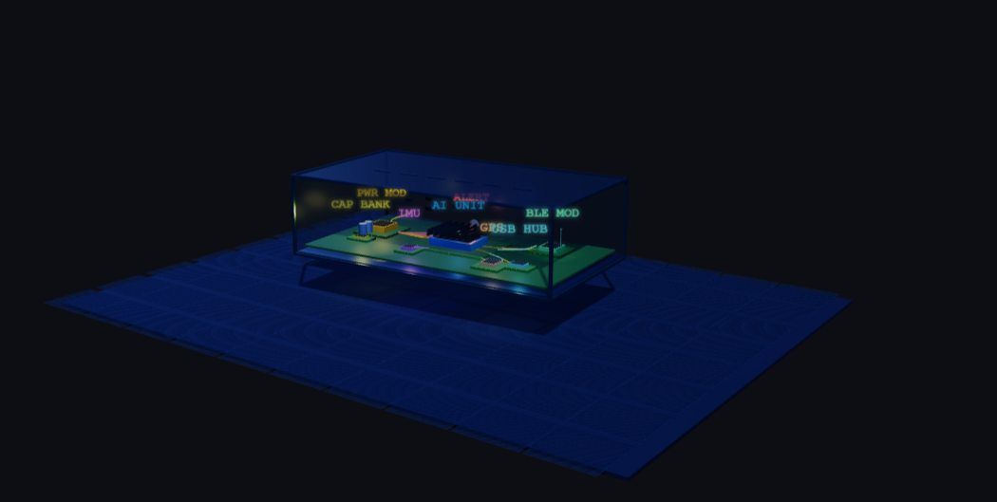
Figure: Project Garuda — Legacy Vehicle Hardware Blueprint v2.0: Designed for trucks, auto-rickshaws, and e-rickshaws with no OBD-II, no smartphone, no smart systems
(Link - https://saketsinghrajput.github.io/garuda-docs/Project_Garuda_3D_Enclosure.html)
The legacy-compatible unit replaces the OBD-II speed/brake data stream with: (1) a magnetic wheel-speed sensor on the drivetrain, (2) a brake-line pressure transducer tapped at the brake master cylinder, and (3) IMU-derived jerk/deceleration as a fallback. This gives equivalent vehicle dynamics data on any vehicle manufactured after approximately 1990.

5. Vehicle Installation & Physical Integration

5.1 Installation Overview
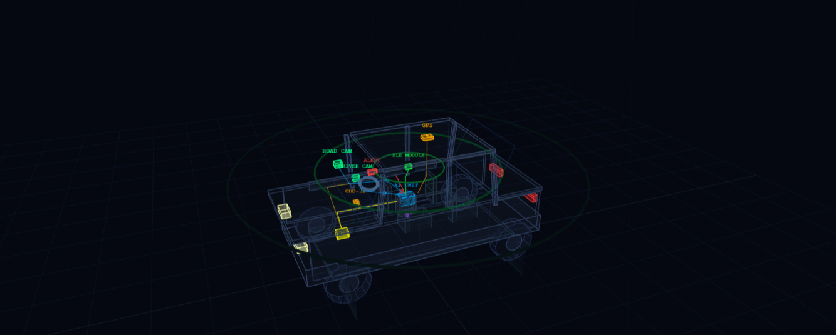
Garuda is designed for professional field installation in under 2 hours with no vehicle modification beyond mounting and wiring. The system is engineered as a modular kit — each subsystem can be independently serviced or replaced without disturbing others. Installation is performed by trained field technicians following a standardized protocol.
Figure: Project Garuda — Real Vehicle Blueprint: Component placement and wiring routing on a commercial truck
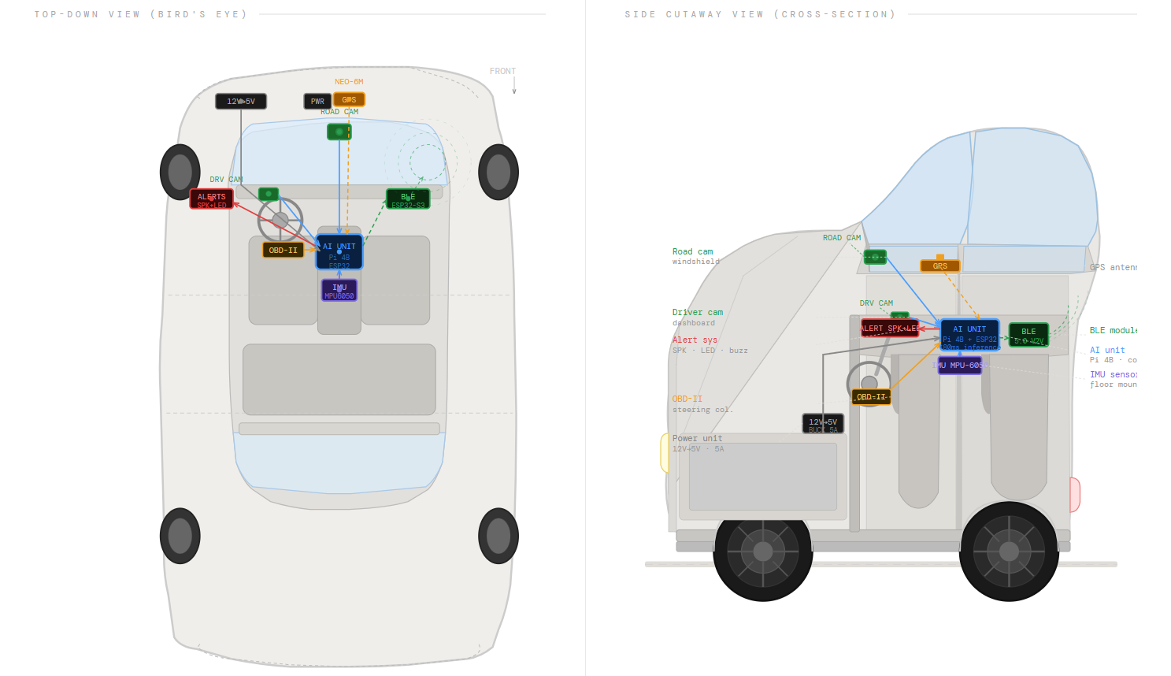
(link: - https://saketsinghrajput.github.io/garuda-docs/Project_Garuda_3D_Wireframe.html)

Figure: Project Garuda — Car/Truck Installation Diagram: Physical sensor placement, cable routing, and mount positions

5.2 Mounting Positions & Rationale
Component | Mount Location | Rationale | Fastening Method
Forward Camera | Windshield center, upper third | Unobstructed road view, minimum vibration, driver line-of-sight preserved | Suction mount + permanent bracket
Driver Camera (IR) | Dashboard top, facing driver | Face coverage angle 60–120cm from driver seat, IR illumination covers night driving | Adhesive mount with tilt adjustment
GPS Antenna | Roof / external top surface | Unobstructed sky view, >4 satellite lock minimum, clear of metal obstructions | Magnetic base or bolt-on plate
Compute Unit (RPi4) | Dashboard lower panel / glove box area | Protected from vibration, away from heat sources, accessible for maintenance | Anti-vibration rubber mount, cable strain relief
Alert Speaker + LED | Driver-facing dashboard | Within 90cm of driver ear, LED visible in peripheral vision | Panel mount, grille cover
12V Power Tap | Fuse box or dedicated circuit | Fused at 5A, switched with ignition — system sleeps when vehicle is off | Spade connector + in-line fuse

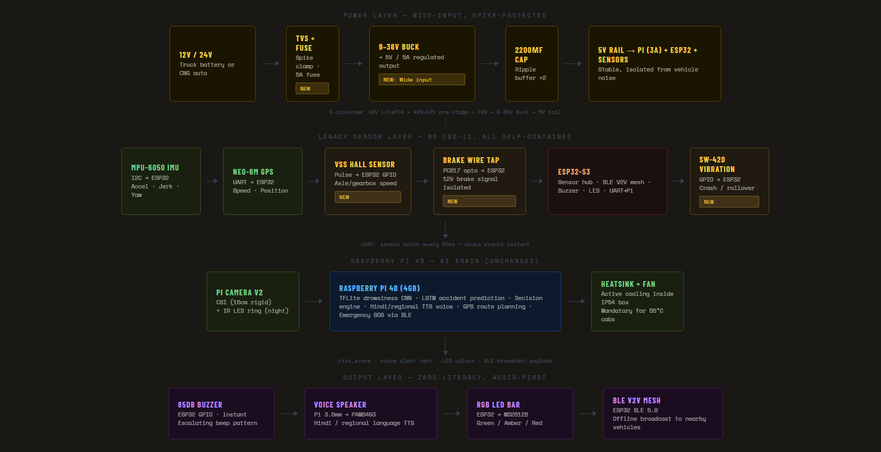

6. AI & Machine Learning Architecture

6.1 Model Stack Overview
Garuda's AI stack is designed for inference on embedded hardware with hard real-time constraints. Every model in the production stack must produce a result within its latency budget or the system falls back to the previous valid reading — never blocking the safety loop.

AI Module | Model Architecture | Latency Budget | Target Accuracy
Drowsiness Detection | MediaPipe Face Mesh + EAR classifier | <80ms per frame | >92% sensitivity, <8% FPR
Forward Collision Warning | YOLOv8-nano (INT8 quantized) | <60ms per frame | >88% mAP on Indian roads
Risk Score Fusion | CNN + LSTM + LightGBM ensemble | <20ms per cycle | AUROC >0.91 on validation set
Lane Departure | Classical CV: Canny + Hough + homography | <15ms per frame | >94% lane detection on NH conditions
Weather Classification | MobileNetV3-small (2-class: clear/adverse) | <30ms per inference | >89% accuracy (fog/rain/clear)
Voice Co-driver (NLP) | Lightweight TTS + rule-based response engine | <200ms end-to-end | Contextually appropriate alert in Hindi/English

6.2 Drowsiness Detection — Technical Detail
The Eye Aspect Ratio (EAR) algorithm is the primary drowsiness detection method, selected for its computational efficiency and proven clinical validity (Soukupová & Čech, 2016). EAR is calculated from six eye landmark coordinates extracted by MediaPipe Face Mesh:

EAR = (||p2 - p6|| + ||p3 - p5||) / (2 × ||p1 - p4||)

Where p1–p6 are the six facial landmarks surrounding the eye. A sustained EAR below 0.25 for more than 1.2 seconds triggers a Level 1 alert (voice warning). Sustained for 2.5 seconds triggers Level 2 (buzzer + voice + speed reduction recommendation). A microsleep event (EAR < 0.20 for > 4 seconds) triggers Level 3 (maximum alert, rest stop routing, fleet manager notification).

Head pose estimation from the same Face Mesh landmark set provides a secondary drowsiness signal — forward head tilt >15° and chin-drop events are weighted into the fatigue risk score independently of EAR.

6.3 Indian Road Dataset — The Core Moat
Garuda's long-term competitive moat is its proprietary dataset of labeled Indian road events. No imported ADAS model (Mobileye, Bosch, Continental) is trained on Indian roads — where cows, overloaded trucks, wrong-way vehicles, unpaved diversions, and unmarked speed bumps are everyday hazards. Garuda's edge deployment is simultaneously a product and a data collection engine.

Milestone | Data Target | Value Created
Month 18 (500 vehicles) | 50M+ km labeled Indian road data | Base dataset for model fine-tuning — no competitor has this
Year 3 (5,000 vehicles) | 500M+ km, 10M+ incident events | Proprietary risk map of India's entire NH network
Year 5 (50,000 vehicles) | 5B+ km, 100M+ events | Insurance underwriting dataset — premium pricing asset

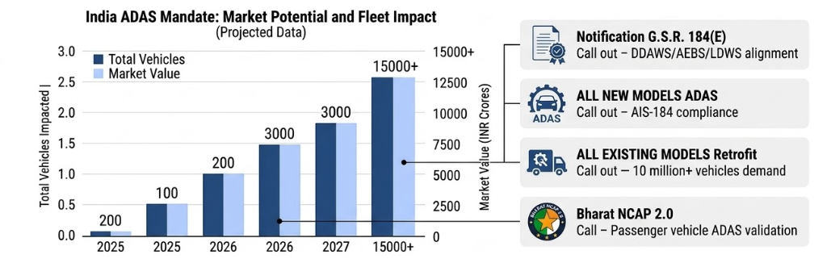

7. Intellectual Property & Patent Landscape

7.1 Novel Technical Contributions Warranting Protection
Garuda's technical architecture contains multiple novel elements that constitute patentable innovations under Indian Patents Act (Section 3, non-obvious utility). The following components are currently being evaluated for patent filing:

Innovation | Novel Element | Claim Basis
Offline BLE V2V Mesh for Road Hazard Broadcasting | Peer-to-peer vehicle hazard mesh with no infrastructure dependency, operating at <200ms latency on automotive BLE hardware | No prior art for offline BLE mesh specifically designed for ADAS hazard propagation on commercial vehicles in India. Distinct from cellular V2X (C-V2X).
Dual-Camera EAR + Head Pose Integrated Drowsiness Scoring | Combined EAR-blink-frequency-head-tilt weighted risk score with adaptive threshold calibrated per driver | Prior art (Soukupová & Čech) covers EAR alone. Novel element is multi-signal fusion with per-driver adaptive baseline calibration.
Legacy Vehicle CAN-less Risk Score Architecture | IMU + wheel speed + brake transducer as a CAN bus substitute for vehicles without OBD-II, feeding an identical risk pipeline | Novel adaptation allowing full ADAS functionality on pre-OBD-II vehicles — no prior art specifically addressing Indian pre-BS4 fleet.
India-Specific Road Hazard Object Classification | YOLOv8 fine-tuned on Indian-specific hazard classes: cattle, overloaded trucks, unpaved diversions, unmarked speed bumps, wrong-way vehicles | Indian road hazard taxonomy is novel — no public dataset or trained model covers this class set. Dataset itself may be protectable as a trade secret.

7.2 IP Strategy
Garuda's IP strategy is structured in three layers:

- Patents (Filed / To File) — The offline BLE mesh protocol and the legacy vehicle CAN-less architecture are the highest-priority patent targets. Filing in India (Complete Specification) is budgeted in the Seed round under Legal allocation (₹18 lakhs). PCT filing for international coverage in Year 2.
- Trade Secrets — The Indian road hazard dataset (50M+ km by Month 18) is not patentable but constitutes a highly valuable trade secret. Dataset will be maintained under strict NDA controls and not publicly disclosed.
- Copyrights — Software source code, AI model weights, and firmware are protected under Indian Copyright Act from creation date. Registration in Year 1.
- Trademarks — "Project Garuda" name and logo trademark application in Year 1 under Class 9 (electronic instruments) and Class 42 (software as a service).

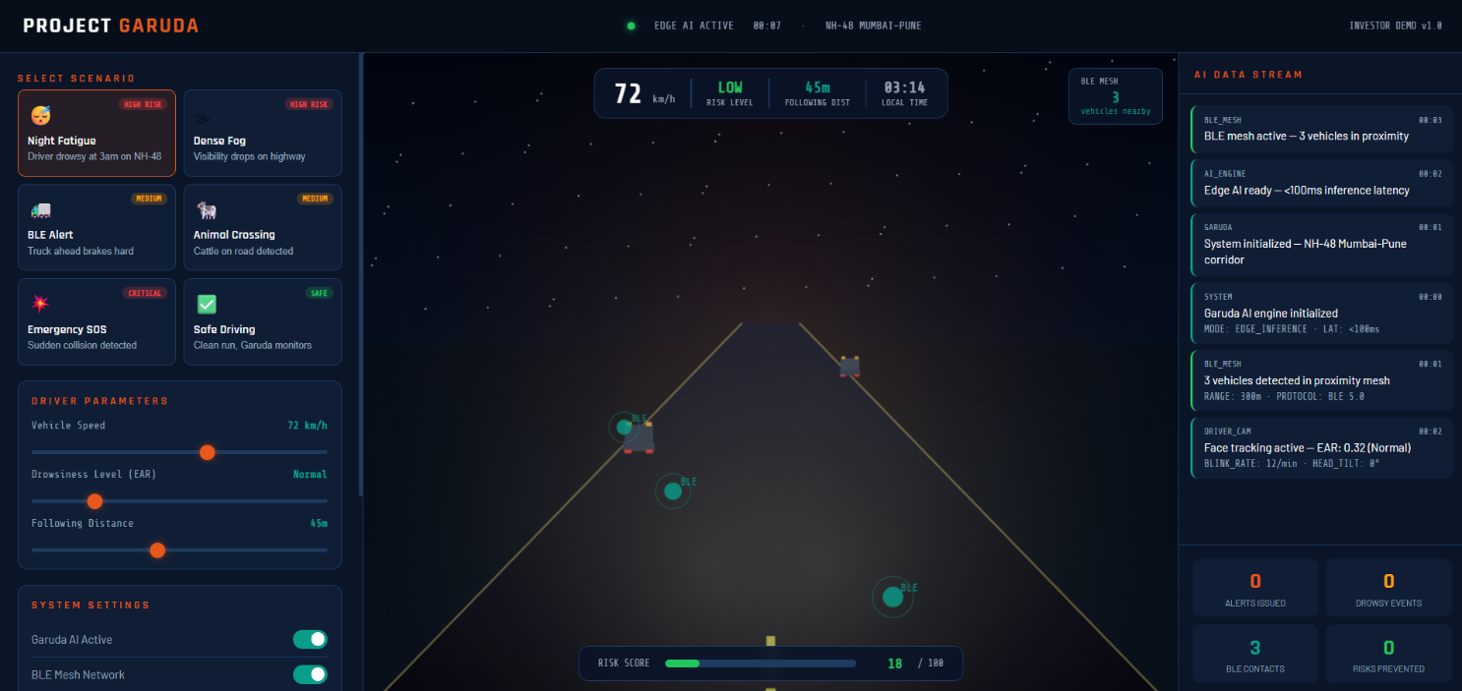
PROJECT GARUDA – Simulation
(Fig 1.3 – Simulation)
(Link - https://saketsinghrajput.github.io/garuda-docs/Project_Garuda_Simulation.html)

8. Competitive Analysis

8.1 Competitive Positioning Matrix
Solution | Offline Edge AI | Legacy Vehicle | BLE V2V | India-Tuned AI | AIS-184 Compliant | Retrofit Aftermarket
Project Garuda | ✓ | ✓ | ✓ | ✓ | ✓ | ✓
Mobileye (OEM) | Partial | ✗ | ✗ | ✗ | Partial | ✗
Bosch ADAS (OEM) | Partial | ✗ | ✗ | ✗ | Partial | ✗
BlackBuck Telematics | ✗ | Partial | ✗ | Partial | ✗ | ✓
Letstrack / Intellicar | ✗ | Partial | ✗ | ✗ | ✗ | ✓
Samsara (Global) | Partial | ✗ | ✗ | ✗ | ✗ | Partial

8.2 Why Garuda Cannot Be Easily Replicated
Garuda's defensibility is not primarily legal (although patents help) — it is data-structural. The four moats that compound over time:

- Indian Road Dataset — Every km driven by a Garuda-equipped vehicle adds to a proprietary dataset that no competitor can access retroactively. By Month 18, Garuda aims to have 50M+ km of labeled Indian road data — a dataset that would take a competitor 2+ years of deployment to replicate, even with unlimited capital.
- AIS-184 Compliance Early Mover — The October 2026 mandate creates a narrow procurement window where fleet operators must purchase certified solutions. Garuda's early entry means its certification documentation, installer network, and fleet references are established before competitors can enter.
- Offline BLE Mesh Network Effect — The BLE V2V network becomes more valuable with each additional Garuda unit on the same highway corridor. A competitor entering the market later finds that the network effect is already established on high-traffic routes.
- Legacy Vehicle Lock-in — Once a Garuda unit is installed and calibrated to a vehicle and driver baseline, switching costs are high. Fleet operators who invest in driver training and integrate fleet analytics into operations do not churn.

9. Results

10. Closing Statement
India's road safety crisis is a national emergency. 1.70 lakh deaths in 2024 alone represent a loss of life equivalent to a major natural disaster — every single year. The Government of India has recognized this, mandated technology as the solution, and set a deadline.

Garuda is not a response to the mandate. It is a purpose-built product that preceded the mandate, was designed for the exact conditions Indian commercial vehicle operators face, and is ready to deploy at scale before the October 2026 deadline closes.

The unit economics are exceptional. The market timing is unique. The technical moat — an offline BLE V2V mesh, India-tuned AI models, and a proprietary road dataset that compounds with every kilometer driven — is structural and defensible.

PROJECT GARUDA — Saving lives at the edge. No cloud required.

