**Day-05**

**Intro to CSS (Cascading Style Sheet)**

1. **Inline CSS**
2. **Internal CSS**
3. **External CSS**

Selectors:

1. class:

* Is a selector by which we select an element in html by using class attribute.
* In css we use dot (.) to define it is class selector.

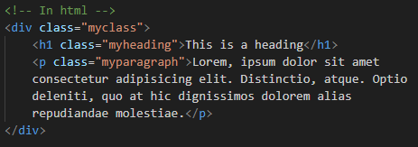

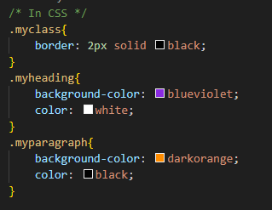

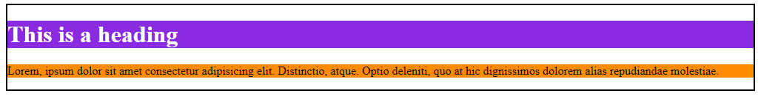

1. id:

* Is a type of selector by which we style elements in html by using id attribute.
* We use hash (#) to defines it is id selector in css.
* Id will over-ride all other selectors

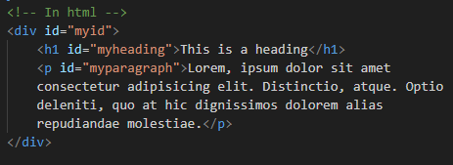

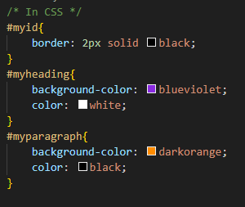

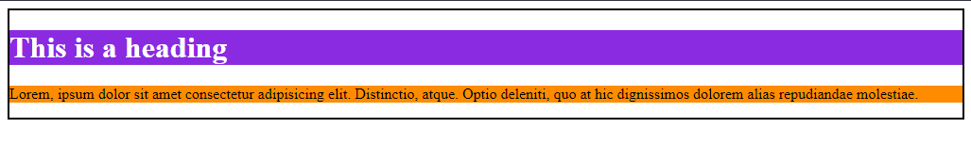

1. Element Selector:

* We can select the element just by its name directly
* No need of any representations for element selector

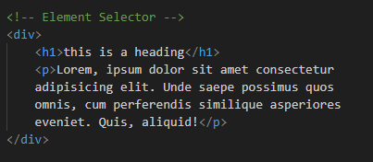

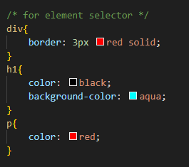

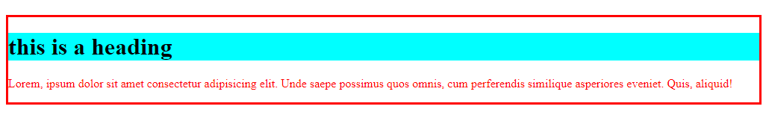

Margin and padding: