**Day-1**

Goals:

1. Architect the web app
2. Master the frontend and backend
   * + **Frontend**: UI/UX(User Interface/User Experience) What you see?
     + **Backend**: The entire data and the functioning of the website is processed.
     + **React**: frontend(helps you to build UI/UX)
     + NodeJS: backend (helps to connect the data to the user site).
3. **Redux**: helps to preserve the data of the user(improvising the react) like adding element into cart.
4. **Databases**: helps in storing the data that is generated by the user. Capable of storing lager data.
5. Write code that should be clean, manageable and reusable for the future use case.
6. Deployment of application.

**M E R N**

M:MongoDB

E:ExpressJS

R:ReactJS

N:NodeJS

RoadMap:­

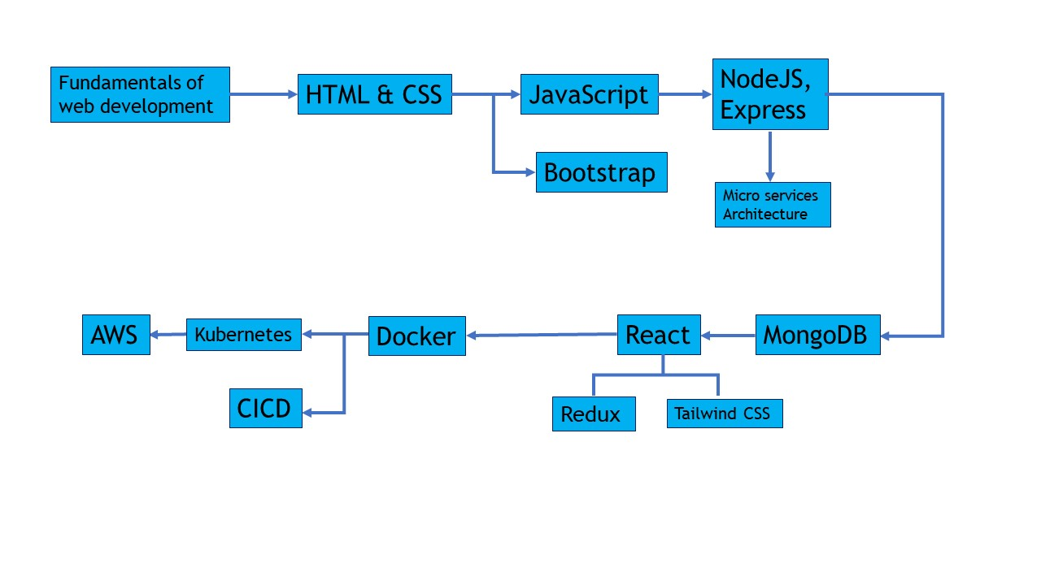

DNS(Domain Name System):

Takes the human readable text the URL and then converts it in IP address fetches the information or website and creates the connection between the user and the website.

Takes the URL converts in to IP address and creates the connection with the server of that particular IP address.

Ex:

[google.com](http://www.google.com) DNS server 64.233.191.255 Deliver the info

URL Structure:

TOP LEVEL DOMAIN(TLD)

https://study.shapeai.com/full-stack#urlstructure

SUB-DOMAIN PATH

DOMAIN ANCHOR