**Day-03**

Media:

1. Image tag:

* Used to insert images from the internet and the owned computer as well.
* Image tag is also a self-closing tag.

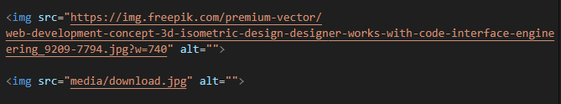

* Here we use width and height to increase or decrease the size of the image by pixels.



* alt="" or alternate is used to display or describe the image with text, whenever the image is not able to load that text will be displayed



1. Video tag:

* Video tag is used to insert videos. This is not a self-closing tag.



1. Here we use controls attribute to get controls display on the video to play, pause and mute etc...
2. Here we can also use width and height to increase or decrease the size.
3. Here we use autoplay by this the video get started playing automatically and to play it with mute we use muted.



Here is also a preferred method to write in another way:

