**Day-04**

Inline block:

1. **Block elements**:

* which take up the entire width that available to them.
* Always starts with a new line.

**Ex:**<p>, <h1> to <h6> etc...

1. **Inline elements:**

* which take up the width as per the data in it or as much as it necessary to it.
* Which does not start from new line.

**Ex:** <img>, <video>, <strong> etc...

**Note:** block elements can contain block and inline elements as well, but where as inline elements can only contain inline elements not the block elements.

Tables:

* We use table tag to insert tables.
* We can only insert rows.
* tr :table row , td : table data , th : table header

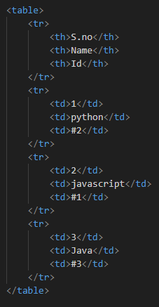

* Here we can add borders as well by border attribute.



Semantic Tags :

Some special and important tags:

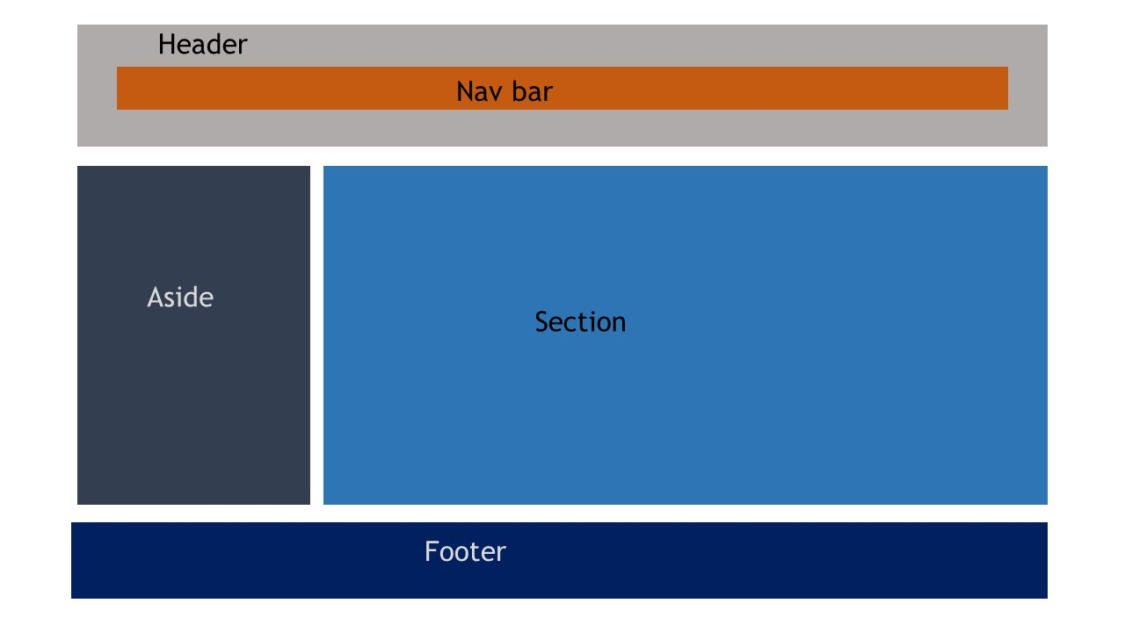

aira=accessible rich internet applications