**Day-2**

1. **Static:** No change, no user interaction, if there is a user interaction also there is no change in the backend or the database.

**Ex:** Documentation Websites, portfolio, Bootstrap etc...

1. **Dynamic:** Changes based on user interaction in database and the backend. Update the content of the website by connecting to the server in the database.

**Ex:** Amazon, Flipkart etc...

**HTML**

1. Headings:

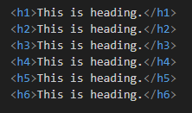

1. Line break:



This is self-closing tag.

Where it means there is a starting tag and the ending tag for heading tags but for line break tag it can end by itself.

1. Paragraph:



Default text style and the paragraph tag style is same.

1. Few text formatting tags:

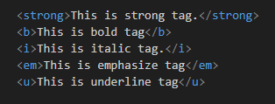

1. Listing:

There are two types of listing:

* + Unordered list: this list is formatted by bullet points rather than number or alphabets.

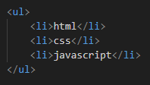

* + Ordered list: this list is formatted by numbering and alphabets rather than bullets

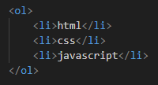

**NOTE:**

* Here we can change the format of lists like numbering to alphabets by using **type** attribute.

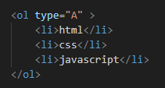

* Also, we can set numbering value by using **value** attribute.

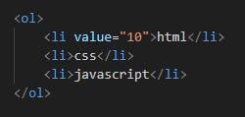

1. Division tag:

Division tag is used to divide the website content by assigning a name to it by class.



1. Line tag:

We use horizontal line tag here for line which is self-closing tag.

