## Problem Statement:

Managing and tracking the internship experiences of a large number of UG and PG students poses significant challenges for educational institutions. Teachers often struggle with the administrative burden of collecting, organizing, and analyzing internship data manually. This process is time-consuming and prone to errors, leading to inefficiencies and a lack of comprehensive oversight. Furthermore, without a streamlined system, it becomes difficult to ensure that internships are effectively aligned with students' academic goals and industry standards. There is also a need for a mechanism that provides clear, actionable feedback to students, helping them to reflect on their experiences and identify areas for improvement. Our project addresses these issues by developing a UG/PG Internship Module that simplifies data management through automated Excel sheet uploads, provides detailed overviews of internship statuses, and facilitates better mentorship and performance assessment. This solution aims to improve the administration and educational value of internships, ensuring that students gain meaningful,

hands-on experience that complements their academic learning..

## Abstract:

The UG/PG Internship Module is designed to streamline the process of managing and monitoring internships for undergraduate and postgraduate students. This module allows teachers to upload Excel sheets containing detailed information about students' internships. Upon uploading, the system generates a comprehensive overview of the internship details, providing insights into student placements, project progress, and mentorship effectiveness. The module aims to enhance the administrative efficiency of handling internships, ensure alignment between academic and industry experiences, and support the overall development of students through structured, real-world work engagements. By integrating these functionalities, the UG/PG Internship Module seeks to bridge the gap between classroom learning and practical industry experience, thereby preparing students for successful careers.

## Introduction:

In today's competitive job market, gaining practical experience through internships is crucial for students' career readiness. Internships bridge the gap between academic theory and real-world application, providing students with hands-on experience in their chosen fields. However, managing and monitoring these internships can be a complex task for educational institutions. Teachers are often overwhelmed with the administrative workload of tracking internship details, ensuring alignment with academic goals, and providing effective mentorship and feedback. The UG/PG Internship Module is designed to address these challenges by offering a streamlined solution that simplifies the management of internship data. By allowing teachers to upload Excel sheets containing students' internship information and generating comprehensive overviews, this module enhances administrative efficiency and supports students' professional development. Through this innovative approach, the UG/PG Internship Module aims to ensure that internships are valuable, well-organized experiences that significantly contribute to students' future career success.

## Objectives:

* **Centralize Faculty Activity Records:** Develop a centralized platform to collect, store, and manage faculty participation data in Faculty Development Programs (FDPs), webinars, seminars, and workshops across institutions.
* **Standardize Evaluation Criteria:** Implement a standardized system for evaluating and assigning marks to faculty activities based on engagement duration and type, ensuring consistent performance assessment.
* **Improve Accountability and Recognition:** Increase transparency and accountability by tracking and recognizing faculty contributions to academic activities beyond their home institution.
* **Streamline Data Management:** Ensure efficient and accurate data entry, storage, and retrieval processes to minimize errors and reduce administrative workload.
* **Secure User Authentication and Access Control:** Implement robust user authentication and role-based access control to protect data integrity and maintain confidentiality.
* **Facilitate Professional Development:** Support faculty members' professional growth by providing a structured approach to recording and evaluating their participation in academic activities.
* **Promote Knowledge Dissemination:** Encourage and recognize faculty involvement in knowledge dissemination activities, fostering a culture of continuous learning and development within the institution.
* **Generate Structured Reports:** Allow administrators to retrieve and present activity data in a structured, tabular format that includes essential details such as faculty name, workshop/seminar title, domain, dates, venue, and marks, supporting clear and comprehensive reporting.

## Software and Tools Required:

1. **Introduction**

# SRS Document

The UG/PG Internships Module will serve as a comprehensive system designed to manage student information, facilitate internship matching, and provide insights into student performance for faculty members. This system aims to enhance the internship experience for students by efficiently matching them with relevant opportunities and offering support throughout their internships. Simultaneously, it aims to streamline administrative tasks for teachers, providing them with easy access to student progress and performance data. Through this system, internships will become more enriching for students while being more manageable for faculty members.

### Purpose

This document is intended for the following group of people:-

* + - Developers for the purpose of maintenance and new releases of the software.
    - Documentation writers.
    - Testers.
    - Data Analyst.

### Scope

The UG/PG Internships Module offers a structured framework for seamlessly integrating internship opportunities into the academic curriculum. It provides diverse placements across industries, aligning activities with course objectives and offering preparatory resources to students. With structured assessment criteria, it evaluates students' performance and fosters partnerships with industry stakeholders for placements and mentorship. Professional development is emphasized through reflection and goal setting, while quality assurance measures ensure integrity and effectiveness. Ultimately, the module aims to prepare students for successful transitions to the workforce, contributing to their academic and professional growth.The software is expected to complete in duration of 1.5 month.

* 1. **Definitions, Acronyms, and Abbreviations**
  2. **References**

The references for the above software are as follows:-

1. [www.google.co.in](http://www.google.co.in/)
2. [www.wikipedia.com](http://www.wikipedia.com/)
3. Files from college
   1. **Overview**

Section 1.0 discusses the purpose and scope of the software.

Section 2.0 describes the overall functionalities and constraints of the software and user characteristics. Section 3.0 and 4.0 details all the requirements needed to design the software.

1. **The Overall Description**
   1. **Product Perspective**

The UG/PG Internships Module serves as an integral component within the academic institution's broader ecosystem, complementing existing curriculum structures and enhancing students' learning experiences. It interfaces with academic departments, faculty members, industry partners, and students to facilitate the seamless integration of internship opportunities into the academic curriculum.

* 1. **Product Functions**
* Internship Management: The module facilitates the management of internship opportunities, including posting, application, selection, and placement processes.
* Curriculum Integration: It ensures alignment of internship activities with course objectives and academic standards, facilitating the awarding of academic credit.
* Student Support: The module provides resources and support services to assist students in preparing for and participating in internships, including resume writing, interview preparation, and mentorship.
* Assessment and Evaluation: It implements structured assessment criteria to evaluate students' performance during internships, ensuring learning outcomes are met and academic standards are maintained.
* Industry Collaboration: The module fosters partnerships with industry stakeholders to facilitate internship placements, mentorship opportunities, and collaborative projects.
* Reporting and Analysis: It generates reports and analyzes data to track internship placements, student outcomes, and program effectiveness, informing decision-making and continuous improvement effort
* Search Filter: Here we are going to implement some s. search filters which are helpful to faculty to get the student data easily. The functions we are including in this are according to academic year, according to company name, according to duration of internship and stipend provided.
  1. **User Characteristics**

There are different kinds of users that will be interacting with the system. The intended users of the software are as follows:-

* **Faculty Members**: These educators, overseeing internships, manage opportunities and support student progress, utilizing the system to streamline administrative tasks and enhance student learning experiences.
* **Administrators**: Responsible for configuring and managing the system, administrators ensure smooth operation and user administration, facilitating effective communication and collaboration between faculty, industry partners, and students.
* **Industry Partners**: Collaborating with educational institutions, industry partners post opportunities, communicate details, and engage with faculty to provide valuable internship experiences, enriching student learning and professional development.
* **Students**: Undergraduate (UG) and postgraduate (PG) students participate in internships to gain practical experience, apply theoretical knowledge, and enhance their employability.
  1. **Constraints**

The major constraints that the project has are as follows:-

* **Resource Constraints**: The availability of resources, including staff, funding, and technology infrastructure, may impose limitations on the scope and scale of internship opportunities offered within the module.
* **Time Constraints**: The duration of internships and academic semesters may impose constraints on the scheduling and coordination of internship activities.
* **Regulatory Constraints**: Compliance with institutional policies, academic regulations, and legal requirements may impose constraints on internship placements, assessment processes, and data privacy considerations.
  1. **Assumptions and Dependencies**

The requirements stated in the SRS could be affected by the following factors: Assumptions and Dependencies:

* **Industry Partnerships**: The success of the internships module depends on establishing and maintaining partnerships with industry stakeholders to provide diverse internship opportunities and support student learning.
* **Faculty Engagement**: The active participation of faculty members is essential for supervising, mentoring, and assessing student internships, ensuring the quality and effectiveness of the internship experiences.
* **Student Engagement**: The engagement and participation of students in internships are crucial for achieving learning outcomes, acquiring practical skills, and maximizing the benefits of the internship’s module.

# 3.System Features

* 1. **Functional requirements**

**1. Student Dashboard**

* Personalized Dashboard: Display a customized dashboard for each student upon login.
* Internship Overview: Show a summary of all internships the student is enrolled in or has completed, including company names, start and end dates, and internship status.
* Internship Details: Provide detailed information about each internship, including mentor details, internship objectives, tasks, and outcomes.
* Progress Tracking: Include progress bars or indicators to show the completion status of each internship.
* Document Upload: Allow students to upload documents related to their internships, such as reports, certificates, or evaluations.

**2. Internship Management**

* Internship Registration: Allow students to register for internships and specify their preferences (e.g., field, location, duration).
* Internship Matching: Match students to internships based on their preferences, academic background, and other criteria.
* Internship Approval: Include a process for faculty or administrators to review and approve internship registrations.
* Internship Feedback: Enable students to provide feedback on their internship experiences, which can be reviewed by faculty or administrators.

**3. Faculty Dashboard**

* Internship Overview: Display a list of all internships for students under their supervision.
* Student Monitoring: Provide tools to monitor the progress of each student's internship, including weekly reports, milestones, and feedback.
* Internship Approval: Allow faculty to approve or reject internship applications and review associated documents.
* Communication Tools: Enable faculty to communicate with students through messages or announcements related to internships.

**4. Admin Dashboard**

* Internship Database: Maintain a comprehensive database of all internships, including company details, mentors, and associated documents.
* Data Viewing and Management: Allow authorized admins to view, edit, and delete internship records. Provide sorting and filtering options for easy data management.
* Access Control: Implement role-based access control to ensure only authorized users can view or modify sensitive information.
* Internship Reports: Generate reports on internships, including student participation, company engagement, and feedback.

**5. Internship Company Management**

* Company Database: Maintain a list of companies offering internships, including contact information, internship descriptions, and requirements.
* Company-Student Matching: Enable companies to view student profiles and select suitable candidates for internships.
* Company Communication: Provide tools for companies to communicate with students and faculty regarding internship opportunities and requirements.

# Validity Checks

Access to the system requires correct user ID and password, with limited login attempts to prevent unauthorized access. Exceeding the limit locks the account, requiring secure recovery methods like email verification. All sensitive data is encrypted, and secure session management prevents session hijacking. Administrators must enter their credentials for access to privileged functions, with role-based access control (RBAC) to manage permissions. Logs of all login attempts are kept for security monitoring. Optional multi-factor authentication (MFA) and robust password policies add extra layers of security..

# Sequencing Information

The information about the users should be entered into the database prior to any of the backup be maintained for all account information

# Error Handling/ Response to Abnormal Situations

If any of the above validation/sequencing flow does not hold true, appropriate error messages will be prompted to the user for doing the needful.

# 4. External Interface Requirements

**4.1.1 User Interface Requirements**

* **Faculty Dashboard**: Provides personalized dashboards for faculty members, displaying activities such as seminars, workshops, and training sessions, with interactive visualizations for easy interpretation.
* **Data Upload Interface**: Offers a user-friendly interface for faculty to upload new data and certificates related to events they have conducted or participated in, with validation checks to ensure data integrity and compatibility.
* **Administrative View**: Provides administrators with a centralized interface to view data for each faculty member individually, featuring search and filtering capabilities for detailed examination.
* **Certificate Download**: Allows faculty members to download certificates for events they have conducted or participated in, supporting multiple formats such as PDF, and enables administrators to download certificates for verification or record-keeping.
* **Data Sorting and Filtering**: Includes sorting and filtering options for tabular data, enabling users to rearrange and filter information based on specific criteria, improving usability.

# Software Interface Requirements

* Operating System Compatibility: Ensure compatibility with common operating systems like Windows, macOS, and Linux to cater to a wide range of users and environments.
* Web Browser Compatibility: Verify accessibility across popular web browsers such as Google Chrome, Mozilla Firefox, and Microsoft Edge to guarantee seamless user experience and maximize system usability.
* Database Management System (DBMS): Utilize a reliable relational database management system (RDBMS) like MySQL, PostgreSQL, or Microsoft SQL Server for efficient data storage and retrieval, ensuring scalability and performance.
* Programming Languages and Frameworks: Select appropriate front-end languages and frameworks (e.g., HTML, CSS, JavaScript) and back-end technologies (e.g., Node.js, Django, Spring Boot) to develop a robust and scalable system that meets project requirements.
* Authentication and Authorization Framework: Implement secure authentication and authorization mechanisms using industry-standard protocols like OAuth 2.0 or JSON Web Tokens (JWT) to protect user data and ensure secure access to system resources, maintaining the integrity and confidentiality of sensitive information.

# Communication Interface Requirements

* Communication Interface Requirements outline the key tools and features needed to support effective communication within the UG/PG Internship Module, ensuring seamless interaction among faculty, admins, and support staff. If you would like further elaboration or additional suggestions, I'm here to help.
* This interface includes Internal Messaging System, Email Notifications, Feedback and Suggestions, User Access Controls.

# Other Non-functional Requirements

* **Performance**: The system should respond to user interactions quickly, with dashboard loading, data retrieval, and report generation completing within acceptable timeframes. Performance should remain consistent, even during peak usage times or with large volumes of data.
* **Scalability**: The system must be scalable, capable of handling an increasing number of students, internships, faculty members, and associated data without impacting performance or system stability.
* **Security**: Robust security measures must be in place, including encryption for data in transit and at rest, role-based access controls, and protection against unauthorized access or data breaches. Implement mechanisms to detect and mitigate potential security threats.
* **Reliability**: The system should be highly reliable, with minimal downtime and robust backup procedures to prevent data loss. Redundancy and failover mechanisms should be in place to ensure uninterrupted access to critical functionalities.
* **Usability**: The user interface must be intuitive and user-friendly, designed to work across different devices and screen sizes. It should be accessible to users with varying levels of technical proficiency.
  1. **Accessibility**: The system must comply with accessibility standards (e.g., WCAG) to ensure equal access for users with disabilities. Features like screen reader support, keyboard navigation, and alternative text for images should be implemented..

# UML Diagrams

#### Usecase Diagram:

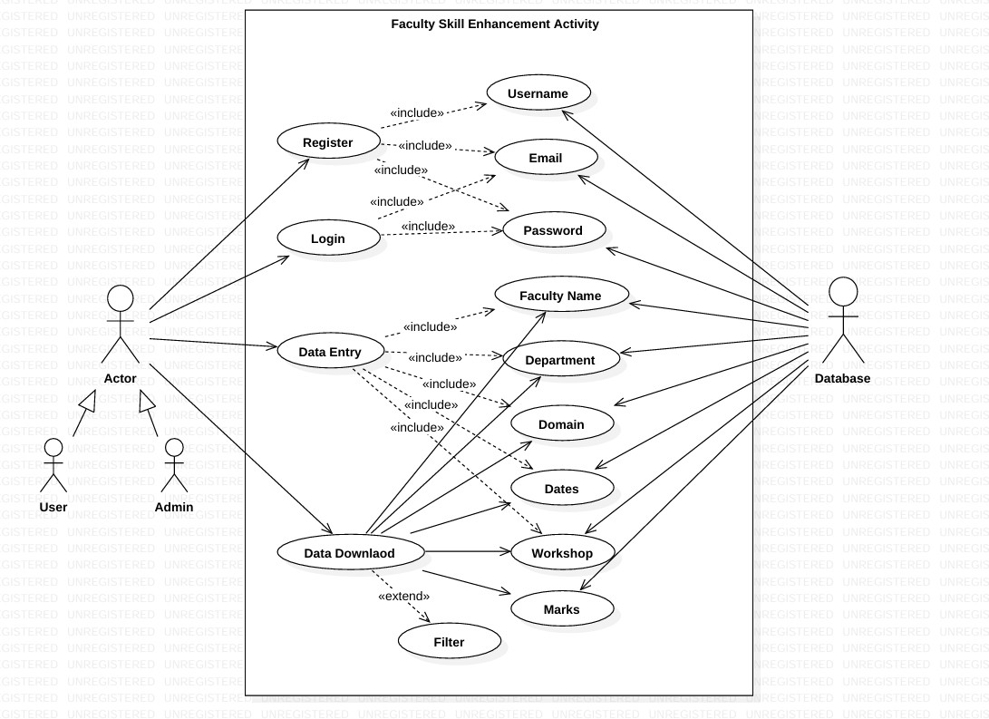

**Class Diagram:**

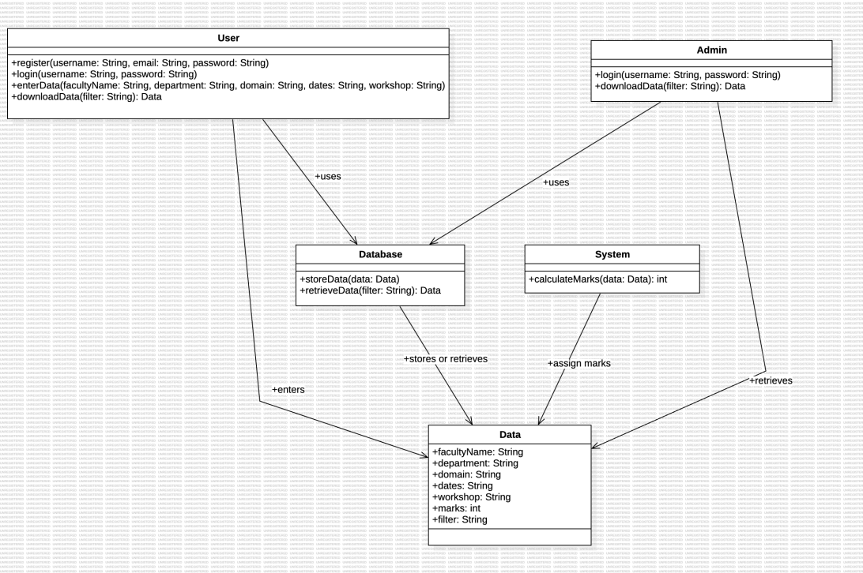

#### Sequence Diagram:

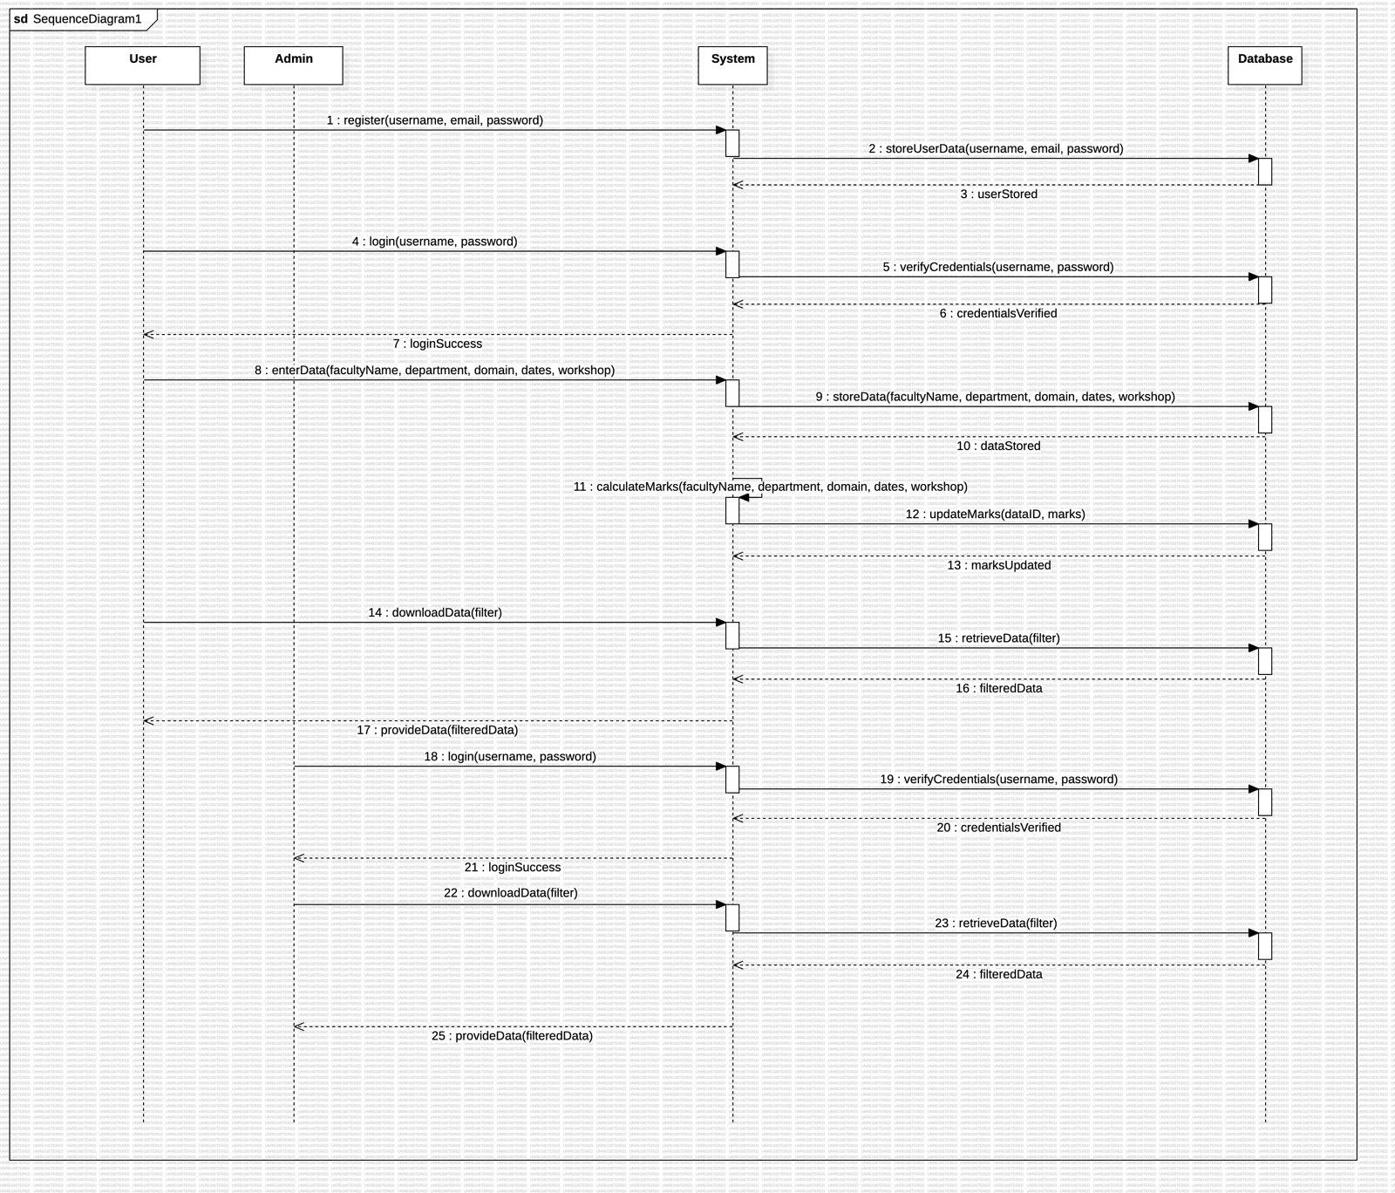

**Object Diagram:**

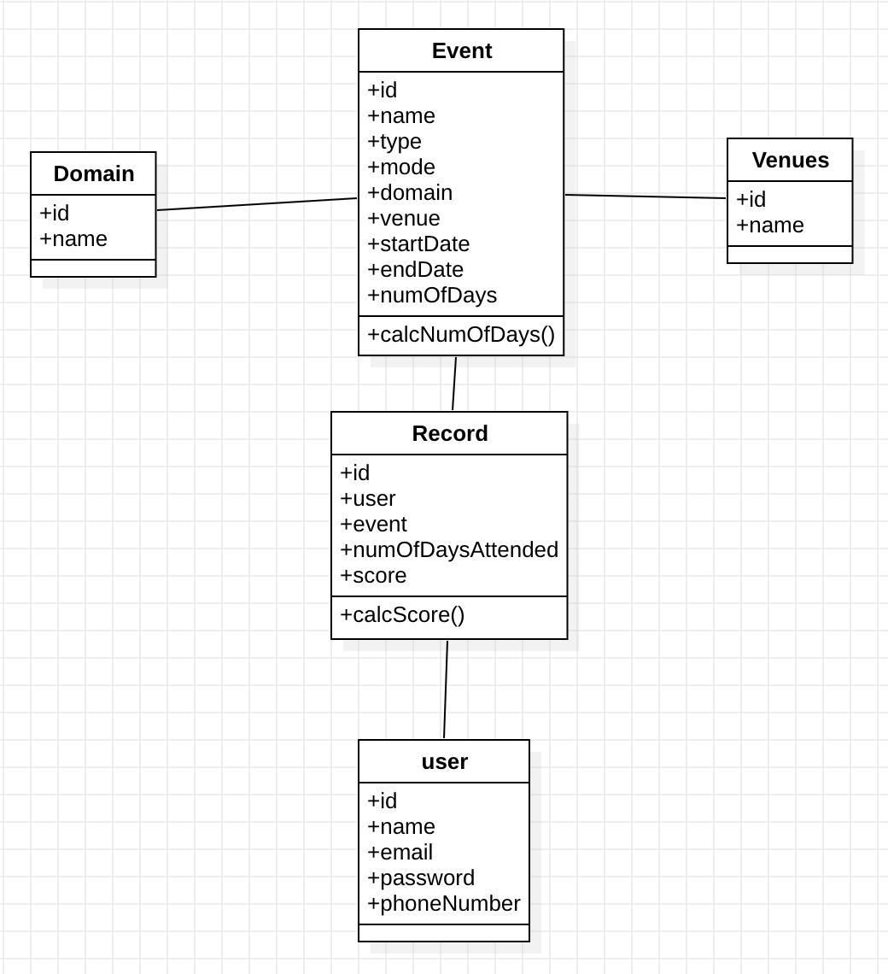

#### State Chart Diagram:

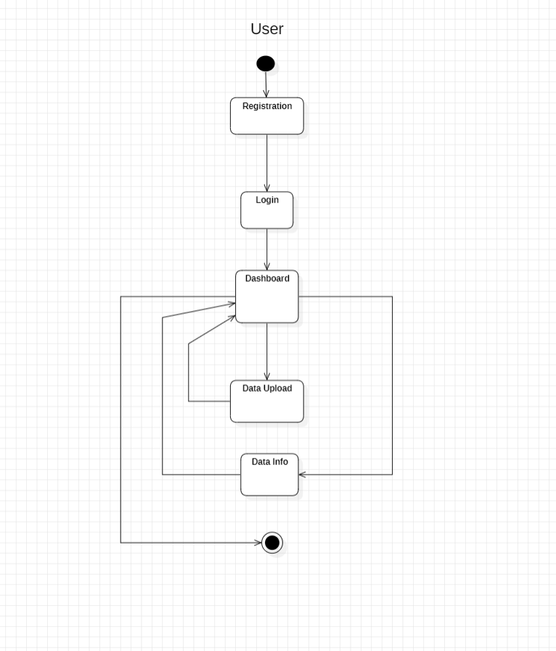

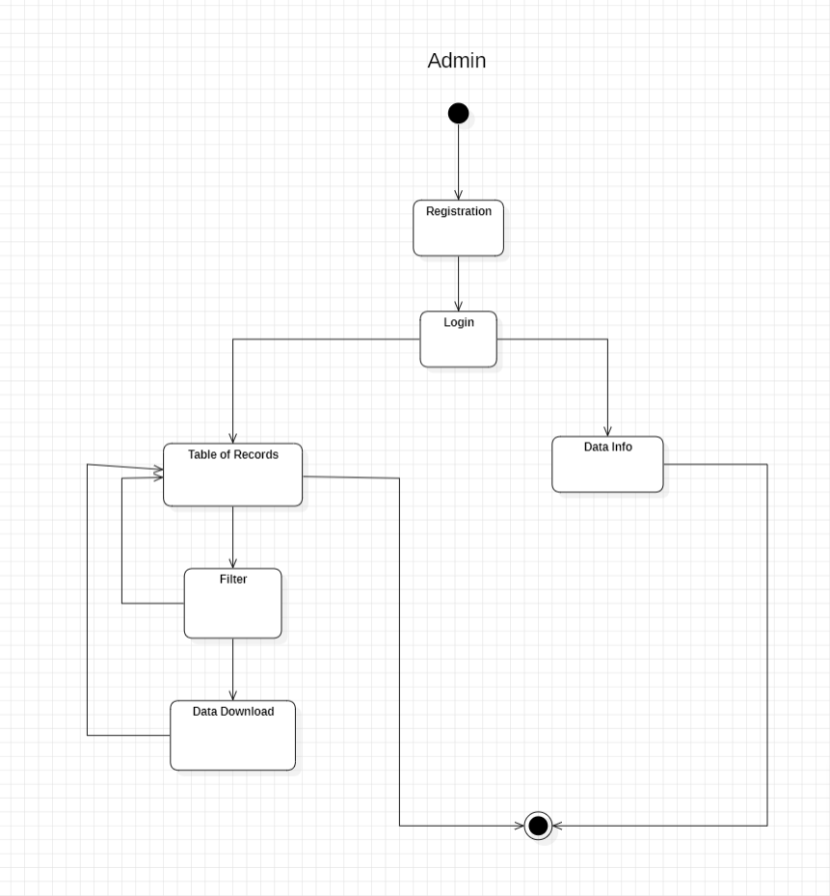

**Activity Diagram:**

#### User

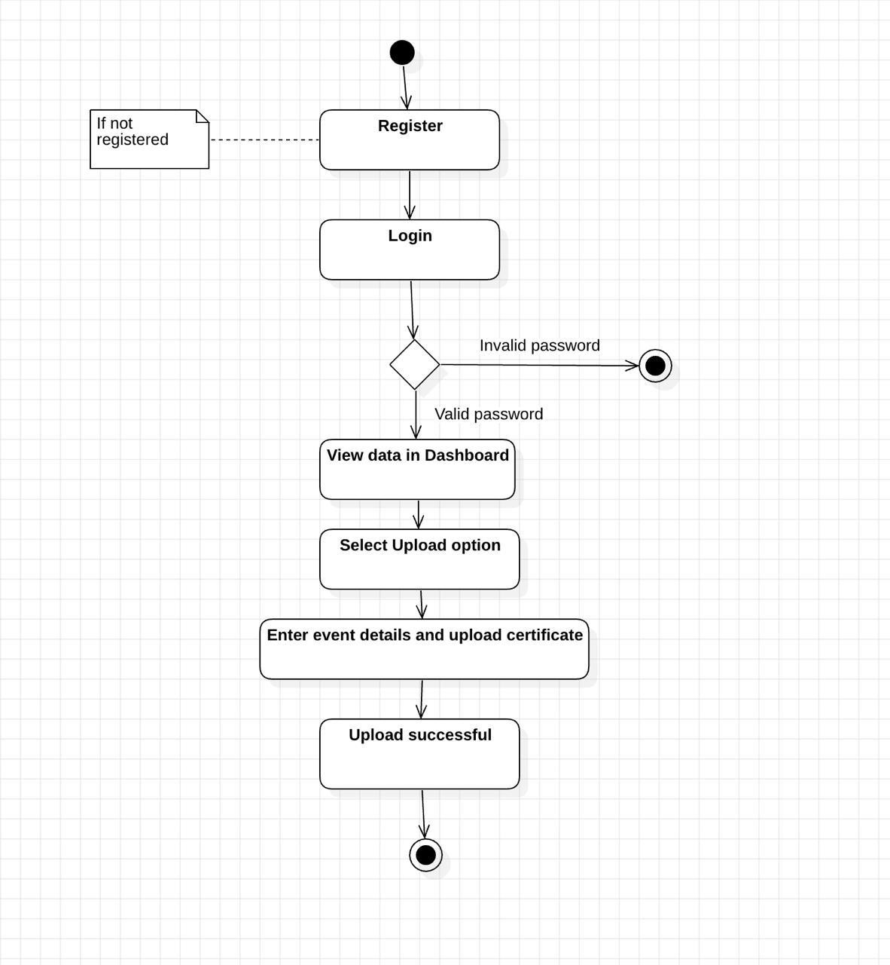

**Admin**

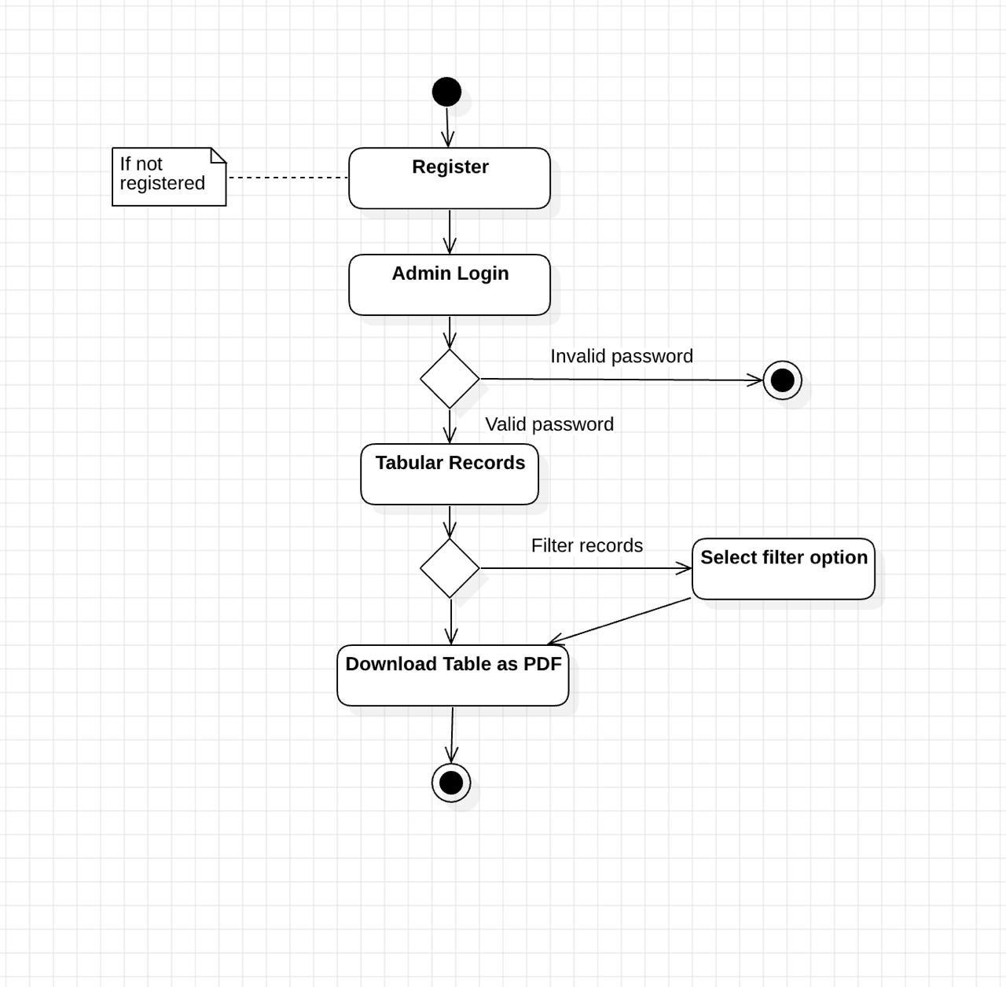

#### Component Diagram:

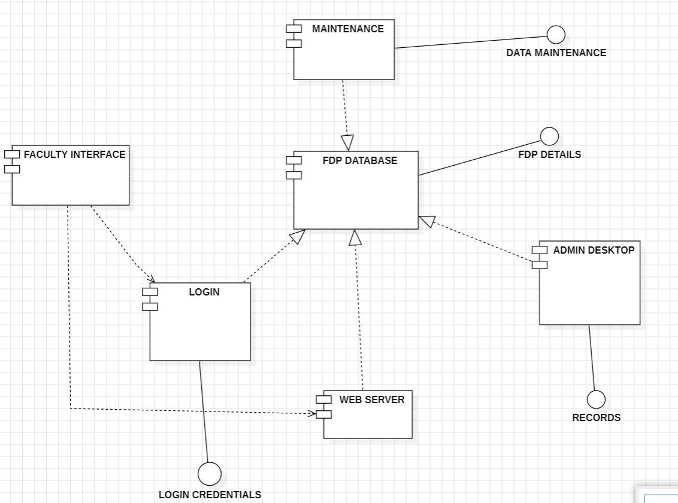

**Deployment Diagram:**

