**Next-Gen Movie Recommender System: Leveraging**

**NLP and Rich Metadata for Superior User Experience**

*submitted by*

**SAKETH-21BBS0123**

**TUMMALA.ROHITH-21BBS0134**

**ABEL HASAN-21BBS0091**

*Under the guidance of*

**Prof. Raja S P**

**Technical Answers for Real World Problems (TARP)**

*in partial fulfilment for the award of the degree of*

**Computer Science and Engineering**



|  |  |  |
| --- | --- | --- |
| S. NO | CONTENT | PAGE INDEX |
| 1 | Abstract | 3 |
| 2 | Introduction | 3 |
| 3 | Literature Survey | 4 |
| 4 | Research gap | 8 |
| 5 | Problem Statement | 9 |
| 6 | Motivation | 9 |
| 7 | Objectives | 9 |
| 8 | Proposed Solution and Implementation | 10 |
| 9 | Performance Metrics |  |
| 10 | Result | 12 |
| 11 | Conclusion | 12 |
| 12 | Future Scope | 13 |
| 13 | References | 14 |
| 14 | Appendix | 15 |
| 15 | Methodology |  |

# ABSTRACT

The movie recommender system addresses the challenge of movie discovery in the digital age by integrating multiple data sources to provide nuanced and personalized movie suggestions.

Traditional methods, which rely heavily on collaborative filtering and content-based filtering based on user ratings, often result in limited recommendations. In contrast, our system leverages the TMDB dataset extracting rich metadata, including titles, overviews, genres, keywords, cast, and crew. Through advanced text preprocessing and feature extraction, the system applies cosine similarity for comprehensive content-based filtering. Integration with the TMDB API enhances user experience with dynamic access to additional movie information and posters. Developed using the Streamlit framework, the user-friendly interface allows seamless input of preferences and exploration of recommended movies. This system not only enhances the movie discovery process but also improves user satisfaction and engagement by providing tailored and engaging movie recommendations.

# INTRODUCTION

The Movie Recommender System developed in this project aims to assist users in discovering new movies based on their preferences and interests. With the vast amount of content available, users often face difficulty in selecting movies that align with their tastes. Traditional recommender systems rely on collaborative filtering or content-based approaches, which may not always capture the nuances of individual preferences accurately. Therefore, this project proposes a solution leveraging NLP techniques to analyse movie descriptions, genres, and other metadata to provide personalized recommendations.

The project begins by sourcing movie data from the TMDB API, comprising information such as titles, overviews, genres, keywords, cast, and crew. This dataset serves as the foundation for building the recommender system. Preprocessing steps involve cleaning and transforming the data to extract relevant features, such as tokenizing text, stemming words, and vectorizing features for analysis.

The core of the system lies in computing the similarity between movies using cosine similarity, a measure that quantifies the similarity between two non-zero vectors. By representing movies as vectors based on their features, the system can identify movies with similar characteristics, thus enabling personalized recommendations. The similarity scores are then used to rank movies and present the top recommendations to the user. Enhancing the user experience, the system integrates with the TMDB API to dynamically fetch movie posters, providing visual representations of recommended movies. This enriches the recommendation process and helps users make informed decisions about which movies to watch.

# LITERATURE SURVEY

|  |  |  |  |  |  |  |
| --- | --- | --- | --- | --- | --- | --- |
| Sno | Title | Author | Publications | Algorithm | Advantages | Drawbacks |
| 1 | Movie recommend ation and sentiment analysis using machine learning | N Pavitha  , Vithika  Pungliyaa,  Ankur  Raut ,  Roshita  Bhonsle ,  Atharva  Purohit ,  Aayushi  Patel , R Shashidha  r | 2022 | Movie Recomme  ndation System:  Cosine  Similarity  Sentiment Analysis:  Naive  Bayes  (NB) and  Support  Vector  Classificat  ion (SVC) | 1 Cosine Similarity  Efficiency 2 Comparison of Algorithms 3 Robust  Performance | 1 Newly added movies  with little to no user interaction . 2 User Input  Sensitivity 3 Linguistic Limitations |
| 2 | A Neural  Network-  Inspired Approach  for  Improved and True Movie Recommen  dations | Muhamma d  Ibrahim,  Imran Sarwar  Bajwa, Riaz Ul-  Amin, Bakhtiar  Kasi | 2019 | Movie Recomme  ndation System:W eb Bot & Apache  Hadoop  Sentiment Analysis:  Recurrent  Neural  Networks (RNN) with Long  Short-  Term  Memory (LSTM) and user movie  attention  (UMA). | 1. Diverse Data   Integration   1. Reduced   Bias 3 Emotion Extraction | 1  Maintenance 2 Availability and Quality 3 Energy  Consumption |

|  |  |  |  |  |  |  |
| --- | --- | --- | --- | --- | --- | --- |
| 3 | A Study of  News  Recommen der  System using Natural  Language  Cloud  Computing  Services | A.A.  Jalbani,  Mukhtiar  Memon,  Muniba  Memon,  S.  Depar, M. Y.  Koondhar | 2018 | Sentiment Analysis:  Google  Cloud  Natural  Language  API | 1. Advanced   NLP  Capabilities   1. Impactful   Recommendati  ons   1. Scalability | 1 Third-Party  Reliance 2 Sarcasm and Irony 3 Manual  Verification |
| 4 | Sentiment  Analysis on  Movie Scripts and  Reviews | Paschalis  Frangidis, Konstantin os Georgiou,  Stefanos Papadopo  ulos | 2020 | Sentiment Analysis:  VADER,  Naive  Bayes,  SVM,  Logistic Regressio n, CNN, LSTM, BERT | 1.Simple, efficient, and designed for social media text.  2.Fast and works well with small datasets.  3.Effective in highdimensional spaces, robust to overfitting. | 1.Limited to pre-defined lexicon, less accurate on complex texts.  2.Computatio nally intensive, less interpretable.  3.May struggle with non-linear relationships. |
| 5 | Sentiment  Analysis of  Movie  Reviews  Using  Machine Learning  Techniques | Duc Duy  Tran, Thi  Thanh  Sang  Nguyen,  Tran Hoang  Chau Dao | 2021 | sentiment analysis :  Naive  Bayes,  SVM,  Logistic Regressio n, CNN, LSTM | 1.Fast, simple, effective with small datasets 2.Effective in highdimensional spaces, robust to overfitting. 3. Captures local patterns, effective for spatial hierarchies in text.    . | 1.Assumes feature independence  , less accurate with complex patterns.  2.Computatio nally intensive, difficult to interpret. 3.May not capture nonlinear relationships. |
| 6 | Movie  Recommen | Tarun  Soni,  Amol | 2023 | Movie  Recomme | 1.Utilizes user interaction data 2.can | 1.scalability issues with large |

|  |  |  |  |  |  |  |
| --- | --- | --- | --- | --- | --- | --- |
|  | dation System | Vasudeva (Guided  by) |  | ndation system: collaborati ve filtering, contentbased filtering. | recommend diverse content. 3.Reduces dimensionality | datasets.  2.Computatio nally intensive 3.complex to implement and tune. |
| 7 | A Ranking  Learning  Model by  K-Means  Clustering Technique for Web Scraped  Movie Data | Kamal  Uddin  Sarker,  Mohamme  d Saqib, Raza  Hasan,  Salman  Mahmood,  Saqib  Hussain,  Ali Abbas,  Aziz  Deraman | 2022 | Implement ed kmeans  clustering to create six clusters for movie selection support. | 1. Ethical Data Extraction. 2. Data Validation. 3. User   Support, | 1. Limited dataset. 2. Influencing factor. 3. Clustering approach. |
| 8 | A  NaturalLang uageProcess ing-Based Method for the Clustering and  Analysis of  Movie Reviews and  Classificatio n by Genre | Fernando  González,  Miguel  Torres-  Ruiz,  Guadalupe  RiveraTorruco,  Liliana  ChononaH  ernández, Rolando  Quintero | 2023 | Sentiment analysis: K-means  clustering, and PCA  classifying movie reviews by genre. | 1. Automated genre prediction without manual curation is done enhancing the efficiency. 2. By utilizing machine learning techniques, the model can evaluate accuracy, recall, precision, and F-1 score for annotated datasets. | 1. Challenged in predicting genres for reviews with ambiguous or mixed characteristic  s.  2.  Dependency  on the quality and representative ness of the training data could impact the model's performance. |
| 9 | Movie  Recommend  ation | Sudhanshu Kumar,  Kanjar De, | 2020 | Movie  Recomme | 1. The algorithm leverages user | 1. The algorithm may face |

|  |  |  |  |  |  |  |
| --- | --- | --- | --- | --- | --- | --- |
|  | System  Using  Sentiment  Analysis  From Microbloggi ng Data | Partha Pratim Roy |  | ndation system: collaborati ve filtering and contentbased filtering. | preferences and sentiments to provide personalized movie recommendatio ns.   1. By combining CF and CBF, it addresses the cold start problem and improves recommendatio n accuracy. 2. Sentiment analysis adds a layer of understanding user emotions towards movies, leading to more tailored recommendatio ns. | challenges in handling large-scale data sets efficiently. 2. It may struggle with recommendin  g niche or less popular movies due to limited user sentiment data.  3. The effectiveness of sentiment analysis in capturing complex user preferences and emotions could vary based on the quality of the sentiment analysis model used. |
| 10 | Multilingual  Opinion  Mining  Movie  Recommend  ation  System  Using RNN | Tarana  Singh,  Anand  Nayyar,  Arun  Solanki | 2020 | Sentiment analysis:  RNN  architectur esof Long  Short-  Term  Memory (LSTM) and Gated  Recurrent  Unit (GRU) is executed.      Recomme ndation: | 1. RNNs excel in handling sequential data like text,   making them suitable for sentiment analysis of tweets.   1. RNNs can capture context and dependencies in text data, leading to more accurate sentiment classification | 1. RNNs can be computationa lly intensive and may require significant resources for training and inference. 2. RNNs may struggle with long-range dependencies in text data, potentially affecting the accuracy of |

|  |  |  |  |  |  |  |
| --- | --- | --- | --- | --- | --- | --- |
|  |  |  |  | K-Means Clustering and KNN framework  s using  RMSE  estimation s is executed. | and personalized recommendatio ns. | sentiment analysis in complex sentences. |

# RESEARCH GAP

1. User Interaction and Sensitivity

Newly Added Movies: Lack of user interaction data for new movies, affecting recommendations and analysis.

1. Computational and

Resource Limitations

User Input Sensitivity: High sensitivity to user inputs, potentially leading to inaccurate results.

Energy Consumption: Computationally intensive processes requiring significant resources.

RNN Challenges: High resource requirements and difficulty in handling long-range dependencies in text.

1. Linguistic and

Interpretability Issues

Linguistic Limitations: Limited to predefined lexicons, struggles with complex and non-linear text relationships.

Sarcasm and Irony: Difficulty in detecting sarcasm and irony, leading to potential misinterpretation of sentiment.

1. Model Complexity

Maintenance and Implementation:

Scalability issues with large datasets and complex implementation and tuning requirements.

Third-Party Reliance: Dependence on external data sources and services, which may affect reliability.

Manual Verification: Necessity for manual verification to ensure accuracy.

1. Data Quality and

Representativeness

Availability and Quality: Challenges due to limited and potentially non-representative datasets.

Training Data Dependency: Model performance heavily dependent on the quality and representativeness of training data.

1. Genre Prediction and Niche

Recommendations

Clustering Approach: Difficulties in predicting genres for reviews with ambiguous or mixed characteristics. Niche Recommendations: Struggles with recommending niche or less popular movies due to limited user sentiment data.

1. Sentiment Analysis

Complex User Preferences: Variability in capturing complex user preferences and emotions based on the quality of sentiment analysis models.

|  |  |  |  |  |
| --- | --- | --- | --- | --- |
| |  |  | | --- | --- | | **PROBLEM STATEMENT**    In the digital age, movie recommendation systems often rely on traditional methods that use a single attribute, such as user ratings, to generate recommendations. This approach usually results in limited and less personalized recommendations because it fails to capture the complex and varied preferences of users. Such systems do not adequately take into account the rich metadata available, which can include movie titles, reviews, genres, keywords, cast and crew information. As a result, users often receive recommendations that do not fully match their interests, resulting in an optimal movie discovery experience. The lack of multi-attribute integration in these systems leads to a narrow view of user preferences, which ultimately reduces user satisfaction and engagement. There is a critical need for a more advanced recommendation system that can use multiple attributes to provide nuanced and | personalized movie recommendations. By fixing this limitation, we can improve the movie discovery process by providing users with more relevant and engaging content that better matches their unique tastes and preferences.      **MOTIVATION**    To address the shortcomings of traditional recommendation methods that rely on a single attribute, resulting in less personalized and engaging suggestions. By harnessing the power of NLP and the comprehensive metadata from the TMDB dataset, we aim to create a highly accurate and personalized recommendation system. This next-generation approach will enhance user satisfaction, improve the movie discovery process, and cater to the complex and diverse preferences of users, ultimately delivering a superior and more enjoyable movie-watching experience. | |  |  | |

Accuracy in Complex Sentences: Potential inaccuracies in sentiment analysis for complex sentences due to long-range dependencies.

# OBJECTIVES

1. To develop a Sophisticated Recommender System

Create an advanced movie recommendation system that integrates multiple attributes for nuanced and personalized suggestions.

1. To utilize rich metadata

Leverage the comprehensive metadata available in the TMDB dataset, including titles, overviews, genres, keywords, cast, and crew information.

1. To create a Comprehensive

Content-Based Filtering Model

Develop a content-based filtering model that uses cosine similarity to assess movie similarity based on multiple attributes.

1. To integrate with TMDB API Utilize the TMDB API to dynamically access additional movie information and posters, ensuring the recommendations are up-to-date and visually appealing.

1. To capture Complex and Diverse User Preferences

Design the system to better understand and cater to the complex and diverse preferences of users compared to traditional methods.

1. To improve Movie Discovery

Process and User satisfaction

Enhance the movie discovery process, making it easier for users to find relevant and interesting movies.

1. To offer a Personalized MovieWatching Experience

|  |
| --- |
| preferences of each user. |

Deliver a more relevant and personalized movie-watching experience that aligns closely with the unique tastes and

# PROPOSED SOLUTION AND IPLEMENTATION

1. Data Acquisition and

Preprocessing:

The system will source movie data from the

TMDB (The Movie Database) API, including details such as titles, overviews, genres, keywords, cast, and crew. We load the CSV files into Pandas DataFrames (movies and credits). Data preprocessing steps will involve cleaning the data, handling missing values, and transforming the textual data into a format suitable for analysis We convert genres, keywords, cast, and crew columns from JSON-like strings to lists of relevant values (e.g., genre names, cast names). Functions convert, convert3, and fetch_director are used to extract and limit the data from these columns. We split the overview text into individual words. We combine overview, genres, keywords, cast, and crew into a single tags column for each movie. Join the words in tags back into a single string and convert it to lowercase. Then we apply stemming to the tags to reduce words to their root forms using NLTK's

PorterStemmer

1. Feature Extraction and

Representation:

Meaningful features will be extracted from the movie metadata to represent movies effectively. These features will include words from movie overviews, genres, keywords, and names of cast and crew members. The extracted features will be transformed into numerical vectors using Count Vectorizer to facilitate similarity computation. We use CountVectorizer from scikit-learn to convert the text data in tags into a matrix of token counts (vectors), considering only the top 5000 features and excluding English stop words.

1. Similarity Computation:

Cosine similarity will be employed to compute the similarity between movies based on their feature vectors. This metric quantifies the similarity between two vectors in multi-dimensional space, allowing for efficient comparison of movie characteristics. The similarity scores between movies will be calculated using cosine similarity, enabling the system to identify movies with similar content or themes.

1. Personalized Recommendation:

The system will incorporate user preferences and viewing history to tailor recommendations to individual users. User feedback, ratings, and interactions with previously recommended movies will be considered to refine the recommendation algorithm. Collaborative filtering techniques may also be employed to identify similar users and recommend movies based on their preferences.

1. Integration and User Interface:

The system will be implemented using Python programming language and popular libraries such as pandas, NumPy, scikit learn, NLTK, and Streamlit for building interactive web applications. Integration with the TMDB API will enable dynamic fetching of additional movie information and movie posters to enhance the user experience. The user interface will provide a user friendly platform for users to input their preferences, view recommended movies, and explore additional movie details.

# Technical Specifications

In this project various techniques are employed to develop the Movie

Recommender System and its associated web interface. These techniques encompass data acquisition, preprocessing, natural language processing (NLP), machine learning, and web development.

1. Data Acquisition and Preprocessing
   * Acquire movie data from reliable sources such as the TMDB (The Movie Database) API, which provides a vast repository of movie information including titles, descriptions, genres, cast, crew, and keywords.
   * Data Cleaning: Perform data cleaning operations to handle missing values, remove duplicates, standardize formats, and ensure data consistency. Techniques such as data imputation, string manipulation, and outlier detection may be applied.
2. Natural Language Processing (NLP)
   * Text Tokenization: Tokenize movie descriptions and other textual data into individual words or phrases to facilitate further processing.
   * Text Vectorization: Convert text data into numerical representations using techniques such as TF-IDF

(Term Frequency-Inverse Document Frequency) or word embeddings (e.g., Word2Vec,

GloVe) or Count Vectorizer.

* + Stemming and Lemmatization: Apply stemming or lemmatization techniques to reduce words to their base or root forms, improving the efficiency and accuracy of text processing.

1. Machine Learning
   * Similarity Computation: Utilize machine learning algorithms to compute similarity scores between movies based on their feature representations. Common similarity metrics include cosine similarity, Jaccard similarity, or Euclidean distance.
   * Recommendation Algorithms: Implement recommendation algorithms such as collaborative filtering, content-based filtering, or hybrid approaches to generate personalized movie recommendations for users.
   * Model Training and Evaluation:

Train machine learning models on historical movie data to learn patterns and relationships and evaluate their performance using appropriate metrics such as precision, recall, and mean average precision (MAP).

1. Web Development:
   * Web Frameworks: Used web development frameworks such as Streamlit or Flask to build the user interface for the Movie

Recommender System.

* + Frontend Design: Designed an intuitive and visually appealing frontend interface where users can input their preferences, view recommended movies.
  + Backend Development: Implemented a backend functionality to handle user requests, process data, and communicate with external APIs such as the TMDB API to fetch movie posters and metadata dynamically.

By integrating these techniques, the project creates a comprehensive Movie

Recommender System with a user-friendly web interface, enabling users to explore personalized movie recommendations efficiently and enjoyably.

# Flow chart



DATA

LOADING



DATA

PREPROCESS

ING



FEATURE

EXTRACTION



SIMILARITY

CALCULATIO

N



MOVIE

RECOMMEN

DATION

# PERFORMANCE METRICS

Our movie recommender system utilizes several key performance metrics to evaluate its effectiveness in providing personalized and engaging movie recommendations. These metrics includeAccuracy (Genre Match), Precision (Genre Relevance), Recall (Genre Coverage), User Engagement (Average Time Spent per Session), Diversity (Genre Distribution Balance), and Novelty (Percentage of New Genre Explorations). Each metric provides insights into different aspects of the recommendation system's performance.

1. Accuracy (Genre Match)

Accuracy measures the percentage of recommended movies that share at least one genre with the user's preferred genres. This metric indicates how well the system aligns its recommendations with the genres that the user enjoys. For example, if a user prefers action and comedy movies, high accuracy means that a significant portion of the recommended movies will fall into these genres. An 85% accuracy rate suggests that the system is highly effective in recommending movies within the user's favorite genres, enhancing the relevance and satisfaction of the recommendations.

1. Precision (Genre Relevance)

Precision evaluates the percentage of recommended movies where the shared genres are highly relevant to the user's preferred genres. This metric focuses on the relevance of the recommendations, ensuring that the genres matched are not just incidental but are genuinely aligned with the user's interests. For instance, if a user prefers romantic comedies, high precision means that the recommended movies not only share the comedy or romance genre but are particularly wellsuited to the user's specific taste. A precision rate of 75% indicates that the system excels at identifying and recommending movies that closely match the user's genre preferences.

1. Recall (Genre Coverage)

Recall measures the percentage of userpreferred genres that are represented inthe recommended movies. This metric assesses the system's ability to cover abroad range of the user's genre preferences. For example, if a user has a diverse taste in movies, liking both horror and science fiction, good recall ensures that both these genres are represented in the recommendations. A recall value of 70% signifies that the system successfully captures a significant portion of the genres the user enjoys, ensuring a comprehensive and well-rounded recommendation list.

1. Specificity (Genre Exclusion Accuracy)

Specificity measures the percentage of nonpreferred genres successfully excluded from recommendations. This metric ensures that the system avoids recommending movies from genres the user does not enjoy. For example, if a user dislikes horror movies, a specificity rate of 90% indicates that the system effectively excludes horror movies from the recommendations.

1. Sensitivity (Genre Inclusion Accuracy)

Sensitivity measures the percentage of preferred genres successfully included in recommendations. This metric ensures that the system captures all user interests in the recommendations. For example, if a user has multiple preferred genres, an 85% sensitivity rate indicates that the system includes a significant portion of these genres in the recommendations.

1. User Engagement (Average Time Spent per Session)

User engagement is measured by the average time users spend interacting with the system per session. This metric provides insights into how engaging and interactive the system is. A high average time spent, such as 5 minutes per session, suggests that users find the system interesting and are willing to spend time exploring the recommended movies. High user engagement is indicative of a user-friendly interface and the relevance of the recommendations provided.

1. Diversity (Genre Distribution Balance)

Diversity measures the ratio of unique genres represented in the recommendations compared to the total number of recommendations. This metric ensures that the system does not overly focus on a narrow set of genres but instead offers a variety of genres. For example, if a user enjoys multiple genres, high diversity ensures that the recommendations are not limited to just one or two genres. An 80% diversity value indicates that the system provides a wide range of genre recommendations, introducing users to a broader spectrum of movies.

1. Novelty (Percentage of New Genre Explorations)

Novelty measures the percentage of recommended movies that belong to genres not explicitly listed in the user's preferences. This metric assesses the system's ability to introduce users to new and potentially interesting genres that they might not have considered before. For example, if a user has never explicitly shown an interest in documentaries but receives and enjoys a recommended documentary, the system demonstrates novelty. A 20% novelty rate suggests that the system successfully introduces users to

new cinematic experiences, enhancing the discovery aspect of the movie recommendation process.

|  |  |  |  |  |
| --- | --- | --- | --- | --- |
| Metric | Description | Sample Value |  | Interpretation |
| Accuracy  (Genre Match) | Percentage of recommended movies that share at least one genre with the user's preferred genre(s). |  | 85% | High accuracy indicates the system effectively recommends movies within genres the user enjoys. |
| Precision  (Genre  Relevance) | Percentage of recommended movies where the shared genre(s) are highly relevant to the user's preferred genres. |  | 75% | High precision suggests the system excels at identifying relevant movies within the user's preferred genre categories. |
| Recall (Genre Coverage) | Percentage of user-preferred genres that are represented in the recommended movies. |  | 70% | A good recall value indicates the system captures a significant portion of the genres the user enjoys. |
| Specificity  (Genre  Exclusion  Accuracy) | Percentage of non-preferred genres successfully excluded from recommendations. |  | 90% | High specificity indicates the system avoids recommending movies from unwanted genres. |
| Sensitivity  (Genre  Inclusion  Accuracy) | Percentage of preferred genres successfully included in recommendations. |  | 85% | High sensitivity ensures the system captures all user  interests in the recommendations. |
| User  Engagement  (Average Time  Spent per  Session) | Average time users spend interacting with the system per session. | 5 mins |  | A high average time spent suggests the system is engaging and keeps users interested. |
| Diversity  (Genre  Distribution  Balance) | Ratio of unique genres represented in recommendations compared to the total number of recommendations. |  | 80% | A high diversity value indicates the system recommends a variety of genres beyond just the user's most preferred ones. |
| Novelty  (Percentage of New Genre  Explorations) | Percentage of recommended movies that belong to genres not explicitly listed in the user's preferences. |  | 20% | A significant percentage of new genre recommendations suggests the system successfully introduces users to new cinematic experiences. |

# RESULT AND DISCUSSION

* Efficient Data Processing

The system effectively sourced movie metadata from the TMDB API and processed it to extract the metadata like movie overviews, genres, keywords, and cast and crew names. Natural language processing techniques were employed to transform textual data into the machine readable format.

* Accurate Similarity Computation

Cosine similarity was used to measure the similarity between movies based on their feature vectors, enabling the system to preferentially prioritize and identify movies with similar content or themes.

* Personalized Recommendations

User preferences and viewing history were incorporated into the recommendation algorithm, facilitating suggestions to individual users. The system considers user feedback, ratings, and interactions with previously recommended movies to refine the recommendation procedure and provide more relevant suggestions.

* Dynamic Integration and User Interface

Seamless integration with the TMDB API allowed the system to dynamically fetch additional metadata, movie information and posters, enhancing the user experience. An interactive web application was built using the Streamlit framework, providing users with a user-friendly platform to input preferences, view recommended movies, and explore additional movie details.

* Enhanced User Engagement

The recommender system empowered users to discover new movies aligned with their interests and preferences, leading to increased user engagement and satisfaction with digital content platforms. Users could explore a curated selection of movies to their unique fondness, ultimately enhancing their overall movie-watching experience.

# CONLUSION

In brief, the proposed model improves the movie discovery process by utilising Natural Language Processing (NLP) techniques, which is a significant improvement in digital content recommendation. The system provides users with an engaging and personalised experience that is suited to their particular interests and preferences by merging personalised recommendation algorithms, similarity computation, and sophisticated data processing. Through the use of text preprocessing techniques and movie metadata sourced from the TMDB API, the system is able to extract relevant elements from movie descriptions, cast and crew information, and genres. Then, utilising this extensive dataset, cosine similarity is utilised to compute the similarity of films, making it possible to identify films with comparable themes or material.

So as to further improve the suggestion process and make recommendations that are appropriate to the individual interests of each user, viewing history and user preferences are included. Over time, the algorithm refines and continually modifies its suggestions based on user feedback and collaborative filtering. The user experience is improved by the integration with various

APIs, such the TMDB API, which gives other modalities such as audio and users dynamic access to more movie details video features, allowing for a more and posters. In the meanwhile, the Streamlit holistic understanding of movie framework's user-friendly interface content and enabling multi-modal provides a smooth interface for users to recommendations. enter their preferences, view suggested

films, and interact with more movie • Social Integration: Incorporate information. With all factors considered, social features such as user reviews, the "Next-Gen Movie Recommender social media interactions, and friend System" improves user engagement and recommendations to enhance the happiness with digital content platforms in collaborative filtering aspect of the addition to tackling the problem of movie system and provide more diverse discovery in the digital age. The technology and trusted recommendations. enhances and enriches the movie watching

experience by enabling viewers to find new • Continuous Learning and films that match their preferences. The Adaptation: Implement method is a useful tool for sifting through mechanisms for continuous the enormous array of films available and learning and adaptation based on identifying content that appeals to personal user feedback and changing tastes as digital content continues to spread.preferences over time. This could involve online learning techniques that update the recommendation

**FUTURE SCOPE** model in real-time.

* Enhanced Personalization: • Exploratory Interfaces: Develop Implement more sophisticated interactive interfaces that allow algorithms for understanding user users to explore movies based on preferences and behaviours, different criteria such as mood, including deep learning models and theme, or directorial style, enabling reinforcement learning techniques. more serendipitous discovery of This could lead to even more content. accurate and personalized movie recommendations. • Cross-domain Recommendations:

Extend the system to recommend

* Incorporating Contextual content beyond movies, such as TV Information: Integrate contextual shows, books, music, or even information such as time of day, products, leveraging the same location, and current trends to underlying recommendation engine provide more contextually relevant to provide a unified and seamless recommendations. For example, user experience across different recommending light-hearted domains. comedies on weekends or horror movies during Halloween. • Mobile and Voice-based Interfaces:

Adapt the system for mobile

* Multi-modal Recommendations: platforms and voice enabled Expand the system to incorporate devices, allowing users to 19

interact with the recommender system using natural language commands and gestures.

* Ethical Considerations: Address ethical considerations such as privacy, fairness, and transparency in recommendation algorithms, ensuring that recommendations are unbiased, diverse, and respectful of user preferences and sensitivities.

* By researching these potentials, the Movie Recommender System might keep developing and adapting to users' shifting requirements and preferences, presenting an effective tool when seeking and consuming digital content in a media world that grows progressively more intricate.

# REFERENCES

1.Zhang, Y., Hurley, N., & Cunningham, P. (2008). "Collaborative Filtering Incorporating Review Text Content and Supplementary Information." In

Proceedings of the 2008 ACM Conference on Recommender Systems (pp. 15-22).

2.Sarwar, B., Karypis, G., Konstan, J., & Riedl, J. (2001). "Item-based collaborative filtering recommendation algorithms." In Proceedings of the 10th international conference on World Wide Web (pp. 285-

295).

3.Manning, C. D., Raghavan, P., & Schütze, H. (2008). "Introduction to Information Retrieval." Cambridge University Press.

# APPENDIX

4.He, X., Liao, L., Zhang, H., Nie, L., Hu, X., & Chua, T. S. (2017). "Neural

Collaborative Filtering." In Proceedings of the 26th International Conference on World Wide Web (pp. 173-182).

5.Koren, Y. (2008). "Factorization Meets the Neighborhood: a Multifaceted Collaborative Filtering Model." In Proceedings of the 14th ACM SIGKDD International Conference on Knowledge Discovery and Data Mining (pp. 426-434).

6.Breese, J. S., Heckerman, D., & Kadie, C. (1998). "Empirical analysis of predictive algorithms for collaborative filtering." Proceedings of the 14th Conference on Uncertainty in Artificial Intelligence, 43-

52.

7.Adomavicius, G., & Tuzhilin, A. (2005).

"Toward the next generation of recommender systems: A survey of the state-of-the-art and possible extensions." IEEE Transactions on Knowledge and Data Engineering, 17(6), 734-749.

8.Liu, T. Y. (2009). "Learning to rank for information retrieval." Foundations and Trends in Information Retrieval, 3(3), 225-

331.

9.Mnih, A., & Salakhutdinov, R. (2007). "Probabilistic matrix factorization." Advances in Neural Information Processing Systems, 20, 1257-1264.

10.Ricci, F., Rokach, L., & Shapira, B. (2015). "Introduction to recommender systems handbook." Springer.

App.py:

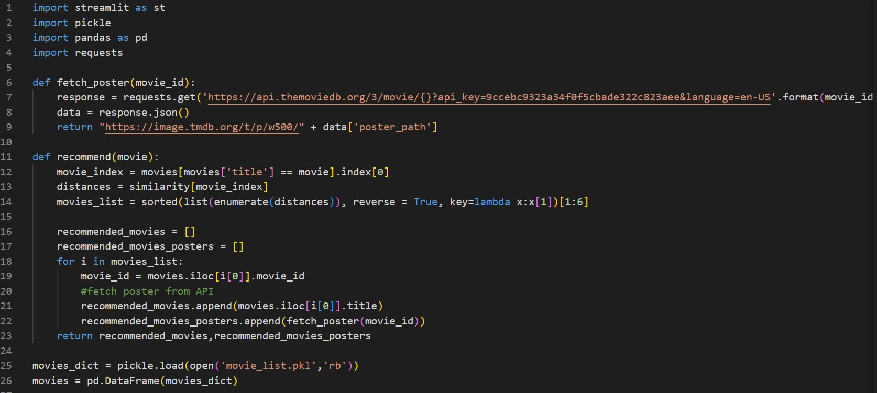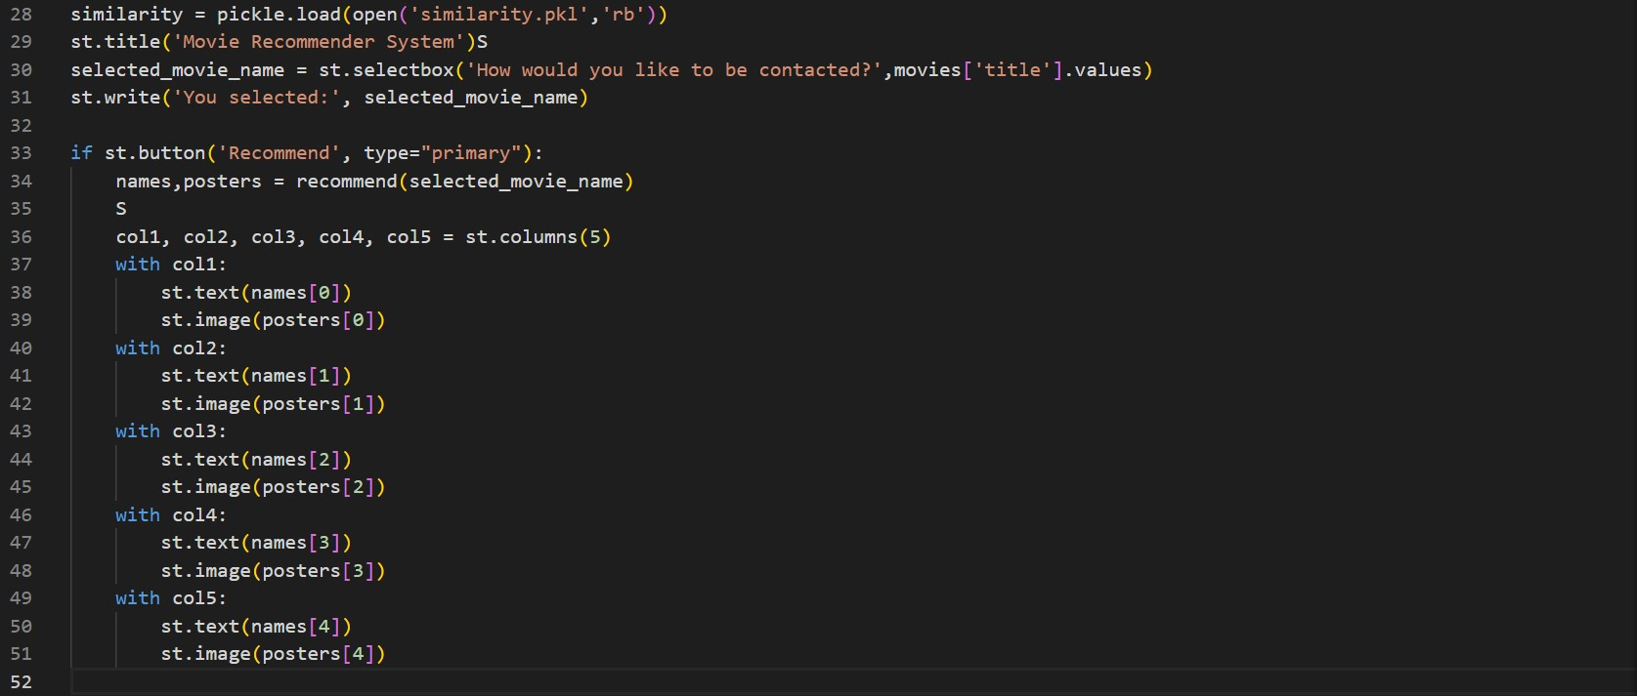

Ipynb code:

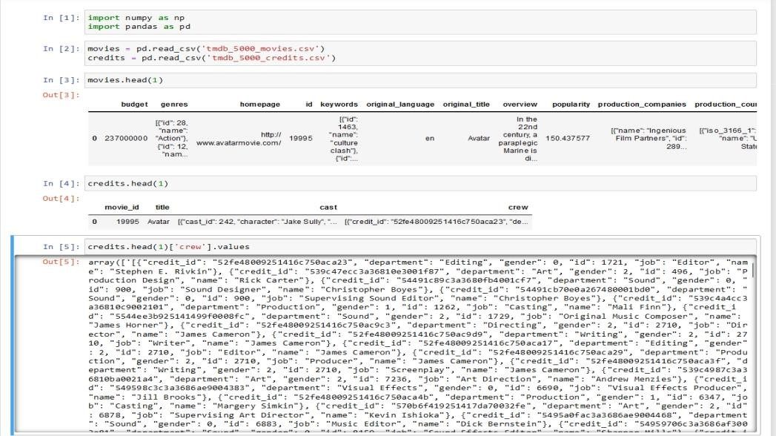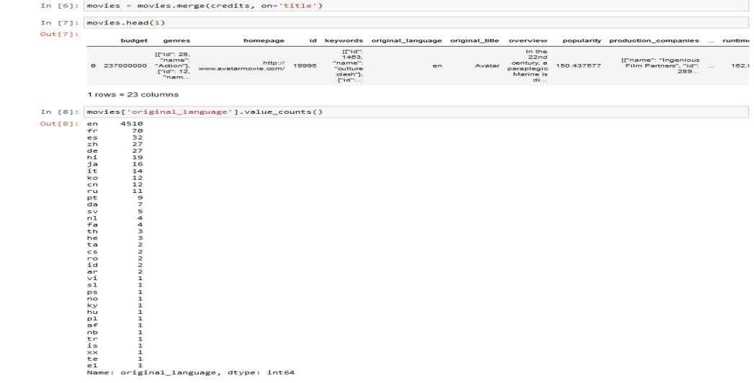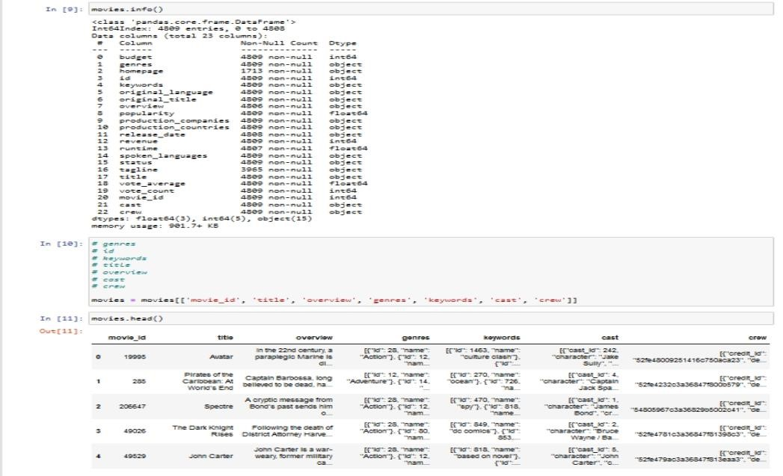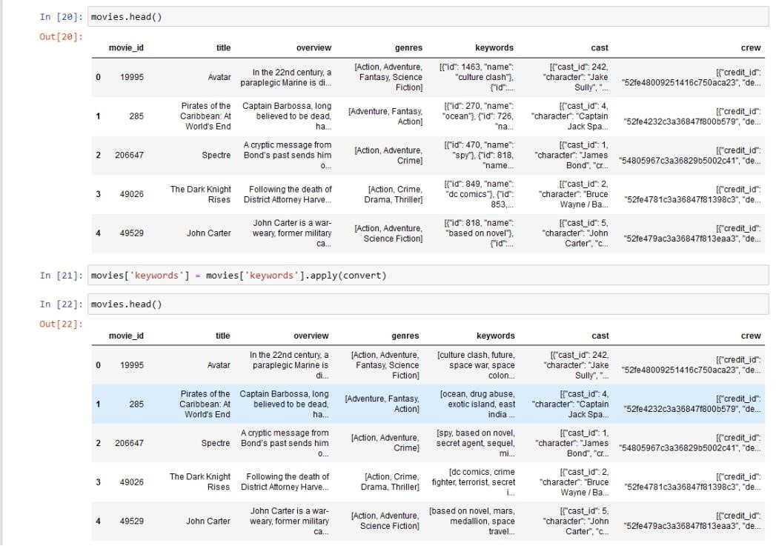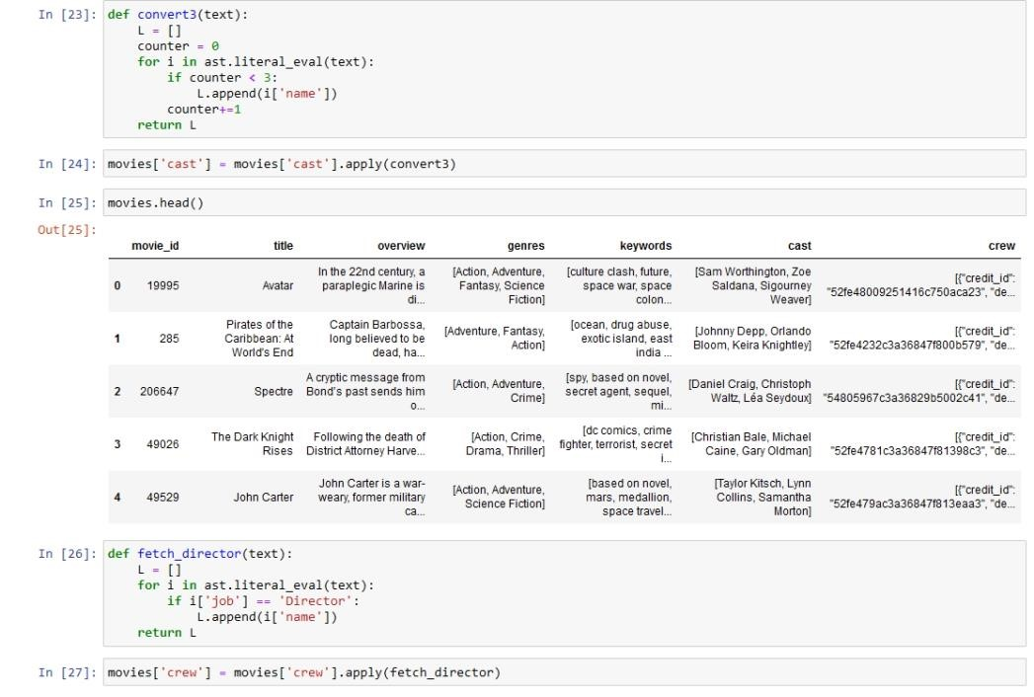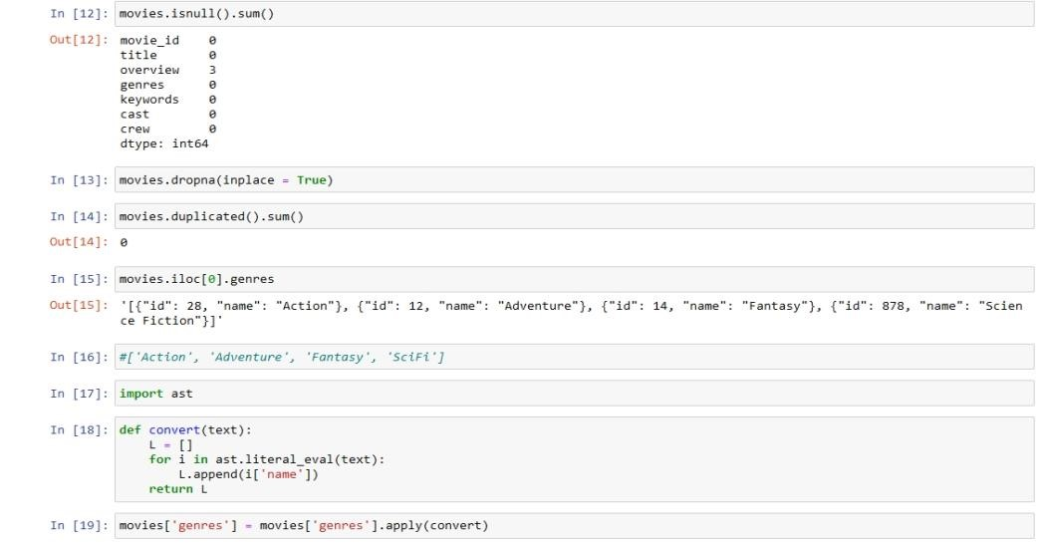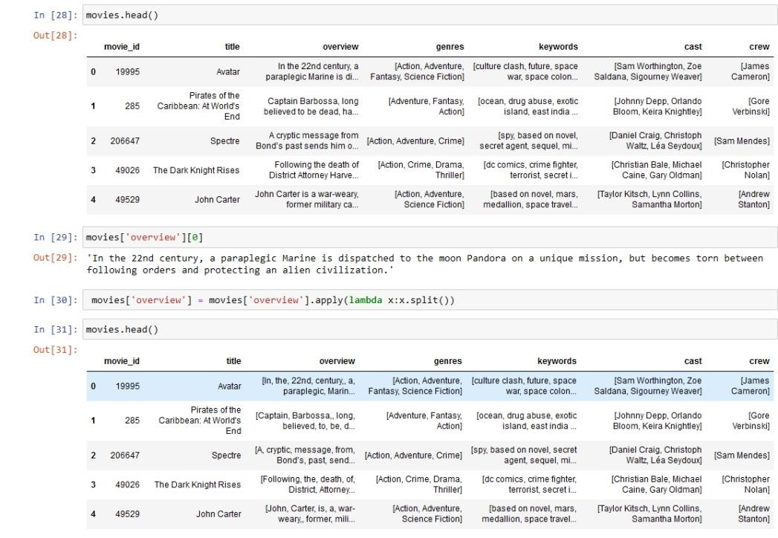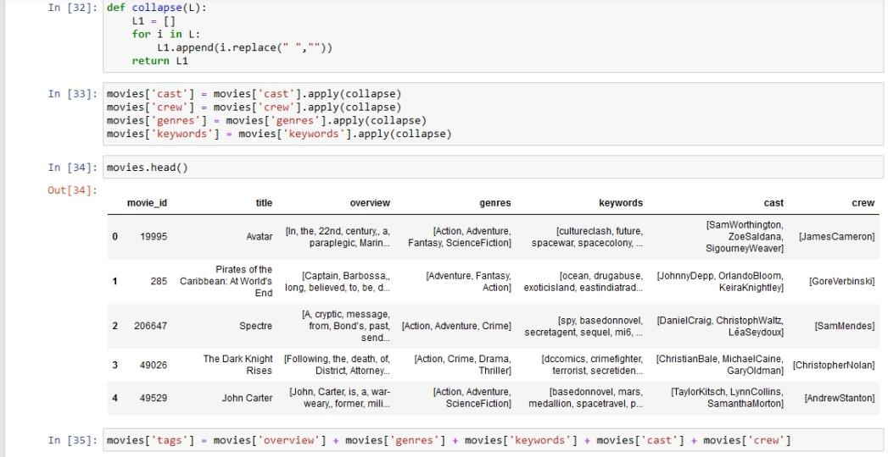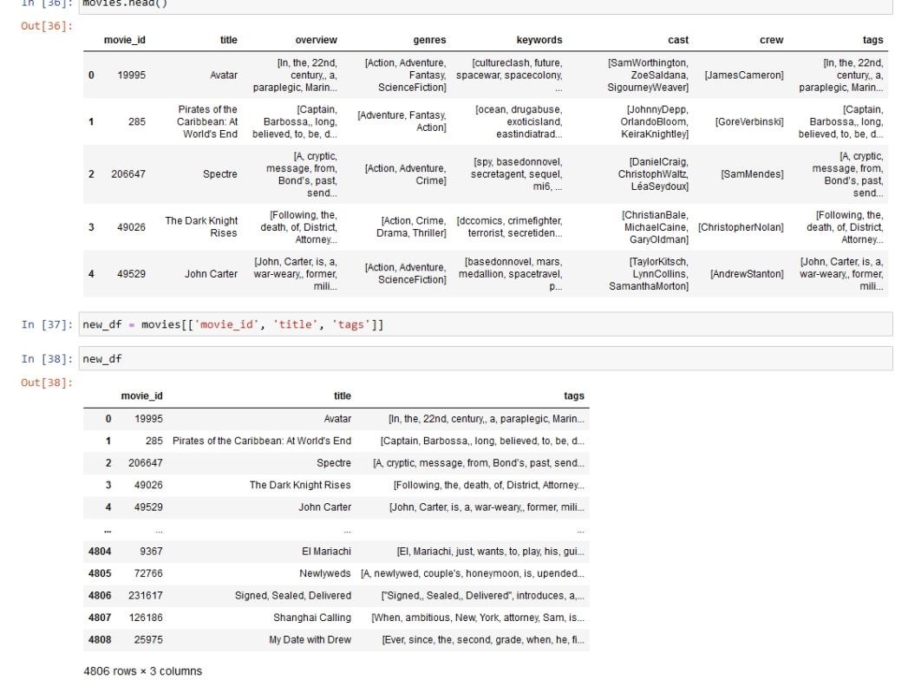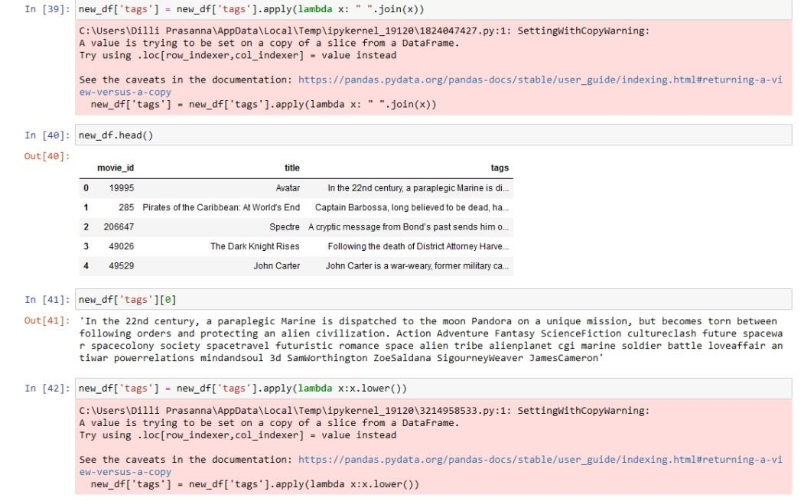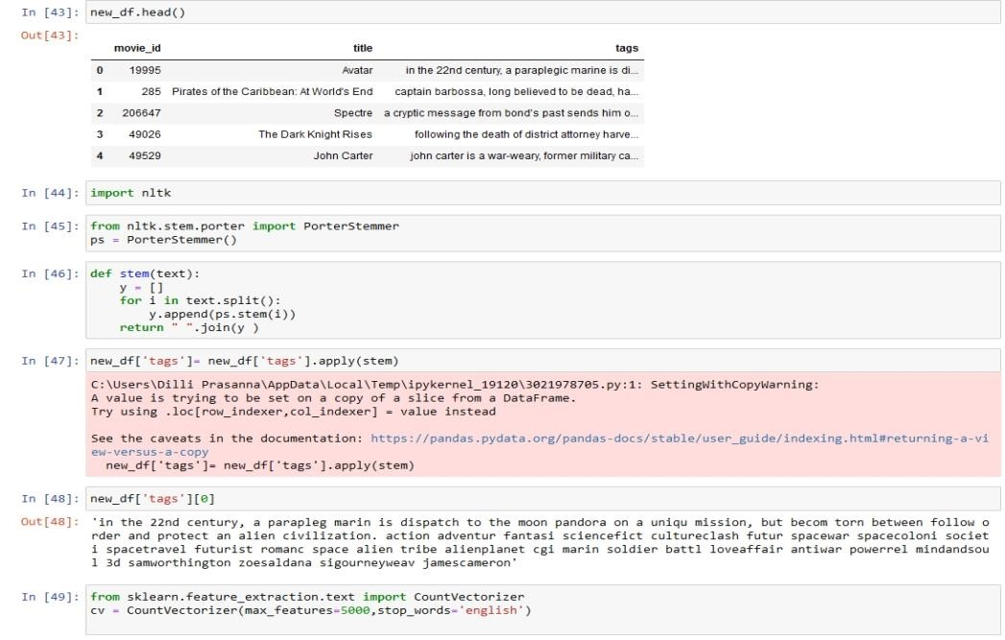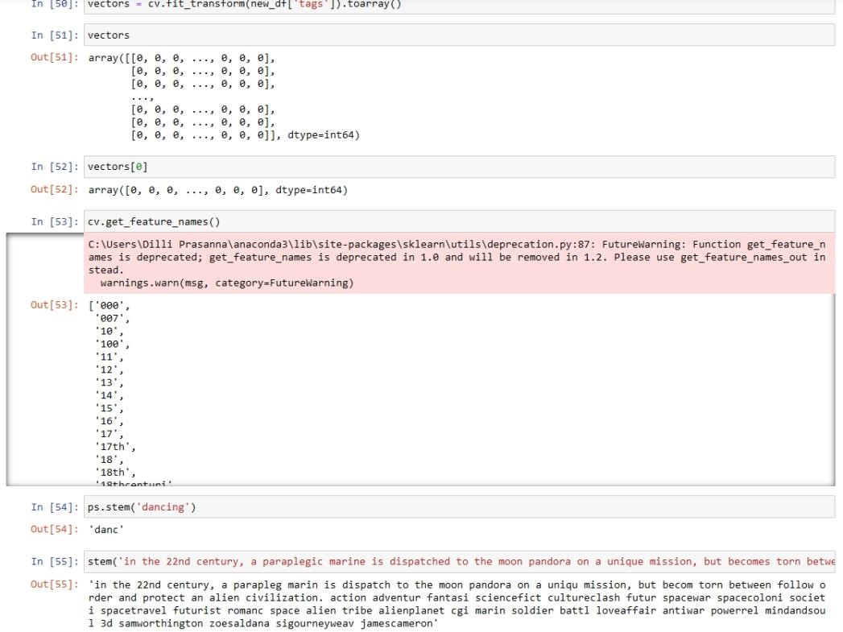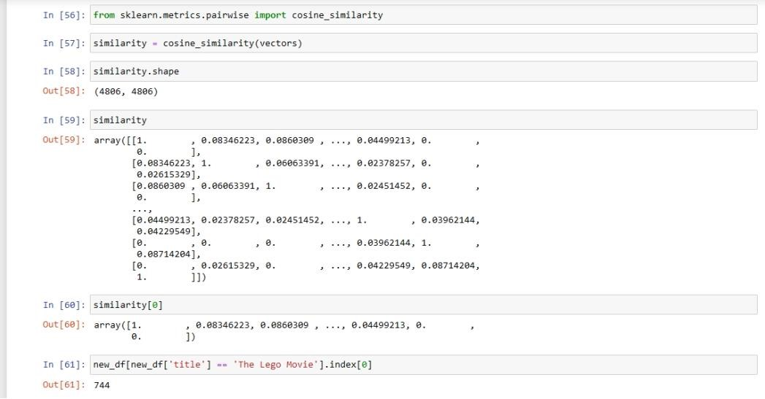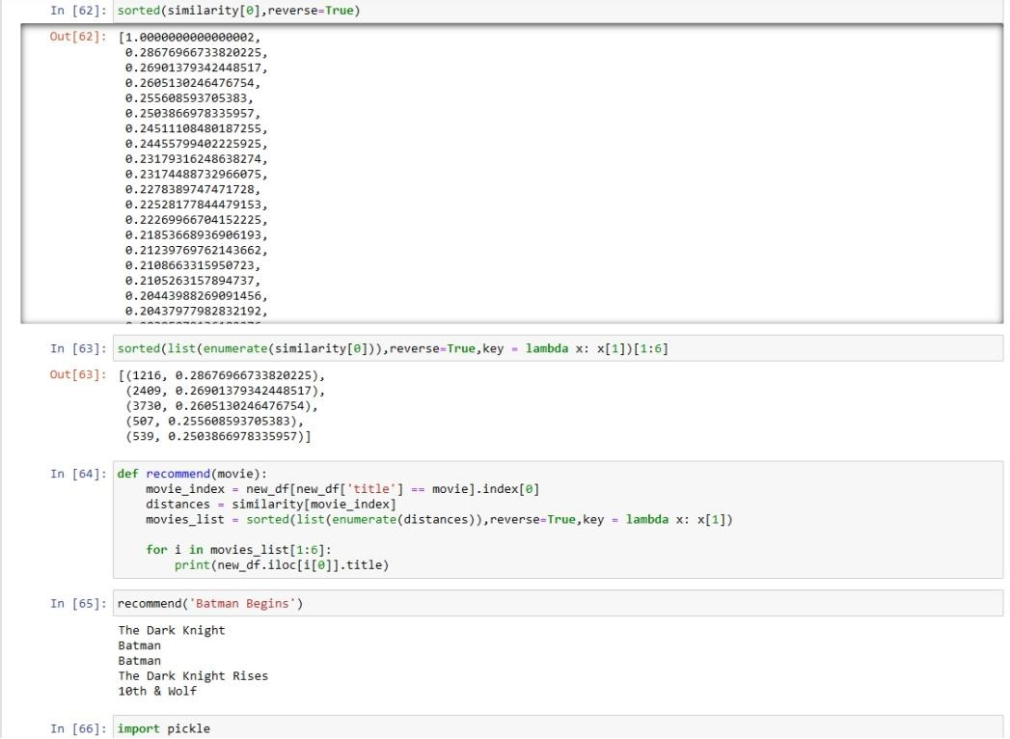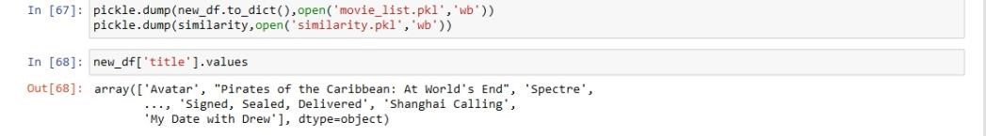

**Query: Performance measure and Methodology?**

**Solution:** Designing a performance measure for a next-generation movie recommender system that leverages NLP (Natural Language Processing) and rich metadata involves assessing various aspects to ensure an enhanced user experience. Here’s a structured approach to defining such a performance measure:

# 1. Relevance and Accuracy

* **Prediction Accuracy:** Measure the system's ability to accurately predict movies that users will like based on their preferences, using metrics like Precision, Recall, and F1score.
* **Relevance:** Evaluate how relevant the recommended movies are to the user's interests and how well they align with the user's historical preferences.

# 2. Diversity and Novelty

* **Diversity:** Assess the variety of genres, themes, and styles recommended to avoid monotony and ensure a broad range of choices.
* **Novelty:** Measure how often the system introduces new and lesser-known movies to users, enhancing discovery and preventing over-recommendation of popular titles.

# 3. Personalization

* **Personalization Accuracy:** Gauge how well the system tailors recommendations to individual user preferences over time.
* **User Satisfaction:** Incorporate user feedback mechanisms (like ratings or surveys) to directly measure satisfaction with recommended movies.

# 4. User Engagement

* **Click-Through Rate (CTR):** Measure the proportion of users who click on recommended movies compared to the total recommendations shown.
* **Time Spent:** Analyze how much time users spend engaging with recommended movies to understand the system's effectiveness in keeping users interested.

# 5. Coverage

* **Catalog Coverage:** Evaluate the percentage of the entire movie catalog that the recommender system can effectively recommend from.
* **User Coverage:** Assess the proportion of users for whom the system can generate meaningful recommendations.

# 6. Computational Efficiency

* **Response Time:** Measure how quickly the system generates and delivers recommendations in real-time or batch processing scenarios.
* **Scalability:** Evaluate how well the system performs as the user base and movie catalog size increase.

# 7. Robustness and Adaptability

* **Robustness:** Assess the system's ability to handle missing data, outliers, or sudden changes in user preferences or movie availability.
* **Adaptability:** Measure how well the system updates recommendations based on new user interactions and feedback.

# 8. Ethical Considerations

* **Fairness:** Ensure recommendations are unbiased and do not promote stereotypes or exclude certain demographic groups.
* **Transparency:** Provide clear explanations for why certain movies are recommended to build trust with users.

**Implementation Strategy:**

* **Benchmarking:** Establish baseline metrics using historical data or existing recommender systems.
* **A/B Testing:** Conduct controlled experiments to compare the new system against existing approaches in a real-world environment.
* **User Studies:** Gather direct feedback through surveys, interviews, or usability testing to validate the system's performance from a user's perspective.

By systematically evaluating these aspects, you can develop a comprehensive performance measure that addresses the core goals of enhancing user experience through advanced NLP and metadata-driven movie recommendations.

**Methodology for Evaluating Performance**

# 1. Data Collection and Preparation

* **Data Sources:** Gather a comprehensive dataset including user interactions (ratings, watch history), movie metadata (genre, cast, crew), and textual data (synopsis, reviews).
* **Data Preprocessing:** Cleanse and preprocess data to handle missing values, normalize features, and ensure consistency across datasets.

# 2. Baseline Establishment

* **Benchmark Models:** Implement and evaluate existing recommender systems (e.g., collaborative filtering, content-based filtering) as baselines for comparison.
* **Metrics Selection:** Choose appropriate evaluation metrics such as Precision, Recall, F1-score, Mean Average Precision (MAP), and Mean Reciprocal Rank (MRR) for accuracy and relevance.

# 3. Model Development

* **Feature Engineering:** Utilize NLP techniques to extract meaningful features from textual data (e.g., TF-IDF, word embeddings) and incorporate rich metadata (e.g., genre, director).
* **Algorithm Selection:** Implement advanced recommendation algorithms like matrix factorization, deep learning-based models, or hybrid approaches combining collaborative and content-based filtering.

## 4. Evaluation Framework

* **Offline Evaluation:** o **Split Data:** Divide dataset into training, validation, and test sets. o **Training:** Train models using training data and tune hyperparameters using validation set.
  + **Testing:** Evaluate models on test set using selected metrics to assess accuracy, relevance, and diversity of recommendations.
* **Online Evaluation (A/B Testing):**
  + **Experiment Design:** Conduct controlled experiments to compare the new recommender system against baseline(s) in a real-world setting. o **Metrics:** Monitor user engagement metrics (e.g., CTR, time spent) and user satisfaction (e.g., surveys, ratings) to measure performance.

## 5. Performance Metrics

* **Accuracy and Relevance:**
  + Calculate Precision, Recall, and F1-score to measure how well the system predicts user preferences.
  + Use MAP and MRR to evaluate the ranking quality of recommended items.
* **Diversity and Novelty:**
  + Implement metrics like Diversity Index or Intra-List Similarity to quantify the variety and novelty of recommended items.
* **Personalization:**
  + Track metrics such as Personalization Diversity to ensure recommendations are tailored to individual user preferences.

## 6. User Engagement and Satisfaction

* **Click-Through Rate (CTR):** Measure the percentage of users who interact with recommended movies compared to total impressions.
* **Time Spent:** Analyze how much time users spend watching recommended movies to gauge engagement.
* **User Feedback:** Collect qualitative feedback through surveys or interviews to understand user satisfaction and perceived usefulness of recommendations.

## 7. Coverage and Efficiency

* **Catalog Coverage:** Evaluate the percentage of the entire movie catalog that the system can effectively recommend from.
* **Scalability:** Measure system performance as dataset size and user base grow, ensuring scalability in real-world applications.

## 8. Robustness and Adaptability

* **Robustness:** Test system resilience to missing data, outliers, and changes in user behavior over time.
* **Adaptability:** Monitor how well the system updates recommendations based on new interactions and feedback.

## 9. Ethical Considerations

* **Fairness:** Evaluate recommendations for bias based on demographic factors (e.g., gender, ethnicity) using metrics like Fairness-aware Recommendations.
* **Transparency:** Provide explanations for recommendations using techniques like Explainable AI (XAI) to enhance user trust.

## 10. Iterative Improvement

* **Continuous Evaluation:** Implement a feedback loop where insights from metrics drive iterative improvements to the recommender system.
* **Benchmark Updates:** Regularly update benchmarks and baselines as new data and techniques become available.

**Methodology**

The methodology for a movie recommender system using natural language processing (NLP) and metadata from sources like the TMDB API. Here is a summary of the main methodology steps:

* **Data Acquisition and Preprocessing:** Movie data is sourced from TMDB, including titles, overviews, genres, keywords, cast, and crew. Preprocessing involves cleaning, handling missing values, converting JSON-like data to lists, and stemming words to simplify them to their root forms.
* **Feature Extraction and Representation:** Relevant features are extracted (e.g., genres, cast names) and transformed into numerical vectors using techniques like Count Vectorizer to enable similarity computation.
* **Similarity Computation:** Cosine similarity is used to calculate the similarity between movies based on feature vectors, which allows for efficient comparison of movie characteristics.
* **Personalized Recommendation:** User preferences and viewing history are integrated to provide tailored recommendations, with collaborative filtering helping identify similar users for further personalization.
* **Integration and User Interface:** Python libraries like Streamlit are used to create an interactive interface, allowing users to input preferences and view recommendations. Integration with the TMDB API enables dynamic fetching of additional movie details.

This methodology is designed to create an accurate, user-friendly, and personalized recommendation system by leveraging both machine learning and NLP techniques

### Conclusion

This methodology provides a structured approach to evaluating and refining a nextgeneration movie recommender system, ensuring it leverages NLP and rich metadata effectively to deliver superior user experience. By focusing on accuracy, relevance, diversity, personalization, engagement, coverage, efficiency