1. Tell what machine you ran this on

This program was run on the flip server.

1. Tell what operating system you were using.

I was using Microsoft Windows 11.

1. Tell what compiler you used.

I used the G++ compiler on the flip server.

1. Include the table of performance data.

|  |  |  |  |
| --- | --- | --- | --- |
| 0: 85.82 | 36.04 | Murfreesboro | TN |
| 1: 116.27 | 37.16 | LasVegas | NV |
| 1 | 331 | 2 | 50.414 |
| 0: 77.42 | 39.58 | Washington | DC |
| 1: 90.98 | 33.99 | Memphis | TN |
| 2: 116.71 | 37.28 | LasVegas | NV |
| 1 | 331 | 3 | 58.616 |
| 0: 74.24 | 40.72 | Newark | NJ |
| 1: 83.91 | 35.14 | Knoxville | TN |
| 2: 98.01 | 35 | OklahomaCity | OK |
| 3: 118.27 | 37.15 | Visalia | CA |
| 1 | 331 | 4 | 66.346 |
| 0: 74.24 | 40.72 | Newark | NJ |
| 1: 108.10 | 36.56 | RioRancho | NM |
| 2: 82.85 | 34.2 | Athens | GA |
| 3: 94.64 | 35.37 | BrokenArrow | OK |
| 4: 119.45 | 37.39 | Clovis | CA |
| 1 | 331 | 5 | 67.051 |
| 0: 74.10 | 40.73 | JerseyCity | NJ |
| 1: 92.01 | 41.15 | CedarRapids | IA |
| 2: 111.39 | 33.45 | Mesa | AZ |
| 3: 81.58 | 28.82 | Orlando | FL |
| 4: 120.86 | 45.93 | Gresham | OR |
| 5: 117.77 | 34.11 | Pomona | CA |
| 6: 96.70 | 31.77 | Waco | TX |
| 7: 106.77 | 39.74 | Boulder | CO |
| 8: 83.57 | 37.95 | Lexington | KY |
| 9: 121.65 | 37.98 | Antioch | CA |
| 1 | 331 | 10 | 82.599 |
| 0: 73.03 | 41.52 | Waterbury | CT |
| 1: 112.53 | 35.42 | Peoria | AZ |
| 2: 119.66 | 36.04 | Visalia | CA |
| 3: 96.97 | 31.62 | Waco | TX |
| 4: 120.86 | 45.93 | Gresham | OR |
| 5: 80.99 | 27.33 | PortSt.Lucie | FL |
| 6: 86.47 | 33.49 | Birmingham | AL |
| 7: 78.58 | 36 | Raleigh | NC |
| 8: 82.22 | 41.8 | Cleveland | OH |
| 9: 87.51 | 40.93 | Joliet | IL |
| 10: 94.56 | 40.89 | DesMoines | IA |
| 11: 105.34 | 38.45 | ColoradoSprings | CO |
| 12: 118.41 | 34.17 | Burbank | CA |
| 13: 117.47 | 33.72 | Corona | CA |
| 14: 121.80 | 38.07 | Antioch | CA |
| 1 | 331 | 15 | 86.431 |
| 0: 71.89 | 42.1 | Worcester | MA |
| 1: 121.03 | 47.58 | Bellevue | WA |
| 2: 120.46 | 39.63 | Reno | NV |
| 3: 96.22 | 29.13 | SugarLand | TX |
| 4: 88.08 | 41.5 | Joliet | IL |
| 5: 78.79 | 35.47 | Cary | NC |
| 6: 119.66 | 36.04 | Visalia | CA |
| 7: 97.41 | 33.42 | Denton | TX |
| 8: 85.75 | 32.61 | Montgomery | AL |
| 9: 117.65 | 34.02 | Ontario | CA |
| 10: 80.98 | 27.1 | PortSt.Lucie | FL |
| 11: 106.77 | 39.74 | Boulder | CO |
| 12: 75.05 | 40.63 | Allentown | PA |
| 13: 82.76 | 41.65 | Dearborn | MI |
| 14: 121.75 | 38.23 | Antioch | CA |
| 15: 111.39 | 33.45 | Mesa | AZ |
| 16: 86.22 | 36.62 | Nashville | TN |
| 17: 120.73 | 44.6 | Bend | OR |
| 18: 94.40 | 41.06 | DesMoines | IA |
| 19: 122.18 | 37.54 | Hayward | CA |
| 1 | 331 | 20 | 95.513 |
| 0: 74.50 | 40.78 | Woodbridge | NJ |
| 1: 121.67 | 37.41 | SanJose | CA |
| 2: 78.82 | 42.17 | Buffalo | NY |
| 3: 120.93 | 39.1 | Roseville | CA |
| 4: 94.48 | 44.87 | Minneapolis | MN |
| 5: 119.60 | 36.65 | Clovis | CA |
| 6: 105.18 | 39.06 | ColoradoSprings | CO |
| 7: 89.23 | 42.98 | Madison | WI |
| 8: 113.17 | 42.36 | SaltLakeCity | UT |
| 9: 80.98 | 27.1 | PortSt.Lucie | FL |
| 10: 73.10 | 41.67 | Waterbury | CT |
| 11: 86.03 | 32.56 | Montgomery | AL |
| 12: 76.62 | 37.67 | NewportNews | VA |
| 13: 122.87 | 38.09 | SantaRosa | CA |
| 14: 111.39 | 33.45 | Mesa | AZ |
| 15: 94.79 | 38.59 | Olathe | KS |
| 16: 88.97 | 41.07 | Peoria | IL |
| 17: 118.02 | 34 | ElMonte | CA |
| 18: 116.93 | 34.01 | MorenoValley | CA |
| 19: 97.95 | 32.87 | FortWorth | TX |
| 20: 119.26 | 34.53 | Ventura | CA |
| 21: 79.93 | 34.72 | Concord | NC |
| 22: 86.39 | 36.37 | Nashville | TN |
| 23: 71.21 | 42.29 | Cambridge | MA |
| 24: 121.03 | 47.58 | Bellevue | WA |
| 25: 94.57 | 30.38 | Beaumont | TX |
| 26: 122.58 | 45.04 | Salem | OR |
| 27: 98.17 | 27.57 | CorpusChristi | TX |
| 28: 84.14 | 41.3 | Toledo | OH |
| 29: 122.17 | 37.92 | Berkeley | CA |
| 1 | 331 | 30 | 99.01 |
| 0: 78.15 | 42.39 | Buffalo | NY |
| 1: 95.65 | 36.07 | BrokenArrow | OK |
| 2: 122.46 | 37.89 | Richmond | CA |
| 3: 122.26 | 47.55 | Renton | WA |
| 4: 119.60 | 36.65 | Clovis | CA |
| 5: 117.67 | 33.81 | Anaheim | CA |
| 6: 96.88 | 32.97 | Carrollton | TX |
| 7: 97.76 | 26.57 | Edinburg | TX |
| 8: 79.48 | 35.57 | Greensboro | NC |
| 9: 84.23 | 40.98 | FortWayne | IN |
| 10: 99.49 | 27.56 | Laredo | TX |
| 11: 82.36 | 27.69 | St.Petersburg | FL |
| 12: 113.32 | 38.49 | St.George | UT |
| 13: 76.62 | 37.67 | NewportNews | VA |
| 14: 94.47 | 41.29 | DesMoines | IA |
| 15: 87.60 | 34.06 | Tuscaloosa | AL |
| 16: 110.66 | 33.44 | Mesa | AZ |
| 17: 122.21 | 44.06 | Bend | OR |
| 18: 80.29 | 25.92 | Hialeah | FL |
| 19: 97.61 | 30.46 | RoundRock | TX |
| 20: 80.32 | 33.26 | NorthCharleston | SC |
| 21: 88.76 | 41.47 | Aurora | IL |
| 22: 82.75 | 30.16 | Gainesville | FL |
| 23: 84.31 | 33.96 | SandySprings | GA |
| 24: 74.35 | 40.58 | Woodbridge | NJ |
| 25: 80.26 | 27.01 | WestPalmBeach | FL |
| 26: 101.58 | 33.02 | Lubbock | TX |
| 27: 93.92 | 30.15 | Beaumont | TX |
| 28: 80.96 | 28.18 | Orlando | FL |
| 29: 81.61 | 32.68 | Savannah | GA |
| 30: 73.10 | 41.67 | Waterbury | CT |
| 31: 105.21 | 40.18 | Boulder | CO |
| 32: 122.73 | 45.43 | Portland | OR |
| 33: 119.03 | 34.54 | Ventura | CA |
| 34: 120.46 | 39.63 | Reno | NV |
| 35: 80.20 | 26.15 | FortLauderdale | FL |
| 36: 71.13 | 41.85 | Brockton | MA |
| 37: 116.77 | 45.22 | Meridian | ID |
| 38: 71.24 | 42.48 | Cambridge | MA |
| 39: 121.72 | 37.85 | Antioch | CA |
| 1 | 331 | 40 | 107.655 |
| 0: 74.08 | 40.68 | JerseyCity | NJ |
| 1: 98.10 | 26.77 | Edinburg | TX |
| 2: 83.90 | 39.64 | Dayton | OH |
| 3: 85.24 | 33.6 | SouthFulton | GA |
| 4: 85.45 | 36.84 | Louisville | KY |
| 5: 119.60 | 36.65 | Clovis | CA |
| 6: 77.31 | 36.38 | NewportNews | VA |
| 7: 119.04 | 35.35 | Bakersfield | CA |
| 8: 83.74 | 42.42 | AnnArbor | MI |
| 9: 82.42 | 28.83 | Gainesville | FL |
| 10: 80.43 | 34.46 | Columbia | SC |
| 11: 114.74 | 36.4 | NorthLasVegas | NV |
| 12: 85.94 | 40.5 | Fishers | IN |
| 13: 112.00 | 33.37 | Tempe | AZ |
| 14: 122.26 | 47.55 | Renton | WA |
| 15: 117.33 | 34.47 | Victorville | CA |
| 16: 117.44 | 34.03 | JurupaValley | CA |
| 17: 108.55 | 45.79 | Billings | MT |
| 18: 101.58 | 33.02 | Lubbock | TX |
| 19: 88.97 | 41.99 | Rockford | IL |
| 20: 81.06 | 41 | Akron | OH |
| 21: 91.08 | 31.55 | BatonRouge | LA |
| 22: 88.77 | 37.08 | Clarksville | TN |
| 23: 104.93 | 39.71 | Denver | CO |
| 24: 122.17 | 37.92 | Berkeley | CA |
| 25: 71.21 | 42.29 | Cambridge | MA |
| 26: 117.13 | 32.95 | SanDiego | CA |
| 27: 95.18 | 29.78 | Pasadena | TX |
| 28: 77.54 | 43.03 | Rochester | NY |
| 29: 76.90 | 39.01 | Washington | DC |
| 30: 94.34 | 44.32 | Minneapolis | MN |
| 31: 75.31 | 40.3 | Philadelphia | PA |
| 32: 116.40 | 43.6 | Meridian | ID |
| 33: 121.67 | 37.41 | SanJose | CA |
| 34: 97.61 | 30.46 | RoundRock | TX |
| 35: 95.04 | 38.65 | Olathe | KS |
| 36: 120.93 | 39.1 | Roseville | CA |
| 37: 111.98 | 40.69 | WestValleyCity | UT |
| 38: 73.03 | 41.77 | Waterbury | CT |
| 39: 111.65 | 40.25 | Provo | UT |
| 40: 117.17 | 33.58 | Murrieta | CA |
| 41: 117.33 | 47.67 | Spokane | WA |
| 42: 119.63 | 34.47 | Ventura | CA |
| 43: 106.64 | 33.64 | LasCruces | NM |
| 44: 80.40 | 26.36 | CoralSprings | FL |
| 45: 117.93 | 33.85 | Fullerton | CA |
| 46: 118.38 | 34.23 | Burbank | CA |
| 47: 96.94 | 33.22 | Frisco | TX |
| 48: 122.58 | 45.04 | Salem | OR |
| 49: 122.87 | 38.09 | SantaRosa | CA |
| 1 | 331 | 50 | 110.27 |
| 2 | 331 | 2 | 12.878 |
| 2 | 331 | 3 | 17 |
| 2 | 331 | 4 | 22.474 |
| 2 | 331 | 5 | 27.99 |
| 2 | 331 | 10 | 63.687 |
| 2 | 331 | 15 | 91.578 |
| 2 | 331 | 20 | 109.774 |
| 2 | 331 | 30 | 134.404 |
| 2 | 331 | 40 | 129.932 |
| 2 | 331 | 50 | 155.432 |
| 4 | 331 | 2 | 7.925 |
| 4 | 331 | 3 | 12.452 |
| 4 | 331 | 4 | 16.125 |
| 4 | 331 | 5 | 18.911 |
| 4 | 331 | 10 | 37.776 |
| 4 | 331 | 15 | 31.185 |
| 4 | 331 | 20 | 86.85 |
| 4 | 331 | 30 | 128.191 |
| 4 | 331 | 40 | 172.744 |
| 4 | 331 | 50 | 155.913 |
| 6 | 331 | 2 | 6.646 |
| 6 | 331 | 3 | 9.554 |
| 6 | 331 | 4 | 13.033 |
| 6 | 331 | 5 | 15.961 |
| 6 | 331 | 10 | 32.77 |
| 6 | 331 | 15 | 48.303 |
| 6 | 331 | 20 | 66.487 |
| 6 | 331 | 30 | 103.066 |
| 6 | 331 | 40 | 128.305 |
| 6 | 331 | 50 | 53.666 |
| 8 | 331 | 2 | 5.78 |
| 8 | 331 | 3 | 8.581 |
| 8 | 331 | 4 | 10.548 |
| 8 | 331 | 5 | 13.729 |
| 8 | 331 | 10 | 26.188 |
| 8 | 331 | 15 | 45.685 |
| 8 | 331 | 20 | 51.566 |
| 8 | 331 | 30 | 80.13 |
| 8 | 331 | 40 | 113.772 |
| 8 | 331 | 50 | 141.649 |

Pivot table with columns as number of threads and rows as number of cities.

1. Include a graph of performance vs. NUMT with the colored curves being NUMCAPITALS.

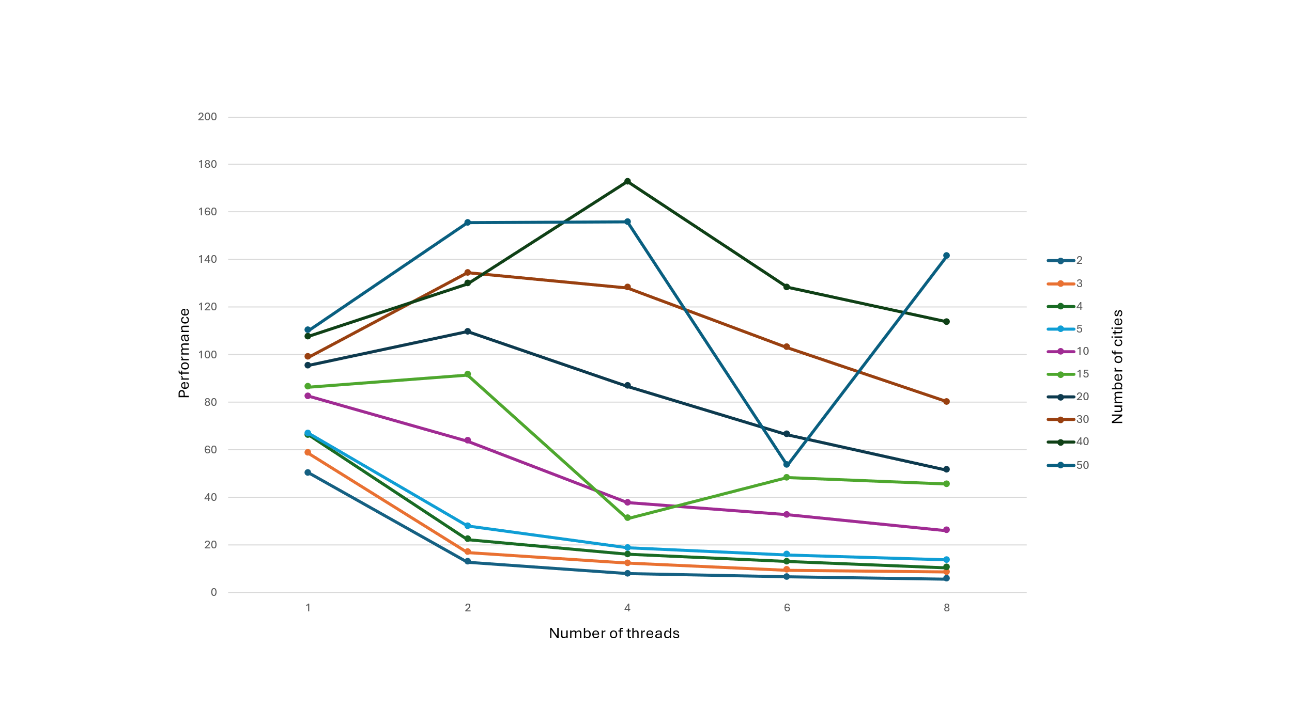

1. Include a graph of performance vs. NUMCAPITALS cities with the colored curves being NUMT.

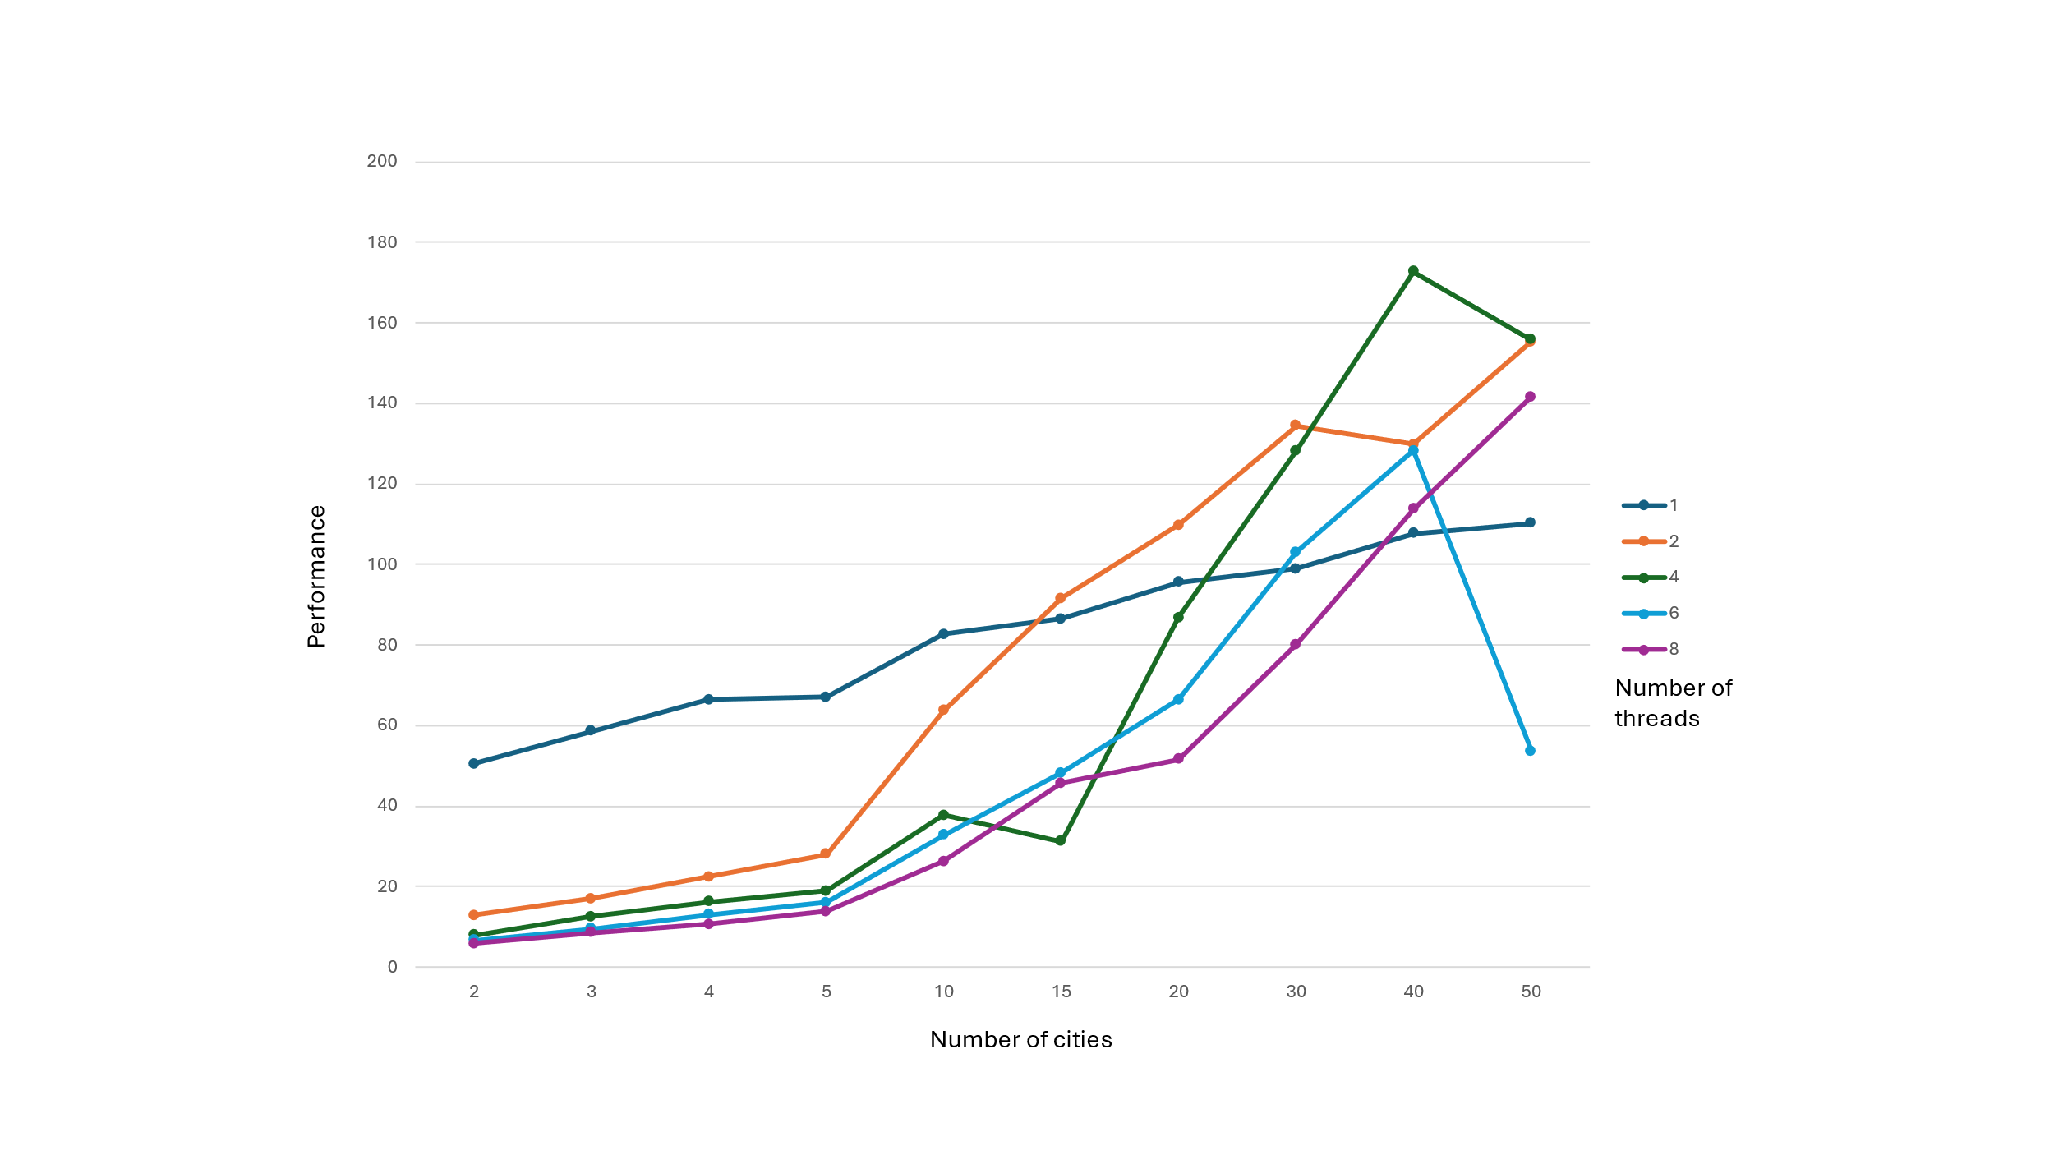

1. Tell us what you discovered by doing this. What patterns are you seeing in the graphs?

From performance vs. NUMCAPITALS we can see that as the number of capitals to be calculated increases the performance decreases, even if the number of threads is 8. There is a sudden spike or drop due to the inconsistencies in the flip server. From performance vs. NUMT we can see that even though the performance decreases as the NUMCAPITALS increases, the performance also increases as NUMT increases. There is a balance between NUMCAPITALS and NUMT.