**Comparison of Speedup with and without SIMD**

**Metta Saketh Srinivasa Rao**

**mettas@oregonstate.edu**

1. What machine did you run this on?

This project was run on the Rabbit server.

1. Show the 2 tables of performances for each array size and the corresponding speedups.

Table of C[i] = A[i] * B[i] experiment data

|  |  |  |  |
| --- | --- | --- | --- |
| ArraySize | NonSimdMul | SimdMul | Speedup of Mul |
| 1000 | 123.76 | 649.35 | 5.25 |
| 2000 | 121.21 | 667.33 | 5.51 |
| 4000 | 123.29 | 661.49 | 5.37 |
| 8000 | 123.92 | 727.87 | 5.87 |
| 16000 | 134.22 | 731.56 | 5.45 |
| 32000 | 144.38 | 779.54 | 5.4 |
| 64000 | 164.89 | 949.03 | 5.76 |
| 128000 | 194.94 | 1154.23 | 5.92 |
| 256000 | 327.1 | 1671.84 | 5.11 |
| 512000 | 325.32 | 1608.88 | 4.95 |
| 1024000 | 327.83 | 1673.33 | 5.1 |
| 2048000 | 321.12 | 1161.5 | 3.62 |
| 4096000 | 332.58 | 812.7 | 2.44 |
| 8000000 | 340.62 | 800.27 | 2.35 |

Table of sum = ΣA[i]*B[i] experiment data

|  |  |  |  |
| --- | --- | --- | --- |
| ArraySize | NonSimdMulSum | SimdMulSum | Speedup of sum |
| 1000 | 131.75 | 645.16 | 4.9 |
| 2000 | 132.48 | 665.11 | 5.02 |
| 4000 | 132.73 | 673.74 | 5.08 |
| 8000 | 143.97 | 729.33 | 5.07 |
| 16000 | 155.13 | 787.87 | 5.08 |
| 32000 | 177.29 | 900.5 | 5.08 |
| 64000 | 221.61 | 1127.51 | 5.09 |
| 128000 | 354.54 | 1804.9 | 5.09 |
| 256000 | 354.5 | 1791.85 | 5.05 |
| 512000 | 352.25 | 1757.43 | 4.99 |
| 1024000 | 354.04 | 1795.81 | 5.07 |
| 2048000 | 353.7 | 1780.06 | 5.03 |
| 4096000 | 344.65 | 1028.23 | 2.98 |
| 8000000 | 355.75 | 973.24 | 2.74 |

1. Show the graphs (or graph) of SIMD/non-SIMD speedup versus array size (either one graph with two curves, or two graphs each with one curve)

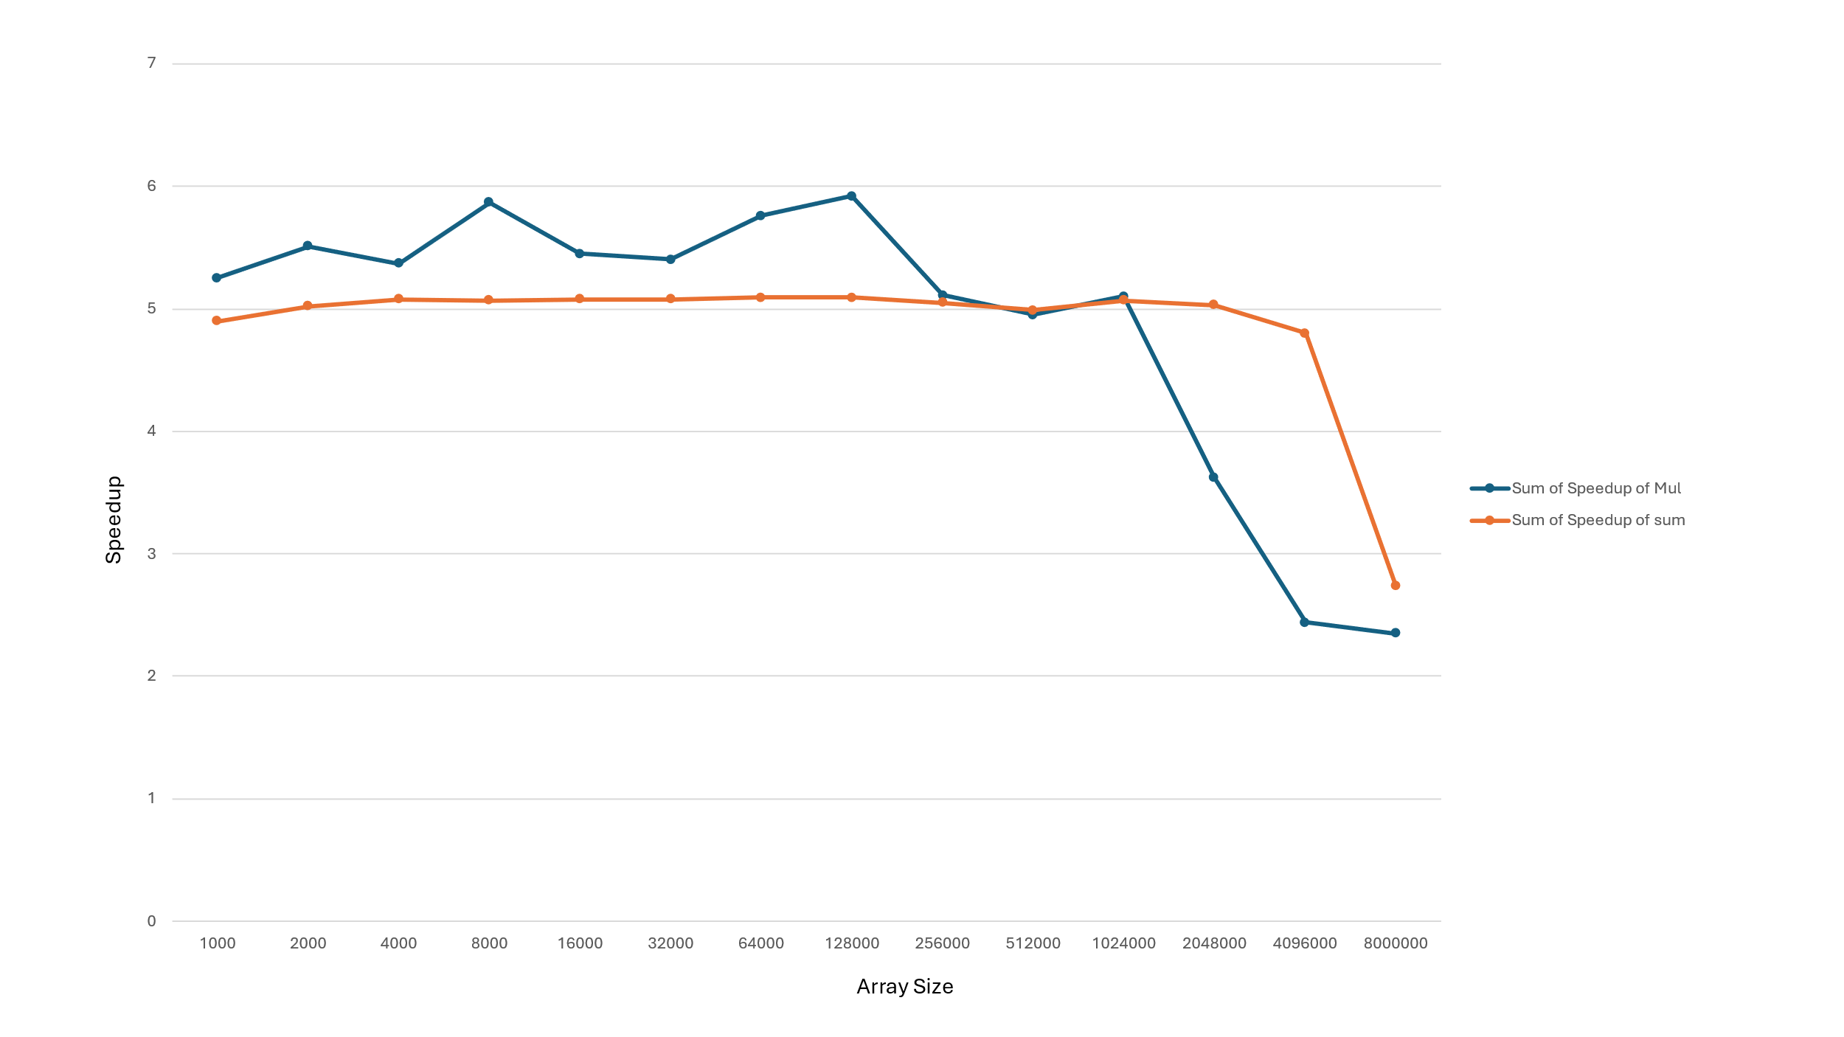

1. What patterns are you seeing in the speedups?

The speedup of sum is nearly constant but drops drastically from 4 million. But the speedup for mul dropped drastically from 1 million array size.

1. Are they consistent across a variety of array sizes?

The speedup for sum and multiplication experiments drops drastically for larger size of arrays, for mul it’s from 1 million array size and for sum it’s 4 million array size.

1. Why or why not, do you think?

The hardware we are using right now cannot handle this large of an array. This is why the speedup drops significantly after 4 million array size even with SIMD usage.