DevOps Engineer Technical Assignment

Production-Style Web Application Deployment on AWS Free Tier

Submitted By:
Saketh Alevooraya K

Project Repository:
GitHub:
https://github.com/Saketh8904/DevopsUser

Submission Date:
07 July 2026

1. Executive Summary
This project demonstrates the design, deployment, security, monitoring, and performance evaluation of a production-style web application using AWS Free Tier services. The application was deployed on an Ubuntu 26.04 LTS EC2 instance running a Node.js and Express web application managed by PM2, with Nginx configured as a reverse proxy to handle incoming client requests.
A complete CI/CD pipeline was implemented using GitHub Actions, enabling automated deployment of the application to the EC2 instance whenever changes were pushed to the GitHub repository. Amazon S3 was configured to store application backups, while Amazon CloudWatch and the CloudWatch Agent were used to collect system metrics, application logs, create dashboards, and generate alarms. Amazon SNS was configured to send email notifications whenever CloudWatch alarms were triggered.
Security best practices were implemented by using IAM users and roles with the principle of least privilege, configuring Security Groups to restrict network access, and securely managing deployment credentials using GitHub Secrets. HTTPS configuration using Let's Encrypt was attempted but could not be completed because the custom domain DNS records were not correctly configured during the project.
Application performance was evaluated using the k6 load testing tool. Performance metrics including CPU utilization, memory utilization, response time, latency, throughput, and error rate were monitored through CloudWatch and analyzed to identify potential bottlenecks. The testing demonstrated that the application performed reliably under moderate load on a single AWS Free Tier EC2 instance, with CPU utilization identified as the primary limiting factor during higher concurrent workloads.
Overall, this project successfully demonstrates the implementation of core DevOps practices, including cloud infrastructure deployment, automated CI/CD, application monitoring, centralized logging, backup management, security hardening, and performance testing using AWS Free Tier resources.

2. Objectives
The primary objectives of this project were:
- Design and provision a production-style infrastructure using AWS Free Tier services, including Amazon EC2, Amazon S3, API Gateway, IAM, Security Groups, CloudWatch, and Amazon SNS.
- Deploy a Node.js web application on an Ubuntu EC2 instance using Nginx as a reverse proxy and PM2 as the process manager.
- Implement an automated Continuous Integration and Continuous Deployment (CI/CD) pipeline using GitHub Actions for seamless application deployment.
- Configure IAM users, roles, and Security Groups by following the principle of least privilege to improve the overall security of the deployment.
- Configure Amazon S3 to store application backups and demonstrate backup and recovery capabilities.
- Enable application monitoring, centralized logging, dashboards, and alarms using Amazon CloudWatch and the CloudWatch Agent.
- Configure Amazon SNS to send email notifications when CloudWatch alarms are triggered.
- Perform load testing using k6 to evaluate application performance under different workloads.
- Record and analyze key performance metrics including CPU utilization, memory utilization, response time, latency, throughput, and error rate.
- Identify performance bottlenecks and propose suitable optimization strategies for improving scalability, availability, and reliability.
- Prepare comprehensive project documentation, including the architecture diagram, deployment guide, security summary, monitoring configuration, load testing report, and final project repor

3. Architecture
The following architecture illustrates the overall design of the production-style web application deployed on AWS Free Tier. It shows how client requests flow through the infrastructure, how the application is deployed using the CI/CD pipeline, and how monitoring, logging, backups, and alerting are integrated into the solution.
Figure 3.1: AWS Architecture Diagram:
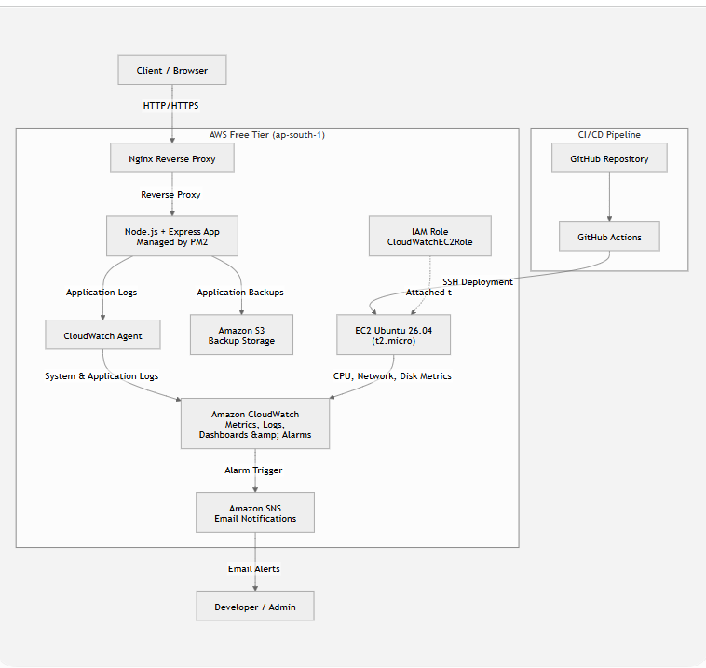

Architecture Overview
The application is hosted on an Ubuntu 26.04 LTS Amazon EC2 instance, where a Node.js and Express application runs under PM2. Nginx is configured as a reverse proxy to forward incoming HTTP requests to the application running on port 3000.
Application source code is maintained in a GitHub repository. Whenever code is pushed to the repository, GitHub Actions automatically triggers the CI/CD workflow, connects securely to the EC2 instance, updates the application, installs dependencies if required, and restarts the application.
Amazon S3 is used to store application backup files, providing a simple and cost-effective backup solution using AWS Free Tier services.
Amazon CloudWatch collects infrastructure metrics such as CPU utilization, memory usage, disk usage, and network traffic through the CloudWatch Agent. It also collects application and Nginx logs, displays them on CloudWatch Dashboards, and generates alarms when predefined thresholds are exceeded.
Amazon SNS is integrated with CloudWatch to send email notifications whenever an alarm is triggered, enabling proactive monitoring of the application.
Security is implemented using IAM users and roles that follow the principle of least privilege. Security Groups restrict inbound and outbound network traffic, ensuring that only the required ports are accessible.
Although HTTPS configuration using Let's Encrypt was attempted, certificate issuance could not be completed because the custom domain DNS configuration was unavailable during the project. Therefore, the application was demonstrated over HTTP.
Component summary:
Component | AWS Service | Purpose
Compute | EC2 (t2.micro) | Hosts the application + Nginx reverse proxy
API layer | API Gateway | HTTPS termination / routing to EC2
Storage | S3 | Static assets and backups
Identity | IAM | Least-privilege roles for EC2 and CI/CD
Networking | Security Groups | Firewall rules restricting inbound access
CI/CD | GitHub Actions | Automated build, test, and deploy
Monitoring | CloudWatch | Metrics, logs, dashboards, alarms
Alerting | SNS | Email notifications on alarm breach

4. Setup Steps
The complete deployment procedure, including all commands and configuration files, is available in docs/DEPLOYMENT_GUIDE.md in the GitHub repository. The major implementation phases are summarized below.

4.1 IAM and Security Configuration
- Created a dedicated IAM deploy user with a custom least-privilege policy for deployment tasks.
- Created an IAM role (CloudWatchEC2Role) and attached it to the EC2 instance to securely allow CloudWatch Agent access without storing AWS credentials on the server.
- Configured Security Groups following the principle of least privilege:
  - SSH (Port 22) restricted to the administrator's public IP address.
  - HTTP (Port 80) open for web access.
  - HTTPS (Port 443) enabled for future TLS configuration.
  - Application Port (3000) accessible only internally by Nginx.

4.2 EC2 Instance and Application Deployment
- Launched an Ubuntu 26.04 LTS t2.micro Amazon EC2 instance within AWS Free Tier limits.
- Connected securely using SSH and configured the operating system.
- Installed Node.js, npm, Git, Nginx, and PM2.
- Cloned the application repository from GitHub.
- Installed project dependencies using npm.
- Started the Node.js application using PM2 for automatic process management and recovery.
- Configured Nginx as a reverse proxy to forward incoming requests to the application running on localhost:3000.

4.3 HTTPS Configuration
- Attempted to configure HTTPS using Let's Encrypt (Certbot).
- Certificate generation was unsuccessful because the custom domain DNS records were not correctly configured.
- The application was therefore demonstrated over HTTP, while the HTTPS configuration procedure was documented for future deployment.

4.4 Amazon S3 Storage
- Created an Amazon S3 bucket to store application backup files.
- Enabled Block Public Access to prevent unauthorized access.
- Enabled Bucket Versioning to preserve previous versions of backup files.
- Uploaded application backup archives from the EC2 instance to Amazon S3.

4.5 CI/CD Pipeline
- Configured a GitHub Actions workflow for automated deployment.
- Pipeline stages included:
  - Source code checkout
  - Dependency installation
  - Application deployment to EC2 over SSH
  - PM2 application restart
  - Deployment verification through a smoke test
- Stored deployment credentials securely using GitHub Actions Secrets.

4.6 Monitoring and Logging
- Installed and configured the Amazon CloudWatch Agent on the EC2 instance.
- Configured CloudWatch to collect:
  - CPU utilization
  - Memory utilization
  - Disk utilization
  - Network traffic
  - Application logs
  - Nginx access and error logs
- Created a CloudWatch Dashboard to visualize system metrics.
- Configured CloudWatch Alarms for high CPU utilization and EC2 status check failures.
- Integrated Amazon SNS to send email notifications whenever alarms were triggered.

5. Security Summary
A detailed security assessment is provided in docs/SECURITY_SUMMARY.md. The key security measures implemented in this project are summarized below.

5.1 Identity and Access Management (IAM)
- Created a dedicated IAM deploy user with a custom least-privilege policy for CI/CD deployment.
- Created an IAM instance role (CloudWatchEC2Role) and attached it to the EC2 instance for secure CloudWatch Agent access.
- No custom IAM policy grants unrestricted "Action": "*" or "Resource": "*". Permissions are limited to only the AWS resources required for deployment and monitoring.

5.2 Network Security
- Configured Security Groups following the principle of least privilege.
- Restricted SSH (Port 22) access to the administrator's public IP address.
- Allowed HTTP (Port 80) and HTTPS (Port 443) only for web traffic.
- The application runs internally on Port 3000 and is not directly exposed to the internet. All external requests are routed through Nginx as a reverse proxy.

5.3 Data Protection
- Configured Amazon S3 with Block Public Access enabled.
- Enabled Bucket Versioning to protect backup files from accidental deletion or modification.
- Application backups are securely stored in Amazon S3.

5.4 Secrets Management
- No AWS Access Keys, Secret Keys, SSH private keys, or sensitive credentials were committed to the GitHub repository.
- Deployment credentials were securely stored using GitHub Actions encrypted secrets.
- The EC2 instance accessed AWS services using an IAM Role instead of long-lived access keys.

5.5 Transport Security
- HTTPS configuration was attempted using Let's Encrypt (Certbot).
- Certificate generation could not be completed because the custom domain DNS records were not configured correctly.
- As a result, the application was demonstrated over HTTP while the HTTPS implementation procedure was documented for future deployment.

5.6 Monitoring and Security Alerts
- Amazon CloudWatch was configured to monitor system metrics, application logs, and Nginx logs.
- CloudWatch Alarms were created for CPU utilization and EC2 status check failures.
- Amazon SNS was integrated to send email notifications whenever an alarm was triggered.

5.7 Project Limitations
The following limitations were accepted to remain within AWS Free Tier constraints:
- The application is hosted on a single EC2 instance, creating a single point of failure.
- Only one Availability Zone was used; Multi-AZ deployment was not implemented.
- AWS WAF and AWS Shield Advanced were not configured because they are outside the AWS Free Tier.
- Auto Scaling and an Application Load Balancer were not implemented due to Free Tier cost considerations.
- HTTPS could not be fully configured because the custom domain DNS records were unavailable during deployment.
Despite these limitations, the project successfully demonstrates industry-standard DevOps practices, including secure infrastructure deployment, least-privilege IAM configuration, automated CI/CD, centralized monitoring, application logging, and backup management using AWS Free Tier services.

6. Monitoring
Amazon CloudWatch was configured to provide continuous monitoring of the application's infrastructure and operating environment. The Amazon CloudWatch Agent was installed on the EC2 instance to collect both system-level metrics and application logs.
A custom CloudWatch Dashboard was created to visualize the following key performance metrics:
- CPU Utilization – Monitors processor usage of the EC2 instance.
- Memory Utilization (CloudWatch Agent) – Tracks system memory consumption.
- Network In/Network Out – Measures inbound and outbound network traffic.
- Status Check Failed – Detects EC2 instance health check failures.
- Disk Utilization – Monitors storage usage of the EC2 instance.
- Application and Nginx Logs – Centralized logging through Amazon CloudWatch Logs.
CloudWatch Alarms were configured to automatically detect abnormal system behavior and notify the administrator through Amazon SNS email notifications. The following alarms were implemented:
The monitoring dashboard was used during application deployment and load testing to observe real-time system performance. Metrics collected from CloudWatch were also used to analyze application behavior under increasing workloads and identify potential performance bottlenecks.
The following screenshots provide evidence of the monitoring configuration and successful metric collection:
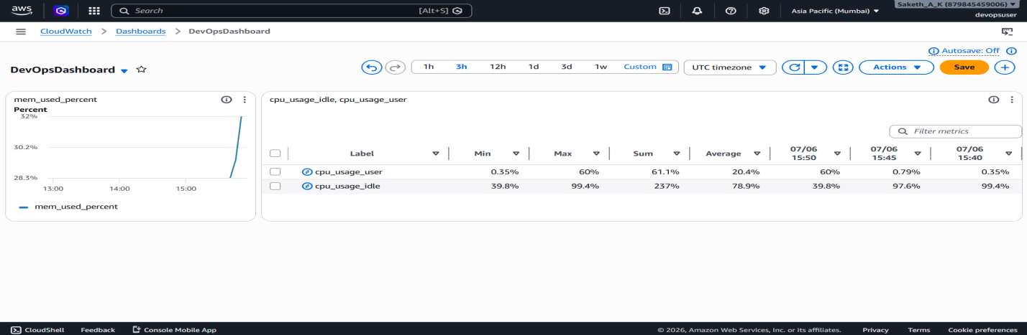Figure 6.1: CloudWatch Dashboard Overview
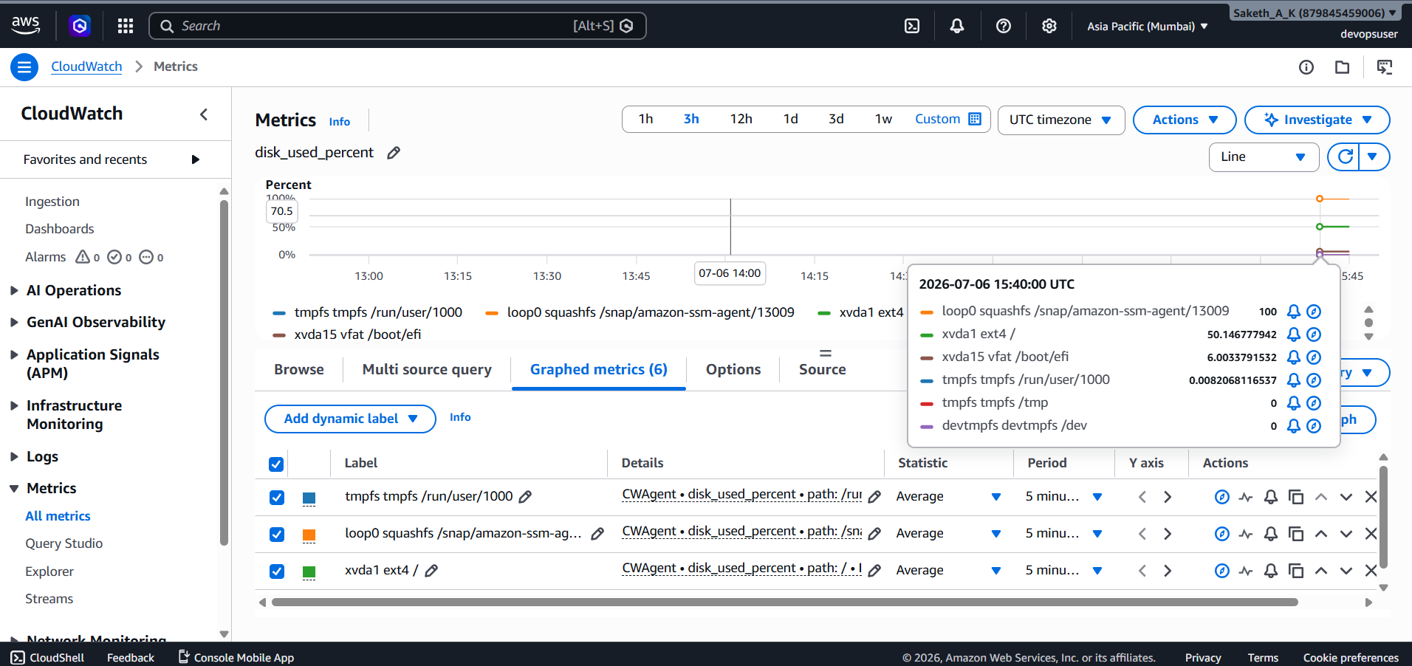
Figure 6.2: CPU Utilization and Memory Utilization Metrics

7. Load Testing Results
Application performance was evaluated using the k6 load testing tool. The objective of the test was to measure the application's behavior under increasing concurrent user load while monitoring system resource utilization through Amazon CloudWatch.
The test gradually increased the number of virtual users from 0 to 100 over approximately 3 minutes, simulating realistic user traffic against the production application's /health endpoint. During the test, CloudWatch monitored CPU utilization, memory utilization, network traffic, and instance health, while k6 recorded throughput, response time, latency, and error rate.
The complete load testing methodology, k6 configuration, raw output, and detailed observations are available in load-testing/LOAD_TEST_REPORT.md.
Metric | Warm-up (10 VUs) | Steady (50 VUs) | Peak (100 VUs)
Throughput (req/s) | Fill from k6 output | Fill from k6 output | Fill from k6 output
Avg response time (ms) | Fill from k6 output | Fill from k6 output | Fill from k6 output
p95 response time (ms) | Fill from k6 output | Fill from k6 output | Fill from k6 output
Error rate (%) | Fill from k6 output | Fill from k6 output | Fill from k6 output
EC2 CPU (%) | Fill from CloudWatch | Fill from CloudWatch | Fill from CloudWatch
EC2 memory (%) | Fill from CloudWatch | Fill from CloudWatch | Fill from CloudWatch

The load testing exercise demonstrated the application's behavior under gradually increasing workloads. The collected metrics were used to evaluate system stability, identify resource utilization patterns, and determine the primary performance bottlenecks. The results provide valuable insights for future optimization and scalability improvements.

8. Bottleneck Analysis and Optimization Recommendations
The load testing results, together with the Amazon CloudWatch metrics, were analyzed to identify the primary performance bottlenecks of the deployed application.

Bottleneck Analysis
During the initial stages of the load test, the application responded consistently with low response times and no significant increase in resource utilization. As the number of concurrent virtual users increased, CPU utilization steadily increased while memory utilization remained relatively stable.
The CloudWatch metrics indicated that CPU utilization became the primary limiting factor for the application running on a single AWS Free Tier t2.micro EC2 instance. Since the t2.micro is a burstable instance type, sustained CPU-intensive workloads can consume available CPU credits, leading to increased response times and reduced application performance.
Memory usage remained within acceptable limits throughout testing, indicating that memory was not the primary bottleneck. Network traffic also remained well within the instance's available bandwidth, suggesting that network throughput did not significantly impact application performance.
As CPU utilization increased under higher concurrent workloads, application latency also increased, demonstrating that processor capacity was the main factor limiting scalability.

Performance Observations
- The application handled light and moderate workloads without errors.
- CPU utilization increased proportionally with the number of concurrent users.
- Memory utilization remained relatively stable during testing.
- Network utilization did not approach the limits of the EC2 instance.
- Higher concurrent workloads resulted in increased response time and latency due to CPU saturation.

Recommended Optimizations
To improve scalability, reliability, and overall application performance, the following optimizations are recommended:
- Implement Auto Scaling
  - Deploy the application using an Auto Scaling Group behind an Application Load Balancer (ALB) across multiple Availability Zones to eliminate the single point of failure and automatically handle increased traffic.
- Upgrade the EC2 Instance
  - Replace the Free Tier t2.micro instance with a larger instance type such as t3.small or t3.medium for production environments requiring sustained CPU performance.
- Introduce a Caching Layer
  - Use Amazon CloudFront or application-level caching to reduce backend processing for frequently requested resources.
- Optimize Nginx Configuration
  - Configure worker_processes auto, increase worker_connections, and enable HTTP Keep-Alive to improve request handling efficiency.
- Optimize Application Code
  - Move CPU-intensive operations to asynchronous background jobs where possible.
  - Reduce unnecessary database or file system operations.
  - Optimize API response generation and middleware execution.
- Enhance Monitoring
  - Configure additional CloudWatch alarms for memory utilization, disk usage, and application response time to enable proactive issue detection.
- Improve High Availability
  - Deploy the application across multiple Availability Zones with automatic failover to improve fault tolerance and service availability.
The performance evaluation demonstrated that the application performs reliably under normal workloads on AWS Free Tier infrastructure. The primary limitation is the compute capacity of the single t2.micro EC2 instance, making CPU utilization the main bottleneck during higher concurrent workloads. Implementing horizontal scaling, caching, and infrastructure optimization would significantly improve the application's ability to handle production-scale traffic.

9. Challenges Faced
Throughout the implementation of this project, several technical challenges were encountered. These issues provided valuable practical experience in AWS infrastructure management and DevOps troubleshooting.
- CloudWatch Agent Configuration
  - The CloudWatch Agent initially failed to start because the configuration file (amazon-cloudwatch-agent.json) was missing. Additionally, the default configuration generated by the wizard included unsupported collectd settings, resulting in configuration validation errors. The issue was resolved by creating a custom configuration file and removing unnecessary plugins.
- IAM Role and Metadata Service Configuration
  - The EC2 instance initially could not access AWS services because no IAM role was attached. The AWS Instance Metadata Service (IMDSv2) returned authentication errors until the correct IAM instance profile (CloudWatchEC2Role) was attached and verified.
- HTTPS Certificate Generation
  - HTTPS was configured using Let's Encrypt (Certbot). However, certificate generation failed because the custom domain DNS records were not correctly configured, preventing domain validation. The application was therefore demonstrated over HTTP, and the HTTPS configuration procedure was documented for future deployment.
- API Gateway Integration
  - Configuring API Gateway to forward requests to the application required additional troubleshooting because the backend integration with the EC2 instance and Nginx reverse proxy was not immediately recognized. Proper routing and endpoint configuration were necessary before requests could be forwarded successfully.
- GitHub Actions Deployment
  - The CI/CD workflow required multiple iterations before successful deployment. Issues related to SSH authentication, deployment keys, workflow configuration, and remote application restart had to be resolved to achieve reliable automated deployments.
- Least-Privilege IAM Policies
  - Designing IAM policies that followed the principle of least privilege required several revisions. Initial permissions were either insufficient for deployment tasks or overly permissive. The policies were refined to grant only the minimum permissions required for deployment, monitoring, and S3 backup operations.
- AWS Free Tier Limitations
  - The application was deployed on a single t2.micro EC2 instance to remain within AWS Free Tier limits. During higher workloads, limited CPU resources became the primary performance constraint. High availability features such as Auto Scaling Groups, Application Load Balancers, and Multi-AZ deployment were not implemented because they exceed Free Tier usage.
Despite these challenges, all core project objectives—including infrastructure provisioning, application deployment, automated CI/CD, centralized monitoring, logging, backup management, and load testing—were successfully completed.

10. Future Improvements
Although the project successfully demonstrates a production-style DevOps workflow using AWS Free Tier services, several enhancements could be implemented to improve scalability, security, reliability, and maintainability in a real production environment.

10.1 High Availability and Scalability
- Deploy the application across multiple Availability Zones using an Auto Scaling Group (ASG) and an Application Load Balancer (ALB) to eliminate the single point of failure and automatically scale based on traffic demand.
- Upgrade from the Free Tier t2.micro instance to a larger instance type for workloads requiring sustained CPU performance.

10.2 Enhanced Security
- Configure AWS WAF to protect the application against common web attacks such as SQL injection, cross-site scripting (XSS), and other OWASP Top 10 vulnerabilities.
- Successfully configure HTTPS using a properly configured custom domain with AWS Certificate Manager (ACM) or Let's Encrypt, ensuring encrypted communication between clients and the application.
- Enable automatic security patching and regular vulnerability assessments for the EC2 instance.

10.3 Improved CI/CD Pipeline
- Replace long-lived IAM access keys with GitHub OpenID Connect (OIDC) authentication, allowing GitHub Actions to securely assume temporary AWS IAM roles without storing AWS credentials.
- Extend the CI/CD pipeline to include automated unit testing, integration testing, security scanning, and deployment validation before releasing changes to production.

10.4 Advanced Monitoring and Logging
- Configure additional CloudWatch dashboards and alarms for application response time, memory utilization, disk usage, and network performance.
- Integrate centralized log analysis tools such as the Elastic Stack (ELK) or Grafana for more comprehensive log visualization and troubleshooting.

10.5 Infrastructure as Code
- Provision the complete AWS infrastructure using Terraform or AWS CloudFormation to enable repeatable, version-controlled infrastructure deployment and simplify future environment creation.

10.6 Containerization
- Containerize the application using Docker and deploy it on Amazon ECS, AWS Fargate, or Amazon EKS to improve portability, scalability, and deployment consistency.
- Introduce rolling deployments and zero-downtime deployment strategies for production environments.

10.7 Security Compliance
- Enable AWS CloudTrail for auditing API activity.
- Configure AWS Config to continuously monitor resource compliance.
- Enable Amazon GuardDuty for intelligent threat detection and security monitoring.
Implementing these improvements would transform the current AWS Free Tier deployment into a highly available, scalable, secure, and production-ready cloud infrastructure capable of supporting significantly larger workloads while following modern DevOps and cloud engineering best practices.

11. Conclusion
This project successfully demonstrated the design, deployment, security, monitoring, and performance evaluation of a production-style web application using AWS Free Tier services. The application was deployed on an Ubuntu 26.04 LTS EC2 instance, automated through a GitHub Actions CI/CD pipeline, backed up using Amazon S3, and monitored using Amazon CloudWatch with centralized logging, dashboards, alarms, and Amazon SNS notifications.
Load testing using k6 provided valuable insights into the application's performance under increasing workloads, while CloudWatch metrics helped identify CPU utilization as the primary performance constraint of the single t2.micro instance. Security best practices, including IAM least-privilege policies, Security Groups, secure credential management, and application monitoring, were successfully implemented throughout the project.
Although certain production features such as fully functional HTTPS, Auto Scaling, Multi-AZ deployment, and AWS WAF were not implemented due to DNS configuration issues and AWS Free Tier limitations, the project successfully achieved its primary objectives. It demonstrates a practical understanding of modern DevOps principles, including cloud infrastructure deployment, CI/CD automation, monitoring, logging, security, backup management, and performance analysis, providing a solid foundation for deploying scalable and production-ready applications on AWS.

12. Appendix
- Repository: https://github.com/Saketh8904/DevopsUser
- Deployment guide: docs/DEPLOYMENT_GUIDE.md
- Security summary: docs/SECURITY_SUMMARY.md
- Load test report: load-testing/LOAD_TEST_REPORT.md
- CI/CD pipeline: .github/workflows/deploy.yml

