AWS DevOps Engineer
Intern Assignment — Project Report
Deploying a Static Website on an AWS EC2 Instance using Nginx
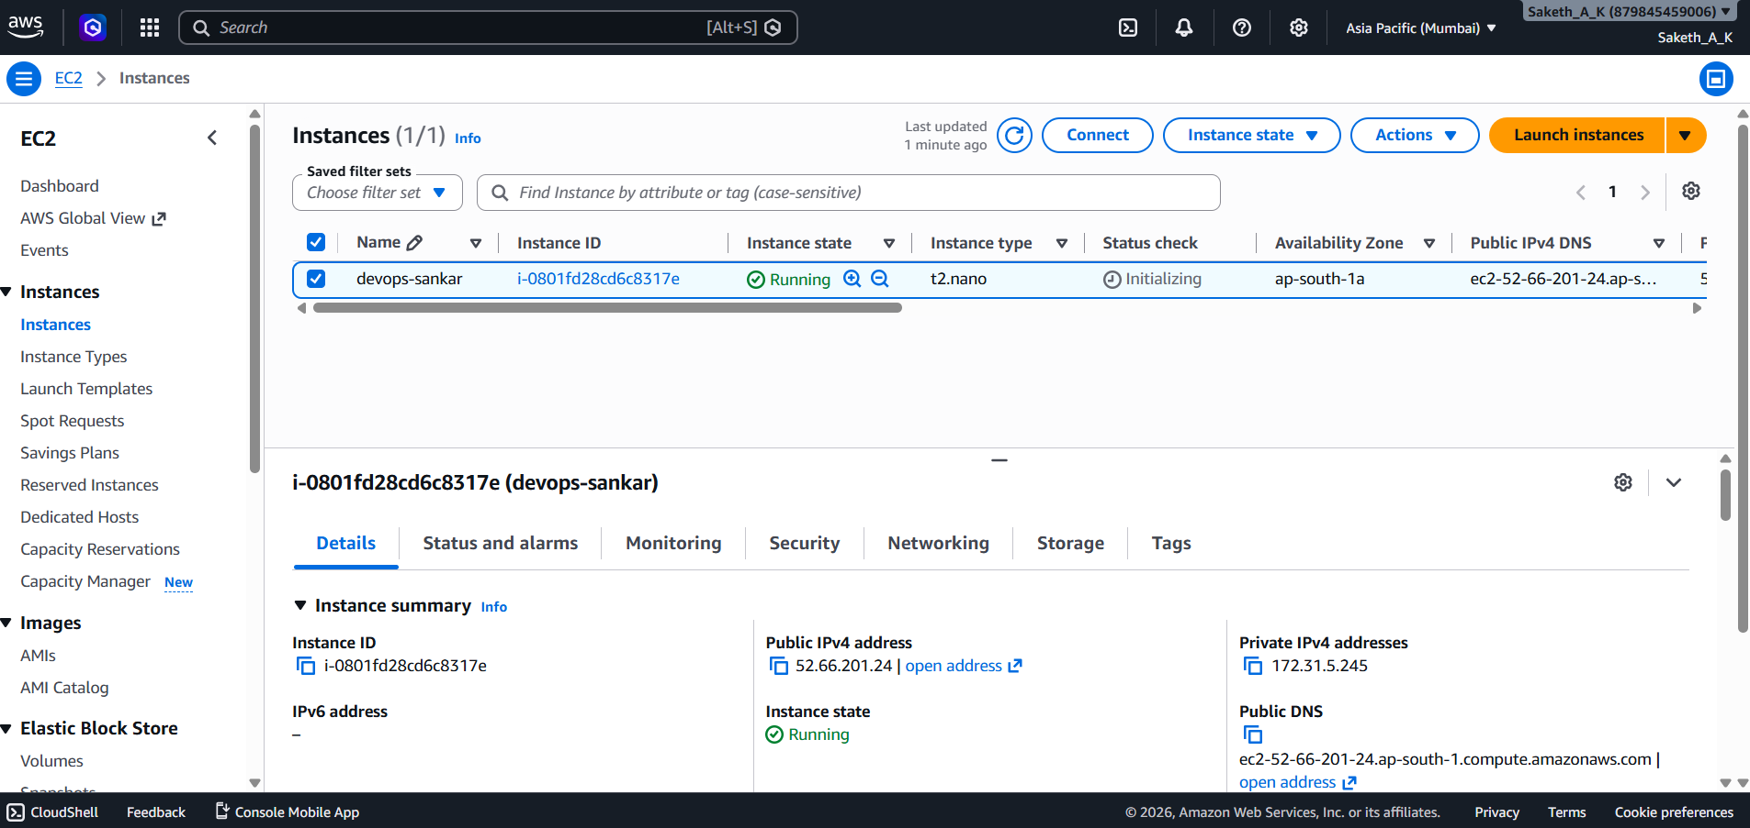
Submitted by
Saketh Alevooraya K
Sir M. Visvesvaraya Institute of Technology
Branch: Computer Science
Email: sakethdec4@email.com
Date: 10 July 2026
GitHub Repository: github.com/Saketh8904/devops-sankar

1. Objective
The objective of this one-day assignment was to provision a Linux server on AWS, configure it as a web server, deploy a simple personal-details web page on it, and document the entire workflow — from infrastructure setup to version control — for evaluation.
The exercise covers five core areas: EC2 provisioning and secure access, Linux server administration, static website hosting with Nginx, Git/GitHub version control, and technical documentation.

2. AWS Services & Tools Used
Compute | Amazon EC2 — Ubuntu instance(s), t2.nano
Networking | Default VPC, default Subnet, 2 Security Groups (launch-wizard-1, devcicd)
Access Control | EC2 Key Pair (.pem) for SSH authentication
Elastic IP | Static public IP allocated & associated with the instance (Bonus)
Region | Asia Pacific (Mumbai) — ap-south-1
Web Server | Nginx 1.28.3 (Ubuntu package)
Containers | Docker Engine — hello-world test container (Bonus)
Automation | Custom Bash script to restart & verify Nginx (Bonus)
Version Control | Git & GitHub

3. Task 1 — EC2 Instance Setup

3.1 Steps Performed
- Logged into the AWS Management Console and opened the EC2 dashboard.
- Launched a new instance named "devops-sankar" using the Ubuntu Server AMI, instance type t2.nano (Free Tier eligible).
- Created a new key pair (devops-sankar-kp.pem) and downloaded it for SSH authentication.
- Created a new Security Group with two inbound rules:
• Port 22 (SSH) — for remote terminal access
• Port 80 (HTTP) — to allow the website to be reached over the browser
- Launched the instance and waited for the state to turn "Running".
- Connected to the instance from a local terminal using SSH and the downloaded key pair.

3.2 Instance Details
Instance Name | devops-sankar
Instance ID | i-0801fd28cd6c8317e
Instance Type | t2.nano
Operating System | Ubuntu (Linux 7.0.0-1006-aws, x86_64)
Public IPv4 Address | 52.66.201.24
Private IPv4 Address | 172.31.5.245
Public DNS | ec2-52-66-201-24.ap-south-1.compute.amazonaws.com
VPC ID | vpc-0dd50307c61c747e5
Subnet ID | subnet-0da44b994c6866bfa (default)
Key Pair | devops-sankar-kp.pem
✏ EDIT ME — The instance was terminated after completing the assignment to avoid ongoing AWS charges, so the Public IP above is no longer reachable. If a fresh instance is running at submission time, replace this IP and re-take the Task 3 browser screenshot.

3.3 SSH Connection Command
ssh -i "devops-sankar-kp.pem" ubuntu@ec2-52-66-201-24.ap-south-1.compute.amazonaws.com

3.4 Screenshots

Fig 3.1 — EC2 Dashboard showing the running "devops-sankar" instance
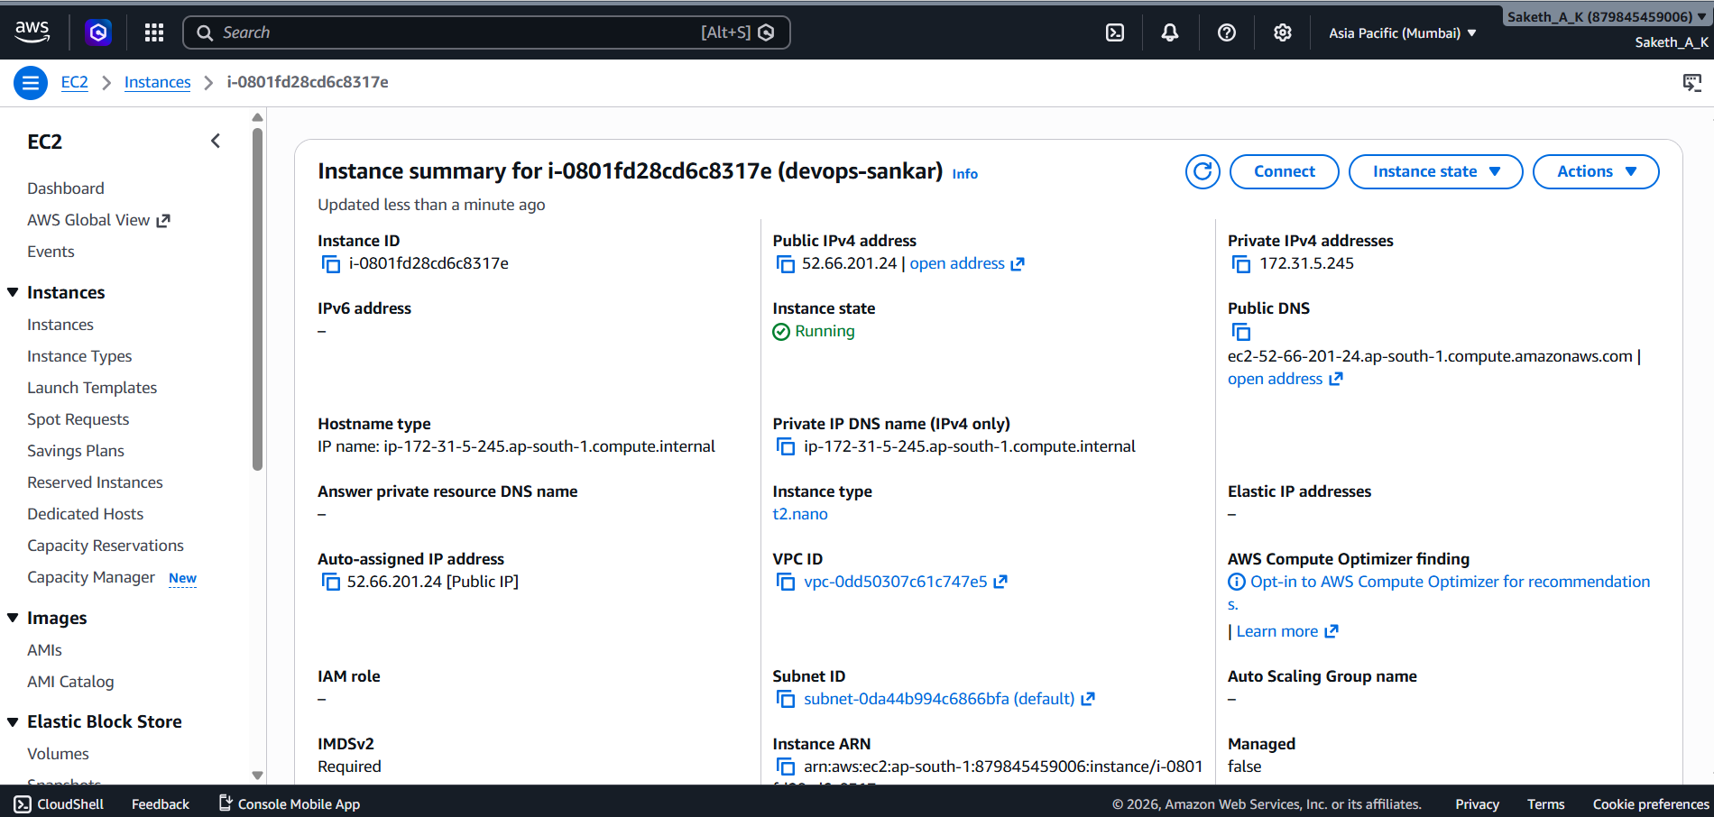
Fig 3.2 — Instance summary with Public/Private IP, VPC and Subnet details
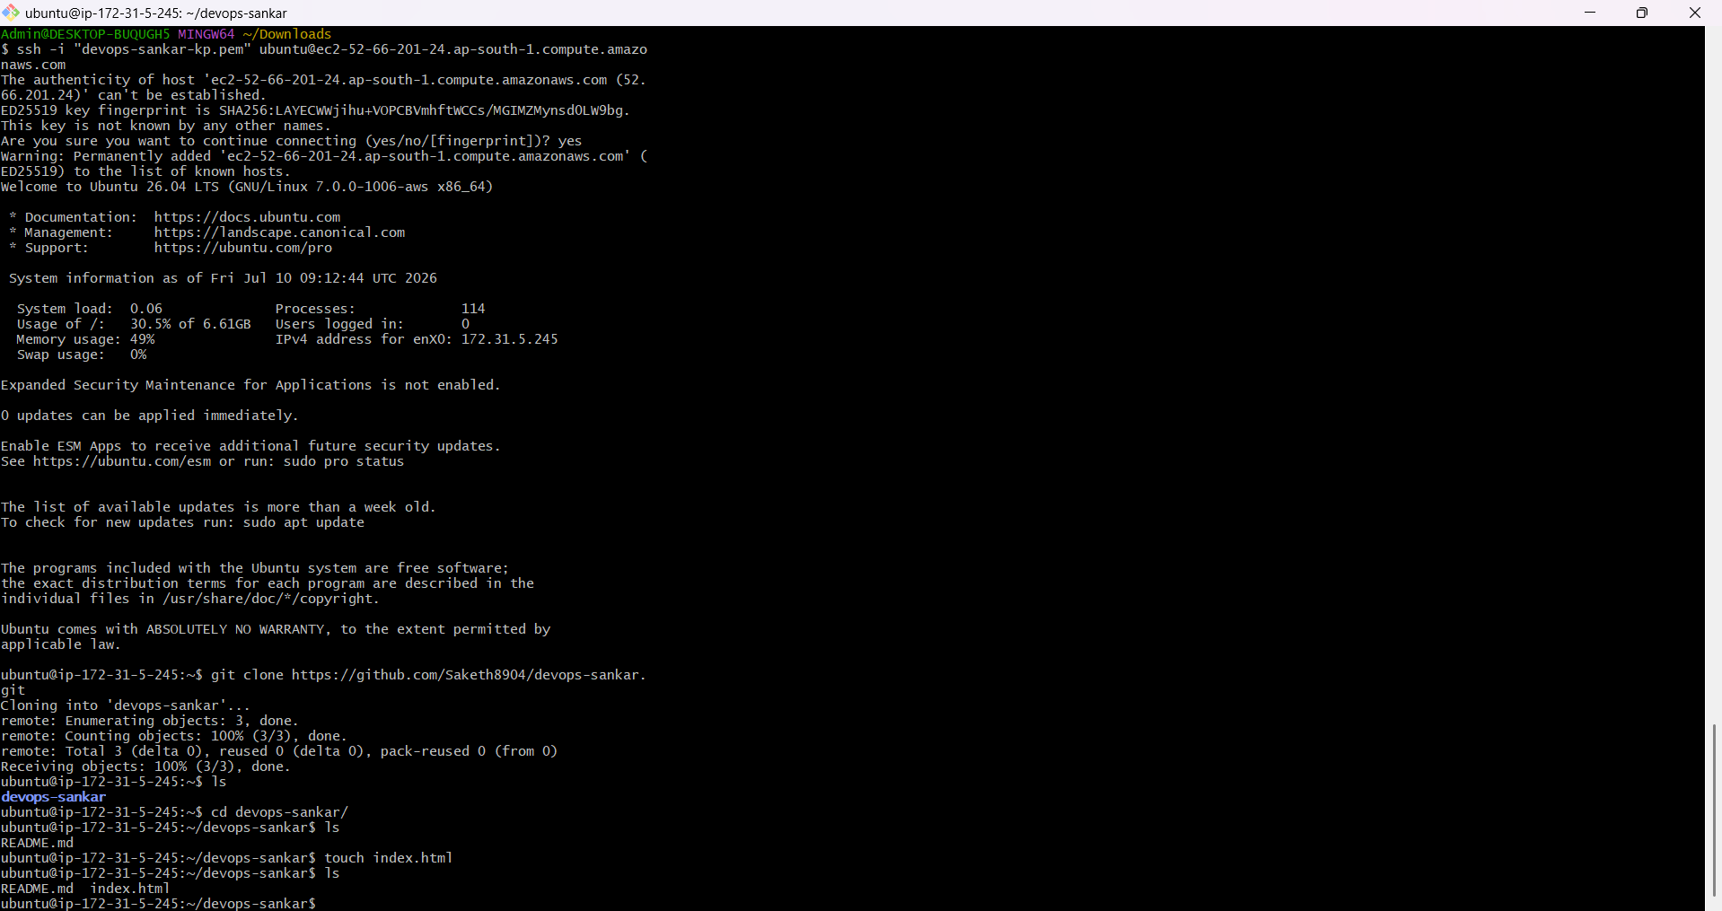
Fig 3.3 — Successful SSH login into the Ubuntu instance from local terminal

4. Task 2 — Linux Basics
After connecting over SSH, the package index was refreshed, Nginx was installed, and standard Linux administration commands were used to inspect the server's health.
Command | Purpose
sudo apt update && sudo apt upgrade -y | Refresh package index and update installed packages
sudo apt install nginx -y | Install the Nginx web server
sudo systemctl start nginx | Start the Nginx service
sudo systemctl enable nginx | Enable Nginx to auto-start on boot
sudo systemctl status nginx | Check whether Nginx is active/running
sudo systemctl restart nginx | Restart Nginx after configuration/content changes
df -h | Check disk space usage in human-readable form
free -h | Check RAM and swap memory usage
ps aux | List all currently running processes
top | View live CPU/memory usage and running processes

Screenshots
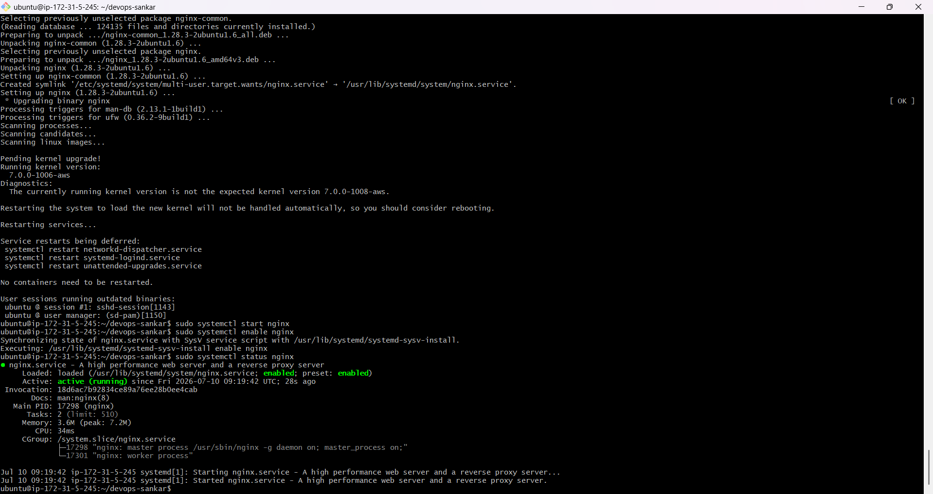
Fig 4.1 — Nginx installed and "active (running)" status confirmed via systemctl
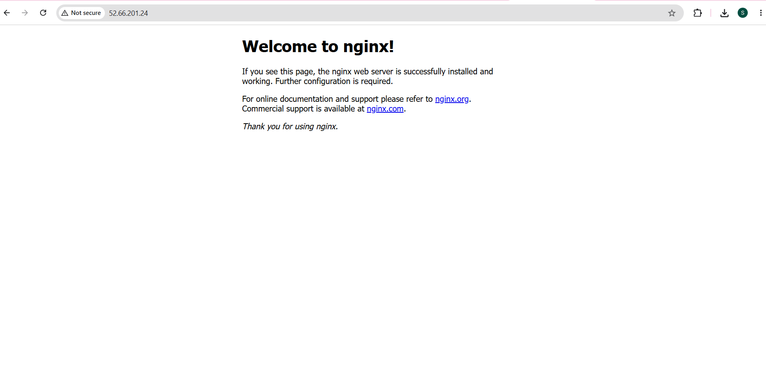
Fig 4.2 — Default Nginx welcome page confirmed reachable via the EC2 Public IP over HTTP (before the custom page was added)

5. Task 3 — Hosting the Website
With Nginx confirmed running and serving its default page (Task 2), the next step was to replace that default page with the personal-details website.

5.1 Steps Performed
- Created index.html containing Name, College, Branch, Email and Current Date inside a styled card layout.
- Copied the file to Nginx's web root, replacing the default landing page:
sudo cp index.html /var/www/html/index.html
sudo systemctl restart nginx
- Opened the EC2 Public IP address in a browser to confirm the custom page was being served instead of the default Nginx page.

5.2 Screenshots
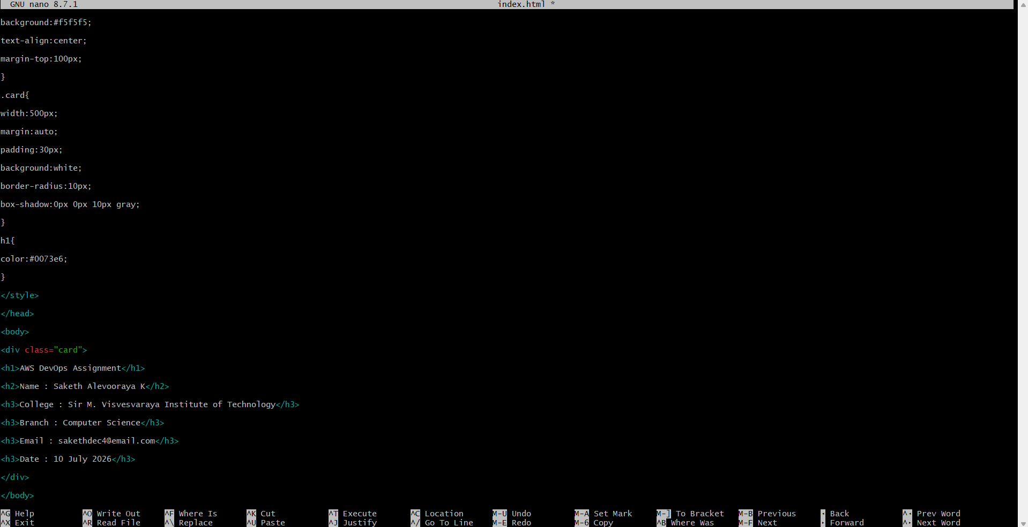
Fig 5.1 — index.html edited on the server using the nano editor

Fig 5.2 — Custom page served successfully via the EC2 Public IP

6. Task 4 — Git & GitHub

6.1 Repository
GitHub Repository: https://github.com/Saketh8904/devops-sankar
The repository contains index.html (the deployed web page), README.md, and a /screenshots folder with all the evidence images used in this report.

6.2 Git Commands Used
Command | Purpose
git clone https://github.com/Saketh8904/devops-sankar.git | Clone the repository onto the EC2 instance / local machine
git add . | Stage changes (index.html, README.md, screenshots)
git commit -m "Add website files and documentation" | Commit staged changes with a message
git push origin main | Push local commits to the GitHub repository

7. Task 5 — Documentation Summary

7.1 Problems Faced
✏ EDIT ME — Add 2–4 real issues you ran into, e.g. "SSH connection initially timed out because port 22 wasn't yet open in the Security Group", "Permission denied errors when copying files into /var/www/html without sudo", or "Key pair .pem file needed chmod 400 before SSH would accept it".

7.2 Key Learnings
✏ EDIT ME — Summarize what you learned, e.g. how EC2 + Security Groups model network access, how systemd manages services like Nginx, how to replace default web content, and how Git ties local/server work back to GitHub.

7.3 Total Time Taken
✏ EDIT ME — State the approximate time spent, e.g. "Completed in ~3 hours: 45 min EC2 setup, 45 min Linux/Nginx, 45 min website + testing, 45 min Git/GitHub and documentation."

8. Bonus Tasks (+10 Marks) — All Four Completed
Although the assignment required completing only one bonus item, all four optional bonus tasks were completed for extra practice.

8.1 Elastic IP Attached
An Elastic IP was allocated in the EC2 console and associated with the running instance, giving the deployment a fixed public address that would persist across stop/start cycles (unlike the default auto-assigned public IP).
Elastic IP | 3.7.180.70
Associated Instance ID | i-0ddd76114f0949d10
Allocation ID | eipalloc-0c90ee45d70a7bb8a
Public DNS | ec2-3-7-180-70.ap-south-1.compute.amazonaws.com
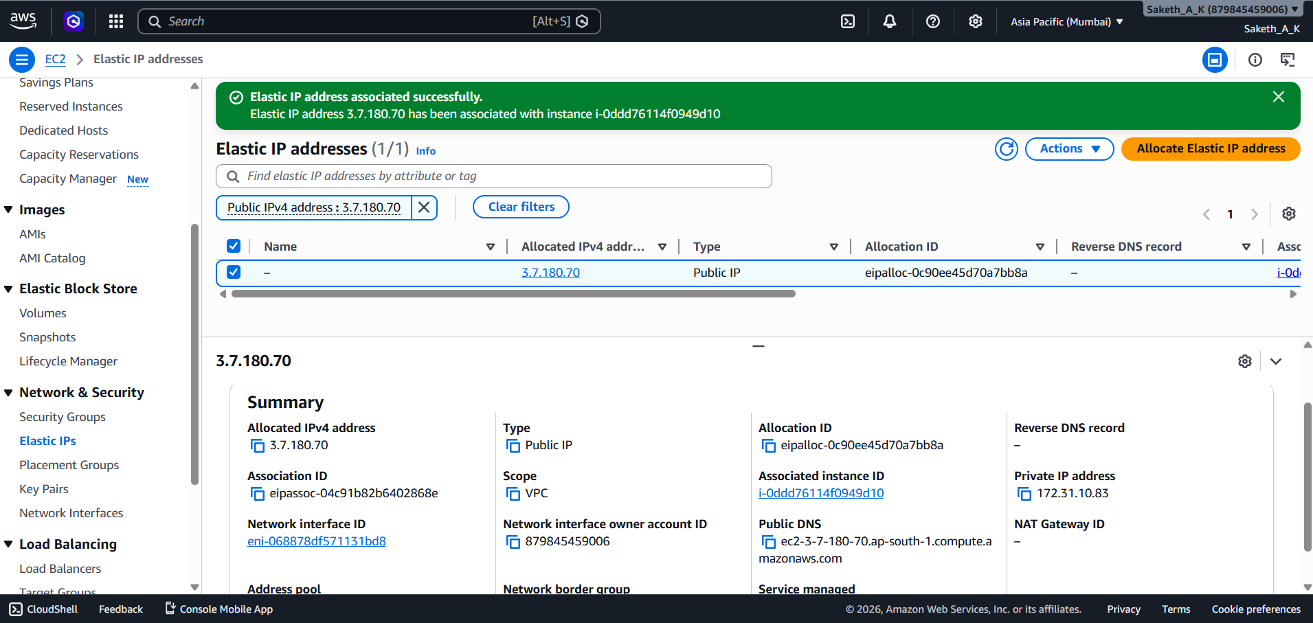
Fig 8.1 — Elastic IP allocated and successfully associated with the instance
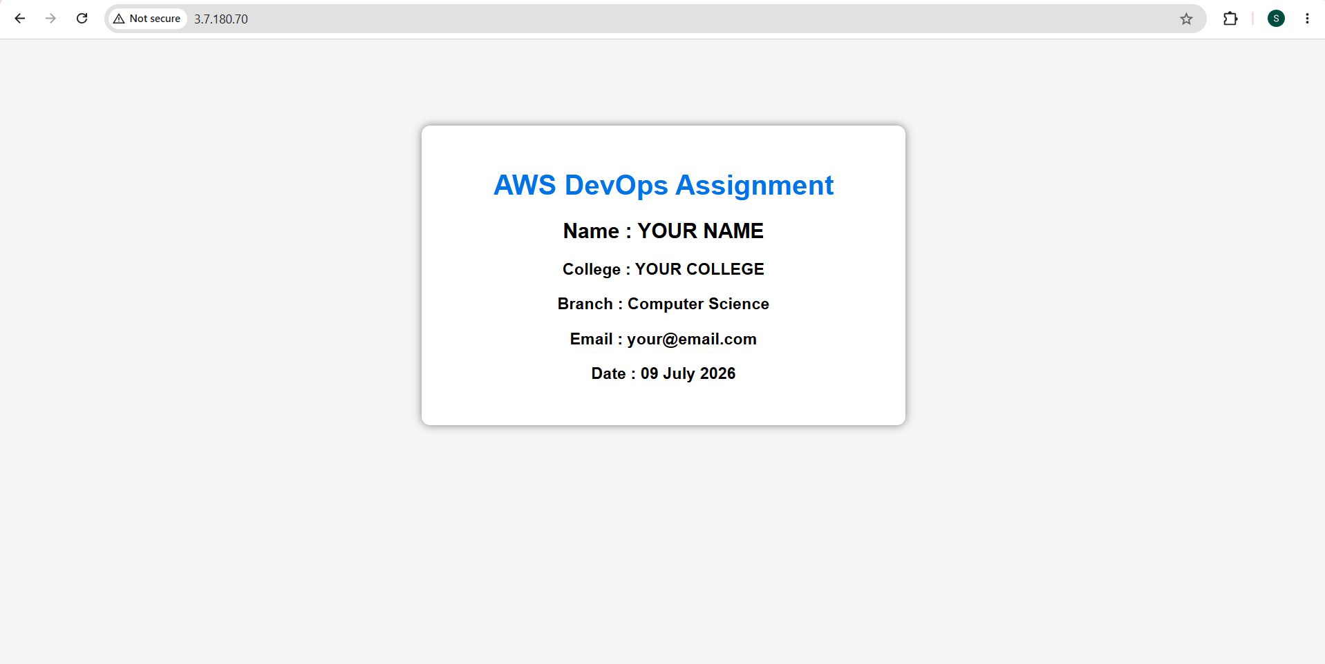
Fig 8.2 — Website reachable via the Elastic IP address (3.7.180.70)

8.2 Second Security Group Created
A second Security Group named "devcicd" (rule: allow SSH) was created and attached to the instance's network interface alongside the original "launch-wizard-1" group, via EC2 → Instance → Security → Change security groups. This demonstrates that multiple Security Groups can be layered on a single instance, with AWS evaluating the union of all their rules.
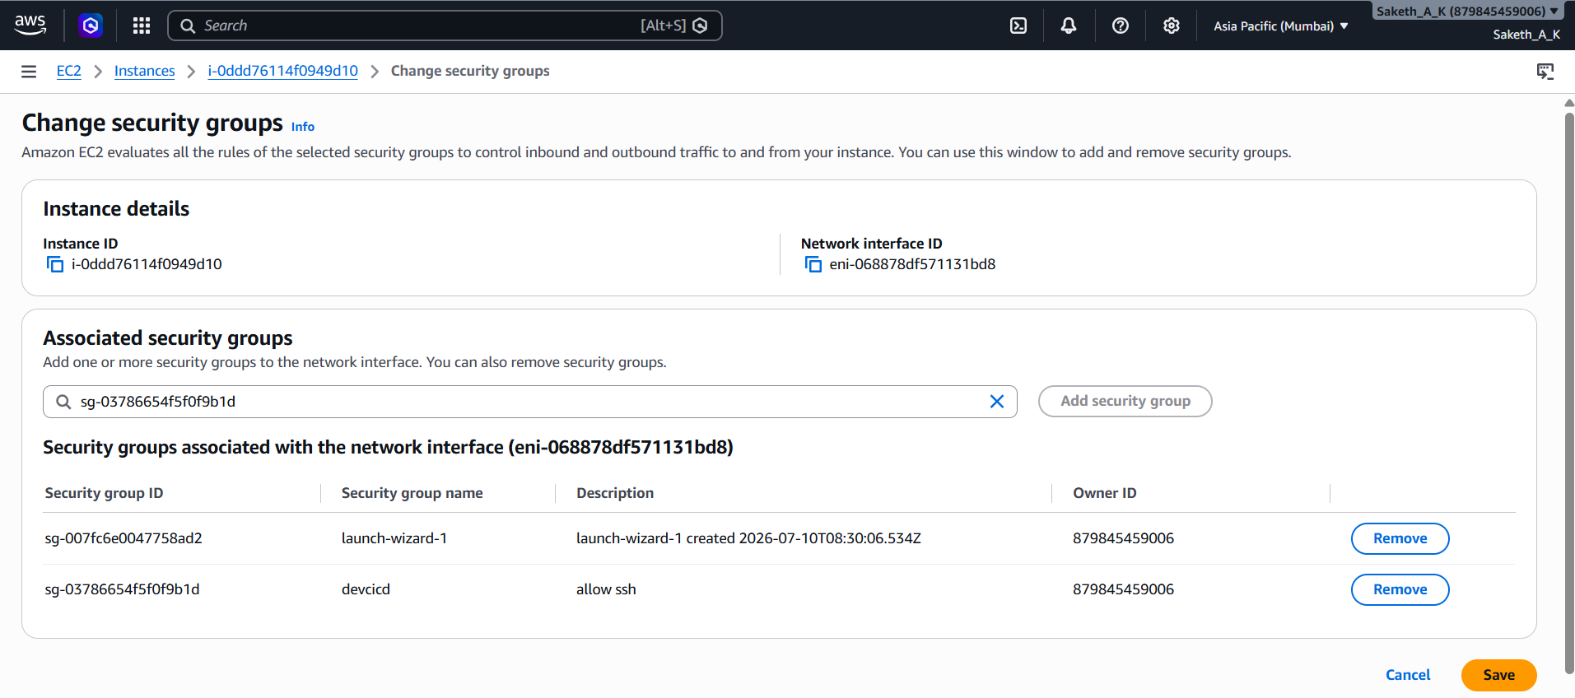
Fig 8.3 — Second Security Group (devcicd) attached alongside the original group

8.3 Docker Installed & hello-world Container Run
sudo apt update
sudo apt install docker.io -y
sudo systemctl start docker
sudo systemctl enable docker
sudo docker run hello-world
sudo docker images
sudo docker ps -a
The hello-world image was pulled from Docker Hub, a container was created and run from it, and the container exited successfully (status 0) after printing Docker's confirmation message — verifying the Docker installation was working correctly.
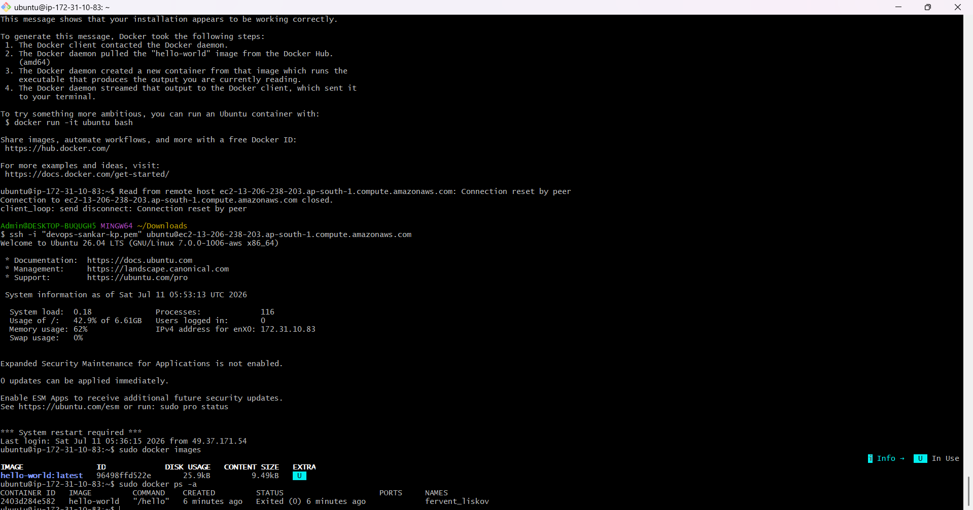
Fig 8.4 — Docker hello-world image pulled and container executed successfully

8.4 Shell Script to Restart Nginx
A shell script (restart-nginx.sh) was written to automate restarting and verifying the Nginx service in one step:
#!/bin/bash
echo "Restarting Nginx..."
sudo systemctl restart nginx
echo "Checking Nginx Status..."
sudo systemctl status nginx --no-pager
echo "Restart Completed Successfully"
Made executable and run with:
chmod +x restart-nginx.sh
./restart-nginx.sh
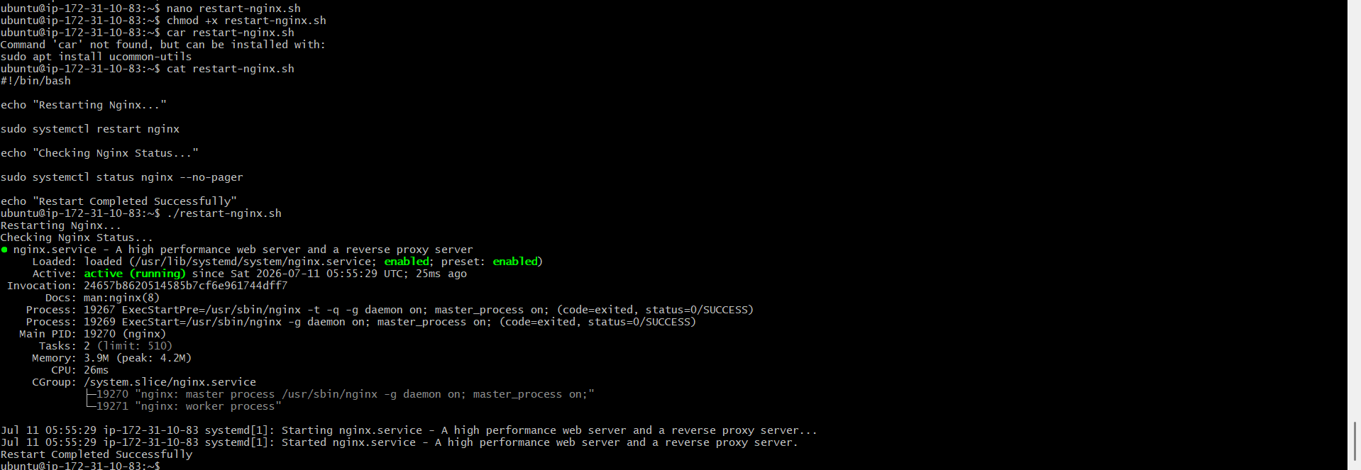
Fig 8.5 — restart-nginx.sh created, made executable, and run — Nginx returned to active (running)

9. Conclusion
This assignment provided hands-on experience with the core AWS DevOps workflow: launching and securing a cloud compute instance, performing basic Linux system administration, deploying a static website behind Nginx, and using Git/GitHub for version control and documentation. All four bonus tasks were additionally completed — Elastic IP allocation, a second Security Group, Docker containerization, and shell-script automation — deepening familiarity with AWS networking, containers, and operational scripting. The instance(s) were terminated after task completion to avoid unnecessary AWS billing, with all evidence preserved in the linked GitHub repository.
— End of Report —

