AI Assisted Coding
Assignment-2.3
HT.NO:2303A52489
Batch: 31
Question:
Task 1:Word Frequency from Text File
❖ Scenario: You are analyzing log files for keyword frequency.
❖ Task: Use Gemini to generate Python code that reads a text file and counts word frequency, then explains the code.
Prompt:
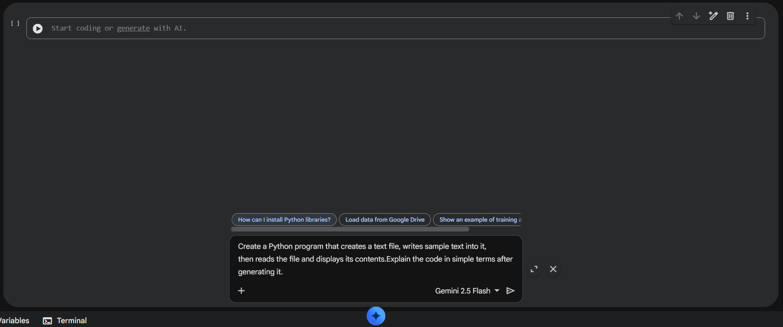

Create a Python program that creates a text file, writes sample text into it, then reads the file and displays its contents. Explain the code in simple terms after generating it.

Code Screenshot:
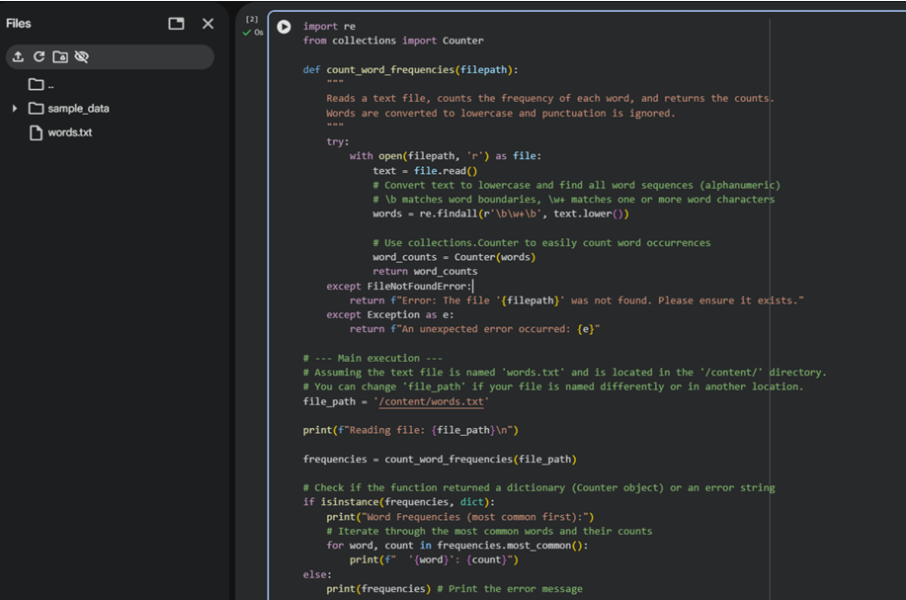
Output:
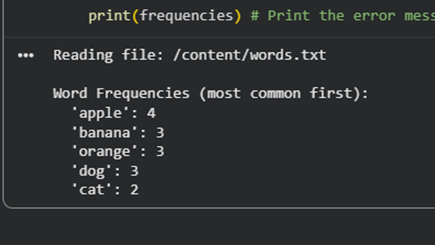

Explanation:
This program reads a text file and splits the content into words. Each word is stored in a dictionary where the key is the word and the value is its count. If a word appears again, its count is increased. Finally, the program prints how many times each word appears in the file. This helps in analyzing text data and finding frequently used words.

Question:
Task 2:
File Operations Using Cursor AI Scenario: You are automating basic file operations. Task: Use Cursor AI to generate a program that: Creates a text file Writes sample text Reads and displays the content
Prompt:
generate a python program, which creates a text file, write sample txt eg.fruits in that, read and display that content
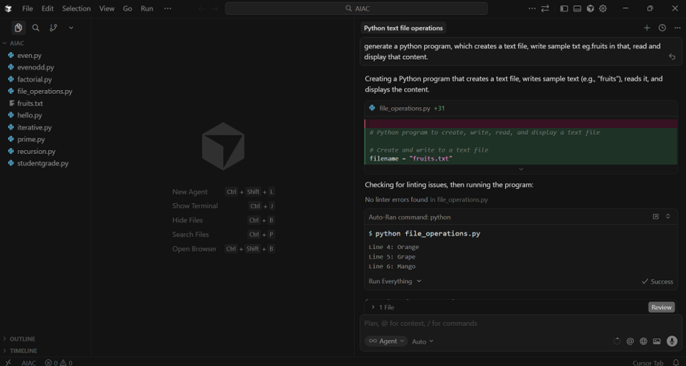.

Code Screenshot:
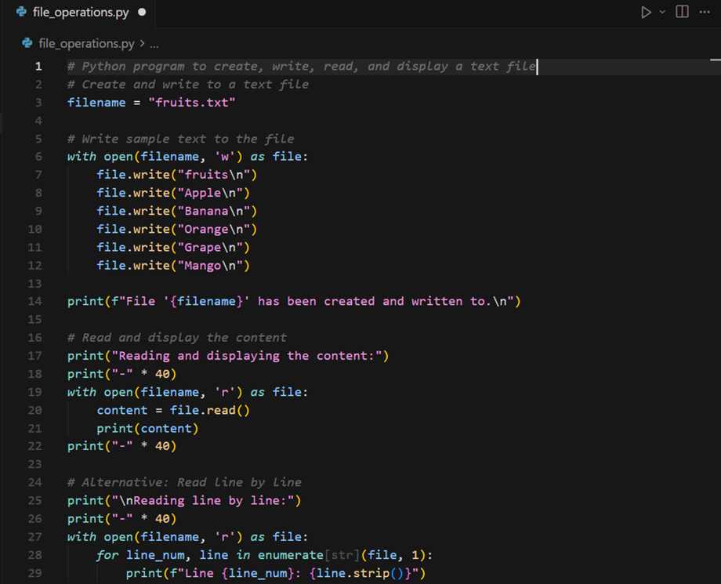

Output:
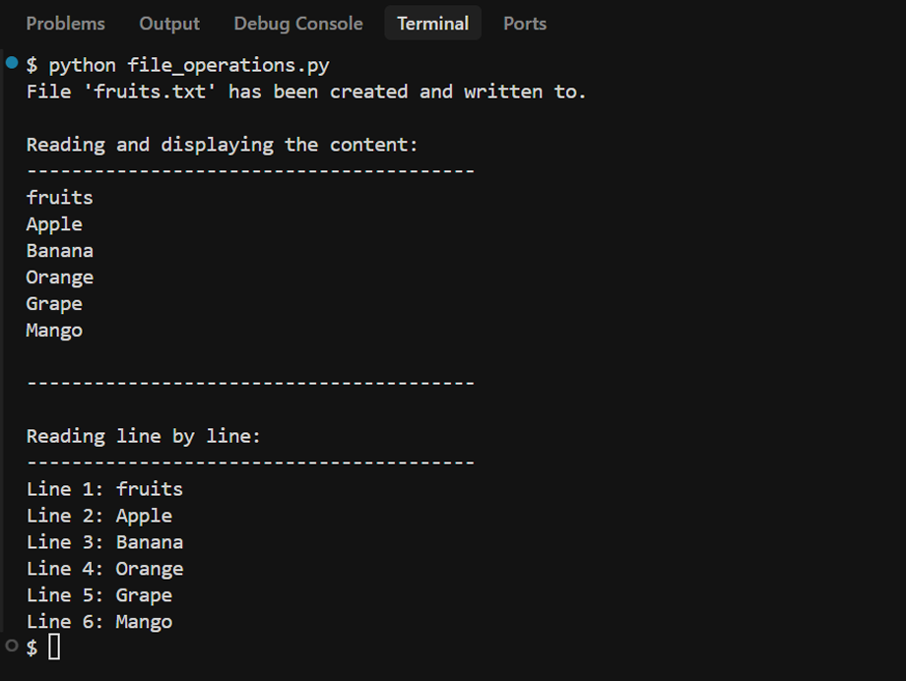

Explanation:
This program demonstrates basic file handling in Python using Cursor. First, a text file is created and sample text is written into it. Then, the same file is opened in read mode and its contents are displayed on the screen. It shows how Python can be used to create, write, and read files easily. Such operations are useful in automation and data storage tasks.

Question:
Task 3: CSV Data Analysis Scenario: You are processing structured data from a CSV file. Task: Use Gemini in Colab to read a CSV file and calculate mean, min, and max.
Prompt:
Generate Python code to read a CSV file and calculate the mean, minimum, and maximum values of a numeric column.

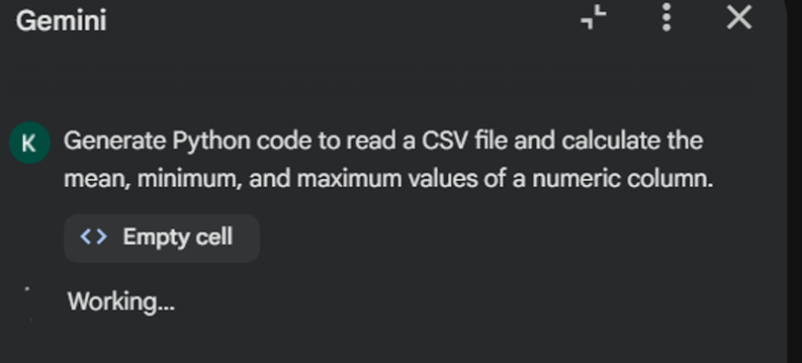

Code Screenshot:
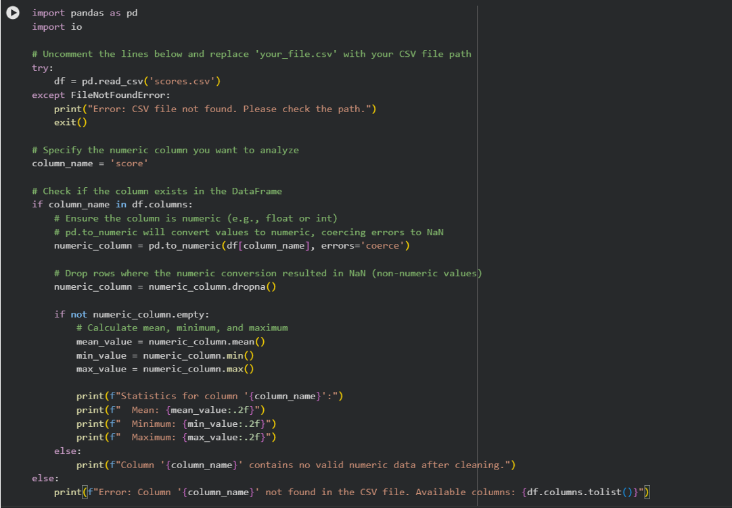

Output(O/P):
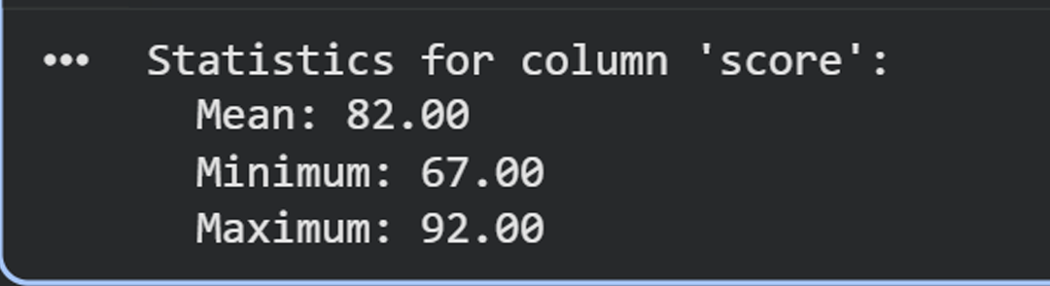

Explanation:
This program reads data from a CSV file using Python. It extracts numerical values from a column and calculates the mean, minimum, and maximum. CSV analysis is used in data processing and analytics applications.

Question:
Task 4: Sorting Lists Manual vs Built-in
Scenario: You are reviewing algorithm choices for efficiency.
Task: Use Gemini to generate:
Bubble sort
Python’s built-in sort( )
Compare both implementations.
Prompt:
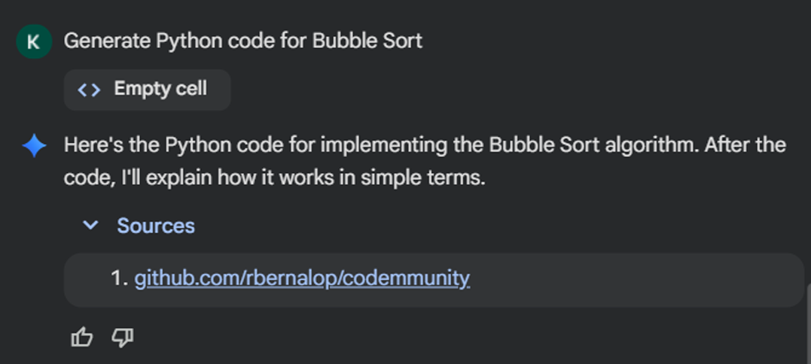

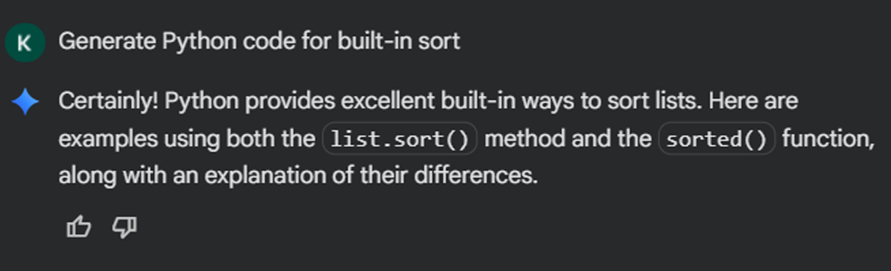

Code Screenshot:
Manual Bubble Sort Code:
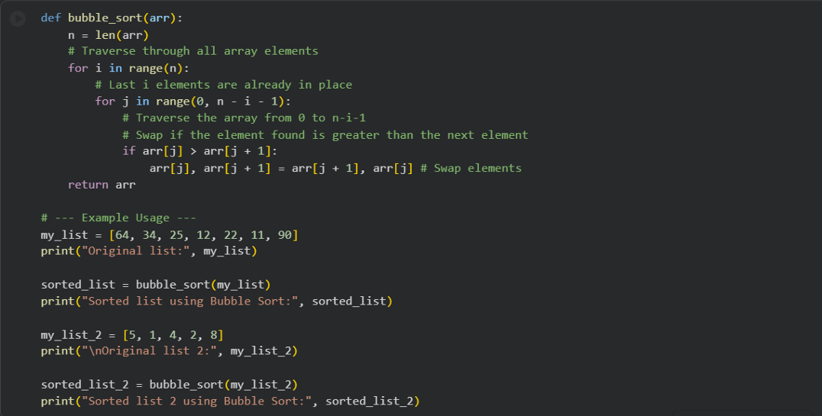
Sorting using sort() function:
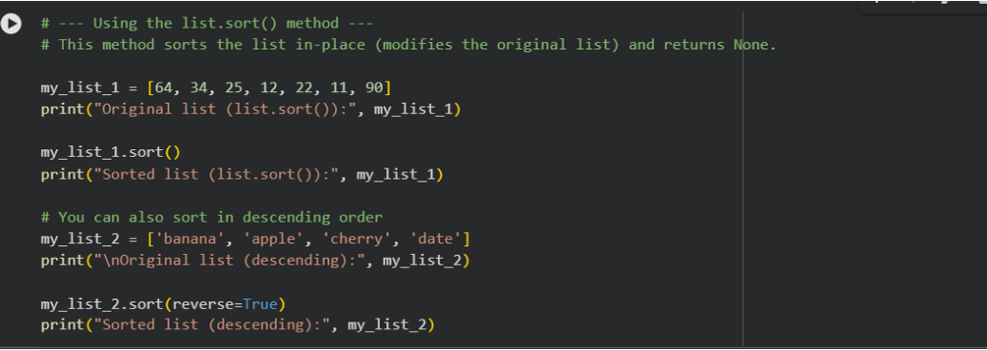
Output:
Bubble sort:
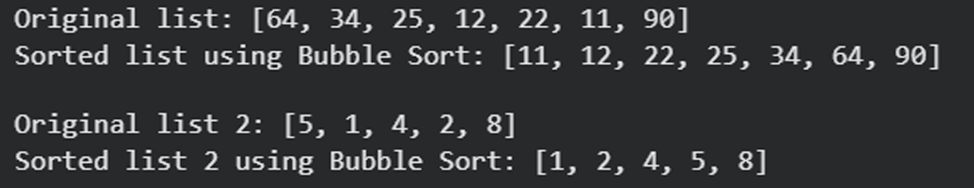

Sort Function:
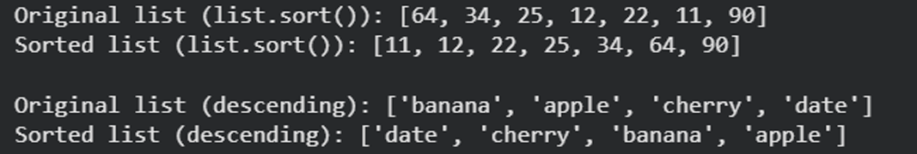

Explanation:
Bubble sort is a simple sorting algorithm that repeatedly compares and swaps adjacent elements. It is easy to understand but inefficient for large data sets. Python’s built-in sort function is shorter, optimized and much faster. The built-in method should be preferred in real-world applications.

