AI Assisted Coding

ASSIGNMENT 9.1

Name: K.Saketh
HT No: 2303A52489
Batch: 31

Problem 1:
Consider the following Python function:
def find_max(numbers):
return max(numbers)
Task:
• Write documentation for the function in all three formats:
(a) Docstring
(b) Inline comments
(c) Google-style documentation
• Critically compare the three approaches. Discuss the
advantages, disadvantages, and suitable use cases of each
style.
• Recommend which documentation style is most effective
for a mathematical utilities library and justify your
answer.

(a) Docstring

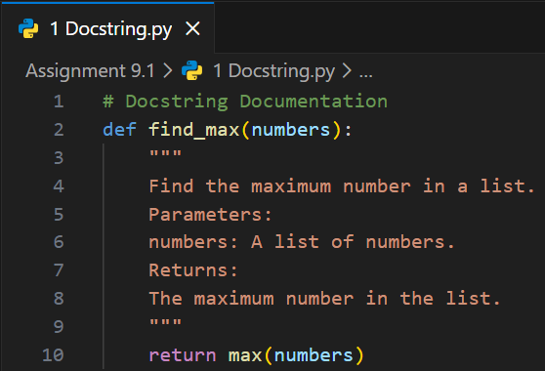

(b) Inline comments

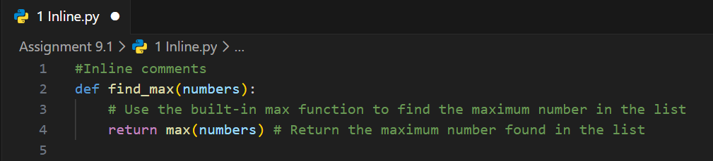

(c) Google-style documentation

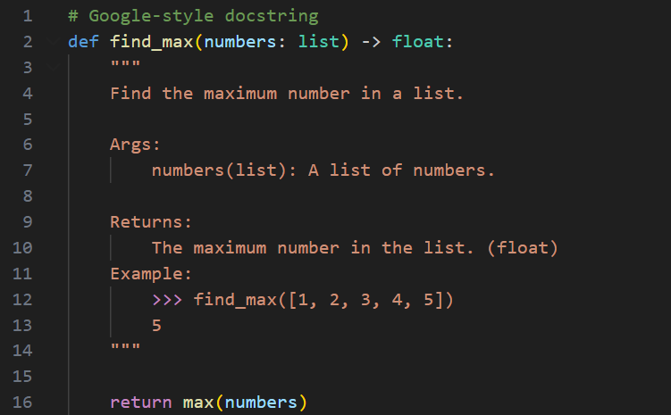
Critically compare the three approaches. Discuss the advantages, disadvantages, and suitable use cases of each style.

Aspect | Docstring | Inline Comments | Google-style
Readability | Good | Minimal | Excellent
IDE Support | Native | None | Native
Formality | Standard | Casual | Professional
Maintenance | Easy | Tedious | Structured
Type Hints | Optional | Unclear | Explicit
Examples | Rare | Never | Common

Format | Advantages | Disadvantages
Docstring | IDE tooltips, help() function, simple | Lacks structure, minimal detail
Inline | Code-adjacent clarity, detailed logic | Not accessible to tools, clutters code
Google | Professional standard, type specs, examples | Verbose, requires more effort

Google-style documentation is most effective for a mathematical utilities library because it is professional, structured, and clear.

Problem 2: Consider the following Python function:
def login(user, password, credentials):
return credentials.get(user) == password
Task:
1. Write documentation in all three formats.
2. Critically compare the approaches.
3. Recommend which style would be most helpful for new
developers onboarding a project, and justify your choice.

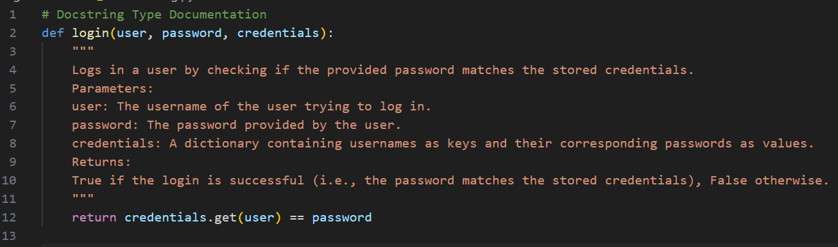
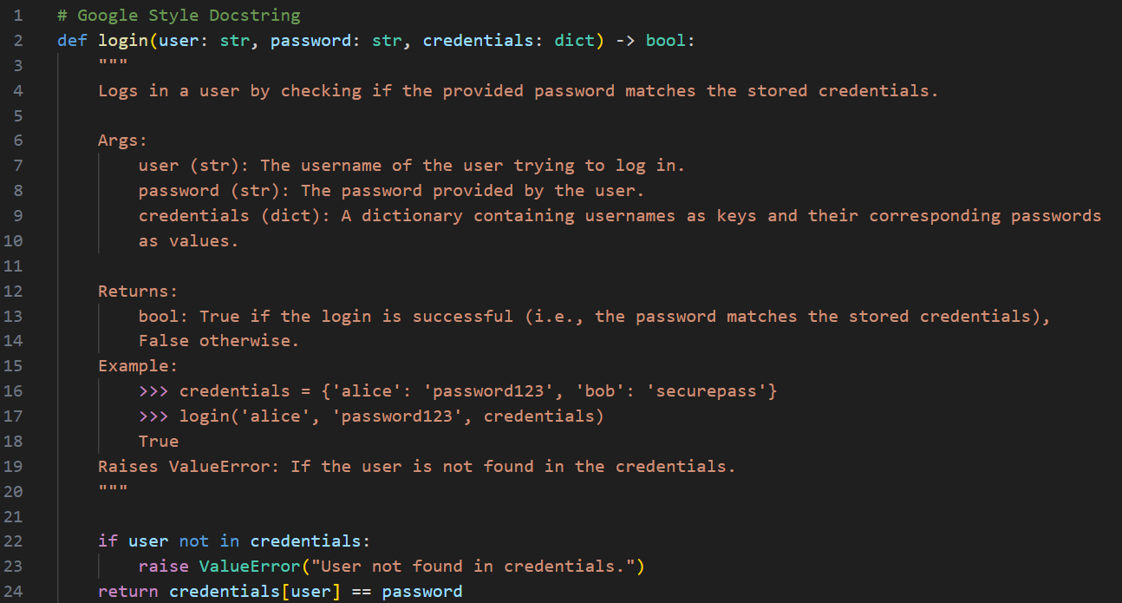
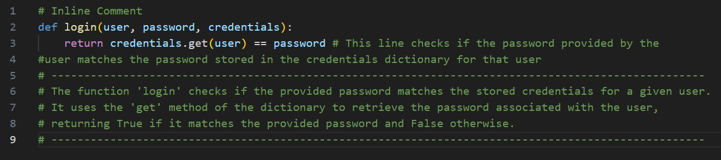

Point | Inline | Docstring | Google Style
Clear for beginners | No | Yes | Yes, very clear
Structured | No | Somewhat | Yes
Professional | No | Medium | Yes
For big projects | No | Okay | Yes
Best for onboarding | No | Good | Best

New developers need clarity, structure, and consistency.
Google style clearly explains inputs, outputs, and possible errors
Therefore, for onboarding new developers in a real project,
It scales well in real-world production systems.
It supports automated documentation generation.
It reduces ambiguity in collaborative projects.
Google-style documentation is the most helpful approach.
Problem 3: Calculator (Automatic Documentation Generation)
Task: Design a Python module named calculator.py and
demonstrate automatic documentation generation.
Instructions:
1. Create a Python module calculator.py that includes the
following functions, each written with appropriate docstrings:
o add(a, b) – returns the sum of two numbers
o subtract(a, b) – returns the difference of two numbers
o multiply(a, b) – returns the product of two numbers
o divide(a, b) – returns the quotient of two numbers
2. Display the module documentation in the terminal using
Python’s documentation tools.
3. Generate and export the module documentation in HTML
format using the pydoc utility, and open the generated HTML
file in a web browser to verify the output.

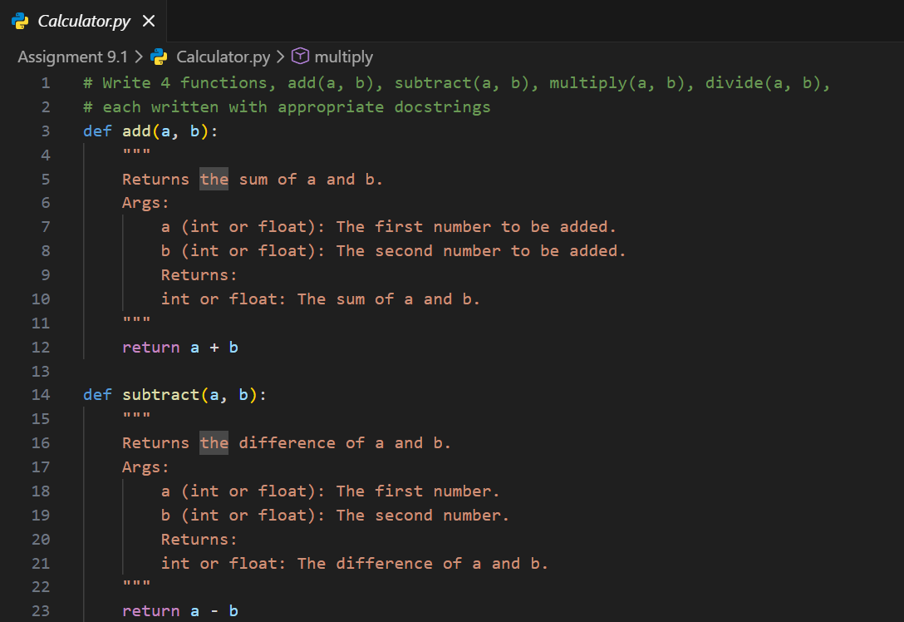
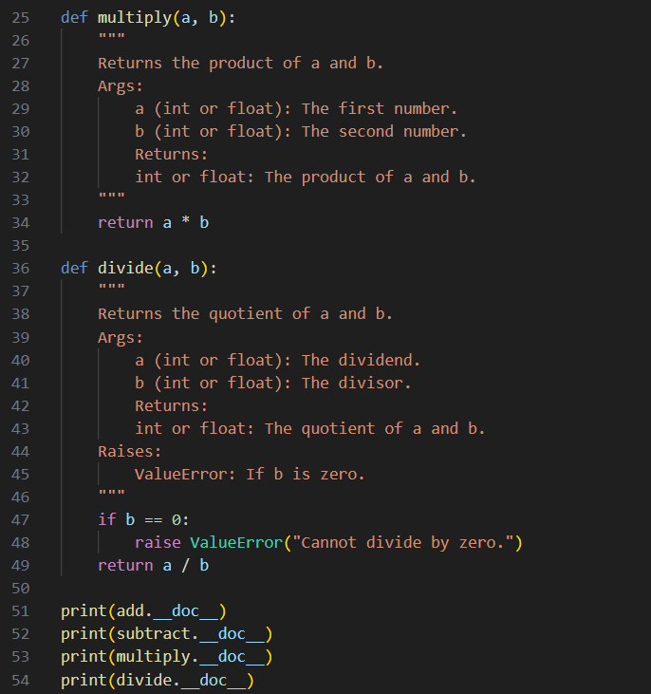
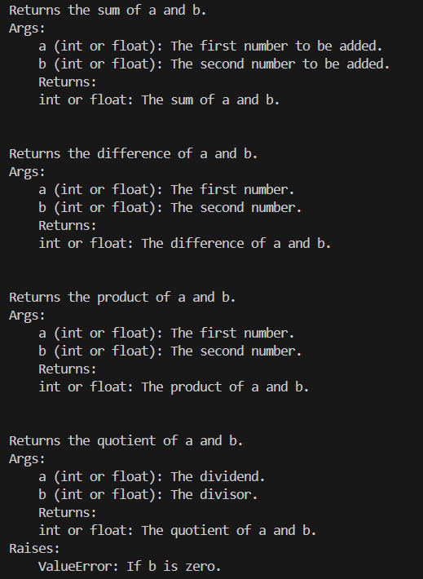
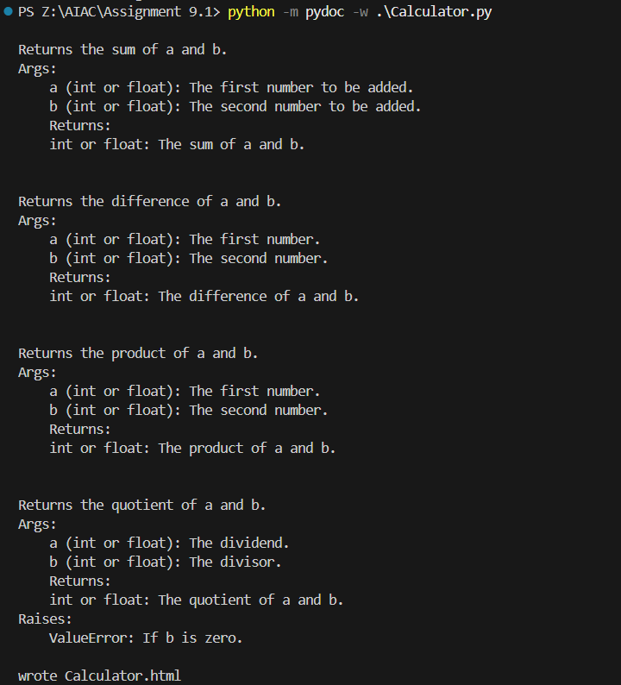
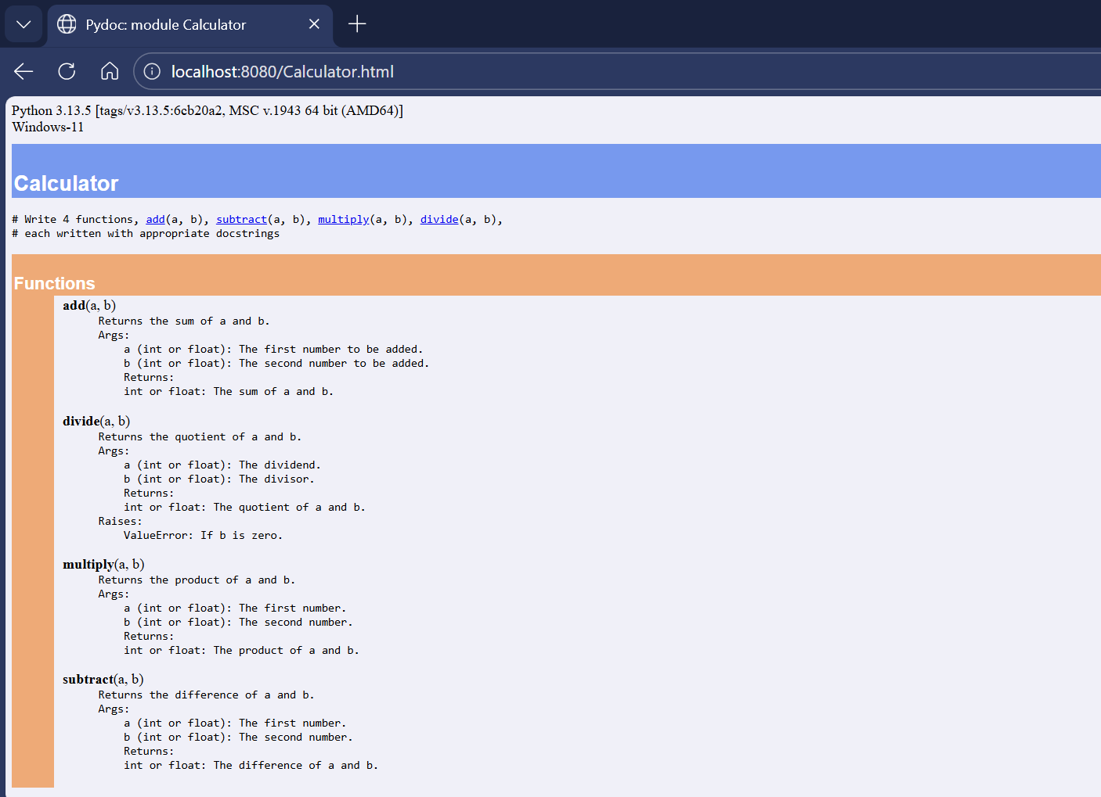

Problem 4: Conversion Utilities Module
Task:
1. Write a module named conversion.py with functions:
o decimal_to_binary(n)
o binary_to_decimal(b)
o decimal_to_hexadecimal(n)
2. Use Copilot for auto-generating docstrings.
3. Generate documentation in the terminal.
4. Export the documentation in HTML format and open it in a
browser.

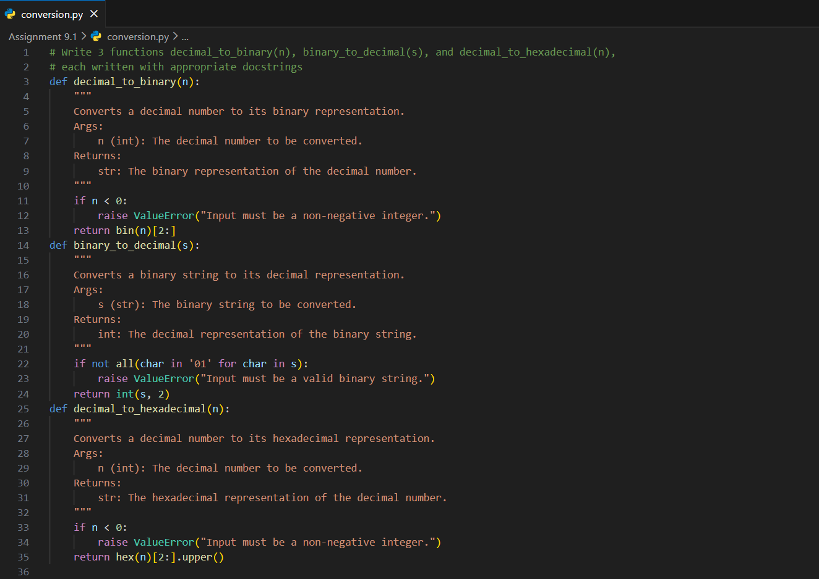
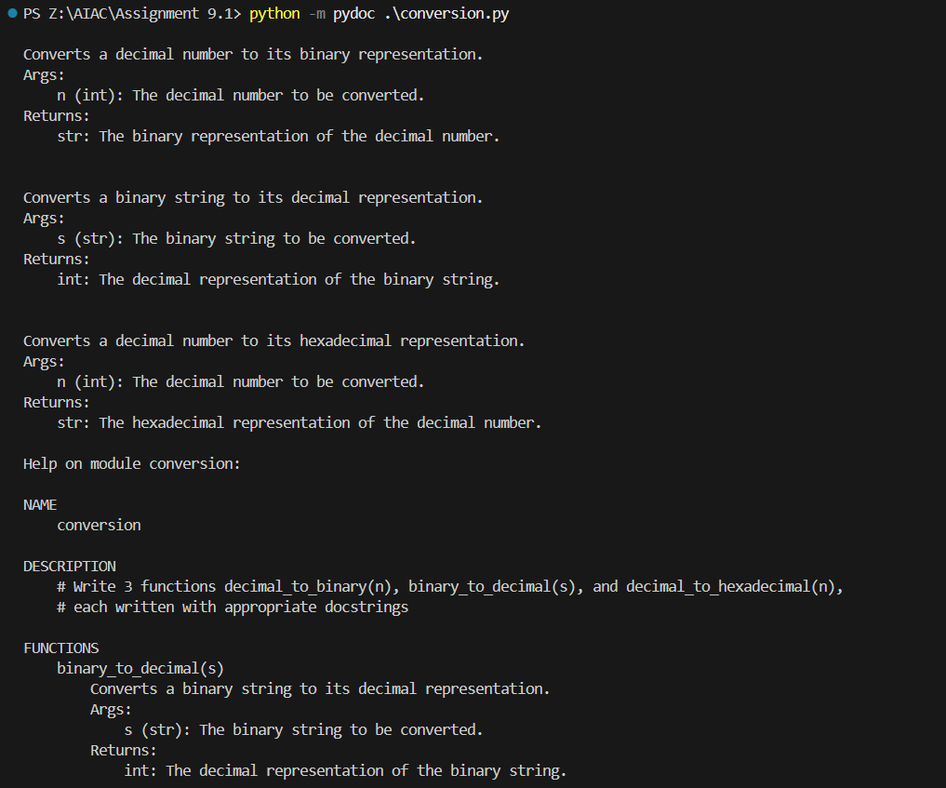
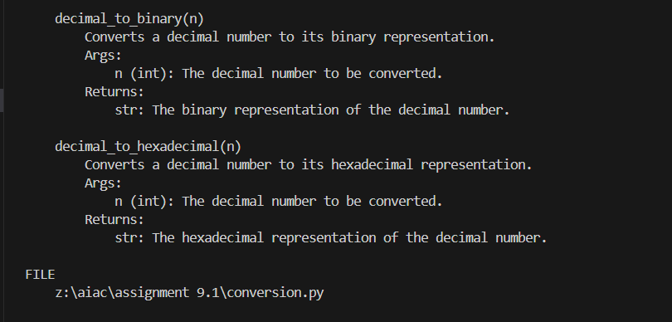
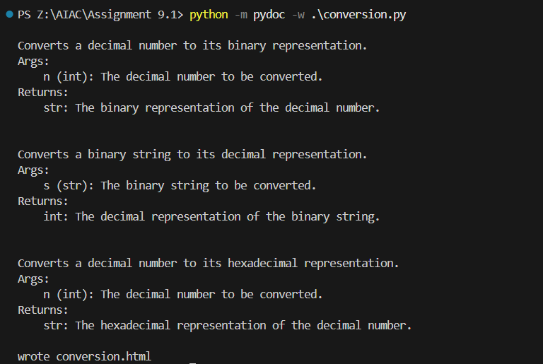
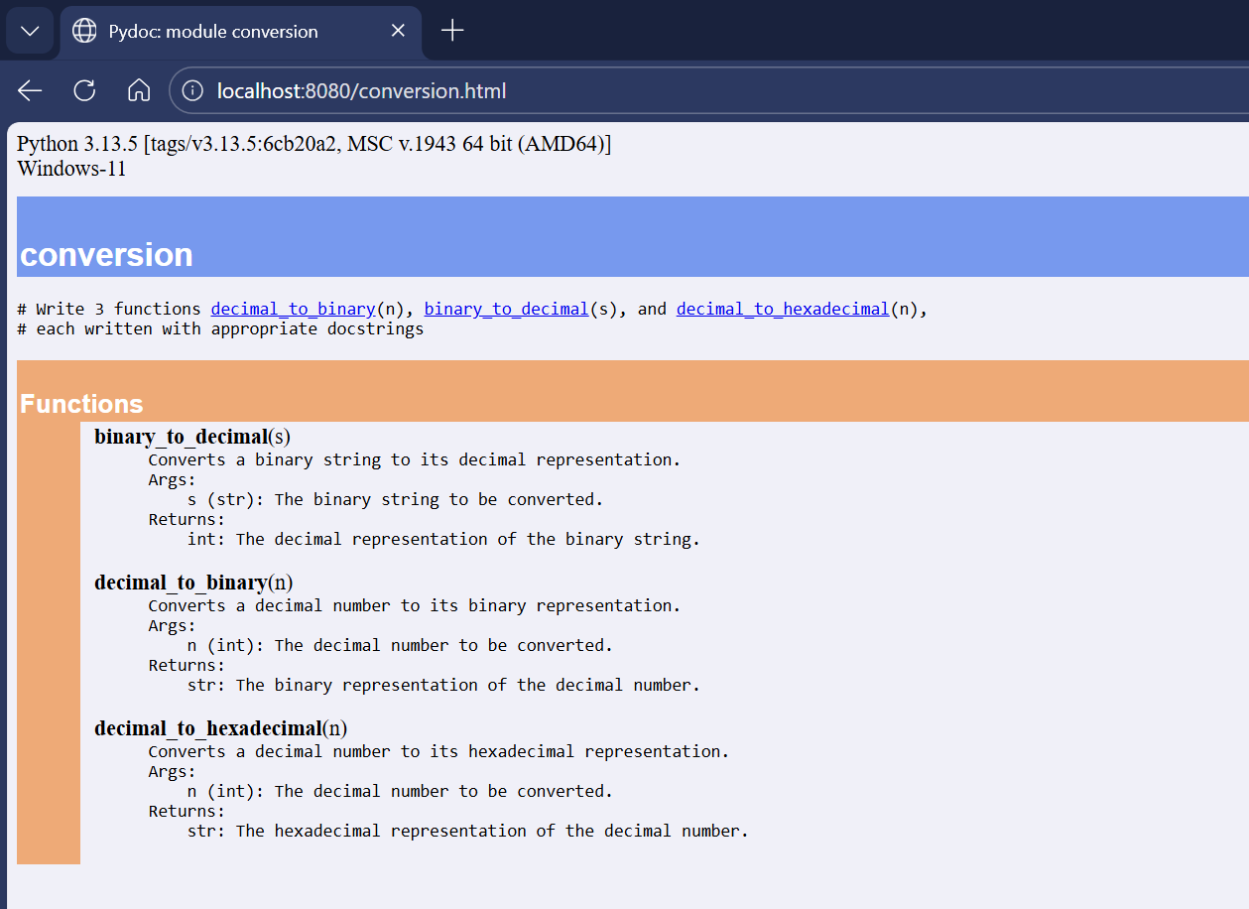
Problem 5 – Course Management Module
Task:
1. Create a module course.py with functions:
o add_course(course_id, name, credits)
o remove_course(course_id)
o get_course(course_id)
2. Add docstrings with Copilot.
3. Generate documentation in the terminal.
4. Export the documentation in HTML format and open it in a
browser.

