Chicago Crime Analysis

library(dplyr)

## Warning: package 'dplyr' was built under R version 3.5.3

##   
## Attaching package: 'dplyr'

## The following objects are masked from 'package:stats':  
##   
## filter, lag

## The following objects are masked from 'package:base':  
##   
## intersect, setdiff, setequal, union

library(ggplot2)

## Warning: package 'ggplot2' was built under R version 3.5.3

library(forecast)

## Warning: package 'forecast' was built under R version 3.5.3

library(stringr)

## Warning: package 'stringr' was built under R version 3.5.3

library(lubridate)

## Warning: package 'lubridate' was built under R version 3.5.2

##   
## Attaching package: 'lubridate'

## The following object is masked from 'package:base':  
##   
## date

crime_data <- read.csv("Crimes_-_One_year_prior_to_present.csv", sep= ",", stringsAsFactors = FALSE)  
crime_data <- crime_data[-c(4,10,12:14,17:19,21:23)]  
crime_data$DATE..OF.OCCURRENCE = as.Date(crime_data$DATE..OF.OCCURRENCE, format = "%m/%d/%Y %I:%M:%S %p")  
type_of_crime <- summarise(group_by(crime_data,PRIMARY.DESCRIPTION), count= n())  
ggplot(type_of_crime, aes(x= reorder(PRIMARY.DESCRIPTION,count), y= count))+ geom_bar(stat= "identity",color= "black", fill= "light blue")+ coord_flip()+ ggtitle("Most Crimes Recorded")

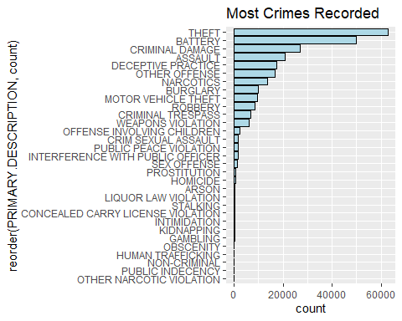

#write.table(crime_data, file="crime_data.csv",sep=",",row.names=F)

theft <- filter(crime_data, PRIMARY.DESCRIPTION== 'THEFT')  
type_of_theft <- summarise(group_by(theft, SECONDARY.DESCRIPTION), count= n())  
  
ggplot(type_of_theft, aes(x= reorder(SECONDARY.DESCRIPTION, count), y= count))+ geom_bar(stat='identity', color= "black", fill= "light blue")+ coord_flip()+ xlab('Type of Theft')+ ggtitle("Most Common type of Thefts")

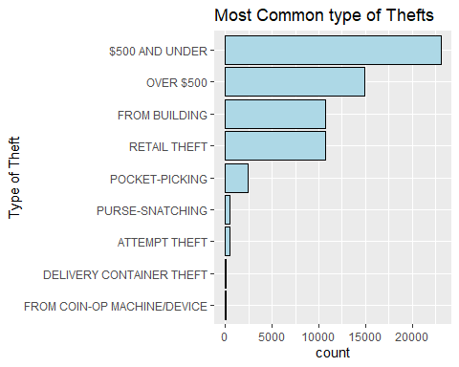

weapons_crime <- filter(crime_data, PRIMARY.DESCRIPTION== 'WEAPONS VIOLATION')  
weapons_crime_by_area <- summarise(group_by(weapons_crime, Community.Areas), count= n())

library(dplyr)  
library(ggplot2)  
library(treemap)

## Warning: package 'treemap' was built under R version 3.5.3

treemap_df <-  
 crime_data %>%  
 group_by(PRIMARY.DESCRIPTION, SECONDARY.DESCRIPTION) %>%  
 summarize(n = n())  
  
treemap(treemap_df,   
 index=c("PRIMARY.DESCRIPTION","SECONDARY.DESCRIPTION"),   
 vSize="n",   
 type="index",  
 fontsize.labels=c(15,12),  
 fontcolor.labels=c("white","orange"),  
 fontface.labels=c(2,1),   
 bg.labels=c("transparent"),  
 align.labels=list(  
 c("center", "center"),   
 c("center", "top")  
 ),   
 overlap.labels=0.2,   
 inflate.labels=F  
 )

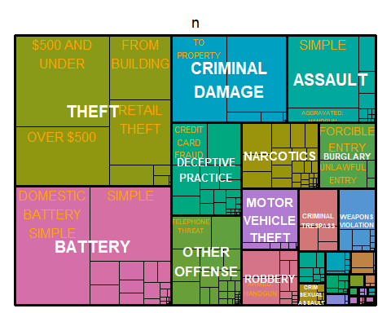

library(stringr)  
crime_data$new_block <- substr(crime_data$BLOCK, start = 8, stop = str_count(crime_data$BLOCK))  
  
crime_by_area <- summarise(group_by(crime_data, new_block), count= n())

crime_for_community <- na.omit(crime_data, cols=crime_data$Community.Areas)  
crime_by_community_area<- summarise(group_by(crime_for_community, Community.Areas), count= n())  
crime_by_community_area <- top_n(crime_by_community_area,40)

## Selecting by count

avg <- 3334.00  
ggplot(crime_by_community_area, aes(x= reorder(Community.Areas, count), y=count))+ geom_bar(stat= 'identity', color= "black", fill= "light blue") +geom_hline(aes(yintercept=avg)) + theme(axis.text.x = element_text(angle = 90))+ xlab('Community Area')+ ylab('Number of Recorded Cases')+ ggtitle("Crime By Community Area")

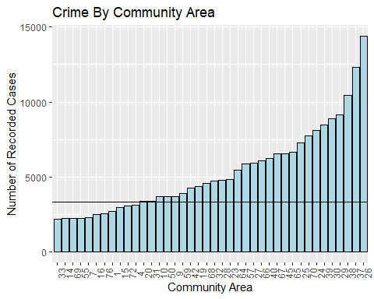

arrests <- filter(crime_data, ARREST== 'Y')  
arrests_by_crime <- summarise(group_by(arrests,PRIMARY.DESCRIPTION), count=n())  
  
ggplot(type_of_crime, aes(x=reorder(PRIMARY.DESCRIPTION, count), y= count))+ geom_bar(stat= 'identity', color= "black", fill= "light blue")+ coord_flip()+ xlab('Type of Crime')+ ggtitle("Most Crimes Recorded")

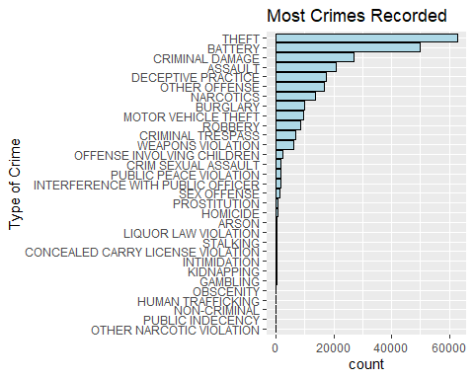

ggplot(arrests_by_crime, aes(x=reorder(PRIMARY.DESCRIPTION, count), y= count))+ geom_bar(stat= 'identity', color= "black", fill= "light blue")+ coord_flip()+ xlab('Type of Crime')+ ggtitle("Most Arrests by Crime")

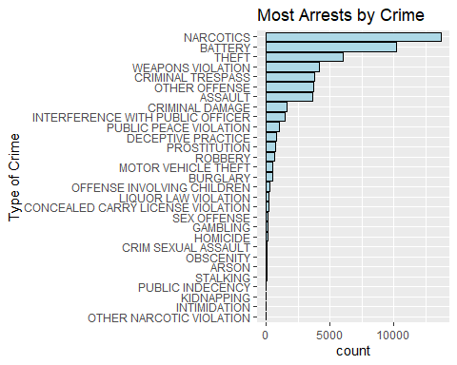

top_crime_recorded <- top_n(type_of_crime,4)

## Selecting by count

top_arrests_recorded <- top_n(arrests_by_crime,4)

## Selecting by count

slices <- c(top_arrests_recorded$count)  
lbls <- c(top_arrests_recorded$PRIMARY.DESCRIPTION)  
pct <- round(slices/sum(slices)*100)  
lbls1 <- paste(lbls,"- ", pct,"%", sep="")  
pie(slices, labels = lbls1, main="Most Arrests by Crime")

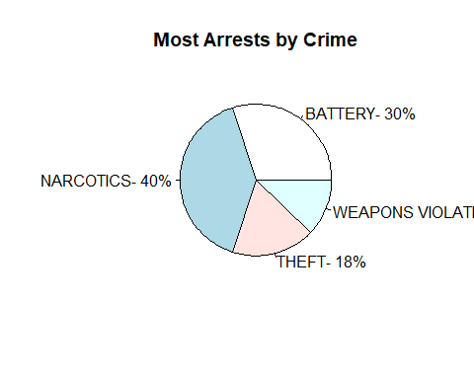

slices <- c(top_crime_recorded$count)  
lbls <- c(top_crime_recorded$PRIMARY.DESCRIPTION)  
pct <- round(slices/sum(slices)*100)  
lbls1 <- paste(lbls,"- ", pct,"%", sep="")  
pie(slices, labels = lbls1, main="Most Crimes Recorded")

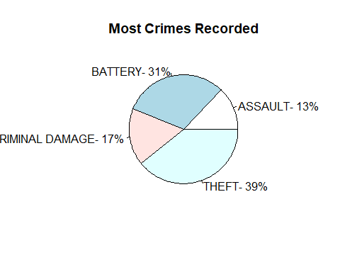

library(lubridate)  
crime_by_date <- summarise(group_by(crime_data, DATE..OF.OCCURRENCE), count= n())  
crime_by_date$month <- month(crime_by_date$DATE..OF.OCCURRENCE)  
crime_by_date$day <- as.Date(crime_by_date$DATE..OF.OCCURRENCE)  
crime_by_date$day <- wday(crime_by_date$day, label=TRUE)  
  
ggplot(crime_by_date, aes(x= month, y= day, fill= count))+ geom_tile() + ggtitle("Crimes variation by Month and Day of the Week")

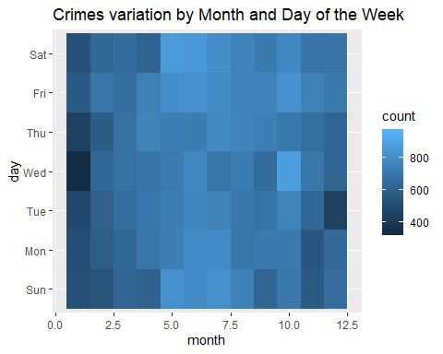

crime_data_2011_2018 <- read.csv("Crimes_2011_2018.csv", sep= ",", stringsAsFactors = FALSE)  
crime_data_2011_2018 <- crime_data_2011_2018[-c(1,4:8,11:13,15:22)]  
crime_data_2011_2018$Date = as.Date(crime_data_2011_2018$Date, format = "%m/%d/%Y %I:%M:%S %p")  
crime_data_2011_2018$Year <- lubridate::year(crime_data_2011_2018$Date)  
crime_data_2011_2018$Month <- lubridate::month(crime_data_2011_2018$Date)  
crime_by_year <- summarise(group_by(crime_data_2011_2018, Year, Month), count=n())  
  
  
  
violent_ts <- ts(crime_by_year$count, start=c(2011, 1), end=c(2018, 12), frequency=12)   
  
 ggseasonplot(violent_ts, year.labels=TRUE, year.labels.left=TRUE) +  
 ylab("Reported Incidents") +  
 ggtitle("Seasonal Plot of Crime Incidents")

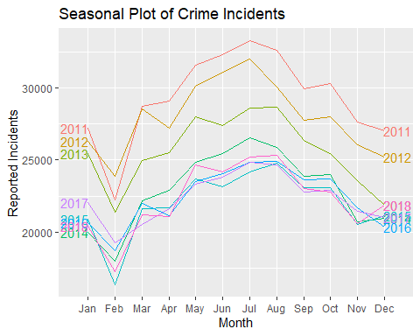

ggplot(crime_by_year)+ aes(x= Month, y= count)+ geom_bar(stat= "identity", color= "black", fill= "light blue")+ ggtitle("Crime of Years")

