**Part3 for K-fold:**

**Elapsed time for cpus:**

| CPU’s | Elapsed Time(secconds) | speedup(x times) |
| --- | --- | --- |
| 1 | 25.242 | 1 |
| 2 | 14.716 | 1.7152540049837206 |
| 3 | 12.751 | 1.9796164614247038 |
| 4 | 10.564 | 2.389370526334034 |

**Elapsed time:**

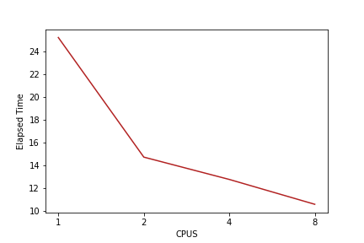

As , you can see the time taken to complete the task gradually declined from using 1 cpus to 8 cpus which is a great utilisation of cpus

**Speed Curve:**

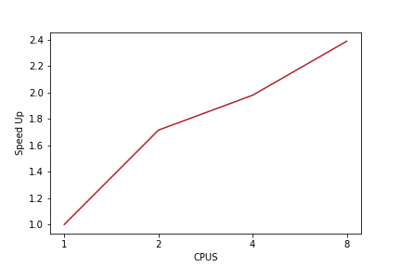

**Speedup:** As you can the graph above the speed up has almost doubled for 4 and 8 cpus.

Speedup = wall clock time of serial execution /wall clock of parallel execution

**Parallel overhead:** There is no parallel overhead for this data as we can see there is no decline at anypoint in the speed.

**Optimal result:** Optimal result is seen with 8 cpus and 4 cpus which took 10 seconds and 12 seconds respectively.