**Part2 - (20000,100)**

**Elapsed time for cpus:**

| **CPU’s** | **Elapsed Time(secconds)** | **speedup(x times)** |
| --- | --- | --- |
| 1 | 0.168 | 1.0 |
| 2 | 0.165 | 1.0192297969401625 |
| 3 | 0.161 | 1.0451277949356026 |
| 4 | 0.164 | 1.0275330765365935 |

**Elapsed time:**

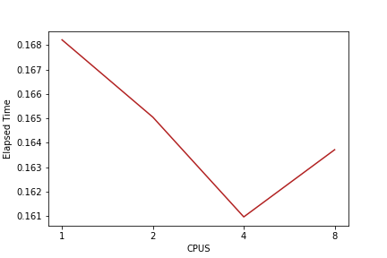

We can see that there is a drop in the time taken for execution of the tasks till 4 cpus which shows this is effective till 4 cpus and then there is a increase in time for 8 cpus.

**Speed Curve:**

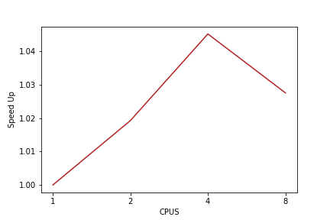

**Speedup:** The speed of the execution gradually increased for 4 cpus and then there is a drop for 8 cpus.

Speedup = wall clock time of serial execution /wall clock of parallel execution

**Parallel overhead:** We can observe here that there is a parallel overhead in the execution with 8 cpus. This is because rather than execution of the task, the time is more consumed coordinating and synchronising between the tasks.

**Optimal result:** It is seen with 4 cpu’s with 0.161 seconds.