***Q1***

***AIM***

* To display the following tables with HTML code

***DESCRIPTION***

* To display the given table in the required format, we will use the table tag and its attributes
* Table is one of the most useful HTML constructs. The main use of tables is that they are used to structure the pieces of information and to structure the whole web page. <table> tag is used to define tables. In the table, <tr> tag is to specify the row. It holds th/td. <th> is used for giving Heading to the table. <td> tag is the table data within the row you create columns by <td> tag. The table data can consist of lists, images, forms, and other elements. The td is a true container that can hold other HTML elements, even more tables.

***PROGRAM***

<?xml version="1.0" encoding="UTF-8"?>

<!DOCTYPE html PUBLIC "-//W3C//DTD XHTML 1.0 Strict//EN"

"http://www.w3.org/TR/xhtml1/DTD/xhtml1-strict.dtd">

<html xmlns="http://www.w3.org/1999/xhtml" xml:lang="en" lang="en">

<head>

<title>Week1_Program-1</title>

</head>

<body>

<table border = "1" width = "25%" height = "100%" cellspacing = "1" cellpadding="20">

<tr>

<td rowspan = "2"></td>

<td></td>

<td></td>

<td></td>

<td></td>

</tr>

<tr>

<td></td>

<td rowspan = "2"></td>

<td></td>

<td></td>

</tr>

<tr>

<td></td>

<td></td>

<td></td>

<td></td>

</tr>

<tr>

<td></td>

<td colspan = "3"></td>

<td rowspan = "2"></td>

</tr>

<tr>

<td></td>

<td></td>

<td></td>

<td></td>

</tr>

</table>

<br/><br/>

<table border = "10" width = "35%" height = "100%" cellspacing = "20" cellpadding="15">

<tr>

<td></td>

<td colspan = "2">Below is a null cell</td>

<td></td>

</tr>

<tr>

<td></td>

<td colspan = "2" style="empty-cells: hide;"></td>

<td></td>

</tr>

<tr>

<td></td>

<td colspan = "2">Above is a null cell</td>

<td></td>

</tr>

</table>

<br/><br/>

<table border = "1" width = "25%" height = "100%" cellspacing = "0" cellpadding="20" caption = "Results of example Code">

<tr>

<td style = "color:brown; background-color:orange;" rowspan = "3"><strong><p>H</p><p>T</p><p>M</p><p>L</p></strong></td>

<td style = "background-color:brown; color:orange;" rowspan = "3" colspan = "3"><strong><p align = "center">Mountain Dragon</p><p align = "center">Web Designs</p></strong></td>

<td bgcolor = "orange" rowspan = "3"></td>

</tr>

</table>

</body>

</html>

***RESULTS/OUTPUT***

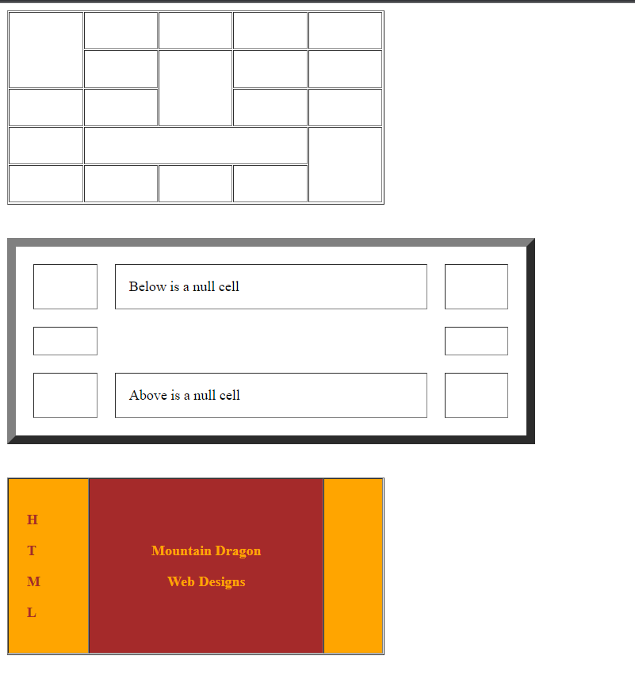

***CONCLUSION***

* The required tables are constructed using HTML code.

***Q2***

***AIM***

* HTML program to display the following nested list.

***DESCRIPTION***

* The required nested list can be displayed using the ordered list tag and changing its attribute ‘type’ as required in the list
* Ordered list also called a Numbered list, is used to present a numbered list of items in the order of importance, or the item is marked with a number. An ordered list must begin with the <ol> followed by <li> list item tag. Using the ‘type’ attribute allows marking list items with different types. By default, the list item markers are set to numbers 1,2,3…. so on.

***PROGRAM***

<?xml version="1.0" encoding="UTF-8"?>

<!DOCTYPE html PUBLIC "-//W3C//DTD XHTML 1.O Strict//EN" "http://www.w3.org/TR/xhtml/DTD/xhtml1-strict.dtd">

<html xmlns="http://www.w3.org/1999/xhtml" xml:lang="en" lang="en">

<head>

<title>Week1_Program-2</title>

</head>

<body>

<h1 align="left">Learning Web Development</h1>

<ol type="I">

<li>Background Skills

<ol type="A">

<li>Unix Commands</li>

<li>Vim Text Editor</li>

</ol>

</li>

<li>

HTML

<ol type="A">

<li>Minimal Page</li>

<li>Headings</li>

<li>Tags</li>

<li>Lists

<ol type="i">

<li>Unordered</li>

<li>Ordered</li>

<li>Definition</li>

<li>Nested</li>

</ol>

</li>

<li>Links

<ol type="i">

<li>Absolute</li>

<li>Relative</li>

</ol>

</li>

<li>Images</li>

</ol>

</li>

<li>CSS

<ol type="A">

<li>Anatomy</li>

<li>Basic Selectors

<ol type="i">

<li>Element</li>

<li>Class</li>

<li>ID</li>

<li>Group</li>

</ol></li>

<li>The DOM</li>

<li>Advanced Selectors</li>

<li>Box Model</li>

</ol>

</li>

<li>Programming

<ol type="A">

<li>Python</li>

<li>JavaScript</li>

</ol></li>

<li>Database

<ol type="A">

<li>Flat File</li>

<li>Relational</li>

</ol></li>

</ol>

</body>

</html>

***RESULTS/OUTPUT***

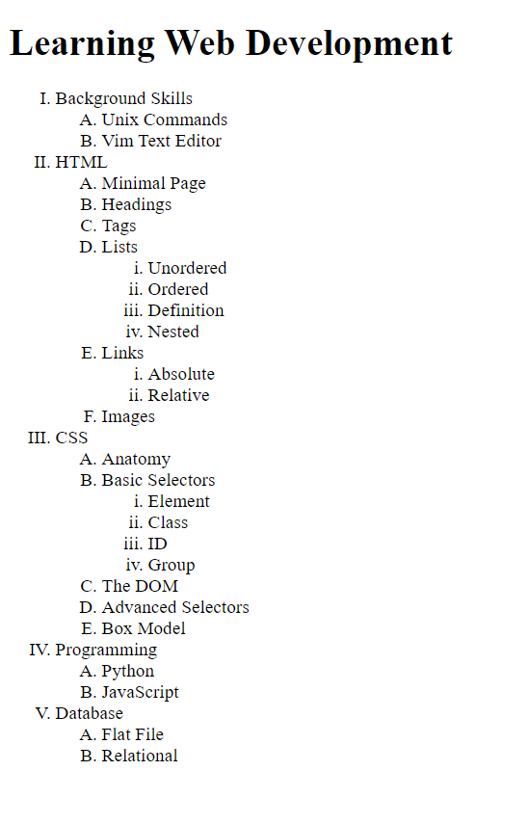

***CONCLUSION***

* The required nested list is built using the ordered list and its attributes.

***Q3***

***AIM***

* A HTML program to prepare your curriculum vitae

***DESCRIPTION***

* To prepare the curriculum vitae, we will use the following tags described below
* In the body tag, we will add the attribute ‘bgcolor’ to change the background color to pink and also ‘font face’ for the text to be in ‘Times New Roman’. <pre> tag was used to display the data in the required format, <p> tag is used to display the next information in a paragraph. <table> tag is used to display the required education and IT skills information in the table with <th>, <tr>, <td> tags. Now Strengths info is displayed with unordered list tag <ul> and <li> for list items. Finally, the <footer> tag is used to display the Name at the bottom of the page, and the <b> tag is used for bold text on the page.

***PROGRAM***

<?xml version="1.0" encoding="UTF-8"?>

<!DOCTYPE html PUBLIC "-//W3C//DTD XHTML 1.O Strict//EN" "http://www.w3.org/TR/xhtml/DTD/xhtml1-strict.dtd">

<html xmlns="http://www.w3.org/1999/xhtml" xml:lang="en" lang="en">

<head>

<title>Week1_Program-3</title>

</head>

<body bgcolor="pink" leftmargin="100" ><font face="Times New Roman, serif">

<h1 align="center"><u>CURRICULUM VITAE</u></h1>

<pre>R.Rajendra Contact:8977573717

DUHACHERLLA Email:rajendra@gmail.com

NALLGERLLA(HD)</pre>

<p>

<h4><u>Career Objective:</u></h4>

Seeking a challenging position, utilizing my abilities developed through my education with an opportunity for career growth based on my merit and promotes the growth of the organisation.

</p>

<p>

<h4><u>Educational Qualification:</u></h4>

<table border="2" bordercolor="white" cellpadding="3" cellspacing="1">

<tr>

<th>Education</th>

<th>University</th>

<th>Percentage</th>

<th>Passout</th>

</tr>

<tr>

<td>SSC</td>

<td>Board of secondary education</td>

<td>65%</td>

<td>2002</td>

</tr>

<tr>

<td>Intermediate</td>

<td>Board of Intermediate</td>

<td>70%</td>

<td>2004</td>

</tr>

<tr>

<td>Degree</td>

<td>Kakatiya University</td>

<td>63%</td>

<td>2007</td>

</tr>

<tr>

<td>P.G</td>

<td>JNTU University</td>

<td>79%</td>

<td>2010</td>

</tr>

</table>

</p>

<p>

<h4><u>IT Related Skills:</u></h4>

<table border="2" bordercolor="white" cellpadding="3" cellspacing="1">

<tr>

<th>Languages</th>

<td>c,c++,Java</td>

</tr>

<tr>

<th>Web Technology</th>

<td>Jsp,HTML</td>

</tr>

<tr>

<th>RDBMS</th>

<td>MS Access,Oracle</td>

</tr>

<tr>

<th>Operating System</th>

<td>Windows XP,2000,2003</td>

</tr>

</table>

</p>

<p>

<h4><u>Strengths:</u></h4>

<ul>

<li>Excellent communication skills and vocabulary</li>

<li>Pleasing personality with clean habits</li>

</ul>

</p>

<footer align='right'><b>[R.Rajendra]</b></footer>

</font>

</body>

</html>

***RESULTS/OUTPUT***

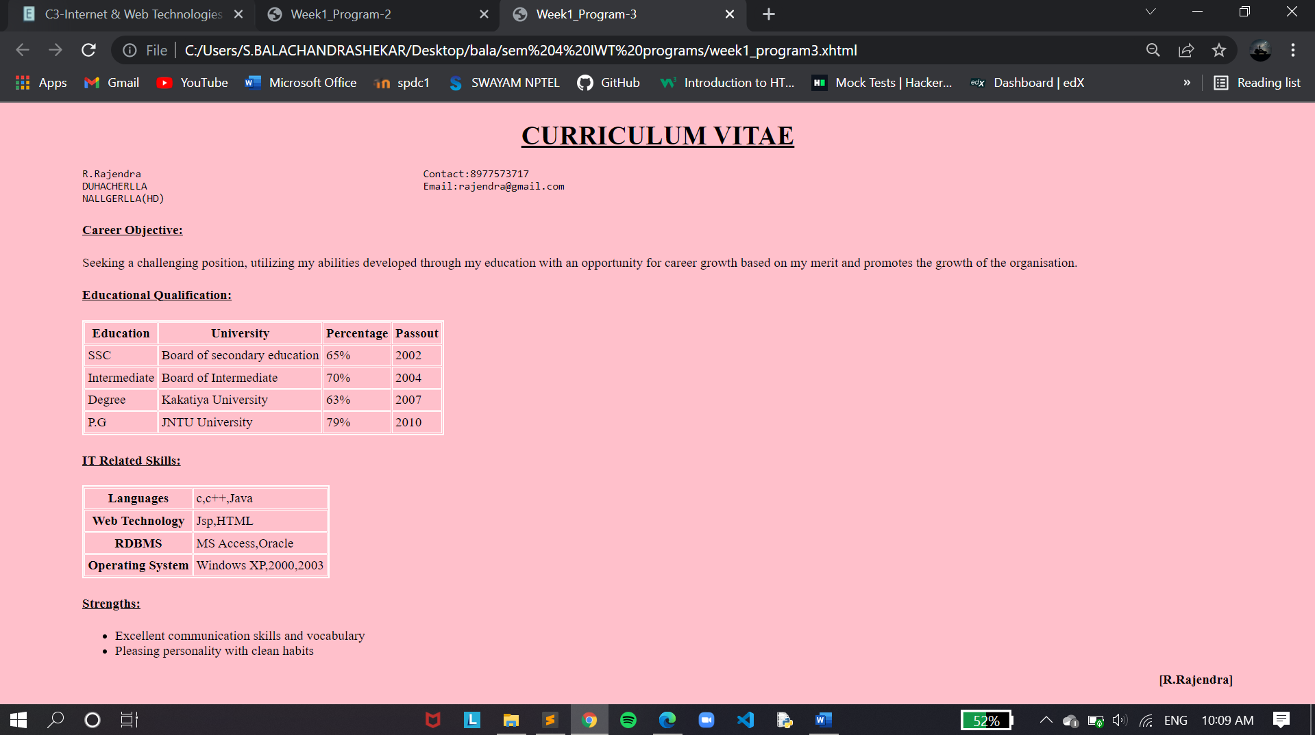

***CONCLUSION***

* The required curriculum vitae is built using the HTML tags