**Q4**

**AIM**

* To create a webpage with 3 frames where one is a horizontal frame that displays the caption and two vertical frames where the left frame contains 4 hyperlinks and the right frame is empty and when the link is clicked, the resultant page should be displayed in the right frame.

**DESCRIPTION**

* The main tag we use for this program is <frameset> tag, its attributes, and elements. To create three frames, we use nested <frameset> tags. In the first <frameset> tag, we will define the horizontal row and then the other <frameset> tag for the vertical frames.
* <a> anchor tag and its attributes ‘href’ and ‘target’ are used for hyperlinks in the left vertical frame. In the ‘href’ attribute, the link of the page will be given and ‘target’ is used to define where we want to open the link. For this program, we will give the target name to be the right vertical frame. Finally using a style tag for the required elements we can give the background color to the elements of the page.

**PROGRAM(S)**

* **Main Page Code**

<?xml version="1.0" encoding="UTF-8"?>

<!DOCTYPE html PUBLIC "-//W3C//DTD XHTML 1.0 Strict//EN"

"http://www.w3.org/TR/xhtml1/DTD/xhtml1-strict.dtd">

<html xmlns="http://www.w3.org/1999/xhtml" xml:lang="en" lang="en">\

<head>

<title>Main Page</title>

<style>

h1{

text-align:center;}

body{

background-color:azure;}

</style>

</head>

<frameset rows="20,80" noresize="yes">

<frame src="titlepage.xhtml" name="row1" />

<frameset cols="30,70" noresize="yes">

<frame src="2-11.xhtml" name="col1" />

<frame name="col2"/></frameset>

</frameset>

</html>

* **Horizontal frame code:**

<!DOCTYPE html >

<html>

<head>Title</head>

<body>

<h1 align="center">Web Pages Using Frames</h1>

</body>

</html>

* **Left frame code:**

<?xml version="1.0" encoding="UTF-8"?>

<!DOCTYPE html PUBLIC "-//W3C//DTD XHTML 1.0 Strict//EN"

"http://www.w3.org/TR/xhtml1/DTD/xhtml1-strict.dtd">

<html xmlns="http://www.w3.org/1999/xhtml" xml:lang="en" lang="en">

<head>

<title>links</title>

<link rel="stylesheet" type="text/css" href="stylesheet.css"/>

</head>

<body>

<a href="2-12.xhtml" target="col2">first page</a>

<a href="2-13.xhtml" target="col2">second page</a>

<a href="2-14.xhtml" target="col2">third page</a>

<a href="2-15.xhtml" target="col2">fourth page</a>

</body>

</html>

**RESULTS/OUTPUT**



**CONCLUSION**

* The required web page with three frames is built using HTML and its tags.

**Q5**

**AIM**

* To create a web registration form in the given format using XHTML.

**DESCRIPTION**

* To create the given registration form, we will use the table tag and its attributes for formatting.
* Using the <table> tag, we will create a structure and in each <td> tag, we will define the elements present in the form. <input> tag is used for the user to enter his data on the webpage and by defining one of its attributes ‘type’ to text, then we can enter data in the form. Similarly, the ‘radio’ attribute is used to insert a radio button in the form. When we insert a radio button for the same data, then their name must be the same so that only one option can be selected from all of them. We also use the <select> tag for selecting an item from the list of items and the <option> tag is used to define those options to be placed in the list. Finally, we use the <button> tag for creating Reset and Submit buttons in the form.

**PROGRAM:**

<?xml version="1.0" encoding="UTF-8"?>

<!DOCTYPE html PUBLIC "-//W3C//DTD XHTML 1.0 Strict//EN"

"http://www.w3.org/TR/xhtml1/DTD/xhtml1-strict.dtd">

<html xmlns="http://www.w3.org/1999/xhtml" xml:lang="en" lang="en">

<head>

<title>Form</title>

</head>

<body bgcolor="pink">

<h1 align="center">ITI STUDENT REGISTRATION FORM</h1>

<table align="center">

<tr>

<td>Name</td>

<td><input type="text" name="Name"/></td>

</tr>

<tr>

<td>Father Name</td>

<td><input type="text" name="FName"/></td>

</tr><tr>

<td>Address</td>

<td><input type="text" name="Address"/></td>

</tr>

<tr>

<td>Sex</td>

<td><input type="radio" name="male"/>Male</td>

<td><input type="radio" name="male"/>Female</td>

</tr>

<tr>

<td>State</td>

<td><select name="states">

<option value='1' selected="selected">ASSAM</option>

<option value='2'>TELANGANA</option>

<option value='3'>GOA</option>

</select></td>

</tr>

<tr>

<td>District</td>

<td>

<select name="District">

<option value='1' selected="selected">AKOLA</option>

<option value='2'>HYDERABAD</option>

<option value='3'>GOA</option>

</select>

</td>

</tr>

<tr>

<td>City</td>

<select name="city">

<option value='1' selected="selected">NEW DELHI</option>

<option value='2'>SECUNDRABAD</option>

<option value='3'>PANAJI</option>

</select>

</tr>

<tr>

<td>Pincode</td>

<td><input type="text" name="Pincode"/></td>

</tr>

<tr>

<td>Course</td>

<td>

<select name="Course">

<option value='1' selected="selected">CSE</option>

<option value='1' >ECE</option>

<option value='1'>EEE</option>

</select>

</td>

</tr>

<tr>

<td>Email ID</td>

<td><input type="text" name="email"/></td>

</tr>

<tr>

<td>DOB</td>

<td><input type="date"/></td>

</tr>

<tr>

<td>Mobile No</td>

<td><input type="text" name="no"/></td>

</tr>

<tr>

<td><button>Reset</button></td>

<td><button>Submit Form</button></td>

</tr>

</table>

</body>

</html>

**RESULTS/OUTPUT**

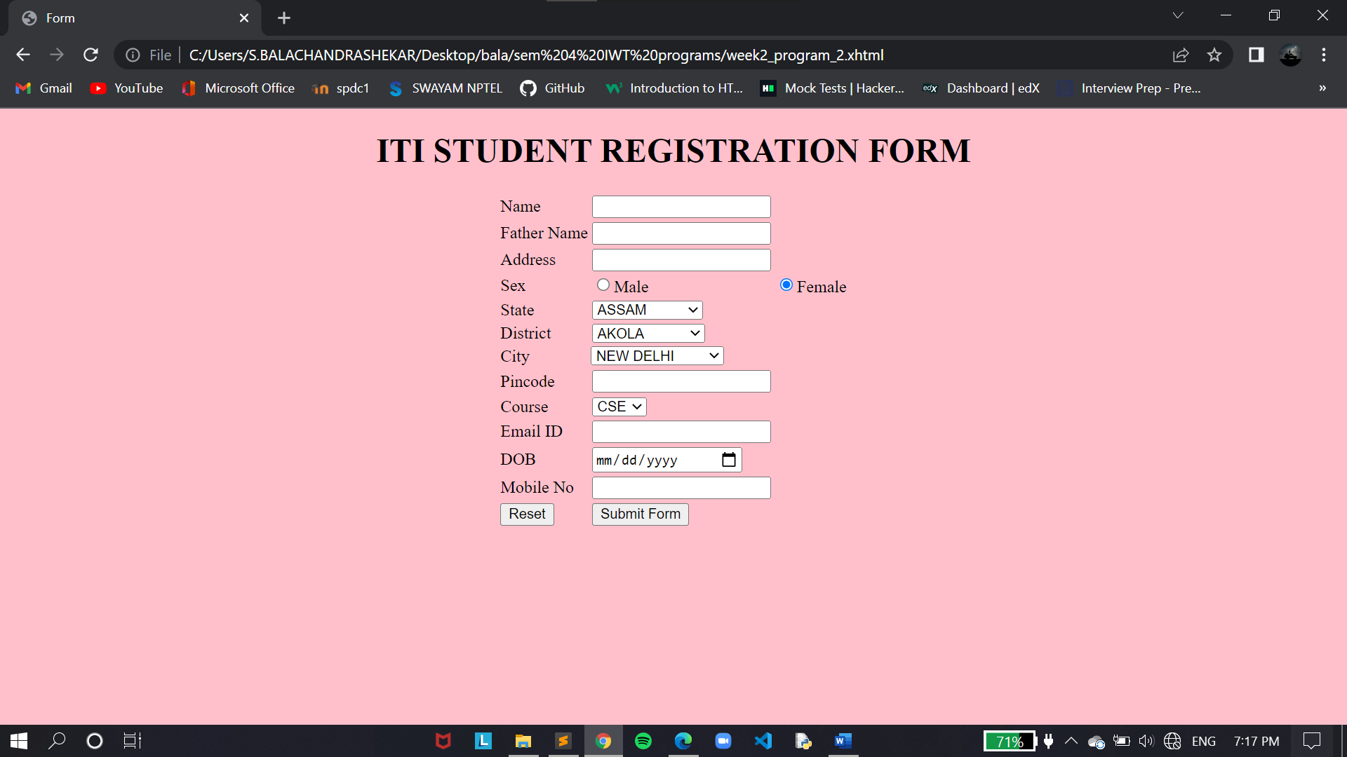

**CONCLUSION**

* The required form is built using the XHTML code.

**Q6**

**AIM**

* A XHTML program to prepare the given registration form in the given format.

**DESCRIPTION**

* To prepare the given registration form, we will use the following tags described below.
* Using the table tag and its attributes, and elements, we can give the required structure to the webpage. By <caption> tag, we define the title of the form and <bgcolor> is set to ‘light grey’ in the table tag. Now using the <td> tag, we will display the text in the required format and beside them, we will use the required <input> type elements for the user to enter the data. <select> is used to select the item from a list of items defined. <option> is used to define the items in the <select> tag. We use the <textarea> tag for more text areas on the page. Finally, we define the buttons on the page with the <button> tag and style them using the <style> tag. To display the ‘>’ and ‘<’ symbols, we use ‘&lt;’ and ‘&gt;’ are used respectively.

**PROGRAM**

<?xml version="1.0" encoding="UTF-8"?>

<!DOCTYPE html PUBLIC "-//W3C//DTD XHTML 1.0 Strict//EN"

"http://www.w3.org/TR/xhtml1/DTD/xhtml1-strict.dtd">

<html xmlns="http://www.w3.org/1999/xhtml" xml:lang="en" lang="en">

<head>

<title>Student Registration Form</title>

<style type="text/css">

#l{

margin-left: 175px;

}

.butt{

width: 65px;

}

</style>

</head>

<body >

<table align="center" bgcolor="lightgrey" width="70%"><caption><h1>Student's Registration Form</h1></caption>

<tr>

<td width="80px">Student ID:</td>

<td><input type="text" name="id" size="15px" /></td>

<td colspan="2" ></td>

<td align="right">School Year:</td>

<td><select name='year'>

<option value='1' selected="selected">2013-2014</option>

<option value='2'>2014-2015</option>

<option value='3'>2015-2016</option>

</select></td>

</tr>

<tr>

<td>First Name:</td>

<td><input type="text" name="FName"/></td>

<td align="right">Last Name:</td>

<td><input type="text" name="LName"/></td>

<td align="right">Middle Name:</td>

<td><input type="text" name="MName"/></td>

</tr>

<tr>

<td align="right">Address:</td>

<td height="75px" width=""><textarea name="add" rows="4"></textarea></td>

<td align="right">Date of Birth:</td>

<td><input type="date" name="dob"/></td>

<td>Place of Birth:</td>

<td><textarea name="place" rows="4"></textarea></td>

</tr>

<tr>

<td align="right">Age:</td>

<td><input type="number" name="age"/></td>

<td align="right">Gender:</td>

<td><input type="radio" name="male"/>Male

<input type="radio" name="male"/>Female</td>

<td align="right">Status:</td>

<td><select name='single'><option value="sing" selected="selected">Single</option>

<option value="marry">Married</option>

<option value="pnta">Prefer Not to Answer</option></select></td>

</tr>

<tr>

<td align="right">Year:</td>

<td><select name="year">

<option value='1' selected="selected">1st</option>

<option>2nd</option>

<option>3rd</option>

<option>4th</option>

</select></td>

<td align="right">Guardian:</td>

<td><input type="text" name="g"/></td>

<td align="right">Relation:</td>

<td><input type="text" name="r"/></td>

</tr>

<tr>

<td align="right">Address:</td>

<td colspan="2"><textarea rows="3" cols="35" name='diffadd'></textarea></td>

<td align="right">Contact# : </td>

<td colspan="2"><input type="text" size="28" name="contact"/></td>

</tr>

<tr>

<td colspan="3"><button class="butt">|&lt;</button>

<button class="butt">&lt;&lt;</button>

<button class="butt">&gt;&gt;</button>

<button class="butt">&gt;|</button>

<label style="margin-left: 15px;">&emsp;0&emsp; OF&emsp; 0&emsp;</label></td>

<td colspan="3" align="right">

<button style="width: 45px;">New</button>

<button style="width: 100px;">Save</button>

</td>

</tr>

</table>

</body>

</html>

**RESULTS/OUTPUT**

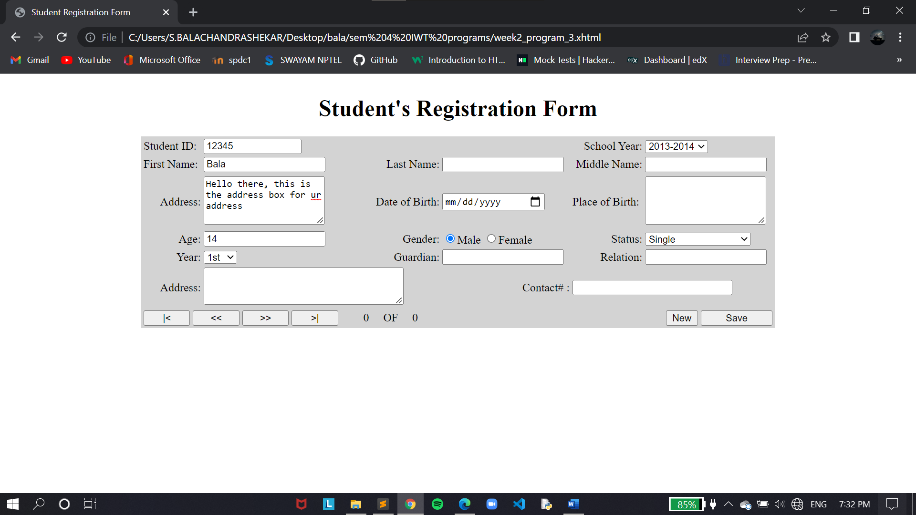

**CONCLUSION**

* The required registration form is built using the html code.