CHEMISTRY

INVESTIGATORY PROJECT

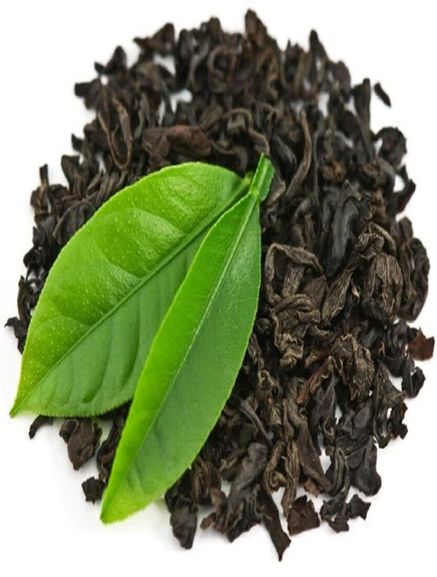

**Submitted by:**

Class: XII Science

**Guided By:**

Acidity in Tea Leaves

Session: 2020-2021

Acknowledgment

I take this opportunity to express my gratitude towards my chemistry teacher **xyz**, for her precious and valuable guidance which played a crucial role in not only my investigatory project on the topic “**Acidity of tea leaves**”, but also throughout the session with my studies. I am very grateful to the school as well, for giving me this opportunity.

Last but not the least I would like to thank my parents and friends for helping me in this project.

Index

1. Abstract

2. Theory

3. Requirements

4. Procedure

5. Observation

6. Result



7. Bibliography

Abstract

**Aim: To compare the acid content of acid in different**

**samples of leaves.**

Tea can be described as an agricultural plant that is industrially important because of the produce of its leaves, when immersed in hot water. Tea however is an aromatic beverage that can be prepared in several different ways.

Each method of preparation has a certain effect on the acidity of the beverage. My aim in this experiment is to capture the difference in the acidity of the beverage by analyzing the mixture in different ways.

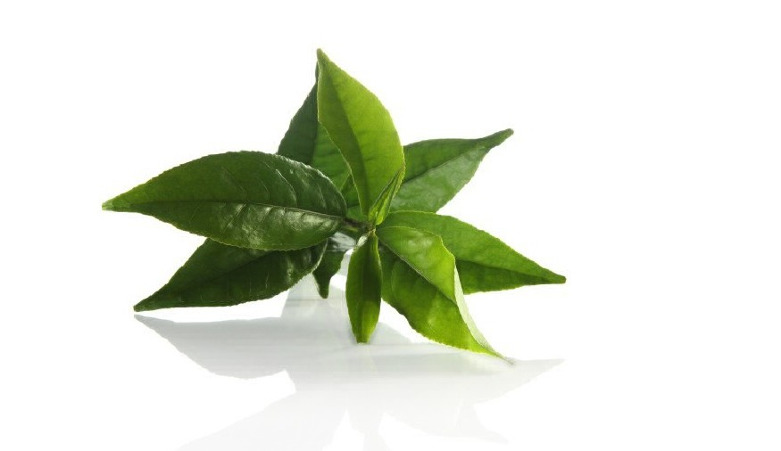Tea after water, is the world’s most popular beverage of consumption, as it is not extremely expensive, and has a pleasant texture and aroma. The leaves of the tea plant are oxidized and cured. The leaves are then introduced into hot/boiling water, which causes a release in the flavor and color contained in the leaf of the plant. Some people prefer to drink tea in this form, while others prefer it with milk. Some people add sugar. All these activities cause different outcomes in the pH value of the beverage.

Theory

* 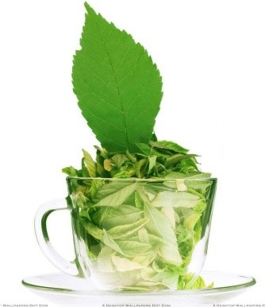Tea contains catechins, a type of antioxidant. In a freshly picked tea leaf, catechins can comprisal up to 30% of the dry weight.
* Tea also contains L-threonine, and the stimulant caffine at about 3% of its dry weight depending on the type, brand and brewing method.
* Tea also contains small amounts of the bromine and theophylline. Due to modern environmental pollution, fluoride and aluminum have also been found to occur in tea.
* Tannic Acid in tea is actually a myth, a rather popular one. The acidity of tea leaves is not due to the tannic acid. Tea contains polyphenols or catechins which are a specific type of tannin.
* The oxalic acid present in the tea leaves is precipitated as calcium oxalate by treatment of aqueous solution of tea with calcium carbonate. Calcium oxalate is then hydrolysed with conc. H2SO4 and recrystallized from water.

Requirements

1. 10gm of three different types of tea leaves

2. Calcium Carbonate (CaCO3)

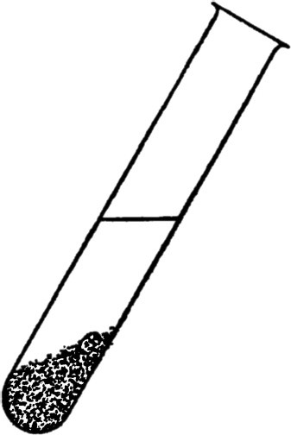3. Filter Paper

4. Funnel

5. Beaker

6. Tripod Stand

7. Bunsen Burner

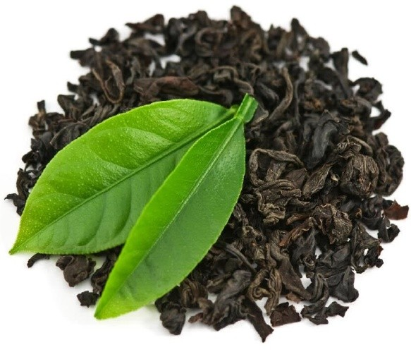

Procedure

1. Weigh exactly 10gm of 1st sample of tea leaves.

2. Take 200ml of distilled water in a beaker.

3. Put tea leaves in above beaker boil it for 10 minutes.

4. Filter above boiled solution using funnel and filter paper in another beaker.

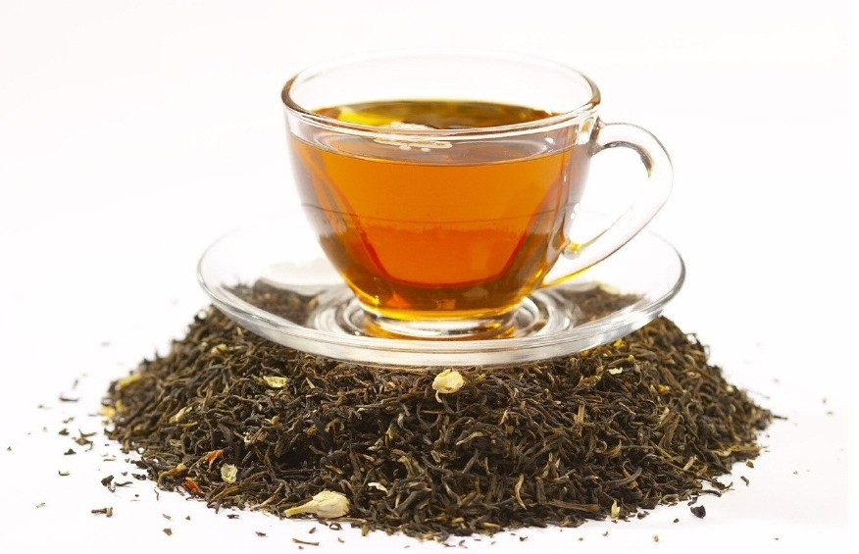5. In filtrate add 4gms of CaCO3 and boil it.

6. Filter above boiled solution using funnel and filter paper in another beaker. There will be a ppt. of Calcium oxalate on the filter paper.

7. Keep filter paper aside and let it dry.

8. Weigh the ppt. of oxalic acid.

9. Repeat the above steps for the other two samples.

Observation

|  |  |  |  |  |
| --- | --- | --- | --- | --- |
| Sr. no. | Brand of tea | Weight of tea leaves | Weight of acid obtained | Percentage of oxalic acid |
| 1 | Red Label | 10gm | 0.91gm | 9.1% |
| 2 | Twining’ | 10gm | 0.97gm | 9.7% |
| 3 | Taj Mahal | 10gm | 0.80gm | 8.0% |

Result

Twining’s has high amount of oxalic acid among Red Label, Taj Mahal, and Twining’s.

Thus, Twining’s has a good flavor.

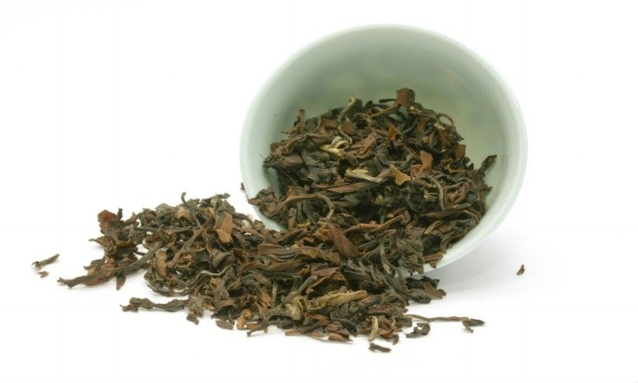



Bibliography

* [www.wikipedia.com](http://www.wikipedia.com)
* <https://www.healthline.com/health/food-nutrition>
* <https://www.yashodahospitals.com/blog>
* <http://www.steepers.net/chemical-composition-of-tea.html>
* <https://www.seminarsonly.com>