**Test ID:01**

Bug Description: When a user clicks on login button then password fields show values.

Environment: QA

Steps: 1. Enter the URL

<https://petstore.octoperf.com/actions/Account.action?signonForm=>

2. Click on the Sign in link.

3. Verify the results.

Actual: Four dots are getting displayed

Expected results: Password field should be blank.

Severity: Low

Priority: High

Screenshot: 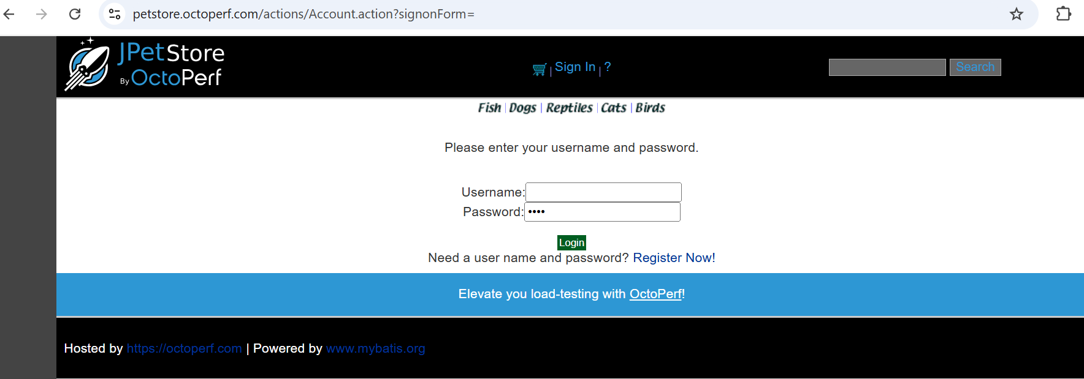

Name of the tester: Sakshi Sakhare.

**Test ID:02**

Bug Description: When a user clicks on the Register button, password fields show values.

Environment: QA

Steps: 1. Enter the URL

<https://petstore.octoperf.com/actions/Account.action?newAccountForm=>

2. Click on the Register link.

3. Verify the results.

Actual: Characters are getting displayed

Expected results: Password field should be blank.

Severity: Low

Priority: High

Screenshot: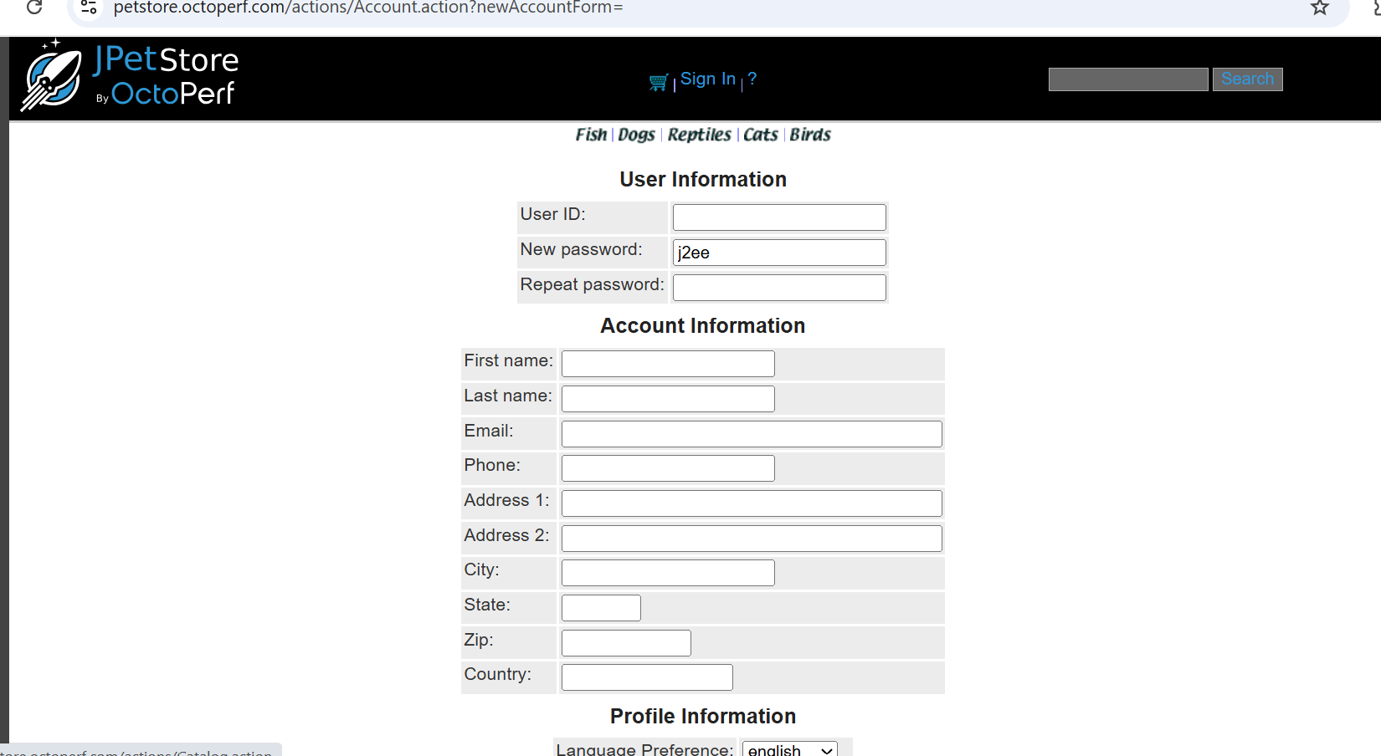

Name of tester: Sakshi Sakhare

**Test ID:03**

Bug Description: When a user clicks on the save account, it is redirecting to error page 500 Internal Server Error.

Environment: QA

Steps: 1. Enter the URL

<https://petstore.octoperf.com/actions/Account.action?newAccountForm=>

2. Click on the Register link.

3. Enter the information and click Save.

4. Verify the results.

Actual: Internal Server Error

Expected results: Display message on the page.

Severity: High

Priority: High

Screenshot:

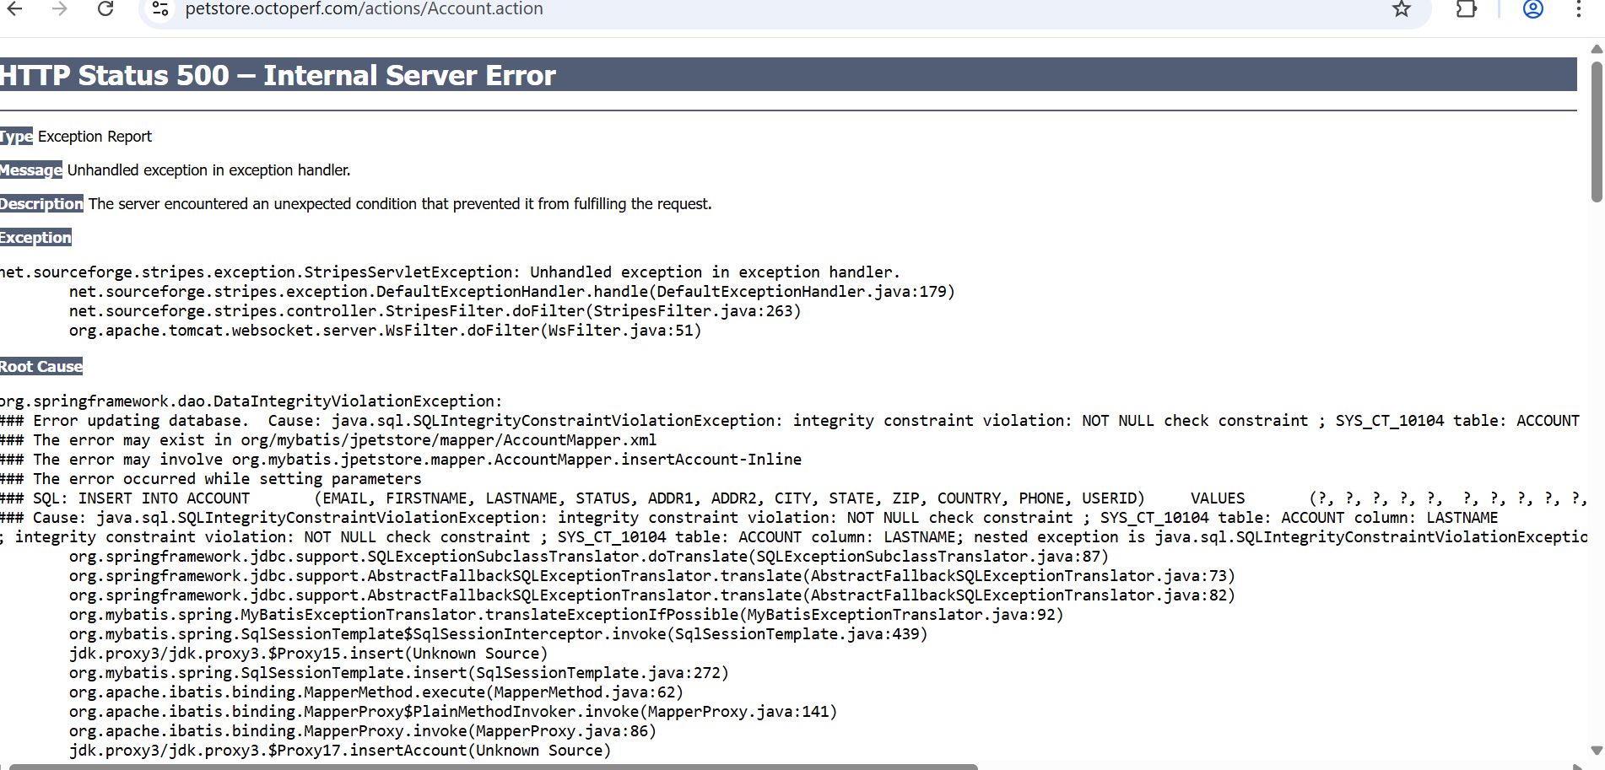

**Test ID:04**

Bug Description: There are two same messages when search without any keywords input

Environment: QA

Steps: 1. Enter the URL

<https://petstore.octoperf.com/actions/Catalog.action>

2. Leave search field empty.

3. Click on Search button.

4. Verify the results.

Actual:

|  |
| --- |
| There are two same message appear |
| "Please enter a keyword to search for, then press the search button." |
| "Please enter a keyword to search for, then press the search button." |

Expected results:

|  |
| --- |
| It should only appear once |
| "Please enter a keyword to search for, then press the search button." |

Severity: High

Priority: High

Screenshot: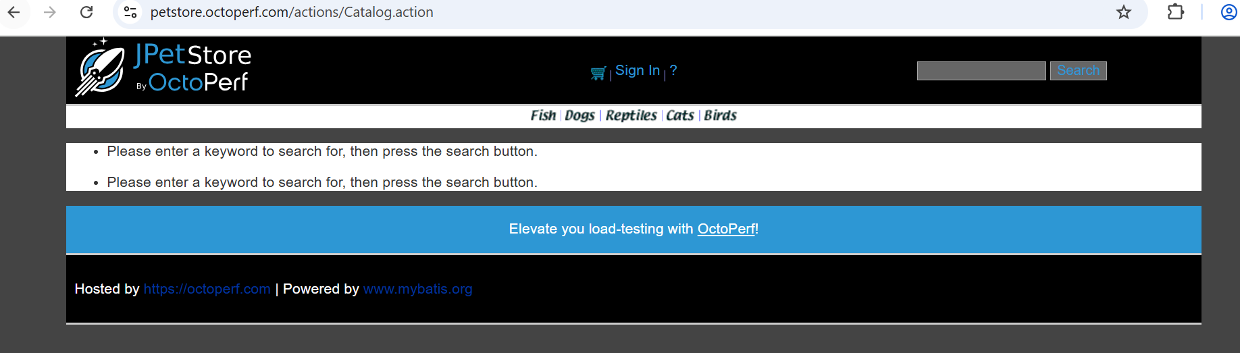

Name of tester: Sakshi Sakhare

**Test ID:05**

Bug Description: User is able to successfully place an order for a product that is bigger in number.

Environment: QA

Steps: 1. Enter the URL

<https://petstore.octoperf.com/actions/Cart.action>

2. Enter bigger values in the cart

3. Click on update.

4. View Results.

Actual:

Showing bigger values.

Expected results: Show the product stock.

Severity: Low

Priority: High

Screenshot:

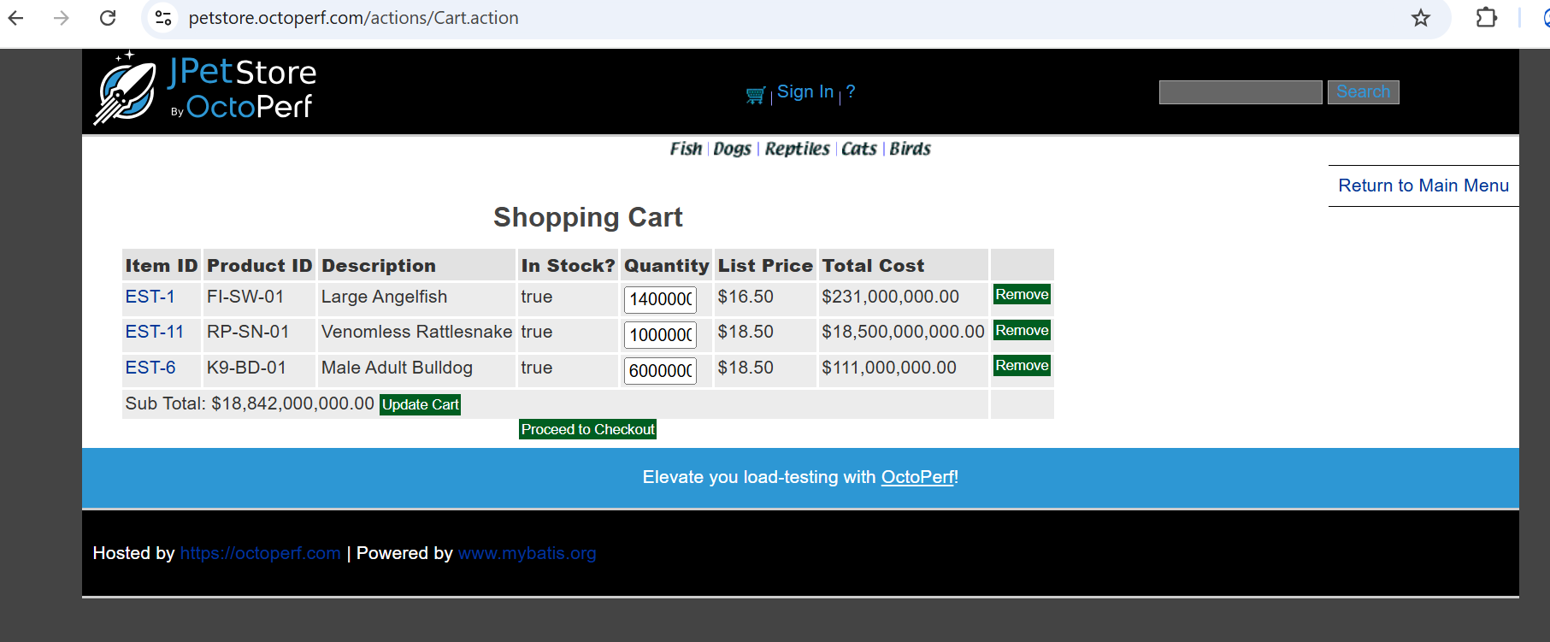

Name of tester: Sakshi Sakhare

**Test ID:06**

Bug Description: User is able to successfully place an order for a product that is marked as not in stock.

Environment: QA

Steps: 1. Enter the URL

<https://petstore.octoperf.com/actions/Catalog.action>

2. Search for a product that is not in stock.

3. Add the product to the cart.

4. Proceed to checkout.

5. View Results.

Actual:

The order is successfully submitted even though the product is not in stock.

Expected results: System should prevent order submission and display an error message indicating the product is not available.

Severity: Low

Priority: High

Screenshot:

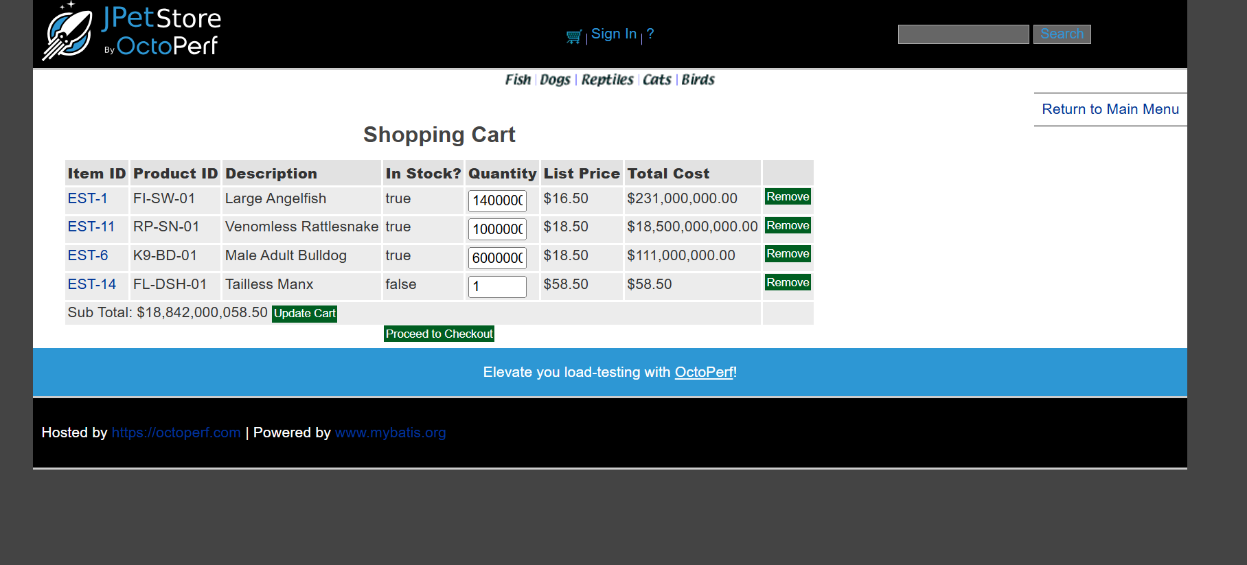Name of tester: Sakshi Sakhare

**Test ID:07**

Bug Description: Language not updated.

Environment: QA

Steps: 1. Enter the URL

<https://petstore.octoperf.com/actions/Account.action?newAccountForm=>

2. Select the language checkbox

3. View Results.

Actual: When a user selects the language, it's not updating on site.

Expected results: It should change the language as per selected checkbox.

Severity: Low

Priority: Medium

Screenshot:

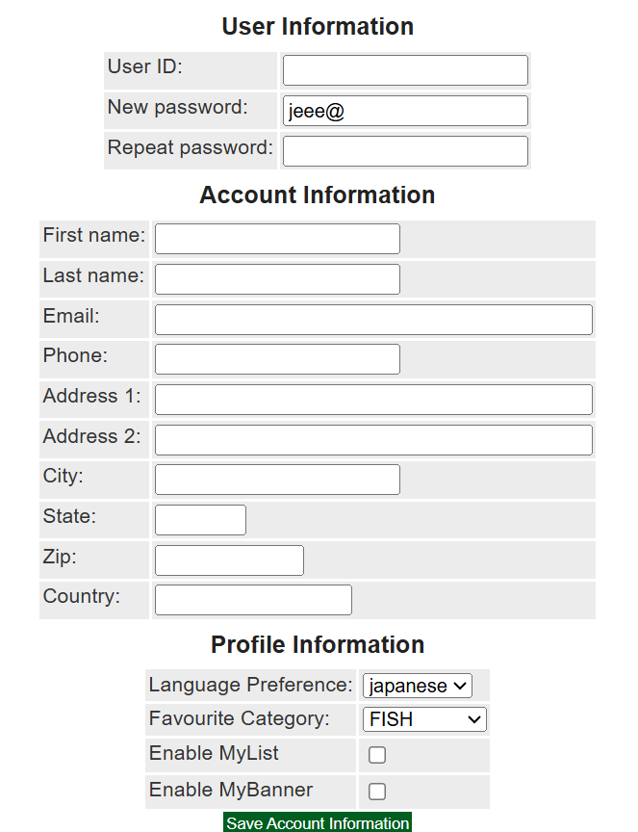

Name of tester: Sakshi Sakhare

**Test ID:08**

Bug Description: Password field accepts fewer than 6 characters.

Environment: QA

Steps: 1. Enter the URL

<https://petstore.octoperf.com/actions/Account.action?newAccountForm=>

2. Enter a password with fewer than 6 characters.

3. Submit the form.

4. View Results.

Actual: Account is created successfully.

Expected results: System should enforce a minimum password length requirement.

Severity: Medium

Priority: High

Screenshot:



Name of tester: Sakshi Sakhare

Test ID:09

Bug Description: No validation for email format during registration.

Environment: QA

Steps: 1. Enter the URL

<https://petstore.octoperf.com/actions/Account.action?newAccountForm=>

2. Enter an invalid email format (e.g., user@com).

3. Submit the form

4. View Results

Actual: Account is created without any error.

Expected results: System should validate email format and show an error.

Severity: Medium

Priority: Medium

Screenshot:

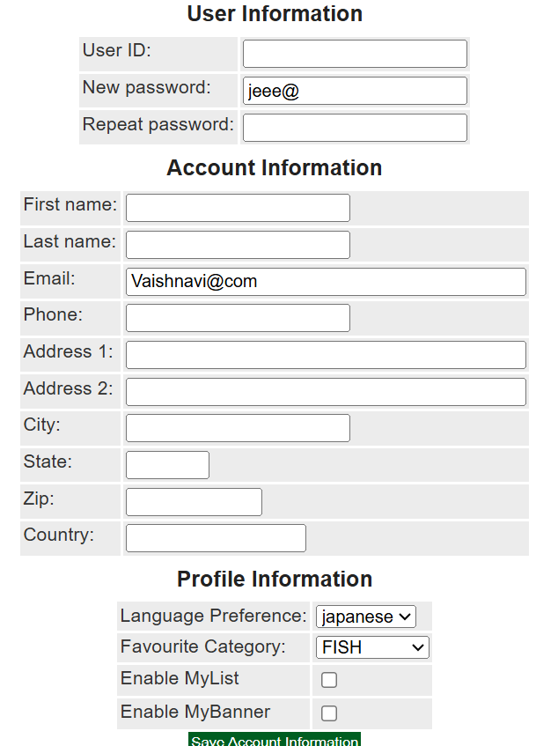

Name of tester: Sakshi Sakhare

**Test ID:10**

Bug Description: Mobile number field accepts alphabetic and special characters.

Environment: QA

Steps: 1. Enter the URL

[https://petstore.octoperf.com/actions/Account.action?newAccountForm](https://petstore.octoperf.com/actions/Account.action)

2. Locate the mobile number input field

3. Enter alphabetic characters (e.g., abc123) or special characters (e.g., @#123).

4. Submit the form.

Actual:

Form is submitted successfully with invalid mobile number input.

Expected results: Mobile number field should accept only numeric input (0–9) and validate for correct length (e.g., 10 digits).

Severity: Medium

Priority: High

Screenshot:

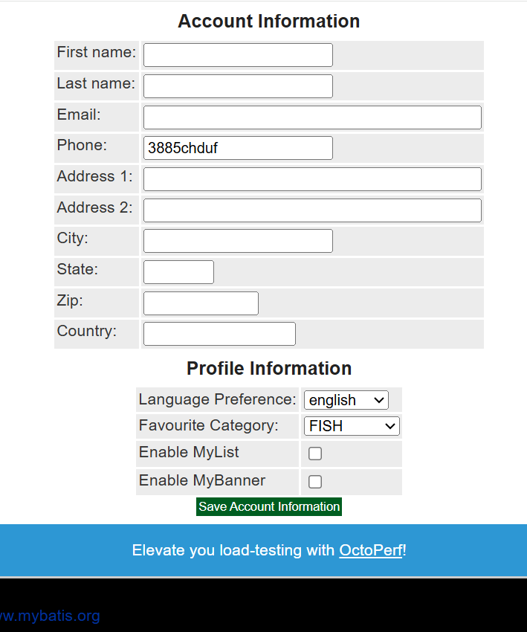

Name of tester: Sakshi Sakhare