**DBW Nodes**

**Description**

Drive by wire (DBW) system will control the vehicle through controlling throttle, braking, and steering. The DBW node logic accepts linear and angular velocity by subscribing to twist_cmd and publish the throttle, brake, and steering commands. The DBW node can be disabled and the driver can control it.

**Inputs and outputs**

This diagram illustrates the inputs and outputs for DBW node:

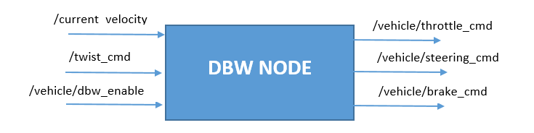

The inputs are:

/current_velocity: published by simulator and used by the DBW node to determine the linear velocity and provide it to controller.

/twist_cmd: Waypoint_follower node publishes it and subscribed by DBW node to publish throttle, steering and brake commands.

/vehicledbw_enable: pusblished by simulator. DBW will determine whether or not to publish throttle, steering, and brake information to respective topics.

The outputs from DBW node are throttle, steering, and brake commands published to throttle_cmd, steering_cmd, and brake_cmd respectively.

**Implementation**

The dbw_node.py logic calls the Controller and Control objects based on linear_vel, angular_vel, current_vel, and dbw_enabled to produce throttle, brake, and steering commands.

If DBW node is enabled, throttle, braking and steering computed through the Controller will be published to /vehicle/throttle_cmd, /vehicle/braking_cmd, and /vehicle/steering_cmd respectively.

The Controller logics within the twist_controller.py employs the PID.py to give a control on throttle command. The steering commands are calculated through yaw_controller.py. Both throttle and steering commands are smoothed by a low pass filter from lowpass.py.