**Dataset Upload:**

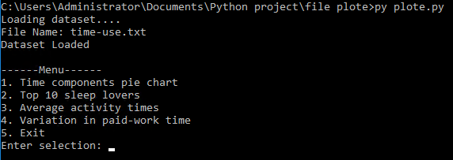

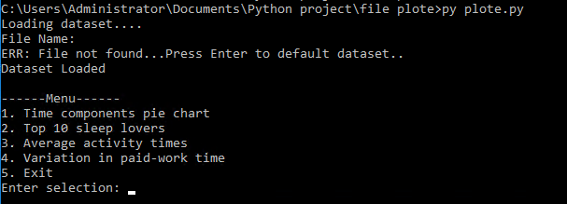

**Case 1 (Time components pie chart):**

**Input Country: Australia**

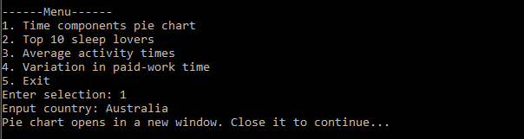

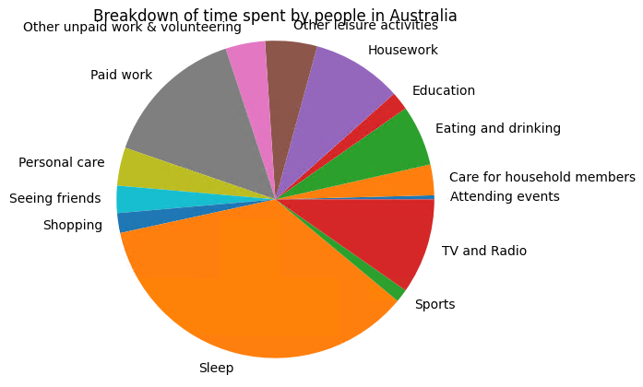

**Input Country: uSa**

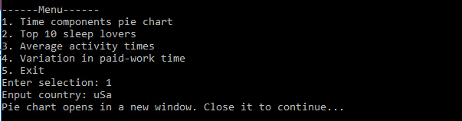

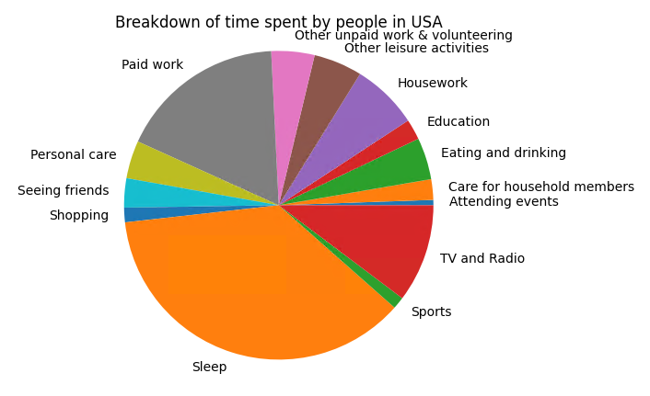

**Input Country: new ZealanD**

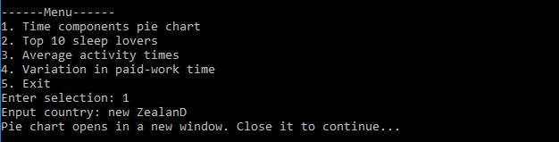

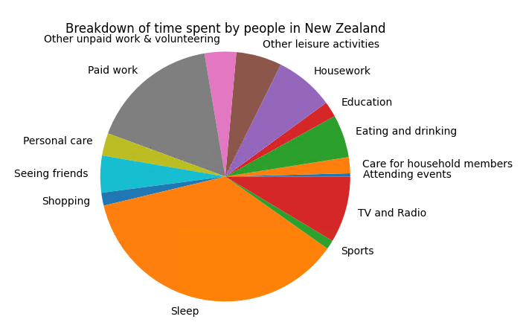

**Input Country: UK**

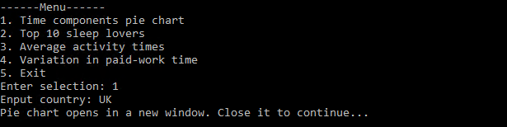

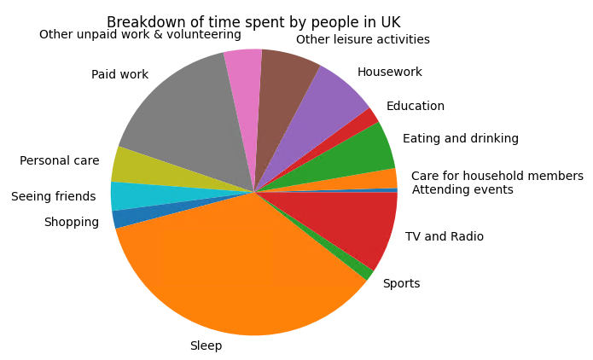

**Input Country: canada**

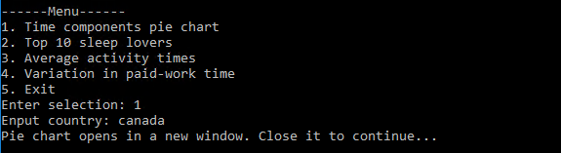

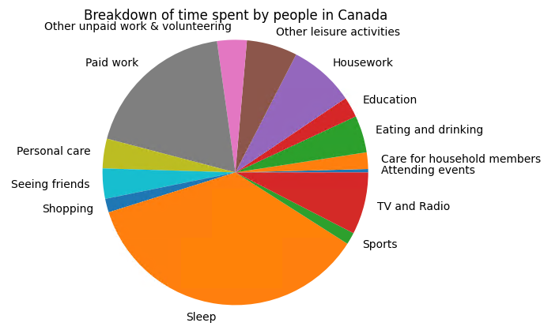

**Input Country: Bangladesh**

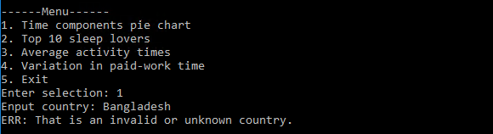

**Case 2 (Top 10 sleep lovers):**

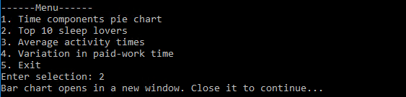

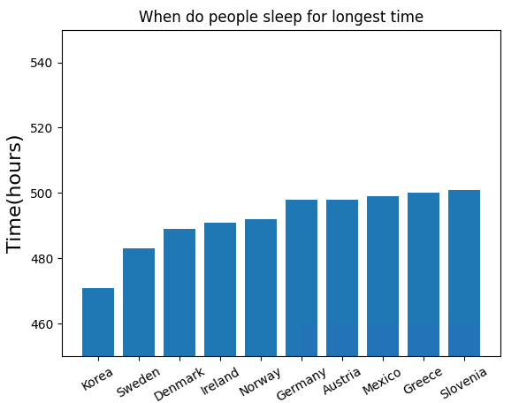

**Case 3 (Average activity times):**

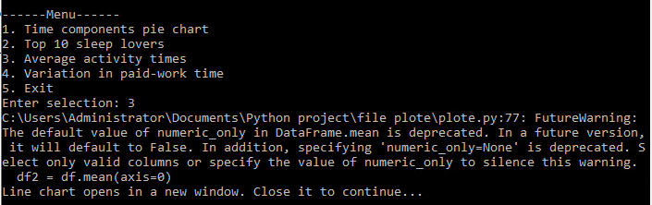

Note: This is just a warning message. No need to worry.

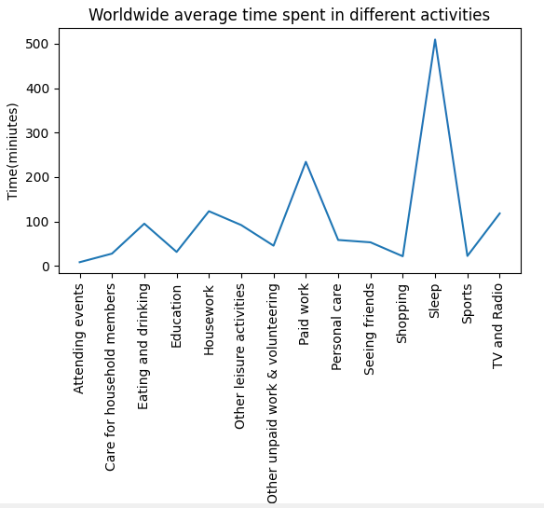

**Case 4 (Variation in paid-work time):**

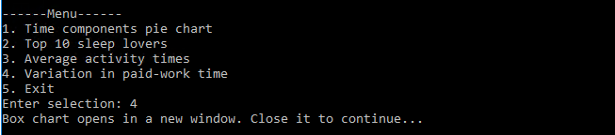

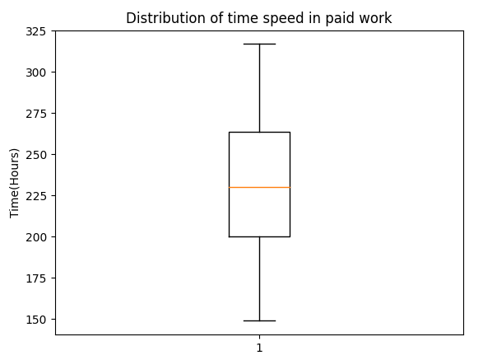

**Case 5 (Exit):**

