**An IoT-Enabled Smart Motorcycle Safety System with Helmet Compliance, Alcohol Detection, and Accident Alert Mechanism**

**Abdul Jobayer,Mohammed Sakib Hasan, Jihadul Islam**

Patuakhali Science and Technology University

Emails: [ug2102008@cse.pstu.ac.bd](mailto:ug2102008@cse.pstu.ac.bd) , [ug2102052@cse.pstu.ac.bd](mailto:ug2102052@cse.pstu.ac.bd) , [ug2102071@cse.pstu.ac.bd](mailto:ug2102071@cse.pstu.ac.bd)

**Abstract—** Motorcycle riders face high accident risks due to helmet non-compliance, alcohol consumption, and hazardous road conditions. This paper proposes an IoT-based safety system integrating helmet detection, alcohol sensing, rain and obstacle monitoring, and accident detection. A GSM module sends alerts, while GPS with machine learning predicts risky road segments. A companion web platform stores rider data and displays real-time location, enabling monitoring and analytics. Voice alerts provide hands-free guidance, enhancing rider safety and timely assistance.

**Keywords—** IoT, motorcycle safety, helmet detection, alcohol sensing, accident detection, GPS, GSM, machine learning, web monitoring, real-time location.

**Research Area**

This research lies in the field of **IoT-enabled intelligent transportation systems**, focusing on motorcycle safety through sensor fusion, machine learning, and web-based real-time monitoring. It integrates hardware, communication networks, and data analytics to prevent accidents, predict road risks, and provide timely alerts for both riders and monitoring platforms.

# Goals and Objectives To develop an IoT-based smart motorcycle safety system that enhances rider safety through real-time monitoring, alerts, and accident prevention.

* Ensure helmet use before starting the bike.
* Detect alcohol consumption and block motor if unsafe.
* Monitor rain and obstacles to provide riding alerts.
* Detect accidents and send emergency SMS.
* Use GPS and ML for hazardous road prediction.
* Store rider data and live location on a web platform.
* Provide hands-free voice alerts.

# Methodology

The proposed system integrates multiple IoT sensors with an Arduino-based controller to monitor rider and environmental conditions. An IR sensor ensures helmet compliance, while an MQ-3 sensor detects alcohol consumption[1]. Rain and ultrasonic sensors provide weather and obstacle awareness, and a vibration sensor identifies accidents. A relay controls the motor based on sensor inputs. Data is transmitted via GSM and GPS modules for emergency alerts, hazardous road prediction using machine learning, and real-time rider tracking on a web platform.[2] Voice output modules deliver hands-free alerts to the rider.

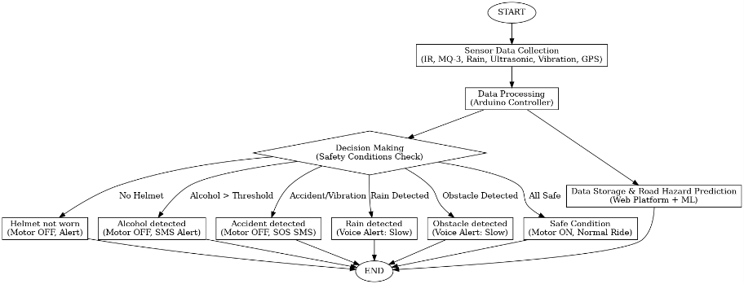

*Fig. 1. flowchart* the Proposed IoT-Based Smart Motorcycle Safety System

# Results and Analysis

The system was tested with different sensor inputs and performed reliably. The IR sensor ensured the bike only started when a helmet was worn, while the MQ-3 alcohol sensor successfully blocked the motor and sent SMS alerts when alcohol exceeded the threshold. The rain sensor issued slow-down alerts during wet conditions, and the ultrasonic sensor detected nearby obstacles effectively. Accident detection with the vibration sensor triggered emergency alerts, while GPS data was logged on the web platform for real-time monitoring. Overall, the integrated IoT system showed effective preventive, adaptive, and emergency safety responses.

# References

1. R. Kumar and M. Singh, “Alcohol detection and accident prevention system for vehicles,” International Journal of Engineering Research & Technology (IJERT), vol. 5, no. 3, pp. 1–5, 2016.
2. H. Lin, Z. Wang, and J. Ma, “Machine learning approaches for road safety prediction using GPS and sensor data,” IEEE Access, vol. 8, pp. 24745–24755, 2020.