*Heaven’s Light is Our Guide*

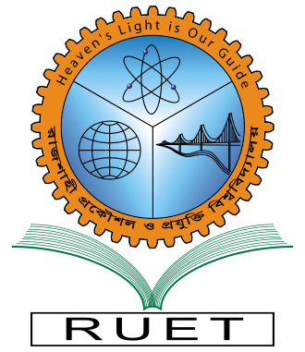

**DEPARTMENT OF COMPUTER SCIENCE & ENGINEERING**

**Rajshahi University Of Engineering & Technology, Bangladesh**

**Surface Crack Detection Using Deep Convolutional Neural Network**

**Author**

Sadman Sakib Radh

Roll No. 1503007

Department of Computer Science & Engineering

Rajshahi University of Engineering & Technology

**Supervised by**

Prof. Dr. Md. Al Mamun

Professor

Department of Computer Science & Engineering

Rajshahi University of Engineering & Technology