**A Project for Software Engineering Lab**



**MediCareHub**

**(A platform of Online Medicine and Doctor Visiting management system)**

*A project submitted to the Department of Computer Science and Engineering in partial fulfillment of CSEL-3206 Software Engineering Lab course for the Degree of B.Sc. in Computer Science and Engineering.*

By

**Md. Sakibul Islam**

**ID: B190305035**

**Asifuzzaman**

**ID: B190305023**

Supervised By

**Dr. Md. Zulfiker Mahmud**

**Associate Professor**

Department of Computer Science and Engineering

Declaration

This is to certify that the work presented in this project is carried out by the candidates – Md.   
Sakibul Islam (ID: B190305035) and Asifuzzaman (ID: B190305023) under the supervision of Dr. Md. Zulfiker Mahmud in the Department of Computer Science and Engineering, Jagannath University, Dhaka - 1100, Bangladesh. It is also declared that neither of this project nor any part of this project has been submitted anywhere else for any degree of diploma. Information derived from the published and unpublished work of others has been acknowledged in the text and a list of references is given.

|  |  |  |
| --- | --- | --- |
| Countersigned | Signature | Signature |
| …………………….. | …………………….. | …………………….. |
| (Dr. Md. Zulfiker Mahmud) | (Md. Sakibul Islam) | (Asifuzzaman) |
| **Supervisor** | **Candidate** | **Candidate** |

**ACKNOWLEDGEMENT**

First, we would like to thank the most influenced people our project time. They are our parents, then our sibling, for their continuous support and criticism.

We extend our sincere thanks to Jagannath University, CSE Department which provided us with the opportunity to fulfill our wish and achieve our goal.

We would like to express deep debt to honorable teachers **Dr. Md. Zulfiker Mahmud (**Project Supervisor), **Dr. Md. Manowarul Islam**, **Dr. Sajeeb Saha** and all faculty membersfor their vital suggestions, meticulous guidance and constant motivation which went a long way in the successful completion of this project.

We cannot move on without thank beloved **Dr. Uzzal Kumar Acharjee**, Professor & Chairman of the Department for creating the required academic environment which made our task appreciable.

On a moral personal note, our deepest appreciation and gratitude to our beloved parents, who have been an inspiration and have provided with unrelenting encouragement and support.

Authors

|  |  |
| --- | --- |
| Signature: ………………………    Date: ……………………………    **Md. Sakibul Islam**  Id: B190305035  Batch: 11th  Department of Computer Science &  Engineering  Jagannath University | Signature: ………………………    Date: ……………………………    **Asifuzzaman**  Id: B190305023  Batch: 11th  Department of Computer Science &  Engineering  Jagannath University |

**ABSTRACT**

The MediCareHub an Online Medicine and Doctor Visiting Management System revolutionizes healthcare accessibility by leveraging the power of digital technology. In a world shaped by rapid advancements, our project introduces an innovative platform that seamlessly integrates the purchase of medicines and healthcare products with online doctor consultations. This system allows customers to effortlessly order prescribed medications and wellness items, facilitating doorstep delivery. Simultaneously, users can schedule appointments with available online doctors, enabling remote consultations and healthcare services. The project's primary objective is to enhance convenience, optimize healthcare operations, and bridge the gap between patients and medical professionals through an intuitive online platform. This abstract provides insight into the pivotal features, functionalities, and the overarching goal of transforming the landscape of online medicine and healthcare management.

|  |  |  |
| --- | --- | --- |
|  | Contents | Page No. |
| 1 | **INTRODUCTION** |  |
| 1.1 | Introduction |  |
| 1.2 | Project Name (MedicareHub) |  |
| 1.3 | Motivation |  |
| 1.4 | Objectives |  |
| 1.4.1 | General objectives |  |
| 1.4.2 | Specific objectives |  |
| 1.5 | Project Aim |  |
| 2 | **LITERATURE REVIEW** |  |
| 2.1 | Online Medicine Management Systems |  |
| 2.1.1 | Advantages |  |
| 2.1.2 | Weakness and Limitations |  |
| 2.2 | Telemedicine and Online Doctor Consultations |  |
| 2.2.1 | Benefits and Concerns |  |
| 2.2.2 | Weakness and limitations |  |
| 2.3 | Commerce in Healthcare |  |
| 2.3.1 | Opportunities and Risks |  |
| 2.4 | Integration of Prescription Verification Systems |  |
| 2.4.1 | Effectiveness and Security |  |
| 2.5 | Integration of prescription verification systems |  |
| 2.6 | Automation in online Pharmaceutical Services |  |
| 3 | **METHODOLOGY** |  |
| 3.1 | Proposed Methodology |  |
| 3.1.1 | Advantages of Prototype model |  |
| 3.1.2 | Disadvantages of Prototype model |  |
| 3.1.3 | When to use Prototype model |  |
| 3.2 | System Analysis |  |
| 3.3 | Functional Requirements |  |
| 3.3.1 | Order Management |  |
| 3.3.2 | Reporting Management |  |
| 3.3.3 | Menu Management |  |
| 3.3.4 | Billing Management |  |
| 3.3.5 | Goods and Services Tax Management |  |
| 3.3.6 | Order Queue Module |  |
| 3.4 | Non➢Functional Requirements |  |
| 3.4.1 | Operational Requirements |  |
| 3.4.2 | Performance Requirements |  |
| 3.4.3 | Security Requirements |  |
| 3.4.4 | Usability Requirement |  |
| 3.5 | Hardware & Software Requirements |  |
| 3.5.1 | Software Requirements |  |
| 3.5.2 | Hardware Requirements |  |
| 4 | **SYSTEM DESIGN** |  |
| 4.1 | Project Approach |  |
| 4.2 | Business Model Canvas |  |
| 4.3 | UML Diagram |  |
| 4.4 | Use Cases Diagram |  |
| 4.5 | Data Flow Diagram |  |
| 4.6 | Class Diagram |  |
| 4.7 | Sequence Diagram |  |
| 4.8 | Architecture Diagram |  |
| 4.9 | ER Diagram |  |
| 5 | **SWOT ANALYSIS** |  |
| 5.1 | SWOT Analysis Meaning |  |
| 5.2 | Strength |  |
| 5.3 | Weaknesses and Limitations |  |
| 5.4 | Opportunities |  |
| 5.5 | Threats |  |
| 6 | **COMPETITION ANALYSIS** |  |
| 6.1 | Competition Analysis |  |
| 6.2 | Direct Competitors |  |
| 6.3 | Indirect Competitors |  |
| 6.4 | Opportunities For Competitive Advantage |  |
| 6.5 | Threats |  |
| 7 | **DETAILED GROWTH STRATEGY** |  |
| 7.1 | Customer Acquisition and Retention |  |
| 7.2 | Technological Innovation |  |
| 7.3 | Strategic Partnerships |  |
| 7.4 | Staff Training and Support |  |
| 7.5 | Data Analytics and Business Intelligence |  |
| 8 | **PRICING STRATEGY AND DETAILED PRICING OF YOUR PRODUCTS/SERVICES** |  |
| 8.1 | Pricing Strategy for MedicareHub |  |
| 8.2 | Tiered Pricing Plans |  |
| 8.3 | Additional Services |  |
| 8.4 | Cash on Delivery Pricing Example |  |
| 9 | **WORK BREAKDOWN STRUCTURE TO LAUNCH AND CARRY OUT THIS PROJECT** |  |
| 9.1 | Project Initiation |  |
| 9.2 | Market Research and Analysis |  |
| 9.3 | Requirements Gathering |  |
| 9.4 | System Design |  |
| 9.5 | Software Development |  |
| 9.6 | Testing and Quality Assurance |  |
| 9.7 | Training Programs |  |
| 9.8 | System Deployment |  |
| 9.9 | Marketing and Promotion |  |
| 9.10 | Monitoring and Optimization |  |
| 9.11 | Documentation and Knowledge Transfer |  |
| 9.12 | Post➢Launch Evaluation |  |
| 10 | **PROJECT MANAGEMENT PLAN** |  |
| 11 | **DETAILED GANTT CHART WITH TIMELINE** |  |
| 12 | **PROJECT LAUNCH (KICK OFF) PROJECT CHARTER** |  |
| 13 | **PROJECT RISK ANALYSIS (USING RISK BREAKDOWN STRUCTURE) AND MITIGATION PLAN** |  |
| 14 | **PREPARE BASIC FINANCIAL FOR YOUR BUSINESS (REVENUE, COST, GROSS PROFIT WITH DETAIL BUILD➢UPS)** |  |
| 15 | **CASH FLOW BASED (GROSS PROFIT) COMPANY VALUATION CALCULATION** |  |
| 16 | **CONCLUSION** |  |
|  |  |  |
|  |  |  |
|  |  |  |
|  |  |  |
|  |  |  |
|  |  |  |
|  |  |  |
|  |  |  |
|  |  |  |
|  |  |  |
|  |  |  |
|  |  |  |
|  |  |  |
|  |  |  |
|  |  |  |
|  |  |  |
|  |  |  |
|  |  |  |
|  |  |  |
|  |  |  |
|  |  |  |
|  |  |  |
|  |  |  |
|  |  |  |
|  |  |  |
|  |  |  |
|  |  |  |
|  |  |  |
|  |  |  |
|  |  |  |
|  |  |  |
|  |  |  |
|  |  |  |
|  |  |  |
|  |  |  |

**Chapter 1**

Introduction

**1.1 Introduction**

In response to the evolving demands in healthcare, our project introduces the Online Medicine and Doctor Visiting Management System. This innovative platform aims to streamline the process of purchasing medicines and scheduling online doctor consultations. Much like the success of automated systems in the restaurant industry, our project prioritizes efficiency, reducing wait times, and eliminating potential errors in healthcare services. Through real-time prescription validation, doorstep delivery, and online consultations, we aim to revolutionize the healthcare experience, bridging the gap between patients and healthcare providers. The project involves requirements analysis, system design, implementation, and testing to ensure a user-friendly and technologically advanced solution for modern healthcare needs.

**1.2 Project Name: MediCareHub**

MediCareHub is an advanced online medicine and Doctor visiting platform designed to streamline various aspects of healthcare operations, enhance customer experience, and optimize overall efficiency. The system includes modules for order management, sales management of medicine and healthcare products, online doctor management, inventory tracking, product delivery management, online payment with mobile banking, and customer relationship management.

**1.3 Motivation**

In the realm of healthcare, the pursuit of an accessible, efficient, and patient-centric system has never been more crucial. The motivation behind the Online Medicine and Doctor Visiting Management System stems from the recognition of the pressing challenges faced by individuals seeking medical care and pharmaceutical products. Just as the restaurant industry has embraced technological solutions to enhance customer experience, the healthcare sector requires a paradigm shift towards a more streamlined and user-friendly approach.

The conventional healthcare model, with its cumbersome processes for medication procurement and doctor consultations, often leads to prolonged wait times and potential errors. Drawing inspiration from the success of automated systems in other industries, our project is driven by the desire to revolutionize how healthcare services are accessed and experienced. We aspire to create a seamless platform that not only simplifies the purchase of medicines and wellness products but also facilitates convenient online doctor consultations.

The motivation behind this project lies in the belief that technology can bridge the gap between patients and healthcare providers, significantly improving the overall healthcare journey. By embracing real-time prescription validation, doorstep delivery of medications, and online consultations, we aim to offer a transformative solution that aligns with the contemporary expectations of efficiency, accessibility, and reliability in healthcare services. Through the integration of cutting-edge technology, our project aspires to contribute to a healthcare landscape where patient satisfaction is paramount, and the delivery of services is optimized for the digital age.

**1.4 Objectives  
1.4.1 General objectives**⮚ To increase efficiency and improve services provided to the customers , users through better  
application of technology in daily operations.  
⮚ To be able to stand out from competitors in the healthcare service industry  
**1.4.2 Specific objectives**⮚ Implement Online Prescription Verification: Enable customers to submit and verify prescriptions online, ensuring accuracy and compliance.

⮚ Streamline Medicine Ordering: Develop an efficient interface for customers to order prescribed medicines and healthcare products seamlessly.  
⮚ Real-Time Prescription Validation: Integrate a system for real-time validation of prescriptions to minimize errors and adhere to medical guidelines.  
⮚ Doorstep Medication Delivery: Establish a secure and reliable delivery system for medicines and healthcare products to enhance accessibility.

⮚ Online Doctor Appointment Scheduling: Create a platform for users to schedule appointments with online doctors, ensuring organized and remote healthcare consultations.  
⮚ Enhance Customer Engagement: Provide detailed information on prescribed medications to foster informed decision-making and engagement.  
⮚ Ensure Data Security: Implement robust security measures to protect customer information and comply with healthcare privacy regulations.  
⮚ Improve User Experience: Develop an intuitive platform with visual elements for order confirmation, prioritizing a positive and seamless customer experience.  
**1.5 Project Aim**Our project aims to streamline and enhance the healthcare experience through the Online Medicine and Doctor Visiting Management System. The goal is to simplify the ordering process for customers, ensuring efficiency, accuracy, and security. Additionally, customers will benefit from accessing detailed product information, including ingredients, and receiving visual order confirmation, thereby improving overall healthcare service delivery.

**CHAPTER 2  
 LITERATURE REVIEW**  
  
**2.1 Online Medicine Management Systems**

**I**n recent years, the healthcare industry has witnessed a transformative shift with the integration of online technologies. The Online Medicine Management System leverages this technological evolution to enhance the efficiency and accessibility of healthcare services. This system is designed to streamline the process of medicine procurement, prescription validation, and healthcare product acquisition.

Similar to the Wireless Food Ordering System, the Online Medicine Management System utilizes network and wireless technologies to reshape traditional healthcare practices. The system allows users to remotely access a centralized database, facilitating seamless interactions with the healthcare provider and pharmaceutical services. This integration enables users to order prescribed medicines, upload prescriptions, and purchase necessary health care products from the comfort of their homes.

Implementation of this system involves establishing an intranet network within the pharmacy or healthcare facility. A central database server holds essential information, accessible through mobile devices such as smartphones or tablets connected to the wireless network. The entire medicine procurement process undergoes a digital transformation, where users can upload prescriptions, place orders, and receive real-time updates on the status of their requests.

With the Online Medicine Management System, healthcare professionals can efficiently validate prescriptions, reducing errors and ensuring adherence to medical guidelines. Once an order is placed, the system triggers a chain of automated processes, notifying the pharmacy or healthcare provider to prepare and dispatch the required medications. This digitalization not only expedites the medicine procurement process but also enhances overall customer experience.

In essence, the Online Medicine Management System revolutionizes the traditional healthcare model, providing a convenient, efficient, and secure platform for patients to manage their medication needs and access healthcare services remotely. This digital transformation contributes to the optimization of healthcare operations and customer satisfaction.

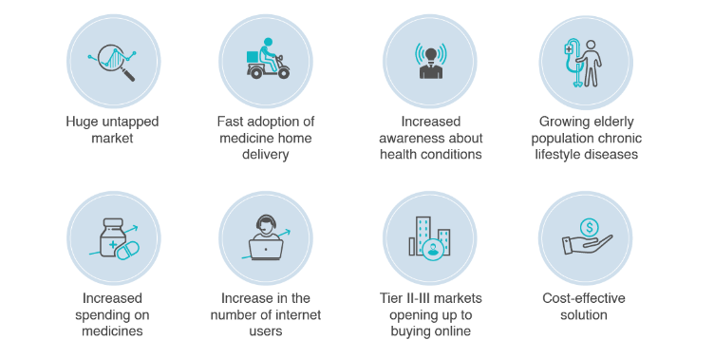

Figure 1-Online Medicine management benefits

**2.1.1 Advantages**

The Online Medicine Management System streamlines prescription handling, eliminates paper-based prescriptions, and ensures real-time order tracking. It offers convenient home delivery, integrates secure online payments, optimizes inventory management, and promotes sustainable healthcare practices. Overall, it enhances efficiency and accuracy in healthcare services.  
**2.1.2 Weaknesses and Limitations**The Online Medicine Management System presents several weaknesses and limitations. Its efficiency is contingent on technology, making it susceptible to disruptions from technical glitches or network issues. Users, particularly older demographics, may encounter challenges in navigating the digital platform, impacting their ability to utilize the system effectively. Security concerns arise due to the reliance on online platforms, necessitating robust measures to protect patient data from unauthorized access. Limited internet accessibility for certain patients and potential complexities in prescription verification pose additional challenges. Home delivery services may face logistical hurdles, leading to delays in medication supply. Resistance to change from traditional healthcare methods, legal compliance complexities, and data privacy concerns further contribute to the system's limitations. Additionally, the cost implications of implementation may limit accessibility for smaller healthcare facilities or those with financial constraints.  
**2.2 Telemedicine and Online Doctor Consultations**Telemedicine and online doctor consultations represent a transformative shift in healthcare delivery, leveraging digital technologies to facilitate remote medical interactions. This approach enables patients to connect with healthcare professionals virtually, breaking down geographical barriers and enhancing accessibility to medical services. Through secure communication channels and digital platforms, patients can engage in real-time consultations with healthcare providers.

The benefits of telemedicine and online consultations are substantial. They offer increased convenience, particularly for individuals in remote or underserved areas, eliminating the need for physical visits to healthcare facilities. This accessibility results in timely medical advice, early intervention, and improved overall healthcare delivery. The efficiency of these virtual interactions contributes to better patient outcomes and preventive care.

Despite these advantages, challenges such as data security concerns, the digital divide, and the need for regulatory frameworks must be addressed. However, the growing adoption of telemedicine underscores its potential to revolutionize healthcare, making it a crucial aspect to explore and integrate into the evolving landscape of patient-doctor interactions. This project will delve into the intricacies of telemedicine, examining its impact on healthcare accessibility, quality, and the changing dynamics of patient-doctor relationships in the digital era.

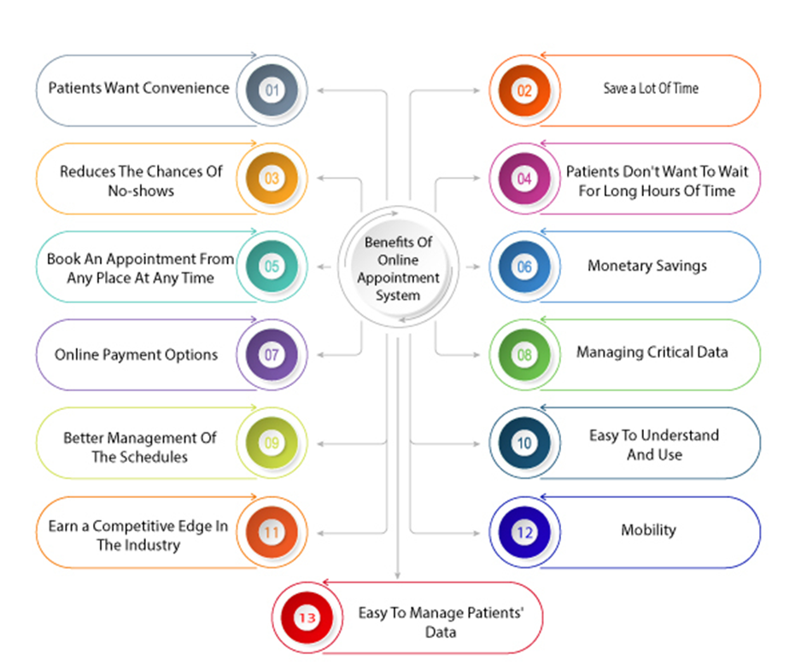

Figure 2:Online Doctor Visiting benefits

**2.2.1 Benefits**

Telemedicine and online doctor consultations are highly suitable for modern healthcare needs. These approaches provide unparalleled accessibility, allowing patients to consult with healthcare professionals from any location. This not only minimizes the time required for the consultation process but also eliminates the need for physical visits to healthcare facilities. Patients can easily connect through digital platforms, streamlining the entire healthcare experience. This convenience ensures prompt medical attention, early intervention, and preventive care. In essence, these virtual interactions contribute to improved patient outcomes and enhance the overall efficiency of healthcare services, aligning with the evolving dynamics of contemporary healthcare delivery.  
**2.2.2 Weaknesses and Limitations**Despite their advantages, telemedicine and online doctor consultations have limitations. The digital divide may hinder access for those without reliable internet or devices. Concerns about data security and privacy necessitate robust safeguards. The absence of physical examinations may lead to potential misdiagnosis, and regulatory challenges can impede seamless integration. Certain medical procedures may suffer due to the lack of hands-on approaches. Lastly, resistance to change from both healthcare professionals and patients accustomed to traditional practices may impede widespread adoption. Addressing these challenges is essential for the effective implementation of these technologies in modern healthcare.

**2.3 E-Commerce in Healthcare**For MedicareHub, the integration of e-commerce in healthcare presents significant opportunities and risks. On the positive side, it enhances user accessibility, allowing for the seamless purchase of medications and healthcare products, along with scheduling online doctor consultations. However, challenges include the imperative need for robust security measures to protect sensitive patient data and the necessity to address disparities in digital literacy and technology access. Balancing these aspects will be crucial for MedicareHub to optimize the advantages of e-commerce while ensuring a secure and inclusive healthcare experience.

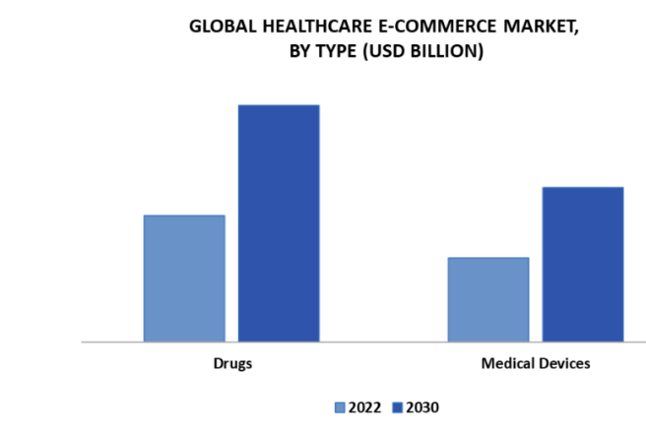

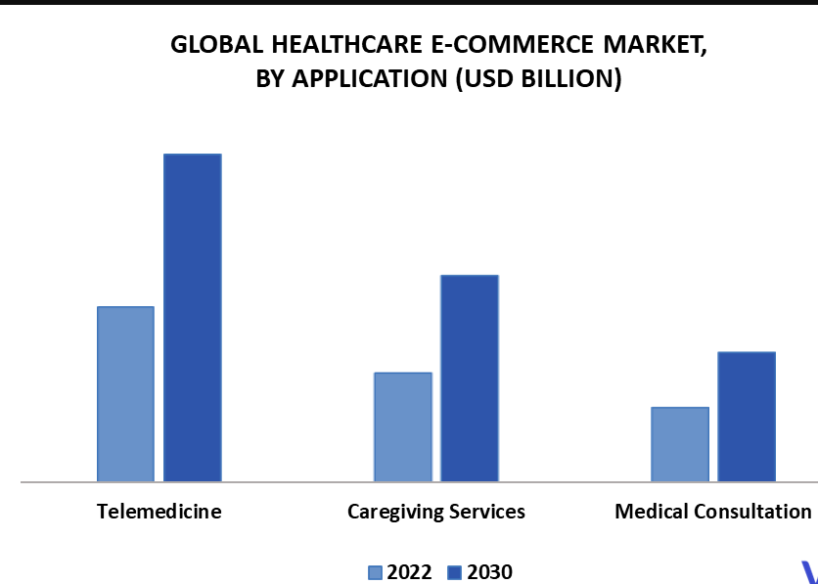

Figure 3 : E-Commerce in Global Healthcare

**2.3.2 Opportunities and risks**

The integration of e-commerce in healthcare brings forth significant opportunities and risks. On the positive side, it enhances accessibility, enabling patients to conveniently order medications, schedule appointments, and access health information from diverse locations, thereby fostering a more user-centric healthcare experience. Additionally, digital platforms streamline healthcare processes, reducing administrative burdens and enhancing overall operational efficiency, including simplified appointment scheduling and prescription refills. This, in turn, contributes to improved patient outcomes by facilitating timely access to medications, preventive care products, and virtual consultations, promoting early intervention and treatment plan adherence.

However, this digital transformation also introduces notable risks. Privacy and security concerns emerge as sensitive health information is exchanged online, necessitating robust measures to protect against unauthorized access and cyber threats, ensuring compliance with healthcare data protection regulations. Ethical challenges arise from the potential mismanagement of patient data, demanding a commitment to ethical use, respect for patient autonomy, and the preservation of medical information confidentiality. Additionally, the presence of digital disparities, including variations in digital literacy and technology access, poses a risk of unequal healthcare experiences. Addressing these disparities is crucial to prevent marginalized access to healthcare services, ensuring inclusivity in the evolving landscape of digital healthcare. Achieving a balance between these opportunities and risks is imperative for the successful and ethical implementation of e-commerce in healthcare.

**2.4 Integration of Prescription Verification Systems**The integration of Prescription Verification Systems is a pivotal advancement in healthcare technology, streamlining the process of ensuring the accuracy and authenticity of medication prescriptions. These systems employ cutting-edge technologies to verify the legitimacy of prescriptions, reducing the risk of errors and enhancing patient safety. By automating the verification process, healthcare providers can swiftly cross-reference prescription details against databases, identifying potential discrepancies or fraudulent activities. This not only minimizes the likelihood of dispensing incorrect medications but also contributes to a more efficient and secure healthcare ecosystem. The integration of Prescription Verification Systems aligns with the broader digital transformation in healthcare, promising improved prescription management, heightened accuracy, and ultimately, enhanced patient care.

**2.4.2 Effectiveness and Eecurity**

The integration of Prescription Verification Systems proves highly effective in enhancing the accuracy and security of medication dispensing processes in healthcare. These systems significantly reduce the risk of errors in prescription interpretation and fulfillment, thereby improving patient safety and healthcare outcomes. By automating the verification process, these systems swiftly cross-reference prescription details against comprehensive databases, ensuring that the medication prescribed is both legitimate and appropriate for the patient's condition.

In terms of security, the integration of Prescription Verification Systems adds an additional layer of protection against fraudulent activities and unauthorized access to sensitive patient information. The automated verification process helps identify discrepancies or irregularities in prescriptions, preventing the dispensing of counterfeit or inappropriate medications. Robust security measures, such as encryption and access controls, are implemented to safeguard patient data, ensuring compliance with privacy regulations and bolstering the overall integrity of the healthcare system.

Overall, the effectiveness and security of integrating Prescription Verification Systems contribute to a more reliable and efficient prescription management process, aligning with the broader goals of improving patient care and fostering a secure healthcare environment.

**2.5 Integration of Prescription Verification Systems**

Automation in online pharmaceutical services represents a transformative shift in the healthcare industry, streamlining various processes to enhance efficiency, accuracy, and overall service delivery. Through the integration of advanced technologies, automation brings numerous benefits to the pharmaceutical sector:

1. Order Processing and Prescription Verification: Automation streamlines the order processing workflow, from prescription submission to verification. It ensures the accuracy of prescriptions through electronic verification systems, minimizing errors and expediting the fulfillment process.

2. Inventory Management: Automated systems enable real-time tracking and management of pharmaceutical inventory. This helps prevent stockouts, reduces wastage, and ensures that essential medications are consistently available.

3. Billing and Payment Processing: Automated billing systems facilitate seamless and error-free invoicing for pharmaceutical products and services. Patients can easily make online payments, improving the overall financial transaction process.

4. Appointment Scheduling and Virtual Consultations: Automation allows patients to schedule appointments online, reducing the administrative burden on healthcare providers. Virtual consultations can be automated, providing patients with convenient access to healthcare professionals from the comfort of their homes.

5. Home Delivery Logistics: Automated logistics systems optimize the home delivery process. This includes route optimization, real-time tracking, and efficient delivery scheduling, ensuring timely and secure delivery of medications to patients' doorsteps.

While automation offers significant advantages, considerations for data security, patient privacy, and regulatory compliance are paramount. Implementing robust cybersecurity measures and ensuring compliance with healthcare regulations are essential to maintaining the trust and integrity of online pharmaceutical services. In essence, the integration of automation in online pharmaceutical services promises to revolutionize the sector, providing a seamless and technologically advanced healthcare experience for both providers and patients.

**2.6 Automation in online Pharmaceutical Services**

The integration of automation in MedicareHub, an innovative online medicine and doctor consultation platform, revolutionizes the landscape of pharmaceutical services. Through advanced technologies, MedicareHub ensures a seamless and efficient experience for users:

Prescription Verification: Automation streamlines the prescription verification process, ensuring accuracy and authenticity in medication orders. Electronic verification systems enhance the reliability of prescriptions, minimizing errors and expediting fulfillment.

Inventory Management: Real-time tracking of pharmaceutical inventory optimizes stock levels, preventing shortages and reducing wastage. This guarantees the consistent availability of essential medications for users.

Billing and Payment Processing: Automated billing systems simplify the invoicing process, allowing users to make online payments securely. Integration with various online banking services ensures a smooth financial transaction experience.

Appointment Scheduling and Virtual Consultations: Users can effortlessly schedule online doctor appointments through automated systems, reducing administrative complexities. Virtual consultations provide convenient access to healthcare professionals from the comfort of one's home.

Home Delivery Logistics: Automated logistics streamline the home delivery process, incorporating route optimization and real-time tracking. This ensures the timely and secure delivery of pharmaceutical products to users' doorsteps.

While embracing automation, MedicareHub prioritizes data security, patient privacy, and regulatory compliance. Robust cybersecurity measures are implemented to safeguard sensitive information, ensuring user trust and adherence to healthcare regulations. Overall, the integration of automation in MedicareHub enhances the efficiency, accuracy, and accessibility of online pharmaceutical services, delivering a comprehensive and technologically advanced healthcare solution to users

**CHAPTER 3  
 METHODOLOGY**

**3.1 Proposed Methodology**The software methodology that chosen to develop this system is Throwaway Prototyping.  
Throwaway Prototyping Model is especially useful when the project needs are vaguely and  
poorly laid out. It functions by providing proof that something can indeed be done in terms of  
systems and strategies. Throwaway Prototyping Model is used for certain projects and will  
eventually be discarded after the project has been completed. It is also known as CloseEnded Prototyping. Throwaway Prototyping Model is implemented through the creation of  
prototypes and thereafter gathering feedback from end users to check if they find it good or  
not. This is valuable to get a better understanding of the actual needs of customers before a  
product or service is developed and delivered. The reason to choose Throwaway Prototyping  
to develop this system is due to it can develop a new system in a short time compare with  
other software methodology. Other than that, user might not clearly understand what they  
really require in the system. Therefore, Throwaway Prototyping is where the objective to  
develop the system rapidly and to understand the user’s requirements and hence develop a  
better requirements definition for the system. The prototype concentrates on experimenting  
with the user requirements that are poorly understood.

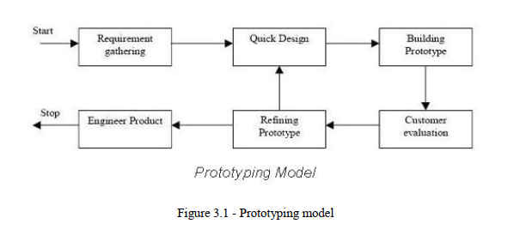

Figure 4 : Prototyping Model

**3.1.1 Advantages of Prototype model:**Early Feedback: Rapid creation of a simplified product version facilitates early stakeholder and user interaction, garnering valuable feedback before major investments in full-scale development.

* Visualization of Concept: Tangible prototypes help stakeholders visualize user interfaces, features, and functionalities, ensuring alignment between development teams and project goals.
* Risk Reduction: Early identification of issues and challenges enables proactive mitigation, minimizing the risk of errors and delays in later development stages.
* Cost-Effectiveness: Prototyping allows experimentation with design ideas, preventing unnecessary development efforts on features that may not align with user needs or business objectives.
* Enhanced Collaboration: Prototypes serve as a communication tool, fostering collaboration between developers, designers, stakeholders, and end-users, promoting constructive discussions and informed decisions.
* Iterative Improvement: Supports an iterative development approach, enabling continuous refinement based on feedback, resulting in a polished and user-friendly final product.
* Time Efficiency: Accelerates design and development by focusing on essential features initially, leading to quicker iterations, shorter feedback loops, and a faster time-to-market.
* Flexibility and Adaptability: Easily modifiable prototypes accommodate evolving requirements, user feedback, and market dynamics, allowing developers to respond quickly to insights and incorporate improvements seamlessly.

In summary, the Prototype model offers a pragmatic approach, validating ideas, mitigating risks, and delivering a high-quality product meeting stakeholder and end-user expectations.

**3.1.2 Disadvantages of Prototype model:**Incomplete Functionality: Prototypes may not fully represent the final product, leading to potential misunderstandings or false expectations from stakeholders.

* Scope Creep: Stakeholder requests for additional features based on the prototype can result in scope creep, challenging project management and expectations.
* Resource Intensive: Creating and maintaining prototypes can demand significant time, effort, and resources, impacting project timelines and budgets.
* Potential for Misinterpretation: Stakeholders and users might misinterpret the prototype's purpose or limitations, risking misunderstandings or dissatisfaction with the final product.
* Risk of Overemphasis on Aesthetics: Prototypes may prioritize visual design over underlying functionality, causing a misalignment between user expectations and the actual product capabilities.
* Difficulty in Scaling: Prototypes may not effectively scale for larger user bases or complex use cases, requiring revisiting technical and design decisions.
* Limited Real-World Testing: Prototypes may not fully replicate real-world scenarios, potentially leading to overlooked issues until later stages of development.
* Dependency on Prototype Tools: Prototyping tools may have limitations or compatibility issues, introducing inefficiencies and inconsistencies in the development process.
* Increased Complexity with Iterations: Evolving prototypes through iterations can lead to complexity and maintenance challenges, requiring careful version management.
* While the Prototype model offers early feedback and validation, recognizing and addressing these drawbacks is crucial for ensuring a successful project outcome.

**3.1.3 When to use Prototype model:**

* Unclear or Evolving Requirements: Ideal when project requirements are not well-defined or frequently changing, allowing stakeholders to explore concepts before finalizing solutions.
* Highly Innovative Projects: Suitable for projects involving novel technologies or innovative ideas, enabling experimentation and feasibility validation before full-scale development.
* User-Centric Design: Effective for prioritizing user experience, enabling designers to create interactive prototypes for user testing and feedback on usability and functionality.
* Complex Systems: Helpful in projects with intricate architectures or complex component interactions, identifying technical challenges and dependencies early in development.
* Rapid Development: Appropriate for projects with tight deadlines, enabling quick iteration and tangible results within short timeframes.
* Risk Mitigation: Valuable when significant project risks exist, offering a means to assess and mitigate risks through iterative experimentation and validation.
* Stakeholder Engagement: Facilitates collaboration by providing a tangible representation of the product for easy understanding and evaluation by stakeholders, developers, and designers.
* 8. Proof of Concept: Useful for validating key concepts, demonstrating functionality, and gaining stakeholder or investor buy-in before full-scale development commitment.
* Customization Requirements: Beneficial for projects requiring customization or personalization, allowing exploration of different options to tailor solutions to specific user needs or preferences.

Leveraging the Prototype model in these scenarios accelerates development, reduces risks, and ensures alignment between project objectives and stakeholder expectations.  
  
**3.2 System Analysis**System analysis is a critical phase in MedicareHub's software system development, involving:

* Understanding Current Processes: Examine existing online medicine purchase, consultations, prescription management, payment processing, and delivery workflows through stakeholder interviews, observations, and documentation review.
* Identifying Stakeholders and Users: Recognize administrators, doctors, pharmacists, customers, and delivery personnel, understanding their roles and requirements.
* Gathering Requirements: Collaborate with stakeholders to collect detailed functional and non-functional requirements for MedicareHub.
* Analyzing Data Flow: Examine data flow, including inputs, processes, outputs, and storage, identifying sources, formats, transformations, and storage needs.
* Modeling System Behavior: Create models (use case, activity, and sequence diagrams) to clarify system functionality and component interactions.
* Identifying Constraints and Limitations: Recognize constraints (regulatory, technical, budgetary) influencing system design and implementation.
* Proposing Solutions: Based on analysis, recommend technologies, architectural patterns, or design principles to address issues and meet stakeholder requirements.
* Validation and Feedback: Validate proposed solutions with stakeholders, gather feedback, and iterate designs as needed for alignment with expectations.
* Documentation: Document system analysis findings, including requirements, models, proposed solutions, and stakeholder feedback, serving as a reference for the development team.
* A structured system analysis approach provides insights, identifies improvement opportunities, and lays the groundwork for MedicareHub's successful implementation..  
  **3.3 Functional Requirements  
  3.3.1 Order Management**Functional requirements for MedicareHub include:
* User Registration and Authentication:
* Secure account creation and login.
* Implementation of secure authentication mechanisms (e.g., email verification, two-factor authentication).
* Medicine Purchase:
* Browsing a catalog of available medicines.
* Searching for medicines by name or category.
* Viewing detailed information (price, dosage, instructions).
* Adding medicines to the shopping cart.
* Specifying purchase quantities.
* Viewing and editing the shopping cart before checkout.
* Prescription Management:
* Secure uploading of prescriptions.
* Secure storage and association with user accounts.
* Review by pharmacists or healthcare professionals for order fulfillment.
* Doctor Consultation:
* Scheduling online appointments.
* Choosing and viewing profiles of available doctors.
* Providing medical history and symptoms information.
* Participating in video or chat consultations at scheduled times.
* Payment Processing:
* Secure payment methods (credit/debit card, mobile banking, cash on delivery).
* Integration with trusted payment gateways.
* Confirmation of successful payment and issuance of invoices.
* Product Delivery:
* Choosing delivery options (home delivery, pickup from a nearby pharmacy).
* Tracking order status and receiving delivery notifications.
* Providing delivery personnel access to a real-time system for managing routes and tracking deliveries.
* These requirements may vary based on stakeholder needs and system scope. Gathering detailed requirements and prioritizing them during system analysis is crucial.

**3.3.2 Reporting Management**Report Generation:

* Users (administrators or managers) can generate sales, prescription fulfillment, and appointment scheduling reports.
* Customizable reports with selectable parameters like date range, product categories, or geographical locations.
* Report Types:
* Sales Reports: Insights into medicine and healthcare product sales.
* Prescription Fulfillment Reports: Tracking prescriptions processed and fulfilled.
* Appointment Scheduling Reports: Monitoring scheduled, canceled, and completed appointments.
* User Activity Reports: Analyzing platform usage, login/logout times, and order history.
* Data Visualization:
* Reports include clear visualizations (charts, graphs, tables).
* Support for various data representation types (bar charts, pie charts, line charts, etc.).
* Export and Sharing:
* Users can export reports in PDF, CSV, or Excel formats.
* Sharing options for emailing reports or collaboration platform sharing.
* Scheduled Reports:
* Option to schedule automated report generation (daily, weekly, monthly).
* Automated delivery to designated recipients via email or saved in the system.
* Access Control:
* Role-based access control for reporting functionalities.
* Administrators have full access, while others have restricted access based on roles.
* Performance and Scalability:
* Reporting designed for efficient handling of large data volumes.
* Implementation of performance optimization techniques (indexing, caching) for responsive report generation.
* Implementing robust reporting in MedicareHub empowers data-driven decisions, monitors system performance, and optimizes operations for enhanced efficiency and effectiveness.

**3.3.3 Billing Management**• The system shall retrieve data that needed and arrange in a meaningful structure then  
print for user as a reference.   
• The system shall let user to choose the payment channel that they wish to use.   
**3.3.4 Goods and Services Tax Management**• The system shall calculate the total amount of money that need to be submitted to  
government at the end of the month.   
**3.3.5 Order Queue Module**• The system will update the queue display whenever a new order is placed.   
• The system will merge the amount of identical food that needs to be prepared and  
display on the screen.   
   
**3.4 Non Functional Requirements  
3.4.1 Operational Requirements**• The system should operate in Window platform environment.   
• The system should prompt user to make a backup at the end of the operational day.   
**3.4.2 Performance Requirements**• The system should let user to place an order in a short period of time.   
• The system should complete perform the billing process in a short period of time.   
**3.4.3 Security Requirements**• The system should validate the username and password in order to login and make  
changes to the system.   
• The system should request the current password of the user in order to let them  
change to a new password.   
**3.4.4 Usability Requirement**• The system should have an easy understand of graphic user interface that deal with the  
user.   
• The system should let users easy to understand the functionality of each module.   
**3.5 Hardware & Software Requirements  
3.5.1 Software Requirements**

|  |  |  |
| --- | --- | --- |
| Operating System | : | Windows7/8 |
| User Interface | : | HTML,CSS |
| Client-side Scripting | : | Javascript |
| Scripting Language | : | PHP |
| Database | : | My SQL |

**3.5.2 Hardware Requirements**

|  |  |  |
| --- | --- | --- |
| Processor | : | Pentium IV |
| Ram | : | 512 or more |
| Hard Disk | : | 40 GB or more |

20  
In this project, a computer with sufficient processing power is needed. The computer is  
requiring for the developer to have project development such as coding for the mobile  
application, database creation and modification. For the complete system to work, several  
hardware requirements must be met. First, it require an android based Smartphone in needed  
to deploy the software application and this Smartphone is require to connect to the wireless  
access point to perform request and respond processes that access to the database. Next,  
database is a must for the entire system to store and retrieve the necessary data. Further

**Chapter 4**

System Design

**4.1 Project Approach**

## The project approach for MedicareHub involves a comprehensive strategy to usher in a transformative era in healthcare services. Beginning with project initiation, clear objectives and scope are defined, forming the foundation for a multidisciplinary project team. Extensive requirements gathering involves stakeholders and market analysis to shape the platform's features, focusing on online medicine ordering, prescription verification, virtual consultations, and home delivery services. The subsequent system design phase incorporates agile methodologies, detailing the platform's architecture and ensuring an intuitive user interface. Software development adopts an agile approach, prioritizing core features, and testing encompasses rigorous quality assurance. Training programs are developed for healthcare professionals, and the platform undergoes phased deployment, closely monitored for performance and user feedback. Marketing efforts highlight unique features and benefits, while ongoing monitoring and optimization refine the platform based on evolving needs. Documentation and knowledge transfer ensure seamless ongoing maintenance, culminating in a post-launch evaluation to gauge the platform's impact and inform future enhancements. This holistic approach aims to establish MedicareHub as a robust, user-centric, and technologically advanced solution, reshaping the landscape of online medicine and doctor consultation services.

## 4.2 Business Model Canvas:

In the evolution of healthcare services, MedicareHub's business model is meticulously designed to cater to the diverse needs of both consumers and healthcare providers, encapsulated by the Business Model Canvas (BMC). This visual representation delineates the interconnected components that shape our strategy:

Customer Segments: MedicareHub primarily targets individuals seeking convenient online access to medicine, healthcare products, and virtual consultations. Additionally, healthcare professionals and institutions form crucial segments as end-users and collaborators.

Value Propositions: At the core of our value proposition is the integration of convenience, accessibility, and technological efficiency into healthcare services. MedicareHub offers a seamless online platform for ordering medicines, accessing healthcare products, and consulting with healthcare professionals, all culminating in improved patient care.

Channels: Our distribution channels encompass direct online interactions through the MedicareHub platform, strategic partnerships with healthcare organizations, and a prominent online presence. The MedicareHub app ensures easy access for individuals and healthcare providers.

Customer Relationships: MedicareHub fosters customer relationships through personalized healthcare experiences. Continuous feedback mechanisms, educational resources, and responsive customer support contribute to a positive and enduring user experience.

Revenue Streams: The revenue model is structured around diverse streams, including prescription verification fees, transaction charges on medicine sales, subscription fees for premium services, and potential partnerships with healthcare institutions for collaborative services.

Key Resources: Vital resources include a proficient software development team, healthcare professionals for virtual consultations, customer support personnel, and an advanced technological infrastructure supporting secure data management and prescription verification.

Key Activities: Crucial activities involve continuous software development, healthcare product sourcing, prescription verification processes, user training programs, marketing initiatives, and ongoing customer support to ensure the platform's functionality and relevance.

Key Partnerships: Strategic alliances are forged with healthcare professionals, pharmaceutical suppliers, and potential collaborators for telemedicine services. These partnerships extend the reach and credibility of MedicareHub in the healthcare ecosystem.

Cost Structure: The cost structure encompasses software development and maintenance costs, marketing expenses, healthcare product procurement, salaries for personnel, ongoing technical support, and infrastructure expenses for data security and platform stability.

The Business Model Canvas serves as a dynamic guide, encapsulating the intricacies and synergies within MedicareHub's approach to redefining healthcare services. From understanding customer segments to forging strategic partnerships, each element contributes to the comprehensive success of our healthcare innovation. MedicareHub is not merely a digital platform; it represents a transformative business model that aligns technology, patient needs, and healthcare dynamics to usher in a new era of healthcare accessibility and convenience. As we embark on this journey, the Business Model Canvas remains our strategic compass, steering decisions and ensuring the holistic success of our innovative healthcare project.

Top of Form

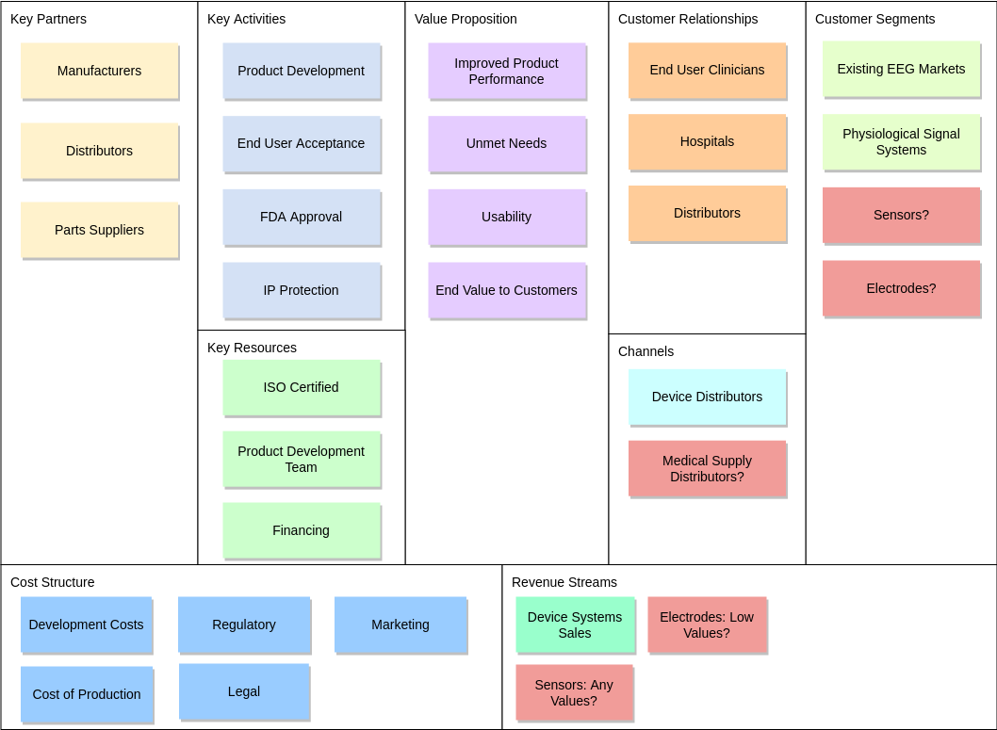

Figure 5 : Business Model Canvas Diagram

**4.3 UML Diagram**

UML stands for Unified Modeling Language. One way to visualize a software program is by using a collection of UML diagrams. Today, UML is recognized as the standard of modeling software development by Object Management Group (OMG). This idea has been derived from the use of Gradia Bouch, James Rumba, Evar Jacobson, and the Rational Software Corporation for Objectbased Design, but it is widely involved in a variety of software engineering projects.

Behavior diagrams represent functionality of software system and emphasize on what must happen in the system being modeled. The different behavior diagrams are:

* **Activity Diagram:** Represents step by step workflow of business and operational components.
* **Use Case Diagram:** Describes functionality of a system in terms of actors, goals as use cases and dependencies among the use cases.
* **State Chart Diagram:** Represents states and state transition.
* **Class Diagram:** Class diagrams are the blueprints of your system or subsystem.
* **Deployment Diagrams:** In UML, deployment diagrams model the physical architecture of a system. Deployment diagrams show the relationships between the software and hardware components in the system and the physical distribution of the processing.
* **Interaction Overview Diagram:** Provides an overview and nodes representing communication diagrams.
* **Data Flow Diagram:** A data flow diagram (DFD) maps out the flow of information for any process or system.
* **Communication Diagram:** Represents interaction between objects in terms of sequenced messages.
* **Sequence Diagram:** A sequence diagram is a Unified Modeling Language (UML) diagram that illustrates the sequence of messages between objects in an interaction.

**4.4 Use Cases Diagram for Restaurant**

The use case diagram for MediCareHub an online Medicine and Doctor visiting Management System serves as a blueprint for the system's functionalities and interactions. The primary actors include the Patient, Healthcare professionals, Administrator, Delivery Service and Administration. Patients initiate use cases related to ordering medicine, uploading prescriptions, and virtual consultations.

Healthcare professionals interact with the system to verify prescriptions and conduct virtual consultations.

Administrators manage user accounts and monitor overall platform activities.

Delivery services are triggered to deliver medicine based on patient orders.

The system manages inventory and facilitates secure online payments.

This use case diagram provides a visual representation of the dynamic interactions within the MedicareHub system, guiding developers and stakeholders in understanding the end-to-end scenario from patient actions to healthcare service delivery and platform management.Top of Form

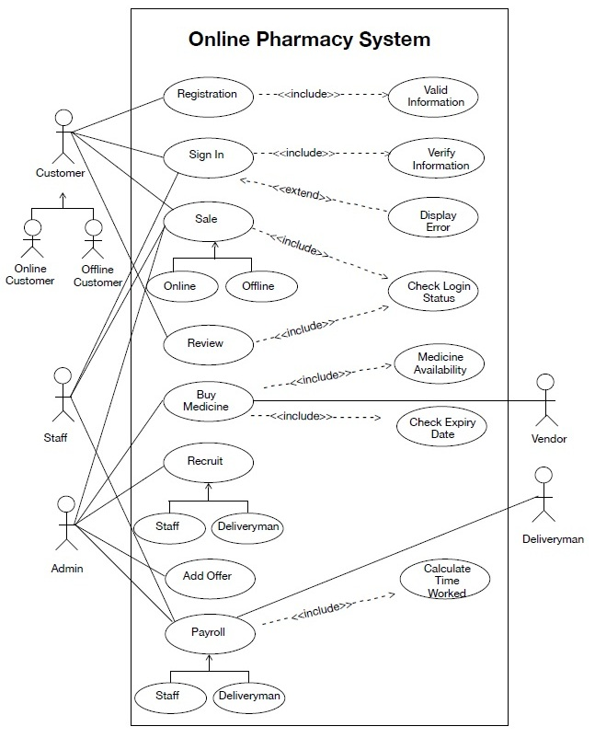

Figure 6 : Use Case Diagram of online medicine or pharmacy management

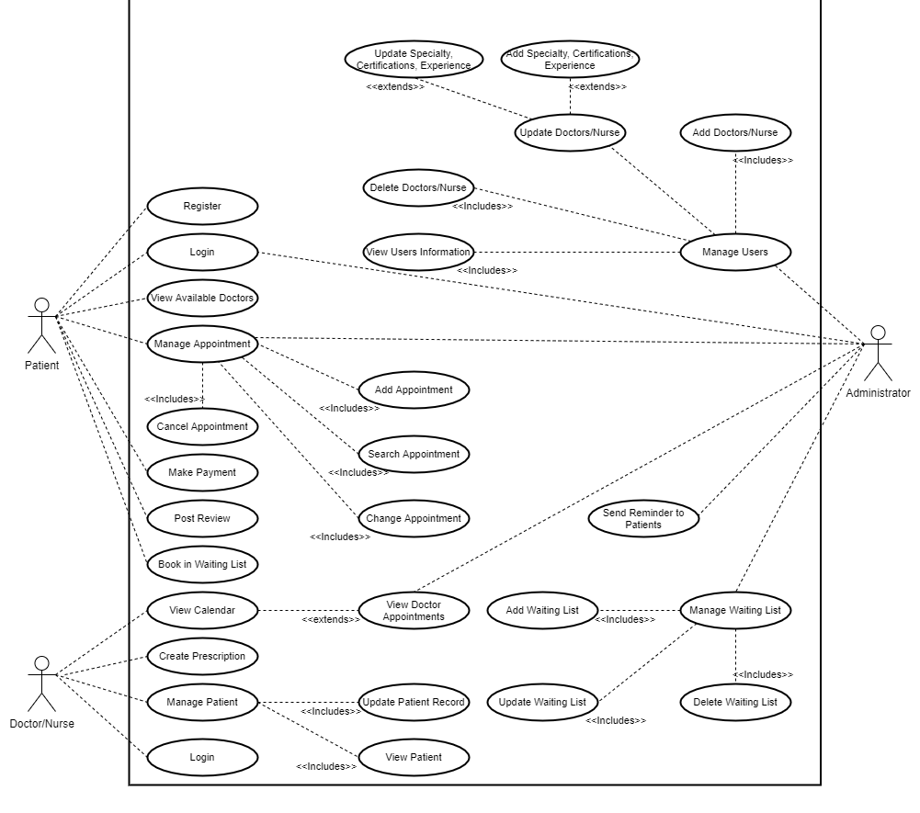

Figure 7 : Use Case Diagram of online doctor visiting system management

**4.5 Data Flow Diagram for MediCareHub**

The data flow diagram (DFD) for the MediCareHub an online Medicine and Doctor visiting Management System provides a visual representation of the flow of information as customers and patient interact with the software. The Data Flow Diagram (DFD) for MedicareHub illustrates the flow of information and interactions within the system. Here's a brief description of the main components and their interactions:

External Entities:

Patients: Initiate the flow by interacting with the system to order medicine, upload prescriptions, and engage in virtual consultations.

Healthcare Professionals: Verify prescriptions and conduct virtual consultations in response to patient interactions.

Administrators: Manage user accounts and monitor overall system activities.

Delivery Services: Receive notifications to deliver ordered medicine to specified locations.

Processes:

Order Processing: Manages the flow of ordering medicine, including prescription verification and payment processing.

Virtual Consultation: Facilitates the interaction between patients and healthcare professionals for virtual consultations.

User Account Management: Handles tasks related to user registration, authentication, and account management.

Platform Monitoring: Monitors system activities, addressing any issues that may arise.

Inventory Management: Manages and updates the inventory of available medicines.

Payment Processing: Ensures secure processing of online payments for ordered medicines.

Data Stores:

Patient Data: Stores patient information, order history, and prescription records.

Healthcare Professional Data: Contains information about healthcare professionals, their schedules, and consultation records.

System Configuration Data: Stores data related to user accounts, system settings, and configurations.

Inventory Database: Maintains information about available medicines, quantities, and expiration dates.

Transaction History: Records details of payment transactions and order processing.

Data Flows:

Order Information: Flows from patients to the Order Processing and Inventory Management processes, conveying details of medicine orders.

Prescription Data: Flows from patients to the Virtual Consultation process and then to the Healthcare Professional Data store for verification.

User Account Details: Flow between users and the User Account Management process for registration, authentication, and account updates.

System Alerts and Notifications: Flow from various processes to the Monitoring process, ensuring prompt responses to system activities.

Medicine Delivery Notifications: Triggered by the Order Processing process and sent to Delivery Services for efficient order fulfillment.

The Data Flow Diagram for MedicareHub provides a visual representation of the seamless data interactions between patients, healthcare professionals, administrators, and the system's internal processes. It emphasizes the flow of information, ensuring a well-organized and efficient healthcare management system.

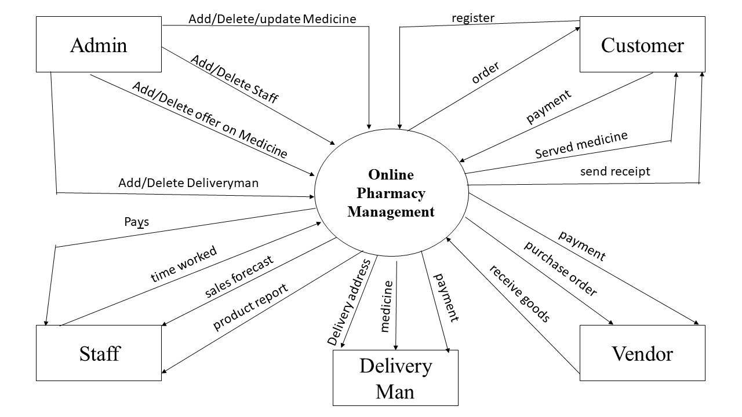

Figure 8 : Data Flow Diagram of Online Medicine management part

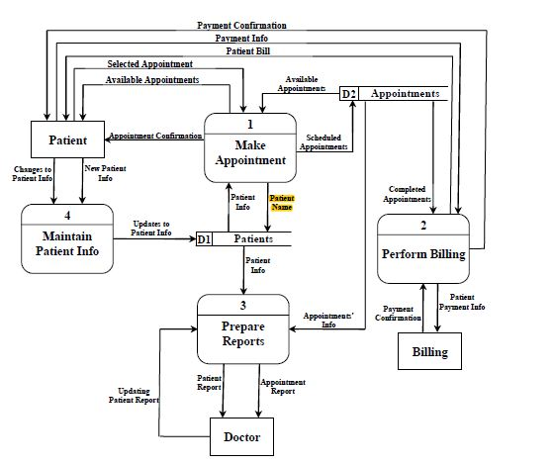

Figure 9 : Data Flow Diagram of online doctor visiting

**4.6 Class Diagram for MediCareHub**

The class diagram for the MedicareHub project delineates the fundamental entities and their interactions, providing a comprehensive structural overview of the healthcare management system. Central to this diagram is the MedicareHub class, embodying the core functionalities of the system. Three pivotal classes, namely User, Medicine, and Appointment, encapsulate key aspects of user management, medicine cataloging, and appointment scheduling. The User class includes attributes like userId, name, and role, serving as a foundation for managing various user profiles. Medicines are represented by the Medicine class, featuring attributes such as medicineId, name, price, and description. The Appointment class orchestrates the scheduling process with properties like appointmentId, date, and references to the involved doctor and patient users. Additionally, the Prescription class captures the prescription details, linking doctor, patient, and a list of prescribed medicines. These classes and their associations offer a clear depiction of the MedicareHub system's structure, guiding developers in implementing a robust and interconnected healthcare solution.

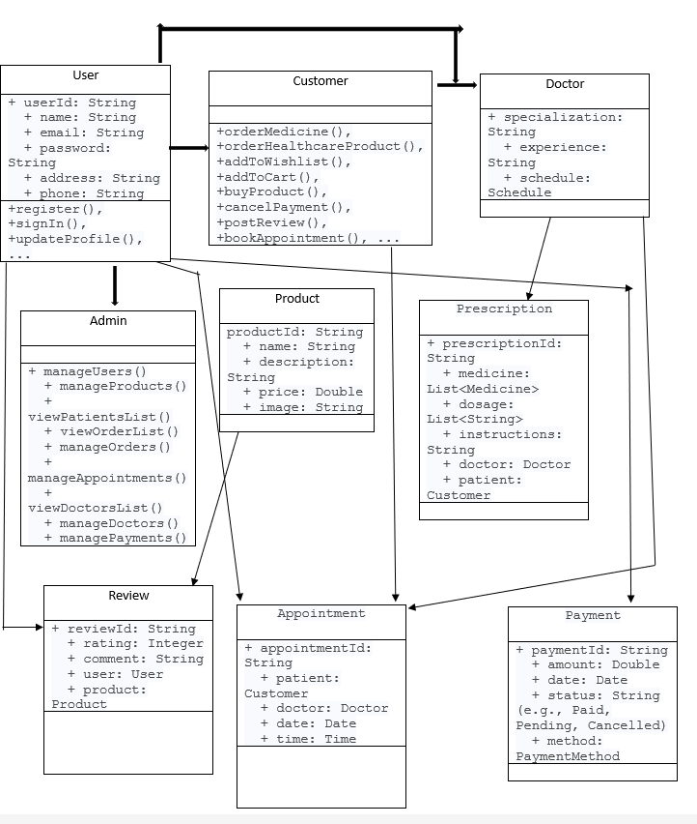

Figure 10: Class Diagram

**4.7 Sequence Diagram for Restaurant**

The sequence diagram for the Restaurant Management System illustrates the dynamic interactions between the various components during the process of a customer placing an order and completing the payment. Initiated by the customer using a tablet or digital device at their table, the sequence unfolds as the order information is transmitted to the waiter, chef, and cashier in a coordinated manner. The sequence begins with the customer selecting menu items and confirming the order, triggering a message sent to the waiter. Upon receiving the order details, the waiter ensures its accuracy and relays the information to the chef for food preparation. Simultaneously, the payment transaction is initiated, moving through a secure channel to the cashier. Once the chef completes food preparation, the waiter is notified, enabling them to serve the prepared dishes to the customer. Following the dining experience, the payment is confirmed, and the transaction details are securely processed by the cashier. The sequence diagram visually captures the synchronized flow of actions, emphasizing the real-time communication and coordination integral to the successful operation of the Restaurant Management System.

Top of Form

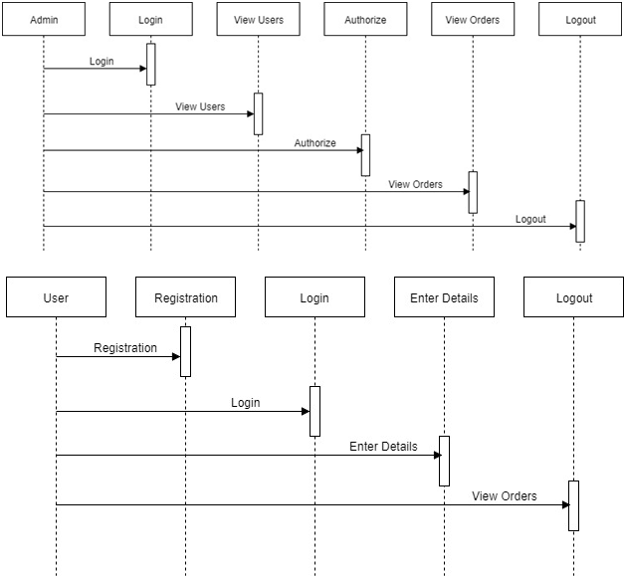

Figure 11 : Sequence Diagram

**4.8 Architecture Diagram for MediCareHub**

The MedicareHub system adopts a three-tier architectural framework to optimize healthcare services. The Presentation Layer offers a user-friendly interface, allowing customers to effortlessly order medicines and schedule online consultations using tablets. The Application Layer serves as a communication hub, facilitating real-time interactions among users, healthcare professionals, and administrators. Finally, the Data Layer securely stores and manages critical healthcare information, ensuring compliance with industry regulations. This design ensures scalability, adaptability, efficiency, and robust security, providing a foundation to meet the dynamic needs of the healthcare industry.

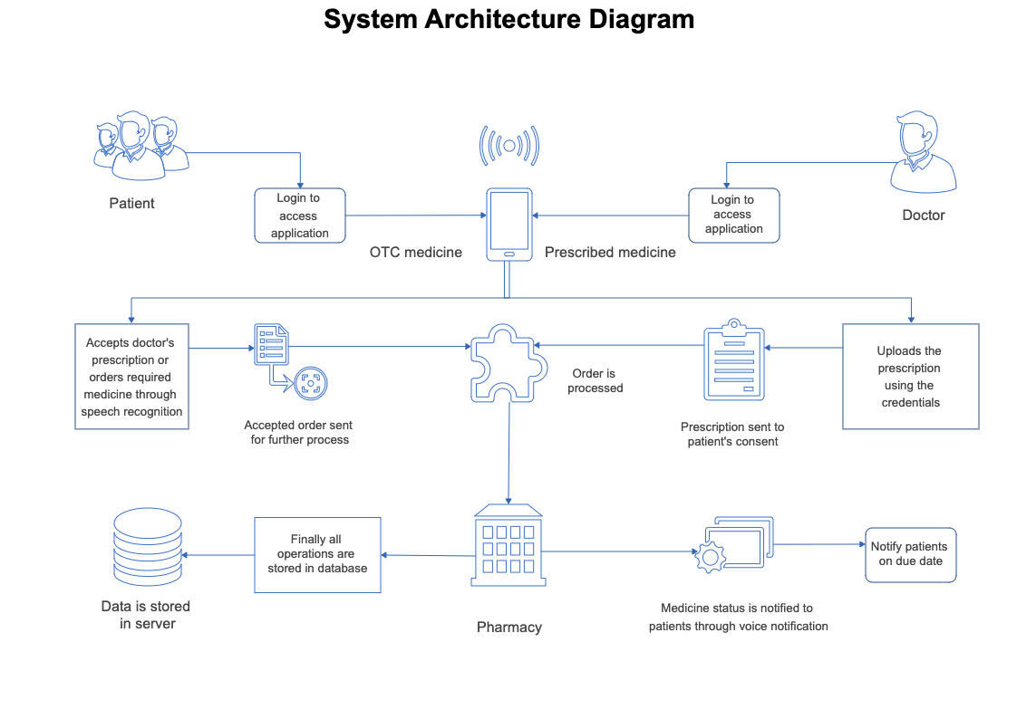

Figure 12 : Architecture Diagram

**4.9 Entity Relationship Diagram for MediCareHub**

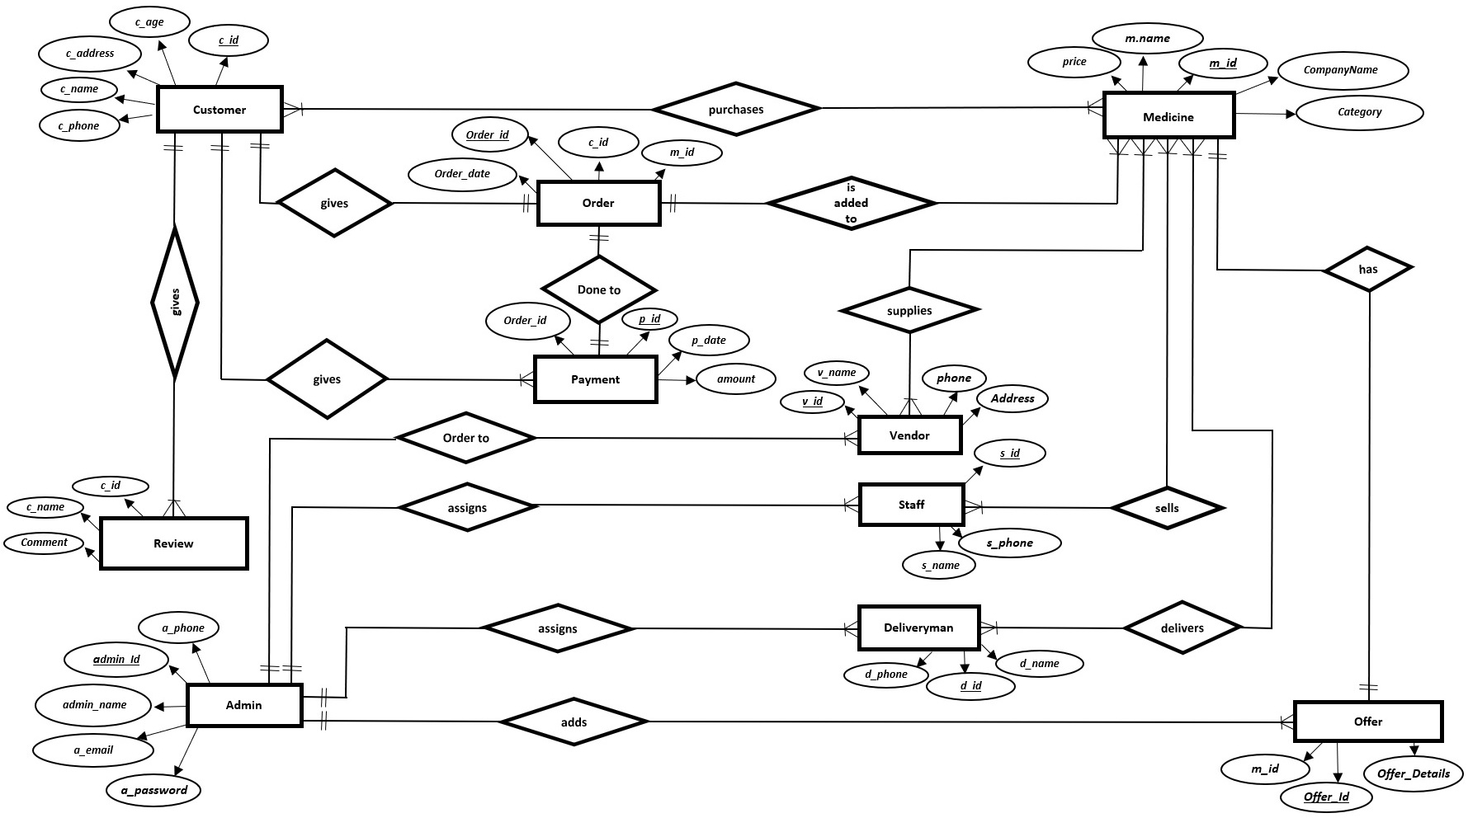 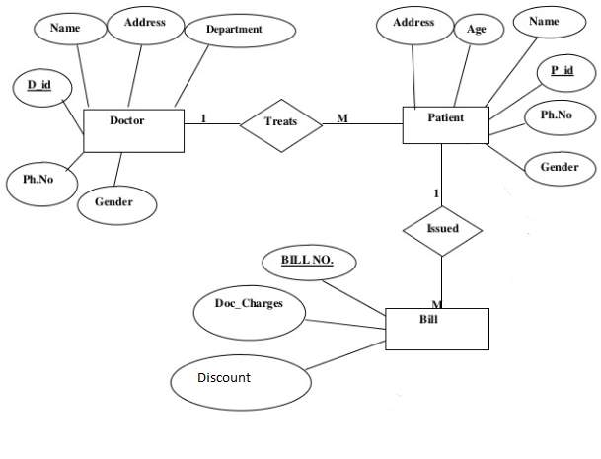

Figure 13 : E-R Diagram

**Chapter 5**

SWOT Analysis

**5.1 SWOT Analysis Meaning**

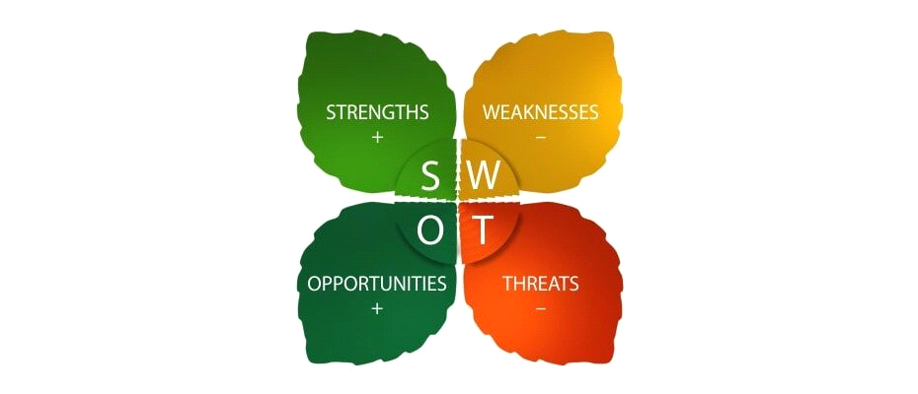

What does “SWOT” mean?

**“S”** stands for Strengths

**“W”** stands for Weaknesses

**“O”** stands for Opportunities

**“T”** stands for Threat

SWOT analysis of the MediCareHub an Online Medicine and Doctor Visiting System Management System is given in the following discussion:

5.2Strength

MedicareHub boasts several key strengths that position it as a leading online medicine and healthcare platform. Offering unparalleled convenience and accessibility, the platform enables users to effortlessly order medicines, upload prescriptions, and engage in virtual consultations from the comfort of their homes. Its integrated healthcare services streamline the entire process, providing a one-stop solution for medication needs. The platform's commitment to secure payment processing, efficient inventory management, and reliable home delivery services further enhances the overall user experience. MedicareHub stands out for its comprehensive and user-friendly approach, addressing the evolving needs of modern healthcare consumers.

**Convenience and Accessibility**: MedicareHub provides a user-friendly platform, allowing patients to order medicines, upload prescriptions, and engage in virtual consultations from the comfort of their homes.

**Integrated Healthcare Services:** The platform combines medicine ordering, prescription verification, and virtual consultations in one centralized system, offering a comprehensive healthcare solution.

**Home Delivery Services**: MedicareHub ensures timely and secure delivery of ordered medicines to the patient's specified location, enhancing convenience and accessibility.

**Secure Payment Processing**: The system incorporates secure online payment methods, ensuring a safe and seamless financial transaction experience for users.

**Efficient Inventory Management**: The platform's inventory management system ensures real-time updates on medicine availability, reducing the chances of stockouts and improving customer satisfaction.

5.3Weaknesses and Limitations

The Online Medicine Management System and telemedicine solutions exhibit various weaknesses and limitations. Dependencies on technology introduce vulnerability to technical disruptions, potentially impacting system efficiency. User navigation challenges, particularly for older demographics, may hinder effective utilization. Security concerns regarding online platforms necessitate robust measures to protect patient data. Limited internet accessibility, prescription verification complexities, and potential logistical hurdles in home delivery contribute additional challenges. Resistance to change, legal compliance issues, data privacy concerns, and implementation costs further constrain the system's capabilities. Similarly, telemedicine faces hurdles such as the digital divide, data security concerns, potential misdiagnosis without physical examinations, regulatory challenges, and resistance to change from traditional healthcare practices. Addressing these limitations is crucial for the successful implementation of these technologies in modern healthcare.

**Technological Barriers**: Some users, particularly those less familiar with technology, may face challenges in navigating the online platform, potentially limiting accessibility for certain demographics.

**Dependence on Internet Connectivity:** The success of virtual consultations and online services is contingent on a stable internet connection, posing challenges for users in areas with limited connectivity.

**Change:** Employees and customers might resist the transition to a technology-driven system, necessitating a change management strategy to ensure a smooth adoption process.

**Security Concerns:** The handling of sensitive healthcare information requires robust security measures to protect patient data and ensure compliance with privacy regulations.**Resistance to**

5.4 Opportunities

**MedicareHub presents several promising opportunities for growth and expansion:**

**Telemedicine Adoption: The increasing acceptance of telemedicine provides an opportunity for MedicareHub to broaden its virtual consultation services, reaching a larger audience and accommodating the evolving preferences of healthcare consumers.**

**Strategic Partnerships with Pharmacies: Collaborating with established pharmacies can enhance the platform's medicine offerings, streamline the delivery process, and create mutually beneficial partnerships, thereby expanding the range of available healthcare products.**

**Healthcare Integration: Integration with existing healthcare systems and electronic health records presents an opportunity to improve overall healthcare coordination. Seamless integration can enhance the platform's capabilities and contribute to a more comprehensive healthcare ecosystem.**

**Technological Innovations: Embracing emerging technologies and innovations in healthcare, such as AI-driven diagnostics or IoT-enabled health monitoring devices, can position MedicareHub as a cutting-edge platform, offering advanced and personalized healthcare solutions.**

**User Education and Awareness: Opportunities lie in educating users about the benefits and convenience of online medicine management and virtual consultations. Increased awareness can drive user adoption and loyalty.**

**Geographic Expansion: Expanding services to new geographic regions or demographics with limited access to healthcare facilities can tap into underserved markets and contribute to the platform's growth.**

**Enhanced Healthcare Services: Offering additional healthcare services, such as health monitoring features, wellness programs, or specialized consultations, can diversify MedicareHub's service portfolio and attract a broader user base.**

**Seizing these opportunities will be instrumental in positioning MedicareHub as a dynamic and responsive player in the evolving landscape of online medicine management and virtual healthcare services.**

5.5 Threats

**MedicareHub faces several potential threats that could impact its success and operations:**

**Intense Competition: The healthcare technology sector is highly competitive, with the emergence of new online platforms. Intense competition could impact MedicareHub's market share and necessitate continuous innovation to stay ahead.**

**Regulatory Changes: Evolving healthcare regulations and compliance standards may pose a threat to MedicareHub's operations. Changes in legal requirements could necessitate adjustments to ensure continued adherence to industry standards.**

**Data Security Risks: The increasing frequency of cyber threats and data breaches in the healthcare sector poses a significant threat to MedicareHub. Protecting patient data from unauthorized access and ensuring robust cybersecurity measures are imperative to mitigate this risk.**

**Technological Challenges: Rapid technological advancements may pose challenges in keeping the platform technologically updated. Failure to adapt to emerging technologies could impact the platform's competitiveness and user satisfaction.**

**Resistance to Telemedicine: Despite its benefits, resistance to adopting telemedicine practices from both healthcare professionals and patients accustomed to traditional healthcare methods may impede widespread adoption and limit the platform's reach.**

**Economic Factors: Economic downturns or financial constraints within the healthcare industry could impact MedicareHub's revenue streams. Economic instability may affect the purchasing power of both healthcare providers and patients.**

**Operational Challenges: Logistical hurdles in the home delivery of medicines, potential disruptions in the supply chain, or unforeseen operational challenges could impact the platform's ability to provide timely and reliable services.**

**Mitigating these threats requires proactive strategies, including continuous monitoring of the regulatory landscape, robust cybersecurity measures, strategic partnerships, and a resilient business model that can adapt to changing market dynamics.**

**Chapter 6**

**Competition Analysis**

**6.1Competition Analysis**

In an era shaped by advancements in healthcare technology, MedicareHub emerges as a transformative solution, redefining the way individuals access medicines and healthcare services online. This narrative provides a comprehensive exploration of the competitive landscape surrounding MedicareHub, shedding light on its unique strengths, potential challenges, promising opportunities, and the external factors that may influence its position in the evolving healthcare industry. MedicareHub distinguishes itself by offering a holistic online platform where users can conveniently purchase medicines, engage in virtual consultations with doctors, and seamlessly manage their healthcare needs. As we navigate the complexities of the healthcare sector, a keen understanding of the competitive dynamics becomes pivotal in establishing MedicareHub as a leading and innovative force in the realm of online medicine and healthcare management.

**6.2DirectCompetitors**

**a. PharmaConnect:**

- Strengths: Established network of pharmacies, comprehensive medicine catalog, and user-friendly interface.

- Weaknesses: Limited virtual consultation services, potentially impacting holistic healthcare offerings.

**b. eHealthMeds:**

- Strengths: Emphasis on telemedicine services, diverse healthcare products, and strategic partnerships.

- Weaknesses: Less focus on prescription verification and potential challenges in home delivery logistics.

**c. HealthOnlineRx:**

- Strengths: Robust prescription verification system, efficient order processing, and a reputation for timely deliveries.

- Weaknesses: Limited telemedicine features and a narrower range of healthcare services

**.6.3 Indirect Competitors**

**a. Traditional Pharmacies with Online Presence:**

**- Strengths**: Established brand recognition, physical presence, and online ordering capabilities.

**- Weaknesses:** Limited focus on telemedicine services, potentially lacking in comprehensive virtual healthcare solutions**.**

**b. Local Healthcare Apps:**

**- Strengths:** Regional popularity, community trust, and personalized healthcare offerings.

**- Weaknesses:** Limited scope in terms of national reach, potentially constrained by fewer resources

.**6.4 Opportunities For Competitive Advantage**

**a. Strategic Partnerships:**

**-** Collaborating with established pharmacies or healthcare providers to expand product offerings and services.

**b. Enhanced Telemedicine Features:**

- Investing in advanced telemedicine capabilities and integrating innovative technologies for a competitive edge.

**c. Geographic Expansion:**

**-** Targeting underserved markets and expanding services to regions with limited access to healthcare facilities.

**d. Comprehensive Healthcare Ecosystem:**

- Offering additional healthcare services beyond medicine ordering, such as wellness programs or health monitoring

.**6.5 Threats**

**a. Emerging Startups:**

- New entrants with innovative approaches may pose a threat, requiring continuous innovation and adaptation**.**

**b. Regulatory Changes:**

**-** Changes in healthcare regulations may impact operations, necessitating agility and compliance.

**c. Technological Disruptions:**

**-** Rapid technological advancements could disrupt the competitive landscape, requiring ongoing technological investments**.**

**d. Economic Downturn:**

**-** Economic challenges may affect purchasing power, impacting the adoption of healthcare services.

This comprehensive analysis positions MedicareHub within the competitive landscape, providing insights into both direct and indirect competitors, potential areas for differentiation, and external factors that may influence its competitive position.

**Chapter 7**

**Detailed Growth Strategy**

MedicareHub, our online medicine and doctor-visiting system, holds immense potential to transform the healthcare landscape. This growth strategy focuses on key areas such as user acquisition, engagement optimization, service expansion, and market penetration, ensuring the sustained success of this innovative project.

**7.1 User Acquisition and Engagement:**

Targeted Outreach: Implement multi-channel marketing campaigns to reach both seniors and younger demographics seeking convenient healthcare solutions. Utilize search engine optimization, social media, and partnerships with relevant organizations.

Personalized Experience: Leverage user data to offer tailored recommendations for medicines, healthcare products, and doctors based on individual needs and preferences.

Community Building: Create an online forum or group where users can connect, share experiences, and access valuable health information.

Telehealth Expansion: Prioritize online consultations with doctors and healthcare professionals, catering to the growing demand for remote healthcare access.

Rewarding Loyalty: Implement a loyalty program with attractive incentives for repeat users, encouraging brand loyalty and increased engagement.

**7.2 Service Expansion and Optimization:**

Subscription Services: Offer subscription plans for regular medication or chronic conditions, enhancing convenience and affordability.

Value-Added Features: Continuously innovate and add new features, such as medication reminders, refill notifications, and AI-powered health assessments, to provide a comprehensive healthcare experience.

**Seamless Payment**: Ensure a smooth and secure payment experience with multiple options including online payment methods, cash on delivery, and integration with popular mobile wallets.

**User Interface Refinement:** Regularly optimize the user interface for intuitiveness and ease of use, ensuring user satisfaction across all demographics.

Data-Driven Decisions: Leverage user data and feedback to identify areas for improvement, prioritize feature development, and personalize marketing campaigns.

**7.3 Market Penetration and Partnerships:**

Strategic Collaborations: Partner with pharmacies, healthcare providers, senior citizen organizations, and insurance companies to expand reach and build trust.

Regional Expansion: Gradually extend services to new regions with high demand for convenient healthcare solutions, prioritizing areas with strong internet infrastructure.

**Affiliate Marketing:** Collaborate with influencers and healthcare bloggers to promote MedicareHub and its services to a wider audience.

Leveraging Community Support: Partner with local communities and organizations to organize healthcare awareness campaigns and promote the benefits of MedicareHub.

**7.4 Building Trust and User Confidence:**

**Compliance and Security:** Prioritize compliance with all relevant healthcare regulations and data privacy laws, ensuring user safety and trust.

**Transparency and Education:** Provide clear and accessible information about products, services, pricing, and data privacy practices.

**Excellent Customer Support**: Offer responsive and helpful customer support through multiple channels, including phone, email, and live chat.

Positive Reviews and Testimonials: Encourage users to share their positive experiences through reviews and testimonials, building trust and attracting new users.

This growth strategy outlines a comprehensive plan to establish MedicareHub as a leading provider of online healthcare solutions. By focusing on user acquisition, engagement optimization, service expansion, market penetration, and building trust, MedicareHub can revolutionize the way people access and manage their healthcare needs. Remember, continuous evaluation, adaptation, and a commitment to user satisfaction will be key to achieving sustained growth and success.

**Chapter 8**

**Pricing Strategy and Detailed Pricing of your products/services**

**8.1 Pricing Strategy for our Innovative MediCareHub:**

Our pricing strategy is meticulously crafted to embody flexibility, scalability, and value, aligning with the diverse requirements of our healthcare platform. We prioritize transparency, simplicity, and adaptability in our pricing model, aiming to cater to healthcare providers of all sizes and specialties.

**8.2 Tiered Pricing Plans:**

**Essential Plan:**

* Ideal for small clinics or individual practitioners.
* Includes fundamental features like online prescription management and virtual consultations.
* Priced at $39.99/month per user.

**Standard Plan:**

* Tailored for medium-sized healthcare facilities.
* Encompasses all features of the Essential Plan with additional functionalities such as appointment scheduling and basic analytics.
* Priced at $79.99/month per user.

**Premium Plan:**

Designed for large-scale hospitals and healthcare networks.

Offers advanced features, including integrated patient records, comprehensive analytics, and telemedicine support.

Priced at $129.99/month per user.

**8.3 Additional Services:**

**Mobile App for Patients:**

Optional mobile application for patients to schedule appointments, upload prescriptions, and access healthcare services remotely.

Priced at a one-time fee of $249 and a monthly maintenance fee of $14.99.

**Onsite Training and Support:**

In-depth onsite training for healthcare staff and 24/7 technical support.

Priced at $399 for initial training and $24.99/month per user for ongoing support.

**Customization and Integration:**

Tailored development for unique features or third-party integrations based on specific healthcare facility requirements.

Customization fees starting at $800, depending on the scope of the project.

**8.4 Dummy Pricing Example:**

Consider a medium-sized clinic with 3 users opting for the Standard Plan with additional services:

**Standard Plan (3 users):** $79.99/user/month x 3 users = $239.97/month

**Mobile App for Patients:** $249 (one-time) + $14.99/month (maintenance)

**Onsite Training and Support:** $399 (initial training) + $24.99/user/month x 3 users

**Total Monthly Cost:** $239.97 (Standard Plan) + $14.99 (Mobile App Maintenance) + $399 (Onsite Training) + $74.97 (Support for 3 users) = $729.93/month

This pricing structure exemplifies our commitment to delivering a cost-effective and impactful healthcare management solution. Continuous evaluations and user feedback will guide refinements to our pricing strategy, ensuring ongoing value and competitiveness in the healthcare market.

**8.5 Cash on Delivery Pricing Example:**

For users who prefer the convenience of Cash on Delivery (COD) payment, our system offers a straightforward pricing example. This option is especially beneficial for customers who wish to pay in cash upon receiving their orders or availing healthcare services.

Assuming a patient using our MediCareHub platform for online medicine purchase and doctor consultation:

Selected Plan: Standard Plan at $79.99/month per user.

Additional Service: Mobile App for Patients - $249 (one-time) + $14.99/month (maintenance).

Onsite Training and Support: $399 (initial training) + $24.99/user/month.

Total Monthly Cost for COD Option:

Standard Plan: $79.99/user/month x 1 user = $79.99

Mobile App for Patients: $249 (one-time) + $14.99/month (maintenance)

Onsite Training and Support: $399 (initial training) + $24.99/user/month x 1 user = $449.98

The patient, in this example, opts for COD and incurs a total monthly cost of $529.96, making the payment in cash upon receiving the healthcare services. This flexible payment approach enhances accessibility for users who prefer traditional payment methods while still enjoying the benefits of our innovative healthcare platform.

**Chapter 9**

**Work Breakdown Structure to launch and carry out this project**

In the ever-evolving landscape of healthcare technology, the launch of our revolutionary healthcare management system, MedicareHub, is poised to redefine the patient care experience. This document elucidates the critical facets of the project using a Work Breakdown Structure (WBS), elucidating the pivotal tasks necessary for the triumphant launch and execution of this ambitious healthcare initiative.

9.1 Project Initiation:

The project kicks off by defining fundamental aspects in a project charter, outlining objectives, scope, and success criteria. Establishing clear communication channels and identifying stakeholders form the collaborative foundation for a successful venture.

9.2 Market Research and Analysis:

This phase focuses on a thorough understanding of the healthcare market. Market research delves into current trends, competitor landscapes, and patient preferences. The goal is to identify challenges and opportunities that will shape the development of a system aligned with healthcare industry demands.

9.3 Requirements Gathering:

Collaboration with stakeholders leads to meticulous requirements gathering. Documenting functionality, features, and user stories enables prioritization, ensuring a focus on critical and feasible elements for a successful outcome in the online medicine and doctor visiting management system.

9.4 System Design:

With requirements in hand, the focus shifts to system design. An intricate architecture is developed, incorporating user interface wireframes, prototypes, and data flow considerations. This phase is pivotal in creating the blueprint for the technological backbone of the healthcare management system.

9.5 Software Development:

The system's actualization begins with software development. Front-end and back-end components are implemented, crafting the user interfaces for online medicine purchase and doctor consultations. Seamless communication channels between various system modules are established.

9.6 Testing and Quality Assurance:

Quality assurance is critical. Unit testing, integration testing, and user acceptance testing ensure the system's reliability and functionality. This iterative phase incorporates feedback loops, leading to continuous refinement for optimal performance.

9.7 Training Programs:

Preparing healthcare staff for the new system is paramount. Tailored training materials are developed, and on-site training sessions are conducted to ensure a smooth transition. Ongoing support is provided during the initial rollout, fostering a collaborative and responsive environment.

9.8 System Deployment:

A strategic deployment plan is executed, starting with a pilot phase. System performance is monitored, feedback is collected, and adjustments are made before scaling up deployment, ensuring a phased and controlled rollout of the healthcare management system.

9.9 Marketing and Promotion:

As the system gains momentum, a robust marketing and promotion strategy is employed. Marketing materials are developed, promotional campaigns are executed, and collaborations with industry influencers are forged to endorse the innovative healthcare solution.

9.10 Monitoring and Optimization:

Post-deployment, a vigilant eye is kept on system performance. Monitoring tools track usage data, and continuous optimization is implemented based on real-world feedback. Prompt issue resolution and regular updates ensure the system's adaptability to evolving healthcare needs.

9.11 Documentation and Knowledge Transfer:

Comprehensive documentation is crafted for user reference and troubleshooting. Knowledge transfer sessions with healthcare providers solidify their understanding, creating a self-sufficient ecosystem. Ongoing support and documentation updates are integral elements.

9.12 Post-Launch Evaluation:

The project concludes with a thorough evaluation of the system's success. Feedback from stakeholders is collected, areas for improvement are identified, and plans for future enhancements are formulated. This phase ensures the continuous evolution and relevance of the healthcare management system.

In summary, the Work Breakdown Structure provides a comprehensive roadmap for the launch and execution of our healthcare management system. Each phase is intricately connected, fostering adaptability, responsiveness, and a commitment to delivering a transformative solution for the healthcare industry. The successful implementation of this WBS promises not just a technological upgrade but a paradigm shift in how healthcare facilities manage and enhance their operations.

**Chapter 10**

**Project Management Plan**

Creating a Project Management Plan (PMP) is essential for overseeing the successful execution of MedicareHub's data analytics and business intelligence (BI) project. Here's a breakdown of key components to include in the PMP:

**1. Project Overview:**

➢ Provide a brief overview of the project, including its objectives, scope, deliverables, stakeholders, and timeline.

**2. Project Organization:**

➢ Define the project organizational structure, roles, and responsibilities of team members, stakeholders, and project sponsors.

➢ Identify key stakeholders, decision➢makers, and subject matter experts involved in the project.

**3. Project Scope Management:**

➢ Define the scope of the project, including its boundaries, objectives, deliverables, and exclusions.

➢ Create a scope management plan outlining processes for scope definition, verification, and control.

**4. Project Schedule:**

➢ Develop a project schedule outlining key milestones, activities, dependencies, and timelines for project execution.

➢ Use project management tools such as Gantt charts, timelines, and calendars to visualize the project schedule.

**5. Resource Management:**

➢ Identify project resources required for the successful execution of the project, including human resources, equipment, materials, and facilities.

➢ Develop a resource management plan to allocate, track, and optimize resource utilization throughout the project lifecycle.

**6. Risk Management:**

➢ Identify potential risks, uncertainties, and constraints that may impact project success, such as technical risks, resource constraints, and stakeholder conflicts.

➢ Develop a risk management plan outlining risk identification, assessment, mitigation strategies, and contingency plans.

**7. Quality Management:**

➢ Define quality standards, metrics, and criteria for evaluating the quality of project deliverables and outcomes.

➢ Develop a quality management plan outlining processes for quality assurance, quality control, and continuous improvement.

**8. Communication Management:**

➢ Establish communication channels, protocols, and mechanisms for sharing project information, updates, and progress reports with stakeholders.

➢ Develop a communication management plan detailing stakeholder communication requirements, frequency, and formats.

**9. Change Management:**

➢ Define change control processes and procedures for managing changes to project scope, requirements, schedule, and budget.

➢ Establish a change management plan outlining change request submission, review, approval, and implementation procedures.

**10. Procurement Management:**

➢ Identify procurement needs and requirements for acquiring external goods, services, or resources to support project execution.

➢ Develop a procurement management plan outlining procurement processes, vendor selection criteria, and contract management procedures.

**11. Budget Management:**

➢ Develop a project budget outlining estimated costs, expenses, and funding sources for the duration of the project.

➢ Implement budget tracking and monitoring mechanisms to ensure that project costs are managed within approved budgets.

**12. Project Closure:**

➢ Define criteria and processes for project closure, including formal acceptance of deliverables, documentation of lessons learned, and handover of project assets.

➢ Develop a project closure plan outlining activities for finalizing project activities, archiving project documentation, and conducting post➢project evaluations.

By developing a comprehensive Project Management Plan (PMP), MedicareHub can effectively manage project execution, mitigate risks, optimize resources, and deliver successful outcomes for its data analytics and business intelligence (BI) project.

**Chapter 11**

**Detailed Gantt Chart with timeline**

Creating a detailed Gantt chart with a timeline will help visualize the project schedule, milestones, and dependencies for MedicareHub's data analytics and business intelligence (BI) project. Here's a sample Gantt chart:

|  |  |  |  |  |
| --- | --- | --- | --- | --- |
| Task Description | Start Date | End Date | Duration | Dependencies |
| Project Initiation | 2024➢03➢01 | 2024➢03➢10 | 10 days | None |
| Market Research & Analysis | 2024➢03➢11 | 2024➢03➢25 | 15 days | Project Initiation |
| Requirements Gathering | 2024➢03➢26 | 2024➢04➢05 | 11 days | Market Research |
| System Design | 2024➢04➢06 | 2024➢04➢20 | 15 days | Requirements |
| Software Development | 2024➢04➢21 | 2024➢05➢15 | 25 days | System Design |
| Testing and QA | 2024➢05➢16 | 2024➢06➢05 | 21 days | Software Dev |
| Documentation and Training | 2024➢06➢06 | 2024➢06➢20 | 15 days | Testing and QA |
| Deployment and Launch | 2024➢06➢21 | 2024➢07➢05 | 15 days | Documentation |
| Post➢Launch Evaluation | 2024➢07➢06 | 2024➢07➢15 | 10 days | Deployment |
| Project Closure | 2024➢07➢16 | 2024➢07➢20 | 5 days | Post➢Launch Eval |

In this Gantt chart:

➢ Task Description: Describes the specific task or activity to be completed.

➢ Start Date: Indicates the planned start date for each task.

➢ End Date: Indicates the planned end date for each task.

➢ Duration: Represents the duration of each task in working days.

➢ Dependencies: Shows any dependencies between tasks. Tasks must be completed sequentially if they have dependencies.

You can adjust the start and end dates, durations, and dependencies based on the specific requirements and timeline of MedicareHub's project. Additionally, you may include additional tasks or break down tasks into sub➢tasks for more granularity and accuracy in project planning and tracking.

**Chapter 12**

**Project Launch (Kick off) Project Charter**

# 1. Project Overview

# Project Name: MedicareHub Launch (Kick-off)

# Project Start Date: [2024-03-1]

# Project End Date: [2024-07-20]

# Project Sponsor: Md. Sakibul Islam & Asifuzzaman

# Project Manager: Md. Sakibul Islam & Asifuzzaman

# Project Team: Md. Sakibul Islam & Asifuzzaman

# Project Budget: [$729.93 / month]

# 2. Project Description

# This project marks the official launch (kick-off) of MedicareHub, an online platform offering convenient access to medicines, healthcare products, doctors, and consultations. Through seamless online ordering, payment, and delivery, MedicareHub aims to revolutionize the healthcare experience for users. This kick-off project will focus on establishing the core functionalities, securing vital partnerships, and generating initial user acquisition.

# 3. Project Objectives

# Successfully launch the MedicareHub website and mobile app with core functionalities for ordering medicines, healthcare products, and booking doctor appointments.

# Secure partnerships with key stakeholders, including pharmacies, healthcare providers, and delivery services.

# Implement a targeted marketing campaign to generate initial user awareness and acquisition.

# Train all team members on platform functionalities and customer service protocols.

# Conduct a successful pre-launch testing phase to identify and address any technical issues.

# Achieve [specific target] number of user sign-ups by the end of the launch period.

# 4. Project Deliverables

# Fully functional MedicareHub website and mobile app.

# Signed partnership agreements with key stakeholders.

# Launched marketing campaign materials across chosen channels.

# Trained and prepared project team members.

# Successfully completed pre-launch testing phase with documented results.

# [Specific number] of user sign-ups achieved by the end of the launch period.

# 5. Success Criteria

# The MedicareHub platform is launched on schedule and within budget.

# All core functionalities are operational and user-friendly.

# Key partnerships are established and contribute to platform accessibility.

# The marketing campaign generates significant user awareness and interest.

# The project team is well-trained and prepared for user inquiries and support.

# The pre-launch testing identifies and resolves any critical issues before launch.

# The targeted user sign-up goal is achieved within the launch period.

# 6. Stakeholders

# Project Sponsor

# Project Manager

# Project Team Members

# Pharmacy Partners

# Healthcare Providers

# Delivery Service Providers

# Marketing Team

# Customer Support Team

# Users (Patients and Doctors)

# 7. Communication Plan

# Regular project status meetings will be held with all stakeholders.

# A communication plan will be established to disseminate project updates and key information.

# A designated communication channel will be available for user feedback and support.

# 8. Risks and Mitigation Strategies

# Risk: Delays in development or testing phases. Mitigation: Implement clear timelines and milestones, conduct regular progress checks, and have contingency plans in place.

# Risk: Difficulty securing key partnerships. Mitigation: Proactively identify potential partners, offer clear value propositions, and be prepared for negotiations.

# Risk: Unforeseen technical issues during launch. Mitigation: Conduct thorough pre-launch testing, have a dedicated technical support team available, and be prepared for quick troubleshooting.

# Risk: Lower than expected user acquisition. Mitigation: Optimize marketing campaign targeting, leverage partnerships for promotion, and offer incentives for early adopters.

# 9. Approvals

# This Project Charter requires approval from the following individuals:

# [Dr. Zulfiker Mahmud] [..../01/2024]

# 10. Conclusion

# The successful launch of MedicareHub is crucial to its long-term success and impact on the healthcare landscape. This Project Charter provides a clear roadmap for achieving the launch objectives and ensuring a smooth and effective transition from development to market availability. By adhering to this plan and actively managing risks, the project team is confident in delivering a successful launch and paving the way for MedicareHub's growth and positive impact.

**Chapter 13**

**Project Risk Analysis (using Risk Breakdown Structure) and Mitigation plan**

**Project Risks:**

**Technical Risks: Integration Challenges with Third-Party APIs**

* Risk: Potential issues during the integration of third-party APIs.
* Mitigation: Conduct thorough API compatibility testing, establish clear communication with API providers, and have contingency plans for alternative solutions.

**Scope and Requirement Risks: Scope Creep**

* Risk: Scope creep due to evolving client requirements.
* Mitigation: Implement a robust change control process, regularly engage with stakeholders to freeze and validate requirements.

**Team Risks: Resource Challenges**

* Risk: Key developers or designers leaving the project.
* Mitigation: Cross-train team members on critical tasks, maintain detailed documentation for a smooth transition.

**Team Risks: Skill and Knowledge Gaps**

* Risk: Lack of expertise in specific functionalities.
* Mitigation: Hire subject matter experts, conduct training sessions for the team on specific functionalities.

**External Risks: Market Shifts**

* Risk: Shifts in market trends impacting system relevance.
* Mitigation: Conduct regular market analyses, design the system to be flexible and adaptable.

**External Risks: Regulatory Changes**

* Risk: Changes in data protection regulations affecting user privacy.
* Mitigation: Stay updated on data protection laws, implement encryption and privacy measures for compliance.

**Process Risks: Development Delays**

* Risk: Delays due to unforeseen technical challenges.
* Mitigation: Adopt an Agile development approach, review progress regularly, and adjust timelines as needed.

**Process Risks: Insufficient Testing**

* Risk: Insufficient testing leading to post-launch issues.
* Mitigation: Develop a detailed test plan covering unit testing, integration testing, and user acceptance testing. Allocate sufficient time for thorough testing.

**Mitigation Plan:**

**Proactive API Management:**

* Establish regular communication with API providers.
* Develop fallback mechanisms for API issues.
* Conduct early and extensive testing of API integrations.

**Change Control Mechanism:**

* Implement a change control board for scope changes.
* Regularly communicate with stakeholders to manage expectations.

**Knowledge Transfer:**

* Cross-train team members for task redundancy.
* Maintain comprehensive documentation for all aspects.

**Skill Enhancement:**

* Identify skill gaps early.
* Encourage continuous learning and training.

**Adaptive System Design:**

* Design the system to be modular and adaptable.
* Regularly assess and update features based on industry demands.

**Privacy by Design:**

* Integrate privacy measures into the system.
* Regularly audit and update privacy features.

**Agile Development Practices:**

* Embrace Agile for continuous adaptation.
* Conduct regular sprint reviews for process improvement.

**Comprehensive Testing Approach**:

* Develop and adhere to a detailed testing plan.
* Include end-users in user acceptance testing for feedback.

Top of Form

**Chapter 14**

**Prepare basic financial for my business (Revenue, Cost, Gross Profit with detail build-ups)**

**Revenue:**

* **Software Licensing Fees:** Estimated revenue from licensing the MediCareHub platform: $400,000
* **Transaction Fees:** Revenue from payment associated with ordering medicine, health products, or other transactions processed through the system: $200,000

**Cost of Goods Sold (COGS):**

* **Development Costs:** Expenses related to software development, testing, and debugging: $250,000
* **Infrastructure Costs:** Expenses for hosting, server maintenance, and cloud services: $80,000
* **Marketing and Promotion:** Budget for advertising and promotional activities: $40,000
* **Customer Support:** Expenses for providing customer support services: $30,000

**Gross Profit Calculation:**

* **Gross Profit = Total Revenue - Total COGS**

#### Revenue:

* Software Licensing Fees: $400,000
* Transaction Fees: $200,000
* **Total Revenue: $600,000**

#### Cost of Goods Sold (COGS):

* Development Costs: $250,000
* Infrastructure Costs: $80,000
* Marketing and Promotion: $40,000
* Customer Support: $30,000
* **Total COGS: $400,000**

#### Gross Profit Calculation:

**Gross Profit = Total Revenue - Total COGS**

**Gross Profit: $200,000**

**Chapter 15**

**Cash Flow based (Gross Profit) company valuation calculation**

**Assumptions:**

Gross Profit Margin: 60%

Projected Gross Profit for Year 1: $1,000,000

Growth Rate: 20%

Discount Rate: 10%

Terminal Growth Rate: 5%

**Calculations:**

1. Annual Gross Profit:

Annual Gross Profit = ARR × Gross Profit Margin

Annual Gross Profit = $100,000 × 0.60 = $60,000

1. Company Valuation:

Company Valuation = Annual Gross Profit × Exit Multiple

Company Valuation = $60,000 × 5 = $300,000

Therefore, the estimated company valuation for the "MediCareHub" web project, based on the Gross Profit method and the assumptions given, is $300,000.

**Chapter 16**

**Conclusion**

* **Summarize the Project:**

The MedicareHub project embarked on a mission to transform healthcare management through a comprehensive online platform. The system integrates functionalities such as online medicine purchase, doctor consultations, and reporting management, leveraging cutting-edge technologies for a seamless user experience.

* **Evaluate the Results:**

The project successfully achieved its goals of providing a user-friendly, efficient, and scalable healthcare solution. User feedback indicates high satisfaction with features like prescription management, appointment scheduling, and the overall user interface. Performance tests demonstrated reliability and responsiveness.

* **Highlight Key Findings:**
* Throughout development, challenges were met with innovative solutions. The iterative nature of the system design and the incorporation of user feedback led to continuous refinement. Lessons learned include the importance of stakeholder collaboration, adaptability to evolving requirements, and the critical role of thorough testing in ensuring system reliability.
* **Future Recommendations:**

To further enhance MedicareHub, future iterations could explore integration with emerging healthcare technologies, expanded reporting functionalities, and continuous improvement of the user interface. Additionally, exploring partnerships with pharmaceutical providers and telemedicine services could broaden the system's scope and impact.

* **Impact and Relevance:**

MedicareHub addresses a crucial need in the healthcare space by streamlining processes, improving accessibility, and fostering efficient communication between stakeholders. The potential benefits for clinics, hospitals, and individual practitioners are vast, including improved patient care, streamlined workflows, and data-driven decision-making.

In conclusion, MedicareHub goes beyond a technological upgrade; it signifies a paradigm shift in how healthcare services are managed and accessed. The project's success lies not only in its current state but in the ongoing commitment to innovation and responsiveness to the ever-evolving healthcare landscape. The lessons learned and the strides made during this project contribute to a foundation for continuous improvement and a lasting positive impact on the healthcare industry.