**Project Name:** Ryans Inventory Analysis

**Project Description:** Explore inventory management using sample sales data to gain valuable insights. Learn to analyze sales trends, stock levels, and demand patterns to optimize inventory. Segment and cluster data to identify high-performing products, seasonal demand, and customer purchasing behavior. Utilize data-driven strategies to reduce stockouts, minimize overstocking, and improve supply chain efficiency. Enhance decision-making by leveraging predictive analytics, sales forecasting, and inventory optimization techniques.

**Used Tools:**

Kaggle: For dataset (<https://www.kaggle.com/datasets/msjahid/ryans-laptop-inventory-and-specifications>)

Python Libraries(pandas): For Cleaning the dataset

MS Power BI: Visualizing the dashboard

**Visual Representation**

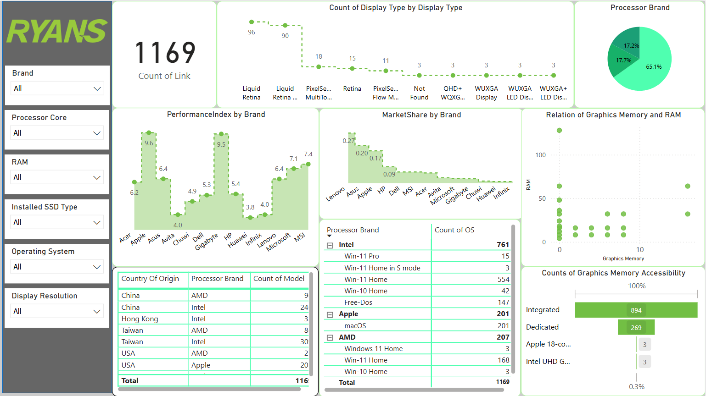

**Key Findings**

Performance Index by Brand:

* The most common display types are Liquid Retina and Liquid Retina XDR. If these models are selling fast, increasing stock levels would be beneficial.
* QHD+, WUXGA, and LED Display models have lower stock movement, so bulk stocking should be reconsidered.

Stock by Processor Brand:

* Intel-based laptops dominate the stock, while AMD and Apple hold a smaller yet notable presence.
* If demand for AMD and Apple models rises, increasing stock levels for these brands could improve sales opportunities.

Performance Index & Stock Quality:

* Apple and Gigabyte laptops have a high-performance index, indicating they feature powerful processor cores, RAM, graphics memory, and extended warranties.
* If low-performance models are not selling well, reducing future orders or offering promotional discounts can help optimize inventory.

Market Share vs. Stock Levels:

* Lenovo, Asus, and Apple hold the highest market share, suggesting they are either best-selling brands or well-stocked.
* If lower-performance models are underperforming in sales, adjusting inventory by reducing orders or offering discounts can enhance profitability.

Graphics Memory Accessibility:

* 76% of the available stock consists of integrated graphics models, indicating a strong focus on general-use laptops.
* Only 23% of stock has dedicated GPUs, meaning high-performance and gaming laptops are limited.
* If gaming laptops are in demand, increasing stock for dedicated GPU models is recommended, while for general-use laptops, maintaining the current high inventory of integrated graphics models is sufficient.

Relation Between Graphics Memory and RAM:

* Laptops with higher graphics memory (e.g., 16GB GPU) tend to have higher RAM configurations (e.g., 64GB RAM, 48GB RAM).
* A significant number of laptops use shared graphics memory, yet require high RAM configurations, which should be considered when managing stock.

Processor Brand with OS Distribution:

* Windows 11 Home is the most widely stocked OS, especially in Intel and AMD models.
* Apple stock exclusively runs macOS, with a limited selection.
* Some Intel-based models feature FreeDOS, which could be marketed toward budget-conscious customers looking for cost-effective solutions.

Stock by Country of Origin:

* China and Taiwan contribute the most to the inventory, especially for Intel and AMD laptops.
* Apple stock primarily originates from the USA, indicating a more region-specific sourcing strategy.

These insights can help optimize inventory management and align stock levels with market demand.

**Conclusions:**

Effective inventory management ensures optimal stock levels, reducing both stockouts and excess inventory. Analyzing sales trends and customer purchasing behaviors helps businesses improve demand forecasting and product availability. By segmenting and clustering data, companies can identify high-performing products and seasonal demand shifts for better stocking strategies. Utilizing predictive analytics enhances supply chain efficiency, minimizing delays and reducing holding costs. Overall, data-driven inventory management boosts operational efficiency, customer satisfaction, and profitability.