Performance and Efficiency: Data-Driven Analysis

Description: This project analyzes vehicle performance and efficiency using key metrics such as miles per gallon (MPG), horsepower, weight, cylinders, displacement, and transmission type. The visualizations highlight strong trade-offs between power and fuel economy, showing that higher horsepower and heavier cars typically result in lower MPG. The analysis emphasizes the importance of balancing customer demand for power with the growing need for efficiency and cost savings. These insights can guide manufacturers, fleet managers, and marketers in designing product strategies, pricing models, and customer-targeted offerings.

Data Source: mtcars (Default dataset in Rstudio).

Data Preparation:
Handle categorical conversions (cyl,carb,gear,am,vs)

Analysis:
Distribution of Cars by Transmission Type: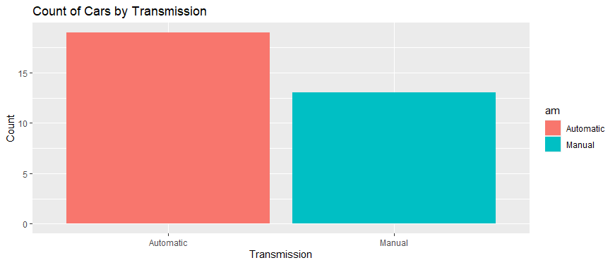
There are more cars of the automatic type than the manual. Which means people mostly choose for as long as their vehicle is the automated type. Maybeit can be for advanced systems like power and comfort. Also, there are some manual car buyers. Those who look for lower purchase and maintenance costs with lower fuel costs.
Recommendations:
Increase the stock of automated cars to fulfill market demands. It can be a great opportunity for parts sellers and servicing centers. Manual cars need different servicing—especially clutch systems, gear synchronizers, and cables. So, there are both opportunities.

Cylinders vs Gears: Key Differences
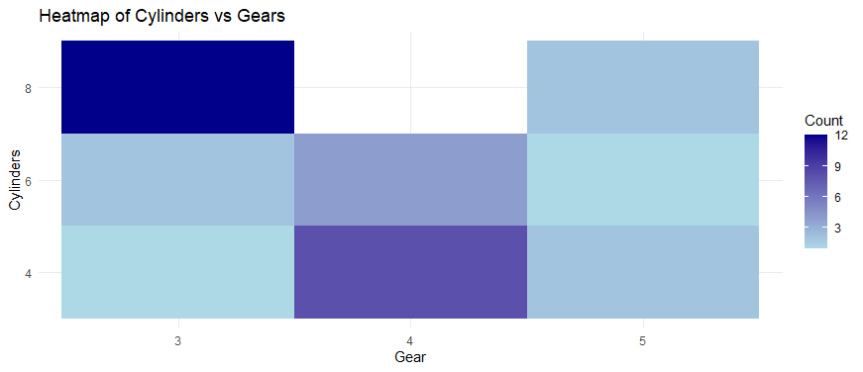
8-cylinder cars are mostly found with 3 or 5 gears. These vehicles are typically high-performance models, such as muscle cars or heavy-duty trucks. Due to their powerful engines, they do not require as many gears to deliver strong acceleration and torque, making lower gear counts sufficient for their performance needs."
Recommendations: Offer specialized tuning services for 8-cylinder vehicles to optimize gear ratios, torque delivery, and fuel efficiency. Many owners of 8-cylinder cars want better power delivery or slightly improved fuel economy. Offering custom gear tuning may be a great decision.

MPG Distribution Overview
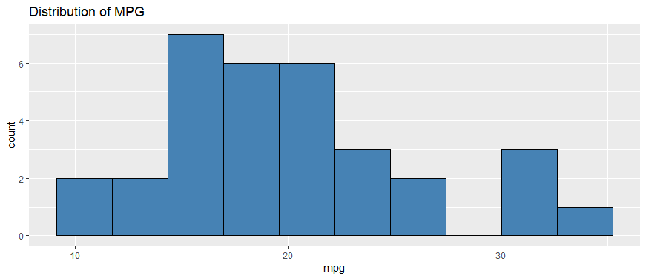
Distribution of miles per gallon (mpg) shows a concentration around 15–22 mpg, with a few high-efficiency vehicles exceeding 30 mpg. There are mostly cars sold which mpg are between in this segment. Also, a relation about high mpg cars: they are not highly sold.
Recommendations: High-MPG models should be positioned as ideal choices for fleet use and economy-focused consumers. To attract more fuel-efficient decisions, buyers can be invited to opt for lighter vehicles, highlighting the long-term cost savings on fuel.

Efficiency vs Performance vs Transmission: A Quick Comparison
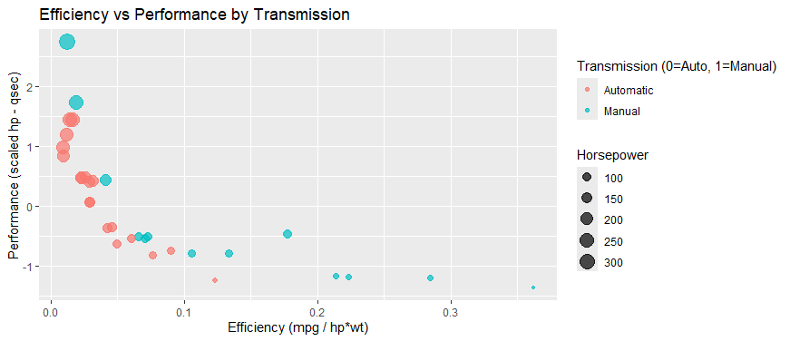
Higher-performance cars (based on hp–qsec) generally show lower efficiency (mpg / hp×wt), which is a trade-off between power and fuel economy. Manual cars (blue) tend to be more efficient than automatics (red) within similar performance levels, particularly in the mid-range. However, automatics dominate the high-performance segment, often with larger engines (larger bubbles) but reduced efficiency, highlighting that power usually comes with an automatic transmission and at the cost of fuel economy. The scatter reveals a clear efficiency performance trade-off: both cannot be maximized together.
Recommendations: For commercial buyers, manual, lighter vehicles are ideal to reduce fuel costs and for high efficiency. Performance or premium buyers should be guided toward automatic, high-horsepower models, with emphasis on comfort and luxury over fuel economy. Manufacturers can focus on hybrid, electric, or advanced transmissions to shift the efficiency performance.

Horsepower Density by Transmission Type
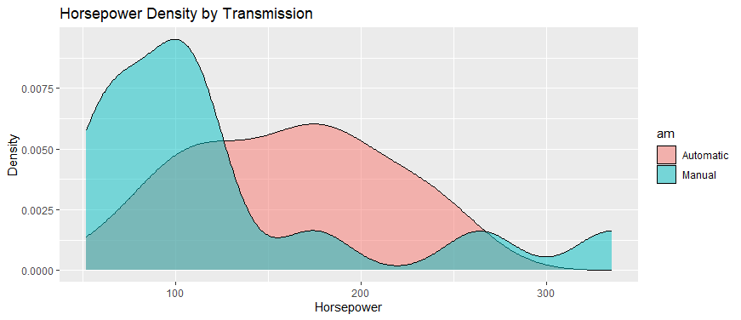
Manual cars (blue) are concentrated in the lower horsepower range (50 to 150 hp), showing their interest to efficiency-focused and budget-conscious buyers. So, automatic cars (red) dominate the 150 250 hp range, aligning with premium and performance-oriented markets. High-horsepower outliers over 300 hp are rare but exist in both categories, pointing to niche demand. The density plot shows manuals peak in the economy zone, while automatics peak in the performance/luxury segment.
Recommendations: Manuals should be positioned as “economy-efficient” options for urban commuters, daily drivers, and fleet buyers, while automatics are best marketed as “performance-luxury” vehicles for comfort-focused and premium segments. suggests their dominance in high-performance models, service centers should prioritize stocking automatic transmission parts due to higher wear and repair demand. Marketing should highlight manuals as the “fuel-smart choice for cost savings” and automatics as delivering “power and comfort without compromise.” To bridge the gap, manufacturers can innovate by offering mid-range automatics with efficiency-boosting technologies like CVTs and dual-clutch systems, appealing to both economy-minded and comfort-seeking customers.

MPG vs. Horsepower: Exploring the Trade-Off
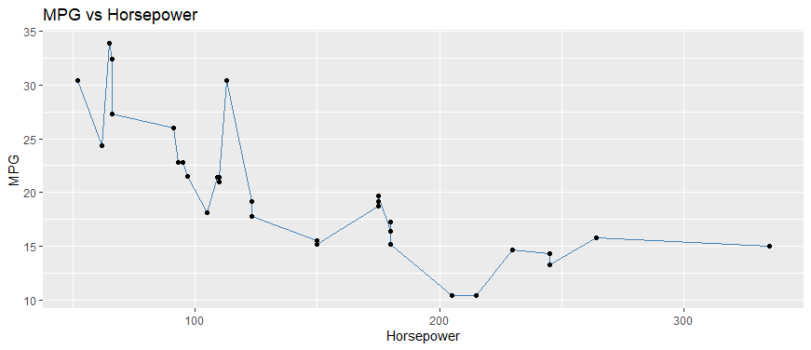

Weight is the strongest driver of mpg, showing a clear negative trend heavier cars consistently deliver lower fuel efficiency. Weight also correlates with horsepower, as larger vehicles require more powerful engines. This results in a distinct cluster of high-weight vehicles with poor fuel economy, highlighting the efficiency cost of added mass and power.
Recommendations: Investing in lightweight materials like aluminum and composites can effectively reduce vehicle weight and improve fuel efficiency. For fleet sales, emphasize the message “lighter = cheaper to run” to appeal to cost-conscious buyers. Additionally, implementing weight-based tax policies could encourage manufacturers and consumers to prioritize lighter, more efficient vehicles.

Conclusions:
This analysis project highlights a clear trade-off between performance and efficiency, with weight and horsepower emerging as the strongest negative drivers of fuel economy. Manual cars dominate the efficiency-focused segment, while automatics lead in performance and comfort. These insights suggest that future opportunities lie in bridging the gap with lightweight materials, hybrid technologies, and smarter transmissions. By aligning product design and marketing with these trends, manufacturers and fleet managers can optimize both cost savings and customer satisfaction.

