**Project Title**: Data Analysis & Visualization Project

**Project Overview**

This repository contains an in-depth analysis of a dataset related to user tracking data, visualized using Google Sheets. The objective is to extract meaningful insights, identify patterns, and present findings through various visual representations to facilitate data-driven decision-making.

**Dataset Description**

The dataset utilized in this project includes:

Tracking Data: Captures key metrics and user activity insights.

**Data Source:** Client

Used Tools

* Google Sheets:

1. Monsterastan Sheet: Customization and formatting of data sheets.
2. Track_Dataset Sheet: Data analysis and trend identification.
3. Dashboard Sheet: Interactive visualization of key insights from track_dataset.

**Key Insights & Findings**

* Trends Identification: Analyzed customer trends across four countries to uncover usage patterns and behavioral insights.
* Performance Metrics: Evaluated key performance indicators (KPIs) to assess user engagement based on the devices they use.
* Visual Representation: Graphs and charts provide a comprehensive overview of user demographics, gender distribution, and visit time trends.

**Actionable Insights**

* Device Usage Distribution:
* Desktop accounts for 36% of traffic, slightly leading over mobile and tablet usage.
* Desktop, mobile, and tablet usage remain closely distributed, emphasizing the need for cross-device optimization in marketing campaigns.
* Engagement Analysis:
* Visit times fluctuate significantly, with some sessions exceeding 13 minutes, while others last less than a minute, indicating potential bounce rates or low engagement.
* Identifying factors influencing session duration can help improve retention and user experience.
* This analysis provides data-driven recommendations to enhance engagement strategies and optimize cross-platform user experiences.

**Visual Representations**

Below are the key visualizations generated from the dataset:

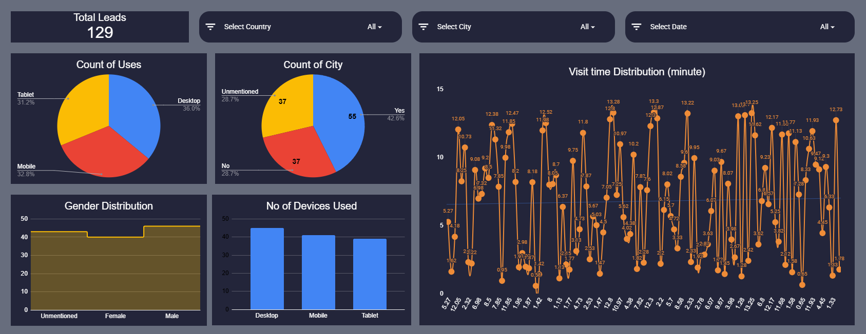

**Tools & Technologies Used**

Google Sheets: Used for data cleaning, analysis, manipulation, and visualization to derive meaningful insights.

**Conclusion**

This analysis uncovers key insights from the dataset and highlights the power of data visualization in enhancing decision-making. Future improvements may involve advanced statistical analysis, predictive modeling, and deeper trend exploration to refine data-driven strategies.