|  |  |  |
| --- | --- | --- |
| **Research and Development Report**  **Corteva Agriscience** | | |
| ***Title*** | | |
| Novel programming pipeline for Herbicide Resistance Prediction | | |
| ***Author(s) and Userid(s)*** | | |
| Sakib Ferdous (kew523), Steven A. Cryer (lz0760) | | |
| ***Reviewer(s) and Userid(s)*** | | |
| Navin Elango (wo8834) or Hudson Takano | | |
| ***Department*** | ***Location (City, State, Country)*** | ***Report Number*** |
| FSD | Indianapolis, IN |  |
| ***Lab Notebook(s)*** | | ***Report Date*** |
|  | | Aug, 2023 |
| ***Key Terms*** | | |
| Herbicide Resistance, Mathematical Modelling, Weed Resistance | | |

Novel programming pipeline for Herbicide Resistance Prediction

Sakib Ferdous, Steven A Cryer

Table of Contents

[Introduction 2](#_Toc143668146)

[Best Management Practices 3](#_Toc143668147)

[Historical Trend in Modelling 5](#_Toc143668148)

[Novel Data Science and Artificial Intelligence (AI) in Herbicide Resistance 5](#_Toc143668149)

[What we did 6](#_Toc143668150)

[Methods 6](#_Toc143668151)

[Previous works 6](#_Toc143668152)

[New pipeline after conversion 7](#_Toc143668153)

[Results 7](#_Toc143668154)

[Capabilities with the new pipeline 7](#_Toc143668155)

[prediction result with new herbicide 8](#_Toc143668156)

[a. Management strategies 11](#_Toc143668157)

[Future direction 15](#_Toc143668158)

[Conclusions 15](#_Toc143668159)

[Acknowledgements 15](#_Toc143668160)

[References 15](#_Toc143668161)

Abstract

# Introduction

In agriculture, unwanted plant species that grow alongside the target crop is generically called weed. Weed compete with the actual crop for food and other resources, thereby potentially causing heavy loss in crop yield. Weeds often reduce the financial value of the crop by diminished quality and increased production cost. Weed control in industrial-scale agriculture is crucial to ensure the optimal growth and productivity of crops. Effective management practices for weed control not only help in minimizing crop yield losses but also reduce competition for resources such as water, nutrients, and sunlight. Historically, there had been several different approaches for tackling this issue – hand weeding, deep tilling, cover crops etc., but using a chemical herbicide is one of the most important ways to control weeds. These herbicides work by targeting a part of the DNA of the targeted weed species. The herbicide component provides a toxic substance resulting in neutralization or halting the further growth of the weed species. But generation-to-generation propagation of the gene creates mutations in the DNA, and mutations which favor the weeds in survival against the herbicide become increasingly prominent in the surviving population. There are increasing number of weeds that manage to evade the herbicide in subsequent years, eventually rendering the herbicide ineffective (deemed weed herbicide resistance).

Herbicide resistance causes economic loss for both the grower and ~~the~~ herbicide producers. It takes a tremendous effort to register molecules to sale as actives ingredients for herbicides. For several decades, widespread application of the herbicides rendered many/most major modes of action resistant. It would be desirable to not only invent herbicides with novel modes of action, but responsibly use exiting herbicides for maximum long term efficacy.

< Ideally, future predictions for herbicide resistance to weds use can be used to aid in appropriate management practices that allow for maximum longevity for a product concept. This is especially true for herbicides since the majority of herbicides have been around for years and development of newer novel acting herbicides have been lacking. Creation of new herbicides often takes agricultural companies over a decade of development time and several hundreds of millions of dollars required for testing and regulatory approval. Thus, understating weed resistance onset is critical for both the manufacturer and the farmer due to limited numbers of modes of action for weed control that exist at this time.>

Mathematical modeling of herbicide resistance is crucial for understanding and managing this evolving challenge in agricultural systems and the best way to potentially predict future weed resistance issues. Herbicide resistance is a complex phenomenon influenced by various factors, including genetics, weed biology, herbicide application strategies, and environmental conditions. Mathematical models allow researchers and practitioners to simulate and analyze the dynamics of herbicide resistance, providing valuable insights into the underlying processes and predicting the future trajectory of resistance development. These models can help assess the effectiveness of different management strategies, such as herbicide rotation, mixtures, or alternative weed control methods, by quantifying their impact on resistance evolution over time. Additionally, mathematical models can inform decision-making by optimizing the allocation of limited resources, such as herbicide use, to maximize weed control efficacy while minimizing the risk of resistance. Overall, such approaches provide a powerful tool for studying herbicide resistance, guiding sustainable management practices, and mi<https://www.msn.com/en-us/feed>tigating the economic and environmental impacts associated with resistant weed populations.

## Best Management Practices

(note: this senctence moved to firsr sentence in Intro)

Some of the best management practices for weed control in industrial-scale agricultural lands are:

Crop Rotation: Implementing a diverse crop rotation system can help break the weed life cycle and reduce weed pressure. Different crops have varying growth habits and requirements, which can help disrupt weed growth patterns and decrease the prevalence of specific weed species.

Tillage Techniques: Strategic tillage practices can help control weeds by burying weed seeds deep in the soil, where they are less likely to germinate. However, excessive tillage can lead to soil erosion and disrupt soil structure, so it is essential to find a balance between weed control and soil conservation.

Cover Crops: Planting cover crops during fallow periods or between main crops can help choke weeds and prevent soil erosion. Covering crops also improve soil health and fertility, reducing the chances of weed establishment.

Mechanical Control: Mechanical methods such as mowing, hoeing, hand-weeding, or using tractor-mounted cultivators can be effective for weed control in certain situations. However, mechanized methods may be labor-intensive and require careful implementation to avoid crop damage.

Chemical Control: Herbicides are an essential tool for weed management when used judiciously and following label instructions. Integrated Pest Management (IPM) principles should be applied, considering factors such as weed species, growth stage, application timing, and environmental impact. It is crucial to rotate herbicides with different modes of action to minimize the risk of herbicide resistance development.

Biological Control: Biological control involves using natural enemies such as insects, mites, or pathogens to suppress weed populations. This method requires careful evaluation to ensure that the introduced organisms target only the intended weed species and do not harm crops or native ecosystems.

Weed Monitoring and Early Intervention: Regular scouting and monitoring of fields for weed presence and growth stages allow for early intervention. Prompt action, such as targeted herbicide application or manual removal, can prevent weeds from becoming established and reduce their impact on crop yields.

Precision Farming Technologies: Advanced technologies such as satellite imagery, drones, and GPS-guided equipment can help identify and manage weed hotspots more precisely. These tools allow for site-specific weed control, minimizing broadcast herbicide use and reducing environmental impacts, and there are many manufacturers exploring this evolving technology for site specific targeting of weeds within a field when they occur (Gerhards et al. 2022)

Advances in site-sepcific weed management in agriculture-A review. [Roland Gerhards](https://onlinelibrary.wiley.com/authored-by/Gerhards/Roland), [Dionisio Andújar Sanchez](https://onlinelibrary.wiley.com/authored-by/And%C3%BAjar+Sanchez/Dionisio), [Pavel Hamouz](https://onlinelibrary.wiley.com/authored-by/Hamouz/Pavel), [Gerassimos G. Peteinatos](https://onlinelibrary.wiley.com/authored-by/Peteinatos/Gerassimos+G.), [Svend Christensen](https://onlinelibrary.wiley.com/authored-by/Christensen/Svend), Cesar Fernandez-Quintanilla. Weed Research, Vol 62, Issue 2, pp. 123-133. April 2022

Weed Seed Bank Management: Long-term weed management involves minimizing the buildup of weed seed banks in the soil. This can be achieved by implementing diverse weed control strategies, preventing seed production, and using practices that promote the decay or burial of weed seeds.

It is important to note that effective weed control practices may vary depending on factors such as crop type, regional climate, weed species, and the overall farming system. Implementing an integrated weed management approach that combines multiple strategies will provide the best long-term results while minimizing environmental impact.

## **Historical Trend in Modelling**

The mathematical modeling of weed resistance to herbicides has progressed from simple conceptual models to more complex and realistic representations of resistance dynamics. This evolution has improved our understanding of resistance mechanisms, guided management strategies, and contributed to the development of sustainable weed control practices. The future of this field is likely to involve continued refinement of models, incorporation of novel data sources, and increased collaboration to address emerging challenges in weed herbicide resistance management. The use of mathematical modeling to study weed herbicide resistance has witnessed significant growth and development over the years [I’d add some references here]. Initially, research in this area focused on simple conceptual models that captured the basic dynamics of resistance evolution. These early models provided a foundation for understanding the fundamental principles driving resistance and the factors influencing its spread. As knowledge and data on resistance mechanisms and genetic factors increased, mathematical models began incorporating more detailed genetic and population-level parameters, allowing for more realistic and accurate predictions. In recent years, there has been a notable shift towards more sophisticated modeling approaches, such as individual-based models and spatially explicit models [again a few references]. These advanced models consider factors such as spatial heterogeneity, landscape connectivity, and gene flow, enabling a better understanding of resistance dynamics at different scales, from local fields to regional landscapes. Furthermore, the integration of statistical techniques, data assimilation, and optimization algorithms has enhanced the ability of models to analyze real-world scenarios and optimize management strategies.

Another significant trend is the increasing recognition of the importance of interdisciplinary collaboration in weed herbicide resistance modeling. Researchers are now working closely with agronomists, geneticists, ecologists, and other stakeholders to gather field data, validate models, and ensure that modeling efforts are relevant and applicable to practical management scenarios.

## Novel Data Science and Artificial Intelligence (AI) in Herbicide Resistance

Novel AI techniques can be harnessed to predict herbicide resistance by leveraging the power of machine learning algorithms and data analysis. These techniques involve training AI models on large datasets that include information on weed species, herbicide treatments, genetic markers, environmental conditions, and resistance outcomes. Ideally, large data sets could be assembled by a variety of different methods, including combining data sets that agricultural companies may have. By analyzing this data, AI models can identify complex patterns and relationships that may not be apparent through traditional statistical approaches. AI models can learn to recognize key features and indicators associated with herbicide resistance, enabling them to make accurate predictions about the likelihood of resistance in different scenarios. Additionally, AI techniques can be used to optimize herbicide management strategies by simulating different scenarios and identifying the most effective herbicide rotations or combinations to delay or mitigate resistance development. The ability of AI to process vast amounts of data and uncover intricate patterns makes it a valuable tool for predicting and managing herbicide resistance in a more precise and proactive manner.

<transition required>

To effectively utilize AI in herbicide resistance prediction, several transitions in modeling tools are required. First, there is a need for comprehensive and high-quality datasets that encompass a wide range of variables, including genetic information, field observations, herbicide usage patterns, and resistance outcomes. These datasets must be appropriately curated, standardized, and made readily available for training AI models. Second, the modeling tools must embrace machine learning algorithms and techniques capable of handling complex, high-dimensional data. AI models such as deep learning architectures, recurrent neural networks, and ensemble methods can be explored to capture intricate patterns and relationships within the data. Third, the modeling tools should enable integration with diverse data sources, such as genomic databases, remote sensing data, and weather forecasts, to enhance the predictive capabilities of the AI models. This integration would require the development of efficient data pipelines and algorithms that can process and assimilate heterogeneous data types. Finally, there is a need for user-friendly interfaces and visualization tools that allow researchers, agronomists, and policymakers to interact with AI models and interpret their predictions effectively. These transitions in modeling tools, encompassing data acquisition, algorithmic development, data integration, and user interfaces, will facilitate the successful incorporation of AI into herbicide resistance prediction efforts [Use reference below here].

Artificial Intelligence Tools and Techniques to Combat Herbicide Resistant Weeds—A Review. [Shirin Ghatrehsamani](https://sciprofiles.com/profile/2254445" \t "_blank), [Gaurav Jha](https://sciprofiles.com/profile/author/U2xVUWpCNW95S3MycG1Rc2c0RjFUZz09" \t "_blank), [Writuparna Dutta](https://sciprofiles.com/profile/1257845" \t "_blank), [Faezeh Molaei](https://sciprofiles.com/profile/2248543" \t "_blank), [Farshina Nazrul](https://sciprofiles.com/profile/author/bGlKQ1Y4Q0FYZ051VEtZdWw5REs1b2Y0NWcwZGM5Y2xKT25OM2NDUy9WV2EwTFNmaDBYUmpWanVCaHNvTlVWcA==" \t "_blank)

[Mathieu Fortin](https://sciprofiles.com/profile/2641108" \t "_blank), [Sangeeta Bansal](https://sciprofiles.com/profile/2604384" \t "_blank), [Udit Debangshi](https://sciprofiles.com/profile/1750127" \t "_blank), and [Jasmine Neupane](https://sciprofiles.com/profile/author/Vm1TVzNXWnhwdjNNZjF1eHRiZUtsRXRqOExYV3BHR0xGK29ycE90MzVJYz0=" \t "_blank), Sustainability, Jan 2023, Sustainability, https://www.mdpi.com/2071-1050/15/3/1843#

<what is desired from a modelling tool>

<necessity of conversion>

<where AI can be applied?>

## What we did

<Convert the existing pipeline>

<how it will bring changes>

<how this can be used>

<testing with newly developed molecules>

# Methods

## Previous works

<how much of the previous report we must write here?>

<discuss the stochasticity present in the previous code>

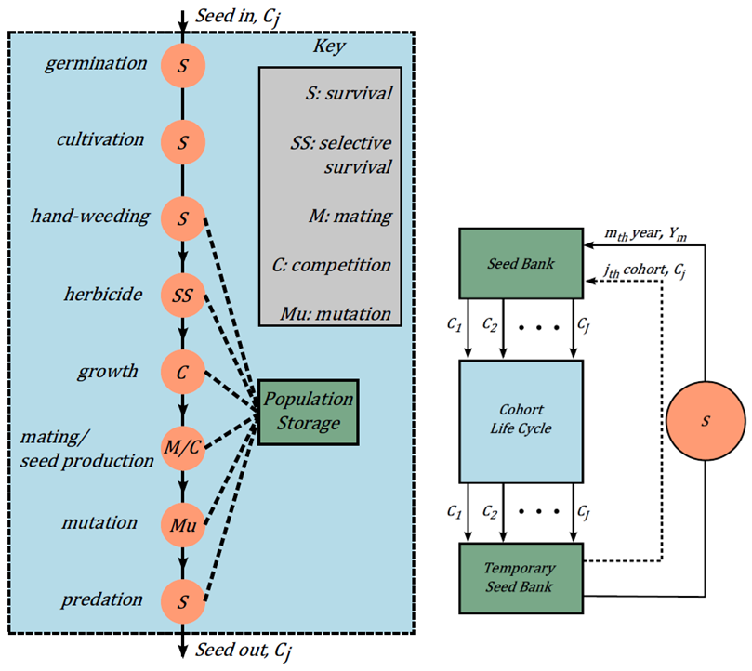

Figure: Original Pipeline

Figure: Dose response curve

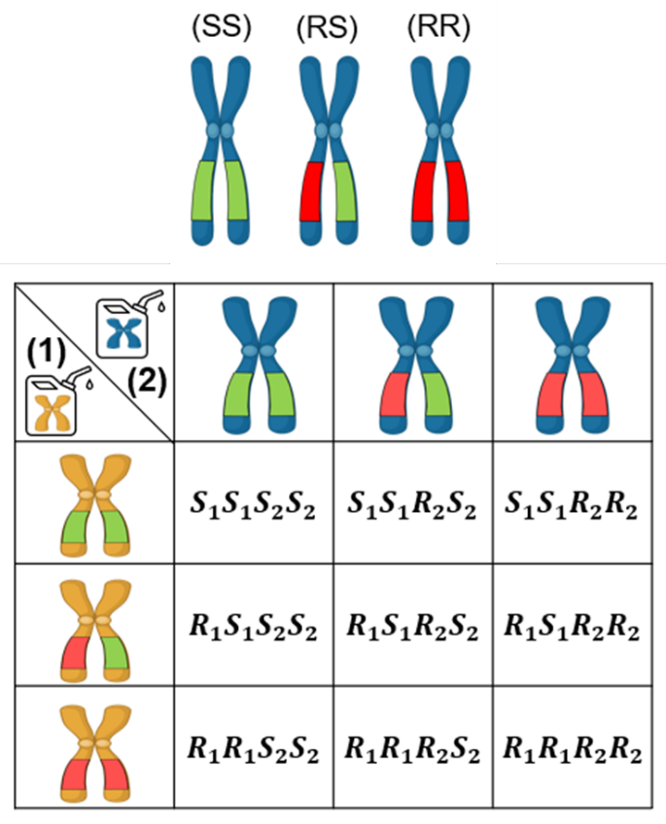

Figure: Mode of action and genotypes

# Results

## New pipeline after conversion

The original weed resistance model of Corvera was originally written in MATLAB and was converted to Python. The individual scripts are converted into python functions and stored inside a single script. Object oriented formatting is used in case of repeating functions.

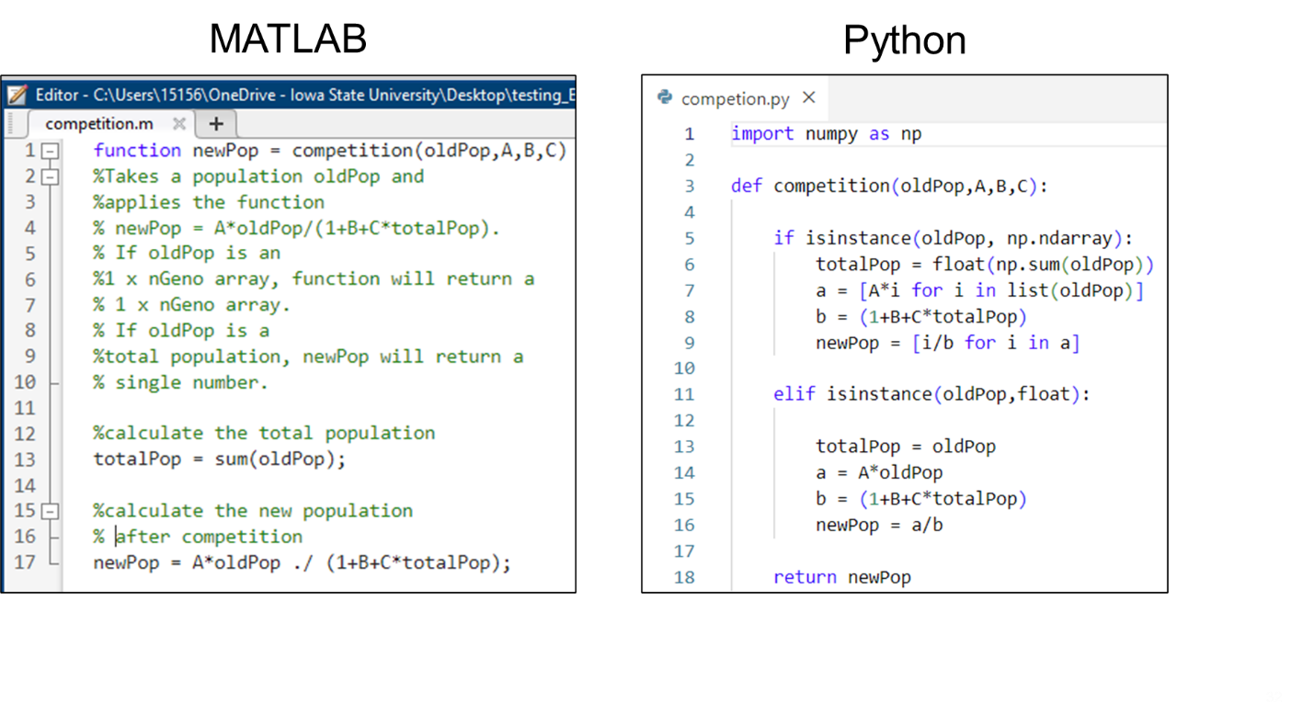

Figure: Matlab and Python programming interface.

## Capabilities with the new pipeline

The previous code from DAS contained a stochastic element where whether development of a resistant trait and continued sustenance depends on stochastic variables in the extinction parameter. In this work for each case simulation is run thousand times for each case and the percentage of time the resistance develop is measured and plotted (at figure inset). For the time where resistance develops, the weed density for both susceptible and resistance biotypes per unit area is also plotted (left figures). The fraction of resistance over the years is also plotted in the right-hand side. For thousand simulations, fraction of resistance in both the resistance developed or not developed cases were averaged and plotted. The area under the curve is calculated and plotted which is defined as the risk integral (RI). For each case the RI is also plotted in the fractional resistance inset.

## Prediction result with new herbicide

<some details on the molecule>  
<molecule structure and properties>

<figure dose response curve>

We gathered dose response data from newly developed molecules X713 and X755. The molecule to be effective against the biotypes and thus this value corresponds to efficacy on susceptible biotype (SS). We assume the efficacy of (RS) and (RR) to be relatively lower than that.

## Sensitivity Analysis

We would like to observe the degree of sensitivity of the modelling pipeline to several input parameters –

1. Initial seedbank density
2. Initial resistant allele frequency
3. Herbicide combination

The parameters are tabulated below.

Table . Simulation results for several initial seed density and resistant allele frequencies.

|  |  |  |  |  |  |
| --- | --- | --- | --- | --- | --- |
| Initial density | Initial frequency | RO time | CR time | TR time | RI |
| 100 |  | 6.0 | 7.1 | 14.4 | 0.82 |
| 100 |  | 4.1 | 5.1 | 11.4 | 0.87 |
| 100 |  | 2.1 | 3.2 | 8.3 | 0.91 |
| 10 |  | 6.0 | 6.9 | 12.7 | 0.84 |
| 1000 |  | 6.2 | 7.6 | 16 | 0.81 |

### Initial allele frequency

|  |  |
| --- | --- |
|  |  |
| Figure : Effect of initial allele frequency. | |

Initial allele frequency observations:

1. Seedbank frequency of resistant allele does not affect the total seedbank density much.
2. Seedbank frequency has been affected in number of times resistance occur.
3. Risk integral is higher with more resistant seedbank.

### Seedbank Density

|  |  |
| --- | --- |
|  |  |
| Figure : Effect of initial seed bank density. | |

Seedbank density:

1. Seedbank density of resistant allele has frequency in the initial phase, in later phase the density is similar.
2. Seedbank density has affected the number of times resistance occurs.
3. Lower initial seedbank poses higher risk for resistance.
4. Risk integral is similar with more resistant seedbank.

### Herbicide Combination

Another plausible scenario is that significant resistance to the first herbicide has developed, and a second herbicide is introduced. Suppose that the initial frequency for gene locus 1 is , and for gene locus 2 is . The median RO, CR, and TR times are 6.1, 8.5, 11.4, and the average RI is 0.81, Table .

Table . Simulation results for two modes of action herbicides, but resistance has already been established for the first herbicide (initial resistant allele frequency ) but not for the 2nd herbicide (initial resistant allele frequency ).

|  |  |  |  |  |
| --- | --- | --- | --- | --- |
|  | RO time | CR time | TR time | RI |
| Herbicide 1 only | 2.1 | 3.2 | 8.3 | 0.91 |
| Herbicide 2 only | 6.0 | 7.0 | 14.4 | 0.82 |
| Herbicide 1 & 2 | 6.1 | 8.5 | 11.4 | 0.81 |

|  |  |
| --- | --- |
|  |  |
| Figure : Treating a heavily resistant field with a second MOA. Best option is using two MOA herbicides simultaneously. | |

\

Herbicide Mixing observations:

1. Resistant frequency for Herbicide 1 was 1e-4 and herbicide 2 were 1e-8.
2. Mixing herbicides can keep the total weed density low.
3. Using only herbicide 1 or a mixture increases the fraction resistant and risk integral. Using only herbicide 2 reduces resistance but at the cost of more weed density.

### Seed-delay

Table . Simulation results for 4 cohorts with and without seed delay.

|  |  |  |  |  |
| --- | --- | --- | --- | --- |
|  | RO time | CR time | TR time | RI |
| 4 cohorts + seed delay | 6.8 | 8.0 | 23.8 | 0.78 |
| 4 cohorts no seed delay | 1.5 | 1.9 | 10 | 0.94 |

|  |  |
| --- | --- |
|  |  |
| Figure : A simulation with 4 cohorts illustrating the effect of seed delay. The winter survival fraction has been set to 0. | |

## Management strategies

To examine the effect of various management practices, default settings will be used, Table . The default initial seed density and resistant allele frequencies for each herbicide are and. These default values are set to both the upper and lower seed banks. Simulations for cultivation, hand weeding, and covering crops are carried out for OFF every year, ON and OFF in alternating years, and ON in all years.

Table : Default weed management configuration

|  |  |  |
| --- | --- | --- |
| **Practice** | **Usage** | **Parameters** |
| Cultivation | OFF |  |
| Hand weeding | OFF |  |
| Cover crop | OFF |  |

### Cultivation

The effect of cultivation is shown in Figure with results summarized in Table . Evidently, resistance is delayed when using cultivation every year, and the risk integral is reduced. Similarly, the effect of hand weeding is shown in and Figure and summarized in Table . Again, it is seen that resistance is delayed by using hand-weeding. However, the effect is less pronounced than cultivation. The effect of cover crops (Table , Figure ) is to delay resistance as well, but its effect is even less pronounced.

Table : Effect of cultivation

|  |  |  |  |
| --- | --- | --- | --- |
|  | OFF | ON/OFF | ON |
| Median resistance onset time (years) | 5.93 (45%) | 8.79 (42%) | 12.12 (26%) |
| Median critical resistance time (years) | 7.64 (45%) | 11.52 (42%) | 19.97 (26%) |
| Median total resistance time (years) | 9.77 (45%) | 14.28 (42%) | 24.20 (24%) |
| Average risk integral | 0.37 | 0.30 | 0.15 |

|  |
| --- |
| Figure : Effect of cultivation for 3 cases: OFF all years, ON odd years + OFF even years, ON all years. Resistance is delayed most by always using cultivation. |

### Hand weeding

Table : Effect of hand weeding

|  |  |  |  |
| --- | --- | --- | --- |
|  | OFF | ON/OFF | ON |
| Median resistance onset time (years) | 5.93 (45%) | 8.31 (42%) | 9.65 (29%) |
| Median critical resistance time (years) | 7.64 (45%) | 10.86 (42%) | 13.56 (29%) |
| Median total resistance time (years) | 9.77 (45%) | 13.78 (42%) | 18.13 (29%) |
| Average risk integral | 0.37 | 0.31 | 0.19 |

Figure: Effect of hand weeding for 3 cases: OFF all years, ON odd years + OFF even years, ON all years. Resistance is delayed most by always using hand weeding.

The weed resistance model developed at DAS takes the best of current academic models to generate a defacto and versatile model to predict the onset of weed resistance of up to 4 different mode of action herbicides that could be applied within a given growing season. However, this model is further expanded and refined to take it out of the hands of a skilled programmer or mathematical modeler and place into the hands of subject matter experts (e.g., weed scientists) via the inclusion of an intuitive graphical user interface (MS Excel and VBA) where both input and simulation output are summarized. Thus, as long as a user understands MS Excel (and the biology of weeds), then they should be able to run simulations and various management practices to explore the impact on weed resistance and product concept profitability into the future. A first for this research area is the incorporation of management practices such that now the onset of weed resistance can be managed. An optimization routine was built around the management practices such that the optimal selection of BMPS over the product lifespan can be selected that maximizes the profitability.

### Tilling

Finally, the effect of tilling is examined. Three cases are considered: No tilling, tilling at year 10, and tilling at year 10 and year 20. In all cases, degradation in the lower seed bank is set to zero. As seen in Figure , all three cases track together until year 10. As the no till case continues to rise, both tillage cases drop to nearly zero. The year 10 till case steadily increases, eventually reaching total resistance at around year 27. The year 20 till case suddenly jumps to year 20. This is because there is no seed degradation in the lower seed bank. The highly resistant seeds which were buried at year 10 are reintroduced at year 20. Thus, depending on soil degradation conditions, more than one tillage may not decrease resistance.

Table: Effect of Tilling

|  |  |  |  |
| --- | --- | --- | --- |
|  | No till | Till year 10 | Till year 10 + 20 |
| Median resistance onset time (years) | 5.93 (45%) | 7.64 (72%) | 13.69 (75%) |
| Median critical resistance time (years) | 7.64 (45%) | 16.52 (66%) | 15.82 (56%) |
| Median total resistance time (years) | 9.77 (45%) | 26.93 (48%) | 19.67 (50%) |
| Average risk integral | 0.37 | 0.30 | 0.29 |

|  |
| --- |
| Figure . Impact of 0, 1, and 2 tillage events. |

General Observations: 1 tillage over the product lifespan (25 years in this example) is the most sensitive management practice and any further tillage in subsequent years provided a diminishing return in terms of minimizing *RI*.

## Future direction

# Conclusions

# Acknowledgements

<previous reports, Anthony Altieri, Argen West>

<Jeremy Kister and others >

# References

## 