**Lab Report:02**

**Name of the Lab Report: Basic Linux Command**

**Linux Command:**

Linux is a Unix-Like operating system. All the Linux/Unix commands are run in the terminal provided by the Linux system. ‘pwd’,’Is’, ‘cd’, ‘mkdir&rmdir’, ‘rm’, ‘touch’, ‘man & --help’, ‘cp’, ‘mv’, ‘locate’, ‘echo’, ‘cat’, ‘nano’, ‘vi,jed,sudo’, ‘du’ etc. are essential Linux Command.

**Description:**

**1. pwd** — The ‘**pwd**’is a command line utility for printing the current working directory. It will print the full system path of the current working directory to standard output. To know which directory you are in, you can use the **‘pwd’**command. It gives us the absolute path, which means the path that starts from the root.



**2. Is –‘ls’**command is used to know what files are in the directly you are in. Hidden files can be seen by using command **‘ls–a’.**

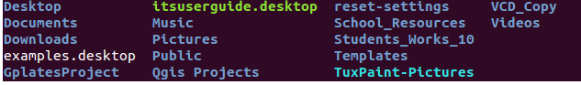

**3. cd—‘cd’** command is used to go to a directory.For example, you are in the home folder,and you want to go to the downloads folder,then you can type in **‘cd Downloads’.**



**4. mkdir&rmdir**—When you need to create a folder or a directory,you can use ‘mkdir’command. For example, if you want to make a directory called “DIY”, then you can type **‘mkdir DIY**’. Use ‘**rmdir’** to delete a directory. But ‘**rmdir’** can only be used to delete an empty directory. To delete a directory containing files, use ‘**rm’**.

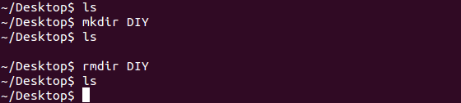

**5. rm-**‘rm’command is used to delete files and directions.



**6.Touch-**‘Touch’ command is used to create a file.



**7. man& --help** — For knowing more about a command and how to use it, use the ‘**man’** command. It shows the manual pages of the command. For example, ‘**man cd**’ shows the manual pages of the ‘**cd’**command.

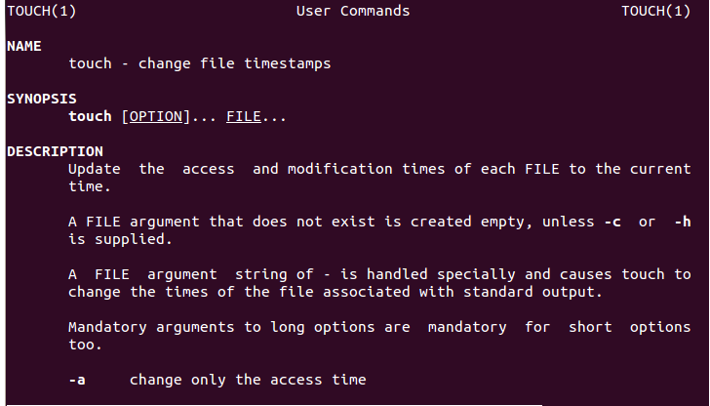

**8. cp** —‘**cp’**command is used to copy files through the command line. It takes two arguments: The first is the location of the file to be copied, the second is where to copy.

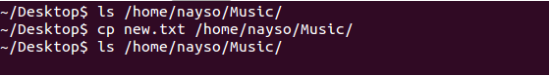

**9. mv** — ‘**mv’** command is used to move files through the command line. It also used to rename a file. For example, if we want to rename the file “**text**” to “**new**”, we can use “**mv text new**”.

**10. locate** — ‘**locate’** command is used to locate a file in a Linux system, just like the search command in Windows. This command is useful when you don't know where a file is saved or the actual name of the file.

**11. echo**—‘**echo**’ command helps us to move some data, usually text into a file. For example, if you want to create a new text file or add to an already made text file, you just need to type in, “**echo hello, my name is Sakib>> new.txt**”.

**12. Cat-**We can use ‘Cat’ command to display the contents of a file.

**13.nano, vi, jed — nano** and **vi** are already installed text editors in the Linux command line. The **nano** command is a good text editor that denotes keywords with color and can recognize most languages. And **vi** is simpler than **nano** doesn't seem as good, because of its color, so I recommend **jed**text editor.

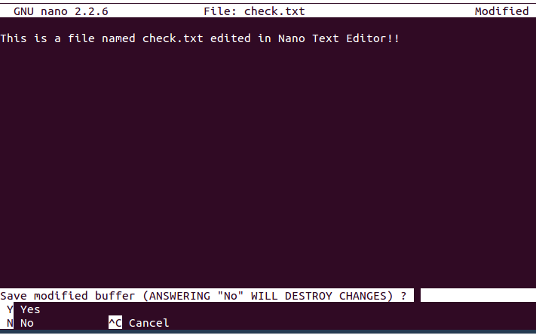

**14. sudo** — A widely used command in the Linux command line, ‘**sudo’** stands for "SuperUser Do". So, if you want any command to be done with administrative or root privileges, you can use the ‘**sudo’** command.

**15. du** — ‘**du’** command is used to know the disk usage of a file in your system. If you want to know the disk usage for a particular folder or file in Linux, you can type in the command ‘**df’** and the name of the folder or file.

