Sakib Shahriyar – 100587434

Muhtasim Chowdhury – 100584755

Nafis Mobasher - 100587562

**Part 1**

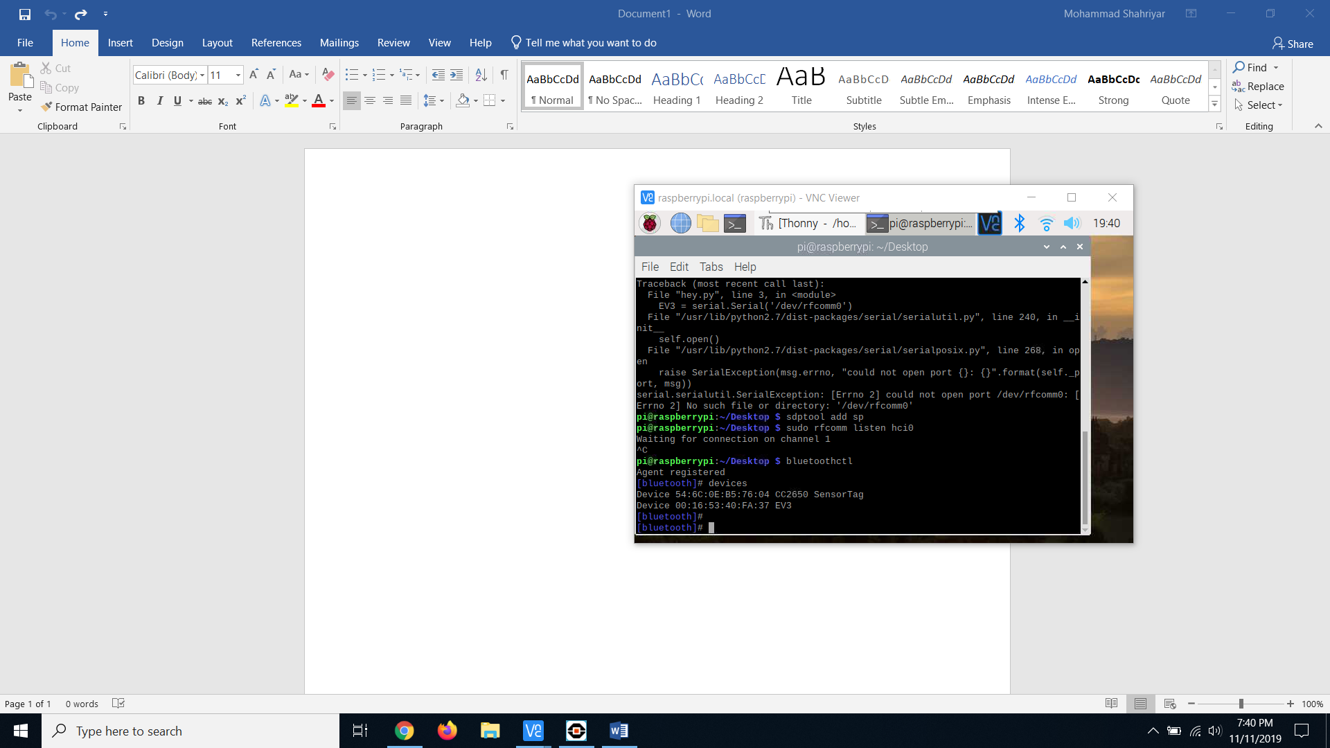

Sensor Tag and EV3 were able to connect to the raspberry Pi through Bluetooth.

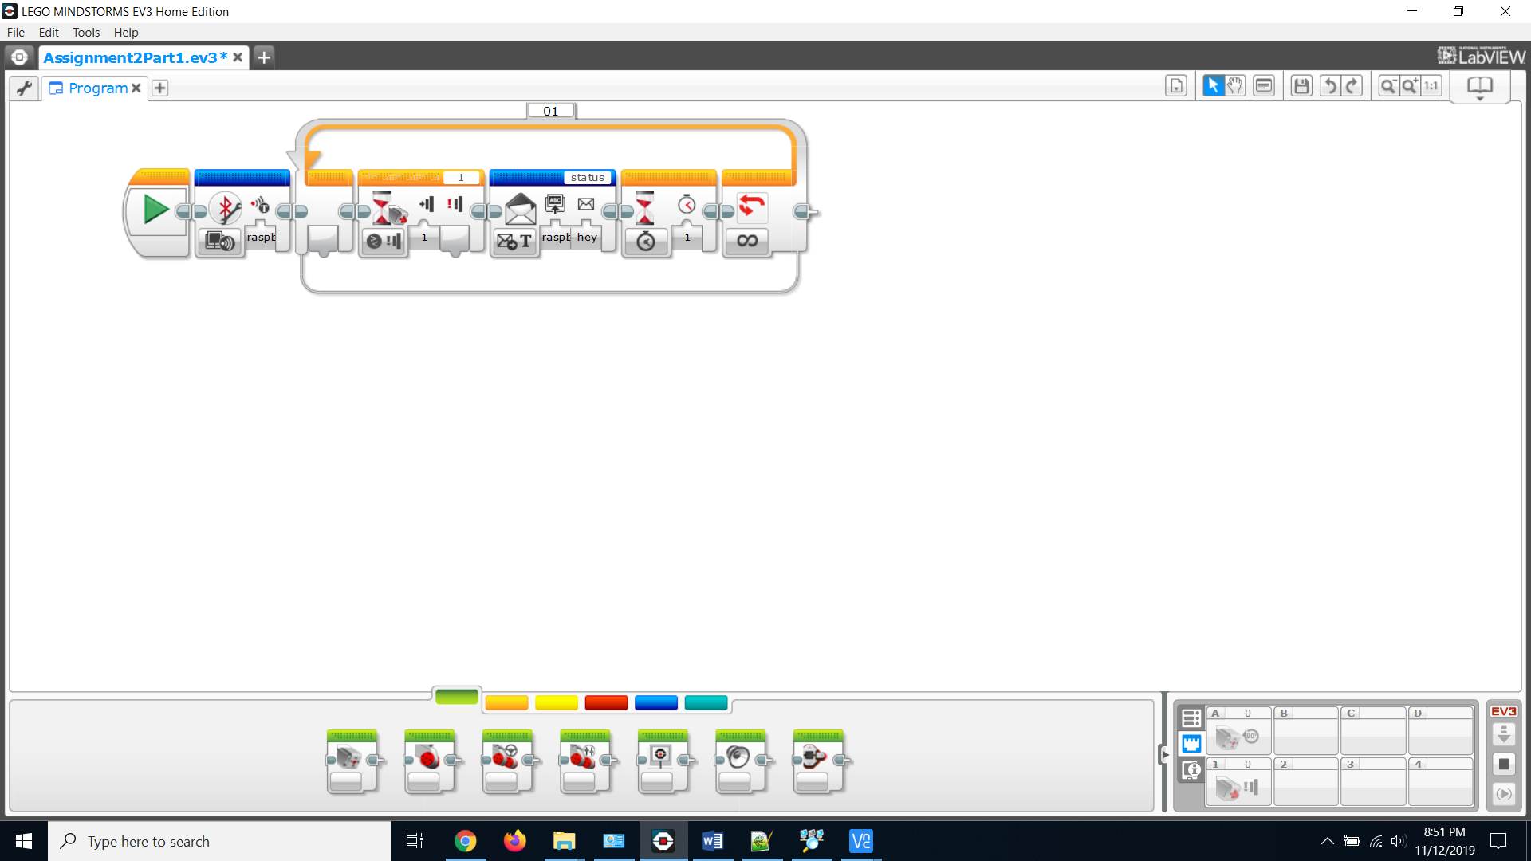

Wrote EV3 Program that uses the Bluetooth from the raspberry pi and submits a message if button is pressed on EV3 using the touch sensor.

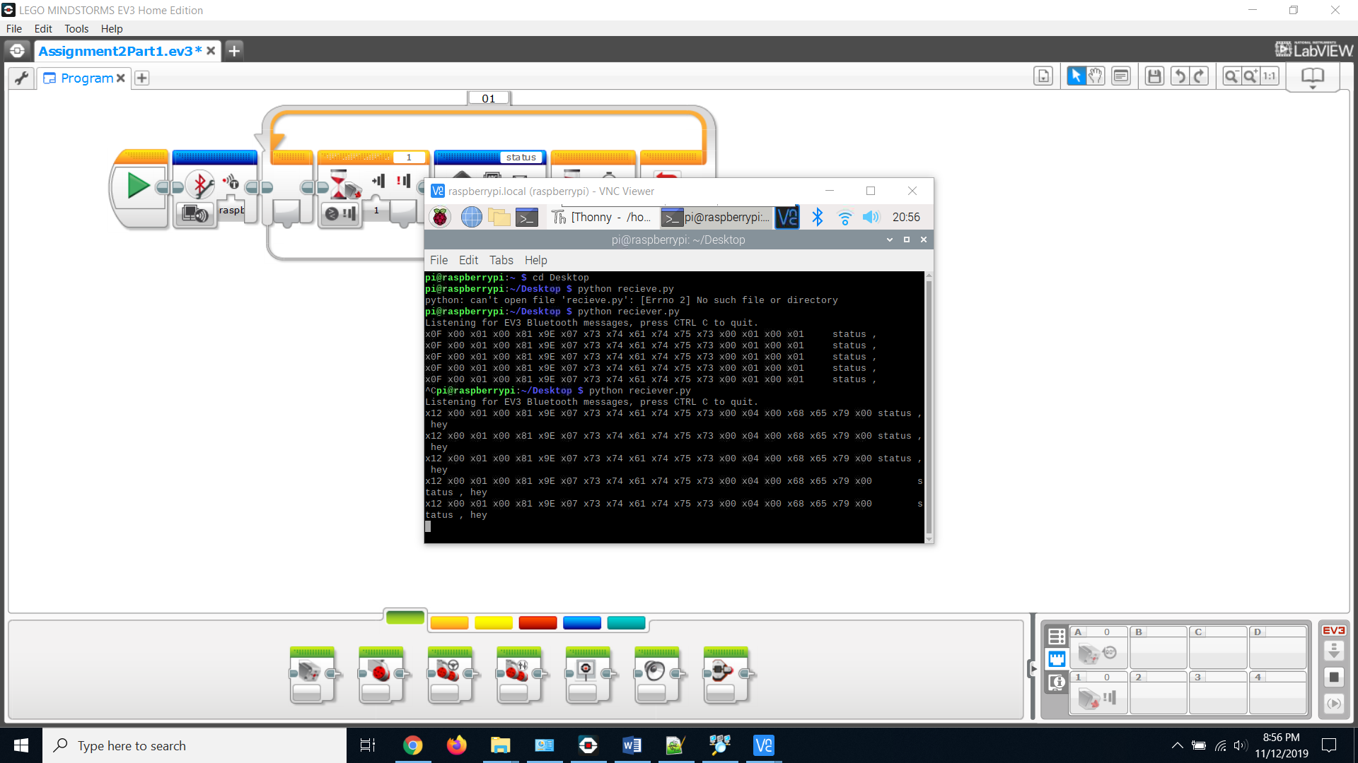

Also, when we changed the messaging block to return text, we were able to output “hey” in the terminal in this case when running receiver.py.

**Part 2**

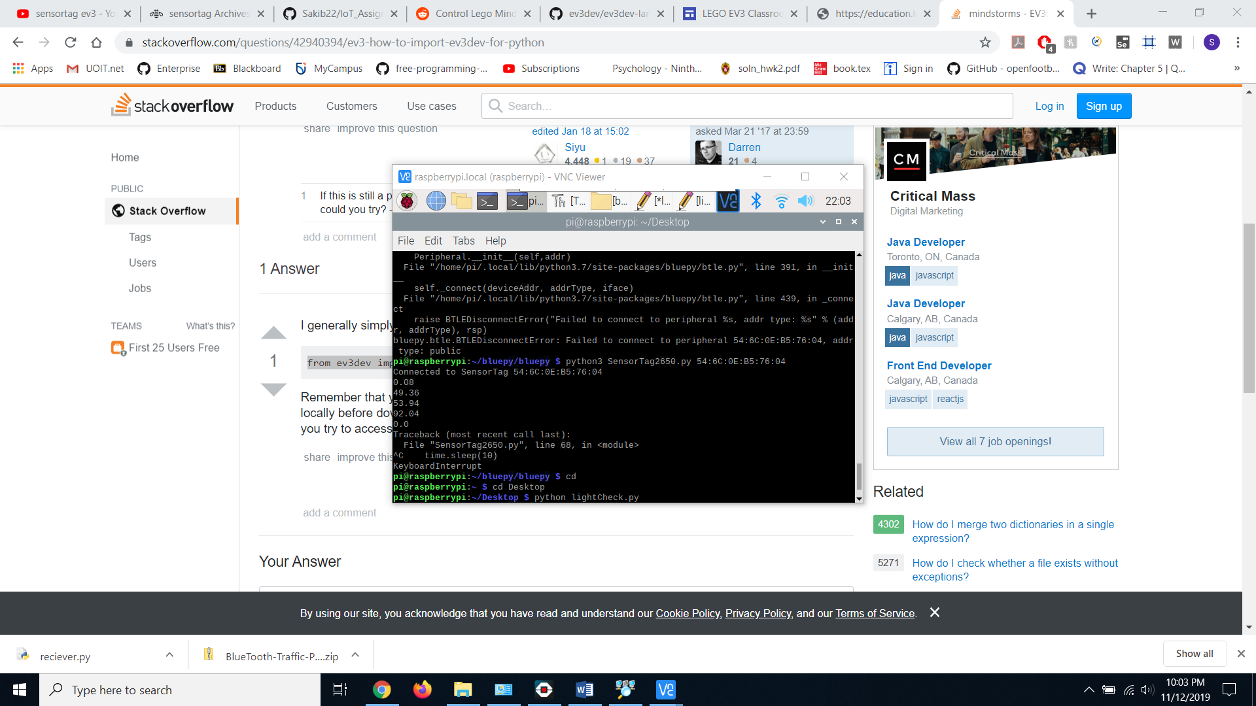

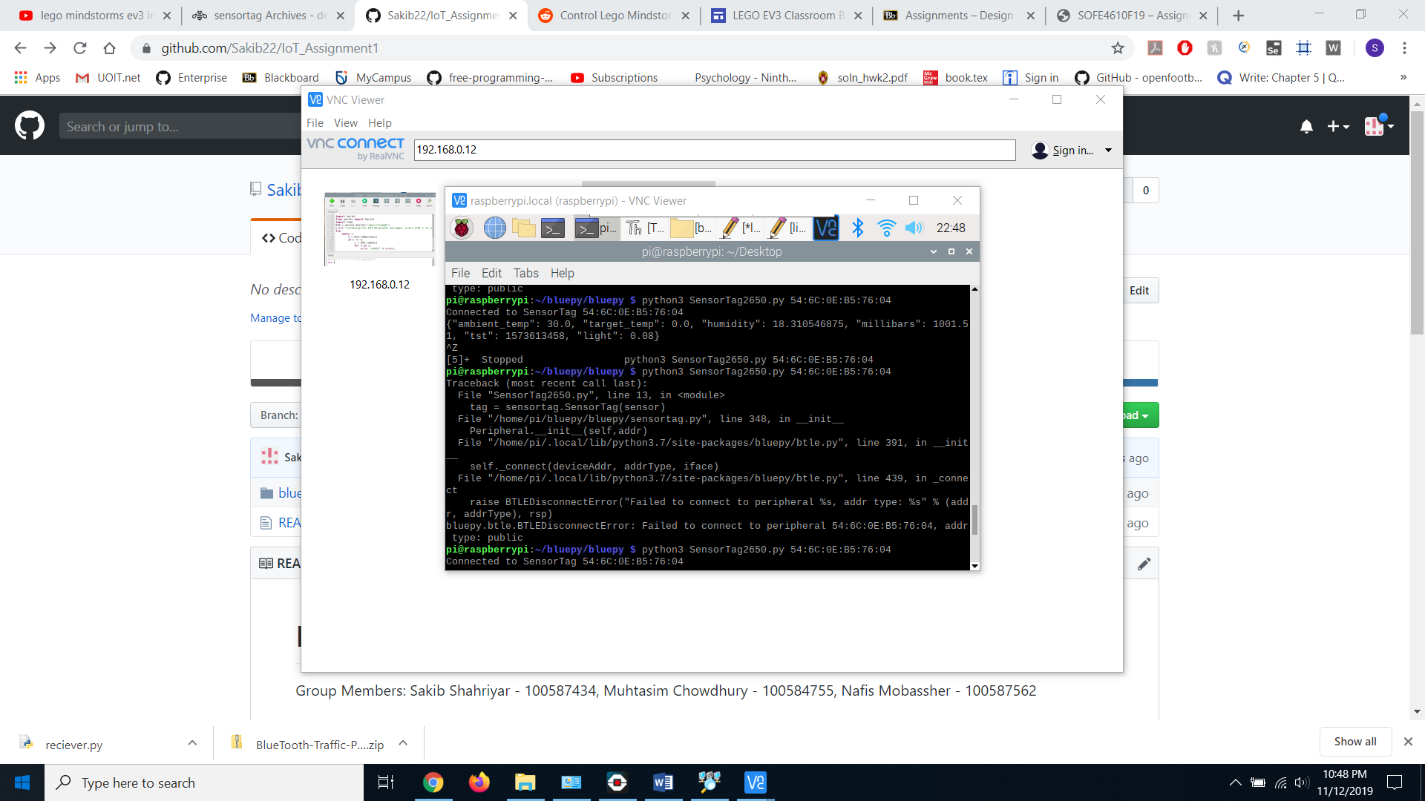

We got to print out the light sensor data, however the battery of the Sensor Tag was running low and we could not run the program at the time. So, we decided to use a touch sensor to demonstrate that the motor was working and was able to react to sensor information.

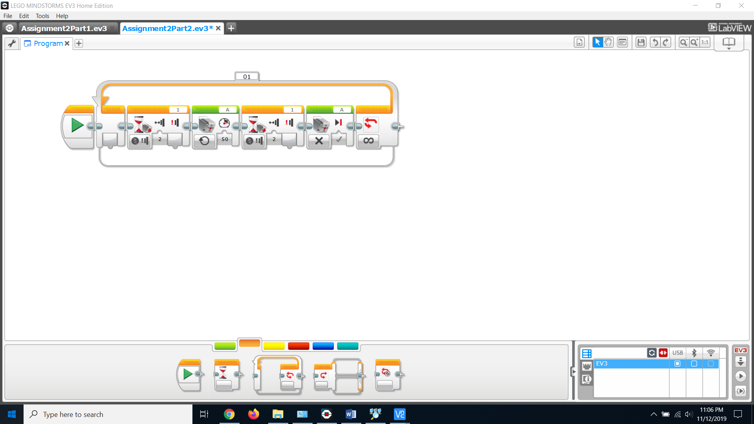

We used the EV3 Program and placed wait time blocks between the on and off motors for the touch sensor. Then we put the blocks in a for loop so that the motor turns on or off whenever the user clicks/reclicks the touch sensor.