SEMESTER FINAL PROJECT
LifeLink
Blood Donation & Emergency Donor Finder
Project Documentation Functionality · Technologies · Workflow · System Process
Item | Detail
Project type | Web application (role-based, database-driven)
Development model | Agile: iterative, incremental delivery in sprints
Back end | PHP 8 (custom MVC, no framework), PDO, MySQL / MariaDB
Front end | Tailwind CSS, Tabler Icons, jQuery
Live URL | https://3digit.agency/rtm/lifelink
Source code | https://github.com/Sakib3s/LifeLink
Document date | 1 October 2026
Prepared by | ______________________________
Student ID | ______________________________
Course / Supervisor | ______________________________
Contents
1 Introduction
Problem, objectives, stakeholders and implementation status
2 System Functionalities
What each role can do, shared features and business rules
3 Core Technologies for Website Development
Technology stack, architecture, database and tooling
4 Workflow Diagrams
Emergency request flow, registration and verification, request status, request processing
5 System Working Process
Step-by-step description of how the system operates, security and deployment
A Appendix
Route reference and system settings

1. Introduction

1.1 Background and problem
When a patient needs blood urgently, families usually search by phone calls, social-media posts and hospital visits. This is slow, unstructured and unreliable: the people contacted are often of the wrong blood group, unavailable or too far away, and there is no record of who responded.
LifeLink is a web application that replaces this search with a structured process. Patients post an emergency request, the system automatically finds donors who are compatible, available, verified and nearby, donors respond with one click, and blood banks publish stock and record donations. Administrators verify participants and monitor the whole platform.

1.2 Objectives
- Reduce the time needed to find a suitable blood donor in an emergency.
- Notify only donors whose blood group is medically compatible with the patient, so nobody is contacted in vain.
- Protect privacy: a donor’s or patient’s contact details are revealed only after a match is accepted.
- Keep the platform trustworthy through administrator verification of donors and blood banks, with a full audit trail.
- Give administrators live visibility of users, requests and outcomes through dashboards, reports and CSV export.

1.3 Stakeholders and roles
Role | Who they are | Main goal
Donor | Volunteer who can give blood | Be notified of compatible nearby requests and respond quickly
Patient | Patient or family member | Raise an urgent request and follow donor responses
Blood bank | Registered blood bank / hospital unit | Publish inventory, record donations, help fulfil requests
Administrator | Platform operator | Verify participants, monitor requests, manage settings, audit activity

1.4 Implementation status
The project follows the Agile model and is delivered module by module. This document describes the complete designed system; the status column shows what is already built and running, so the document can be read honestly against the code base.
Module | Content | Status
Foundation | Router, database layer, views, Tailwind pipeline, schema (13 tables) | Implemented
Authentication & roles | Register, sign in/out, role checks, verification messaging, rate limiting | Implemented
Admin console | Users, verification queues, request monitor, settings, audit log | Implemented
Reports | Admin aggregates and CSV export | Implemented
Production deployment | Subpath deployment package for shared hosting | Implemented
Donor module | Profile, availability toggle, donation history, eligibility checklist | Planned
Patient module | Emergency request form, request list and status timeline | Planned
Matching engine | Compatibility, distance ranking, accept / decline | Planned
Blood bank module | Inventory, donation recording, assisting view | Planned
Notification centre | Bell dropdown, unread count, mark as read (notifications are already created by the admin actions) | Partial
Role dashboards & hardening | Aggregates per role, PHPUnit tests, final security review | Planned

2. System Functionalities
Functions are grouped by role. Implemented means it is built and working in the current release; Partial means part of it exists; Planned means it is designed and scheduled for a later sprint.

2.1 Visitor (not signed in)
Function | Description | Status
Landing page | Explains the service, shows the blood-compatibility summary and calls to action | Implemented
How it works | Four-step explanation and frequently asked questions | Implemented
Register | Choose Donor, Patient or Blood bank; role-specific fields are shown for the chosen role | Implemented
Sign in | Email and password, brute-force protection, redirect to the page the user originally wanted | Implemented

2.2 Donor
Function | Description | Status
Registration profile | Blood group, gender, date of birth, weight, address and city stored with the account | Implemented
Awaiting-verification state | Clear banner until an administrator verifies the donor profile | Implemented
Dashboard | Blood group, availability and total donations at a glance, next-step links | Implemented
Profile management | Edit personal, location and contact data | Planned
Availability toggle | Switch between Available and Unavailable with one click (AJAX) | Planned
Donation history | Read-only list of past donations | Planned
Eligibility checklist | Self-assessment (recent donation, health, weight, age); result stored as eligible / not eligible / needs review | Planned
Respond to requests | See compatible requests; accept or decline; contact details of the patient revealed on accept | Planned

2.3 Patient
Function | Description | Status
Registration profile | Address and city stored with the account | Implemented
Dashboard | Shortcut to create a request and to the request list | Implemented
Create emergency request | Blood group, units, urgency (critical / high / normal), hospital, location, needed-by time, notes; validated in the browser and on the server | Planned
My requests and detail | List of own requests with a status timeline and donor responses | Planned
Cancel request | Patient can cancel an open or matched request | Planned

2.4 Blood bank
Function | Description | Status
Registration and verification | Bank name, licence number, address and phone; verified by an administrator | Implemented
Dashboard | Verification state and links to inventory and donation recording | Implemented
Inventory management | Units available per blood group, edited inline (AJAX) | Planned
Record donation | Log a donation against a donor and, optionally, a request | Planned
Assisting view | Open requests the bank can help fulfil from stock | Planned

2.5 Administrator
Function | Description | Status
Dashboard | Totals of users by role, pending verifications, requests by status, open and critical requests | Implemented
User management | Search and filter by role and status; suspend or reactivate an account (the user is notified; administrators are protected) | Implemented
Verification queues | Approve or reject donors and blood banks; a rejection can carry a reason that is sent to the user | Implemented
Request monitor | All requests with filters for status, blood group, urgency and free text | Implemented
System settings | Matching radius, maximum donors notified, urgency windows, auto-expire window | Implemented
Audit log | Searchable record of logins, registrations, verifications, suspensions, settings changes and exports | Implemented
Reports and CSV export | Date-range aggregates (fulfilled rate, average matches, breakdowns, top cities) and CSV download of requests | Implemented

2.6 Shared functions
Function | Description | Status
Role-based access control | Every page and action checks the user’s role on the server; other roles receive a 403 page | Implemented
In-app notifications | Notifications are created for verification results and account status changes | Implemented
Notification bell | Unread counter and dropdown list, mark as read | Planned
Responsive interface | Mobile-first layout, tested from 360 px wide screens; reusable buttons, forms, tables, badges, pagination | Implemented
Error pages | Friendly 403, 404 and 500 pages; JSON errors for AJAX calls | Implemented

2.7 Business rules

Blood compatibility
The matching logic uses this fixed lookup (kept in code, not in the database). A donor is a candidate for a request only if the donor’s group appears in the “Can donate to” column and the request’s group is in that list.
Donor group | Can donate to | Note
O− | O−, O+, A−, A+, B−, B+, AB−, AB+ | Universal donor
O+ | O+, A+, B+, AB+
A− | A−, A+, AB−, AB+
A+ | A+, AB+
B− | B−, B+, AB−, AB+
B+ | B+, AB+
AB− | AB−, AB+
AB+ | AB+ | Universal recipient (receives from all)

Other rules
- Verification gate: only verified donors can be matched and only verified blood banks can act; unverified users can sign in and complete their profile.
- Privacy: phone number and exact address of a donor or patient are not shown until the match is accepted.
- Eligibility: whole-blood donors are asked to wait about 12 weeks between donations; the last donation date is stored per donor.
- Urgency levels: critical, high and normal; their time windows are administrator settings.
- Request statuses: open, matched, fulfilled, cancelled, expired. Match statuses: pending, accepted, declined, expired.
- Suspended accounts cannot sign in and are signed out immediately on their next request.

3. Core Technologies for Website Development
LifeLink is deliberately built without a large framework. A small custom core keeps the code easy to understand, explain and maintain, while still following professional practices (MVC-style separation, prepared statements, reusable components).

3.1 Technology stack
Layer | Technology | Why it is used
Server language | PHP 8.4 (requires 8.2+) | Widely hosted, fast, strict typing available; runs on any shared hosting
Architecture | Custom MVC-style structure: Controllers, Models, Views, Services, Middleware, front-controller Router | Clear separation of concerns without framework overhead
Database | MySQL 8 / MariaDB 11 (InnoDB, utf8mb4) | Relational integrity with foreign keys; transactions for registration
Database access | PDO with prepared statements | Prevents SQL injection; no ORM, every query is explicit
Dependency manager | Composer (PSR-4 autoloading, vlucas/phpdotenv) | Class autoloading and .env configuration
Styling | Tailwind CSS 3 (built with the CLI) | Consistent design system; only the used CSS is shipped
Icons | Tabler Icons (webfont) | Consistent icon set for every screen
Client scripting | jQuery 3 and vanilla JavaScript | AJAX calls (availability, notifications, inline edit) and small UI behaviour
Typography | Inter (interface) and Newsreader (headings), via Google Fonts | Readable, professional look; two families only
Testing | PHPUnit 11 | Unit tests for validation, compatibility lookup and matching
Local environment | DDEV (Docker): nginx, PHP 8.4, MariaDB 11.8, Node 24 | Identical, repeatable development environment
Build tooling | Node.js / npm, PostCSS, Autoprefixer | Compiles Tailwind and copies vendor assets
Version control | Git and GitHub | History per sprint; backup and submission
Production hosting | Hostinger shared hosting (Apache / LiteSpeed, .htaccess) | Live deployment under https://3digit.agency/rtm/lifelink

3.2 Application architecture
Every request enters through one file, public/index.php, and is handled by the same layered pipeline (see Figure 4 in Section 4). Each layer has a single responsibility:
Layer | Location | Responsibility
Front controller | public/index.php | Only PHP file reachable from the web; boots the app and dispatches the request
Core | src/Core/ | Router, Request/Response, Session, CSRF, Auth, Validator, View, Database (PDO), Config, Paginator
Middleware | src/Middleware/ | Guest, Auth, Role and CSRF guards run before a controller
Controllers | src/Controllers/ | Validate input, enforce permissions, call models and services, choose a view
Models | src/Models/ | Thin data-access classes (User, Donor, Patient, BloodBank, BloodRequest, Notification, Setting, AuditLog)
Services | src/Services/ | Business logic: NotificationService, ReportService, RateLimiter (MatchingService and EligibilityService planned)
Views | views/ | PHP templates only: layouts, reusable partials (button, form field, table, badge, alert, pagination, sidebar)
Routes | routes/web.php | Single table mapping method + path to controller action and middleware

3.3 Project folder structure
blood-bank/
public/ web root: index.php, .htaccess, compiled assets
src/ application code (Core, Controllers, Models, Services, Middleware)
views/ layouts, partials and pages per role
routes/web.php route table
database/ migrations.sql (schema), seed.sql (demo data)
resources/ Tailwind source and configuration
scripts/ asset copy and production build scripts
tests/ PHPUnit tests
.env.example configuration template (real .env is never committed)

3.4 Database design
The schema has 13 InnoDB tables with foreign keys and indexes on every foreign key and on frequently filtered columns (status, blood group, city). It is created by one idempotent script, database/migrations.sql.
Table | Purpose
users | Every account: name, email, phone, password hash, role, status
donors | Donor profile: blood group, birth date, location, availability, verification, last donation, total donations
patients | Patient profile: address, city, coordinates
blood_banks | Blood bank profile: name, licence, address, phone, verification
blood_requests | Emergency requests: group, units, urgency, hospital, location, needed-by, status
matches | A compatible donor surfaced for a request, with distance and response status (unique per request + donor)
donations | Recorded donation events linked to donor, blood bank and optional request
inventory | Units on hand per blood bank and blood group
notifications | In-app messages with type, read flag and related record
eligibility_checks | Stored result and checklist (JSON) of the donor self-assessment
audit_logs | Who did what, to which record, from which IP address
settings | Administrator-editable key/value configuration
rate_limits | Counters used to throttle repeated sign-in attempts

3.5 User interface and design system
- Restrained palette: a desaturated blood-red brand colour, neutral greys, and semantic colours used only for status badges and alerts.
- No gradients, no glass effects; one-pixel borders instead of heavy shadows; small, consistent corner radii.
- Reusable PHP partials (button, badge, alert, form field, table empty state, pagination, statistic card) so every page uses identical markup.
- Mobile-first, responsive layout with a slide-over sidebar on small screens.

3.6 Development and deployment tooling
- DDEV provides the local web server, PHP, database and Node in containers.
- `npm run build:css` compiles Tailwind and copies the icon font and jQuery into public/assets.
- `scripts/build-deploy.sh` builds the production package: production-only Composer dependencies, compiled assets, production configuration, and an administrator SQL file; no demo data.
- Git/GitHub stores the history; generated assets and all credentials are excluded by .gitignore.

4. Workflow Diagrams
The diagrams below show how people and the system interact. Green boxes mark successful outcomes, amber marks decisions or waiting states, and blue marks administrator actions.

4.1 Emergency request to fulfilment
This is the core business process of LifeLink. Three actors take part: the patient, the LifeLink system (matching engine and notifications) and the donor.
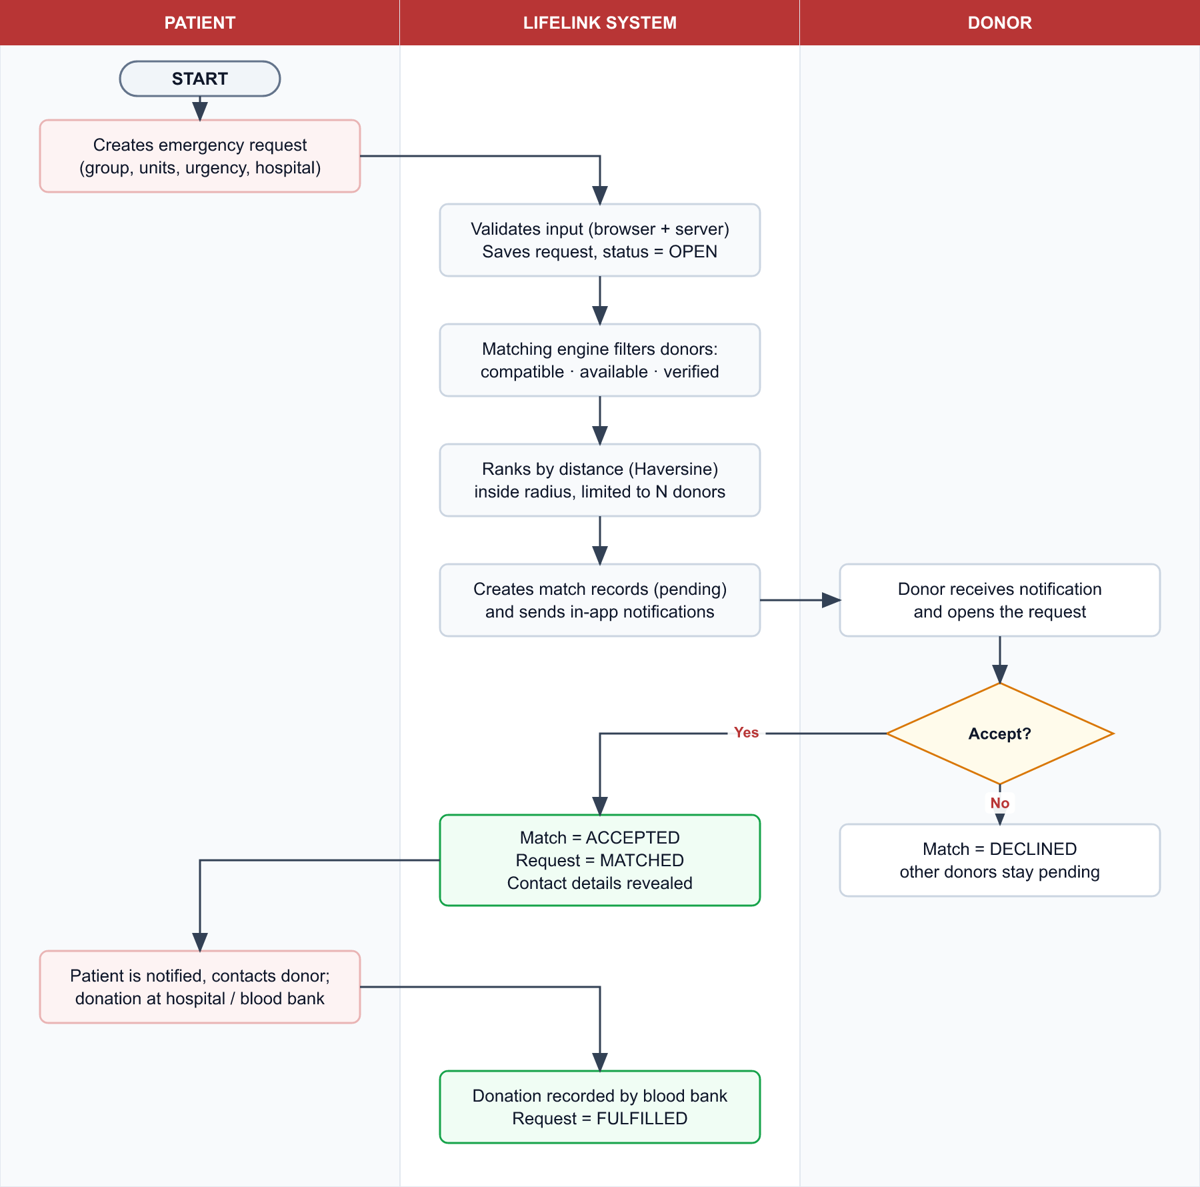
Figure 1: Emergency blood request workflow (swim-lane diagram)
Reading the diagram. The patient submits a request; the system validates it and stores it as OPEN. The matching engine keeps only donors who are compatible, available and verified, ranks them by distance and limits the list. Each selected donor receives a notification. If the donor accepts, the request becomes MATCHED and contact details are revealed to both sides; if the donor declines, only that match closes and other donors stay pending. After the donation, a blood bank records it and the request becomes FULFILLED.

4.2 Registration and verification
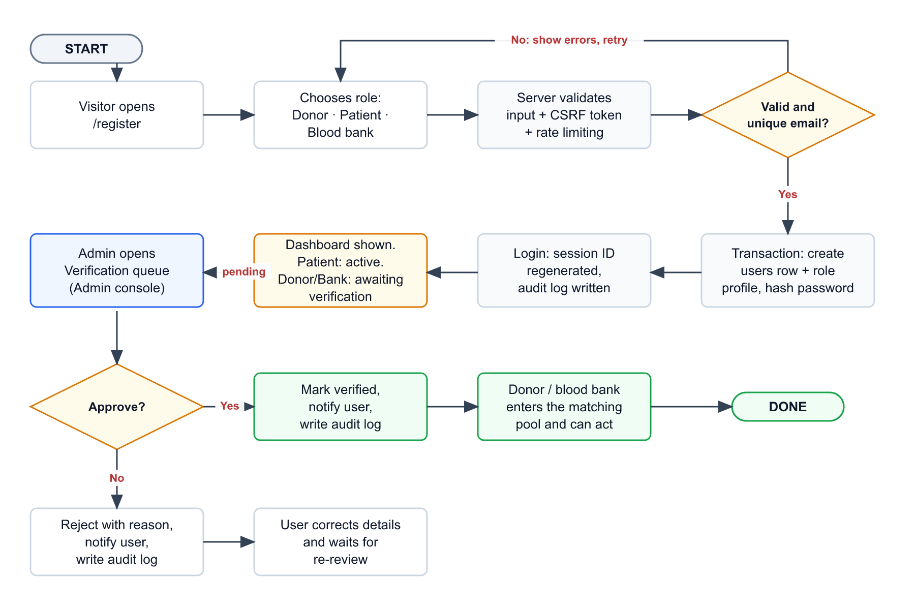
Figure 2: Registration and administrator verification workflow
Reading the diagram. Validation failures return the user to the form with messages and the entered values kept. On success the account and its role profile are created in one database transaction, so there is never an account without a profile. Patients are active immediately. Donors and blood banks can sign in, but wait in the administrator queue; once approved they enter the matching pool. A rejection carries an optional reason, and every decision is written to the audit log and sent to the user as a notification.

4.3 Request status lifecycle
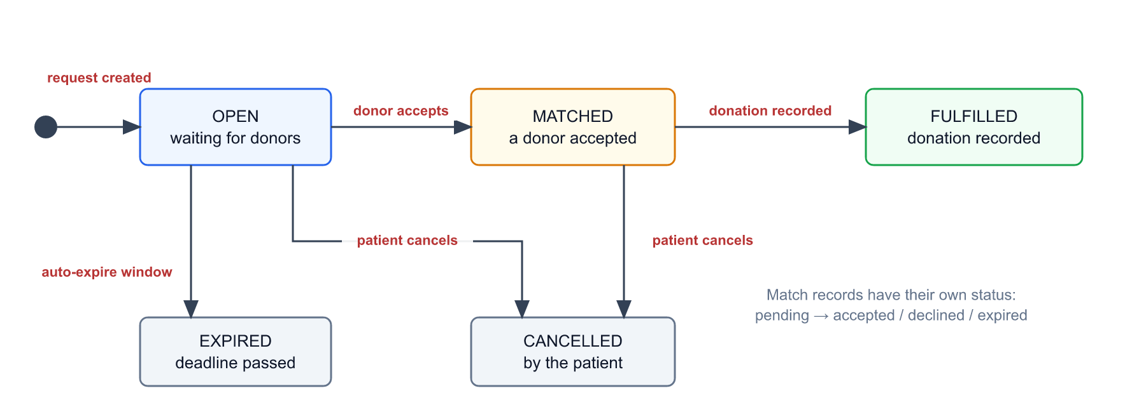
Figure 3: Status lifecycle of a blood request
A request starts as OPEN. It becomes MATCHED when a donor accepts and FULFILLED when the donation is recorded. A request can be CANCELLED by the patient, or EXPIRED when the time window configured in system settings passes without fulfilment.

4.4 How a request is processed by the application
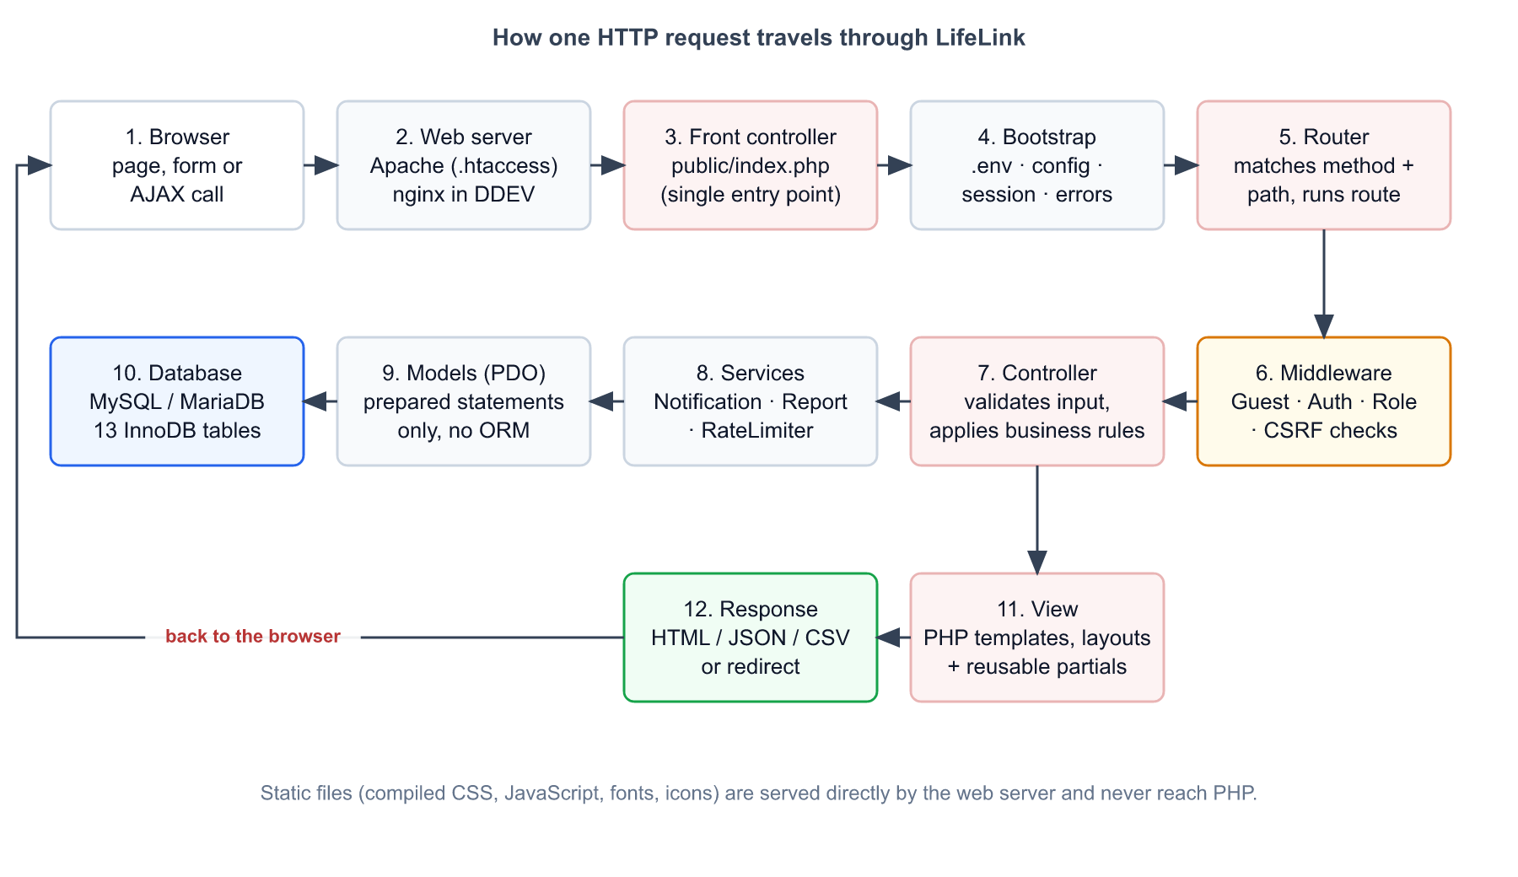
Figure 4: Path of one HTTP request through the application layers
The same twelve steps apply to every page and every AJAX call. Section 5.1 explains them one by one.

5. System Working Process

5.1 Request lifecycle
This is what happens, in order, when a user opens a page or submits a form:
- Browser sends an HTTP request (for example POST /admin/users/7/suspend).
- Web server serves real files (CSS, JavaScript, fonts) directly. Every other URL is rewritten to public/index.php (.htaccess on Apache/LiteSpeed, try_files on nginx).
- Front controller locates the application folder and loads the bootstrap.
- Bootstrap reads .env, builds the configuration, sets the time zone and error policy, and starts a secure session.
- Router removes the deployment sub-path, then matches HTTP method and path against the route table and extracts parameters such as {id}.
- Middleware runs in order: is the visitor a guest (for login pages), is the user signed in, does the role match, is the CSRF token valid. Any failure stops the request with a redirect, a 401, 403 or 419.
- Controller validates input with the Validator, re-checks the role, and applies the business rule.
- Services perform cross-cutting work such as creating notifications or building reports.
- Models run prepared SQL statements through PDO.
- Database stores or returns rows; multi-step writes use transactions.
- View renders a PHP template inside a layout; every dynamic value is HTML-escaped.
- Response is sent back as HTML, JSON (AJAX), CSV (export) or a redirect.

5.2 Authentication and session management
- Passwords are hashed with password_hash() (bcrypt) and checked with password_verify(); the hash is upgraded automatically at sign-in if the algorithm is strengthened.
- On successful sign-in the session ID is regenerated to prevent session fixation. Only the user ID is stored in the session; the user row is reloaded on every request, so a suspended or deleted account is logged out immediately.
- The session cookie is HttpOnly, SameSite=Lax, scoped to the application path, and Secure when served over HTTPS.
- Sign-out clears the session data and issues a new session ID.
- Rate limiting: after 5 failed attempts within 5 minutes for the same IP address and email, further attempts are refused. Counters live in the rate_limits table; a successful sign-in clears them.

5.3 Authorization (who may do what)
Access control is enforced on the server in two layers: route middleware (RoleMiddleware:admin) and a second check inside each controller action (requireRole()). Hiding a menu link is never treated as protection.
Area | Guest | Donor | Patient | Blood bank | Admin
Landing, how it works, login, register | Yes | Redirect | Redirect | Redirect | Redirect
/dashboard | Login | Yes | Yes | Yes | Redirect to /admin
/admin and all /admin/* pages | Login | 403 | 403 | 403 | Yes

5.4 Registration and verification process
- The visitor selects a role and fills the form. Role-specific fields (for example blood group for donors, bank name for blood banks) are shown by JavaScript, but the server validates everything again.
- The server checks the CSRF token, validates every field, and checks that the email and phone number are unique.
- In one transaction the system inserts the users row and the matching donors, patients or blood_banks row.
- The user is signed in and sees the dashboard. Donors and blood banks see an “Awaiting verification” banner.
- An administrator opens Verification queue and approves or rejects. Approval sets is_verified, the verifier and the time; rejection clears verification and stores the optional reason in the notification.
- Both outcomes create an audit-log entry and a notification for the user.

5.5 Matching engine (designed process)
When a patient creates a request, the matching service builds the list of donors to notify:
- Compatibility: from the compatibility table, take every donor group that can donate to the request’s blood group.
- Eligibility filters: keep donors that are verified, marked available, with an active account, and not already matched to this request.
- Distance: when both donor and request have coordinates, compute the great-circle distance with the Haversine formula and keep donors inside the configured radius (default 25 km).
- Ranking: sort by distance, nearest first; donors without coordinates are ranked after located donors, preferring the same city.
- Limit: keep at most the configured number of donors (default 25).
- Persist and notify: insert one matches row per donor with status pending, and create a notification for each donor.
- Response: a donor’s accept or decline updates the match; an accept sets the request to matched, reveals contact details and notifies the patient.
a = sin²(Δφ/2) + cos φ1 · cos φ2 · sin²(Δλ/2)
distance_km = 2 · R · asin( √a ) R = 6371 km (mean Earth radius)

5.6 Notification process
Notifications are rows in the notifications table created by NotificationService. Currently they are created when an administrator verifies or rejects a donor or blood bank and when an account is suspended or reactivated. The matching and donation modules will use the same service. The bell dropdown will load the unread count and recent items by AJAX and mark them as read.

5.7 Administrator operations and audit trail
- Every mutating admin action checks the role, validates the target, performs the change, writes an audit-log row (action, target type and id, details, IP address) and notifies the affected user.
- Safety rules: an administrator cannot suspend their own account or another administrator.
- Audited actions include sign-in success and failure, registration, sign-out, user suspend and reactivate, donor and bank verify and reject, settings update and report export.
- The audit log can be filtered by action and searched by actor, target or details.

5.8 Reporting
ReportService runs parameterised aggregate queries for a chosen date range: requests by status, urgency and blood group; fulfilled rate; average matches per request; donation units; verified donors and banks; and the top cities by request volume. The same filters drive the CSV export, which streams the request log with patient, group, units, urgency, status, hospital, city and match counts.

5.9 Security measures
Threat | Countermeasure in LifeLink
SQL injection | PDO prepared statements with emulation disabled; dynamic column names are whitelisted
Cross-site scripting (XSS) | Every dynamic value in a view passes through e() (htmlspecialchars)
Cross-site request forgery | Per-session token on every write, verified with hash_equals; failure returns HTTP 419
Weak or leaked passwords | bcrypt hashing; passwords are never stored in session, logs or form re-population
Session hijacking / fixation | ID regeneration on login, HttpOnly + SameSite cookies, Secure over HTTPS
Brute-force sign-in | Rate limit per IP and email, audit of failed attempts
Privilege escalation | Server-side role checks in middleware and controller; 403 on mismatch
Exposure of secrets and code | Credentials only in .env (git-ignored); application code, .env and vendor live outside the web root in production
Privacy of donors and patients | Contact details and exact location are released only after a match is accepted
Information leakage | Debug output disabled in production; errors are logged, not displayed

5.10 Deployment process
The live site runs at https://3digit.agency/rtm/lifelink. The application derives its base path from the APP_URL setting, so all links, redirects, assets and the session cookie work under this sub-folder without code changes.
- Run the build script. It compiles CSS, installs production-only Composer packages, copies the application, generates the production .env, and produces an administrator SQL file with a random password.
- Upload the package: the application folder goes next to public_html (not web-accessible); the contents of public/ go to public_html/rtm/lifelink/.
- In phpMyAdmin, import migrations.sql and then create-admin.sql. Demo data is never imported on the live site.
- Open the live URL, sign in as administrator, change nothing until the password is stored safely, and test a registration.

5.11 Development process (Agile)
The project is developed iteratively. Each sprint delivers a working, tested increment that is committed to Git; priorities are adjusted from feedback between sprints. Sprint boundaries below were recorded from the commit history.
Sprint | Goal | Delivered | Commit | Status
1 | Foundation | Router, PDO layer, views, Tailwind pipeline, schema, landing and error pages | 14db5ae | Implemented
2 | Authentication and roles | Register, sign in/out, middleware, dashboards, verification messaging, seed data | 2ea7161 | Implemented
3 | Admin console (brought forward after feedback) | Users, verifications, requests, settings, audit log, reports and CSV; two core bugs fixed | 1131cf0 | Implemented
4 | Production readiness | Sub-path deployment, .htaccess, build script, deployment guide | 5532581 | Implemented
5 | Donor module | Profile, availability toggle, donation history, eligibility | — | Planned
6 | Patient module | Request form with validation, list, status timeline | — | Planned
7 | Matching engine | Compatibility, distance ranking, accept / decline | — | Planned
8 | Blood bank and notifications | Inventory, donation recording, notification bell | — | Planned
9 | Dashboards and hardening | Role aggregates, PHPUnit tests, security review | — | Planned

Agile in practice: Sprint 3 shows the Agile principle of responding to change: the administrator pages were requested while the donor module was next in the backlog, so the backlog was re-ordered and the admin console was delivered first.

Appendix

A. Route reference (implemented)
Method | Path | Purpose | Access
GET | / | Landing page | Public
GET | /how-it-works | Explanation and FAQ | Public
GET / POST | /login | Sign-in form / submit | Guest
GET / POST | /register | Registration form / submit | Guest
POST | /logout | Sign out | Signed in
GET | /dashboard | Role dashboard (admin is redirected) | Signed in
GET | /admin | Admin dashboard | Admin
GET | /admin/users | User list with filters | Admin
POST | /admin/users/{id}/suspend | activate | Change account status | Admin
GET | /admin/verifications | Pending donors and banks | Admin
POST | /admin/verifications/donor|bank/{id}/approve | reject | Decide verification | Admin
GET | /admin/requests | All requests with filters | Admin
GET / POST | /admin/settings | View and save settings | Admin
GET | /admin/audit | Audit log viewer | Admin
GET | /admin/reports | Aggregates for a date range | Admin
GET | /admin/reports/export | CSV download of requests | Admin

B. System settings
Setting key | Default | Meaning
match_default_radius_km | 25 | Donors within this distance of a request are considered
match_max_donors_per_request | 25 | Upper bound on donors notified per request
urgency_critical_hours | 6 | Needed within this many hours = critical
urgency_high_hours | 24 | Needed within this many hours = high
request_auto_expire_hours | 72 | Open requests older than this expire

