**Task 2.1**

|  |  |  |
| --- | --- | --- |
| Elapsed time is 9.987109 seconds.  k: 1  N: 4017  Nerrs: 132  acc: 0.96714 | Elapsed time is 9.951864 seconds.  k: 3  N: 4017  Nerrs: 171  acc: 0.957431 | Elapsed time is 9.896921 seconds.  k: 5  N: 4017  Nerrs: 196  acc: 0.951207 |
| Elapsed time is 9.923703 seconds.  k: 10  N: 4017  Nerrs: 247  acc: 0.938511 | Elapsed time is 12.401225 seconds.  k: 20  N: 4017  Nerrs: 280  acc: 0.930296 | >> Ks = [1,3,5,10,20];  >> task2_1(Xtrn, Ytrn, Xtst, Ytst, Ks) |

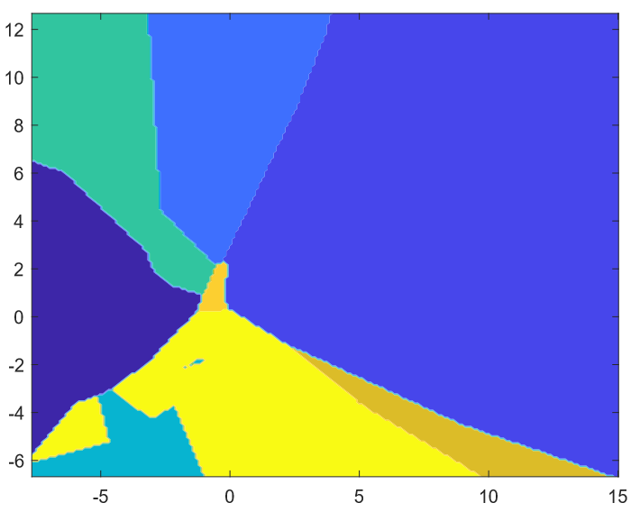Figure 2.1: Runtimes for run_knn_classifier

**Task 2.2**

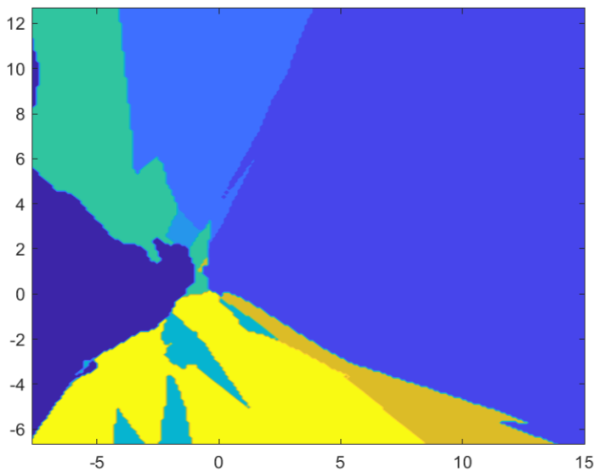Figure 2.2.1: Cross-section image of decision regions with k-NN for k =1

Figure 2.2.2: Cross-section image of decision regions with k-NN for k =3

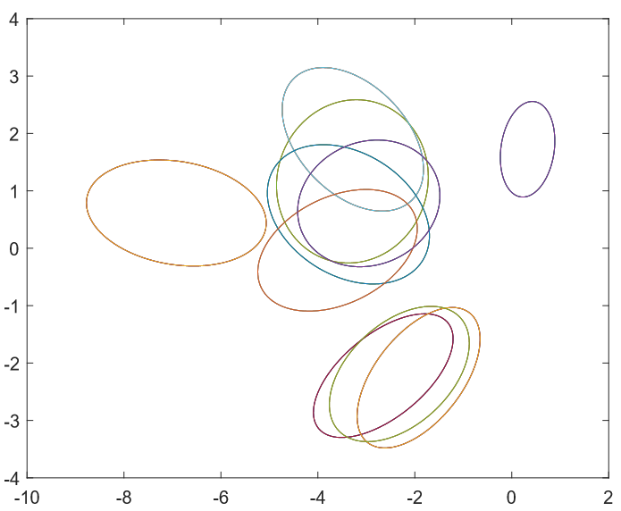**Task 2.3**

Figure 2.3: Class-wise Gaussian distributions on the plane of first two principal components

**Task 2.4**  >> Corrs = task2_4(Xtrn, Ytrn) ; **Corrs =**

|  |  |  |  |  |  |  |  |  |  |  |
| --- | --- | --- | --- | --- | --- | --- | --- | --- | --- | --- |
| **-0.1899;** | **0.1739;** | **0.0532;** | **-0.4178;** | **0.5948;** | **-0.3077;** | **0.3586;** | **0.5503;** | **0.1223;** | **0.4543;** | **0.0000** |

**Task 2.5** >> task2_5(Xtrn, Ytrn, Xtst, Ytst, 0.01)

Elapsed time is 3.205050 seconds.

N: 4017

Nerrs: 198

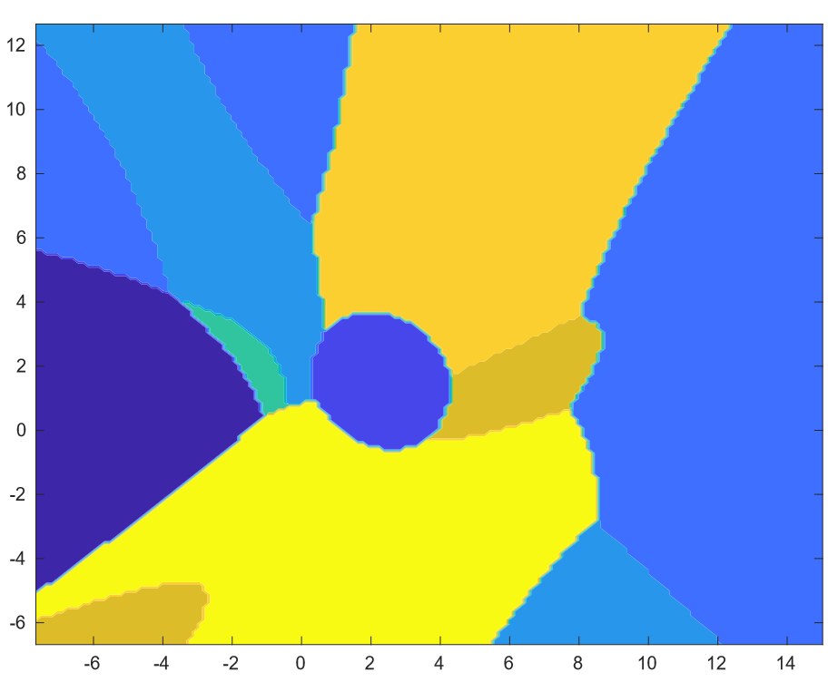acc: 0.950709 (95.1%)

**Task 2.6**

Figure 2.6: Cross-section image of decision regions with Gaussian classifiers

**Task 2.7**

|  |  |  |  |
| --- | --- | --- | --- |
| >> task2_7(Xtrn, Ytrn, Xtst, Ytst, 0.01, 0.9) ratio: 0.9 N: 4017 Nerrs: 204 acc: 0.949216 | >> task2_7(Xtrn, Ytrn, Xtst, Ytst, 0.01, 0.8)  ratio: 0.8 N: 4017 Nerrs: 201 acc: 0.949963 | >> task2_7(Xtrn, Ytrn, Xtst, Ytst, 0.01, 0.7) ratio: 0.7 N: 4017 Nerrs: 202 acc: 0.949714 | >> task2_7(Xtrn, Ytrn, Xtst, Ytst, 0.01, 0.6) ratio: 0.6 N: 4017 Nerrs: 200 acc: 0.950212 |
| >> task2_7(Xtrn, Ytrn, Xtst, Ytst, 0.01, 0.5) ratio: 0.5 N: 4017 Nerrs: 193 acc: 0.951954 | >> task2_7(Xtrn, Ytrn, Xtst, Ytst, 0.01, 0.4) ratio: 0.4 N: 4017 Nerrs: 195 acc: 0.951456 | >> task2_7(Xtrn, Ytrn, Xtst, Ytst, 0.01, 0.3) ratio: 0.3 N: 4017 Nerrs: 202 acc: 0.949714 |  |

**Task 2.8**

|  |  |  |
| --- | --- | --- |
| >> task2_8(Xtrn, Ytrn, Xtst, Ytst, 0.01, 2) Elapsed time is 8.133596 seconds. # of test samples: 4017 # of test errors: 2894 Accuracy: 0.279562 | >> task2_8(Xtrn, Ytrn, Xtst, Ytst, 0.01, 5) Elapsed time is 32.302300 seconds. # of test samples: 4017 # of test errors: 3292 Accuracy: 0.180483 | >> task2_8(Xtrn, Ytrn, Xtst, Ytst, 0.01, 10) Elapsed time is 59.861179 seconds. # of test samples: 4017 # of test errors: 3623 Accuracy: 0.0980831 |