Software Architecture and Data Collection System

System Architecture and Interoperability
AIMScribe was developed not as a clinical application but as an event-driven, decentralised agent architecture, in which each consulting room operates as an autonomous node. The endpoint element, aimscribe.exe, is a lightweight edge daemon presented to the clinician only as a system-tray icon. Acquisition, segmentation and transmission run on independent threads and an asynchronous transport loop, so that disk and network latency cannot propagate back into the audio path. This separation is a deployment requirement, not an optimisation: the study sites run legacy, lower-specification workstations on which any blocking operation would degrade the electronic health record (EHR) in active use. Audio is acquired as linear PCM at the capture device's native sample rate, with operating-system resampling and channel down-mixing excluded from the path, at a sustained 88.2 kB s⁻¹.
The interoperability layer is agnostic to the partner record system. Rather than requiring each vendor to integrate with a remote service, it is exposed as a loopback interface on the clinician's workstation, addressed by a small quantity of JavaScript within the existing EHR page. One contract is therefore implemented identically for the three partner systems in the deployment — CMED, Aalo and Amader Susastho — none of which holds cryptographic material, stores audio, exposes an endpoint, or alters its server infrastructure. The architecture admits no inbound connection from a partner system to the research backend; all traffic crossing an organisational boundary originates within the clinic.
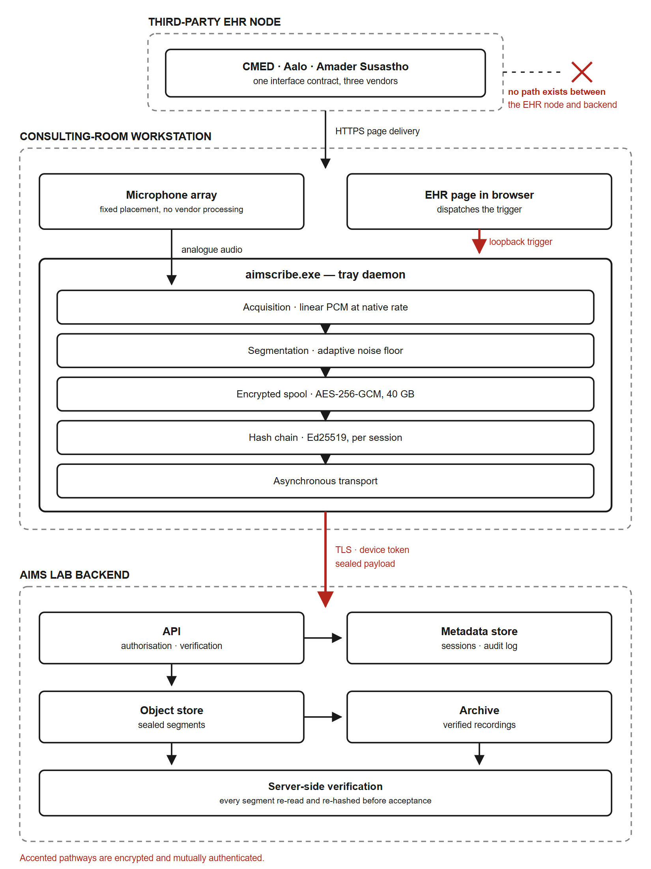
Figure 1 | Architecture block diagram. Boundaries of the consulting-room workstation, the third-party electronic health record (EHR) node and the AIMS Lab backend. The EHR node serves the clinical page over HTTPS; that page signals the aimscribe.exe tray daemon over a loopback channel confined to the same machine. Accented pathways are encrypted and mutually authenticated, carrying sealed audio and device-authenticated control traffic. No network path exists between the EHR node and the backend.

Zero-Touch Trigger Mechanism and Acoustic Pre-processing
Acquisition imposes no interface burden on the consultation. Requiring a clinician to start and stop a recorder introduces cognitive load when attention is owed to the patient, and such controls are reliably forgotten. The trigger is therefore derived from an action already performed: an EHR interface event, the selection of patient details, dispatches a signal over the loopback channel to the local daemon, and background capture begins. Authorisation is obtained from the backend in parallel with acquisition rather than before it. Transient network latency thus cannot displace the opening seconds of the encounter, in which the presenting complaint is typically stated.
Triggering is synchronised with a fixed acoustic configuration in each room, necessary because the enclosures are acoustically hostile: ceiling fans, corridor traffic and paediatric distress are continuous rather than intermittent. Segment boundaries are placed using short-term root-mean-square energy together with zero-crossing rate, evaluated against an adaptive noise floor so that the criterion tracks the room rather than assuming a fixed threshold. The zero-crossing term keeps boundaries out of unvoiced fricatives, which carry low energy and mimic pauses. Silence positions boundaries but is never excised: the archived recording is retained bit-identical to the acquired signal. Material for downstream speech recognition and diarisation is derived from that archive as a separate, disposable rendition.
Characterisation of the deployed hardware proved consequential. Conferencing speakerphones applying vendor noise suppression were found to gate quiet interlocutors, reducing 8.7% of frames to digital silence. On affected units the quieter speaker was attenuated to −56 to −69 dBFS, against −36 to −42 dBFS on correctly configured units; the louder speaker was unaffected. Because patients speak more quietly and at greater distance than clinicians, such processing removes precisely the signal of interest. Specification of the acquisition path was consequently treated as a measured commissioning requirement rather than a procurement detail.
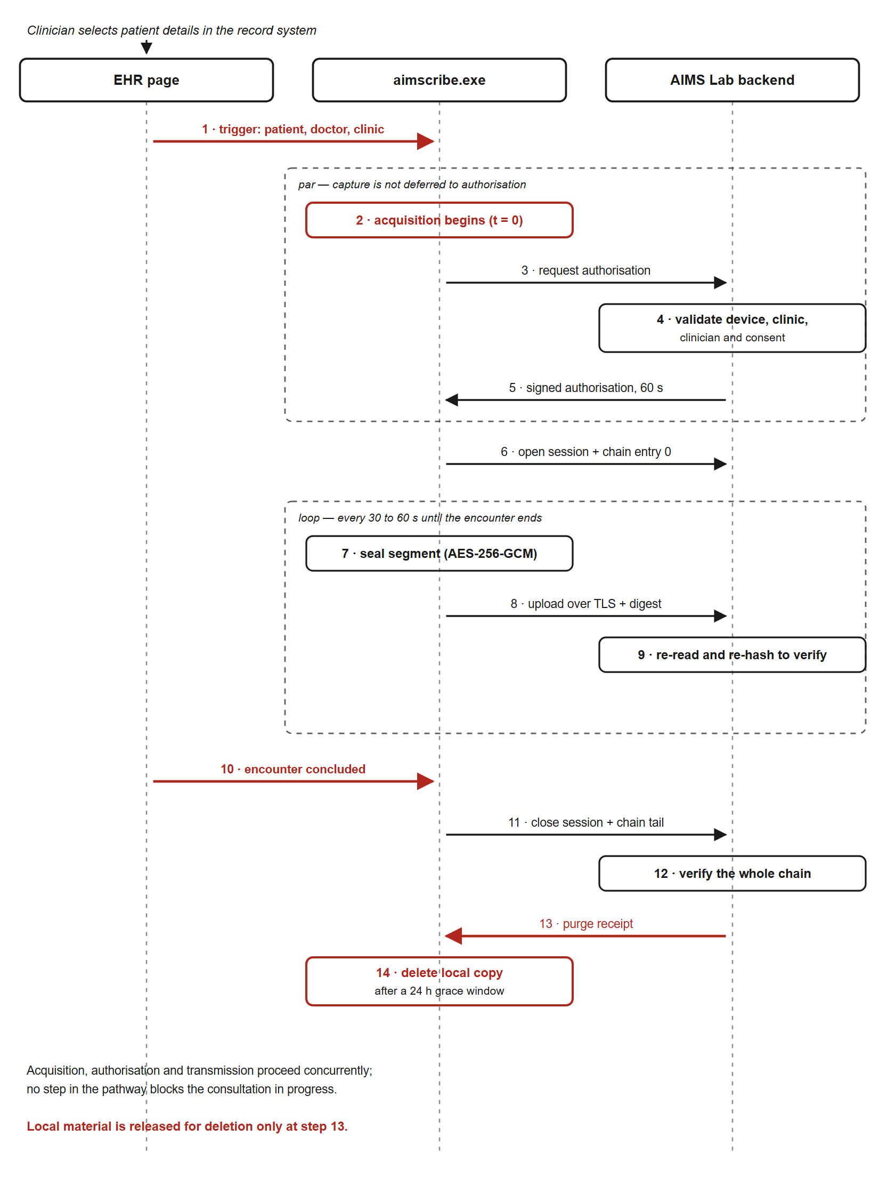
Figure 2 | Sequence of the acquisition pathway. Selection of patient details dispatches a trigger to the local daemon. Acquisition begins immediately while authorisation is validated by the backend in parallel, so that network latency cannot displace the opening of the encounter. Segments are sealed, uploaded and verified by server-side re-hashing throughout. Local material is released for deletion only against a purge receipt confirming that a verified archival copy exists.

Network Fault Tolerance and Edge Caching
Connectivity across the study sites is intermittent, and the acquisition path was therefore made offline-first rather than offline-tolerant. Each sealed segment is encrypted under AES-256-GCM and committed to a local spool before transmission is attempted. Every state transition is appended to a synchronously flushed journal, so that abrupt power loss cannot render a partial segment indistinguishable from a complete one. The spool is provisioned at 40 GB — approximately 135 recorded hours, or three weeks of a room's activity without connectivity. Synchronisation is opportunistic: when bandwidth returns, queued segments are transmitted in chain order by a background loop decoupled from acquisition, so that drainage of an accumulated backlog does not perturb the consultation in progress.

Deterministic Data Labelling and Synchronisation
Each archived recording is named under a fixed taxonomy, PatientID_DoctorID_HospitalID_StartTime_EndTime_Date, which functions as a relational mapping strategy rather than a filing convention. Identifiers are supplied by the record system at triggering and constrained to a restricted character set, since they become directory names on the archival volume. Consultations proceed back-to-back at intervals of twenty to thirty seconds; the start time of a succeeding encounter is therefore adopted as the end time of its predecessor, so that recordings tile the session without gap or overlap. Referential integrity between the audio corpus and the structured record is thus established at acquisition rather than reconstructed afterwards. An interlock further withholds session closure until the encounter has been concluded in the record system. Inadvertent selection of a subsequent patient therefore cannot truncate an active consultation — a failure mode observed in pilot operation, and not recoverable afterwards.

Device Binding and Cryptographic Security
Access to the acquisition path is constrained by hardware-anchored authentication. Each workstation is commissioned once by an administrator, using a single-use activation credential exchanged for a device identity and an asymmetric key pair generated on, and never leaving, that machine; the backend retains the credential only as a cryptographic digest. Binding is between workstation and research backend, and is therefore independent of the partner record system.
Registration establishes that a machine may record at all; a separate authorisation — short-lived, single-use, issued per encounter and verified against a pinned public key — establishes that a particular request is legitimate. The two controls are deliberately distinct: an enrolled workstation without the second would record for any page loaded in the clinician's browser. Compromise of EHR access alone therefore confers no capability to initiate or intercept acquisition.
Integrity is maintained end-to-end by a per-session hash chain. Each entry — session opening, every segment, every interruption, and closure — embeds the digest of its predecessor and is signed by the device key, rendering deletion, reordering and substitution detectable. Segments are verified on arrival by re-reading the stored object and recomputing its digest server-side. Local material is released for deletion only against a signed purge receipt attesting that a verified archival copy exists; any discrepancy quarantines the session, withholds the receipt and preserves both copies. A continuous chain of custody is thereby maintained from acquisition to archive, under which tampering, silent truncation and corruption at rest are detectable rather than merely improbable.

