AIMScribe — Integration Guide for CMED
What CMED needs to build, and what CMED needs to send.
AIMS LAB · Independent University, Bangladesh · 14 September 2026

1. The whole integration in one page
AIMScribe records the conversation between a doctor and a patient, so that it can later be transcribed and turned into a draft prescription. It cannot know *which* consultation it is recording. Only CMED knows that.
So CMED tells it. Three signals, across two channels.
 | Signal | Sent when | Sent to
API 1 | Trigger | The doctor opens the patient's details | The recorder on the doctor's PC
API 2 | Patient information | At the same moment as API 1 | The AIMS LAB backend
API 3 | Prescription built | The doctor builds the prescription | Both — see §5

That is the entire integration. Everything else in this document explains those three signals.
What CMED does not have to do. Nothing about patient consent (§9b). No audio to capture, store or handle. No cryptographic keys to hold or rotate. No changes to the CMED database. No new login system. No software to install on the doctor's PC. No screen to build — every message the doctor sees comes from our own small on-screen control, not from CMED.

2. The two channels
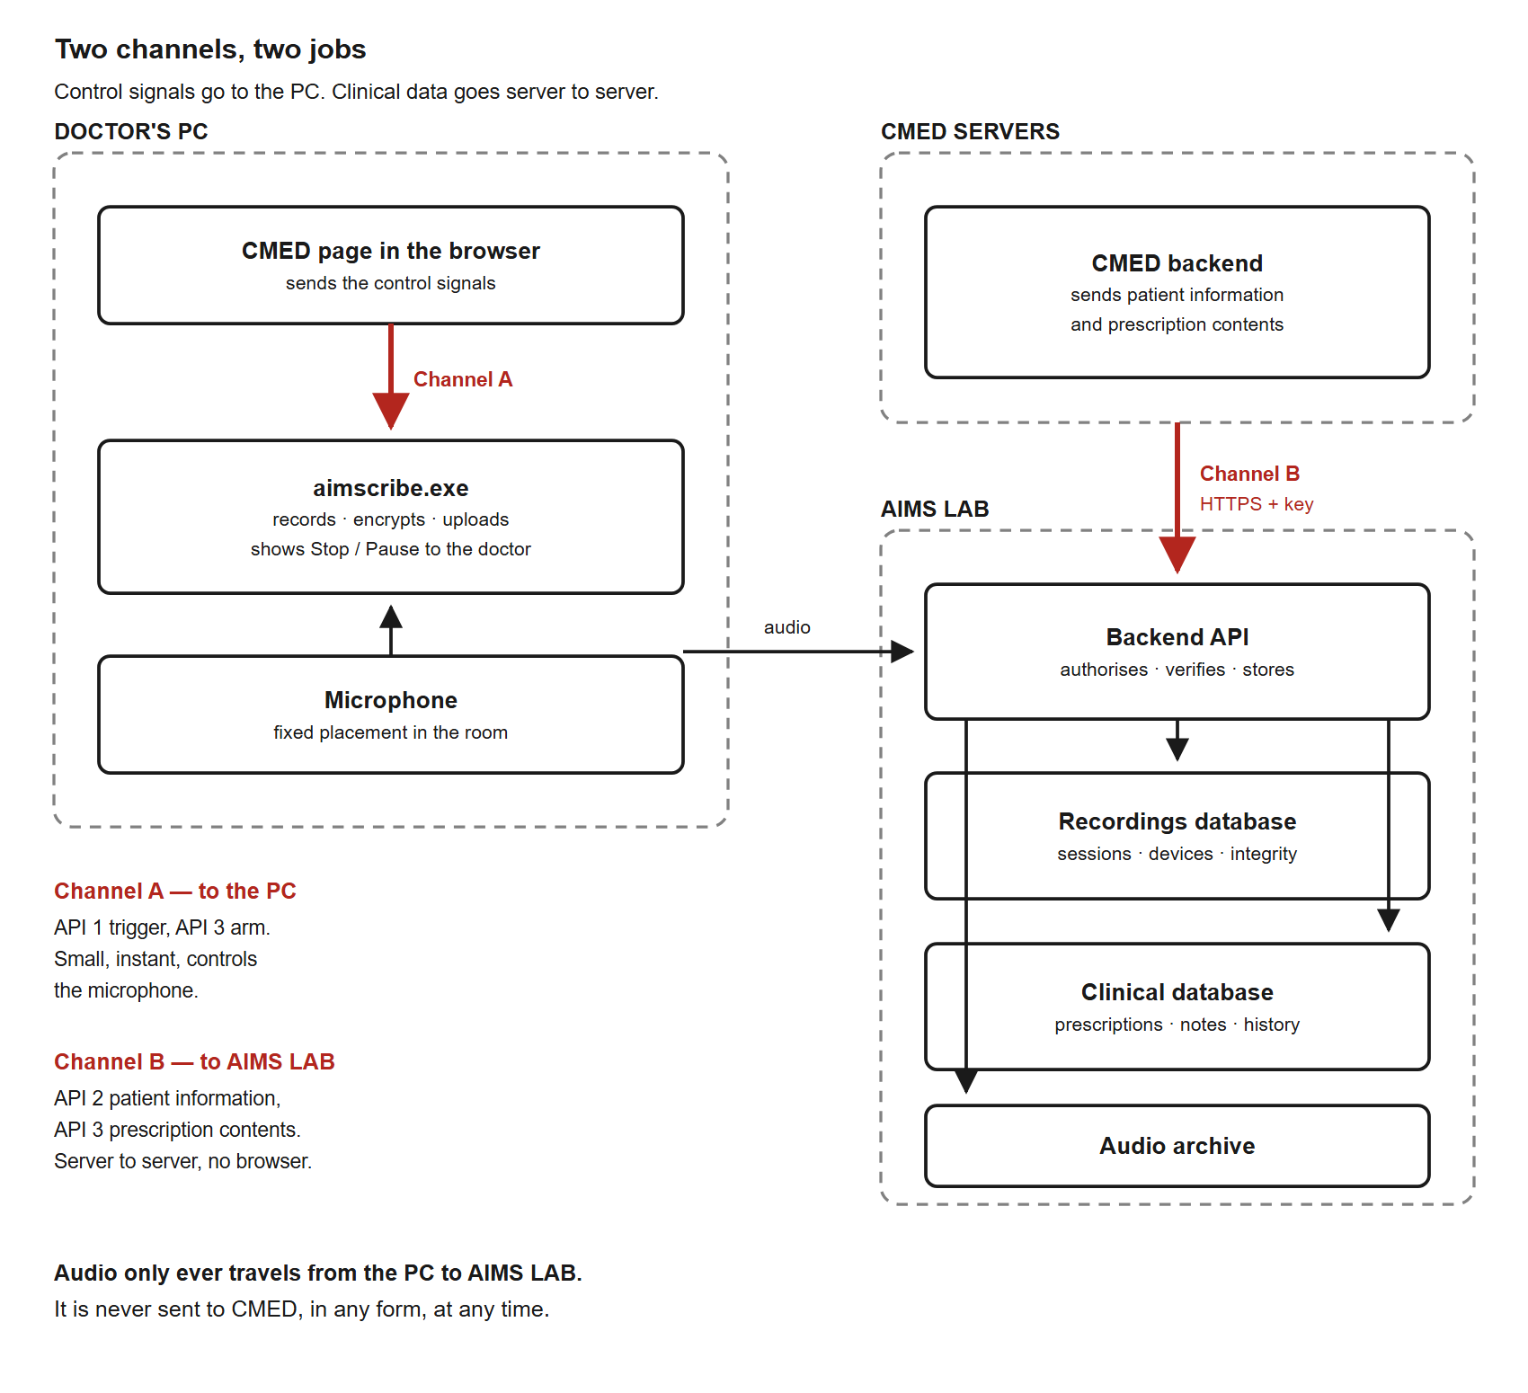
Figure 1 | Two channels, two jobs. Control signals travel to the recorder on the doctor's own PC. Clinical data travels server to server from CMED to the AIMS LAB backend. Audio travels only from the PC to AIMS LAB, and never to CMED.
Channel A — CMED page to the recorder on the same PC. Address: ws://127.0.0.1:5050/ws. This is a connection from the CMED page in the doctor's browser to a program running on that same computer. It never leaves the machine. It carries only small control messages, because it has to be instant — the microphone must open the moment the doctor opens the patient.
*Why a local connection and not a call to our server?* Because the recorder is on the doctor's PC. A message that had to travel to a server and back before the microphone opened would lose the first seconds of the consultation, which is exactly when the patient says why they came.
Channel B — CMED backend to the AIMS LAB backend. Address: https://<aims-backend>/api/v2/clinical/..., authenticated with an API key we issue to CMED. This carries the clinical data: patient information, prescriptions, notes, history. It is server to server, so payload size does not matter and nothing sensitive passes through a browser.

3. One consultation, start to finish
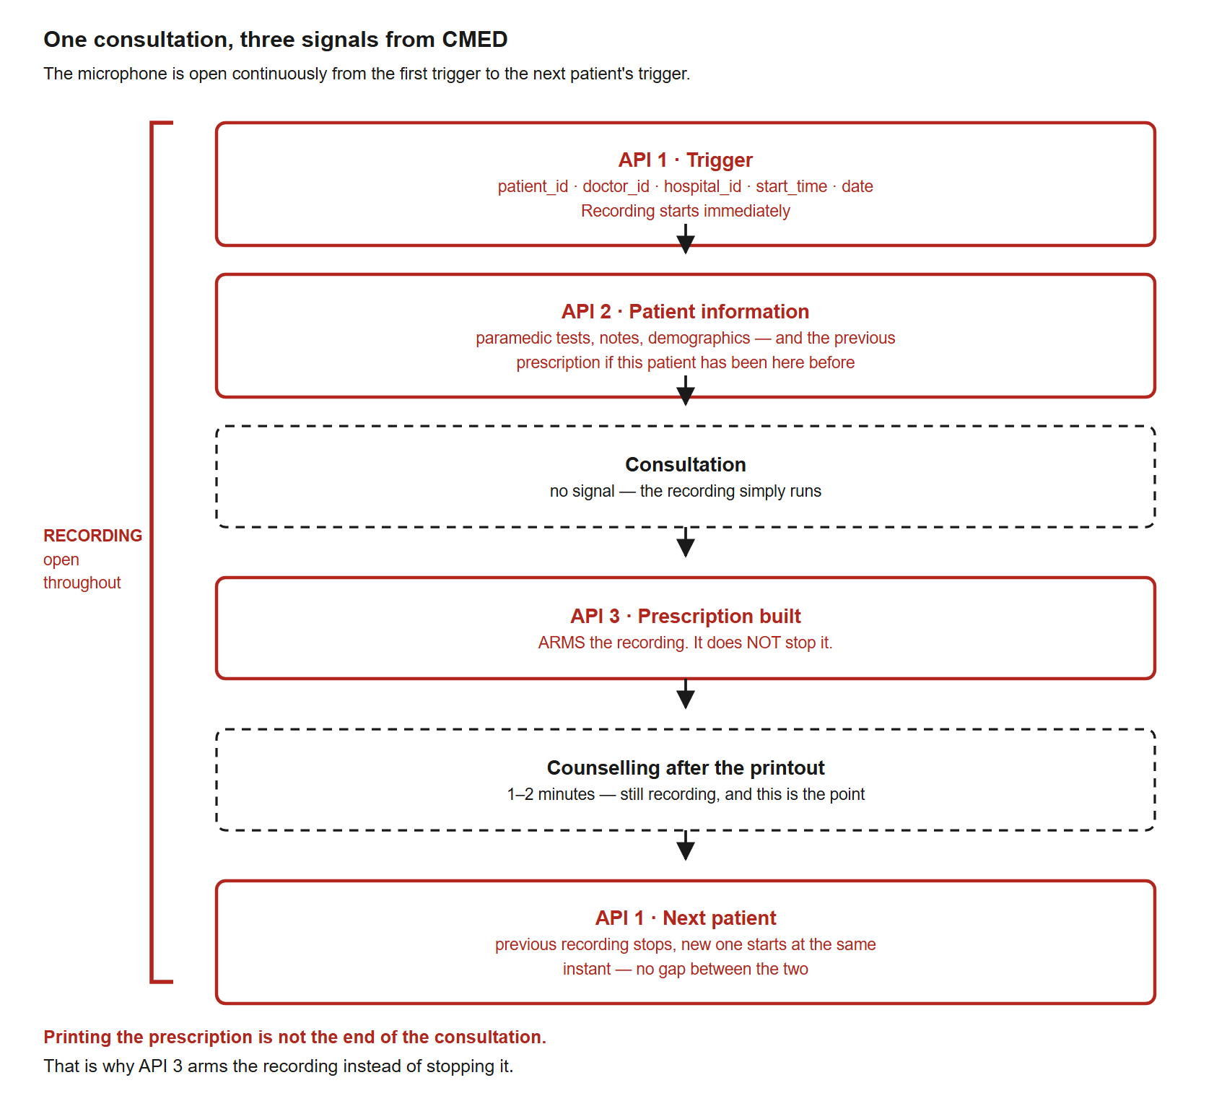
Figure 2 | The three signals across one consultation. The recording starts on API 1 and stays open continuously until the next patient's API 1. API 3 arms the recording; it does not stop it.
The point most easily missed is API 3. Printing the prescription is not the end of the consultation. The doctor prints, hands the paper over, and then counsels the patient for another minute or two — and that counselling is exactly the part worth recording. So API 3 does not stop the recording. It *arms* it, meaning: this consultation is finished, so the next patient is now allowed to end it.
The recording actually stops when the next patient's API 1 arrives. At that moment the previous recording closes and the new one opens at the same instant, on a separate thread, so there is no gap between the two patients.

4. API 1 — Trigger (start the recording)
When: the doctor opens the patient's details or history. Where: Channel A, the local connection.
{
"command": "start",
"request_id": "cmed-7f3a2b91",
"trigger": {
"patient_id": "P0012345",
"doctor_id": "DR0042",
"hospital_id": "CMED-DHK-BANANI-01",
"start_time": "2026-09-10T10:14:32+06:00",
"date": "2026-09-10"
}
}
Field | Required | Rule
patient_id | Yes | Letters, numbers, _ and - only. Up to 64 characters. Must be the same value every time for the same patient.
doctor_id | Yes | Same rule. Never leave it blank — we will refuse rather than guess.
hospital_id | Yes | Same rule. Must be the clinic this PC belongs to.
start_time | Yes | Full date and time with the time zone, e.g. +06:00.
date | Yes | YYYY-MM-DD.
request_id | Helpful | Anything you like; we send it back so you can match the reply.

Why `patient_id` must be stable. It becomes the folder and file name for that patient's recordings. If it changes for the same patient, their recordings become two unrelated sets and cannot be put back together afterwards.
Reply:
{ "event": "ack", "command": "start", "request_id": "cmed-7f3a2b91",
"status": 200, "code": "RECORDING_STARTED",
"data": { "session_id": "01JB8XQ4M7YZ2K9V3N5P6R8T0W" } }
Keep session_id in the page. You send it back with the arm signal in §6a. Your server does not need it — see §5.

5. API 2 — Patient information (at the same moment as API 1)
When: the moment the doctor opens the patient's details — at the same time as your page sends API 1. Do not wait for the recording to start. Where: Channel B, server to server.
Before the patient enters the doctor's room, a paramedic records their details and takes basic measurements. The doctor needs those at the start of the consultation, and so do we. If the patient has been to this hospital before, we also need their most recent prescription — the doctor refers to it, and our system needs it to make sense of what is said.
POST /api/v2/clinical/patient-information
X-CMED-Key: <the key we issue to you>
{
"patient_id": "P0012345",
"doctor_id": "DR0042",
"hospital_id": "CMED-DHK-BANANI-01",
"start_time": "2026-09-10T10:14:32+06:00",
"date": "2026-09-10",
"demographics": {
"name": "…", "sex": "female", "age_years": 34,
"phone": "…", "address": "…"
},
"paramedic": {
"recorded_at": "2026-09-10T10:06:00+06:00",
"weight_kg": 58.0, "height_cm": 156,
"blood_pressure": "120/80", "pulse_bpm": 78,
"temperature_c": 37.1, "spo2_percent": 98,
"notes": "…"
},
"previous_visit": {
"date": "2026-06-02",
"prescription": { "…": "…" },
"diagnoses": ["…"],
"notes": "…"
}
}
previous_visit is null for a patient who has not been to this hospital before. Send everything you hold for a returning patient — we would rather receive a field we do not yet use than discover later that it was never sent.
The fields required differ between male and female patients. Send what applies; our database enforces the right rules for each.
The five fields at the top must be exactly the same as in API 1 — the same patient, doctor, hospital, date, and the same start_time character for character. Create start_time once, on your server, and use that one value in both messages. This is how we connect the patient information to the right recording, and how we confirm the recording is genuine (§9). No session_id is needed.

6. API 3 — Prescription built (arm the recording)
This one does two things at once, on both channels.
6a. Arm the recording — Channel A, to the PC.
{ "command": "prescription_built",
"request_id": "cmed-7f3a2b92",
"patient_id": "P0012345",
"session_id": "01JB8XQ4M7YZ2K9V3N5P6R8T0W",
"occurred_at": "2026-09-10T10:26:11+06:00" }
Reply: 200 GATE_ARMED. The recording keeps running.
6b. Send the prescription — Channel B, server to server.
POST /api/v2/clinical/prescription
X-CMED-Key: <your key>
{
"patient_id": "P0012345",
"doctor_id": "DR0042",
"hospital_id": "CMED-DHK-BANANI-01",
"start_time": "2026-09-10T10:14:32+06:00",
"date": "2026-09-10",
"issued_at": "2026-09-10T10:26:11+06:00",
"diagnoses": ["…"],
"items": [
{ "drug": "…", "dose": "…", "frequency": "…", "duration": "…",
"instructions": "…" }
],
"investigations": ["…"],
"advice": "…",
"follow_up": "2026-10-10",
"notes": "…"
}
The five fields at the top are the same five as in API 1 and API 2, with the consultation's original start_time — not the time the prescription was issued. That is how the prescription attaches to the right consultation.
Send items as a list, one entry per prescribed medicine, rather than as one block of text. We store each field in its own column, and a list we have to take apart later loses information that was there when you sent it.

7. What happens when the next patient arrives
Nothing new to send. You simply send API 1 again, for the new patient.
Situation | What we do
API 3 was received for the current patient | Previous recording closes, new one opens at the same instant. No gap.
API 3 was not received | We refuse the new trigger with 409 GATE_NOT_ARMED, and the current recording keeps running

That second row is deliberate. If a doctor clicks another patient by accident in the middle of a consultation, the current recording is not cut in half. It keeps going. Your page can ignore the 409 — nothing is broken, and nothing needs to be shown to the doctor.

8. What comes back
Branch on code, never on message. The message text is shown to doctors and will be reworded; the code will not change.
status | code | Meaning | What CMED should do
200 | RECORDING_STARTED | Recording | Keep the session_id
200 | GATE_ARMED | API 3 accepted | Nothing
400 | MISSING_FIELD | A required field is absent | Fix the payload — a build-time bug
400 | INVALID_IDENTIFIER | An id has characters we do not allow | Fix the identifier
401 | AUTHORISATION_FAILED | We could not authorise this recording | Log it; do not retry automatically
401 | CLINIC_MISMATCH | This PC does not belong to that hospital | Log and tell us; the mapping is wrong
403 | ORIGIN_NOT_ALLOWED | Your page address is not on our list | Configuration — tell us the address
409 | GATE_NOT_ARMED | A consultation is still open | Expected. Do nothing.
423 | DEVICE_NOT_ENROLLED | This PC is not registered | Tell us which machine
503 | AGENT_NOT_READY | Recorder is starting | Retry once after a moment
— | *no connection* | Recorder not installed or not running | Log it and carry on

Replies from our server to API 2 and the prescription (Channel B).
status | code | Meaning | What CMED's server should do
202 | ACCEPTED | Stored | Nothing
200 | ALREADY_RECEIVED | This exact request was already stored | Nothing
400 · 401 · 413 · 422 | e.g. MISSING_FIELD, INVALID_KEY, SCHEMA_INVALID | The request is wrong | Log it for a developer; do not retry unchanged
429 · 500 · 503 | RATE_LIMITED, SERVER_ERROR, UNAVAILABLE | Busy or failing on our side | Retry in the background, with a growing delay, for up to 24 hours

The rule that matters more than any of the above: if anything at all goes wrong with AIMScribe, your page must carry on as if it were not there. A lost recording is a lost recording. A doctor who cannot see a patient because a recorder failed is a much worse outcome. In practice this is one line:
aimscribe.startConsultation({ … }).catch(() => {});

9. How we know the request is genuine
CMED does not hold any key and does not have to prove anything. The checks are ours, and they run on our side. This section is here so your security reviewer can see what they are.
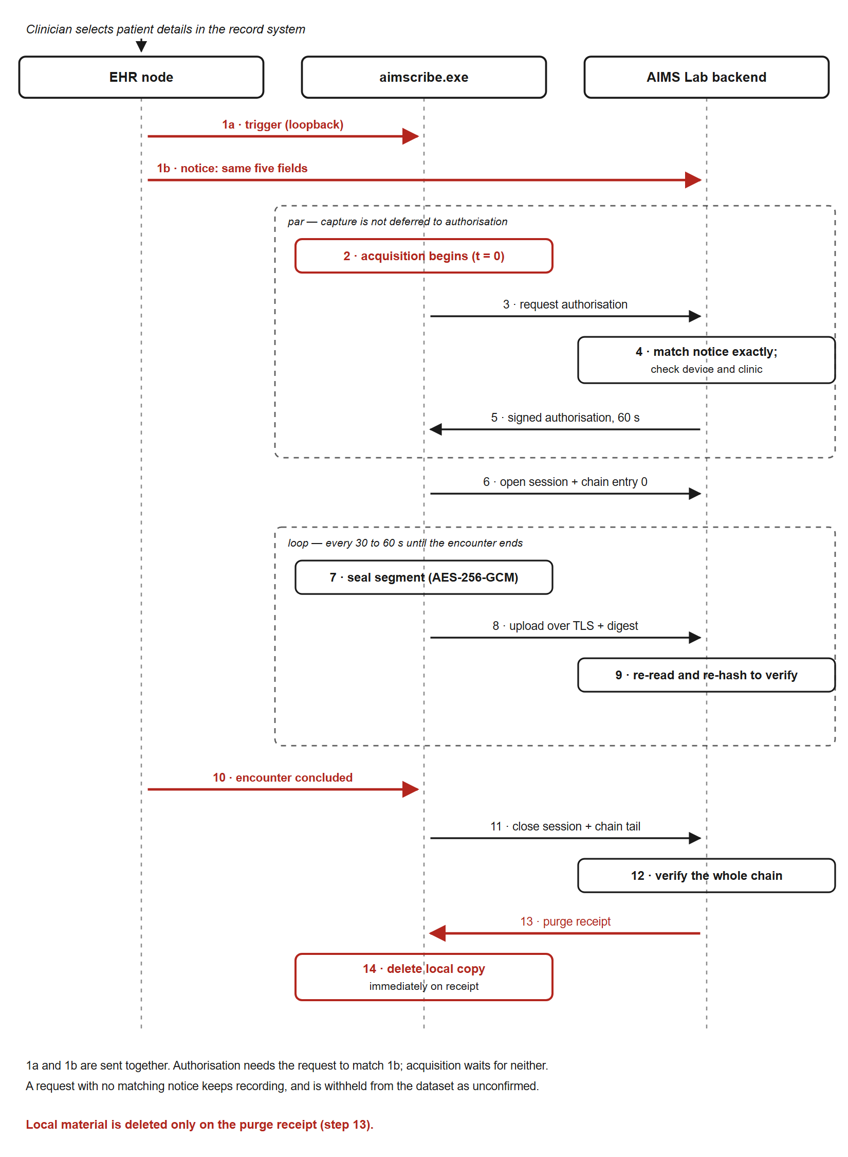
Figure 3 | What happens behind the trigger. The recording starts immediately, while authorisation is checked in parallel, so a slow network never costs the opening of the consultation.
Every PC is registered once, before it is used. An administrator from AIMS LAB issues a one-time activation code for that specific machine. The first time the recorder runs, it exchanges that code for a permanent identity and generates a private key that never leaves the computer. The code is single-use and expires. After that, the machine is known to us and is tied to one clinic.
A registered PC still cannot record just because someone asks it to. Every consultation needs its own short-lived permission, which the recorder requests from our backend at the moment of the trigger. Our backend checks that the doctor exists and works at that clinic, and that the clinic matches the machine's registration. The permission it issues lasts sixty seconds and works once.
Why both. Registration answers *may this machine record at all*. The per-consultation permission answers *is this particular request genuine*. Without the second, any web page the doctor happened to open could start a recording on a registered machine. With it, even someone who obtained CMED access could not start or intercept a recording.
One thing we need from you: the exact web address your page is served from — scheme, host and port, for both production and testing. We put it on an allowlist, and a connection from anywhere else is refused before it is even accepted.

9a. Every recording is confirmed by your server
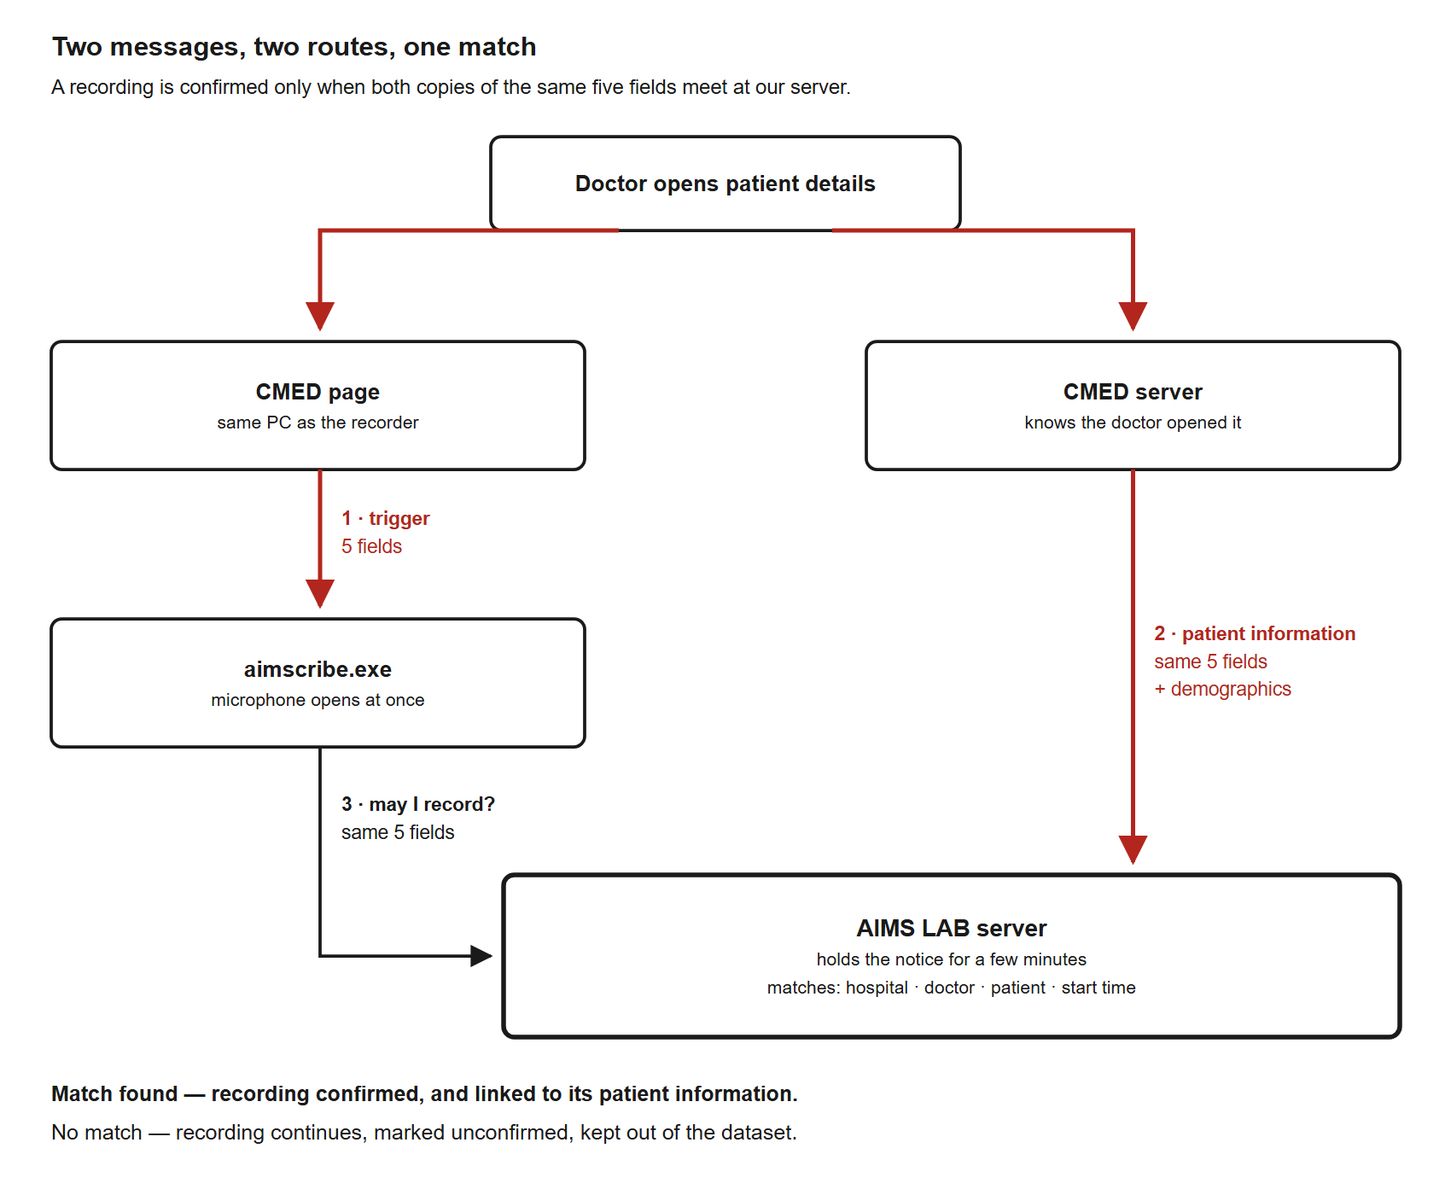
Figure 4 | Two messages, two routes, one match. When the doctor opens a patient, your page sends API 1 to the recorder and your server sends API 2 to us. Both carry the same five fields. Our server confirms the recording only if the two match.
When the recorder asks our server for permission, our server looks for the patient information your server sent (API 2) with the same hospital, doctor, patient, date and start_time. The hospital must also be the clinic this PC is registered to.
A fake web page on the doctor's PC could reach the recorder, but it cannot make your server send us a matching API 2. So its recording is never confirmed.
The microphone does not wait for this check. It opens straight away, and the check runs alongside it.
Situation | What happens
API 2 arrives within a second or two | Confirmed. Nobody notices anything.
API 2 is late | Recording keeps running. The recorder asks again every few seconds and is confirmed once API 2 arrives.
API 2 never arrives | Recording is not cut. It is uploaded but marked *unconfirmed*, kept out of the dataset, and we are alerted. If API 2 arrives later it is admitted; if not, it is deleted from our server after 24 hours.
The doctor opens a patient just to look | Your API 2 arrives but no recording asks for it. It expires after a few minutes. No harm.
The doctor opens the same patient twice | We match the most recent unused API 2.

What this asks of you. Nothing beyond what you already send: API 2 at the moment the patient is opened, with the same five fields as API 1. That timing is the whole requirement. If API 2 is sent late as a matter of routine, recordings will sit unconfirmed until it arrives.

9b. When a patient does not want to be recorded
CMED sends nothing about consent. Reception asks each patient before the consultation, as the clinic does today.
If a patient does not want to be recorded — before or during the consultation — the doctor presses the red Stop button on our on-screen control and chooses Patient did not consent. The microphone stops the moment the button is pressed. That consultation's recording is then deleted from the PC and from our servers, and we keep none of the patient information or prescription you send for that visit.
Nothing changes for you. Keep sending API 1, API 2 and API 3 as normal. Our server still replies 202 ACCEPTED and simply keeps nothing for that visit. The recorder may reply 409 NO_ACTIVE_SESSION to the arm signal; ignore it, as for any other 409. The next patient is recorded as usual.

10. What never crosses between us
Direction | Never
AIMS LAB → CMED | Audio, in any form. Transcripts. Any AI-generated output through this interface.
CMED → AIMS LAB | Anything you have not agreed to send. We ask for nothing beyond §5 and §6.

Audio is recorded on the doctor's PC, encrypted before it is written to disk, uploaded to AIMS LAB, and deleted from the PC as soon as we confirm we hold a verified copy. It never travels to CMED.

11. What we need from you to begin
# | What | Effort
1 | The exact page addresses, production and testing | 10 minutes
2 | Your clinic identifiers, and which AIMS LAB hospital each maps to | 30 minutes, once
3 | Confirmation that patient_id never changes for a patient | —
4 | Open the local connection from your page and keep it open | half a day
5 | Send API 1 when the doctor opens patient details | half a day
6 | Send API 3 when the prescription is built | quarter of a day
7 | Send API 2 from your backend at the moment the patient is opened, and the prescription when it is built, both with the same five fields as API 1 | one day
8 | Handle the replies by code; ignore failures quietly | half a day
9 | Joint testing with us | one day
 | Total | 3–4 developer-days

We provide a single test page that connects to the recorder, sends each signal and prints the reply, so your developer can see the whole thing working before writing any CMED code.

12. Who to ask
Send questions to AIMS LAB, Independent University Bangladesh. If something in this document is ambiguous, it is a fault in the document — tell us and we will fix it rather than leave you to guess.

