Software Architecture and Data Collection System

System Architecture and Interoperability
AIMScribe was developed not as a clinical application but as an event-driven, decentralised agent architecture, in which each consulting room operates as an autonomous node. The endpoint element, aimscribe.exe, is a lightweight edge daemon presented to the clinician only as a system-tray icon. Acquisition, segmentation and transmission run on independent threads and an asynchronous transport loop, so that disk and network latency cannot propagate back into the audio path. This separation is a deployment requirement, not an optimisation: the study sites run legacy, lower-specification workstations on which any blocking operation would degrade the electronic health record (EHR) in active use. Audio is acquired as linear PCM at the capture device's native sample rate, with operating-system resampling and channel down-mixing excluded from the path, at a sustained 88.2 kB s⁻¹.
The interoperability layer is agnostic to the partner record system. Rather than requiring each vendor to integrate with a remote service, it is exposed as a loopback interface on the clinician's workstation, addressed by a small quantity of JavaScript within the existing EHR page. One contract is therefore implemented identically for the three partner systems in the deployment — CMED, Aalo and Amader Susastho — none of which holds cryptographic material, stores audio, or alters its server infrastructure. Two channels are used, and the separation is deliberate. Control signals reach the daemon on the clinician's own machine and never leave it, because they must take effect the moment a patient is opened. Clinical data travels server to server to the research backend, so no sensitive content passes through a browser. Audio travels towards the partner system on neither channel.
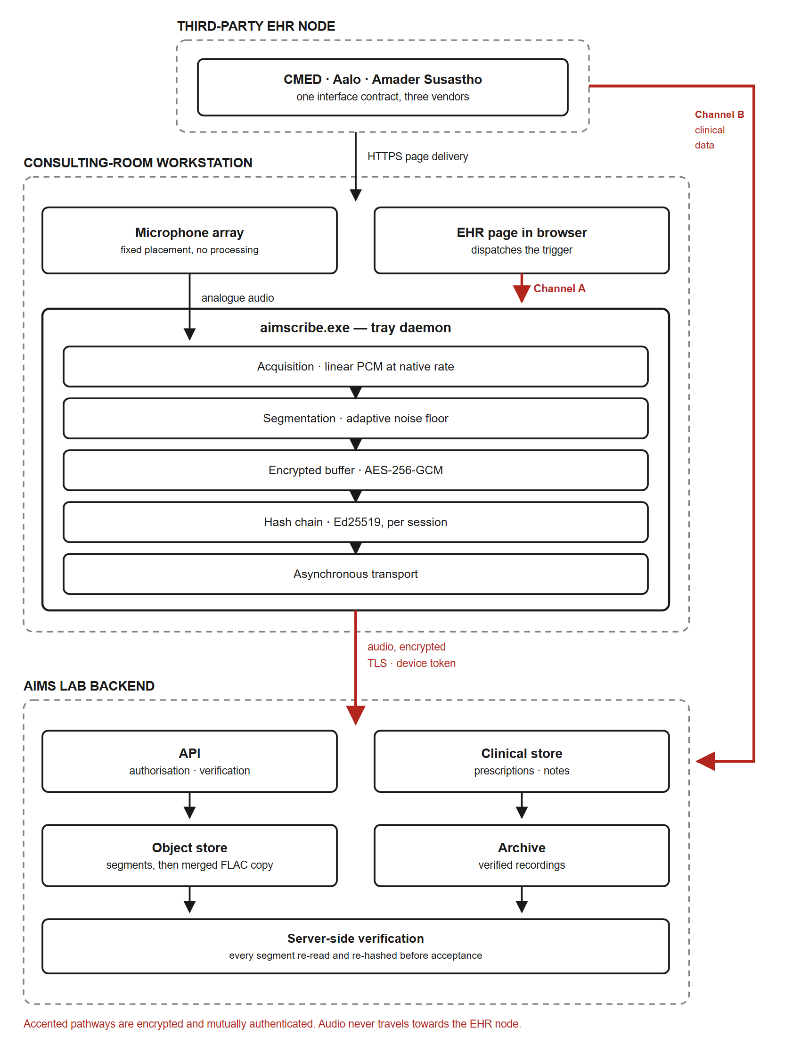
Figure 1 | Architecture block diagram. Boundaries of the consulting-room workstation, the third-party electronic health record (EHR) node and the AIMS Lab backend. The EHR node serves the clinical page over HTTPS. That page signals the aimscribe.exe tray daemon over a loopback channel confined to the same machine (Channel A), while clinical data reaches the backend server to server (Channel B). Accented pathways are encrypted and mutually authenticated. Audio travels only from the workstation to the backend, and never towards the EHR node.

Zero-Touch Trigger Mechanism and Acoustic Pre-processing
Acquisition imposes no interface burden on the consultation. Requiring a clinician to start and stop a recorder introduces cognitive load when attention is owed to the patient, and such controls are reliably forgotten. The trigger is therefore derived from an action already performed: an EHR interface event, the selection of patient details, dispatches a signal over the loopback channel to the local daemon, and background capture begins. Authorisation is obtained from the backend in parallel with acquisition rather than before it. Transient network latency thus cannot displace the opening seconds of the encounter, in which the presenting complaint is typically stated.
Triggering is synchronised with a fixed acoustic configuration in each room, necessary because the enclosures are acoustically hostile: ceiling fans, corridor traffic and paediatric distress are continuous rather than intermittent. Segment boundaries are placed using short-term root-mean-square energy together with zero-crossing rate, evaluated against an adaptive noise floor so that the criterion tracks the room rather than assuming a fixed threshold. The zero-crossing term keeps boundaries out of unvoiced fricatives, which carry low energy and mimic pauses. Silence positions boundaries but is never excised: the archived recording is retained bit-identical to the acquired signal. Material for downstream speech recognition and diarisation is derived from that archive as a separate, disposable rendition.
Characterisation of the deployed hardware proved consequential. Conferencing speakerphones applying vendor noise suppression were found to gate quiet interlocutors, reducing 8.7% of frames to digital silence. On affected units the quieter speaker was attenuated to −56 to −69 dBFS, against −36 to −42 dBFS on correctly configured units; the louder speaker was unaffected. Because patients speak more quietly and at greater distance than clinicians, such processing removes precisely the signal of interest. Specification of the acquisition path was consequently treated as a measured commissioning requirement rather than a procurement detail.
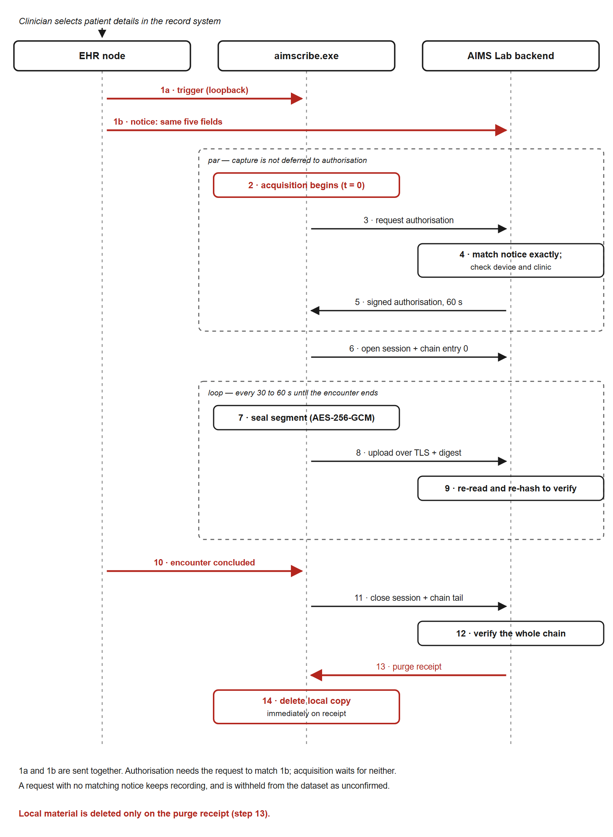
Figure 2 | Sequence of the acquisition pathway. Opening a patient sends two messages at once: a trigger to the local daemon (1a) and a corroborating notice from the EHR server to the backend (1b). Acquisition begins immediately, and the backend authorises the recording only if the daemon's request matches the notice exactly. Segments are sealed, uploaded and verified by server-side re-hashing throughout. Local material is deleted as soon as a purge receipt confirms that a verified copy exists.

Network Fault Tolerance and Edge Caching
Connectivity across the study sites is intermittent, and the acquisition path was therefore made offline-first rather than offline-tolerant. Each sealed segment is encrypted under AES-256-GCM and committed to a local buffer before transmission is attempted. Every state transition is appended to a synchronously flushed journal, so that abrupt power loss cannot render a partial segment indistinguishable from a complete one. The buffer is sized for interruptions of minutes rather than days, and nothing is retained on the workstation once the server confirms a verified copy. Synchronisation is opportunistic: when bandwidth returns, queued segments are transmitted in chain order by a background loop decoupled from acquisition, so that drainage of an accumulated backlog does not perturb the consultation in progress.

Deterministic Data Labelling and Synchronisation
Each archived recording is named under a fixed taxonomy, PatientID_DoctorID_HospitalID_StartTime_EndTime_Date, which functions as a relational mapping strategy rather than a filing convention. Identifiers are supplied by the record system at triggering and constrained to a restricted character set, since they become directory names on the archival volume. Consultations proceed back-to-back at intervals of twenty to thirty seconds; the start time of a succeeding encounter is therefore adopted as the end time of its predecessor, so that recordings tile the session without gap or overlap. Referential integrity between the audio corpus and the structured record is thus established at acquisition rather than reconstructed afterwards. An interlock further withholds session closure until the encounter has been concluded in the record system. Inadvertent selection of a subsequent patient therefore cannot truncate an active consultation — a failure mode observed in pilot operation, and not recoverable afterwards.

Device Binding and Cryptographic Security
Access to the acquisition path is constrained by hardware-anchored authentication. Each workstation is commissioned once by an administrator, using a single-use activation credential. That credential is exchanged for a device identity and an asymmetric key pair generated on, and never leaving, that machine. The backend retains the credential only as a cryptographic digest. Binding is between workstation and research backend, and is therefore independent of the partner record system.
Registration establishes that a machine may record at all; a separate authorisation — short-lived, single-use, issued per encounter and verified against a pinned public key — establishes that a particular request is legitimate. The two controls are deliberately distinct: an enrolled workstation without the second would record for any page loaded in the clinician's browser.
Authorisation is in turn conditioned on corroboration from the record system. When a patient is opened, the EHR server sends the same encounter identifiers — patient, clinician, facility, date and start time — directly to the research backend, while the page signals the daemon. A request to record is authorised only if it matches such a notice exactly. The start time is generated once by the EHR server and carried in both messages, so the match is unaffected by clock drift between workstation and servers. A page running on the workstation can reach the daemon but cannot cause the EHR server to issue a notice, so a spurious trigger is never admitted to the corpus. Corroboration does not gate acquisition: a recording whose notice is late continues, is held back as unconfirmed, and is admitted when the notice arrives or discarded after 24 hours. The same match links each recording to its structured clinical record from the moment acquisition begins.
Integrity is maintained end-to-end by a per-session hash chain. Each entry — session opening, every segment, every interruption, and closure — embeds the digest of its predecessor and is signed by the device key, rendering deletion, reordering and substitution detectable. Segments are verified on arrival by re-reading the stored object and recomputing its digest server-side. Local material is deleted as soon as a signed receipt attests that a verified server-side copy exists. A segment that fails verification is still delivered, to a quarantine area outside the evidence archive, so that no recording is left on the workstation or lost from the corpus. Segment objects remain in object storage until the consultation has been merged into the archive and verified against its chain. The merged recording is then compressed losslessly, confirmed to decode to samples identical to the archive, encrypted and retained in object storage as an off-site copy; only once that copy has been verified are the segment objects deleted. A continuous chain of custody is thereby maintained from acquisition to archive, under which tampering, silent truncation and corruption at rest are detectable rather than merely improbable.

