ISDN5240 RoboFab: Preliminary Proposal Template (Blank) Team Members: XXX, XXX
1. Introduction
Concept & Goals:
Clearly and concisely describe the object or installation you plan to fabricate. What is its primary purpose (aesthetic, structural, functional)? What are the key goals? Maybe 1-2 pictures.
Why Robotics:
Justify the use of a robot. Explain why this project necessitates or significantly benefits from an industrial robot compared to other manual or digital fabrication methods. (e.g., complex geometry, scale, repetition, precision, or the need for a custom toolpath).
2. Related Works
Project 1:
[Project Name] by [Creator/Studio]. Briefly describe the project and how it relates to or inspires your concept. 1-2 pics. (Include a source link if available).
Project 2:
[Project Name] by [Creator/Studio]. Briefly describe the project, focusing on a technique, technology, or material strategy that you find relevant. 1-2 pics. (Include a source link if available).

Non-planar 3D Printing Based on Coral Reef Morphology (Sample) Wenjun Liu, Xingxin He
1. Introduction
Concept & Goals:
We propose to fabricate a bio-inspired artificial reef structure using robotic non-planar 3D printing technology. The primary purpose of the installation is to support coral population restoration by providing a suitable substrate for coral larval attachment and growth. The design incorporates highly organic forms, continuously varying curvatures, and complex porous structures that mimic natural reef ecosystems.
This project aims to explore the formal and functional possibilities of non-planar 3D printing while addressing urgent ecological challenges through design innovation.
Our main goals include:
1. Exploring segmentation algorithms for complex surfaces to ensure printability and continuity.
2. Researching non-planar printing path generation methods to achieve path smoothness and material uniformity.
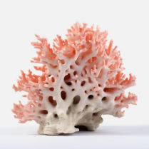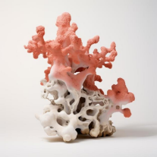
Why Robotics:
This project necessitates the use of an industrial robot due to the intricate geometric features and functional requirements of the artificial reef. The six-axis robotic arm enables continuous adjustment of the print head orientation, allowing for the creation of complex surface textures and micro-topographies that are essential for coral propagation. These capabilities are beyond the reach of conventional three-axis 3D printing or manual fabrication methods, which cannot achieve the same degree of curvature control, material continuity,
or structural customization.
2. Related Works
Project 1:
"Fluid Forms" by Digital Building Technologies, ETH Zurich
This project developed an innovative robotic non-planar 3D printing method focused on decomposing complex curved surfaces into printable structural segments. The research team used computational algorithms to generate continuous printing paths aligned with principal stress directions, optimizing both structural performance and material efficiency. Their breakthroughs in surface segmentation, structural line extraction, and trajectory planning provide critical insights for our research on coral reef surface design and printing strategy.
Source: https://dbt.arch.ethz.ch/project/fluid-forms/
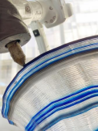 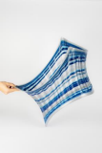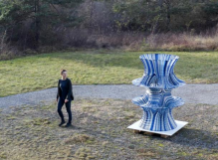Project 2:
MX3D pioneered a large-scale robotic additive manufacturing system to construct a fully 3D-printed stainless steel bridge in Amsterdam. The project employed multiple industrial robots working collaboratively through wire arc additive manufacturing (WAAM) to fabricate free-form metal structures at an architectural scale. Their experience in segmenting large structures, coordinating multi-robot printing paths, and ensuring real-time quality control offers valuable engineering knowledge for our study.
Source: https://www.arup.com/projects/mx3d-bridge/
