**Test Plan**

**for**

**Bikroy.com Website**

**Overview:**

Bikroy.com is a marketplace to hold exchange communication among buyers and sellers on the business of daily essential goods that are in new or used condition. Initially, this site was developed to ensure the C2C (Consumer to Consumer) business, where a general person wished to sell his/her old stuff at a suitable price and a mass of people could fulfill their desire to buy highly expensive materials at an affordable price. Along with keeping this reputation this platform now offers new products to sell. At the beginning of their journey in 2012, they held their business in a way that every material in your house is now available at a welcoming price. Again, this company has a Srilankan version which is identifiable with <https://ikman.lk/> domain.

**Scope:**

Being an e-commerce platform like Bikroy.com, multiple features are working on their frontend backend to attract the audience. In general, a simple e-commerce website will have features like,

1. Customers can buy items as registered or guest user
2. Items can be posted to sell
3. CRM dashboard (for administrators and operators) to monitor or track the whole business
4. Customer can filter their choice of items
5. Communication system between buyer and seller
6. Add to cart, wish list, and checkout of items
7. Suitable and secure payment gateway method to maintain transactions

Similar to every e-commerce platform, the main features of this platform are buying and selling. For selling, the seller just showcases the products and the buyer just chooses the product with his/her preference.

Now let’s see, how this platform allows consumers to buy and sell products,

Here to sell the product, the seller must post an Ad for his/her relevant product. Below ad posting process is described through a UML diagram,

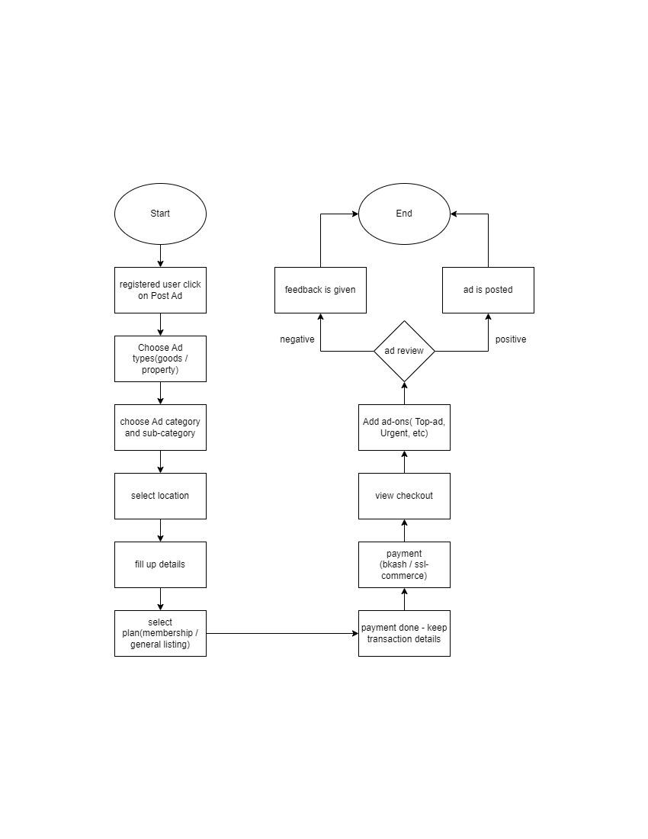

For buying any product, the functionality is very simple. Buyers just have to choose their product with their preference and contact the seller for discussion. Below buying process is explained,

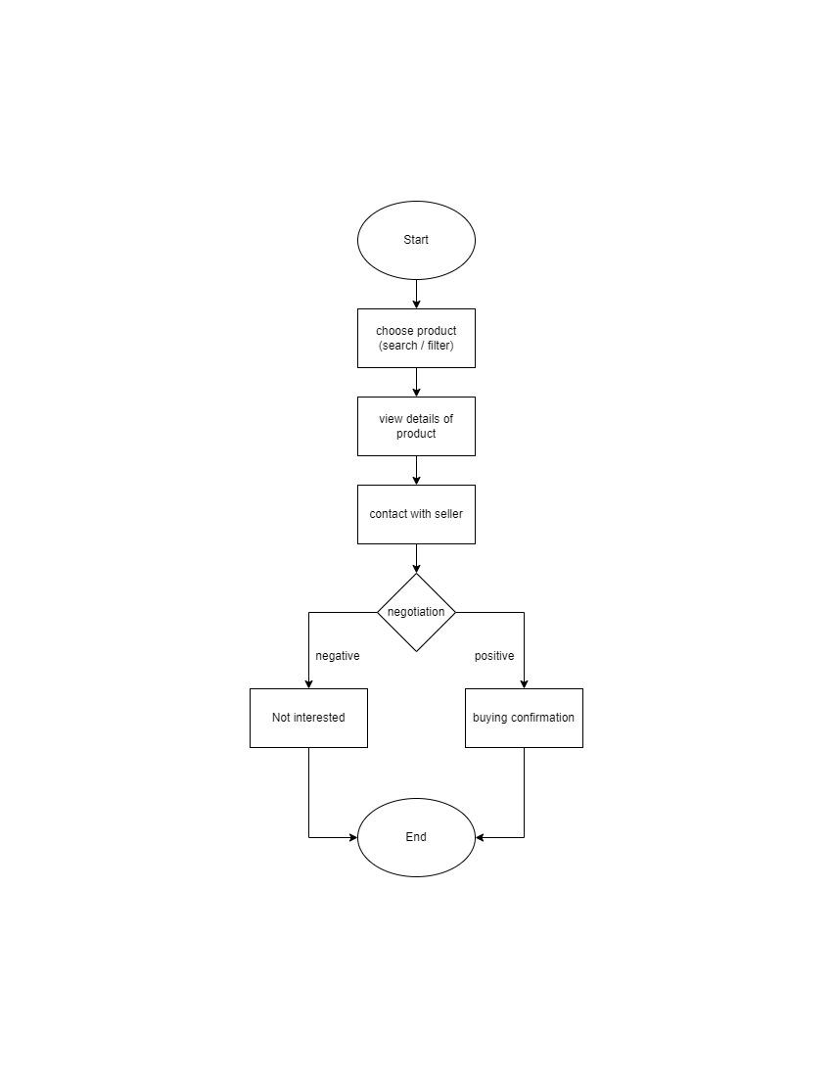

Along with these basic e-commerce functionalities, there are more features to explore for this app.

Such as,

1. Registered user feature with user dashboard (member and other users) for the consumer
2. Provides the localization feature (Bangla and English)
3. Home page that provides the summary of the app
4. The footer section provides the usable links for this business
5. Provides an item filter or item selection page
6. Provides an item descriptor page
7. Provides multiple payment options such as Bkash and SSLCommerce
8. Provides the save ad feature
9. Provides the share-in media feature
10. Provides feature to promote the item
11. Provides a feature to report against the item
12. Provides the related item section on the item descriptor page
13. Provides upper related footer section in item selection or filter page and item descriptor page that offer more specific
14. Provide a link to srilankan version of this app
15. Provide Bikroy job domain
16. App in google play store
17. App in apple store

* Inclusion: These feature are taken to test for the running version of Bikroy.com

1. Authentication system
2. User dashboard
3. Home page
4. Footer
5. Item selection page
6. Item descriptor page
7. Post ad operation
8. Chatbox in user dashboard
9. Chatbox between buyer and seller

* Test Environment: In this test process, only a browser will be needed to run.

1. Browser: Version 124.0.6367.62 (Official Build) (64-bit)

* Exclusion: For this test process these features are avoided to test.

1. Bikroy jobs
2. Srilankan version of bikroy.com
3. App in google play store
4. App in apple store
5. Payment options
6. Jobs portion in the user dashboard
7. Advertisement section in the app

**Test Strategy:**

This plan will follow the test process sequence,

1. Explore the features of app
2. Draft those feature
3. Select features to test
4. Test plan preparation
5. Test scenario preparation
6. Test Data preparation
7. Test case preparation
8. Test execution
9. Test report generation
10. Checking entry and exit criteria
11. Bug report generation
12. Final revision

In this testing procedure following Test design techniques will be in used for preparing Test Data and Test Cases

1. Equivalence class partitioning

In this test process, there are input field which will only accept a single type of data. Such as,

* Login with phone number -> it will take only digits as value
* Search box in home page and item selection page -> it will take only string as value
* Price range in item selection page -> it will take only numbers as value

1. Boundary value analysis

This test will allow only certain boundaries of certain types of value. Such as,

* Login with phone number -> only allow 11 digits
* Search box in home page and item selection page -> allow certain length of string
* Price range in item selection page -> does not allow negative values

1. State Transition

This technique will be used for checking the FALSE ATTEMPTS in login system

1. Error Guessing

The rest of the test cases will be prepared with this technique. It is simply a hypothetical technique to point out the error in the system.

Defect Reporting Procedure:

1. In the test execution process, every test case will be executed
2. All the failed test cases will be revised from the test execution report
3. Those test cases will be noted on the bug report with their reproducible steps and proof.

**Test Schedule:**

| Tasks | Dates |
| --- | --- |
| Exploratory test for feature selection | 24th April 2024 |
| Exploratory test for feature selection | 25th April 2024 |
| Test Scenario Preparation | 26th April 2024 |
| Test Case Generation | 26th April 2024 |
| Test Case Generation | 27th April 2024 |
| Test Execution and Test Execution Report  Generation | 27th April 2024 |
| Bug report preparation | 28th April 2024 |
| Submission | 28th April 2024 |

**Deliverables:**

1. Test Plan Document
2. Test Scenarios List in Google Sheet [https://docs.google.com/spreadsheets/d/10Hnhok_FieCaS8E870Qf7GZxtqNguU6jaLsWNW15zUw/edit?usp=sharing]
3. Test Cases List in the Google Sheet [https://docs.google.com/spreadsheets/d/1wvlTZ8AvSgMDwoWYLr3HTGEyiCP3Lkh4-MCo41roni4/edit?usp=sharing]
4. Test Execution report in the Google Sheet [https://docs.google.com/spreadsheets/d/1-AEG4FJdQsBgozoEKCaFhWhWKwUo-u4gfdSKxnolL_U/edit?usp=sharing]
5. Bug Report in Google Sheet [https://docs.google.com/spreadsheets/d/1DLm3iv-YF2HVDEMmEDvTerzcHwFv-rr2R-Erv27OsF0/edit?usp=sharing]

**Entry & Exit Criteria:**

1. Exploration of Features of this App

* Entry criteria: The fully built app is on the hand,https://bikroy.com/en
* Exit criteria: All the features are explored and listed in a draft

1. Preparation of Test Scenarios

* Entry criteria: The list of features is ready
* Exit criteria: All the high-level features are broken into segments. Those segments are documented with proper Test Scenario ID

1. Preparation of Test Cases

* Entry criteria: Partial Test Scenario is prepared
* Exit criteria: All test scenarios are broken into pieces with test design techniques and test data

1. Preparation of Test Execution Report

* Entry criteria: Test Cases are prepared with Test Data
* Exit criteria: All the test cases are executed and results are defined and the test cases are mapped with test scenarios in the test scenarios list

1. Preparation of Bug Report

* Entry criteria: The test report is ready
* Exit criteria: All the failed test cases are revised and enlisted.

Note: As per the instruction, I am supposed to have an end-to-end functionality test on bikroy.com. Through this testing process, the safety of this application(bikroy.com) was my prime consideration. Following that, no security or vulnerability test has been executed. Some bugs or issues are found that won’t cause any harm to this app. Rather those are just the deviations from the expected behavior of any feature from the consumer's point of view.