  - INDIVIDUAL COURSE EXAMINATION

EasyAnnotate
  - A Lightweight AI-Assisted Road-Object Annotation Platform
AI Vision | M.Sc. Applied Data Science & Artificial Intelligence | SRH University
Report date: 2 November 2026
Author: Zhixiao Yang (100005784)

Project at a glance
Item | Scope
Application | Python-only Streamlit web demo; single-user, local execution
Vision task | Ten-class road-object detection and bounding-box annotation
Model | Pretrained BDD100K-specific YOLO11n; no training or fine-tuning
Evaluation | 100 BDD100K validation images; 1,744 human-labeled objects
Deliverable | Editable annotations, local save/restore and YOLO ZIP export

Executive summary
EasyAnnotate is a compact human-in-the-loop annotation application for road-scene images. A user uploads an image, obtains proposed bounding boxes from a pretrained BDD100K-specific YOLO11n detector, corrects the predictions in an interactive canvas, saves the corrected annotations and exports a standard YOLO-format ZIP archive. The system deliberately prioritizes a small and reproducible engineering workflow suitable for a single-person course examination.
The model was evaluated against existing human ground-truth labels on 100 BDD100K validation images comprising 1,744 object instances. It obtained precision 0.6432, recall 0.4023, mAP@0.5 0.4934 and mAP@0.5:0.95 0.3016. Measured model inference on an Apple M3 CPU averaged 15.2 ms per image. These findings establish that automatic proposals are computationally feasible but incomplete; consequently, manual correction remains essential.
The application workflow and model-quality evidence are documented below. The numerical manual-versus-assisted annotation time comparison has not yet been supplied and is explicitly identified as pending rather than estimated.

1. Problem and Target Users
Creating object-detection datasets requires humans to draw and classify bounding boxes around every relevant object. In road scenes, a single frame can include multiple vehicles, pedestrians and small traffic infrastructure objects. Repeated manual placement and labeling can be slow, especially when objects are dense or partially obscured.
The target user is a student, researcher or small computer-vision team preparing or correcting road-object annotations. The goal is to reduce routine box creation while preserving human control over the final labels. The scope is a local single-user demo rather than an industrial annotation service.

2. Requirements and Design Decisions
Requirement | Implementation | User value
Manual annotation | Upload image; draw and resize labeled rectangles | Control over missed or difficult objects
AI assistance | Integrated YOLO11n inference via Auto Annotate | Generate an editable starting point
Correction | Change class, move/resize and delete boxes | Fix false positives and localization errors
Saved output | JSON annotation state and normalized local image | Resume editing the same image
Export | Image + YOLO TXT labels + data.yaml in ZIP | Portable standard-format annotations
Evidence | Detection metrics and qualitative GT/prediction comparisons | Verify quality and failure cases
Only two-dimensional bounding boxes are supported. Instance segmentation, authentication, database services, cloud deployment, Docker and model training were intentionally excluded to minimize complexity unrelated to the examination objective.

3. System Architecture
The system consists of a Streamlit user interface, an annotation-state layer, a detector adapter and two output modules. The repository uses a src/easy_annotate Python package; application imports use the easy_annotate.* namespace.
Component | Responsibility
app.py | Streamlit sidebar, uploader, edit canvas, annotation list and actions
easy_annotate.detector | Cached pretrained YOLO11n loading and CPU inference
easy_annotate.storage | Local image plus JSON state persistence and restoration
easy_annotate.exporter | Conversion from pixel coordinates to normalized YOLO labels and ZIP creation
scripts/ | Dataset acquisition, GT visualization and reproducible model evaluation
Workflow: upload image → initialize canvas → optionally run Auto Annotate → edit predicted/manual boxes → save locally → export YOLO ZIP. YOLO predictions are converted into canvas objects in display coordinates; edited rectangles are converted back to original-image coordinates before saving or export. A separate initialization snapshot is used to avoid stale Canvas updates causing box flicker during reruns.
The application can be started with one command: uv run streamlit run app.py. No external backend is required. Runtime model assets are stored in models/, while evaluation samples are kept under datasets/bdd100k-road/.

4. Model Selection and Data

4.1 Pretrained model
The selected model is YOLO11n fine-tuned on BDD100K and released by the Hugging Face account “dronefreak” [2]. The student did not train or fine-tune it. The Nano size was chosen to support fast local CPU inference and straightforward Ultralytics integration. It covers ten relevant categories: person, rider, car, truck, bus, train, motor, bike, traffic light and traffic sign.
The locally evaluated checkpoint has 100 fused layers, 2,584,102 parameters and approximately 6.4 GFLOPs according to the evaluation log. The original model publisher reports a separate benchmark on its own evaluation setup; those published numbers must not be conflated with the results in this report.

4.2 Human-annotated evaluation data
The dataset is a 100-image subset of BDD100K road-scene validation imagery, sampled with a fixed random seed of 42. Original image-level JSON human annotations were converted into normalized YOLO text labels without using model predictions as ground truth. The resulting evaluation set contains 1,744 labeled instances and no corrupt images. BDD100K contains diverse driving conditions and road-object categories [1].
The model publisher describes its “test” data as corresponding to the official BDD100K validation split [2]. Thus this exercise is a small-scale validation-set replication, not a truly independent external benchmark. A subset of 100 images is also insufficient for precise estimates of very rare classes.

5. Model Evaluation Method
A fixed pretrained checkpoint was evaluated using Ultralytics model.val() with image size 640 on an Apple M3 CPU. Bounding-box predictions were compared with the existing human labels. Precision measures the proportion of matched predictions among predictions; recall measures the proportion of matched objects among ground-truth instances. Average precision integrates the class-specific precision-recall curve; mAP@0.5 uses a 0.5 IoU matching criterion, while mAP@0.5:0.95 averages over IoU thresholds from 0.5 to 0.95.
Experiment environment: Python 3.12.13, Ultralytics 8.4.189, PyTorch 2.14.1, Apple M3 CPU. The validation log reported 0.2 ms preprocessing, 15.2 ms inference and 0.3 ms postprocessing per image; these model-level timings do not include upload, front-end rendering or human review.

5.1 Aggregate metrics
Measure | Result
Images / human-labeled objects | 100 / 1,744
Precision | 0.6432 (64.32%)
Recall | 0.4023 (40.23%)
mAP@0.5 | 0.4934 (49.34%)
mAP@0.5:0.95 | 0.3016 (30.16%)
Inference speed | 15.2 ms per image (Apple M3 CPU)
Precision exceeds recall by 24.09 percentage points. The detector can therefore provide useful proposals, but a substantial proportion of human-labeled objects may still require addition during review. This motivates the explicit add, edit and delete tools in the application.

5.2 Class-level analysis
Class | GT instances | Precision | Recall | mAP@0.5
person | 123 | 0.745 | 0.366 | 0.469
rider | 3 | 0.448 | 0.667 | 0.582
car | 928 | 0.776 | 0.625 | 0.717
truck | 37 | 0.753 | 0.495 | 0.692
bus | 19 | 0.654 | 0.579 | 0.638
motor | 1 | 0.000 | 0.000 | 0.000
bike | 6 | 1.000 | 0.000 | 0.320
traffic light | 283 | 0.703 | 0.470 | 0.534
traffic sign | 344 | 0.709 | 0.419 | 0.489
Car accounts for 928 of 1,744 ground-truth instances (53.2%) and achieves the highest well-supported mAP@0.5 (0.717). Trucks and buses also show useful performance, although their sample counts are smaller. Traffic lights and signs are more challenging due to small targets and crowded scenes. The rider, motor and bike results are unstable because they represent only 3, 1 and 6 ground-truth objects, respectively. No train instances were present in this 100-image sample, so train performance cannot be estimated.

5.3 Confidence-threshold behavior
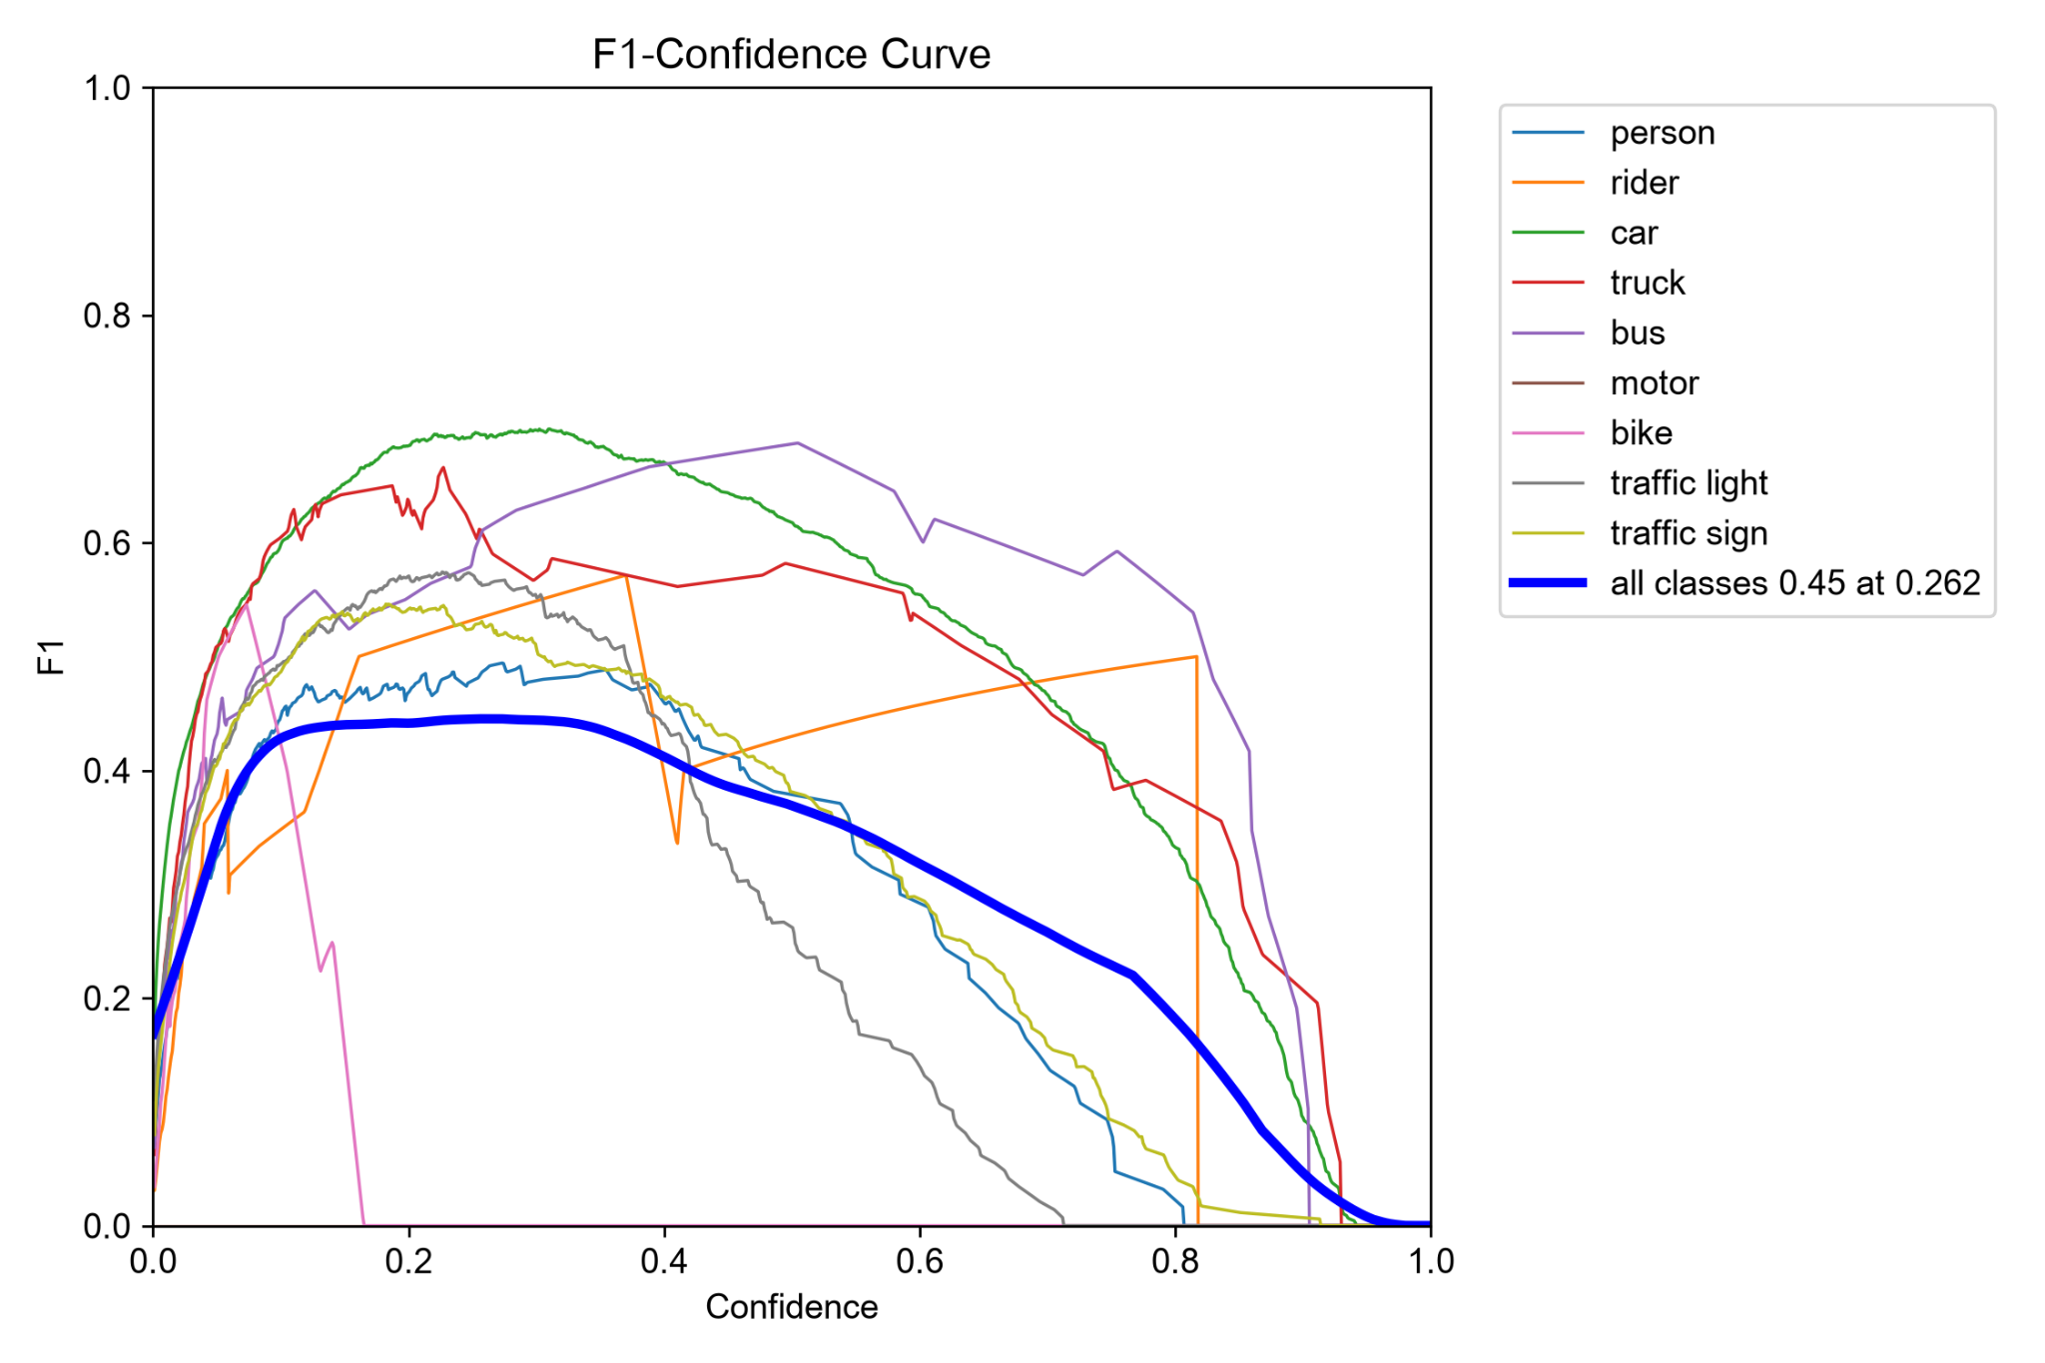
Figure 1. F1 score versus prediction confidence. The reported all-class maximum is approximately F1 = 0.45 at confidence 0.262.
F1 is maximized near 0.262 in this validation sample, supporting a pragmatic default confidence of 0.25 for annotation suggestions. This threshold still leaves many misses and should be viewed as an adjustable operational tradeoff rather than a universal optimum.
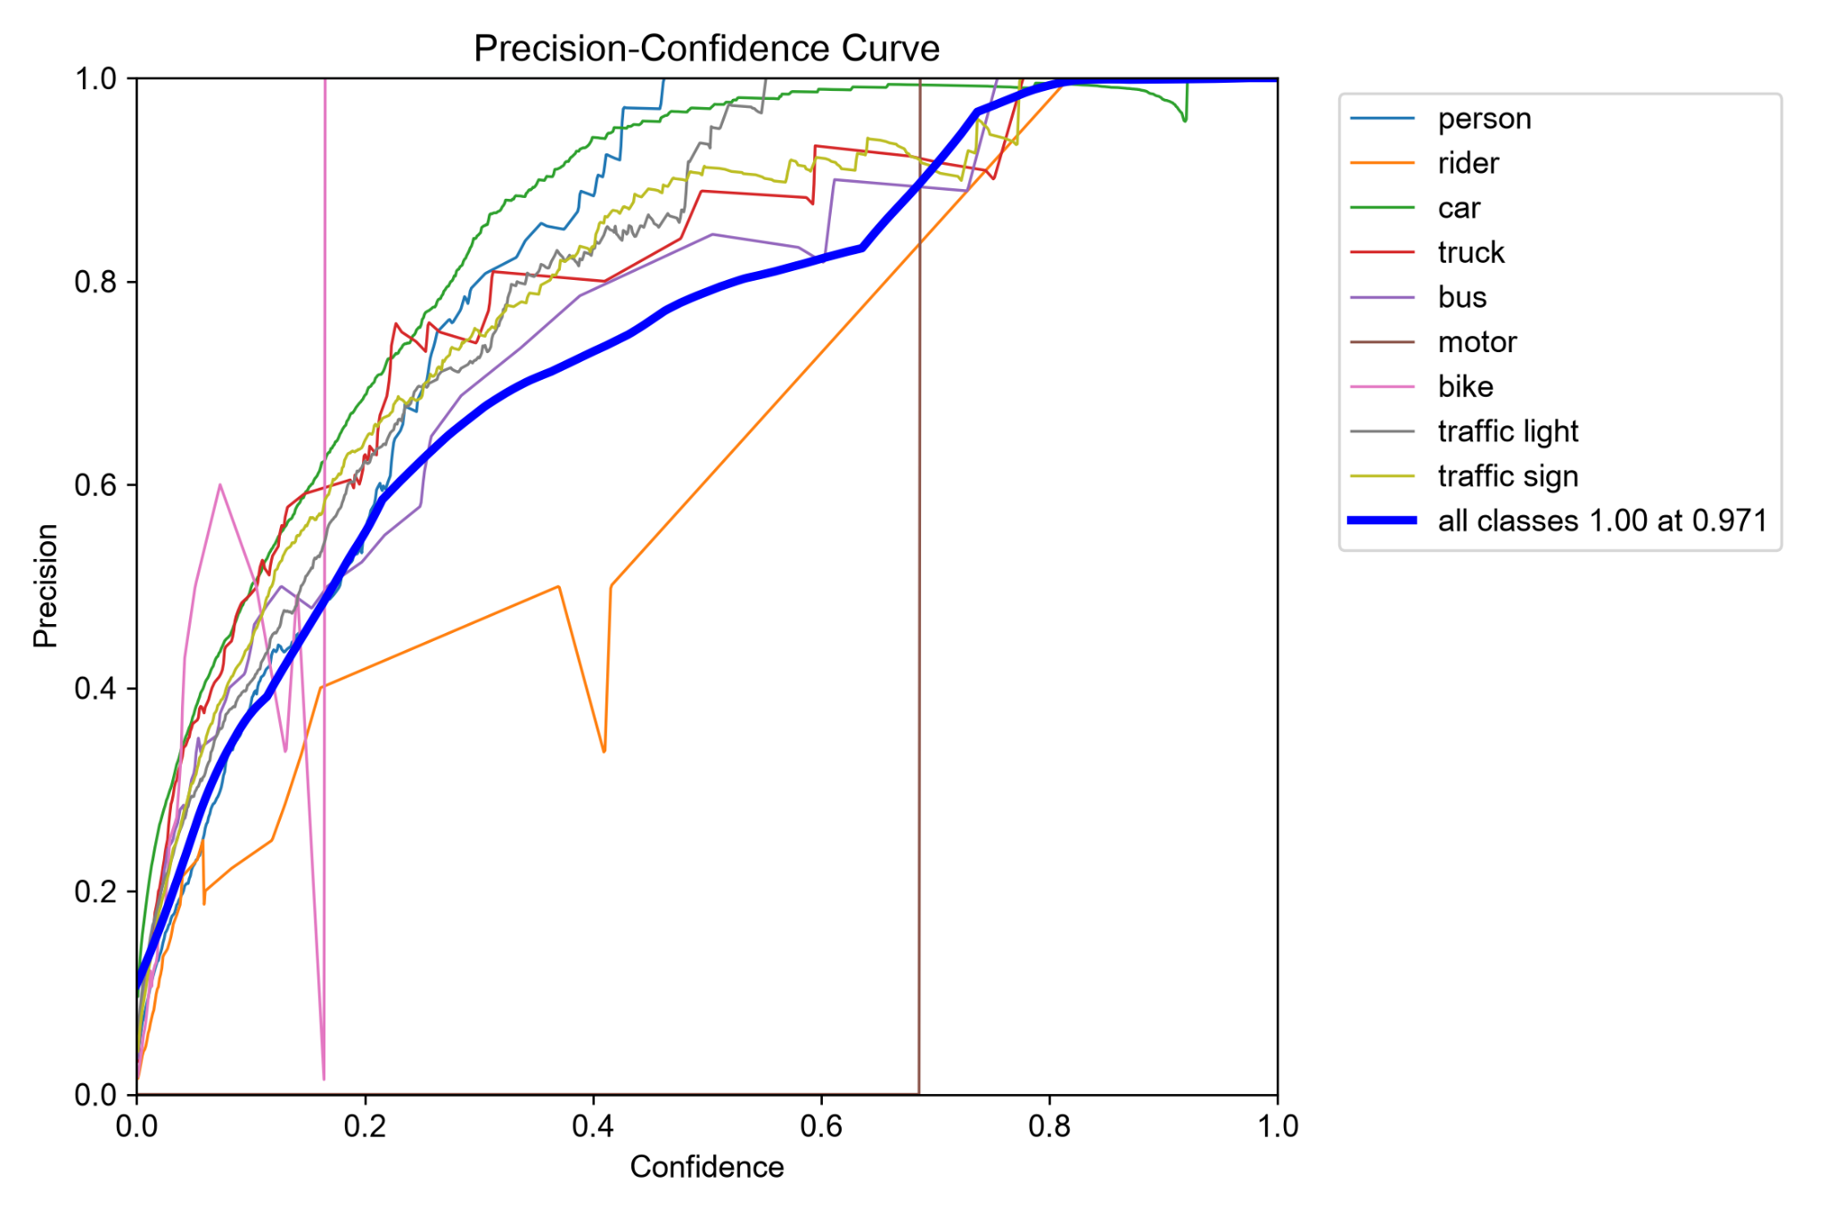 | 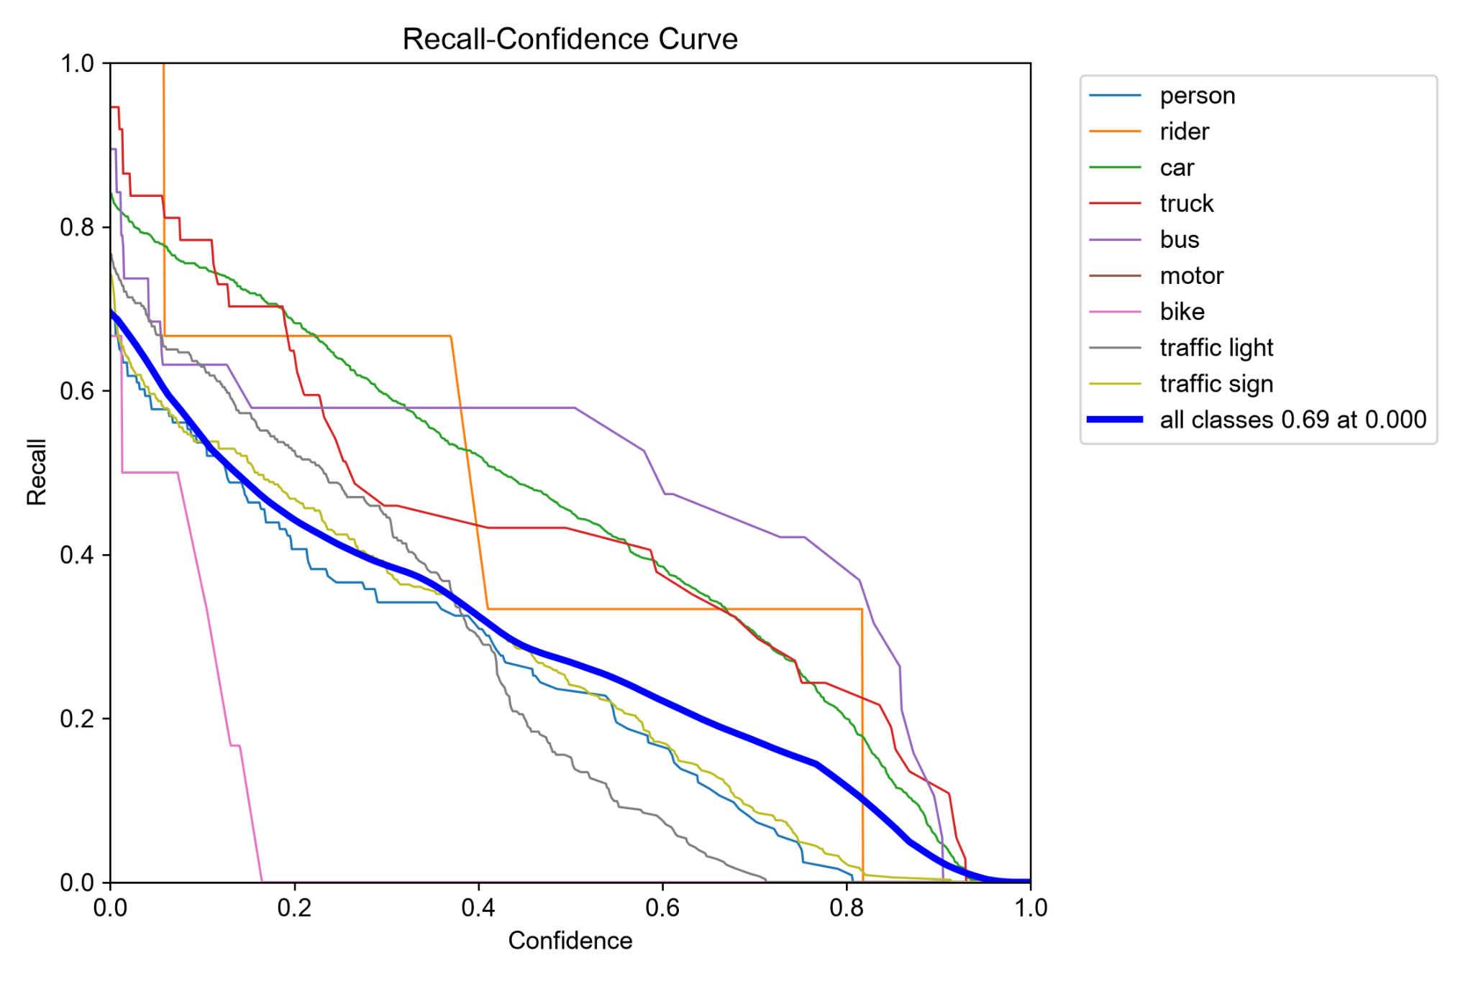
Figure 2. Precision-confidence (left) and recall-confidence (right) curves. Increasing the threshold usually improves prediction precision while reducing recall.
The extremely high precision shown near a confidence threshold of 0.971 applies only to the few surviving high-confidence predictions; it should not be interpreted as near-perfect overall detection. Conversely, low thresholds display more candidate boxes but increase the amount of work needed to remove false positives.

5.4 Precision–recall and confusion analysis
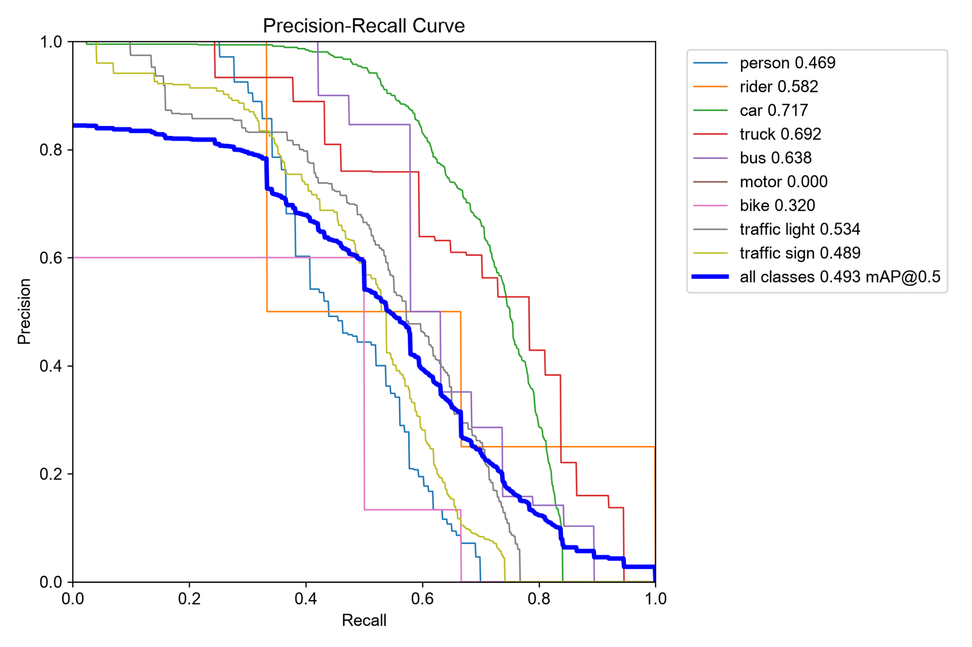
Figure 3. Per-class precision–recall curves; blue curve summarizes mAP@0.5 ≈ 0.493.
The car curve sustains relatively high precision over a broad recall range, whereas person, traffic sign and traffic light degrade earlier. Sparse categories produce stepped or unstable curves. The plot is consistent with the per-class summary and emphasizes category-dependent assisted-annotation utility.
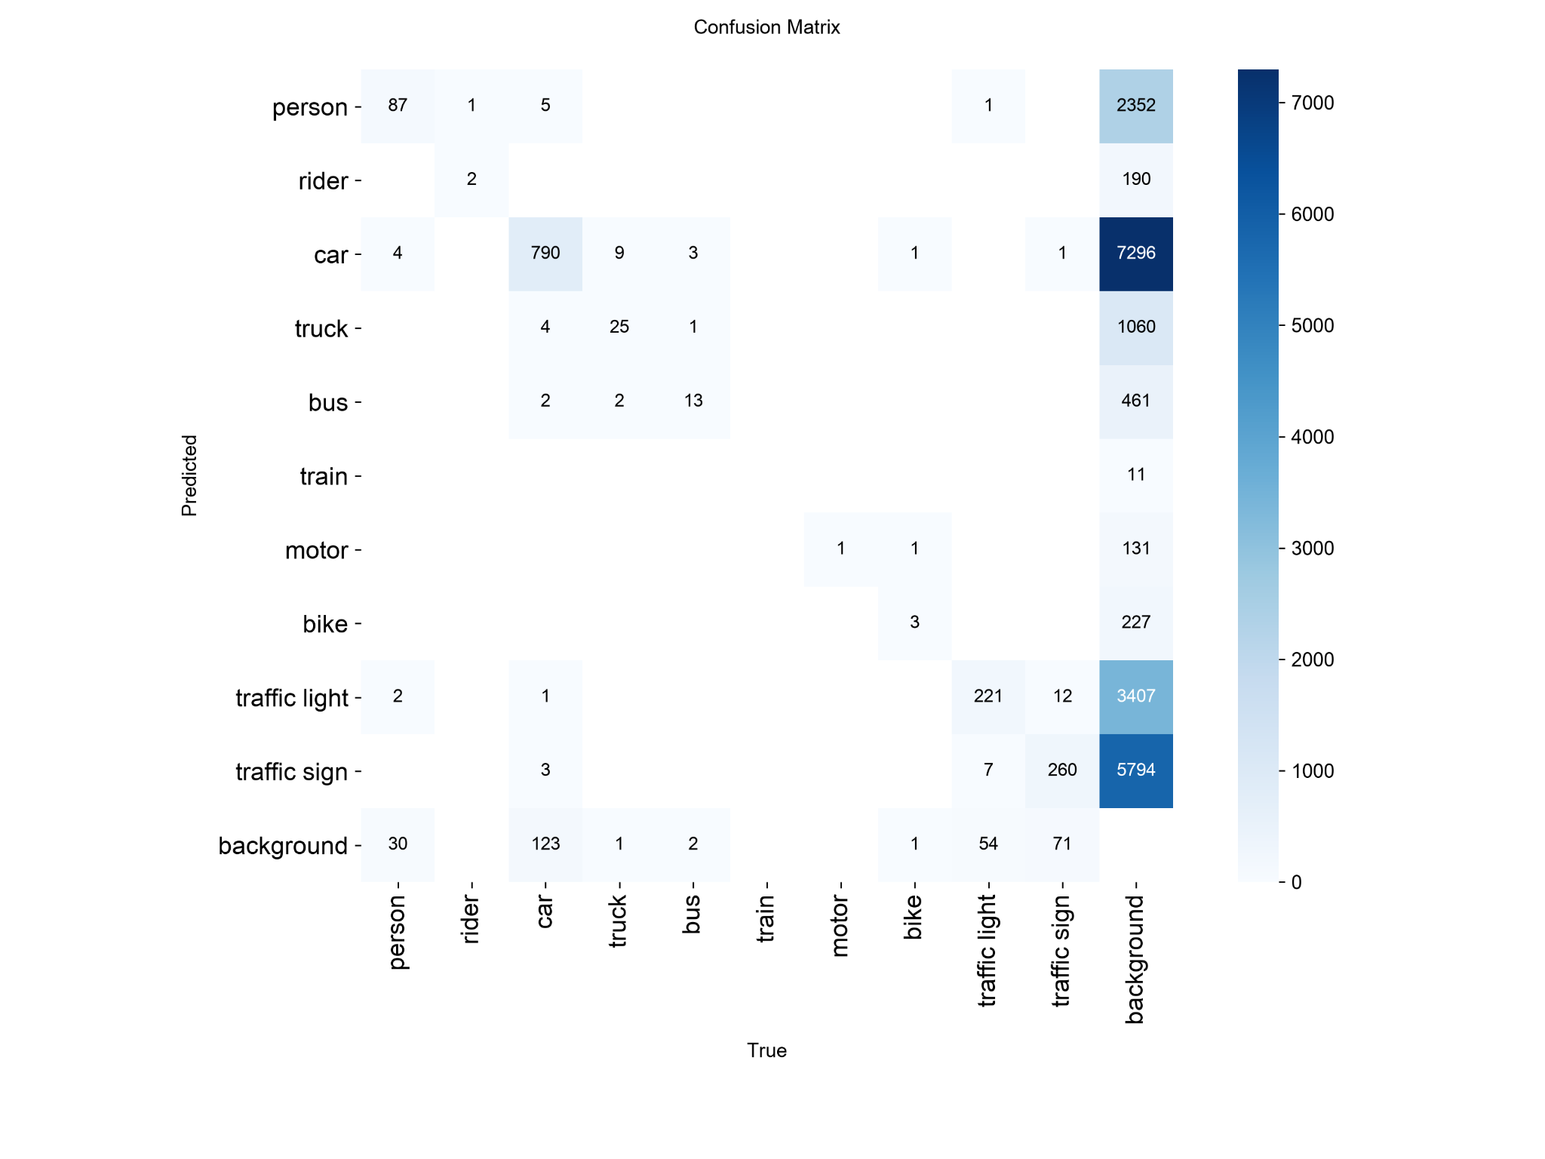
Figure 4. Raw detection confusion matrix; last row/column represent unmatched predictions and missed ground-truth objects.
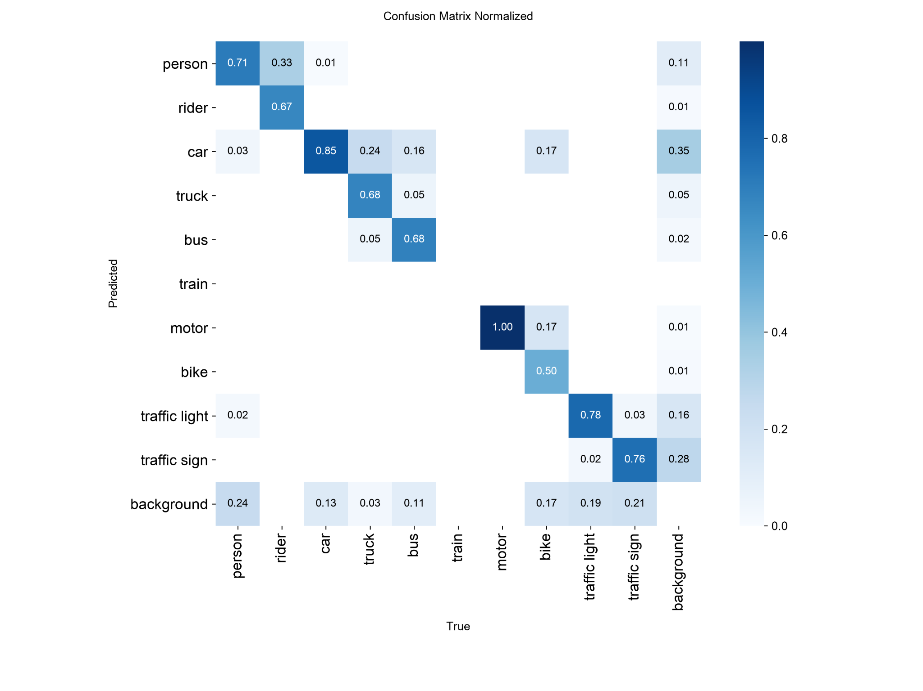
Figure 5. Normalized detection confusion matrix. Axes: predicted class (vertical), true class (horizontal).
The normalized matrix shows that correct car matches are dominant among the selected well-populated classes. Some truck and bus objects are confused with car, while misses and unmatched predictions involve the background category. Because the background column represents unmatched predictions, its values should not be treated as an ordinary classification class frequency.

6. Qualitative Failure Cases
The provided validation montage pairs offer examples across daylight, nighttime and visually cluttered road scenes. They demonstrate both correct large-object proposals and difficulties around small signs, traffic lights, distant vehicles and overlapping boxes. The visual comparisons are qualitative; no extra failure counts are inferred from the montages.
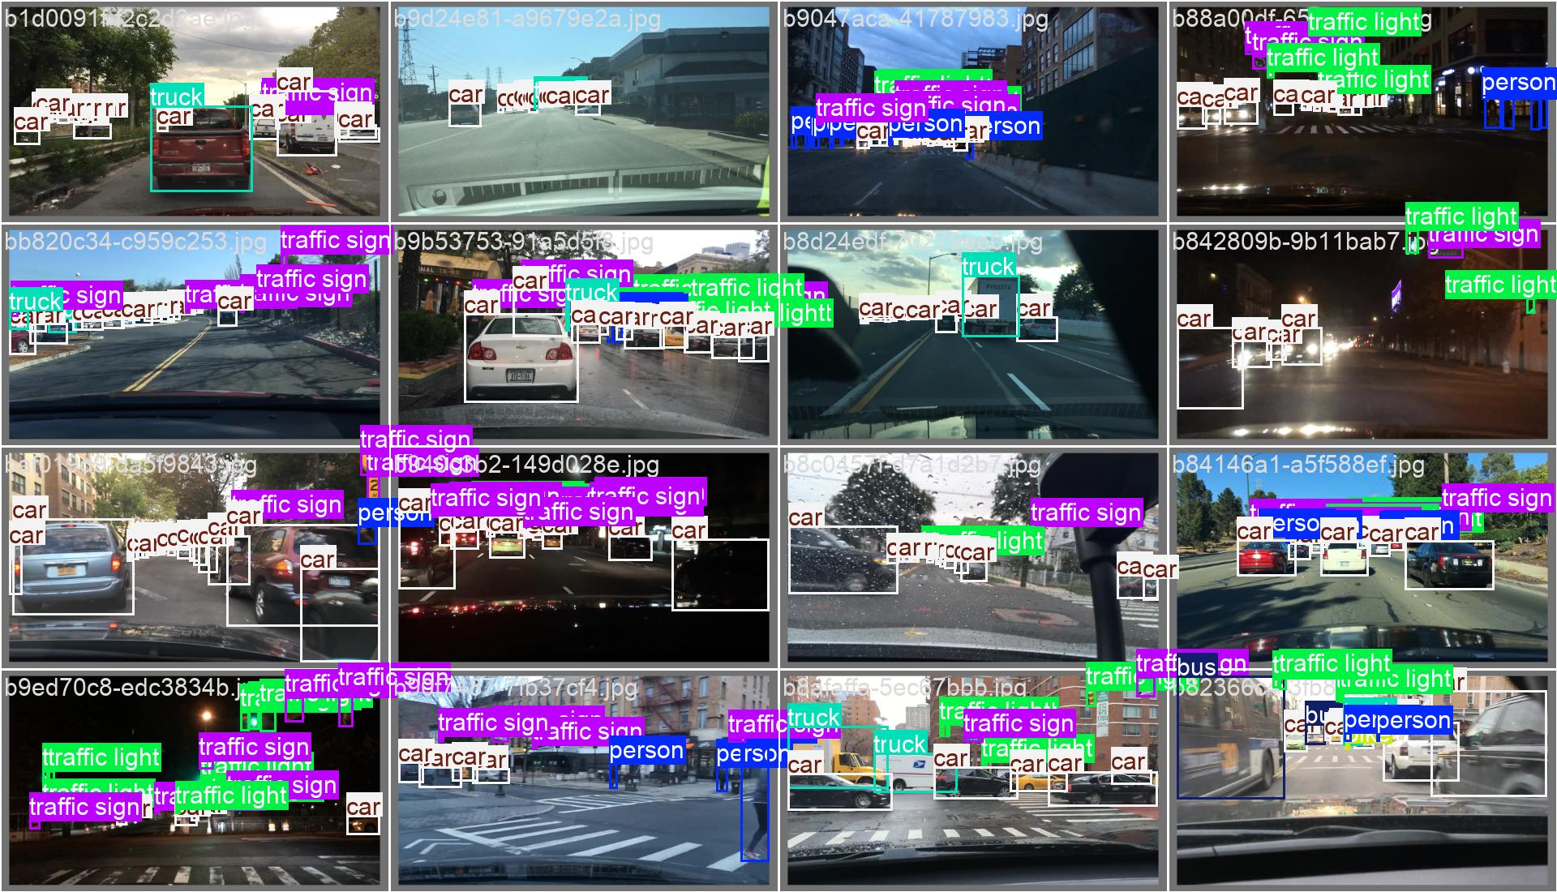 | 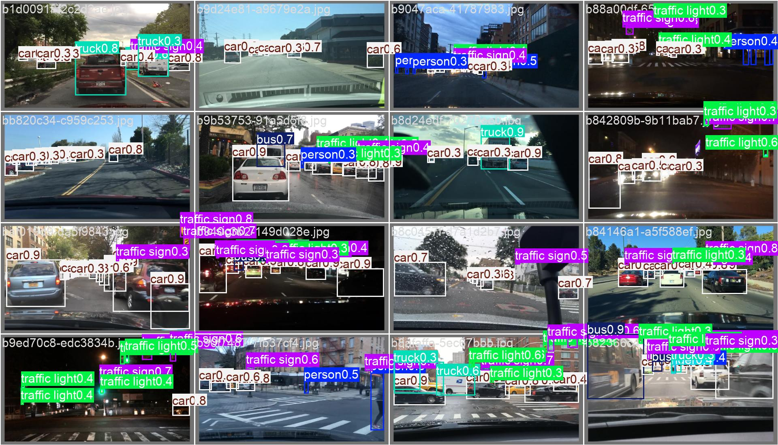
Figure 6. Validation batch 0: human ground truth (left) and model predictions (right). Dense multi-object road scenes illustrate correct vehicle detections together with missing small objects.
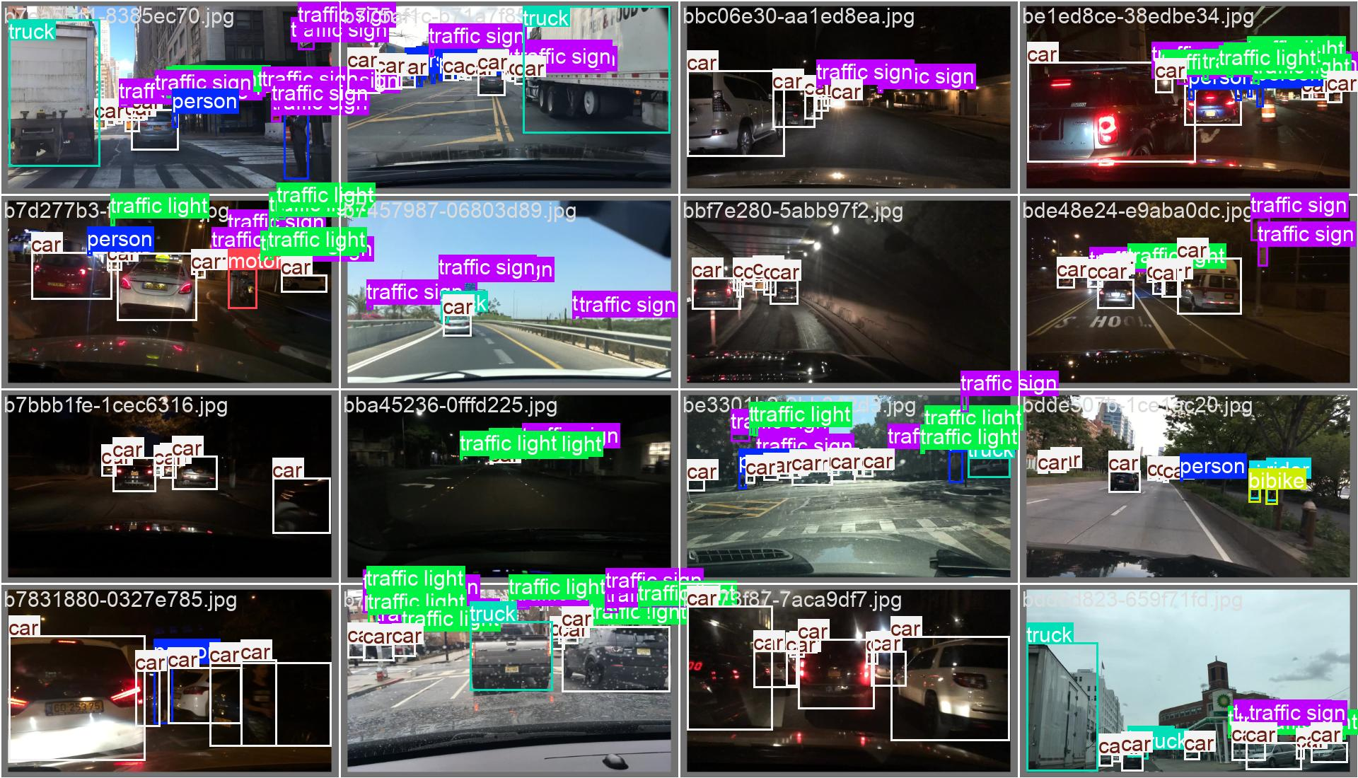 | 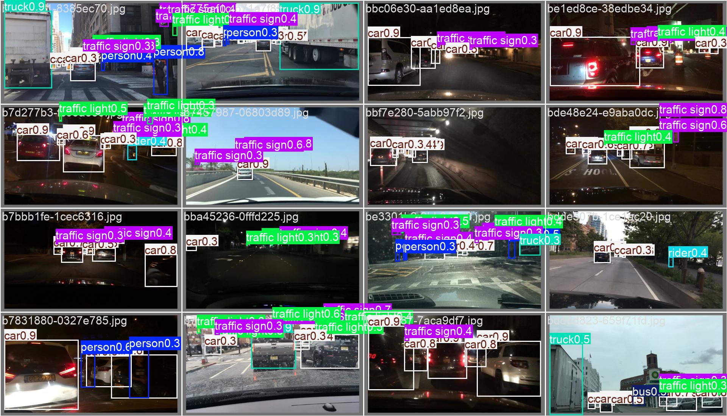
Figure 7. Validation batch 1: human ground truth (left) and model predictions (right). Nighttime scenes show increased difficulty from poor illumination and overlapping traffic targets.
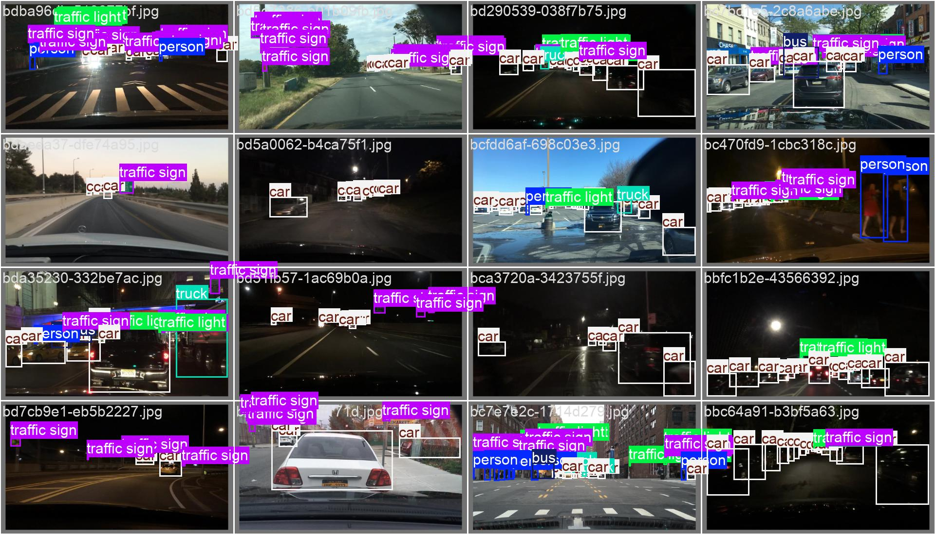 | 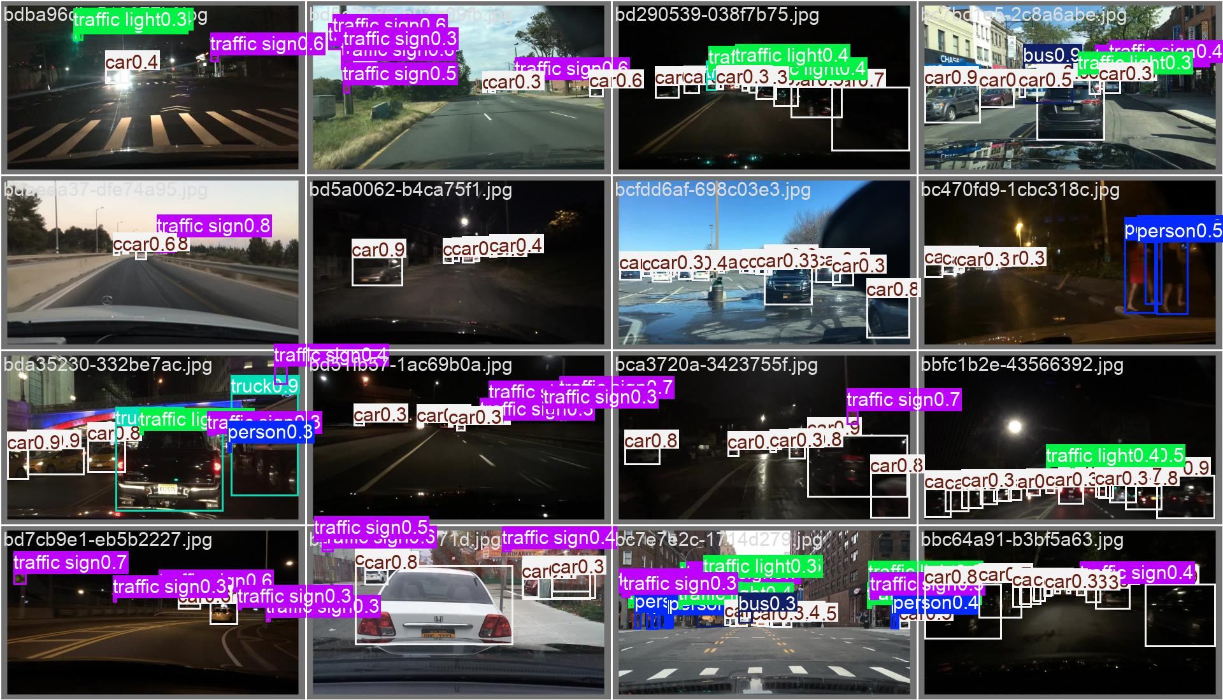
Figure 8. Validation batch 2: human ground truth (left) and model predictions (right). Long-range vehicles, signs and multiple close boxes require manual review.
Representative failure modes: (1) missed pedestrians or distant vehicles, (2) incomplete detection of very small traffic signs/lights, (3) category confusion among vehicle subtypes, and (4) prediction boxes that require repositioning. These cases justify user correction rather than blindly accepting model output.

7. Annotation-Effort Evaluation
The efficiency of EasyAnnotate was assessed through a qualitative comparison between manual annotation and AI-assisted annotation.
Manual annotation requires users to identify objects, draw bounding boxes, and assign class labels individually. Depending on the number of objects and scene complexity, annotating a single road image may take several minutes.
With AI assistance, the pretrained YOLO11n model generates initial bounding boxes automatically. Users only need to review the predictions, correct inaccurate boxes, remove false detections, and add missing objects. The time required therefore depends primarily on the number of necessary corrections.
For relatively simple images containing only a few objects, the AI-assisted workflow can potentially be completed within seconds. More complex scenes may require additional manual adjustments, particularly when the model misses small or occluded objects.
Overall, EasyAnnotate demonstrates the potential to reduce manual annotation effort by automating the initial detection process. However, no controlled timing experiment was conducted, so the actual time savings cannot be quantified.

8. Limitations and Ethical / Licensing Considerations
First, low recall means AI suggestions can omit objects, especially small or occluded targets. Second, only a modest 100-image validation subset was used; the sample is dominated by cars and has very few motorcycles, bikes or riders. Third, the model was developed on BDD100K and tested on imagery from the same dataset family, limiting claims about geographic, camera and domain transfer. Fourth, annotation-time evidence is pending and one image would offer only illustrative evidence. Fifth, save and export operate locally and the interface has no collaboration or multi-user features.
Source images and annotations originate from BDD100K, subject to its dataset terms [1, 3]. Model weights come from a third-party Hugging Face release carrying an AGPL-3.0 license notice [2]. The project cites its software packages and data sources; any redistribution must respect applicable model, dataset and library licenses.

9. Conclusion
EasyAnnotate satisfies the core engineering workflow of an AI-assisted road-object annotation demo: upload, manual labeling, integrated object detection, correction, local persistence and standard-format export. The quantitative evaluation demonstrates that the compact pretrained YOLO11n can generate road-object proposals quickly on a CPU, but its recall and class-dependent errors make human verification indispensable. The remaining evidence needed for a complete examination submission is a timed manual-versus-assisted comparison and a short end-to-end demonstration video.

References
[1] Yu, F., Chen, H., Wang, X., et al. (2020). BDD100K: A Diverse Driving Dataset for Heterogeneous Multitask Learning. Proceedings of CVPR, 2636–2645. https://openaccess.thecvf.com/content_CVPR_2020/html/Yu_BDD100K_A_Diverse_Driving_Dataset_for_Heterogeneous_Multitask_Learning_CVPR_2020_paper.html
[2] dronefreak. BDD100K YOLO11n fine-tuned model card and weights. Hugging Face. https://huggingface.co/dronefreak/bdd100k-yolo11n (accessed 2 Nov 2026).
[3] BDD100K dataset and toolkit. https://bdd-data.berkeley.edu/ ; https://github.com/bdd100k/bdd100k (accessed 2 Nov 2026).
[4] Ultralytics. YOLO11 model documentation. https://docs.ultralytics.com/models/yolo11/ (accessed 2 Nov 2026).
[5] Streamlit. Streamlit documentation. https://docs.streamlit.io/ (accessed 2 Nov 2026).
[6] Streamlit Drawable Canvas. Project source and package documentation. https://github.com/andfanilo/streamlit-drawable-canvas (accessed 2 Nov 2026).
[7] Loguru. Python logging library. https://github.com/Delgan/loguru (accessed 2 Nov 2026).
[8] Pillow. Python Imaging Library fork. https://pillow.readthedocs.io/ (accessed 2 Nov 2026).
[9] PyYAML. YAML parser/emitter for Python. https://pyyaml.org/ (accessed 2 Nov 2026).
[10] Hugging Face Hub. Python client documentation. https://huggingface.co/docs/huggingface_hub/ (accessed 2 Nov 2026).

Appendix A. Reproduction Commands
uv sync
uv run python scripts/download_model.py
uv run python scripts/download_dataset.py --count 100 --seed 42
uv run python scripts/evaluate.py
uv run streamlit run app.py
Local outputs used for this report: results/model-evaluation-2/; original user-provided validation curves, confusion matrices and visual montage images. Model quality was computed against human labels, not auto-generated annotations.

